**jQuery Thermometer Instructions**

1. Put the images, js, and css folders in the same directory as you html file.   
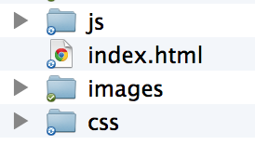

If you want to upload them somewhere else, you’ll need to change the src url’s in the next step.

2. On your HTML page inside the <head> tags add the following code:   
  
<link href="css/goal-thermometer.css" rel="stylesheet" type="text/css" />

<script type="text/javascript">

var currentAmount = 567;

</script>

<script src="http://code.jquery.com/jquery-latest.js"></script>

<script type="text/javascript" src="js/goal-thermometer.js"></script>

Change “currentAmount” to however much you’ve made so far. We put this variable here so it’s easier to add a dynamic value via php.

3. Open the goal-thermometer.js and edit the following variables:

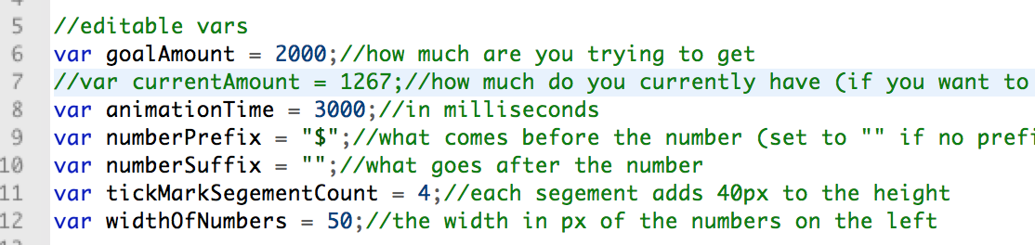

4. If you’ve put the images in a different folder, update the links here.

