

CENTENNIAL COLLEGE PROGRESS CAMPUS

COURSE COMP229 Fall 2015

GROUP PROJECT

Scenario: Your employer, E-Solutions Inc., has won the bid for a contract to build an e-commerce web application for a smaller on-line retail store.
You will use Microsoft Visual Studio 2013 to develop the application that could be additionally deployed using the MS Cloud Computing solution.

The users will use a browser to access the on-line store.
For development purposes you will use the IIS7/IIS7.5 that comes with Windows 7. The business information will be saved in an MS SQL Server 2012 database. Active server pages (ASP.NET 4.5) will be used to implement the server-side processing of the client requests.

The project will have several major components:

• The browser-based GUI is a collection of .aspx documents that allows the user to navigate the web site and select the products he wants to purchase. Esthetics and functionality are of utmost importance. Use master pages and CSS for a better layout and navigation in your application. You will use Visual Studio 2013 Ultimate to design the storefront templates for your project.

• Part of the design effort will be dedicated to the modeling of the database. Good design is required for fast retrieval of the information requested by different customers. SQL Server 2012 Developer will be used to implement the database that supports the on-line store..

Following is a description of the common business processes related to the on-line store:

Customers reach the home page of the online store. Here they are welcome by an attractive interface that allows them to select a certain product category. Once they select the preferred category and click on it, a list of the products available in the chosen category is displayed on the screen. Certain products may be listed in more that one category (e.g. a certain CD could be listed both in the Jazz and Blues categories).

Each product selected for purchasing will be added to the customer’s shopping cart (basket).

The client may choose to see his shopping cart from time to time. He should be able to remove items that he no longer wants. He may also change the quantity for a product he had selected in the cart.

Following is an example of a screen showing a typical shopping basket:
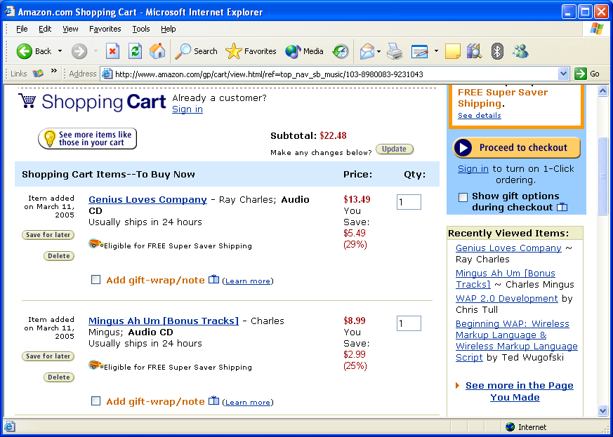

When the user is done browsing and picking products, he may choose to checkout and place the purchase order. Your application will allow the shoppers to pay using the PayPal service.

Separately, you have to provide a web-based administrative interface to allow updates to the online catalog of products offered for sale.

(20% of project mark) Each team has to add 2 additional customer-friendly features that require database access to be implemented (e.g. cross-sale, up-sale, volume discount, etc.)

Each project will be accompanied by a Word document called ProjectDocumentation.doc, explaining the following aspects of your project:
• scope / target audience for the project
• site diagram
• screenshots of all the web forms.
• database diagram
• description of additional customer-friendly features
• description of security features
• analysis of the team effort to implement the project with a list of the active members and their contribution to the project.
• a list of challenges that your group encountered while developing the project and the solutions found to surpass those difficulties.

Project Marking
- 5% of the project mark is based on the documentation,
- 15% on the weekly deliverables during the development period,
- 80% on the design and functionality of the web application as described above (60% for the core functionality, 20% for the two special features).

Once deployed, you have to zip your application files and put them in the Team Project dropbox.
The project is due by Fri. Dec. 18 at 10 p.m.

