Running the CARB H+T tool
CNT has developed a set of R scripts that communicate with a set of MS Excel files to generate a set of models that estimate the housing and transportation affordability index for California Census Block Groups.

System Requirements:
To run these models and scenarios you will need the following resources:
- A GitHub account to download the tools - https://github.com/
- GitHub Desktop – not required but very useful https://desktop.github.com/
- The R statistical package - https://www.r-project.org/
- RStudio – again not required but very useful https://posit.co/download/rstudio-desktop/
- Microsoft Excel
Make sure R is installed, along with the other packages above.

Get the tools:
There is a repository on GitHub that contains all the necessary scripts and files to
- Train the models
- Run the models for various households
- Run three scenarios
  - One estimating the H+T changes if there would be road pricing
  - One for MTC area estimating changes given their Priority Development Area plan
  - One for SAGOG Green Zone
It is located at https://github.com/Center-for-Neighborhood-Technology/carb_ht_model.git if you have problems gaining access to this repository let us know.
The repository holds several folders shown in this screenshot:
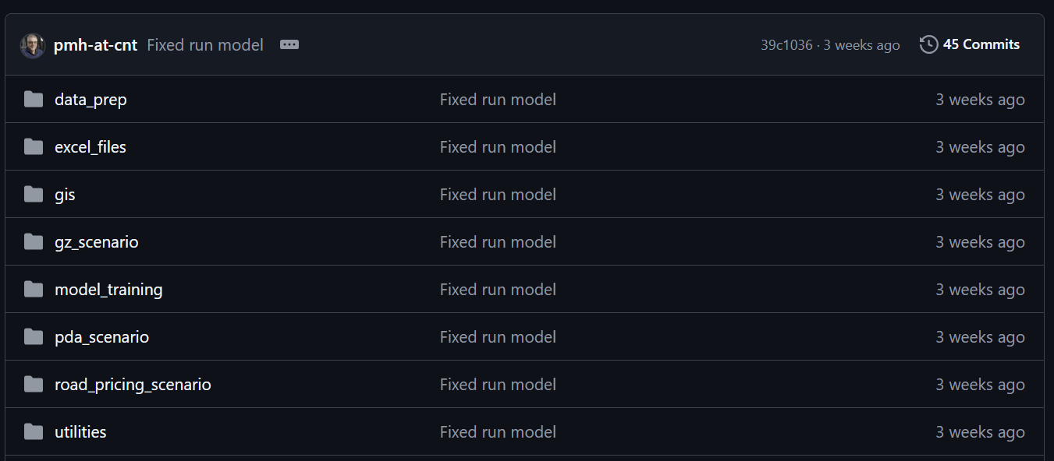
All these folders have scripts that will run various aspects of the tool except for:
- excel_files – this contains the excel files that are needed to run the models and scenarios
- gis - this contains the many of the processes gis files that have been created in the process of running the tools
- utilities – contains scripts that are used in various other scrips in the tool

Data Preparation
In the data_prep folder there is a “master.r” scrips, it contains the step in order needed to create the data to train and run the models. In this script there are commands that run the scripts that do the following (as commented in the script):
- install and load all the libraries that will be needed.
  - source("./utilities/manage_packages.R")
- suppress warnings
  - options(warn = -1)
- install and load all the libraries that will be needed.
  - source("./utilities/manage_packages.R")
- This script is helps you run all the scripts to train the models. First get all the block groups and cut out the water, you only need do this once.
  - source("./data_prep/get_census_geos.R")
- First get the ACS data.
  - source("./data_prep/get_acs_data.R")
- Make all the gravity indicators - this takes some time so only run this once.
  - source("./data_prep/make_gravity.R")
- Normalize the VMT from the CNT model to the CARB county vmt data.
  - source("./data_prep/normalize_vmt.R")
- Create the data for doing the fit.
  - source("./data_prep/create_fitting_data.R")
- Restore warnings.
  - options(warn = 0)
You have now created all the data and GIS files you will need.

Model Training
In the model_training folder there is a “master.r” scrips, it contains the step in order needed to train and run the models. In this script there are commands that run the scripts that do the following (as commented in the script):
- install and load all the libraries that will be needed.
  - source("./utilities/manage_packages.R")
- suppress warnings
  - options(warn = -1)
- install and load all the libraries that will be needed
  - source("./utilities/manage_packages.R")
- now we can do the fits and save the result there will be a few plots, If you set make_plots to TRUE and messages that you should to confirm things are going well.
  - rm(list=ls())
  - make_plots<-TRUE
  - source("./model_training/ols_fits.R")
- Now run the model, you will be asked for what household
  - Source("./model_training/run_models.R")
- Restore warnings
  - options(warn = 0)
You have now created and stored models for transportation and housing costs.

Road Pricing Scenario
In the road_pricing_scenario folder there is only “road_pricing.r” scrips, it contains code to run the road pricing scenario, there is a variable at “price_per_mile” that is currently set at $0.04 per mile, this can be adjusted so that you can run various values, by changing the value of “price_per_mile” on line 16 of the script.

MTC’s PDA Growth Scenario
In the pda_scenario folder there is a “master.r” scrips, it contains the step in order needed to train and run this scenario. In this script there are commands that run the scripts that do the following (as commented in the script):
- This script helps you run all the scripts to run MTC PDA Growth scenario
- install and load all the libraries that will be needed.
  - source("./utilities/manage_packages.R")
- Suppress warnings.
  - options(warn = -1)
- First allocate the growth.
  - source("./pda_scenario/mtc_pda_allocation.R")
- Now create the data to run the models.
  - source("./pda_scenario/create_model_data.r")
- Run the models and calculate the affordability indexes.
  - source("./pda_scenario/calc_ht.R")
- If you want to run the "flat" allocations you need to.
  - source("./pda_scenario/mtc_flat_allocation.R")
- Create the data to run the models.
  - source("./pda_scenario/create_model_data_flat.r")
- Run the models and calculate the affordability indexes.
  - source("./pda_scenario/calc_flat_ht.R")
- Finally. there is a first take on analyzing these data.
  - source("./pda_scenario/analysis.R")
- Restore warnings
  - options(warn = 0)

SACOG’s Green Zone Growth Scenario
In the gz_scenario folder there is a “master.r” scrips, it contains the step in order needed to train and run this scenario.
- This script is helps you run all the scripts to run MTC PDA Growth scenario.
- Install and load all the libraries that will be needed.
  - source("./utilities/manage_packages.R")
- Suppress warnings.
  - options(warn = -1)
- This script first allocates the growth.
  - source("./gz_scenario/gz_allocation.R")
- Create the data to run the models.
  - source("./gz_scenario/create_model_data.r")
- Run the models and calculate the affordability indexes.
  - source("./gz_scenario/calc_ht.R")
- If you want to run the "flat" allocations you need to.
  - source("./gz_scenario/gz_flat_allocation.R")
- Create the data to run the models.
  - source("./gz_scenario/create_flat_model_data.r")
- Run the models and calculate the affordability indexes.
  - source("./gz_scenario/calc_flat_ht.R")
- Finally, there is a first take on analyzing these data.
  - source("./gz_scenario/analysis.R")
- Turn warning back on.
  - options(warn = 0)

