Replication of a Research Claim from Gelfand et al. (2020),
from PsyArXiv

Replication Team: Andrew Tyner, Bob Reed, Diem Vo, and Tom Coupe

Research Scientist: Nick Fox

Action Editor: Nathaniel Porter
November 16, 2020

REPLICATION OF A RESEARCH CLAIM FROM GELFAND ET AL. (2020),

FROM PSYARXIV

Claim Summary
The claim selected for replication from Gelfand et al. is that cultural tightness and government efficiency should combine to predict the infection rate associated with COVID-19, such that the nations that fare the best may have both culturally tight norms and efficient governments. This reflects the following statement from the paper’s abstract: “Nations with efficient governments and tight cultures have been most effective at limiting COVID-19’s infection rate and mortality likelihood.” The authors predicted that cultural tightness and government efficiency would predict slower growth rates of COVID-19 and lower mortality likelihoods, and that nations with high cultural tightness and high government efficiency would show especially slow growth rate and mortality likelihood. The authors captured infection rate by fitting regression equations for each nation, log-transforming the outcome variable (cases per million people) and the predictor variable (days) to account for the exponential growth rate of the virus. Log-transformation converts exponential growth rates into linear growth rates, which can be predicted in a general linear model. This model found a significant interaction between tightness and efficiency, b = -.17, SE = .07, t(41) = -2.23, p = .031.

Here is the corresponding result from the Gelfand et al. study:
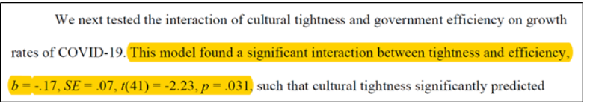

Replication Criteria
Criteria for a successful replication attempt for the SCORE project is a statistically significant effect (alpha = .05, two tailed) in the same pattern as the original study on the focal hypothesis test ( H* ).

For this study, this criteria is met by a negative and statistically significant coefficient on the variable “eff_tight”.

The replication dataset adds observations to the original study dataset. Note that it makes no sense to estimate the exponential growth rate regressions without the original data. So a single analysis on the combined dataset will be performed.

Replication Results
In the original paper the estimated coefficient is negative (-0.17) and significant. In the replication, the estimated coefficient is negative (-0.026) but not significant at the 5% significance level.

Thus the replication claim was unsuccessful according to the SCORE criteria.

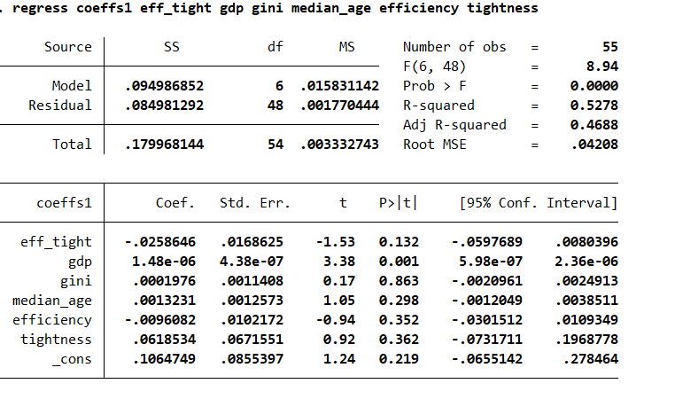

Cohen’s f squared = 0.04512934998.

The full results can be found in the “Gelfand_Results” that is loaded up on the top portion of the OSF project site.

Power analysis:

This study used a combination of original observations and new data, so there is no target.

Deviations from the Original Study
The replication dataset is 42% larger than the original. It includes much of the original study’s data. It mostly differs by adding additional days of data to the original study, which averaged about 22 days of day. In contrast, the replication study allows 30 days of observations for each country. The number 30 was chosen because an informal inspection of the literature indicated that this was a common number of days for estimating exponential growth rate regressions.

The replication differs in a few cases by using less data. The original study had eight countries with more than 30 days of data. The maximum was 65 days. This not only affected the total number of observations, but since the original study weighted by number of observations, it gave greater weight to countries with more observations. Thus, from a practical perspective, the replication study is more than 42% different than the original.

The original study used weighted OLS as different countries had different number of observations available. There is no reason to weight the different estimated coefficients in the replication because the number of observations per country is the same

Deviations from the Preregistration
The original ECDC dataset had missing observations for some dates. The cumulative counts reported in the EDCD data, however, suggest these missing dates are in fact days with 0 cases. I modified the code to replace missing dates by zero case dates. This affected only few countries and only few observations used for each countries estimate, so overall, the estimate was affected only in a very minor way. This change did not affect the overall conclusion about the replication

Citation:
Gelfand, Michele J., Joshua Conrad Jackson, Xinyue Pan, Dana Nau, Munqith Dagher, and CY Chiu (2020), “Cultural and Institutional Factors Predicting the Infection Rate and Mortality Likelihood of the COVID-19 Pandemic”, PsyRxiv

Citation to Data:
Datasets used (and see below):
- https://tcdata360.worldbank.org/indicators/h8125e315?country=BRA&indicator=40979&viz=line_chart&years=2007,2016
- https://www.imf.org/external/pubs/ft/weo/2019/02/weodata/index.aspx
- https://data.worldbank.org/indicator/SI.POV.GINI
- https://www.cia.gov/library/publications/download/download-2018/index.html
- https://www.ecdc.europa.eu/en/publications-data/download-todays-data-geographic-distribution-covid-19-cases-worldwide.

Files necessary to reproduce the empirical results (stored at top portion of OSF project site):

1) “Analysis_script_v2.do” (Programming code that produces the replication results – included as stata do file and pdf)

2) “gelfand_replication_data.csv” (Replication dataset)

3) “Gelfand_Results” (All the estimation results available both as scml file and pdf)

Files necessary to recreate the replication dataset (stored under “Data” section of OSF project site):
See below.

Files necessary to recreate the replication dataset (stored under “Data” section of OSF project site):

Name of datasets | Brief description | Where data can be downloaded/obtained | Requirement
README.txt | .txt file which gives instructions for creating the replication dataset. | https://osf.io/dvtyw/ | None
efficiency_data_world_bank.csv | Correspondence with the corresponding author suggested that the specific item used to measure government efficiency was the 2016 government efficiency value row from the following source: https://tcdata360.worldbank.org/indicators/h8125e315?country=BRA&indicator=40979&viz=line_chart&years=2007,2016  Data was downloaded 10/13/20 via the ‘Download source data’ link. Data downloads as ‘data.csv’ but has been renamed as ‘efficiency_data_world_bank.csv’ for documentation purposes. | https://osf.io/szudm/ | None
country.vars.csv | The authors' original country-level variables | https://osf.io/qpdmj | None
COVID-19-geographic-disbtribution-worldwide-2020-08-27.csv | COVID-19-geographic-disbtribution-worldwide-2020-08-27.csv [https://osf.io/zf8ma/], for ECDC COVID data. Originally accessed via: https://www.ecdc.europa.eu/en/publications-data/download-todays-data-geographic-distribution-covid-19-cases-worldwide | https://osf.io/zf8ma/ | None
WEOOct2019all.csv | WEOOct2019all.csv for GDP per capita data. Originally accessed via: https://www.imf.org/external/pubs/ft/weo/2019/02/weodata/index.aspx | https://osf.io/3s85p/ | None
API_SI.POV.GINI_DS2_en_csv_v2_1217501.csv | API_SI.POV.GINI_DS2_en_csv_v2_1217501.csv for the primary Gini measure (alternative measure created by hand; see R script). Originally accessed via: https://data.worldbank.org/indicator/SI.POV.GINI | https://osf.io/xtejr/ | None
rawdata_343.txt | rawdata_343.txt for median age data. Originally accessed via: https://www.cia.gov/library/publications/download/download-2018/index.html | https://osf.io/j63ha/ | None
gelfand_6708_data_prep.R | gelfand_6708_data_prep.R is used to create the replication dataset. All files above are require to create the replication dataset | https://osf.io/6xkd7/ | None
gelfand_6708_data_dictionary.tsv | Data dictionary | https://osf.io/ztswq/ | None

