Replication of a research claim from LeBoeulf et al., 2010 from Journal of Marketing Research

Replication Team: Sangsuk Yoon (University of Dayton)

Project ID: LeBoeuf_JournMarketRes_2010_EKBZ - Yoon_618k

OSF project: https://osf.io/e9y6b/

Preregistration: https://docs.google.com/document/d/17FK2ckqn5kOrpCh-P8i6-2haHU_NMpEMDaOdZzx9L8M/edit

Claim summary: This replication attempts to test the main claim from LeBoeuf & Simmons (2010) that products predominantly associated with utilitarian attitudes at the product category level support less utilitarian and more symbolic attitudes at the brand level, while products predominantly associated with symbolic attitudes at the product category level support less symbolic and more utilitarian attitudes at the brand level (H1). Participants were randomly assigned to either Category (NoBrand) or Brand condition and were asked to evaluate each of eight products (four Utilitarian products and four Symbolic products) regarding how much benefits the product provides (benefit rating) and the degree to which it symbolizes a certain thing (symbolism rating). The claim was tested using a 2 (Level: Category (NoBrand) or Brand; between-participant) × 2 (unbranded Product Type: Utilitarian or symbolic; within-participant) mixed ANOVA on the benefit rating - symbolism rating difference scores (benefit rating - symbolism rating; averaged for each participant and by product type), where the critical test is the Level × Product Type interaction.

Replication criteria: The criteria for a successful replication attempt for this SCORE project is a statistically significant Level (Category (NoBrand) vs. Brand) x Product Type (Utilitarian vs. Symbolic) interaction in the mixed ANOVA effect (alpha = .05, two-tailed) in the same pattern as the original study (i.e., products that support symbolic category-level attitudes are associated more utilitarian attitudes when branded, while products that support utilitarian category-level attitudes are associated with more symbolic attitudes when branded).

Replication result (Stage 1):
The replication included 557 participants in the analytic sample to reach the requirements for stage 1 data collection (N = 500). There was a significant interaction of Level x Product Type on the benefit rating - symbolism rating difference scores (F(1, 555) = 10.89, p = 0.001, two-tailed, partial eta squared = 0.02; see the figure below), such that products that support symbolic attitudes are associated more utilitarian attitudes when branded, while products that support utilitarian attitudes are associated more with symbolic attitudes when branded.

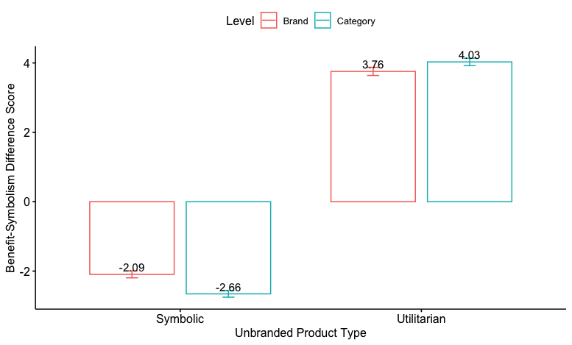

Deviations from preregistration:
- It was originally planned to fully randomize across the three experimental conditions (NoBrand vs. BrandA vs. BrandB). However, due to the randomization error, one condition was collected first (BrandB), and the other conditions were randomized subsequently. However, no data analysis was conducted before the data collection was completed.
- (subsequent post-hoc analysis) It has not been pre-registered, but the post-hoc test with Tukey multiple comparison corrections result showed that the benefit - symbolic difference score was significantly different for the symbolic product category (t(923) = 3.78, p = .0002), while that for the utilitarian product category was not significantly different (t(923) = -1.839, p = .0662). This pattern was consistent with the original study.

Description of materials provided:
- All relevant materials are posted to the OSF repository.
- (Experimental Stimuli) The Qualtrics survey that was used for data collection is posted to the OSF repository under the “Methods and Materials” section (“LeBouef_JournMarketRes_2010_EKBZ_Replication_Survey_Final.qsf” and “LeBouef_JournMarketRes_2010_EKBZ_Replication_Survey_Final.pdf”). The list of product categories and brand names is also posted in the same section (“ItemsList_Final.xlsx”).
- (Data) Data were collected from multiple class sessions, and for each instructor, there is a separate dataset. The “raw_datasets” folder of the Data section on the OSF repository includes all these 10 raw datasets. These 10 datasets were combined using the script, “LeBouef_618k_CombiningDatasets.R”, and the combined dataset (“LeBeouf_replication_data.csv”) and the R script are under the “combined_dataset” folder of the Data section on the OSF repository.
- (Analysis) The analysis script (“LeBoeuf_JournMarketRes_2010_EKBZ_Yoon_Direct Replication_618K_Final.R”) is under the Analysis section on the OSF repository.

Citation:
- LeBoeuf, R. A., & Simmons, J. P. (2010). Branding alters attitude functions and reduces the advantage of function-matching persuasive appeals. Journal of Marketing Research, 47(2), 348-360.

