Planes, Trains, and Armored Mobiles: Introducing a Dataset of the Global Distribution of Military Capabilities (rDMC)

Anonymized version

November 17, 2022

This article introduces a new dataset on the disaggregated military capabilities states possess from 1970 – 2014. While practitioners have long recognized the importance of what weapons states own, scholars have largely examined surrounding questions in piecemeal fashion due to data limitations. The Distribution of Military Capabilities (rDMC) dataset identifies the weapons portfolios of states over the past half century at various levels of aggregation suitable to a wide variety of research questions. This paper begins by explaining the value of collecting data on disaggregated national military capabilities, the data’s scope, and the data collection process. I then identify some initial trends about changes in the distribution of military capabilities across states. I conclude by identifying future research use of the data as both a dependent and independent variable. These data allows scholars to better investigate both international questions concerning power projection, military innovation, and conflict outcomes as well as domestic questions like coup risks, use of force decisions, and interest group lobbying.

# 1 Introduction

The military capabilities states possess are an important instrument of military power, and consequently national power. Yet existing work on how states exercise military power are limited in empirical identification to coarse measures like military spending or military personnel. Not all soldiers are created equal, and much has been said about the problems of measuring military power using military spending figures (Perlo-Freeman 2017) or aggregate measures like the Composite Index of National Capabilities (CINC) (Beckley 2018; Carroll and Kenkel 2019). I define military capabilities as the technologies and weapons that states can use in combat operations. While military capabilities are but one of only many components of military power, its effects are significant, if hotly debated (Lieber 2005; R. Brooks and Stanley 2007). Inconsistent findings about the role of capabilities in conflict stem not from the fact that they do not matter, but rather they have been improperly identified and coarsely measured (van Creveld 2005).

This paper contributes to ongoing research about the technological dimension of military power by producing the first comprehensive dataset of the distribution of military capabilities across all states from 1970 – 2014. Disaggregating military power into its component parts is an important, yet underdeveloped, enterprise. While aggregate military spending may help differentiate large and globally capably militaries from smaller ones, it risks conflating differences in the *composition* of nominally equivalently sized militaries. The composition of a state’s military may influence its power projection and warfighting capabilities in some conflicts, but not others (Gartzke and Lindsay 2020), and the relationship between the military capabilities a country could acquire, actually possesses, and subsequently uses in a contest could shed light on contrasting findings about the impact of military capabilities on international affairs (Douglass and Gannon 2019).

This paper proceeds as follows. Section 2 identifies the role that military capabilities play as both a dependent and independent variable in the study of international politics. Section 3 outlines existing empirical work on the military capabilities states possess. Section 4 outlines the scope of the newly produced Distribution of Military Capabilities (rDMC) dataset and section 5 briefly describes the data collection process. Section 6 identifies some initial trends in variation in the distribution of military capabilities across time and space and Section 7 concludes.

# 2 The case for disaggregating defense

One of the most political aspects of international security for policymakers concerns what military capabilities a state should possess. What a states produces and omits in its defense portfolio reflects its political priorities in ways that economic considerations alone cannot explain (Caverley 2007). As then-Senator Joseph Biden (2008) remarked regarding domestic economic policy during his vice presidential campaign, “[d]on’t tell me what you value. Show me your budget, and I’ll tell you what you value.” This also holds true in the military context, where disconnects concerning a state’s budget and alleged priorities are missed by scholars looking at top-line spending figures. Despite decades of concern about a Chinese invasion of Taiwan, it was not until 2017 that China began investing in the amphibious assault capabilities that are necessary for that threat to actually be carried out (Office of the Secretary of Defense 2018, 95–99). This important fact was missed by many who looked only at the size of China’s defense budget, rather than what capabilities they actually possessed.

The wide body of literature studying war has recognized that international affairs is influenced by *how* states fight (Gannon 2022). The United States’ decision to adopt a more capital-intensive military concentrated in a few high-value weapons may explain its relatively infrequent uses of force, given its high military spending (Fordham 2004), while states with combined arms militaries are able to end civil conflicts more rapidly (Caverley and Sechser 2017). Looking at specific military domains, states with capable navies fight wars further from their borders (Crisher 2017) while those conducting aerial mobilizations fail at demonstrating resolve (Post 2019). Concerning intrastate conflict, access to armored fighting vehicles helped the Yemeni Army secure the capital during the 1962 coup (Albrecht and Eibl 2018, p 319) and well-resourced armies are better able to negotiate with their civilian counterparts in a way that shapes civil-military relations (Kadercan 2014).

Domestically, the portfolio of military capabilities also informs questions outside the traditional scope of international security. Tension between political budget constraints and military security desires gets to the heart of the role that military capabilities play in furthering our understanding of national politics (Cappella Zielinski 2016). Partisan politics is intricately tied to the composition of a state’s military, as the Cold War witnessed a preference among Republican US presidents for funding strategic forces while Democratic presidents funding conventional forces during the Cold War (Fordham 2002). In the 1960’s, the US developed the F-111 fighter-bomber and C-5A jumbo transport aircraft to keep production lines for the four major aerospace corporations funded, demonstrating how patterns of weapons acquisition can tell us about the role of domestic industry in political decisions (Kurth 1972).

# 3 Existing measures of military capabilities

The combination of capabilities that comprise a military’s toolkit determine the operations it undertakes, the types of threats it can credibly make, and the consequences of resorting to force. Military means likely matter, but proving that they do (and if so, the degree and circumstance) is an impossible endeavor without empirical data on the distribution of those means across time and space. Despite the importance of disaggregated military capabilities and a recognition of the shortcomings of aggregate measures for explaining concepts of interest, most current research uses measures only of the *size* of state militaries.[1] National militaries are primarily quantified and compared by military spending levels or, in rarer cases, military personnel counts. Yet, defense dollars don’t tell us what capabilities a state can actually use during a conflict. Despite its frequent use, data on military spending also poses known problems for quantitative cross-national and temporal comparison (Perlo-Freeman 2017). Since there are no common definitions about what constitutes military spending, some states measure things like pension and R&D while others do not (Amara and Paskevics 2010). Exchange rates are often used to standardize all spending to the same currency, but with ill-information applications of domestic purchasing power (Fontanel 1996). Difficulty accounting for inflation and budget cycles also dramatically impacts inferences drawn from different data sources (Lebovic 1999). The IMF, UN Office for Disarmament Affairs, US Bureau of Arms Control, Verification, and Compliance, International Institute for Strategic Studies (IISS), and Stockholm International Peace Research Institute (SIPRI) all produce annual military spending estimates using different estimating procedures, primary sources, and preparation methods (Brzoska 1981), meaning findings from one data source are often not supported using comparable data from another source (Boniface 1995). Since the cost of military platforms has increased over time, having data on the actual platforms helps get around the problems of accounting for military “purchasing power” over time.

Research on variation in the *composition* of militaries remains nascent. Scholars have noted “there is a lack of knowledge about variation between states in their behavior on armaments policy decisions” because of problems empirically identifying the military capabilities states possess (Mawdsley 2018). Recent works that disaggregate military capabilities have narrowed their focus to a small set of platforms like mechanized vehicles (Lyall and Wilson 2009; Sechser and Saunders 2010), strategic lift aircraft (Kupchan 1988), principal naval platforms (Crisher and Souva 2014), or fighter jets (Saunders and Souva 2020) or to a small set of countries like great powers (S. G. Brooks and Wohlforth 2016) or China and its regional rivals (Beckley 2017). Even the most detailed of these are selective in their disaggregation; Saunders and Souva (2020) do not include bombers, air transport, or support aircraft, Sechser and Saunders (2010) omit helicopters, and Souva (2023) aggregates all capabilities to five categories (nuclear weapons, naval tonnage, air power, armor, and ballistic missiles) . The primary reason for this relatively limited use of fine-grained high-quality data is difficulty in converting the data to an easily-usable format and standardizing it across countries and years. rDMC aims to overcome all of these problems in being a massively expanded dataset that better enables systematic analysis across time, space, and military capability.

# 4 The rDMC dataset: scope and data generating process

This paper introduces the first comprehensive dataset of disaggregated military capabilities measures as the annual count of military capabilities owned by 184 countries from 1970 – 2014. By military capabilities, I mean the technologies, weapons, and equipment that states can use in combat operations, excluding small arms like handguns and rifles and also excluding munitions and bombs for which annual data is unreliable.[2] The data were coded by a team of 39 undergraduate coders from four universities over the past five years, resulting in 354,405 unique observations. Figure shows the percent of years coded for each country. 54% of countries have no missing data across the entire time span, with the median country having data available for 95% of its years and the mean country having 88% coverage.[3] The data and all code used to process, clean, and analyze the data are publicly available at (website redacted).

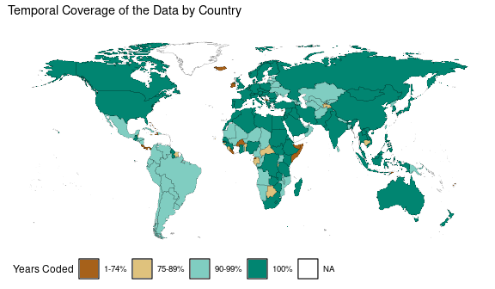

Figure 4.1: Missingness map illustrating the extent of available data on state military capabilities. Almost all states have data for at least 90% of the years they were recognized state entities.

The data comes from the annual International Institute for Strategic Studies (IISS) Military Balance reports (n.d.). Policymakers frequently use the IISS Military Balance to guide their decisions. The former Supreme Allied Commander of NATO, Admiral James Stavridis, said “throughout my career, I have relied extensively on The Military Balance produced so expertly by the IISS. It is the”go to” source for serious analysts and warriors facing real world challenges.” Former US Army General Petraeus describes it as “the go-to source of unclassified, independent information on defense capabilities around the world”. Similarly, former US Secretary of Defense Robert Gates noted it “provides essential facts and analysis for decision-makers and for better informed public debate” and former US Secretary of Defense Leon Panetta remarked it is “widely recognised as the best unclassified source of defense information on personnel, equipment and budgets for every country.”[4]

As with much data in international affairs, concerns about data quality and accuracy remain salient. The extensive use of the IISS Military Balance by policymakers as well as by other scholars gives confidence in its accuracy and allows for the data codings to be validated. Most of this academic work has used IISS data on military spending (Wohlforth 1999; Greenhill and Major 2007) or personnel (Stanton 2013; Gaibulloev et al. 2015). Recent works by Lyall and Wilson (2009), Sechser and Saunders (2010), S. G. Brooks and Wohlforth (2016), and Caverley and Sechser (2017) use detailed information from the IISS Military Balance on platforms like mechanized vehicles and power projection platforms. The accuracy of the data has also been double checked in instances where there are reliable primary source data from government reports. New Zealand, for example, publishes annual reports on the military’s performance targets that describe the resources at the military’s disposal (Alexander, King, and Robert 2002). Although such data is not available for all countries nor for all years, checking the data where possible provides face validity about its accuracy.

# 5 Data Collection and Formats

The first step of the data collection process creates a consistent typology of military equipment types, equipment names, and unit names. I create three versions of the data. The first, *rDMC raw*, organizes military equipment true to the original IISS categorizations. The second and third, *rDMC long* and *rDMC wide* produce a new more aggregated classification of military capabilities. The *rDMC* codebook defines the military capabilities included. Table shows the unique values that exist at each nested level, and how that is aggregated in the final classification. A detailed description of the three different data versions follows.

## 5.1 rDMC raw

*rDMC raw* provides an unaltered version of the original data without subjective coding decisions or equipment categorizations. IISS categorizes military capabilities in five descending levels: equipment types, equipment subtypes, equipment names, equipment subnames, and unit names.[5] An example is provided in Figure ??. Equipment type involves the most aggregate categorizations (“aircraft” or “armored fighting vehicles”). Equipment names are the next primary IISS categorization (“transport” or “fighter” aircraft). Subtype and subname are auxiliary classifications that exist for some, but not all technologies (designations of “light”, “medium”, and “heavy” transport aircraft or “FFM” frigates with surface to air missiles). Lastly, the unit names identifies specific models (“M1A1 Abrams” tank). *rDMC raw* is the only version of the data that provides this unit-level information.[6] In this way, scholars can used the disaggregated data to identify, for example, how many countries have Aim-9 Sidewinder missiles in each year. Comparisons across country and year are possible, provided the research is careful in noting different naming conventions at the unit level.[7]

4. If I understand correctly, the author will provide the disaggregated data so that users can either create their own aggregations or just record which countries have a specific type of air-to-air missile. Is that correct? In other words, can researchers determine the number of countries that have Aim-9 Sidewinder missiles from this data set? Would researchers be able to learn how many Aim-9's each country has?

*rDMC raw* can be used to examine questions concerning topics like combat effectiveness, arms sales, and interest group lobbying. Scholars have identified the challenges of identifying observable ex-ante proxies for the military effectiveness of particular platforms (R. Brooks and Stanley 2007). Biddle (2005, 135) uses the age of a military capability as a proxy for its effectiveness. During Operation Desert Storm, the average date of introduction for US weapons was 1974 while Iraq’s was 1962, with the assumption being that newer capabilities were more advanced. But until now, broader measures of the age of different components of a state’s military portfolio have remained un-examined. Figure shows a broader comparison of the age of introduction for each main battle tank in the data as well as its last recorded year in service. The year of introduction is identified as the first year in which at least one state possessed that type of tank.[8] Scholars could broaden Biddle’s analysis beyond the Gulf War by identifying differences in predicted battlefield performance across generations of all types of technologies. This exercise also serves as a method of data validation, as the data are consistent with historical accounts concerning the development of many of these tanks like the M1 Abrams entering service in 1980 and the Japanese Type 10 being developed in 2012 (Ludeke 2018).

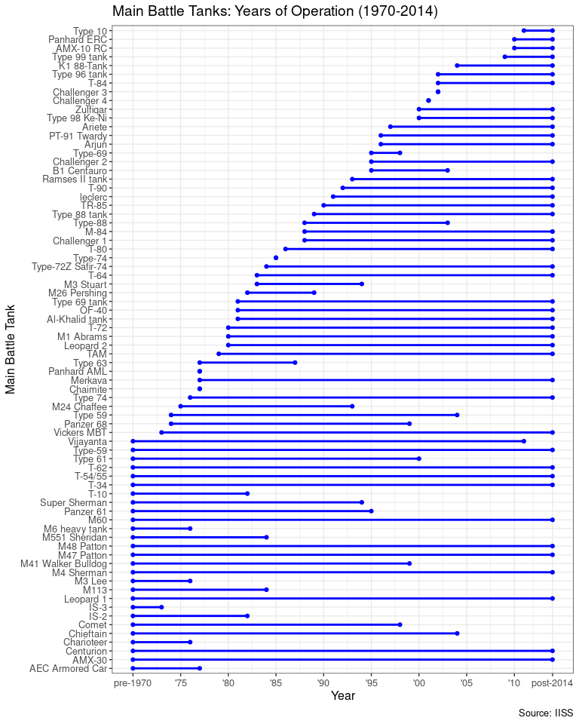

Figure 5.1: The first year in which each type of main battle tank was deployed by any state. The figure is organized chronologically, with the newest main battle tanks at the top.

## 5.2 rDMC long and rDMC wide

*rDMC long* and *rDMC wide* provide a new, aggregated typology of national military capabilities.[9] The 69 categories that comprise the technologies are shown in Figure . These categories were chosen because they represent weapons categories commonly recognized and used by states in arms reduction agreements like the Treaty on Conventional Armed Forces in Europe (CFE). As a result, national records are most consistent and accurate at this level of analysis since those records were used during international negotiations. The resulting data provides a count of, for example, “aircraft – transport” for every country with a value that is the sum of all the rows in *rDMC raw* that had the original 5-level categorizations that match the new “aircraft - transport” category.

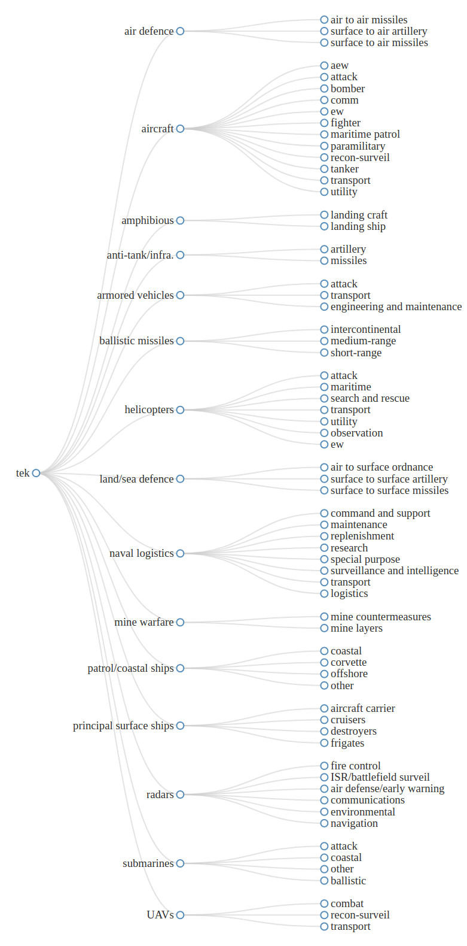

Figure 5.2: Description of the disaggregated technology categories used to compute the distribution of military capabilities.

Empirically, this new typology is helpful because the technology categories are definitionally uniform across the data sample. Unlike *rDMC raw*, the new typology is standardized so it is consistent across country and year, thus simplifying time series-cross sectional comparisons. Where inconsistencies arise, transparent coding decisions were made with reference to external sources documented in the code repository. This ensure that, for example, the C-130H Hercules is always listed with an equipment type coding of ‘aircraft’ and an equipment name coding of ‘transport (TPT)’.[10] Aggregating the technology categories also reduces the sparseness of a dataset that is already zero-inflated. While most country-years possess armored fighting vehicles, not all possess every kind of armored fighting vehicle (main battle tanks, armored personnel carriers, armored infantry fighting vehicles, and reconnaissance vehicles) let alone each of the 1,759 distinct units categorized as “armored fighting vehicles”. That is not to say that every type or model is the same; but those distinctions present computational challenges for broad international relations questions. Scholars interested in making those distinctions are advised to use the *rDMC raw* version of the data.

There are, of course, many ways to categorize technologies depending on the research question. Disagreement over the categories produced by *rDMC long* and *rDMC* *wide* are remedied by the existence of *rDMC raw* that can be used by scholars to produce their own categorizations. “Aircraft – transport” and “helicopters – transport” could be considered somewhat interchangeable to those interested in a state’s ability to move personnel and material. Alternatively, “helicopters – transport” and “helicopters – search and rescue” may be reasonably combined if studying arms sales or military base location given their similar physical make-up. In other cases, categories could be further *dis*aggregated. The category “aircraft – maritime patrol”, for example, include anti-submarine warfare, anti-surface warfare, and maritime reconnaissance which all “patrol” different areas of the sea. Rather than try to create and justify a single definitive ontology of military technologies, the data are constructed so that all aggregations are transparent and modular. By simply selecting new aggregation categories, scholars can produce their own counts with different categories to produce a new dataset consistent with classifications that suit their research question.

# 6 Global Trends

This section identifies some descriptive trends in military capabilities across time and space to highlight ways scholars can use these data in their own research.

## 6.1 Technological Trends Across Time

*rDMC* can shed light on topics like military diffusion and military effectiveness by providing empirical data about how militaries change over time. For example, research on military diffusion has argued that the rate at which weapons technologies spread to other states around the globe influences the likelihood of war (Bas and Coe 2012) as well as its outcomes (Zarzecki 2002). Yet research on how and when diffusion occurs has been empirically limited to particular technologies, states, or time periods (Horowitz 2010; Gilli and Gilli 2014). Providing the first comparison across all military technologies and states over the past half century, Figure shows the number of countries that possessed each military technology in a given year. Although there is a general global trend of innovation, it is not constant across military capabilities. The number of states possessing certain capabilities like surface-to-air and surface-to-surface missiles has increased dramatically since 1970. This is in marked contrast to ballistic missiles, where their diffusion over time has been much more limited.[11] Fighter aircraft have increasingly diffused at a more rapid rate than bombers, despite a seeming decline in ground attack aircraft.



Figure 6.1: The number of countries possessing at least one unit of each major military category of technology. Darker cells mean more countries possessed that technology in that year.

Understanding these changes over time can also speak to questions of military effectiveness. For example, much has been written about the consequences of aerial bombing (Pape 1996; Allen and Martinez Machain 2017). Although this research has looked at cases where states used aerial bombing, it does not identify what states have the capacity to conduct aerial bombing or how that changes over time.[12] Figure shows annual changes in the total number of military aircraft as well as changes in the annual average across all states. The end of the Cold War in 1991 is an important turning point in both respects. The number of total military aircraft in the world dropped from roughly 40,000 to just over 20,000 and the average military aircraft per country went from around 400 to just under 200. Why such a significant reduction in combat aircraft worldwide? Part of the explanation may be the Adapted Treaty on Conventional Armed Forces in Europe (CFE) which required NATO and the Warsaw Pact – referred to in the CFE as the “Groups of States” – to each maintain no more than 6,800 combat aircraft (Bolving 2000). This resulted in the destruction of 69,000 military units designated as Treaty Limited Equipment, with the Warsaw Pact destroying over 30% of its arsenal and NATO destroying 5% (McCausland 2012).

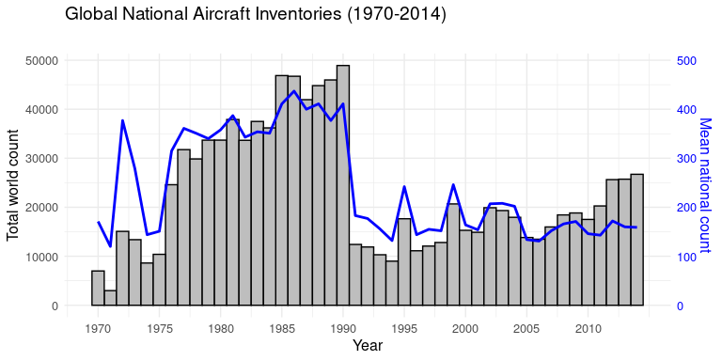

Figure 6.2: Bars bars (left y-axis) represent the total number of military aircraft in the world in each year. The blue line (right y-axis) represents the average number of aircraft owned by each national military in each year.

## 6.2 Technological Trends Across States

Military capabilities differ in their purpose (Lindsay and Gartzke 2022). Some capabilities are most salient for states projecting power while others are relevant for territorial defense. All else being equal, what capabilities do states emphasize? Figure shows the distribution of US military capabilities relative to the world average at decade intervals. Not surprisingly, US capabilities generally dwarf those of the rest of the international system. But this is not universal, nor is the degree of US dominance constant. For much of the past half century, the United States has had fewer anti-tank/anti-infrastructure capabilities as well as fewer mine warfare capabilities than the average state. The 2022 Russian invasion of Ukraine has made this fact especially salient, as transfers of one third of the US anti-tank/anti-infrastructure weapons stockpile to Ukraine has prompted concern about the sustainability of such support (Cancian 2022).

Variation in the US distribution of capabilities could be explained by myriad factors. Perhaps geography makes mine warfare less valuable since the US primarily fights its wars far from home. Military capabilities have substitutes and complements, and it’s possible that anti-tank/anti-infrastructure needs are adequately addressed with bombing aircraft and land defense missiles. Quantity is also not synonymous with quality, so it could be that the US is still more than sufficiently capable in these domains, but with fewer platforms. Whatever the theorized explanation, these new data now allows scholars to empirically examine claims about why states possess the distribution of military capabilities that they do.

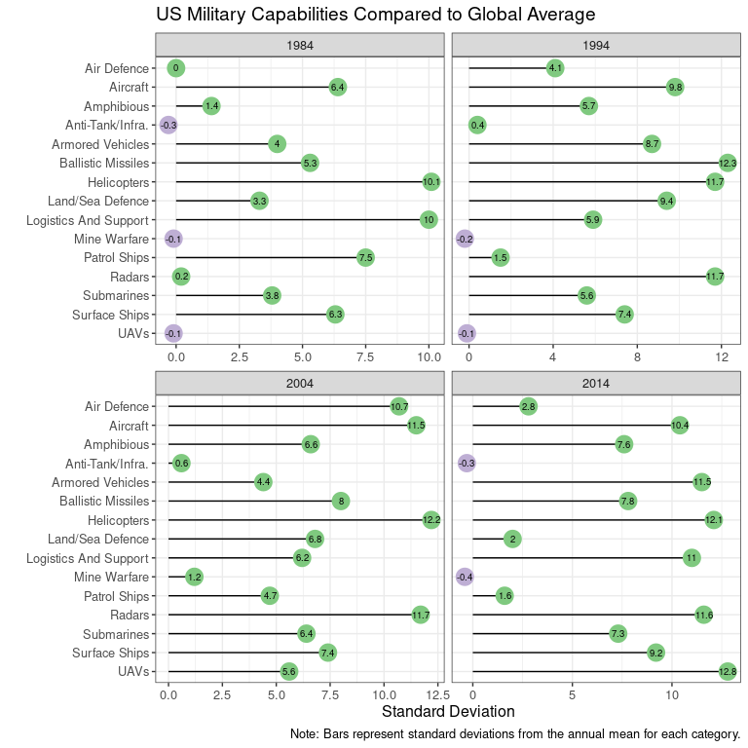

Figure 6.3: Count of US military capabilities relative to other states in decade intervals. Each bar represents the standard deviation of the count of US capabilities relative to the world average. Colors represent positive and negative standard deviations.

When do states’ military portfolios most closely mirror those of others? Some scholars argued socialization and competition under anarchy results in convergence, whereby states emulate the capabilities of the most powerful states in the international system (Waltz 1979 p 127; Resende-Santos 1996 p 196) while others have noted functional differentiation across allies who produce distinct, complementary military assets (Gannon 2021). Although there are instances of Cold War military planners falling prey to the homeopathy heuristic by embracing “missile matching” vis-à-vis their rivals (Kanwisher 1989), systematic evidence of similarity or difference across states’ militaries has remained empirically untested. This claim is significant for scholars of international politics. If states mirror the military capabilities of others, then “new and proven military methods, even if they are truly revolutionary, will have no lasting affect on the balance of international influence” (Goldman and Andres 1999, p 83). This also has implications for what we know about security cooperation, with scholars cautioning that states imitating the military practices of their peers “rarely resort to alliances for their security” (Parent and Rosato 2015 p 52).

*rDMC* allows the similarity of militaries around the world to be identified and quantitatively measured. Figure shows the results of a k-means clustering analysis for all states in 2004 using binary values indicating whether a state possessed each of the 74 military technologies.[13] A form of community detection, k-means clustering is an un-supervised learning algorithm that partitions the data into clusters of most-similar states using a gap statistic identifying the optimal number of groups (Tibshirani, Walther, and Hastie 2001).[14] There are eight distinct clusters of countries that share significant commonality in the military capabilities they possess. States with militaries most similar to the US include great power rivals like Russia and China, some allies like France, Germany, and Spain, but not other allies like Poland, Sweden, and Canada. There is similarity across states in some geographic regions like Central Asia, but significant dissimilarity across states in other regions like Latin America.

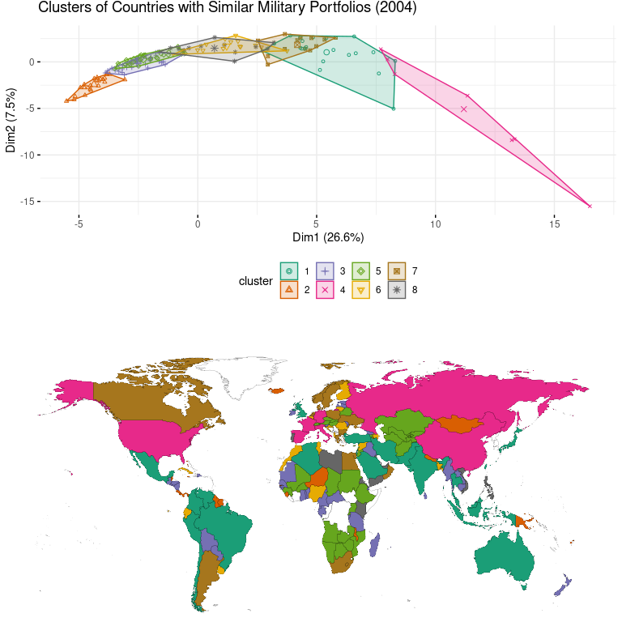

Figure 6.4: K-means clustering showing the similarity of military technologies portfolios.

Cautioning that Figure is a simplified example (a single year and using binary rather than count values), the results nonetheless demonstrate the utility of disaggregating military capabilities for identifying similarity in national defense portfolios and generating testable hypotheses concerning the relationship between military composition and factors like technological capacity, geography, threat environment, and conflict history. The fact there are differences in how even similarly-sized states arm themselves is prima facie evidence of the non-fungibility of material military power.

# 7 Conclusion

This paper merely represents version 1.0 of a dataset that has demonstrated value in helping us understand how states fight; efforts are already underway to expand the data temporally – both beyond 2014 and further back than 1970, as well as increase the ease of using *raw rDMC* by standardizing unit names across space and time. Even still, while much ink has been spilled debating the degree to which military technology matters, rDMC 1.0 can help the discussion productively shift to *what* military technologies matter and *how*. Understanding differences in the composition of military capabilities is vital to understanding military power precisely because these components are not homogeneous. Identifying the dimensions of this heterogeneity is a necessary precondition for explaining why states develop the weapons portfolio that they do as well as the consequences of armament decisions. The composition of military assets, rather than the defense dollars spent, are what truly matter for how well states deal with threats to their security because military spending itself does not create military power. Rather, that money must be translated into capabilities that allow for the exercise of power through a variety of distinct means.

To date, explanations of the causes or effects of variation in the composition of a state’s military assets has been empirically limited because that data has not existed in a form conducive to systematic analysis. As a new, disaggregated dataset on the military capabilities states possessed over the past half century, *rDMC* can help the broader scholarly community better explain how states arm, why, and to what effect.

# References

Akerman, Anders, and Anna Larsson Seim. 2014. “The Global Arms Trade Network 1950.” *Journal of Comparative Economics* 42 (3): 535–51. <https://doi.org/10.1016/j.jce.2014.03.001>.

Albrecht, Holger, and Ferdinand Eibl. 2018. “How to Keep Officers in the Barracks: Causes, Agents, and Types of Military Coups.” *International Studies Quarterly* 62 (2): 315–28. <https://doi.org/10.1093/isq/sqx085>.

Alexander, J., Alan B. King, and W. Robert. 2002. “Country Survey XVII: New Zealand’s Defence Policy.” *Defence and Peace Economics* 13 (4): 287–309. <https://doi.org/10.1080/10242690212355>.

Allen, Susan Hannah, and Carla Martinez Machain. 2017. “Understanding the Impact of Air Power.” *Conflict Management and Peace Science* 36 (5): 545–58. <https://doi.org/10.1177/0738894216682485>.

Amara, Jomana, and Martins Paskevics. 2010. “Unfulfilled Promises: The Impact of Accession on Military Expenditure Trends for New NATO Members.” *Comparative Strategy* 29 (5): 432–49. <https://doi.org/10.1080/01495933.2010.520988>.

Bas, Muhammet A., and Andrew J. Coe. 2012. “Arms Diffusion and War.” *Journal of Conflict Resolution* 56 (4): 651–74. <https://doi.org/10.1177/0022002712445740>.

Beckley, Michael. 2017. “The Emerging Military Balance in East Asia: How China’s Neighbors Can Check Chinese Naval Expansion.” *International Security* 42 (2): 78–119. <https://doi.org/10.1162/ISEC_a_00294>.

———. 2018. “The Power of Nations: Measuring What Matters.” *International Security* 43 (2): 7–44. <https://doi.org/10.1162/isec_a_00328>.

Biddle, Stephen. 2005. *Military Power: Explaining Victory and Defeat in Modern Battle*. Manas Publications.

Biden, Joseph. 2008. “Biden’s Remarks on McCain’s Policies.” *The New York Times*, September.

Bolving, Klaus. 2000. “The Adapted Treaty on Conventional Armed Forces in Europe - CFE - Considerations Concerning Baltic CFE-Membership.” *Baltic Defence Review* 4 (2000): 31–66.

Boniface, Pascal. 1995. *L’année Stratégique 1995. Les Équilibres Militaire*. Paris: Dunod for the Institut des Relations Internationales et Strategiques.

Brooks, Risa, and Elizabeth Stanley, eds. 2007. *Creating Military Power: The Sources of Military Effectiveness*. Stanford University Press.

Brooks, Stephen G., and William C. Wohlforth. 2016. “The Rise and Fall of the Great Powers in the Twenty-first Century: China’s Rise and the Fate of America’s Global Position.” *International Security* 40 (3): 7–53. <https://doi.org/10.1162/ISEC_a_00225>.

Brzoska, Michael. 1981. “The Reporting of Military Expenditures.” *Journal of Peace Research* 18 (3): 261–75.

Cancian, Mark F. 2022. “Will the United States Run Out of Javelins Before Russia Runs Out of Tanks?” Commentary. Center for Strategic & International Studies.

Cappella Zielinski, Rosella. 2016. *How States Pay for Wars*. Cornell University Press.

Carroll, Robert J., and Brenton Kenkel. 2019. “Prediction, Proxies, and Power.” *American Journal of Political Science* 63 (3): 577–93. <https://doi.org/10.1111/ajps.12442>.

Caverley, Jonathan D. 2007. “United States Hegemony and the New Economics of Defense.” *Security Studies* 16 (4): 598–614. <https://doi.org/10.1080/09636410701740825>.

Caverley, Jonathan D., and Todd S. Sechser. 2017. “Military Technology and the Duration of Civil Conflict.” *International Studies Quarterly* 61 (3): 704–20. <https://doi.org/10.1093/isq/sqx023>.

Crisher, Brian. 2017. “Naval Power, Endogeneity, and Long-Distance Disputes.” *Research and Politics* 4 (1): 1–6.

Crisher, Brian, and Mark Souva. 2014. “Power at Sea: A Naval Power Dataset, 1865-2011.” *International Interactions* 40 (4): 602–29. <https://doi.org/10.1080/03050629.2014.918039>.

Delgado, Mercedes, Michael E. Porter, and Scott Stern. 2016. “Defining Clusters of Related Industries.” *Journal of Economic Geography* 16 (1): 1–38. <https://doi.org/10.1093/jeg/lbv017>.

Douglass, Rex W., and J Andrés Gannon. 2019. “Churning Butter into Guns: Identifying Latent Military Capacity.” Working {{Paper}}.

Eyre, Dana P., and Mark C. Suchman. 1996. “Status, Norms and the Proliferation of Conventional Weapons: An Institutional Theory Approach.” In *The Culture of National Security: Norms and Identity in World Politics*, edited by Peter J. Katzenstein, 79–113. New York, NY: Columbia University Press.

Fontanel, Jacques. 1996. “The Comparison of Military Budgets of the Eastern and Central European Countries.” *Defence and Peace Economics* 7 (2): 135–47. <https://doi.org/10.1080/10430719608404847>.

Fordham, Benjamin O. 2002. “Domestic Politics, International Pressure, and the Allocation of American Cold War Military Spending.” *The Journal of Politics* 64 (1): 63–88. <https://doi.org/10.1111/1468-2508.00118>.

———. 2004. “A Very Sharp Sword: The Influence of Military Capabilities on American Decisions to Use Force.” *Journal of Conflict Resolution* 48 (5): 632–56. <https://doi.org/10.1177/0022002704267935>.

Gaibulloev, Khusrav, Justin George, Todd Sandler, and Hirofumi Shimizu. 2015. “Personnel Contributions to UN and Non-UN Peacekeeping Missions: A Public Goods Approach.” *Journal of Peace Research* 52 (6): 727–42. <https://doi.org/10.1177/0022343315579245>.

Gannon, J Andrés. 2021. “Use Their Force: Interstate Security Alignments and the Distribution of Military Capabilities.” PhD thesis, UC San Diego.

———. 2022. “One If by Land, and Two If by Sea: Cross-domain Contests and the Escalation of International Crises.” *International Studies Quarterly* 66 (4).

Gartzke, Erik A., and Jon R. Lindsay. 2020. “The Influence of Sea Power on Politics: Domain- and Platform-Specific Attributes of Material Capabilities.” *Security Studies* 29 (4): 601–36. <https://doi.org/10.1080/09636412.2020.1811450>.

Gilli, Andrea, and Mauro Gilli. 2014. “The Spread of Military Innovations: Adoption Capacity Theory, Tactical Incentives, and the Case of Suicide Terrorism.” *Security Studies* 23 (3): 513–47. <https://doi.org/10.1080/09636412.2014.935233>.

Gleditsch, Kristian Skrede, and Michael D. Ward. 2006. “Diffusion and the International Context of Democratization.” *International Organization* 60 (4): 911–33.

Goldman, Emily O., and Richard B. Andres. 1999. “Systemic Effects of Military Innovation and Diffusion.” *Security Studies* 8 (4): 79–125. <https://doi.org/10.1080/09636419908429387>.

Greenhill, Kelly M., and Solomon Major. 2007. “The Perils of Profiling: Civil War Spoilers and the Collapse of Intrastate Peace Accords.” *International Security* 31 (3): 7–40. <https://doi.org/10.1162/isec.2007.31.3.7>.

Horowitz, Michael C. 2010. *The Diffusion of Military Power: Causes and Consequences for International Politics*. Princeton University Press.

International Institute for Strategic Studies. n.d. *The Military Balance*. Oxford: Oxford University Press.

Kadercan, Burak. 2014. “Strong Armies, Slow Adaptation: Civil-Military Relations and the Diffusion of Military Power.” *International Security* 38 (3): 117–52. <https://doi.org/10.1162/ISEC_a_00146>.

Kahn, Lauren, and Michael C. Horowitz. 2022. “Who Gets Smart: Explaining How Precision Bombs Proliferate.” *Journal of Conflict Resolution*, July. <https://doi.org/10.2139/ssrn.3792071>.

Kanwisher, Nancy. 1989. “Cognitive Heuristics and American Security Policy.” *Journal of Conflict Resolution* 33 (4): 652–75. <https://doi.org/10.1177/0022002789033004004>.

Kupchan, Charles. 1988. “NATO and the Persian Gulf: Examining Intra-Alliance Behavior.” *International Organization* 42 (2): 317–46.

Kurth, James R. 1972. “The Political Economy of Weapons Procurement: The Follow-on Imperative.” *The American Economic Review* 62 (1/2): 304–11.

Lebovic, James. 1999. “Using Military Spending Data: The Complexity of Simple Inference.” *Journal of Peace Research* 36 (6): 681–97.

Leeds, Brett Ashley, Jeffrey Ritter, Sara Mitchell, and Andrew Long. 2002. “Alliance Treaty Obligations and Provisions, 1815-1944.” *International Interactions* 28 (3): 237–60. <https://doi.org/10.1080/03050620213653>.

Lieber, Keir A. 2005. *War and the Engineers: The Primacy of Politics Over Technology*. Cornell University Press.

Lindsay, Jon R., and Erik A. Gartzke. 2022. “Politics by Many Other Means: The Comparative Strategic Advantages of Operational Domains.” *Journal of Strategic Studies* 45 (5): 743–76. <https://doi.org/10.1080/01402390.2020.1768372>.

Ludeke, Alexander. 2018. *International Tank Development From 1970*. Pen and Sword.

Lyall, Jason, and Isaiah Wilson. 2009. “Rage Against the Machines: Explaining Outcomes in Counterinsurgency Wars.” *International Organization* 63 (1): 67–106. <https://doi.org/10.1017/S0020818309090031>.

Mawdsley, Jocelyn. 2018. “Armaments Decision-Making: Are European States Really Different?” *Comparative Strategy* 37 (4): 260–71. <https://doi.org/10.1080/01495933.2018.1497319>.

McCausland, Jeffrey D. 2012. “European/Eurasian Security and the Treaty on Conventional Armed Forces in Europe.” Strategic Studies Institute, US Army War College.

Office of the Secretary of Defense. 2018. “Military and Security Developments Involving the People’s Republic of China 2018.” Annual {{Report}} to {{Congress}} 8-0F67E5F. Department of Defense.

Pape, Robert A. 1996. *Bombing to Win: Air Power and Coercion in War*. Cornell University Press.

Parent, Joseph M., and Sebastian Rosato. 2015. “Balancing in Neorealism.” *International Security* 40 (2): 51–86. <https://doi.org/10.1162/ISEC_a_00216>.

Perlo-Freeman, Sam. 2017. “Monitoring Military Expenditure.” SIPRI.

Post, Abigail. 2019. “Flying to Fail: Costly Signals and Air Power in Crisis Bargaining.” *Journal of Conflict Resolution* 63 (4): 869–95. <https://doi.org/10.1177/0022002718777043>.

Resende-Santos, Joâo. 1996. “Anarchy and the Emulation of Military Systems: Military Organization and Technology in South America, 1870.” *Security Studies* 5 (3): 193–260. <https://doi.org/10.1080/09636419608429280>.

Saunders, Richard, and Mark Souva. 2020. “Command of the Skies: An Airpower Dataset.” *Conflict Management and Peace Science* 37 (6): 735–55. <https://doi.org/10.1177/0738894219863348>.

Schwartz, Joshua A., and Michael C Horowitz. 2021. “To Compete or Retreat? The Global Diffusion of Precision Strike.” Working {{Paper}}.

Sechser, Todd S., and Elizabeth N. Saunders. 2010. “The Army You Have: The Determinants of Military Mechanization, 1979.” *International Studies Quarterly* 54 (2): 481–511. <https://doi.org/10.1111/j.1468-2478.2010.00596.x>.

Souva, Mark. 2023. “Material Military Power: A Country-Year Measure of Military Power, 1865-2019.” *Journal of Peace Research*.

Stanton, Jessica A. 2013. “Terrorism in the Context of Civil War.” *The Journal of Politics* 75 (4): 1009–22. <https://doi.org/10.1017/S0022381613000984>.

Tibshirani, Robert, Guenther Walther, and Trevor Hastie. 2001. “Estimating the Number of Clusters in a Data Set via the Gap Statistic.” *Journal of the Royal Statistical Society: Series B (Statistical Methodology)* 63 (2): 411–23. <https://doi.org/10.1111/1467-9868.00293>.

van Creveld, Martin. 2005. “Less Than Meets the Eye.” *Journal of Strategic Studies* 28 (3): 449–52. <https://doi.org/10.1080/01402390500137341>.

Waltz, Kenneth. 1979. *Theory of International Politics*. Waveland Press.

Whitten, Guy D., and Laron K. Williams. 2011. “Buttery Guns and Welfare Hawks: The Politics of Defense Spending in Advanced Industrial Democracies.” *American Journal of Political Science* 55 (1): 117–34. <https://doi.org/10.1111/j.1540-5907.2010.00479.x>.

Wohlforth, William C. 1999. “The Stability of a Unipolar World.” *International Security* 24 (1): 5–41. <https://doi.org/10.1162/016228899560031>.

Zarzecki, Thomas W. 2002. *Arms Diffusion: The Spread of Military Innovations in the International System*. Psychology Press.

1. Of course, these two are not synonymous. Military capabilities are only one component of military spending and the cost of labor is a large component of military spending (Whitten and Williams 2011).
2. See the section “Defining military capabilities” in the codebook for a more detailed definition of military capabilities.
3. I use percent of years since not all countries exist across the entire duration of the data. 100% of Slovenia is covered, for example, because data exists for all 22 years since since it established independence in 1991.
4. Quotes come from [IISS Testimonials](https://www.iiss.org/publications/the-military-balance)
5. While these 5 classifications levels are produced by IISS, their labels are the author’s.
6. Standardizing string variables across unit names is a challenging endeavor that will be advanced in future iterations of the data. For more information about using the unit-level information in *rDMC raw*, see the appendix.
7. For example, entries exist for the “AIM-9”, “AIM-9 Sidewinder”, “Aim-9”, and “Aim-9 Sidewinder”, which all refer to the same capability but with differences in capitalization and punctuation. rDMC 2.0 will standardize the unit-level names, but the time-intensive nature of that effort means it will not be completed for some time.
8. Since the data starts in 1970, tanks first deployed in 1970 most likely represent models developed before then. A more thorough analysis would track down the actual deployment date for each tank model, rather than relying on their deployment date as done here. Importantly, the data does distinguish between different platform upgrades, differentiating an F-16A from an F-16B in most cases.
9. *rDMC long* and *rDMC wide* are identical in terms of scope and values and differ only in the unit of analysis. In *rDMC long* the unit of analysis is the country-year-technology while in *rDMC wide* the unit of analysis is the country-year. They are both provided to simplify the process of merging with existing datasets much like the Alliance Treaty Obligations and Provisions (ATOP) provides alliance data at various units of analysis (Leeds et al. 2002).
10. There are cases where an equipment’s category changes in ways the data maintains. For example, many aircraft and helicopters are phased out by being shifted to non-combat roles like training before they are fully retired. A country may thus experience a decrease in combat aircraft and an increase in training aircraft from one year to the next without the actual aircraft they possess changing.
11. For existing work on missile proliferation, see Kahn and Horowitz (2022) and Schwartz and Horowitz (2021).
12. New data on combat aircraft has recently been produced by Saunders and Souva (2020).
13. I exclude states with a population below 750,000 as done by Eyre and Suchman (1996) and Sechser and Saunders (2010). Other states are missing data because they were not yet sovereign states (South Sudan) or because data on military capabilities was not collected for states just after or still in a serious civil conflict (Congo).
14. This clustering method has been used for community detection of economic industries (Delgado, Porter, and Stern 2016), democratization patterns (Gleditsch and Ward 2006), and arms sales (Akerman and Seim 2014).