Dear Editorial Team,

Please find my final manuscript entitled "Planes, Trains, and Armored Mobiles: Introducing a Dataset of the Global Distribution of Military Capabilities (rDMC)" (#ISQ-2022-11-0579.R1) which has been accepted for publication.

The GBAT tool website does not appear to be working right now, but a comparable alternative, the Gender Citation Balance Index tool (https://postlab.psych.wisc.edu/gcbialyzer), indicates that the female scholars are authors or co-authors of 33% of the paper’s citations.

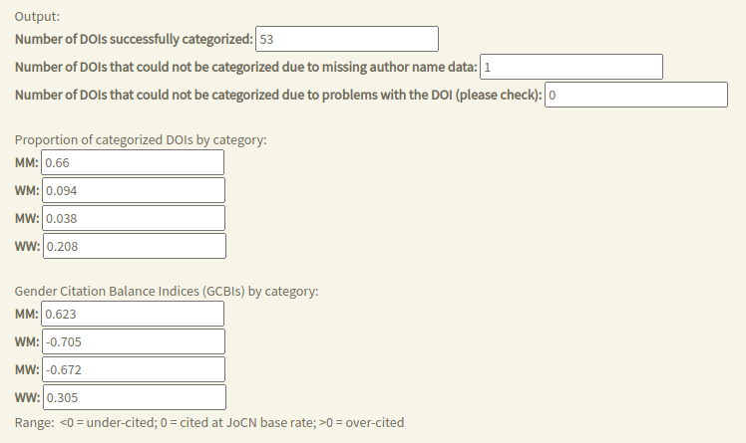

Thank you,

J Andres Gannon