Ankle draft risk model under winter clothing conditions
Tobias Kramer^{1,✉}, Junmeng Lyu^{1,4}, and Stefano Schiavon^{1,2,3}
2026-05-20
¹ Center for the Built Environment, University of California, Berkeley, USA
² Department of Architecture, College of Environmental Design, University of California, Berkeley, USA
³ Department of Civil and Environmental Engineering, College of Engineering, University of California, Berkeley, USA
⁴ Department of Architecture, School of Design, Shanghai Jiao Tong University, Shanghai, China
✉ Correspondence: Tobias Kramer <t.kramer@berkeley.edu>

Abstract
The ankle draft model incorporated in ASHRAE Standard 55 was derived from studies in which participants mainly wore summer clothing with exposed ankles (~0.5 clo), potentially leading to overly conservative perimeter heating or facade insulation requirements in winter conditions where occupants typically wear long trousers, socks, and closed-toe shoes (~0.75 clo). This study evaluated thermal comfort responses to ankle-level draft under such winter clothing conditions through controlled laboratory experiments with 51 participants. Using a within-subjects repeated-measures design, we exposed participants to nine conditions varying supply air temperature (15, 17, and 19°C) and ankle-level air speed (0.1–0.7 m/s) simulating window downdraft while they wore clothing ensembles targeting 0.75 clo.
The existing ankle draft model systematically overpredicted dissatisfaction across all conditions. While prior studies with exposed ankles reported dissatisfaction rates of 23–57%, we observed rates of only 6–20%, with the existing model overestimating dissatisfaction by an average of 2.8 times and by as much as 39% at high air speeds. We fit generalized linear mixed-effects models to data from this study and prior research, developing separate prediction equations for ankle-covered and ankle-uncovered conditions. The covered-ankle model exhibited both a lower baseline dissatisfaction risk and reduced sensitivity to air speed. Whole-body thermal sensation and ankle-level air speed were the only significant predictors; ankle air temperature and room temperature were not significant within the tested ranges.
These findings support differentiating ASHRAE Standard 55 ankle draft criteria by clothing insulation level. Adopting a covered-ankle criterion for winter heating scenarios will enable meaningful reductions in perimeter heating and facade insulation requirements without compromising occupant comfort, with associated benefits for installation costs, energy use, and carbon emissions.

1. Introduction
Cold downdraft near windows is a common source of local thermal discomfort in buildings during winter (Fanger et al., 1988; Heiselberg, 1994). When outdoor temperatures drop, the interior surface of windows, particularly large or poorly insulated glazing, becomes significantly cooler than the surrounding air. This temperature differential causes nearby air to cool, increase in density, and descend, creating a localized airflow pattern that can cause discomfort at the lower extremities of seated occupants (Larsson & Moshfegh, 2002; Schellen et al., 2012). Building designers typically address this issue by increasing the insulation level of windows, so that the interior surface temperature is higher, adding mullions to break the downward flow and by installing perimeter heating systems, such as radiators or in-floor heating, to counteract the downdraft effect and to prevent thermal discomfort in the ankle region.
The current approach to evaluating ankle draft risk relies on a predictive model presented in Liu et al. (2017), which estimates the predicted percentage dissatisfied (PPD) with ankle draft as a function of air speed and temperature at ankle level, as well as whole-body thermal sensation. This model was derived from laboratory experiments conducted under cooling conditions typical of underfloor air distribution (UFAD) and displacement ventilation systems and is incorporated into ASHRAE Standard 55 (ASHRAE, 2023). Importantly, the 110 participants in these foundational studies, including an earlier investigation by Schiavon et al. (2016), wore summer clothing with exposed ankles, resulting in clothing insulation levels of approximately 0.5 clo.
However, building occupants in winter typically wear substantially different attire. Analysis of the ASHRAE Global Thermal Comfort Database II (Földváry Ličina et al., 2018) indicates that median clothing insulation in commercial spaces during heating seasons is approximately 0.75 clo, with occupants commonly wearing long trousers, closed-toe shoes and socks that cover the ankle region. This discrepancy raises an important question: does the current ankle draft model, which is calibrated for summer conditions where approximately two-thirds of test cases involved exposed ankles, accurately predict discomfort when ankles are covered by clothing?
If the current model overestimates draft risk under winter clothing conditions, the practical implications are significant. Designers may be specifying solutions, like perimeter heating systems, that are larger than necessary, or installing them in situations where they could be avoided entirely. This has consequences for both first costs and operational energy consumption and related carbon emission. Conversely, if the model underestimates risk, occupants may experience discomfort that compromises satisfaction and performance.
The objective of this study is to evaluate thermal comfort responses to ankle-level draft under typical winter clothing conditions through controlled laboratory experiments. We aim to: (1) characterize whole-body and local thermal perception across a range of supply air temperatures and air speeds representative of window downdraft conditions; (2) compare observed dissatisfaction rates with predictions from the existing ankle draft model; and (3) assess whether the current ASHRAE 55 criteria require adjustment for winter scenarios. The findings are intended to inform guidance on perimeter heating requirements and support more energy-efficient building design without compromising occupant comfort.

2. Methods

2.1 Experimental design
We conducted a controlled laboratory experiment using a within-subjects repeated-measures design. Each participant was exposed to nine experimental conditions in a 3×3 factorial arrangement, varying supply air temperature (SAT) at three levels (15, 17, and 19°C) and air speed at ankle level at three levels (low, medium, high; ranging between 0.1–0.7 m/s). The SAT and air speeds were selected to represent the range of conditions associated with window downdraft under typical winter conditions (Manz & Frank, 2004) and to be consistent with earlier studies focusing on summer conditions (Liu et al., 2017; Schiavon et al., 2016)
Participants attended four sessions: an introductory session for explaining the experiment and obtaining consent, followed by three experimental sessions of approximately two hours each. Each experimental session corresponded to one SAT level, with participants experiencing all three air speed conditions within that session in a counterbalanced order. We scheduled sessions on separate days to minimize carryover effects and subjects were allowed to attend the three sessions in their preferred order.

2.2 Climate chamber and apparatus
We conducted the experiment in the climate-controlled chamber at the Center for the Built Environment, UC Berkeley. The chamber floor area is approximately 25 m². We set up three workstations to allow simultaneous testing of multiple participants and three seats for reacclimatization during breaks in the back of the room. Ambient room conditions were maintained at approximately 22°C operative temperature, 50% relative humidity, and background air velocity below 0.1 m/s, targeting a whole-body thermal sensation of approximately −0.5 (slightly cool) on the ASHRAE seven-point scale as calculated using the CBE Comfort Tool (Tartarini et al., 2020).
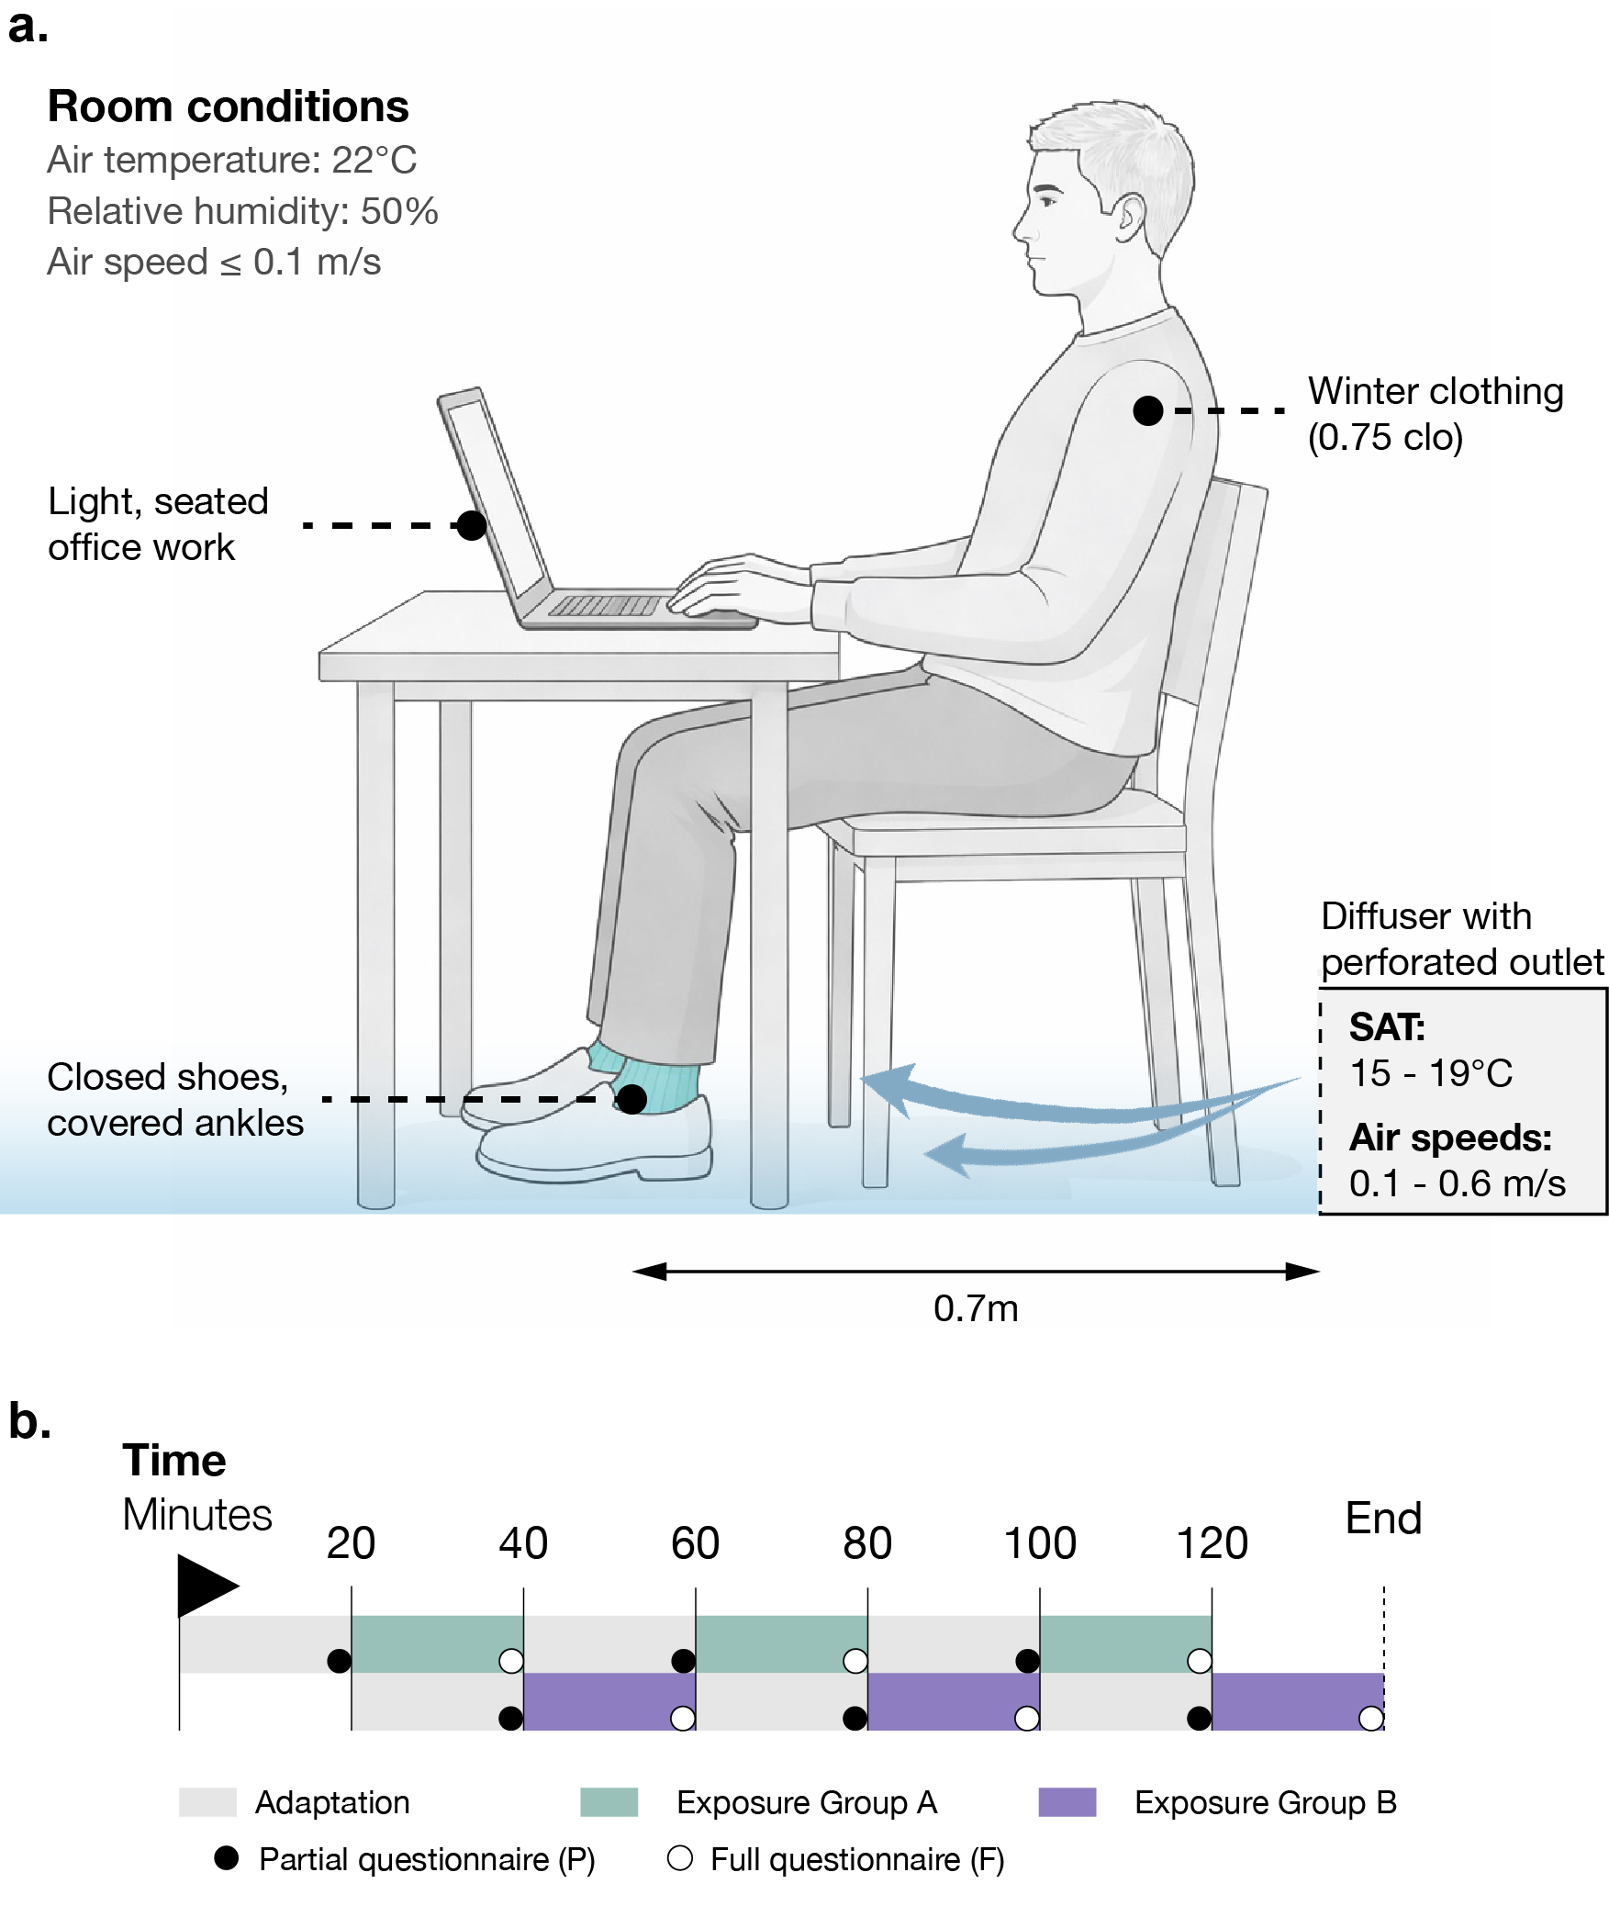
Figure 1: Experimental configuration and temporal protocol: (a) Seated occupant positioned 0.7 m from the custom displacement diffuser, which simulates window downdraft by directing conditioned air toward the ankle region from behind; (b) Timeline of the 120-minute experimental sessions featuring overlapping participant groups and synchronized questionnaire intervals to characterize the progression of local and whole-body thermal perception.
We used custom built displacement diffusers to deliver conditioned air to the ankle region of participants seated at the three workstations. To simulate a window downdraft, the diffuser was positioned 0.7 m behind each workstation, directing airflow toward the participants’ lower legs. This setup targeted one of the most thermally sensitive body regions highly susceptible to draft, as described by Toftum & Zhou (1997). The diffuser was connected to an independent air handling unit capable of delivering supply air at the target temperatures and flow rates. The three supply air temperatures represent temperatures at the VAV outlet and we controlled air flow rates by damper adjustment. Turbulence intensity at the measurement location was approximately 30% (see Table 3), consistent with values reported in prior ankle draft studies (Fanger et al., 1988; Liu et al., 2017). The three seats in the back of the room were not affected by the diffusers, which were directed at the three workstations only.

2.3 Monitoring

2.3.1 Environmental
We measured head-level air temperature (1.1 m) at each workstation using calibrated Atmocube monitors (Atmotech Inc., United States; air temperature: -40 to +125°C, ±0.5°C, relative humidity: 0 to 100%RH, ±2 %RH, CO₂: 0 to 5000 ppm, ±50 ppm + 2.5% of reading at standard room levels) positioned within 0.5 m of participants. To measure air velocity and air temperature at ankle level (0.1 m) we used the AirDistSys 5000 omnidirectional hot-wire anemometers (Sensor Electronic, Poland, air velocity: 0.05-5 m/s, accuracy: ±0.02 m/s ±2% of reading; temperature: -10 to +50°C, accuracy: ±0.2°C, sampling interval: 1 s). Room-level measurements of CO₂ concentration, PM_{2.5}, illuminance and sound pressure levels were recorded throughout each session but not reported here because they stayed constant and within expected ranges.

2.3.2 Physiological
In addition, we recorded continuously participants skin temperature on the lateral lower leg (mid-calf) and feet using iButton sensors (Thermochron, Maxim Integrated, USA, Type DS1923; measurement range: 20°C to 85°C; accuracy: ±0.5°C; resolution: 0.0625°C) attached with medical-grade hypoallergenic tape. We used the skin temperature data to assess local cooling responses and as physiological correlates of subjective thermal sensation.

2.3.3 Subjective feedback
To assess the perception of the thermal environment we used validated scales consistent with prior ankle draft research and ASHRAE Standard 55 requirements. We employed two questionnaires: a comprehensive one, encompassing all questions, administered shortly before the conclusion of the exposure (F), and a concise, partial one, comprising a subset of the questions, at the end of each adaptation period. For details on the timing of the questionnaires, please refer to Figure 1, and for information on the constructs and their respective scales, please refer to Table 1 below. We administered the questions electronically via a custom survey tool written in Java. Participants were not required to respond to any individual question, though completion rates were monitored.
Table 1: Survey constructs and measurement scales, including information if the question was used in the full (F) and partial (P) subject feedback questionnaire.
Construct | Use | Question | Scale type | Levels
Thermal sensation | F, P | How do you feel right now? | 7-point continuous | −3 (cold) −2 (cool) −1 (slightly cool) 0 (neutral) +1 (slightly warm) +2 (warm) +3 (hot)
Thermal comfort | F, P | Right now do you find this environment…? | 6-point continuous | −3 (very uncomfortable) −2 (uncomfortable) −1 (just uncomfortable) +1 (just comfortable) +2 (comfortable) +3 (very comfortable)
Thermal preference | F, P | Right now would you prefer to be…? | 3-point ordinal | −1 (warmer) | 0 (no change) | +1 (cooler)
Thermal acceptability | F, P | Please rate your acceptance of the current thermal environment | 4-point continuous | −2 (clearly unacceptable) −1 (just unacceptable) +1 (just acceptable) +2 (clearly acceptable)
Air movement acceptability at ankles | F | Please rate your acceptance of air movement at your ankles | 4-point continuous | −2 (clearly unacceptable) −1 (just unacceptable) +1 (just acceptable) +2 (clearly acceptable)
Air movement preference at ankles | F | Right now around my ankles I would prefer…? | 3-point ordinal | −1 (less air movement) | 0 (no change) | +1 (more air movement)
Clothing change | F | Did you adjust your upper body clothing? | binary | Yes | No

2.4 Participants
We recruited 51 participants from the university community and local area through the Experimental Social Science Laboratory (Xlab) platform and email outreach to individuals who had participated in previous studies and consented to future contact. Eligible participants were between 21 and 55 years of age, fluent in English, and free from chronic cardiorespiratory conditions or recent major surgery. Pregnant individuals were excluded. The UC Berkeley Committee for Protection of Human Subjects (CPHS) approved the research protocol (CPHS ##2025-07-18795). Before the tests, all subjects signed an informed consent form. Demographic details of the cohort are summarized in Table 2.

2.5 Experimental protocol
Upon arrival for each experimental session, we checked participants for elevated temperature and fitted them with skin temperature sensors. Participants then entered the climate chamber and completed a 20-minute adaptation period in the acclimatization zone under baseline conditions.
To simulate typical winter attire, we instructed participants to wear a long-sleeve top, long trousers (ending just above the ankle), thin socks, and closed-toe shoes. This ensemble targets a clothing insulation of approximately 0.75 clo, consistent with the median value observed in commercial buildings during heating seasons (Földváry Ličina et al., 2018). Participants were permitted to make minor clothing adjustments during sessions (e.g., rolling sleeves), and any changes were recorded.
Following adaptation, participants were exposed to three consecutive 20-minute conditions at different air speed levels, with 20-minute rest periods between conditions (see Figure 1). The sequence of air speed conditions was counterbalanced across participants and sessions. At the end of each exposure and adaptation interval, participants completed the standardized questionnaires listed in Section 2.3.3.

2.6 Statistical analysis

2.6.1 Variable processing
Thermal sensation votes were collected on a continuous scale. For descriptive analyses, we mapped these values to the corresponding categorical sensation levels, whereas the original continuous values were retained for statistical modeling. We dichotomized ankle airflow acceptability as acceptable or unacceptable for subsequent analyses. The original recorded votes for thermal acceptability, thermal preference, ankle thermal preference, and ankle airflow preference were retained without further processing. Consistent with the definition used by Liu et al. (2017), we defined ankle draft dissatisfaction as an ankle thermal sensation vote below 0 (neutral) together with an ankle airflow acceptability vote below 0.

2.6.2 Within-subject comparisons
We used a within-subject repeated-measures design and conducted comparisons between experimental conditions within participants. We analyzed continuous variables using paired-samples t-tests and reported paired Cohen’s d as the effect size. We analyzed ordinal variables using the paired Wilcoxon signed-rank test, reporting the test statistic based on the normal approximation and the effect size r. For multiple pairwise comparisons within each family of tests, we adjusted p-values using the Benjamini-Hochberg method (Benjamini & Hochberg, 1995).

2.6.3 Evaluation of the existing ankle draft model
Applying it to the experimental data, we calculated the predicted percentage of dissatisfaction with ankle draft at each observation point. Predictions were then averaged by experimental condition and compared with the observed dissatisfaction percentages. We used calibration curves to quantitatively assess the model’s predictive performance in this study’s dataset (Van Calster et al., 2016) and report the calibration intercept and slope, AUC, and Brier score. All analyses were implemented using the R package CalibrationCurves (De Cock et al., 2025).

2.6.4 Development of the new ankle draft model
We modeled ankle draft dissatisfaction using a generalized linear mixed model with a binomial distribution and logit link, as the outcome was binary and repeated observations were correlated within subjects. We included the subject as a random intercept to account for between-subject heterogeneity and within-subject dependence arising from repeated measurements. To enable an integrated analysis of the effects of different clothing conditions on ankle draft dissatisfaction, we also included data from Liu et al. (2017) in the modeling dataset. Continuous predictors were mean-centered using the overall means of the combined dataset before model fitting.
In this generalized linear mixed model, the inverse-logit transformation is nonlinear. As a result, direct back-transformation of the fixed-effects linear predictor yields a conditional probability, representing an individual-level prediction when the random effect is set to zero, rather than a population-averaged probability. To characterize the average risk of dissatisfaction at the population level, we therefore use marginal probabilities instead of conditional probabilities (Neuhaus et al., 1991). Specifically, we extracted fixed-effect estimates and the variance of the random intercept from the fitted model, assuming that the random intercept followed a normal distribution with mean zero. We then approximated integration over the random effects using Monte Carlo simulation (K = 10,000, random seed = 1), and calculated the marginal predicted probability for each combination of predictor values.
Because these marginal probabilities generally cannot be written as a simple closed-form equation, we used the Monte Carlo-simulated marginal probabilities to fit an approximate linear equation for logit(P). Applying the inverse-logit transformation to the fitted equation yielded a closed-form prediction equation. We evaluated the accuracy of this approximation using coefficient of determination (R²).

2.7 Software and data
We performed all data processing, statistical analyses, and model fitting in R (version 4.4.1). The main packages we used were tidyverse (version 2.0.0), lme4 (version 2.0.1), rstatix (version 0.7.3), and CalibrationCurves (version 3.0.0). Data and analysis code are available on: https://github.com/CenterForTheBuiltEnvironment/ankle-draft-II

3. Results

3.1 Participants and environmental conditions
Table 2: Summary of demographic information (median [IQR]) on study participants.
Sex | No. Subjects | Age [a] | Height [m] | Weight [kg] | Body Mass Index (BMI)
All | 51 | 22.0 [21.0, 24.0] | 1.68 [1.64, 1.75] | 68.0 [61.0, 75.0] | 23.3 [21.4, 25.6]
Female | 28 | 22.5 [21.0, 25.2] | 1.65 [1.63, 1.68] | 64.5 [58.8, 72.2] | 23.0 [21.3, 26.0]
Male | 20 | 22.0 [21.0, 22.5] | 1.79 [1.75, 1.83] | 72.5 [66.0, 84.2] | 23.4 [21.5, 24.8]
Third Gender / Other | 3 | 22.0 [21.5, 22.5] | 1.60 [1.60, 1.61] | 68.0 [56.5, 70.5] | 25.6 [21.6, 27.1]

@tbl-demographics provides a summary of the demographic information collected from the study participants. Since the demographic data is not uniformly distributed, we use the median and interquartile range (IQR) to describe the dataset. A total of 51 subjects participated in the study (28 female, 20 male, 3 other), with a median age of 22.0 [21.0, 24.0] years.
Table 3: Summary of environmental measurements.
Measurement | 15°C | 17°C | 19°C
Air temperature, head level (°C) | 21.9 ( ± 0.2) | 21.9 ( ± 0.3) | 21.9 ( ± 0.2)
Relative humidity (%) | 54.9 ( ± 5.5) | 52.3 ( ± 5) | 51.2 ( ± 4.8)
Air temperature, ankle level (°C) | 17.6 ( ± 0.2) | 18.3 ( ± 0.2) | 19.7 ( ± 0.2)
Air speed, low (m/s) | 0.14 ( ± 0.02) | 0.16 ( ± 0.01) | 0.18 ( ± 0.01)
Air speed, medium (m/s) | 0.37 ( ± 0.02) | 0.39 ( ± 0.03) | 0.42 ( ± 0.03)
Air speed, high (m/s) | 0.64 ( ± 0.04) | 0.62 ( ± 0.01) | 0.65 ( ± 0.03)
Turbulence, low (%) | 0.36 ( ± 0.02) | 0.34 ( ± 0.01) | 0.3 ( ± 0.01)
Turbulence, medium (%) | 0.26 ( ± 0.02) | 0.23 ( ± 0.01) | 0.23 ( ± 0.02)
Turbulence, high (%) | 0.24 ( ± 0.01) | 0.24 ( ± 0.01) | 0.23 ( ± 0.01)

Table 3 provides an overview of the measured environmental conditions. Across all three sessions, head-level air temperature remained stable at 21.9 ( ± 0.2) °C, 21.9 ( ± 0.3) °C, and 21.9 ( ± 0.2) °C, and relative humidity was comparable across sessions, confirming stable background thermal conditions and establishing a baseline in line with the PMV target level of ~ -0.5 (slightly cool).
As the primary experimental manipulation, we set supply air temperatures to 15°C, 17°C, and 19°C to simulate the effect of window downdraft. As shown in Table 3, ankle-level air temperatures, measured by the hot-wire anemometer at 0.1 m, were consistently higher than the supply setpoints due to mixing with the warmer ambient air, and reached ranges of approximately 17–18°C, 18–19°C, and 19–20°C for the three conditions respectively. Because the ankle-level temperature is the quantity relevant to thermal comfort and to the draft risk model, all subsequent analyses use the measured ankle-level air temperature rather than the supply setpoint as the experimental grouping variable. Within each session, we then exposed subjects to three airspeed levels at separate workstations. We measured consistent air speeds across all three workstations and sessions, confirming reliable reproduction of the low, medium, and high airspeed conditions. Turbulence intensities remained low to medium throughout, indicating stable and controlled airflow (Fanger et al., 1988).

3.2 Whole body thermal perception
Figure 2 shows whole-body thermal sensation votes plotted against ankle air temperature and air speed. Votes ranged predominantly from Cool to Slightly warm across conditions. Thermal sensation increased with ankle-level air temperature in all air speed groups, with steeper slopes at medium and high air speeds (b ≈ 0.15 – 0.17 per °C) than at low air speed (b ≈ 0.04 per °C); however, ankle-level air temperature explained limited variance across all groups (R² ≤ 0.03). No systematic relationship was observed between whole-body thermal sensation and ankle air speed, consistent with ankle-level airflow having limited influence on whole-body thermal perception (see Section 6 for response distributions).
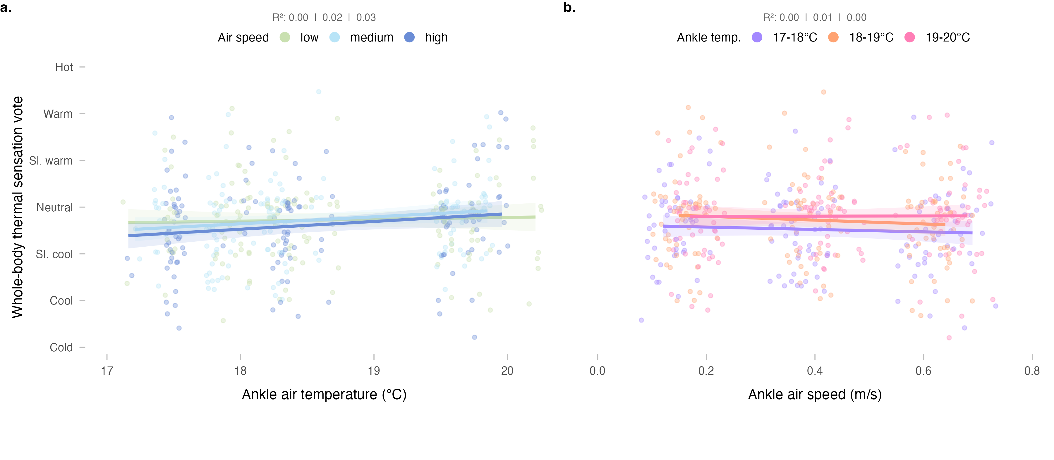
Figure 2: Whole-body thermal sensation votes plotted against ankle air temperature (a) and air speed (b), with per-group linear regression lines and 95% confidence bands. Sensations were predominantly in the Cool to Slightly warm range; ankle-level air temperature showed a modest positive association at medium and high air speeds, while no clear relationship with air speed was observed.
Figure 3 shows whole-body thermal acceptability plotted against ankle air temperature and air speed. Responses were predominantly on the acceptable side of the scale across all conditions. No strong linear relationship was found between thermal acceptability and either ankle-level air temperature or air speed (R² ≤ 0.008 in all groups), indicating that the range of conditions tested did not substantially compromise whole-body thermal comfort (see Section 6 for response distributions).
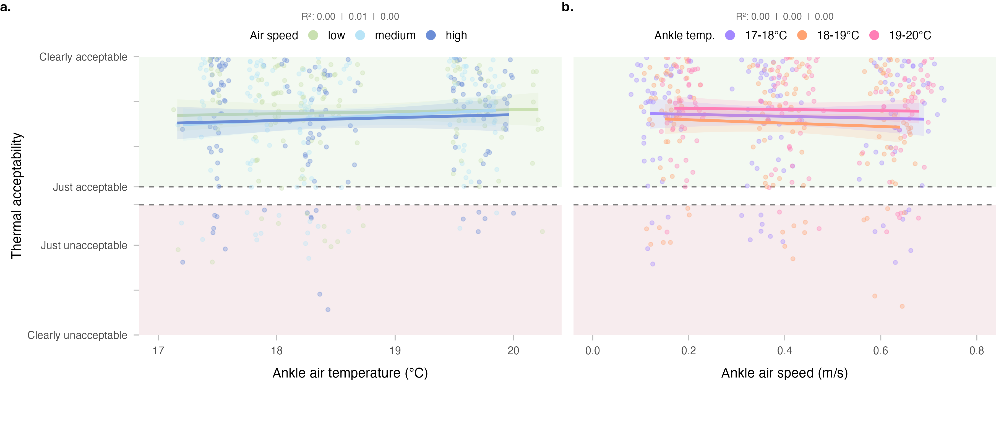
Figure 3: Whole-body thermal acceptability votes plotted against ankle air temperature (a) and air speed (b), with per-group linear regression lines and 95% confidence bands. Acceptability was predominantly positive across all conditions, with no strong linear association with ankle-level air temperature or air speed.

3.3 Ankle level observations

3.3.1 Thermal perception
Figure 4 presents ankle-level thermal sensation votes plotted against ankle air temperature and air speed. Sensations at the ankles were generally cooler than whole-body ratings. Ankle-level air temperature showed a positive association with ankle sensation across all air speed groups (b ≈ 0.03 – 0.17 per °C), consistent with whole-body results. The relationship with ankle air speed was negative across all ankle-level air temperature conditions and strongest at 17–18°C (b = -1.18, R² = 0.05), indicating that higher air speeds increased local cool sensations most noticeably at the coolest ankle-level air temperature. The association was weaker at 18–19°C and 19–20°C (b ≈ -0.45 to -0.54, R² ≤ 0.01) (see Section 6 for response distributions).
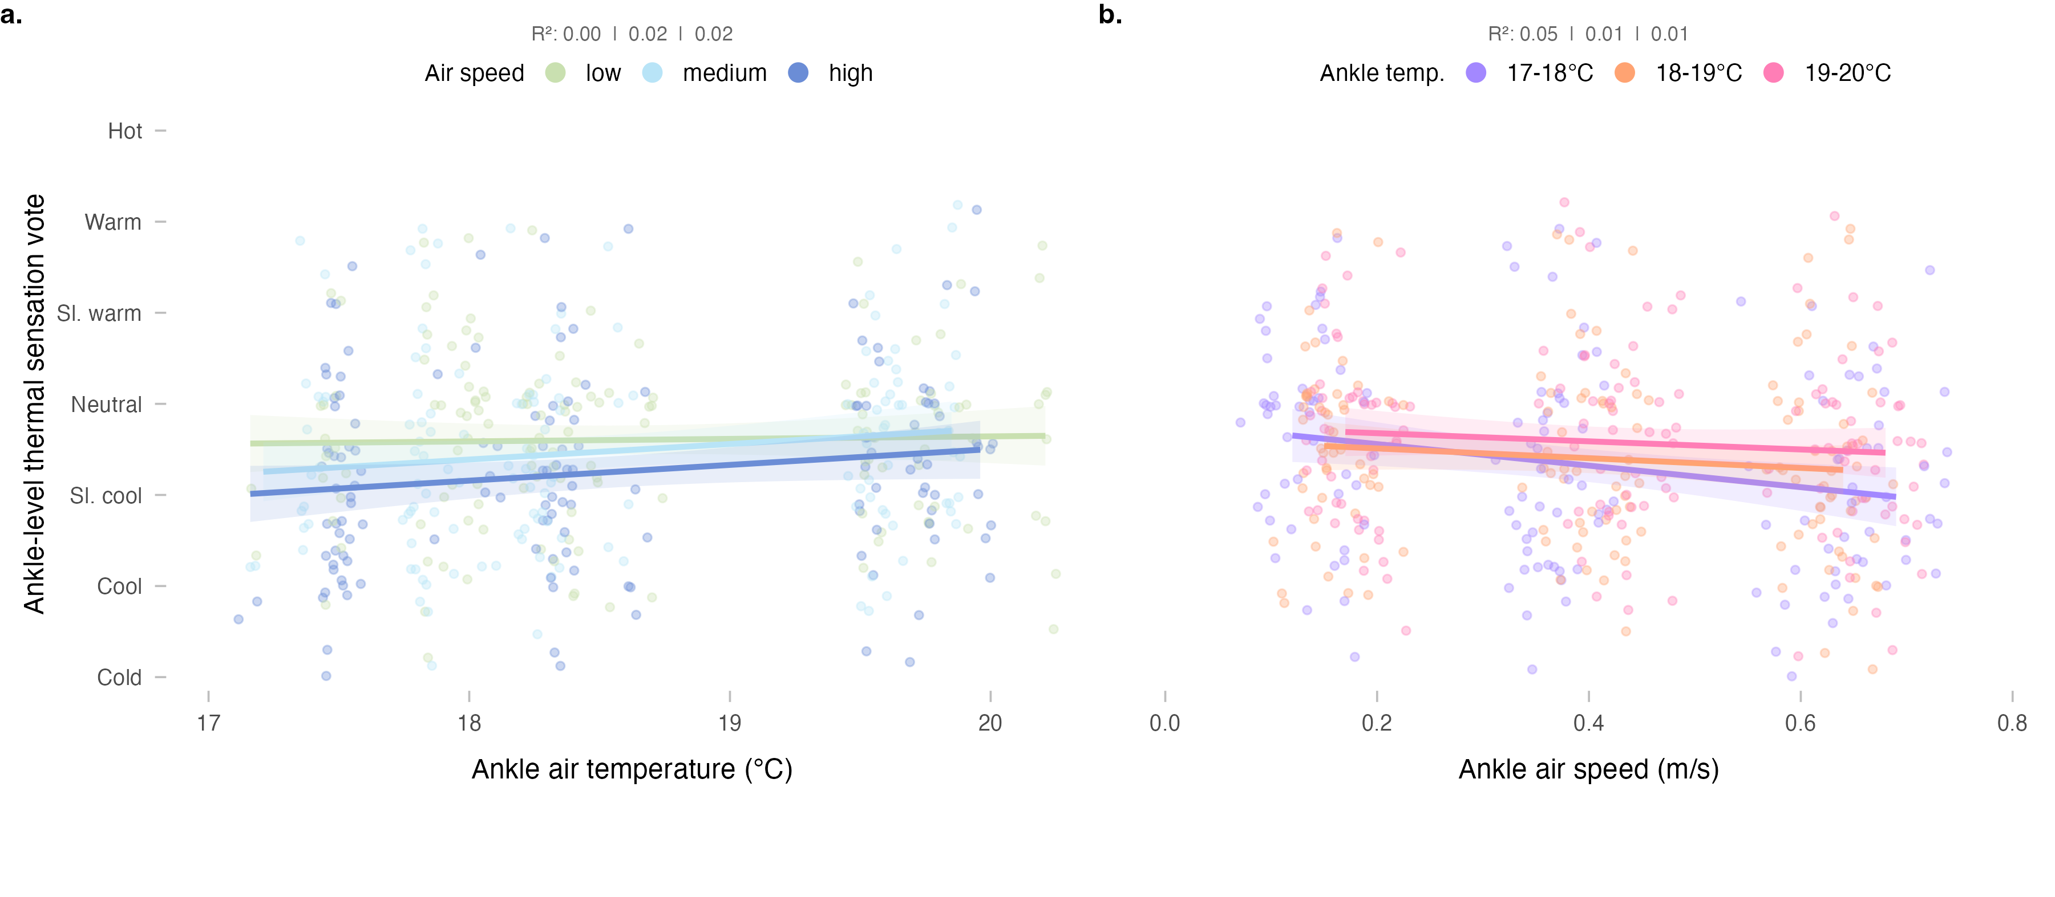
Figure 4: Ankle-level thermal sensation votes plotted against ankle air temperature (a) and air speed (b), with per-group linear regression lines and 95% confidence bands. Ankle sensations were generally cooler than whole-body ratings; the strongest negative association with air speed was observed at the lowest ankle-level air temperature condition (17–18°C).

3.3.2 Air movement perception
Figure 5 shows air movement acceptability at the ankle level plotted against ankle-level air temperature and air speed. Despite the localized cooling, responses were predominantly on the acceptable side of the scale. Air movement acceptability showed a consistent negative association with air speed across all ankle-level air temperature conditions (b ≈ -0.58 to -0.65 per m/s), while the relationship with ankle-level air temperature was negligible for the low and high air speed groups (b ≈ 0.03) and modest for the medium group (b ≈ 0.2). Linear regression explained a small proportion of variance in all groups (R² ≤ 0.021), indicating substantial individual variability in acceptability ratings (see Section 6 for response distributions).
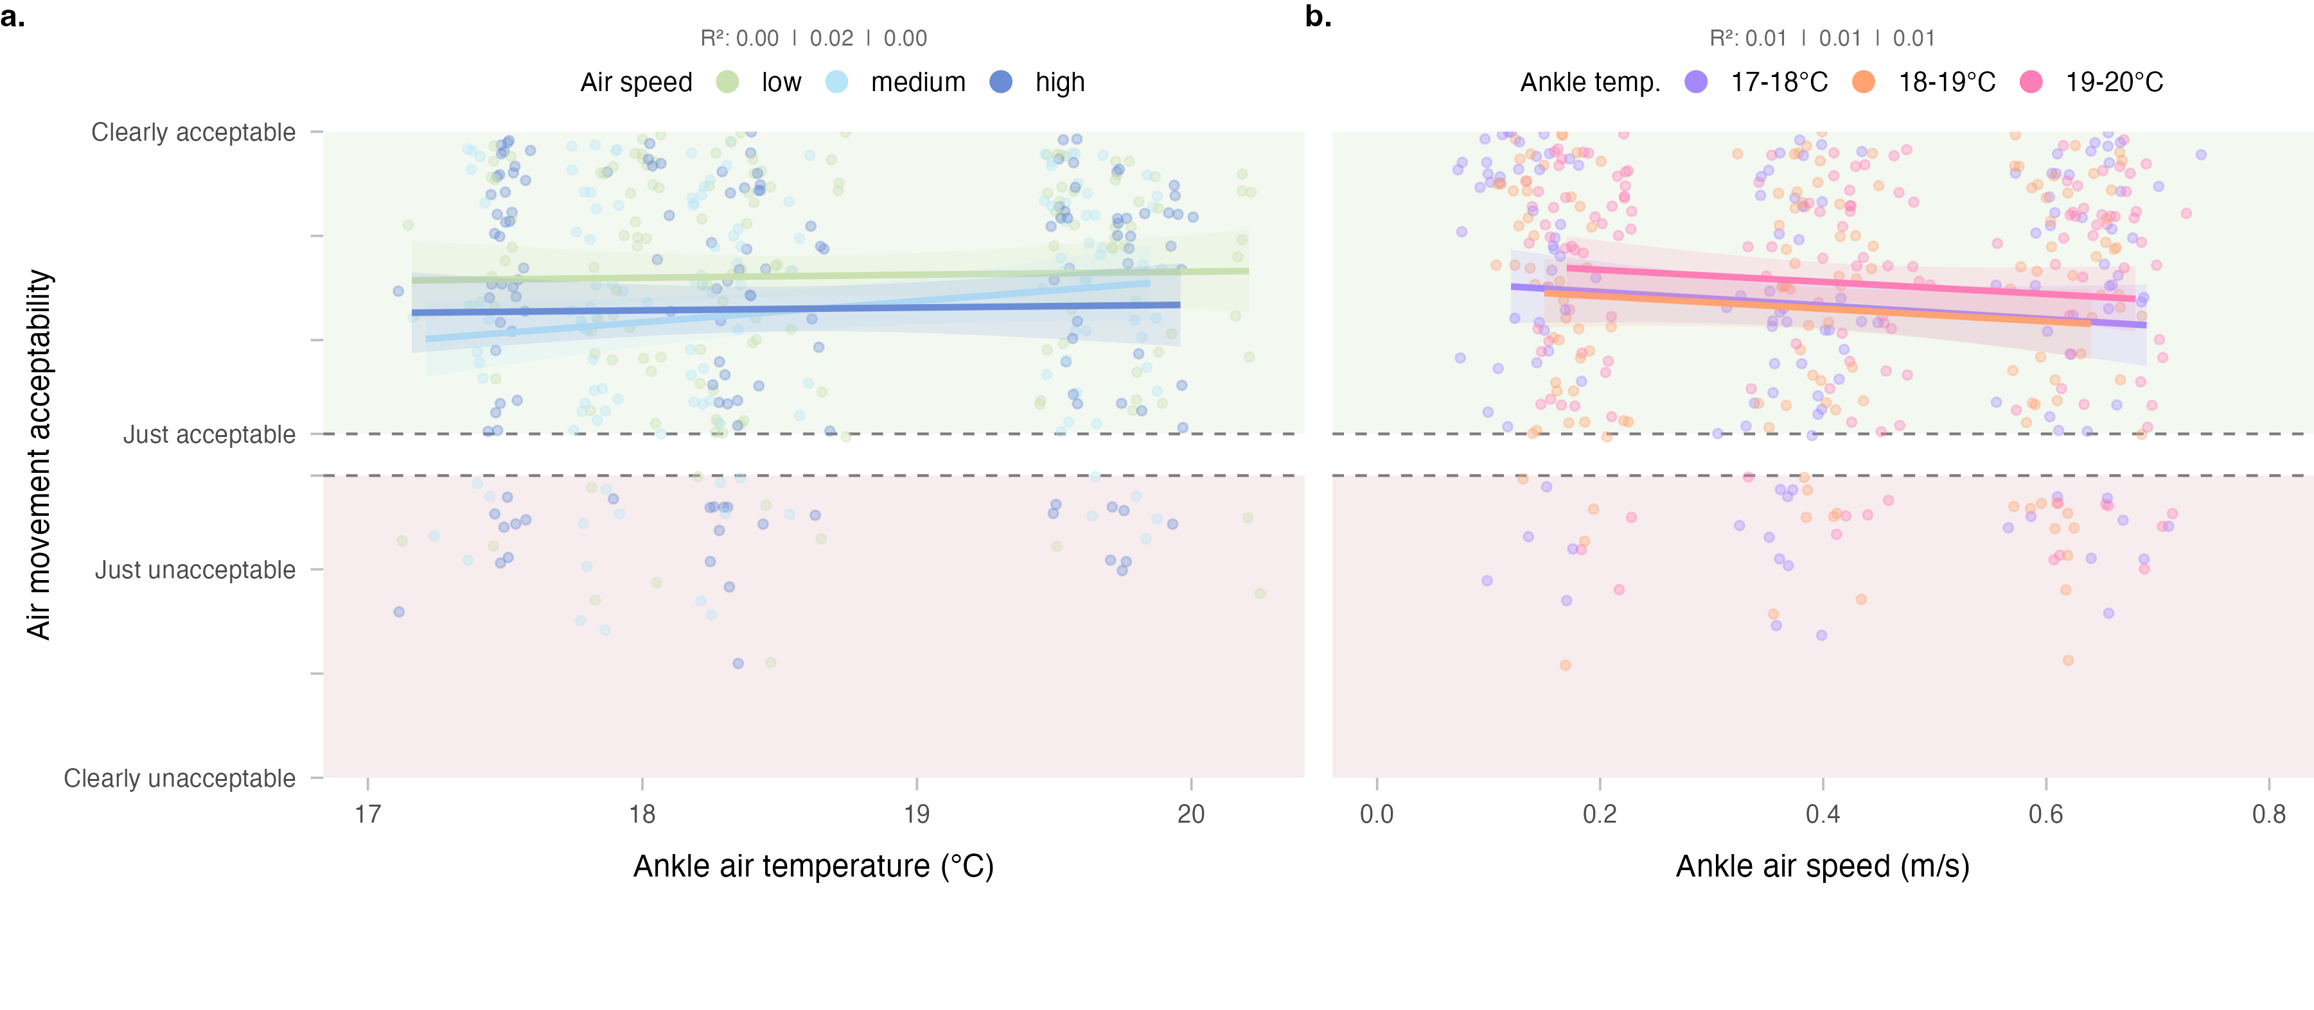
Figure 5: Ankle-level air movement acceptability votes plotted against ankle air temperature (a) and air speed (b), with per-group linear regression lines and 95% confidence bands. Acceptability was predominantly positive; a consistent negative association with air speed was observed across all ankle-level air temperature conditions.

3.3.3 Skin temperature
Figure 6 illustrates the progression of ankle skin temperatures throughout the exposure period. Using the pre-exposure adaptation period as a baseline, ankle skin temperatures dropped under all conditions, with final reductions ranging from -1.7°C to -0.8°C. In general, the magnitude of this skin temperature reduction increased with air speed, as medium and high air speeds produced greater local cooling than low air speed across all three ankle-level air temperature conditions.
Statistical analysis using BH correction confirmed that the cooling differences between low and medium air speeds, as well as between low and high air speeds, were significant at all ankle-level air temperature conditions (p_adj < 0.05 and p_adj < 0.001, respectively). In contrast, the difference between medium and high air speeds reached significance only at 19-20°C (p_adj = 0.012). These findings indicate that increasing local airflow increases the short-term cooling response of the ankle skin and most noticeable temperature drops occur when shifting away from the lowest air speed setting.
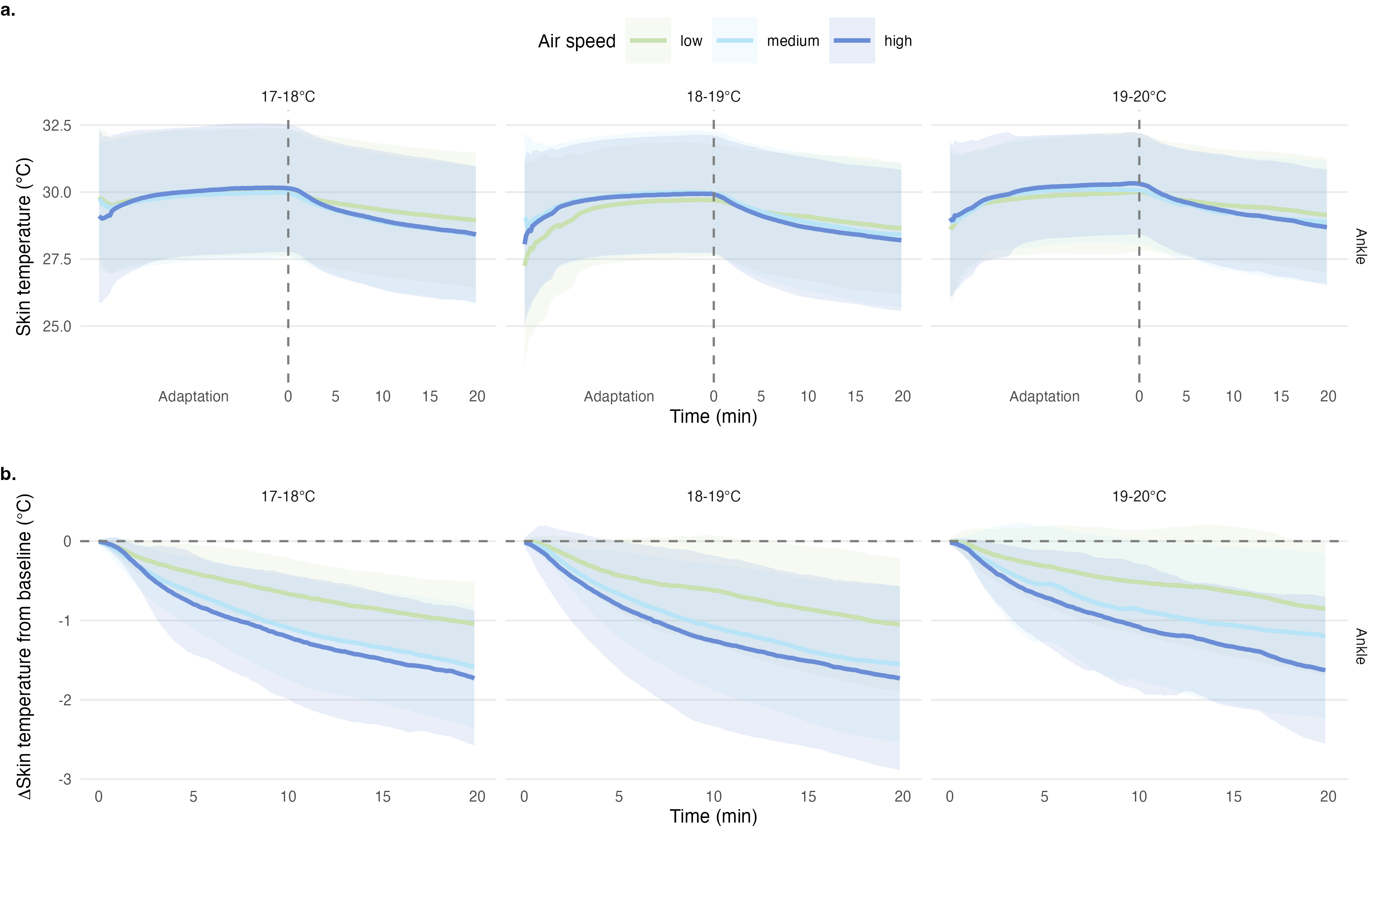
Figure 6: Time course of ankle skin temperature during the formal exposure phase across the nine experimental conditions for (a) absolute skin temperature and (b) change relative to the adaptation-period baseline ( Shaded bands denote the between-subject mean ± 1 SD): Local cooling intensified as air speed increased, with the most significant temperature drops occurring when moving from low to medium airflow.

3.4 Dissatisfaction with ankle draft
Figure 7(a) compares the dissatisfaction rates predicted by the Liu model against our experimental observations. Across all conditions, the existing model consistently overpredicted local thermal dissatisfaction. At a 17–18°C ankle temperature, the discrepancy between predicted and observed rates widened as air speed increased: the model overpredicted dissatisfaction by 8 percentage points (pp), rising to 39 pp at high flow (0.6 m/s).
We observed similar trends at 18–19°C and 19–20°C. Notably, for the 19–20°C condition at high air speed (0.6 m/s), the model predicted a PPD of 50%, while the actual dissatisfied rate was only 17%, resulting in a mean overestimation of 34 pp. Across all experimental sessions, the model overpredicted dissatisfaction by an average of 23 pp.
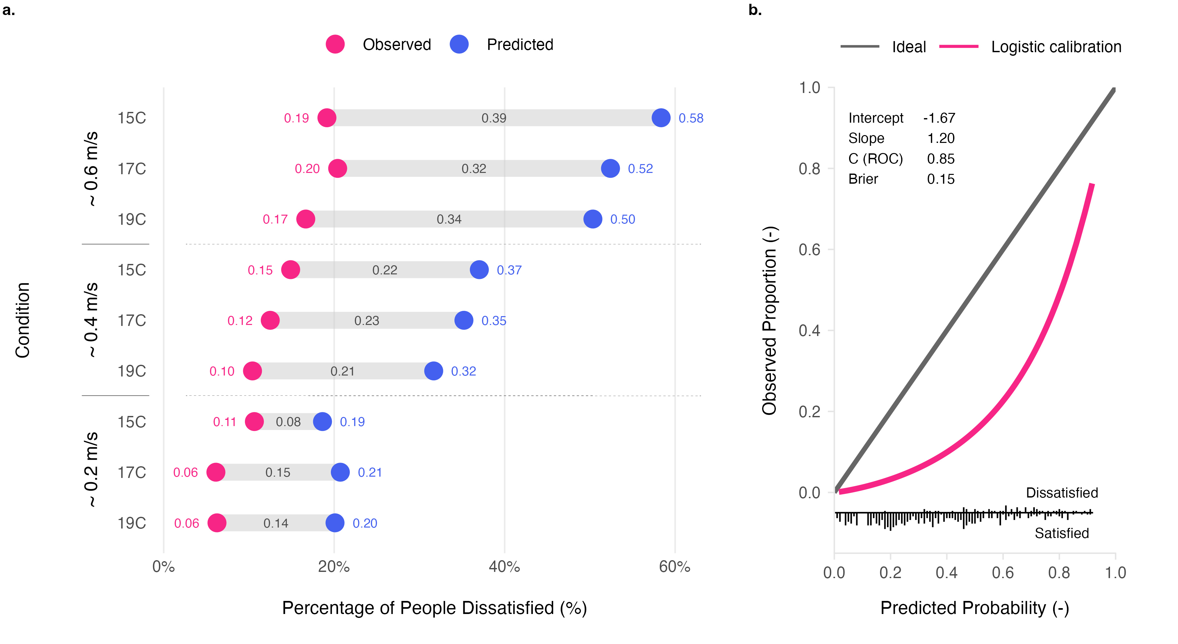
Figure 7: Performance and calibration of the Liu local dissatisfaction model: (a) The model consistently overpredicted ankle-level dissatisfaction across all conditions, with discrepancies widening at higher air speeds (points represent mean values, with the segment length indicating the magnitude of model overestimation); (b) calibration curve of the existing model on this study dataset.
In addition, we evaluated the performance of the existing ankle draft model by fitting its predictions—based on local air speed and whole-body thermal sensation—against our observed binary satisfaction outcomes using logistic regression. The resulting calibration curve is shown in Figure 7(b). In a well-calibrated model, the curve should closely follow the 45° ideal line; however, our results show the curve located predominantly below this line.
While the model maintained acceptable discriminative ability (AUC = 0.77), meaning it can effectively rank which conditions are more likely to cause discomfort, the calibration statistics reveal significant inaccuracy in the magnitude of its predictions. With a Brier score of 0.14 and a systematic shift away from the ideal line, the results confirm that the existing model consistently overestimates the probability of ankle draft dissatisfaction under winter conditions.

3.5 Updated model for winter conditions
As shown in Section 3.4, the existing model showed limited accuracy in predicting ankle draft dissatisfaction under winter conditions. This highlights the need for a revised model that accounts for differences in application contexts. To enable an integrated analysis of the effects of different factors on ankle draft dissatisfaction, we combined data from Liu et al. (2017) and collected in this study in the modeling dataset. To identify significant predictors, a model including all candidate predictors was first fitted following the methods described in Section 2.6.4. Given that both datasets were obtained from repeated measurements, subject-level dependence was accounted for in the analysis. The result of the screening model is shown in Table 4. Ankle-level air speed, whole-body thermal sensation, and ankle condition were significantly correlated with ankle draft dissatisfaction, whereas room air temperature, ankle-level air temperature, and turbulence intensity were not significant within the range investigated in this study.
Table 4: Results of the generalized linear mixed-effects model used for predictor screening.
Predictor | Estimate | SE | z | p
Air speed at ankle | 3.20 | 0.57 | 5.57 | <0.001
Room air temperature | -0.12 | 0.25 | -0.51 | 0.612
Air temperature at ankle | -0.08 | 0.07 | -1.14 | 0.254
Whole-body thermal sensation | -1.44 | 0.13 | -11.32 | <0.001
Turbulence intensity | 0.39 | 1.36 | 0.29 | 0.776
Ankle condition (uncovered vs. covered) | 1.22 | 0.44 | 2.79 | 0.005
Season | -1.59 | 0.85 | -1.86 | 0.063

Table 5: Generalized linear mixed-effects models for the ankle-uncovered and ankle-covered conditions.
Condition | Predictor | Estimate | SE | z | p
Ankle uncovered | Intercept | -1.64 | 0.32 | -5.16 | <0.001
 | Air speed at ankle | 3.51 | 0.61 | 5.75 | <0.001
 | Whole-body thermal sensation | -1.46 | 0.16 | -9.35 | <0.001
Ankle covered | Intercept | -3.55 | 0.45 | -7.97 | <0.001
 | Air speed at ankle | 2.74 | 0.91 | 3.01 | 0.003
 | Whole-body thermal sensation | -1.46 | 0.22 | -6.62 | <0.001

Based on these results, separate mixed-effects models for ankle draft dissatisfaction were developed for the ankle-uncovered and ankle-covered conditions, using ankle-level air speed and whole-body thermal sensation as predictors. As shown in Table 5, the two final models exhibited the same structure but different coefficients. The intercept of the covered model was 1.91 units lower than that of the uncovered model, indicating a lower baseline risk of ankle draft dissatisfaction when the ankle was covered by clothing. In addition, the air speed coefficient was smaller in the covered model than in the uncovered model, indicating reduced sensitivity of dissatisfaction to air speed under ankle-covered conditions.
For the ankle-uncovered condition, the approximate closed-form equation derived from the marginal predictions of the mixed-effects model can be written as:
$$PPD_{AD}=\frac{exp\left(−2.087+2.255V−0.915TS\right)}{1+exp\left(−2.087+2.255V−0.915TS\right)}$$
For the ankle-covered condition, the corresponding approximate closed-form equation is:
$$PPD_{AD}=\frac{exp\left(−3.222+1.878V−0.983TS\right)}{1+exp\left(−3.222+1.878V−0.983TS\right)}$$
Where, $PPD_{AD}$ is the predicted percentage dissatisfied with ankle draft, $V$ is air speed at ankle (m/s), and $TS$ is whole-body thermal sensation.
These linear approximations reproduced the marginal predictions of the mixed-effects models with high accuracy. The corresponding $R^{2}$ values were 0.9989 for the uncovered condition and 0.9967 for the covered condition, indicating that the approximate equations preserved the predictive behavior of the original mixed-effects models well. The resulting model predictions are shown in Figure 8.
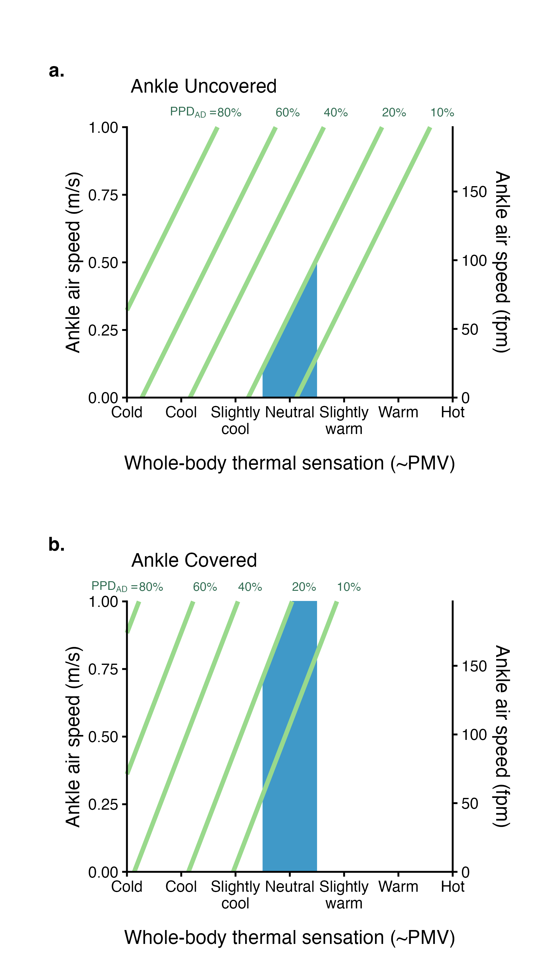
Figure 8: Updated ankle draft dissatisfaction model under exposed and covered conditions. (a) ankle-uncovered conditions, and (b) ankle-covered conditions.

4. Discussion

4.1 Comparison with prior research
The central finding of this study is that ankle-level dissatisfaction under winter clothing conditions (≥0.75 clo) is substantially lower than predicted by the existing model of Liu et al. (2017) and than observed in prior studies with exposed ankles. In the experiments of Schiavon et al. (2016), where participants wore summer clothing (~0.6 clo) with exposed ankles and lower legs, unacceptability rates ranged from 23% to 57%. Under the ankle-covered conditions in this study, airflow unacceptability ranged from only 6% to 20% across comparable air speed and temperature conditions.
These findings align with other research on the protective effects of lower-body coverage. Zhou et al. (2022) reported that high-top shoes increased ankle airflow acceptability by approximately 15% in stratified heating environments, demonstrating that even partial ankle coverage meaningfully reduces sensitivity to local airflow. Similarly, Toftum & Nielsen (1996) found that occupants with cooler overall thermal sensations are more likely to perceive airflow as uncomfortable, and that higher clothing insulation attenuates the interaction between ambient temperature and airflow-induced discomfort.
The limited variance explained by the linear regression models in Figure 4 and Figure 5 further supports this interpretation. Across all conditions, R² values did not exceed 0.05, with the strongest association observed for ankle-level thermal sensation versus air speed at 17–18°C (R² = 0.05). Liu et al. (2017) reported an R² of 0.10 for ankle air movement acceptability versus air speed alone, and an adjusted R² of 0.22 for a model including both whole-body thermal sensation and ankle air speed — substantially higher than our values and consistent with the greater sensitivity to ankle draft expected under summer clothing conditions with exposed ankles.
Regarding predictor selection, only whole-body thermal sensation and air speed were significant predictors of dissatisfaction in our models, consistent with the structures reported by Toftum & Nielsen (1996) and Liu et al. (2017). Cheng et al. (2023) similarly identified a relationship between overall thermal sensation and draft rate thresholds, further supporting its inclusion as a predictor.
Although the dataset used by Liu et al. (2017) included both exposed and covered ankle conditions, no significant clothing effect was identified in their analysis even if the ankle condition (covered vs uncovered) was the third most important variable after ankle air speed and whole-body thermal sensation. The discrepancy in the significance of this variable likely stems from their use of standard logistic regression, which pooled observations across subjects without accounting for the non-independence introduced by repeated measures. This approach may have masked the clothing effect as a between-subject variable due to inter-individual variability, which is a limitation addressed in our study through the use of mixed-effects models.

4.2 Mechanisms
Two complementary pathways, physiological and psychological, may explain the reduced sensitivity to ankle draft under winter clothing conditions.
From a physiological perspective, the skin temperature results indicate that winter clothing attenuates, though does not eliminate, the local cooling effect of airflow. During the final steady-state period, significant reductions in ankle skin temperature occurred only at the coolest ankle-level air temperature condition (17–18°C), where medium and high air speeds produced lower skin temperatures than the low-speed condition. At 18–19°C and 19–20°C, variations in air speed did not yield significant differences in steady-state skin temperature, and no significant differences were observed between medium and high air speeds at any ankle-level air temperature condition. These findings suggest that detectable local cooling requires a sufficiently large environmental contrast.
Thermal sensation changes are more closely associated with rapid variations in skin temperature than with absolute values (Choi & Loftness, 2012; Kenshalo et al., 1968). In this study, ankle $ΔT_{\text{sk}}$ relative to the baseline adaptation period showed significant differences between low and medium/high air speed conditions across all ankle-level air temperature conditions (effect size $d≈0.6\text{-}0.9$). Consistent with this, local ankle thermal sensation at medium and high speeds was significantly lower than at low speed under the 17–18°C condition. However, air movement acceptability did not differ significantly across conditions, indicating that while air speed produced measurable shifts in skin temperature and local thermal sensation, the magnitude of these changes was insufficient to generate distinguishable differences in dissatisfaction within the tested range. From a heat transfer perspective, clothing coverage increases local thermal resistance and reduces convective and radiative heat exchange (Nishi et al., 1975; Oguro et al., 2001), suppressing both the magnitude and variability of skin temperature changes and making it less likely that occupants cross discomfort thresholds.
Psychological factors may also contribute to the observed tolerance. Occupants wearing thicker lower-body clothing may perceive themselves as “protected,” increasing their tolerance to local airflow. Prior research has demonstrated that thermal perception is not solely determined by physical stimuli but is modulated by expectations and informational cues. Providing occupants with temperature information or group perception feedback can improve thermal comfort evaluations (Zhang et al., 2022), and thermal expectations themselves influence perception (Schweiker et al., 2020). Field studies have also identified associations between perceived control and thermal satisfaction in winter conditions (Xu & Li, 2021). These findings suggest that the subjective sense of being protected by clothing may enhance tolerance to ankle draft, though this psychological pathway was not directly measured in the present study and warrants further investigation.
Together, these physiological and psychological mechanisms likely act in concert: clothing reduces the physical cooling stimulus while simultaneously altering occupants’ expectations and perceived vulnerability to draft.

4.3 Implications for building design and standards
The ankle draft model of Liu et al. (2017), now incorporated into ASHRAE Standard 55, does not distinguish between covered and uncovered ankle conditions. Given the standard’s acceptable thermal sensation range of PMV = −0.5 to +0.5, the current criterion requires ankle-level air speed below 0.22 m/s to achieve less than 20% dissatisfied when TS = −0.5. This constraint may be overly conservative for typical winter environments where occupants wear clothing that covers the ankle.
The findings of this study support a differentiated approach. For winter conditions with ankle coverage (≥0.75 clo), the covered-ankle model developed here indicates that dissatisfaction remains within acceptable limits at air speeds that would exceed the current threshold. Empirical predictions of window downdraft suggest that maximum velocities at approximately 1 m from the façade are around 0.25 m/s, with peak velocities often falling within 0.1–0.2 m/s under milder outdoor conditions or with smaller window areas (Lyons et al., 1999). Many of these scenarios would be acceptable under the covered-ankle model but flagged as problematic under the current single-threshold approach.
For practitioners, this suggests a two-criteria framework: apply the existing model (or the uncovered-ankle model from this study) when evaluating spaces where occupants are likely to have exposed ankles, and apply the covered-ankle model for winter heating scenarios where long trousers, socks, and closed-toe shoes are expected. Within the near-neutral thermal range where ASHRAE Standard 55 applies, PMV provides a reasonable proxy for whole-body thermal sensation during design evaluation.
The practical benefits are significant. Perimeter heating systems, increased façade insulation and other techniques used to reduce the downdraft represent non-trivial costs and carbon emissions in both installation and operation. If covered and uncovered conditions are evaluated separately, designers may be able to downsize or remove solutions used to manage the problem. This approach could yield meaningful reductions in first costs, energy consumption, and associated carbon emissions while maintaining occupant comfort.

4.4 Limitations
Several limitations should be considered when interpreting these findings.
First, this study was conducted in a controlled laboratory environment with standardized clothing, which differs from real settings where occupants exhibit considerable variability in attire even during winter months. While we targeted 0.75 clo to represent median winter clothing, actual insulation levels vary with individual preferences, building temperatures, and cultural norms. The protective effect of ankle coverage may differ with clothing types not tested here, such as ankle-length skirts, cropped trousers, or low-cut shoes.
Second, the participant sample consisted primarily of university-affiliated individuals within a limited age range. Thermal sensitivity varies with age, and older occupants may respond differently to ankle draft. The generalizability of these findings to broader occupant populations warrants further investigation.
Third, the experimental protocol involved 20-minute exposure periods, whereas real office occupants experience sustained exposure over hours. Whether dissatisfaction accumulates or diminishes with prolonged exposure was not assessed. Similarly, participants remained seated throughout; standing or walking occupants may have different thermal experiences at the ankle level.
Fourth, the experimental conditions covered supply air temperatures of 15–19°C, leading to ankle-level air temperatures from 17-20°C, and air speeds of 0.1–0.7 m/s. While these ranges were selected to represent typical window downdraft conditions, more extreme scenarios (colder supply/ankle-level temperatures or higher velocities) were not tested. The model predictions should be applied with caution outside the tested parameter space.
Fifth, airflow was delivered from behind the participants to simulate a window downdraft approaching their lower legs from the façade. This scenario, identified by Toftum & Zhou (1997) as one of the most unfavorable situations, was used to study the impact of airflow on the participants.. Other airflow directions (lateral or frontal) may produce different perceptual responses, particularly given potential differences in skin exposure and attention to the stimulus source.
Finally, the experimental setup simulated the convective component of window downdraft but did not include radiant asymmetry from a cold window surface. In real buildings, occupants near poorly insulated glazing experience both convective cooling from downdraft and radiant heat loss to the cold surface. The combined effect of these two mechanisms on ankle-level comfort was beyond the scope of this study.

5. Conclusions
This study evaluated thermal comfort responses to ankle-level draft under typical winter clothing conditions. Through controlled laboratory experiments with participants wearing approximately 0.75 clo ensembles that covered the ankle, we characterized local and whole-body thermal perception across a range of ankle level air temperatures (17-20°C) and air speeds (0.1–0.7m/s) simulating window downdraft.
The principal findings indicate that the existing ankle draft model systematically overpredicts dissatisfaction under winter clothing conditions. While prior studies with exposed ankles reported dissatisfaction rates between 23% and 57% under similar air speeds, our observations with covered ankles ranged from only 6% to 20%. This suggests that ankle coverage substantially reduces sensitivity to local draft, a conclusion supported by the covered-ankle model developed in this study; the model demonstrates both a lower baseline risk and a reduced response to air speed compared to uncovered-ankle models, with an intercept difference of approximately 1.5 units on the logit scale.
Consistent with prior model structures, we found that whole-body thermal sensation and air speed at the ankle are the primary predictors of dissatisfaction, whereas ankle air temperature, room temperature, and turbulence intensity were not significant within the tested ranges. This reduced sensitivity under winter clothing appears to stem from a combination of physiological mechanisms, specifically attenuated skin cooling due to increased thermal resistance, and potentially psychological factors, such as a perceived sense of protection provided by the clothing coverage.
These findings support a differentiated approach to ankle draft assessment in building standards. For winter heating scenarios where occupants typically wear clothing that covers the ankle (≥0.75 clo), the covered-ankle model provides more accurate predictions than the current ASHRAE Standard 55 criterion. Adopting separate criteria for covered and uncovered conditions could enable significant reductions in perimeter heating requirements without compromising occupant comfort, yielding benefits in installation costs, energy consumption, and carbon emissions.

CRediT authorship contribution statement
Tobias Kramer: Conceptualization, Data curation, Formal analysis, Methodology, Investigation, Project administration, Software, Writing - original draft, Writing - review & editing. Junmeng Lyu: Data curation, Formal analysis, Methodology, Investigation, Software, Writing - original draft, Writing - review & editing. Stefano Schiavon: Conceptualization, Funding acquisition, Methodology, Project administration, Supervision, Writing - review & editing.

Declaration of competing interest
All authors declare no competing interest. The Center for the Built Environment (CBE) at the University of California, Berkeley, with which the authors are affiliated, is advised and funded in part by approximately 50 partners that represent a diversity of organizations from the building industry, including manufacturers, building owners, facility managers, contractors, architects, engineers, government agencies, and utilities.

Data availability
The datasets generated and analyzed during the current study as well as the full source code of the data analysis workflow are available in the following GitHub repository: https://github.com/CenterForTheBuiltEnvironment/ankle-draft-II

Declaration of Generative AI and AI-assisted technologies in the writing process
During the preparation of this work, the authors utilized the chatbot Claude to enhance the language and readability of the content. Subsequently, they reviewed and edited the material as required, while maintaining full accountability for the publication’s content.

Acknowledgements
Schüco and the Center for the Built Environment at the University of California, Berkeley supported this research.

6. Appendix A: Response distributions
The following figures show the full response distributions for thermal sensation, thermal preference, and air movement acceptability and preference. These complement the scatter plots with linear regression lines presented in Section 3 in the main text.
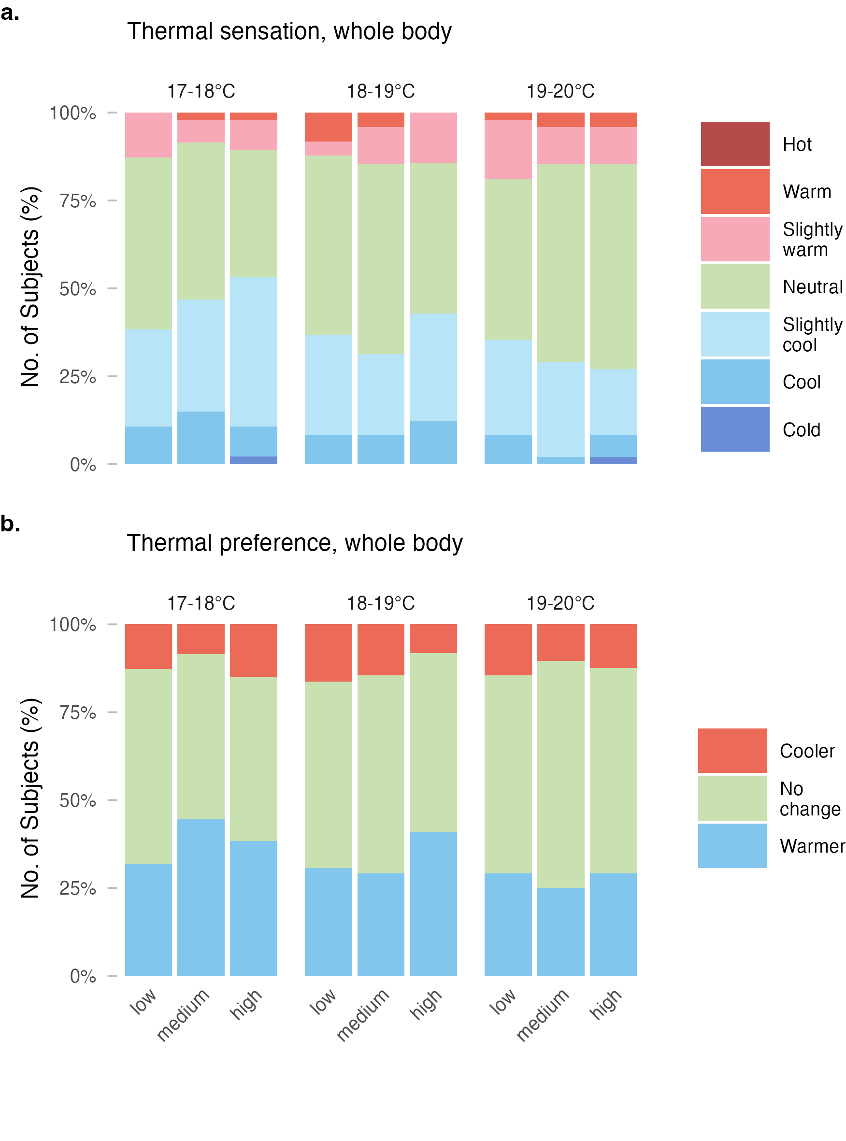
Figure 9: Whole-body thermal sensation (a) and thermal preference (b) votes by ankle-level air temperature and air speed. Participants predominantly reported neutral to cool sensations, with lower ankle-level air temperatures increasing the proportion preferring warmer conditions.

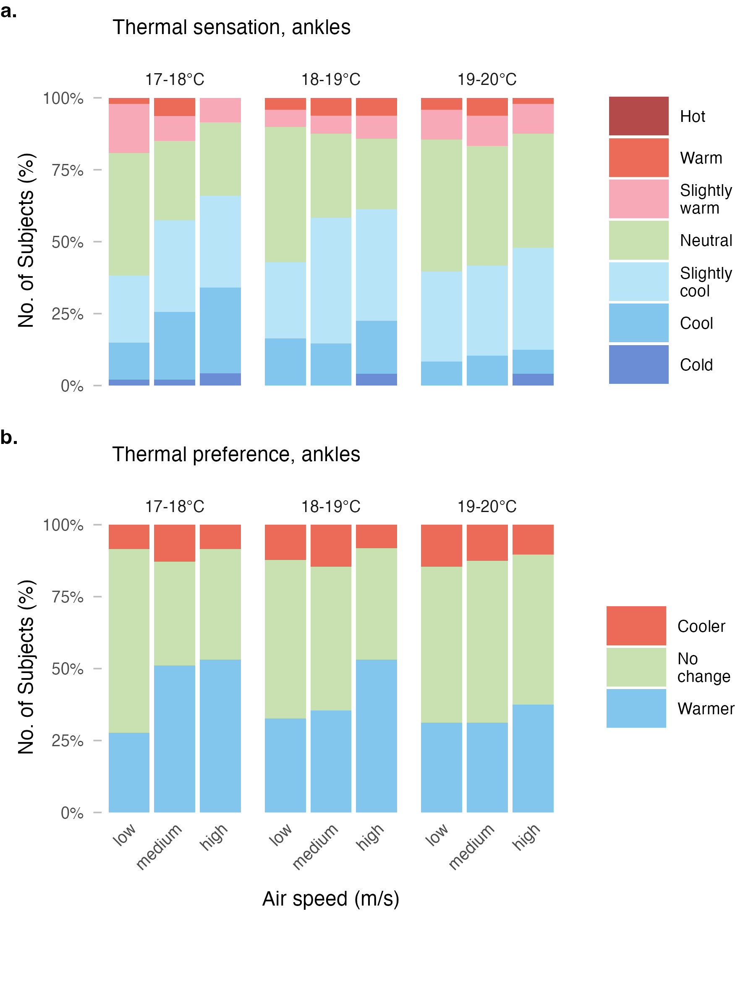
Figure 10: Ankle-level thermal sensation (a) and thermal preference (b) votes by ankle-level air temperature and air speed. Sensations were generally cooler at the ankles than whole-body ratings, with lower ankle-level air temperatures and higher air speeds increasing cool sensations and the preference for warmer conditions.

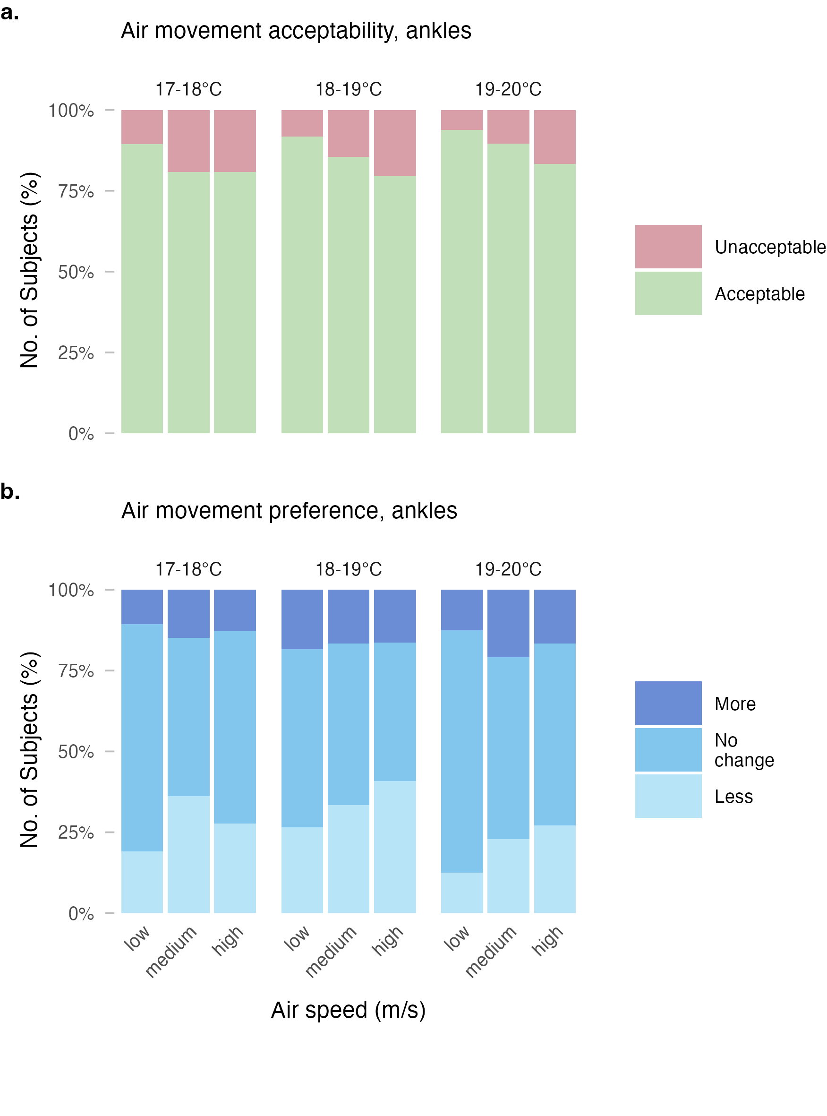
Figure 11: Ankle-level air movement acceptability (a) and preference (b) votes by ankle-level air temperature and air speed. Most participants found ankle air movement acceptable, though higher air speeds increased the preference for less air movement.

References
ASHRAE. (2023). ANSI/ASHRAE Standard 55-2023: Thermal Environmental Conditions for Human Occupancy. American Society of Heating, Refrigerating; Air-Conditioning Engineers.
Benjamini, Y., & Hochberg, Y. (1995). Controlling the false discovery rate: A practical and powerful approach to multiple testing. Journal of the Royal Statistical Society: Series B (Methodological), 57(1), 289–300. https://doi.org/10.1111/j.2517-6161.1995.tb02031.x
Cheng, F., Cheng, Y., & Lin, Z. (2023). Experimental study of draft-related local discomfort in a room with stratum ventilation. Applied Thermal Engineering, 234, 121259. https://doi.org/10.1016/j.applthermaleng.2023.121259
Choi, J.-H., & Loftness, V. (2012). Investigation of human body skin temperatures as a bio-signal to indicate overall thermal sensations. 58, 258–269.
De Cock, B., Nieboer, D., Van Calster, B., Steyerberg, E. W., & Vergouwe, Y. (2025). The CalibrationCurves package: Assessing the agreement between observed outcomes and predictions. https://doi.org/10.32614/CRAN.package.CalibrationCurves
Fanger, P. O., Melikov, A. K., Hanzawa, H., & Ring, J. (1988). Air turbulence and sensation of draught. Energy and Buildings, 12(1), 21–39. https://doi.org/10.1016/0378-7788(88)90053-9
Földváry Ličina, V., Cheung, T., Zhang, H., Dear, R. de, Parkinson, T., Arens, E., Chun, C., Schiavon, S., Luo, M., Brager, G., Li, P., Kaam, S., Adebamowo, M. A., Andamon, M. M., Babich, F., Bouden, C., Bukovianska, H., Candido, C., Cao, B., … Zhou, X. (2018). Development of the ASHRAE Global Thermal Comfort Database II. Building and Environment, 142, 502–512. https://doi.org/10.1016/j.buildenv.2018.06.022
Heiselberg, P. (1994). Draught risk from cold vertical surfaces. Special Issue Papers from Indoor Air ’93, 29(3), 297–301. https://doi.org/https://doi.org/10.1016/0360-1323(94)90026-4
Kenshalo, D. R., Holmes, C. E., & Wood, P. B. (1968). Warm and cool thresholds as a function of rate of stimulus temperature change. 3, 81–84.
Larsson, U., & Moshfegh, B. (2002). Experimental investigation of downdraught from well-insulated windows. Building and Environment, 37(11), 1073–1082. https://doi.org/10.1016/S0360-1323(01)00110-X
Liu, S., Schiavon, S., Kabanshi, A., & Nazaroff, W. W. (2017). Predicted percentage dissatisfied with ankle draft. Indoor Air, 27(4), 852–862. https://doi.org/10.1111/ina.12364
Lyons, P., Arasteh, D., & Huizenga, C. (1999). Window Performance for Human Thermal Comfort (LBNL-44032). Ernest Orlando Lawrence Berkeley National Laboratory. https://windows.lbl.gov/sites/default/files/lbnl-44032.pdf
Manz, H., & Frank, T. (2004). Analysis of thermal comfort near cold vertical surfaces by means of computational fluid dynamics. Indoor + Built Environment, 13(3), 233–242. https://doi.org/10.1177/1420326X04043733
Neuhaus, J. M., Kalbfleisch, J. D., & Hauck, W. W. (1991). A comparison of cluster-specific and population-averaged approaches for analyzing correlated binary data. International Statistical Review, 59(1), 25–36. https://doi.org/10.2307/1403572
Nishi, Y., Gonzalez, R., & Gagge, A. P. (1975). Direct measurement of clothing heat transfer properties during sensible and insensible heat exchange with thermal environment. ASHRAE Trans., 81, 183–199.
Oguro, M., Arens, E., Dear, R. de, Zhang, H., & Katayama, T. (2001). Evaluation of the effect of air flow on clothing insulation and total heat transfer coefficient for each part of the clothed human body.
Schellen, L., Timmers, S., Loomans, M., Nelissen, E., Hensen, J. L. M., & Marken Lichtenbelt, W. van. (2012). Downdraught assessment during design: Experimental and numerical evaluation of a rule of thumb. Building and Environment, 57, 290–301. https://doi.org/10.1016/j.buildenv.2012.04.011
Schiavon, S., Rim, D., Pasut, W., & Nazaroff, W. W. (2016). Sensation of draft at uncovered ankles for women exposed to displacement ventilation and underfloor air distribution systems. Building and Environment, 96, 228–236. https://doi.org/10.1016/j.buildenv.2015.11.009
Schweiker, M., Rissetto, R., & Wagner, A. (2020). Thermal expectation: Influencing factors and its effect on thermal perception. Energy and Buildings, 210, 109729. https://doi.org/10.1016/j.enbuild.2019.109729
Tartarini, F., Schiavon, S., Cheung, T., & Hoyt, T. (2020). CBE thermal comfort tool: Online tool for thermal comfort calculations and visualizations. SoftwareX, 12, 100563. https://doi.org/https://doi.org/10.1016/j.softx.2020.100563
Toftum, J., & Nielsen, R. (1996). Draught sensitivity is influenced by general thermal sensation. International Journal of Industrial Ergonomics, 18, 295–305. https://doi.org/10.1016/0169-8141(95)00070-4
Toftum, J., & Zhou, G. (1997). Effect of airflow direction on human perception of draught. https://api.semanticscholar.org/CorpusID:6498310
Van Calster, B., Nieboer, D., Vergouwe, Y., De Cock, B., Pencina, M. J., & Steyerberg, E. W. (2016). A calibration hierarchy for risk models was defined: From utopia to empirical data. Journal of Clinical Epidemiology, 74, 167–176. https://doi.org/https://doi.org/10.1016/j.jclinepi.2015.12.005
Xu, C., & Li, S. (2021). Influence of perceived control on thermal comfort in winter, A case study in hot summer and cold winter zone in China. Journal of Building Engineering, 40, 102389. https://doi.org/10.1016/j.jobe.2021.102389
Zhang, Z., Lin, B., Geng, Y., Zhou, H., Wu, X., & Zhang, C. (2022). The effect of temperature and group perception feedbacks on thermal comfort. Energy and Buildings, 254, 111603. https://doi.org/10.1016/j.enbuild.2021.111603
Zhou, B., Yang, B., Wu, M., Guo, Y., Wang, F., & Li, A. (2022). Draught sensation assessment in an occupied space heated by stratified ventilation system: Attachment ventilation with relayed fans. Building and Environment, 207, 108500. https://doi.org/10.1016/j.buildenv.2021.108500

