Supplementary material

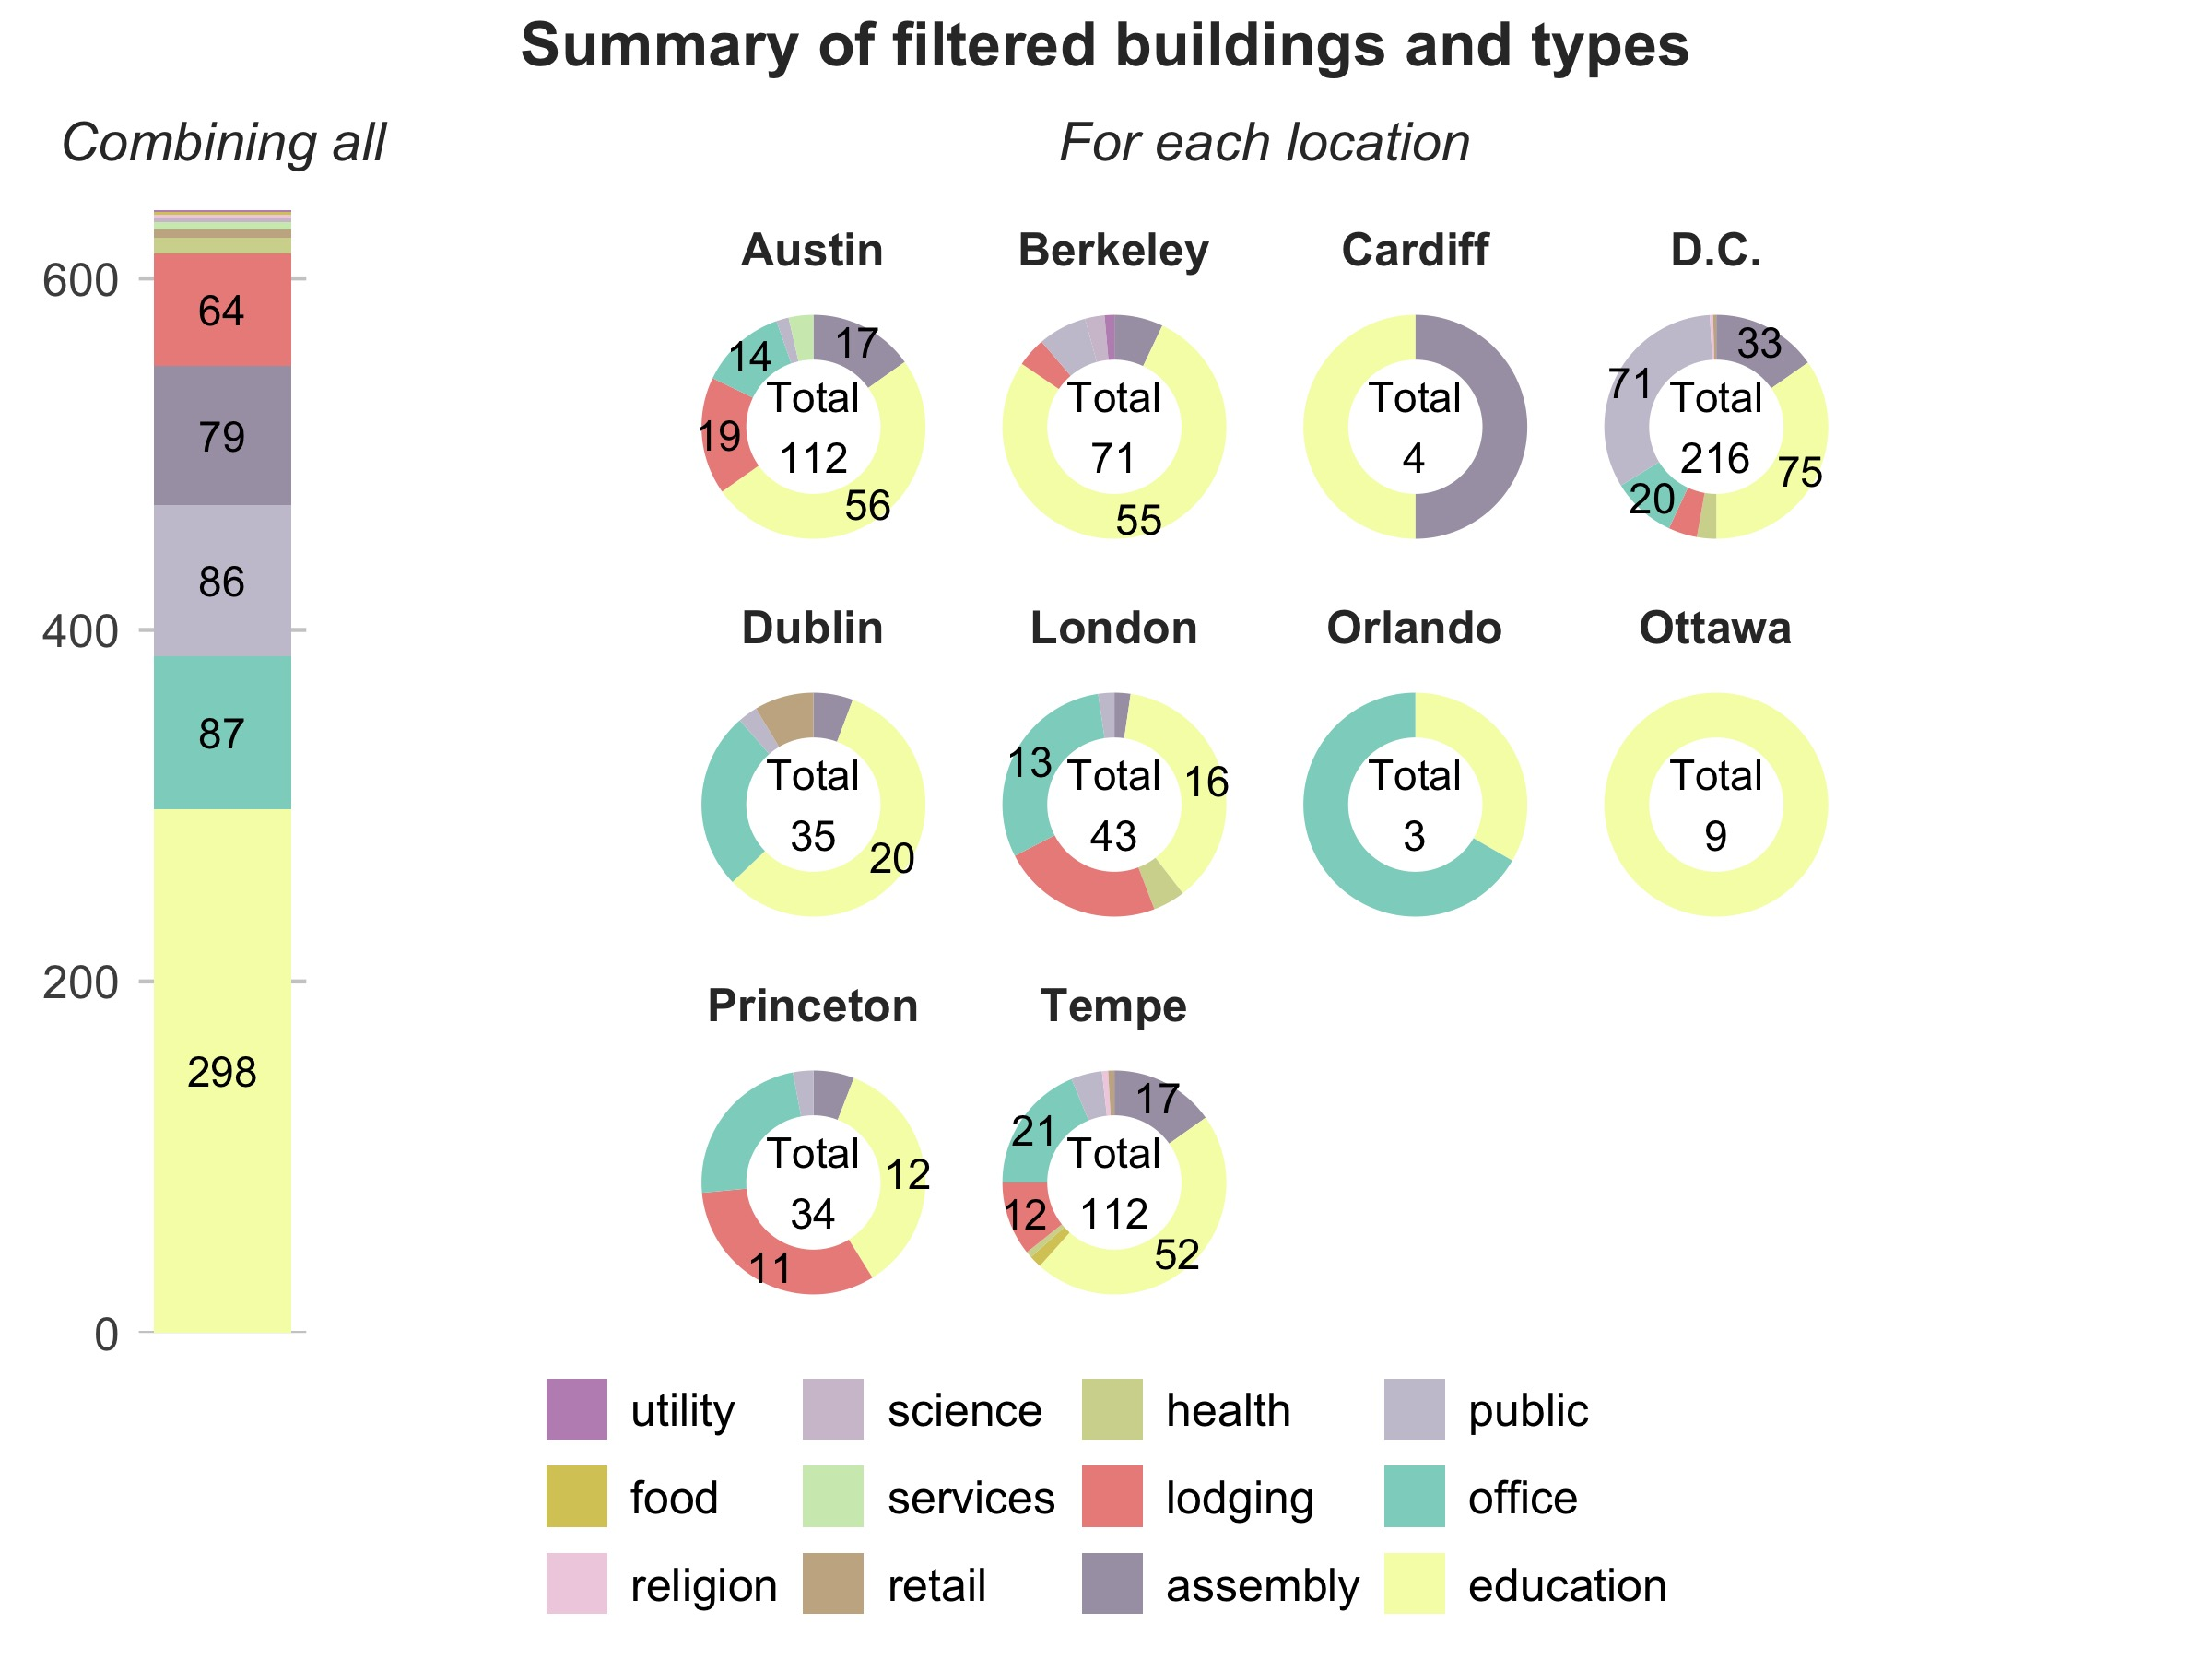

Figure 1: Site summary of the filtered buildings from BDG2 dataset (counts < 10 are omitted for visualization; left: aggregated counts of buildings for each type; right: breakdown building counts for each building type at each location)

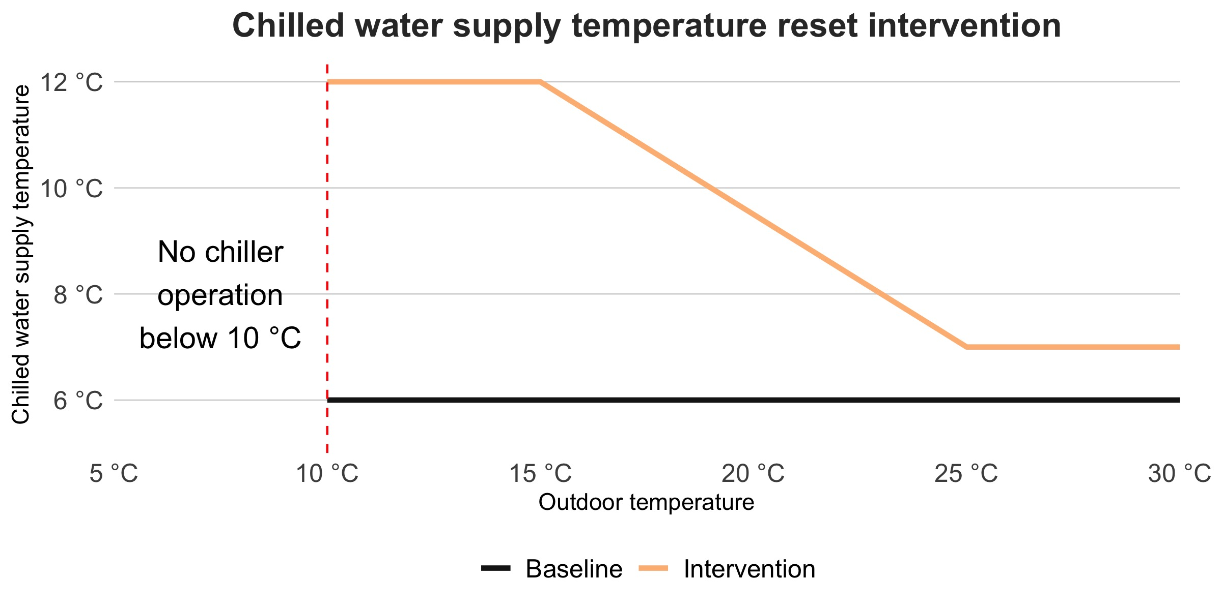

Figure 2: Proposed intervention strategy: chilled water supply temperature reset based on outdoor temperature.

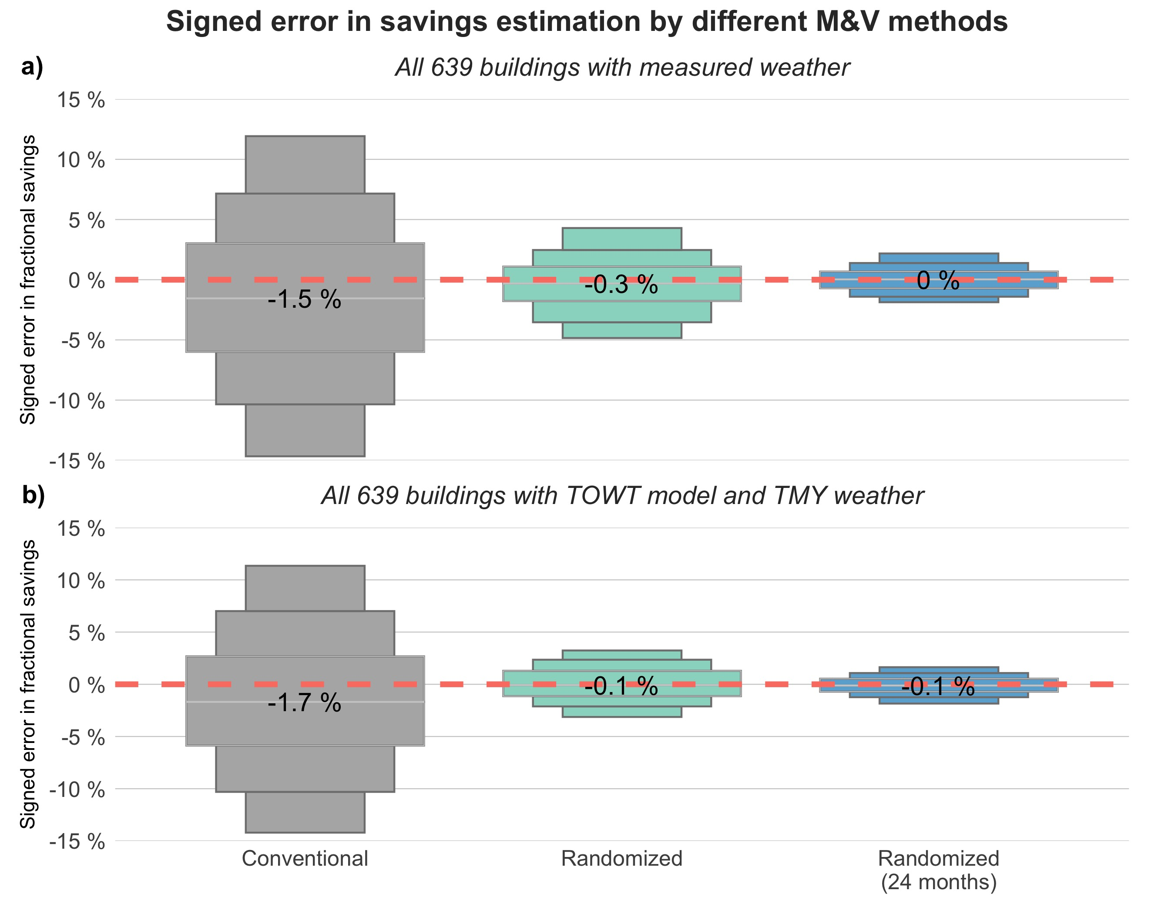

Figure 3: Distribution of estimated deviation (without absolute calculation) from the ground-truth savings calculated by the two M&V methods (red dashed line highlighting 0% error)

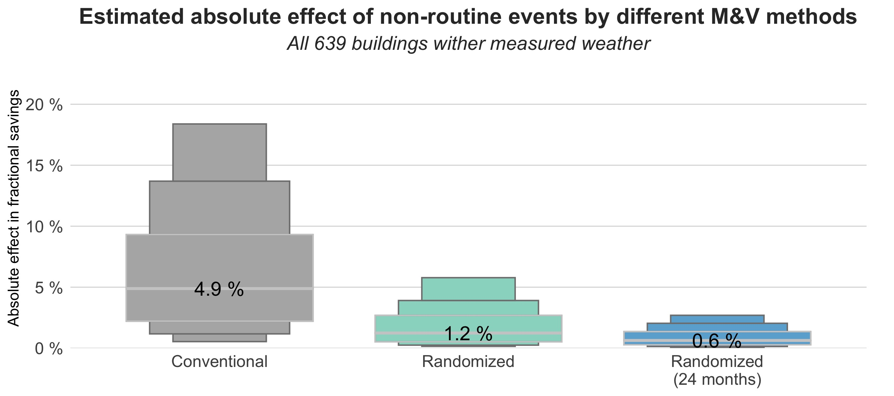

Figure 4: Comparison between the two M&V methods in detecting no intervention effect when buildings are subject to baseline change.

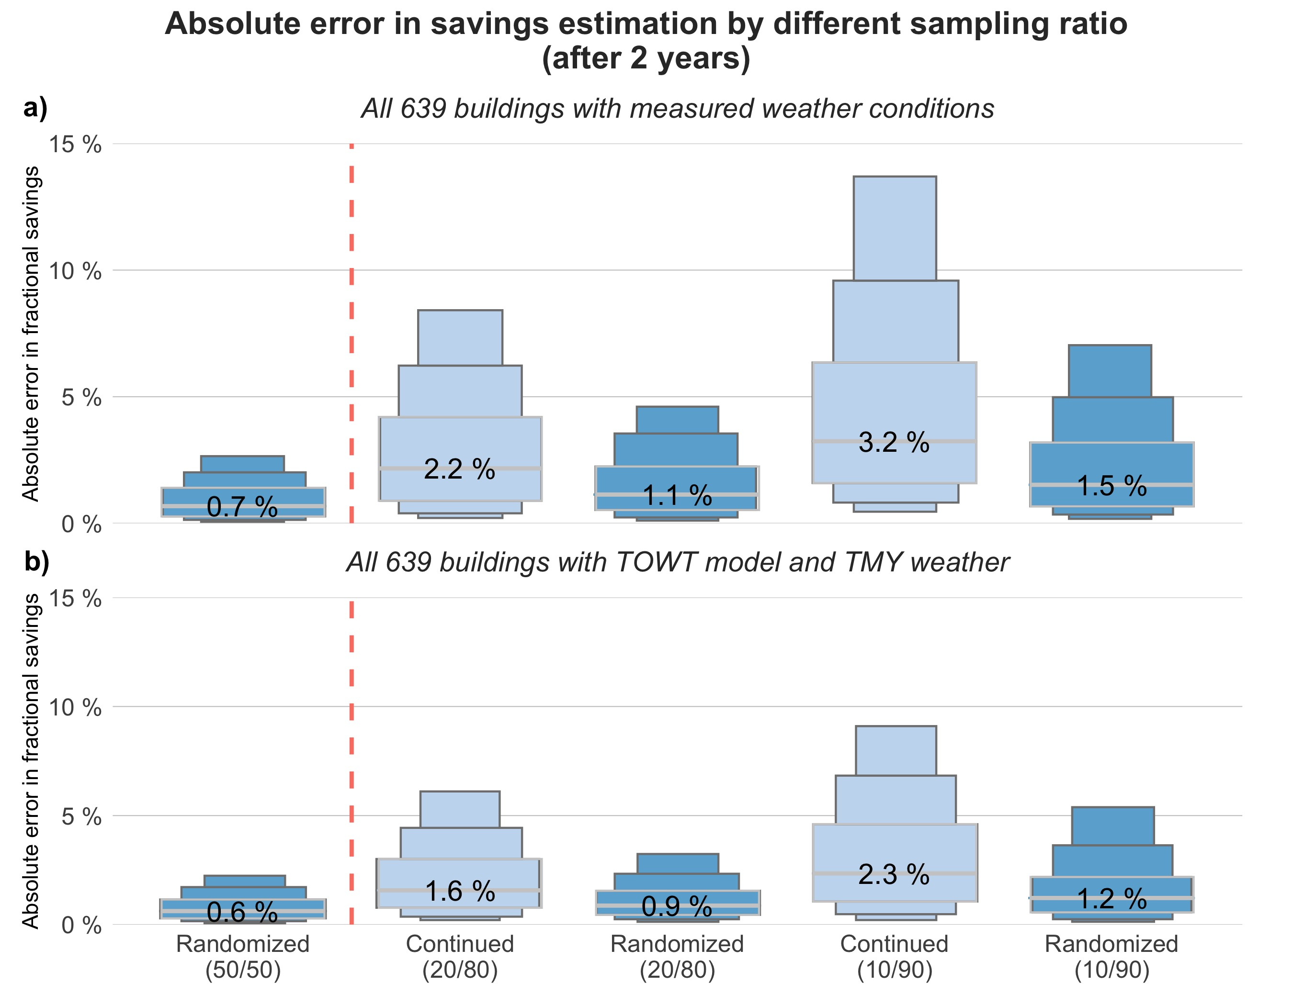

Figure 5: Comparison of different sampling ratio impact on M&V estimation accuracy over the entire 24 months (previous results of sampling at 50%/50% shown on the left side of the red dashed line)

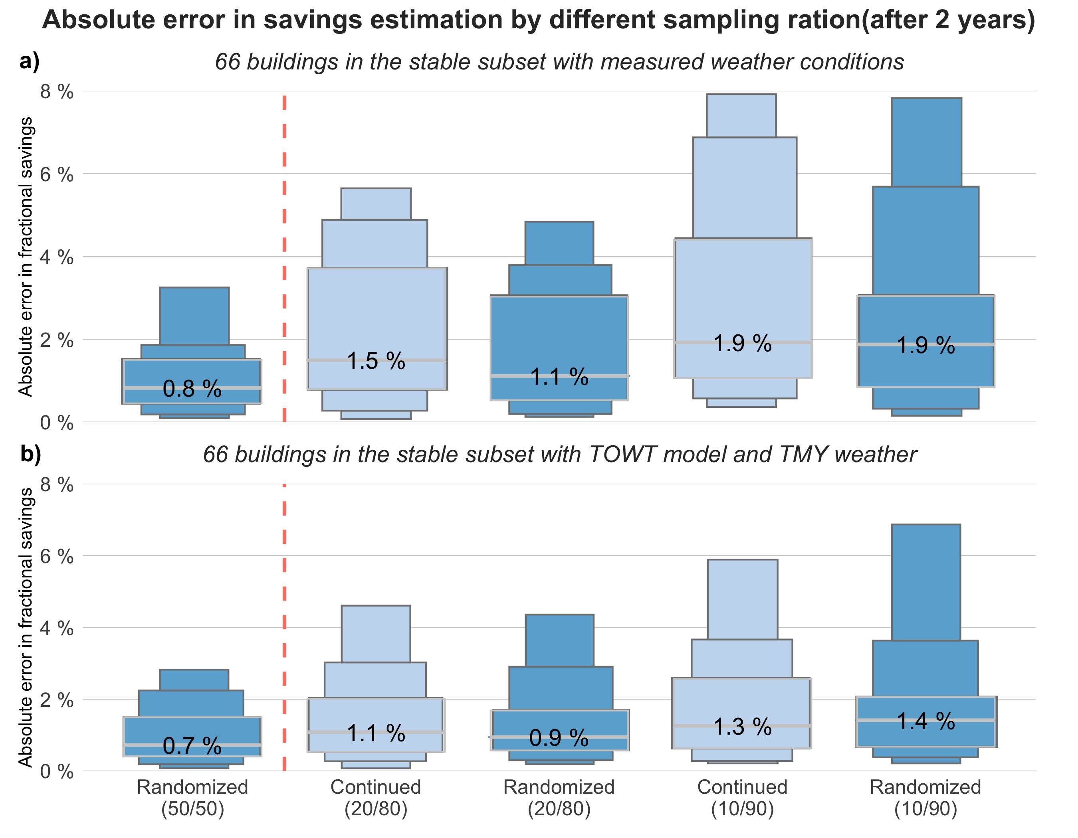

Figure 6: Comparison of different sampling ratio impact on M&V estimation accuracy using buildings with stable electricity usage over the entire 24 months (results of sampling at 50%/50% shown on the left side of the red dashed line)

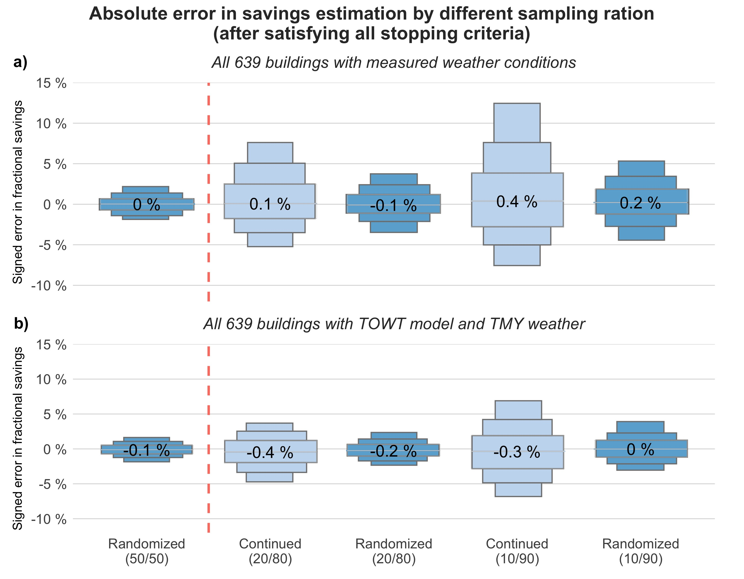

Figure 7: Comparison of different sampling ratio impact on M&V estimation accuracy at the time of satisfying all stopping criteria (expressed without absolute calculation for errors)

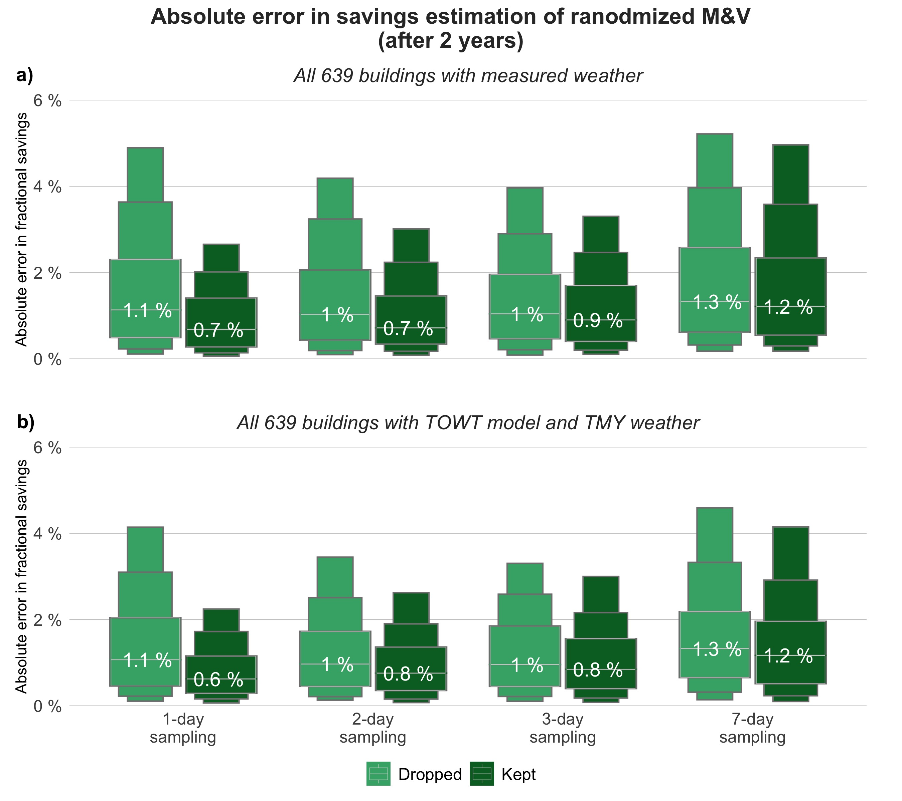

Figure 8: Comparison of different sampling interval impact on M&V estimation accuracy over the course of two years (dropped: all non-consecutive days were dropped; kept: all measurements were kept)

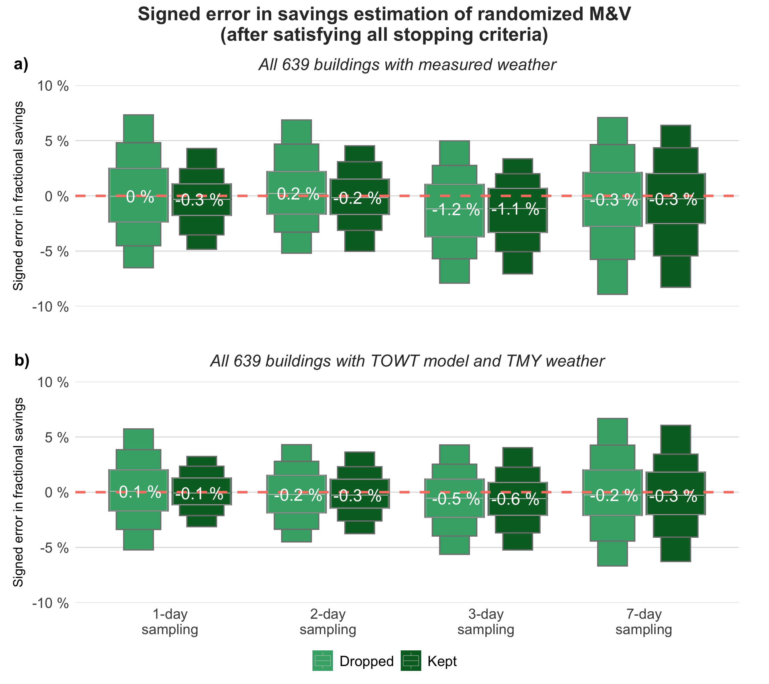

Figure 9: Comparison of different sampling interval impact on M&V estimation accuracy after satisfying all stopping criteria (without absolute calculation)

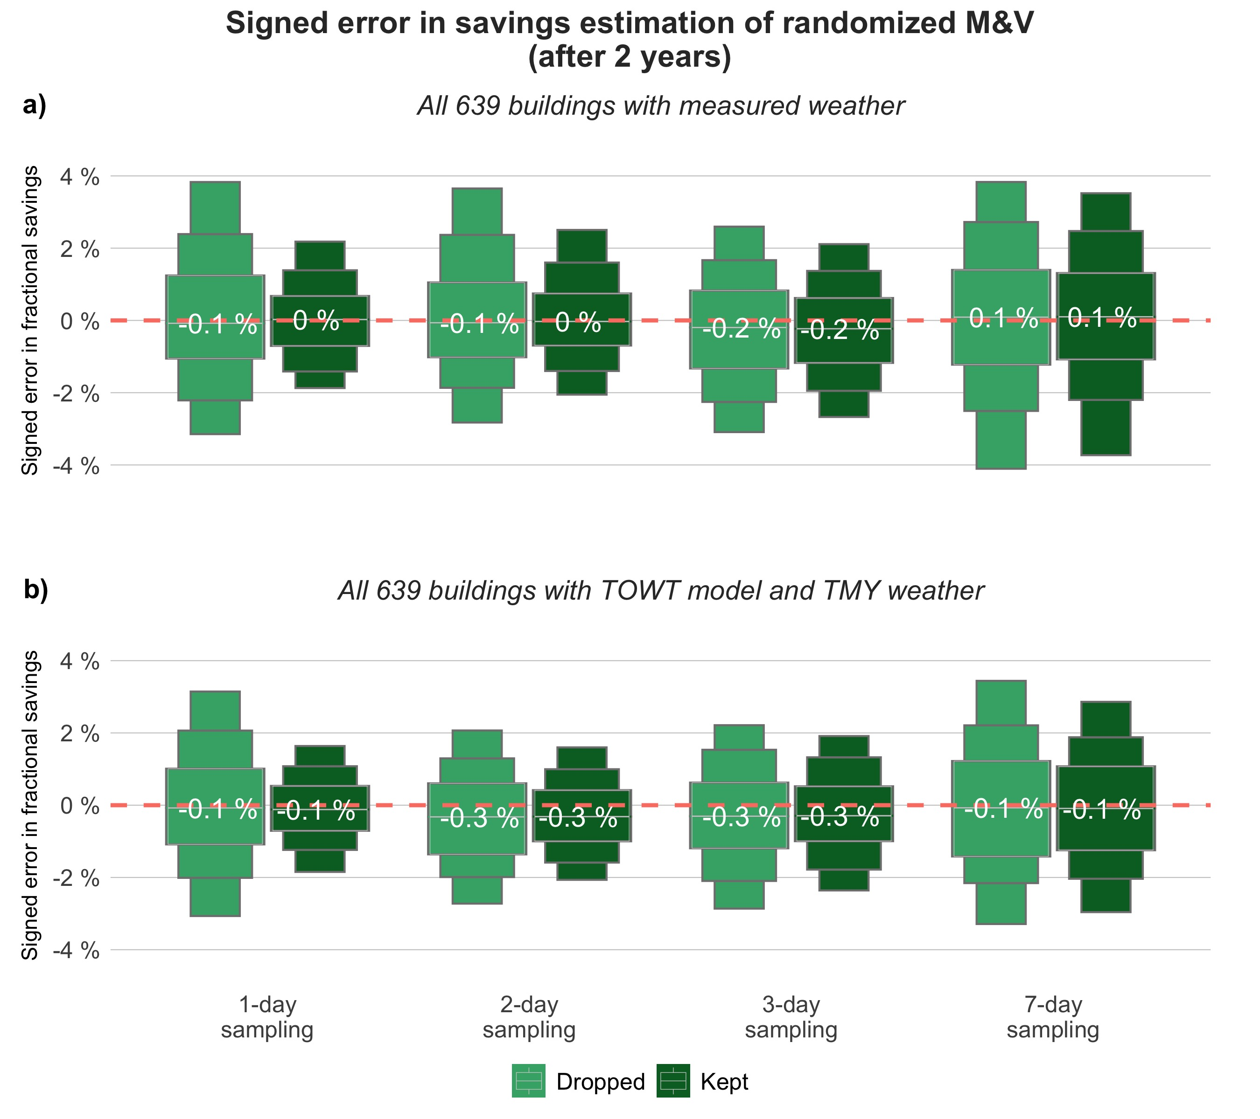

Figure 10: Comparison of different sampling interval impact on M&V estimation accuracy over the course of the two years (without absolute calculation)

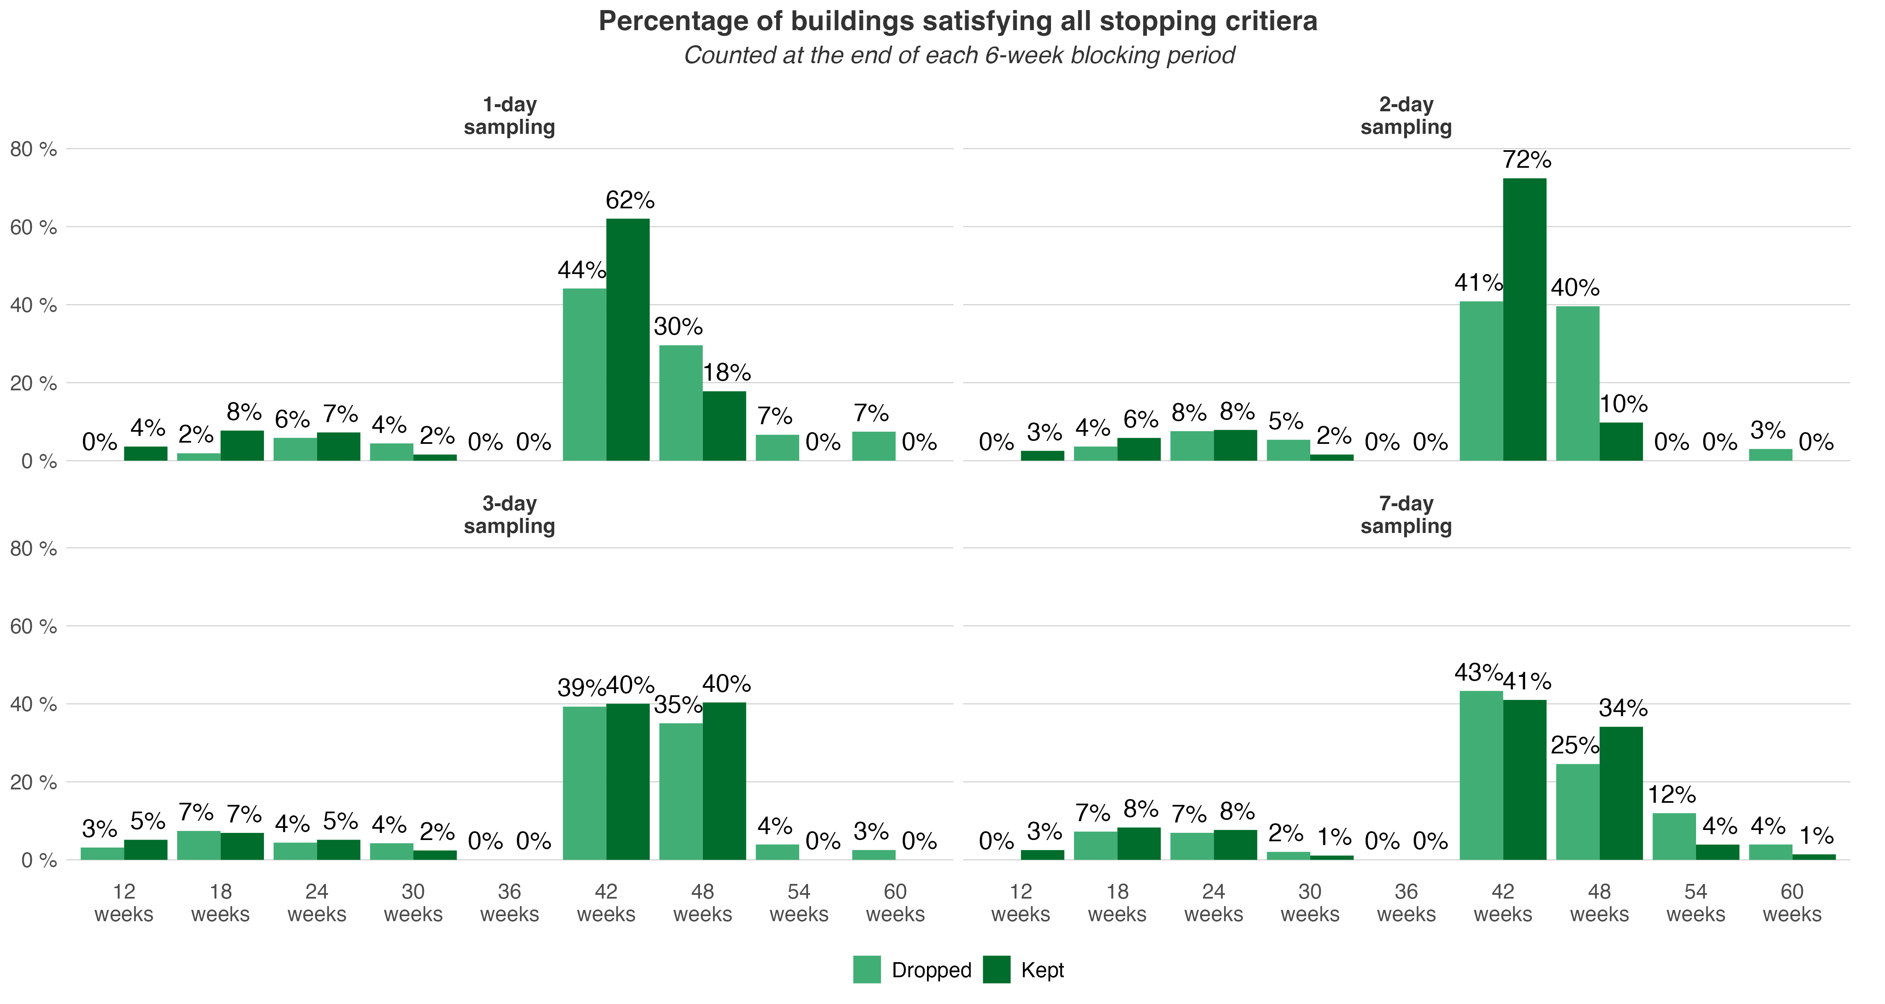

Figure 11: Time required to satisfy all stopping criteria starting from March and using a shorter blocking period of 6 weeks