Example word report

Paul Raftery [1] [2]

2023-08-28

# Abstract

The above heading doesn’t count towards heading numbers. Handy for abstracts, nomenclature, etc. If you want to change the style and formatting of any of the headings you can do so by modifying the Styles in the word template references above, ‘template.docx’.

# 1 First level heading

Here’s how you cite a reference (Raftery et al. 2018). It must be in the bibliography file ‘references.bib’, which is in the bibtex file format and can be automatically output by a citation management software. For example, Zotero.

## 1.1 Second level heading

You can and should perform any short calculations directly in the text. For example, there are 150 rows in the Iris dataset. The mean species length is 5.84333333333333. Anything more substantial should be calculated (and well commented) in a separate code chunk.

The mean species length of the modified iris dataset is 5.86447463744983.

### 1.1.1 Third level heading

Here’s how you cross reference figure 1.1 and here’s how you include a footnote

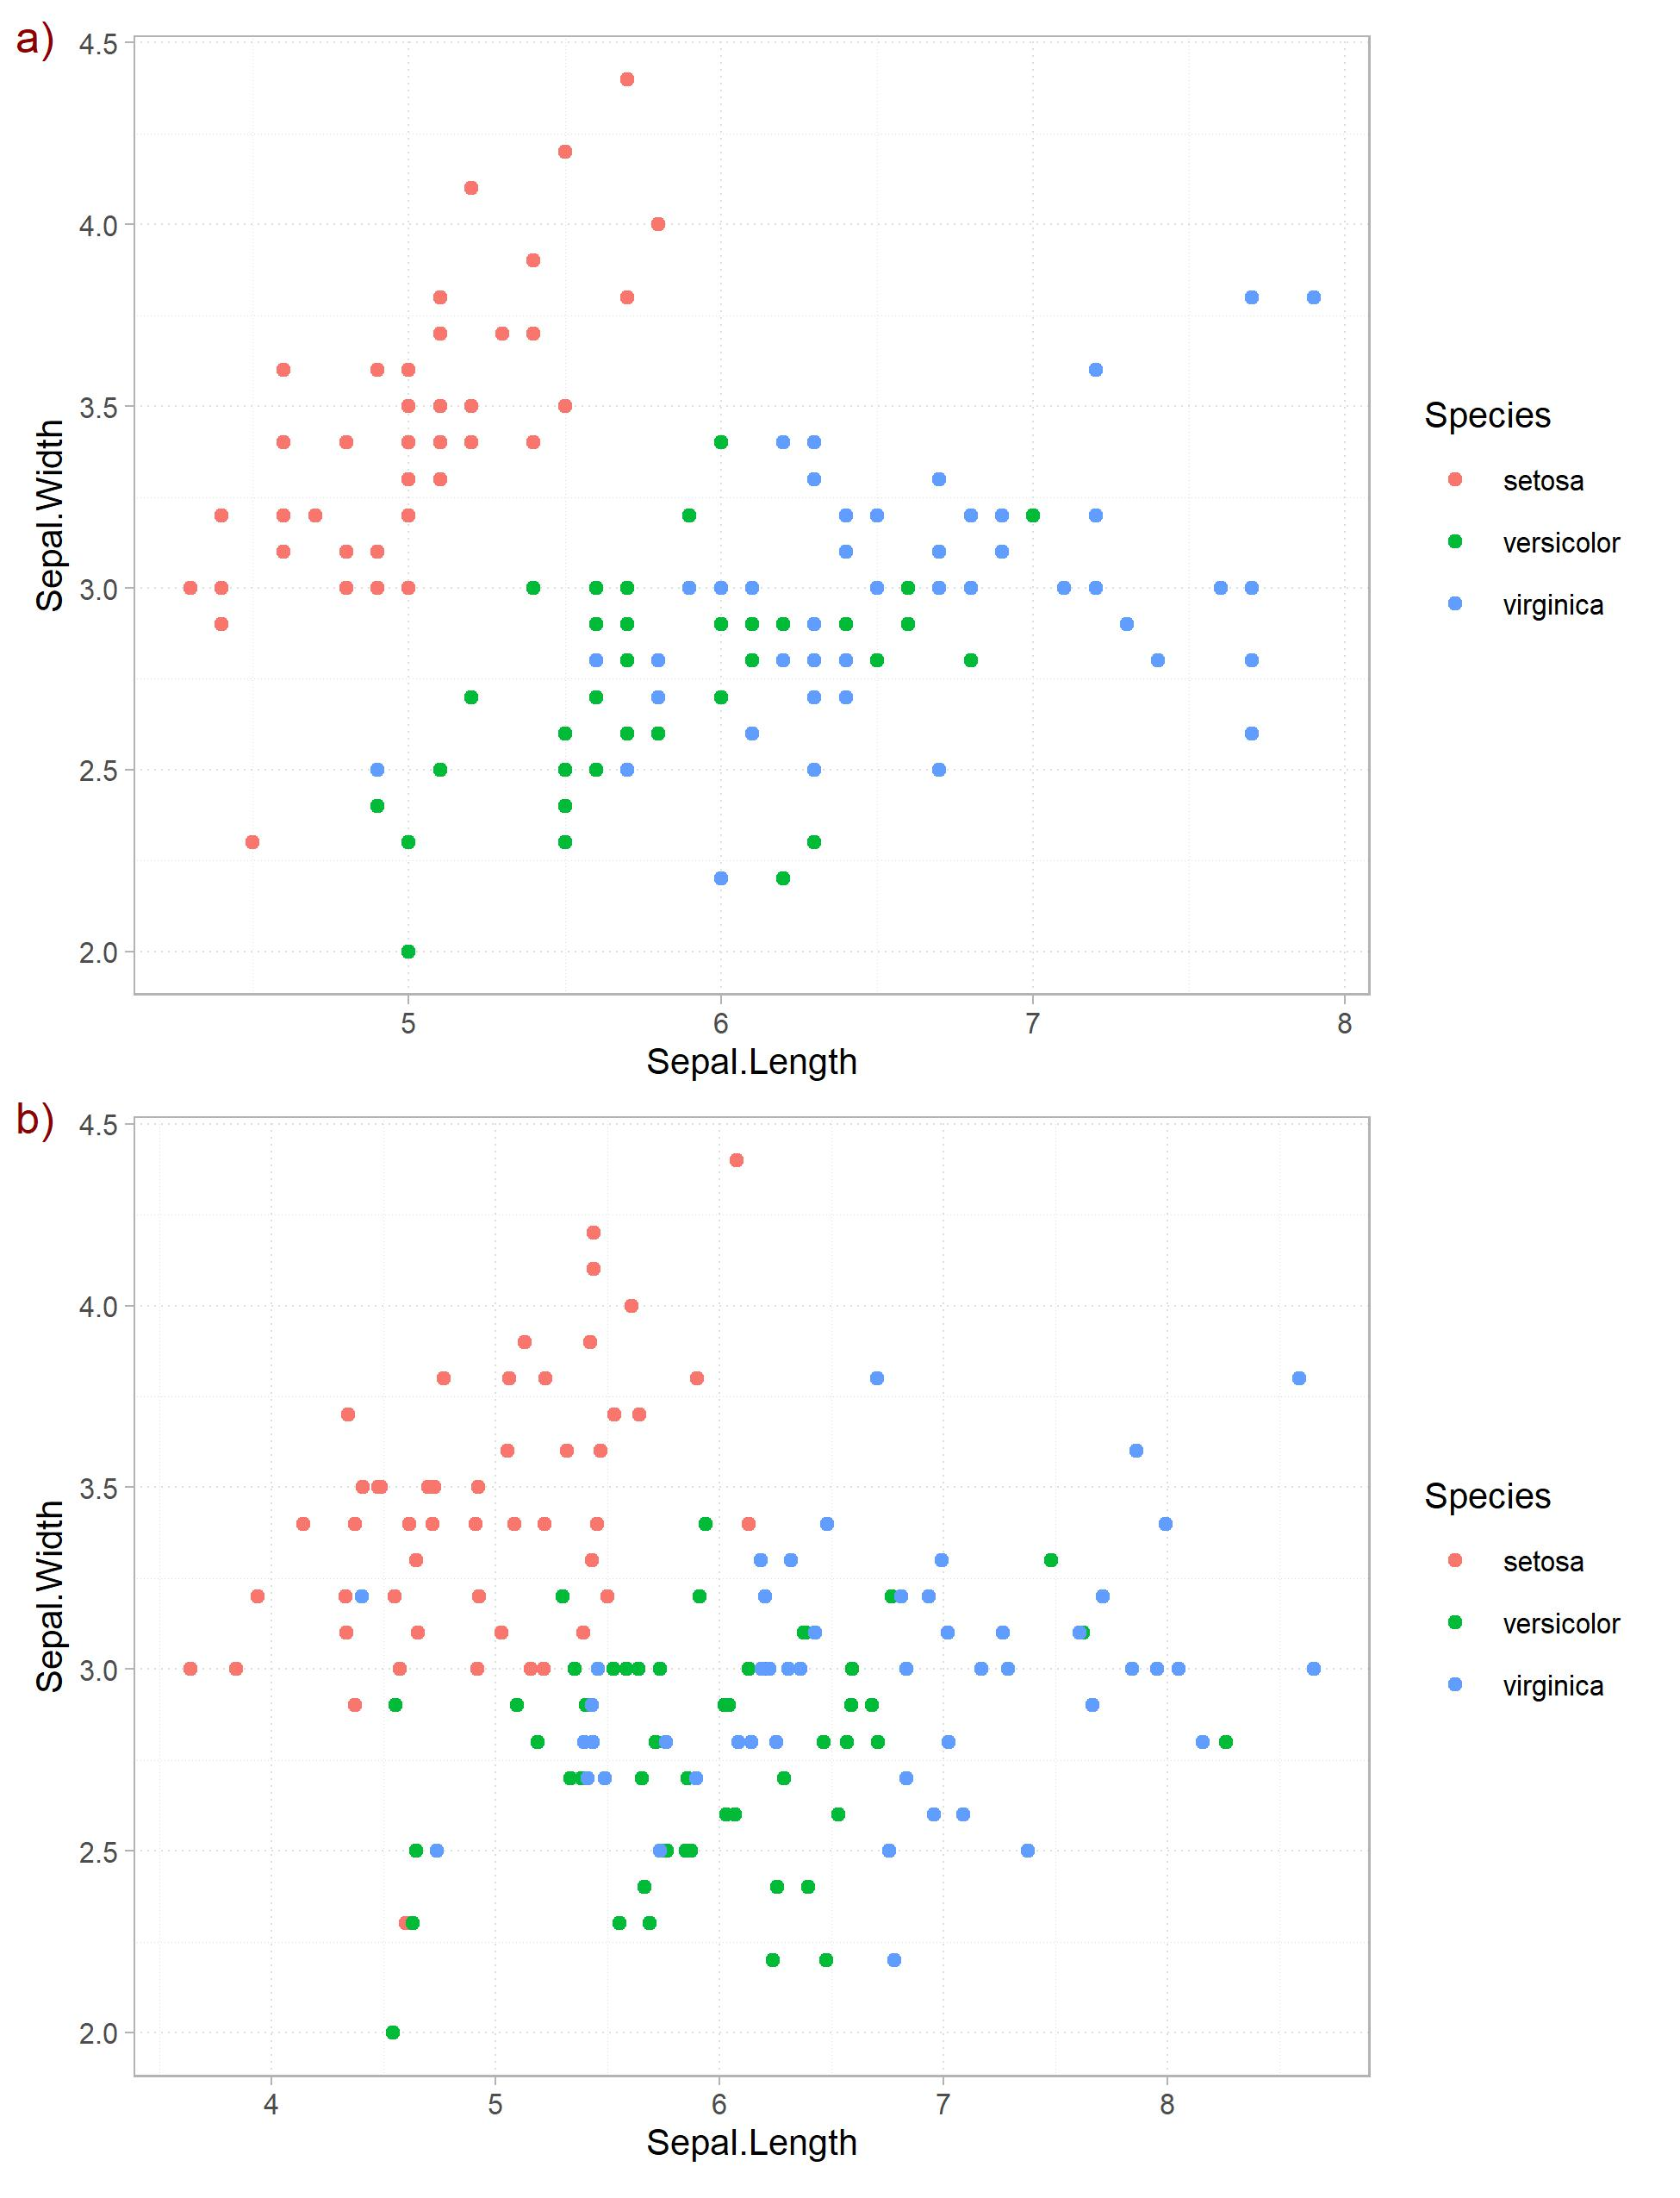

Figure 1.1: Your fig caption here

# References

Raftery, Paul, Angela Geronazzo, Hwakong Cheng, and Gwelen Paliaga. 2018. “Quantifying Energy Losses in Hot Water Reheat Systems.” *Energy and Buildings* 179 (November): 183–99. <https://doi.org/10.1016/j.enbuild.2018.09.020>.

1. Center for the Built Environment, University of California Berkeley, USA
2. Correspondence to [p.raftery@berkeley.edu](mailto:p.raftery@berkeley.edu)