Title of the example word file

Paul Raftery[1] [2], Author2AtSameOrg 1, Author3atDifferentOrg[3]

2024-10-09

# Abstract

The above heading doesn’t count towards heading numbers. This is handy for abstracts, nomenclature, etc. If you want to change the style and formatting of any of the headings in the finished document you can do so by modifying the Styles in the word template referenced above, ‘template.docx.’

# 1 First level heading

This is how you cite a reference [1]. It must be in the bibliography file ‘references.bib,’ which is in the bibtex file format and can be automatically output by a citation management software.

## 1.1 Second level heading

You can and should perform any short calculations directly in the text. For example, there are 150 rows in the Iris dataset. The mean species length is 5.84. Anything more substantial should be calculated (and well commented) in a separate code chunk. Note the number of significant digits is set globally above but can be overwritten as needed, for example that same value to more precision is 5.8433. You can also reduce precision in large values above the decimal where needed, for example, report 58433.33 as 58000.

The mean species length of the modified iris dataset is 5.96.

### 1.1.1 Third level heading

Here’s how you cross reference a figure 1.1, or a table 1.1 or a section. This is how you include a footnote[4].

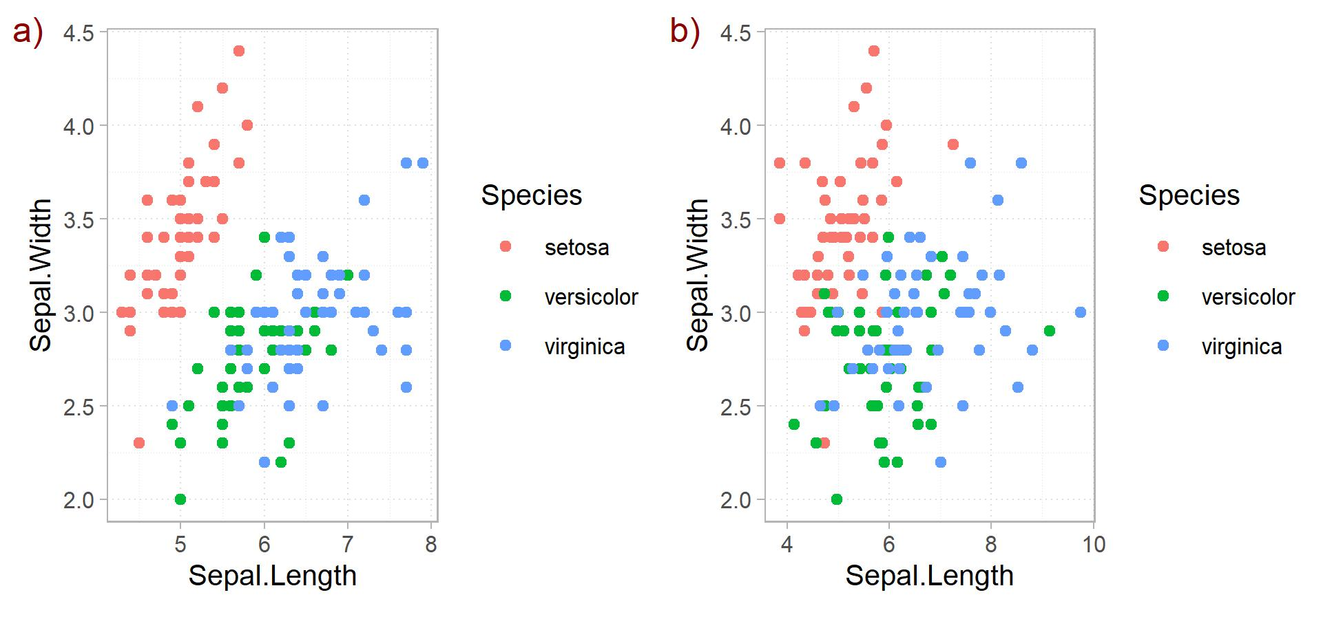

Figure 1.1: Your fig caption here

Table 1.1: Your table caption here

|  | mpg | cyl | disp | hp | drat |
| --- | --- | --- | --- | --- | --- |
| Mazda RX4 | 21 | 6 | 160 | 110 | 3.9 |
| Mazda RX4 Wag | 21 | 6 | 160 | 110 | 3.9 |
| Datsun 710 | 23 | 4 | 108 | 93 | 3.8 |
| Hornet 4 Drive | 21 | 6 | 258 | 110 | 3.1 |
| Hornet Sportabout | 19 | 8 | 360 | 175 | 3.1 |

You can include an equation using LaTeX code, for example see equation (1.1).

$$θ^{*}|L^{*},δ^{2},Y,σ_{u}^{2}∼N\left(B^{−1}W′L^{*},δ^{2}B^{−1}\right) \left(1.1\right)$$

#### 1.1.1.1 Fourth level heading (but don’t use this many)

No need to deal with specifying superscript or subscript as you can just use the relevant unicode symbol directly in either the body text or in code chunks, e.g. ft², m³, CO₂, ½, °C.

# 2 Aiding the review process

Though the output is a formatted Word file, the review process is still a bit clunky. I generally turn on track changes and send to co-authors for review. Then you manually bring those changes back into the .qmd file.  
Sometimes it’s handy to add a comment in the actual Word file output.

# CRediT authorship contribution statement

**Author1Name**: Conceptualization, Data curation, Formal analysis, Funding acquisition, Methodology, Investigation, Project administration, Software, Supervision, Writing - original draft, Writing - review & editing.

# Declaration of competing interest

All authors declare XYZ competing interest. The Center for the Built Environment (CBE) at the University of California, Berkeley, with which one authors is affiliated, is advised and funded in part by many approximately 50 partners that represent a diversity of organizations from the building industry, including manufacturers, building owners, facility managers, contractors, architects, engineers, government agencies, and utilities.

# Acknowledgements

The Funding Agency (Grant: XYZ) and the Center for the Built Environment at the University of California, Berkeley supported this research. Don’t forget to thank any other folks who contributed!

# References

The string used to cite a reference is what’s used to link the Bibtex file (references.bib) to a specific reference. You can use the BetterBibtex plugin within Zotero to automatically create these for your project, and to write the associated .bib file.

[1] P. Raftery, A. Geronazzo, H. Cheng, G. Paliaga, Quantifying energy losses in hot water reheat systems, Energy and Buildings 179 (2018) 183–199. <https://doi.org/10.1016/j.enbuild.2018.09.020>.

1. Center for the Built Environment, University of California Berkeley, USA
2. Correspondence to [p.raftery@berkeley.edu](mailto:p.raftery@berkeley.edu)
3. DifferentOrg
4. Your footnote text goes here. It can go anywhere in the .qmd file but it seems easiest to put it at the end of the paragraph where the footnote is first included.