Novel Randomized M&V Examples

2024-05-22

Table of Contents

# 1 Objective

The purpose of this document is to provide open-source code for analysts who wish to apply the novel measurement and verification (M&V) procedure described in the associated paper to their own projects or datasets. By following the guidance below, users should be able to:

1. Replicate the novel M&V method proposed in the manuscript:
   * Design a randomized and balanced switchback control implementation schedule consisting of a baseline strategy and an intervention strategy,
   * Conduct sequential analysis to infer intervention effect on a target metric (e.g. energy consumption, carbon emissions, or thermal comfort).
2. Demonstrate the reliability of the novel randomized method and compare it with the conventional method under:
   * Scenario A: Discrete non-routine events
   * Scenario B: Continuous baseline change
   * Scenario C: Missing measurements

By replicating the method proposed in the manuscript, we aim to demonstrate that the novel M&V approach can reach a conclusion faster than the standards requirements and provide a robust uncertainty quantification. Additionally, by evaluating savings estimations under various common scenarios, we showcase the reliability of this new method in overcoming the limitations of conventional approaches (e.g. the impact of changes in building performance that are wholely unrelated to the intervention). This example code follows the flowchart depicted in the manuscript and provides a minimal example for demonstration purposes. The analyst should make reasonable adjustments to address their specific use case.

require(pacman)  
  
# load packages using pacman  
pacman::p_load(tidyverse, lubridate, here, rmarkdown,   
 scales, patchwork, magrittr, janitor, qpcR, knitr, # general  
 ggpmisc, # linear regression  
 ggpubr,  
 sjstats, pwr, # anova results  
 nmecr, # m&v modeling package for TOWT  
 slider, # moving averages  
 sprtt, # sequential testing  
 base, blocksdesign, # blocking  
 rstatix, #pipe friendly stats  
 overlapping, # distribution overlapping percentage  
 effsize, bootES, dabestr) #effect size

## package 'cli' successfully unpacked and MD5 sums checked  
## package 'vctrs' successfully unpacked and MD5 sums checked  
## package 'slider' successfully unpacked and MD5 sums checked  
##   
## The downloaded binary packages are in  
## C:\Users\praft\AppData\Local\Temp\RtmpoNLpoE\downloaded_packages

# turn off scientific notation  
options(scipen = 999, digits = 15)  
  
# set directory  
here::i_am("Example.rmd")  
  
# set default theme for ggplot  
theme_set(theme_minimal())  
  
# define base ggplot theme  
theme_update(plot.title = element_text(size = 14, colour = "grey20", face = "bold", hjust = 0.5),  
 plot.subtitle = element_text(size = 10, colour = "grey20", face = "italic", hjust = 0.5, margin = margin(b = 10)),  
 plot.caption = element_text(size = 10, colour = "grey20", face = "italic", hjust = 0.5),  
 plot.background = element_rect(fill = "white", colour = NA),  
 panel.grid.minor = element_blank(),  
 panel.grid.major = element_blank(),  
 axis.text = element_text(size = 10),  
 strip.text = element_text(size = 10, color = "grey20", face = "bold"),  
 strip.background = element_blank())  
  
# define global color theme (from palatte "Set2")  
ls_colours <- c("Baseline" = "#99d8c9",   
 "True baseline" = "#99d8c9",  
 "Biased baseline" = "#1b9e77",  
 "Intervention" = "#fdbb84",  
 "True interv" = "#fdbb84")  
  
# Get case study example data  
readfile_path <- "./readfiles/"  
  
# Load defined functions  
function_path <- "./functions/"

# 2 M&V use case

We apply the same use case described in the manuscript where a software-as-a-service control company offers a more efficient chiller control algorithm. Here, the analyst aims the determine the amount of HVAC energy saved by this control intervention. The overall M&V protocol regarding sampling ratio, carryover effect, blocking design and stopping criteria remain the same as the manuscript. For demonstration purposes, the M&V procedure here does not include an annual saving estimation normalized on typical weather using fitted energy models. Instead, we use the average treatment effect (ATE) by calculating the mean difference between baseline measurements and intervention measurements to estimate the energy-saved by the control algorithm (and normalize using the mean of the baseline measurements to obtain fractional savings).

# 3 Use case measurement dataset

For this demonstration, we simply create a hypothetical baseline and intervention measurement set by considering a linear function including outdoor temperature ($temp$), peak and off-peak hour indicator ($δ_{peak}$, $δ_{off−peak}$) as independent variables:

$$Energy=β_{0}+β_{1}*temp+β_{2}*δ_{peak}+β_{3}*δ_{off−peak}+ϵ$$

The $ϵ$ term accounts for random noise sampled from a normal distribution $N\left(0,{10}^{2}\right)$. The created measurement set for baseline and intervention controls is shown in figure 3.1. If the analyst follows the conventional M&V method described in ASHRAE Guideline 14 (G14) or the International Performance Measurement and Verification Protocol (IPMVP), then only baseline measurements are measurable/observable during the pre-retrofit period and only intervention measurements are measurable during the post-retrofit period. In other words, the control strategy switches between baseline and intervention one time in the entire study period.

# load holidays  
list_holidays <- read_csv(paste0(readfile_path, "us_holidays_2022.csv"),  
 col_names = c("date", "weekday", "holiday")) %>%  
 mutate(date = mdy(date))  
  
# load tmy weather file  
df_tmy <- read_csv(paste0(readfile_path, "USA_IL_Chicago.Midway.Intl.AP.725340_TMY3.epw"),  
 skip = 8, col_types = "ddddd-d---------------------------------",  
 col_names = c("year", "month", "day", "hour", "min", "tmy")) %>%  
 mutate(year = 2022,  
 time = ymd_h(paste(paste(year, month, day, sep = "-"), hour, sep = " ")),  
 temp = tmy) %>%  
 dplyr::select(time, temp)  
  
# load temperature from local weather station  
df_weather <- list.files(path = readfile_path, pattern = str_glue("weather_*"), full.name = TRUE) %>%  
 map_dfr(read_rds) %>%  
 mutate(datetime = with_tz(datetime_UTC, tz = "America/Chicago")) %>%   
 select(c(datetime, t_out)) %>%   
 mutate(across(t_out, ~ zoo::na.approx(., na.rm = FALSE))) %>%  
 filter(datetime >= as.Date("2021-01-01")) %>%   
 filter(datetime < as.Date("2023-01-01")) %>%   
 unique() %>%   
 arrange(datetime)  
  
# Create a sequence of hourly timestamps for one year  
timestamps <- seq(from = as.POSIXct("2021-01-01 00:00:00"),  
 to = as.POSIXct("2022-12-31 23:00:00"),  
 by = "hour")  
  
# Define peak hours (e.g., 12 PM to 6 PM)  
peak_hours <- as.integer(format(timestamps, "%H") %in% c("12", "13", "14", "15", "16", "17"))  
  
# Calculate non-peak hours  
non_peak_hours <- 1 - peak_hours  
  
# Baseline model parameters  
intercept <- 45  
beta_peak <- 20  
beta_temp <- 0.9  
beta_non_peak <- 5  
  
# Compute the energy consumption  
energy_consumption <- intercept +  
 beta_temp * df_weather$t_out +  
 beta_peak * peak_hours +  
 beta_non_peak * non_peak_hours +  
 rnorm(length(timestamps), mean = 0, sd = sqrt(100))  
  
# Create a data frame  
df_base <- data.frame(datetime = timestamps,  
 t_out = df_weather$t_out ,  
 power = energy_consumption)   
  
# Output the first few rows of the dataset  
head(df_base)

## datetime t_out power  
## 1 2021-01-01 00:00:00 -1.66666666666667 37.4624535738062  
## 2 2021-01-01 01:00:00 -1.54000000000000 50.3565798079353  
## 3 2021-01-01 02:00:00 -1.41333333333333 61.5000367844276  
## 4 2021-01-01 03:00:00 -1.28666666666667 56.7288773497163  
## 5 2021-01-01 04:00:00 -1.16000000000000 49.7921983477024  
## 6 2021-01-01 05:00:00 -1.03333333333333 41.7105748869048

# Intervention model parameters  
intercept <- 40  
beta_temp <- 0.5  
beta_peak <- 12  
beta_non_peak <- 10  
  
# Compute the energy consumption  
energy_consumption <- intercept +  
 beta_temp * df_weather$t_out +  
 beta_peak * peak_hours +  
 beta_non_peak * non_peak_hours +  
 rnorm(length(timestamps), mean = 0, sd = sqrt(100))  
  
# Create a data frame  
df_interv <- data.frame(datetime = timestamps,  
 t_out = df_weather$t_out,  
 power = energy_consumption)

df_base %>%   
 rename(Baseline = power,   
 base_t_out = t_out) %>%   
 left_join(df_interv %>% rename(Intervention = power), by = "datetime") %>%   
 pivot_longer(-c(datetime, base_t_out, t_out), names_to = "parameter", values_to = "value") %>%   
 ggplot(aes(x = t_out, y = value, color = parameter)) +  
 geom_point(size = 0.1, alpha = 0.1) +  
 geom_smooth() +  
 scale_x_continuous(expand = c(0, 0),   
 limits = c(-15, 35),  
 breaks = breaks_pretty(n = 5),  
 labels = number_format(suffix = " °C")) +  
 scale_y_continuous(expand = c(0, 0),   
 labels = number_format(suffix = " kW")) +  
 scale_color_manual(values = ls_colours) +  
 labs(x = NULL,   
 y = NULL,  
 color = NULL,   
 title = "Created baseline and intervention measurements") +  
 theme(panel.grid.major.y = element_line(colour = "grey80", size = 0.25),  
 legend.direction = "horizontal",  
 legend.position = "bottom",  
 plot.margin = margin(t = 2, r = 7, b = 2, l = 2, unit = "mm"))

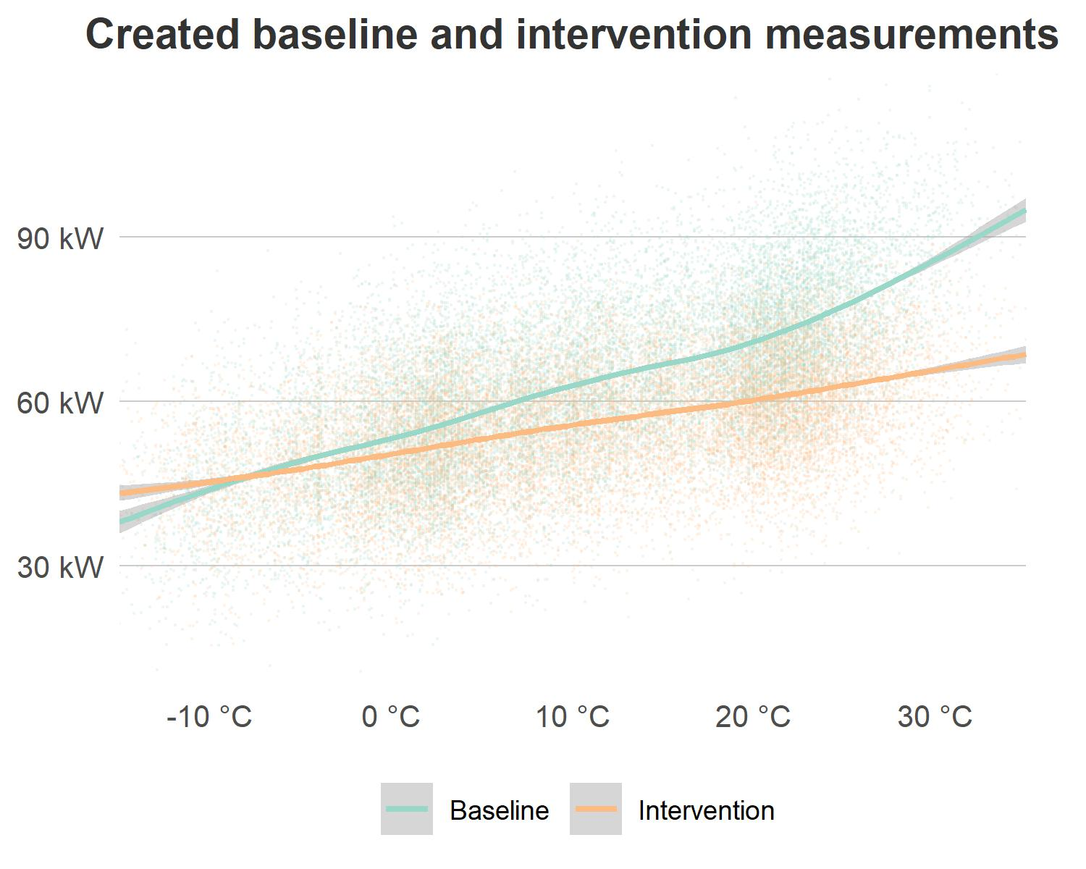

Figure 3.1: Generated hypothetical baseline and intervention measurements using a linear function (data points show hourly energy consumption and line fitted using the loess function).

# 4 Novel randomized M&V analysis

## 4.1 Switchback experimental design

As most control intervention strategies can be implemented interchangeably with the building baseline control, we argue in the paper that randomizing the implementation sequence between intervention and baseline control strategies can balance the impact of confounding variables when estimating the intervention effect, find a result faster, and be more robust to the occurrence of changes in performance that are unrelated to the intervention. A simple way to get started is using a built-in function ’*sample()’* in R package *‘base’* to randomly select at each sampling interval which strategy to implement.

# Define strategies and number of days  
strategies <- c("Base", "Intervention")  
num_weeks <- 12  
days_per_week <- 7  
total_days <- num_weeks * days_per_week  
  
# Randomly assign strategies to each day  
assigned_strategies <- sample(strategies, total_days, replace = TRUE)  
  
# Convert the linear structure into a weekly structure for easier interpretation  
weekly_assignment <- matrix(assigned_strategies, nrow = num_weeks, ncol = days_per_week)  
  
print(weekly_assignment[1, ])

## [1] "Intervention" "Base" "Intervention" "Intervention" "Base"   
## [6] "Base" "Intervention"

In statistics, average treatment effect (ATE) estimation depends on the statistical power of unbiased randomization and balanced sample size. This means to accurately estimate the energy-saving effect of the intervention control strategy, we should design an unbiased randomization that has an equal amount of measurements for each level of confounding variables. Therefore, a simple complete randomization can still be biased, for instance, getting a poor randomization where a the baseline, by chance, is sampled more often on weekends and vice versa. This can be avoided by designing a block randomization, which is a type of experimental design that first divides the testing units into blocks and then randomly assigns which strategy to implement for each unit within each block. Thus in practice, each block type corresponds to one confounding variable, and since strategies are sampled at the block level, this means each confounding variable is covered by all testing strategies. For example, building energy consumption is known to be affected by occupancy, time, and outdoor weather conditions. If the control service company wishes to bill the customer based on the savings solely from the control retrofit itself, the M&V analyst should decompose the measured energy savings and adjust for the influence from mild weather or decreased occupancy. For the example in this document, we assume just two strategies are being tested, over a blocking period of 12 weeks.

To do block design, we usde a function in R called *‘blocks()’* from the *‘blocksdesign’* package. We further bonded other functions and inputs to make the package more versatile and one example is shown below. Once successfully called, the function will return a list consisting of schedule output and schedule summaries. The detailed schedule can be viewed by calling the schedule key name.

source(paste0(function_path, "blocking.R")) # block design schedule generation function  
schedule <- blocking(start_date = "2021-01-01",  
 n_weeks = 48,   
 n_seasons = 4,   
 seed = 390,   
 searches = 20,   
 jumps = 20,   
 treatments = 2,   
 consec = 1)  
  
kable(head(schedule$schedule, n = 14))

| season | date | weekday | strategy |
| --- | --- | --- | --- |
| 1 | 2021-01-01 | Fri | 1 |
| 1 | 2021-01-02 | Sat | 2 |
| 1 | 2021-01-03 | Sun | 1 |
| 1 | 2021-01-04 | Mon | 2 |
| 1 | 2021-01-05 | Tue | 1 |
| 1 | 2021-01-06 | Wed | 1 |
| 1 | 2021-01-07 | Thu | 1 |
| 1 | 2021-01-08 | Fri | 2 |
| 1 | 2021-01-09 | Sat | 1 |
| 1 | 2021-01-10 | Sun | 1 |
| 1 | 2021-01-11 | Mon | 1 |
| 1 | 2021-01-12 | Tue | 1 |
| 1 | 2021-01-13 | Wed | 1 |
| 1 | 2021-01-14 | Thu | 2 |

To check whether the blocking experimental design is balanced, we can call three built-in summary table outputs:

1. Weekday summary: calculates how many days are sampled for each season weekday and strategy combination.
2. Consecutive days summary: calculates how many consecutive days are sampled for each strategy

kable(head(schedule$weekday_summary))

| season | weekday | strategy | n |
| --- | --- | --- | --- |
| 1 | 1 | 1 | 6 |
| 1 | 1 | 2 | 6 |
| 1 | 2 | 1 | 6 |
| 1 | 2 | 2 | 6 |
| 1 | 3 | 1 | 6 |
| 1 | 3 | 2 | 6 |

kable(head(schedule$consec_summary))

| strategy | consecutive |
| --- | --- |
| 1 | 80 |
| 2 | 81 |

## 4.2 Sequential analysis of the intervention effect

This section replicates the sequential analysis described in the manuscript using the newly created measurement dataset. The results are shown in figure 4.1.

# source(paste0(function_path, "saving_pred.R")) # annual saving estimation function  
source(paste0(function_path, "ol_est.R")) # independent variable overlapping calculation  
  
# Combine random sampling  
df_schedule <- data.frame(strategy = schedule$schedule$strategy,  
 datetime = schedule$schedule$date)  
df_base_sch <- df_base %>%   
 left_join(df_schedule, by = "datetime") %>%   
 fill(strategy, .direction = "down") %>%   
 filter(strategy == 1)  
  
df_interv_sch <- df_interv %>%   
 left_join(df_schedule, by = "datetime") %>%   
 fill(strategy, .direction = "down") %>%   
 filter(strategy == 2)  
  
df_hourly <- bind_rows(df_base_sch, df_interv_sch) %>%   
 arrange(datetime)  
  
# make daily totals  
df_daily <- df_hourly %>%  
 group_by(datetime = floor_date(datetime, unit = "day")) %>%  
 summarise(strategy = unique(strategy),  
 power_ave = mean(power, na.rm = TRUE),  
 power_peak = max(power, na.rm = TRUE),  
 t_out = mean(t_out, na.rm = TRUE)) %>%  
 ungroup()

# prepare sequential test dataset  
sprt_hourly <- df_hourly %>%  
 mutate(week = interval(min(datetime), datetime) %>% as.numeric('weeks') %>% floor())  
  
# set analysis parameters  
param_sprt <- list(baseline = "Baseline",  
 strategy = "Intervention",  
 parameter = "power_ave", # choice: power_ave; mmoer; co2  
 label = "power", # choice: power; emissions  
 n_weeks = 60)  
  
# prepare dataframe for analysis  
df_sprt <- df_daily %>%  
 mutate(strategy = as.factor(strategy),  
 strategy = recode_factor(strategy, "1" = "Baseline", "2" = "Intervention")) %>%  
 filter(strategy %in% c(param_sprt$baseline, param_sprt$strategy)) %>%  
 pivot_longer(cols = -c(datetime, strategy),   
 names_to = "parameter",   
 values_to = "value") %>%  
 mutate(week = interval(min(datetime), datetime) %>% as.numeric('weeks') %>% floor(),  
 value = value) %>%  
 filter(str_detect(parameter, param_sprt$parameter)) %>%  
 droplevels()  
  
  
# define list to store weekly means  
df_means <- list()  
  
# calculate weekly means  
for (i in 1:param_sprt$n_weeks) {  
   
 # subset data by week  
 df_means[[i]] <- df_sprt %>%  
 filter(week <= i) %>%  
 group_by(strategy,   
 parameter) %>%  
 summarise(week = i,  
 value_ave = mean(value, na.rm = TRUE),  
 value_sd = sd(value, na.rm = TRUE),   
 .groups = "keep") %>%  
 ungroup()  
  
}  
  
# combine list into df  
df_means <- bind_rows(df_means)  
  
# define lists to store stopping criteria results  
## SPRT results  
sprt_res <- list()  
  
## 80% independent variable  
overlap_base <- list()  
overlap_s2 <- list()  
quantile_tmy <- quantile(df_tmy$temp, na.rm = TRUE, c(0, 0.99))  
  
# do sample  
for (i in 2:param_sprt$n_weeks) {  
   
 # subset data by week  
 df_seq <- df_sprt %>%  
 filter(week <= i) %>%  
 droplevels()  
   
 # Calculate overlapping temperature range  
 overlap_base[[i]] <- tibble("n_weeks" = i,   
 overlap_base = sprt_hourly %>%  
 filter(week <= i & strategy == 1) %>%   
 ol_est(., quantile_tmy))  
   
 overlap_s2[[i]] <- tibble("n_weeks" = i,   
 overlap_s2 = sprt_hourly %>%  
 filter(week <= i & strategy == 2) %>%   
 ol_est(., quantile_tmy))  
  
   
 # do test  
 results_seq <- seq_ttest(x = value ~ strategy,   
 data = df_seq,  
 d = 0.5,   
 power = 0.9,   
 alternative = "less", # greater  
 paired = FALSE,  
 verbose = TRUE)  
   
 # calculate effect size  
 results_ci <- effsize::cohen.d(d = df_seq$value,  
 f = df_seq$strategy,  
 conf.level = 0.90,  
 paired = FALSE,  
 na.rm = TRUE)  
   
 # update user  
 # print(paste0("Calculating effect size for week ", i))  
   
 # bootstrap effect size  
 results_bs <- bootES::bootES(data = df_seq, R = 1000,   
 contrast = c(param_sprt$baseline, param_sprt$strategy),  
 data.col = "value", group.col = "strategy")  
   
 # extract test statistic  
 sprt_res[[i]] <- tibble("n_weeks" = i,   
 "threshold_lower" = exp(results_seq@B_boundary_log),  
 "threshold_upper" = exp(results_seq@A_boundary_log),  
 "statistic" = results_seq@likelihood_ratio,  
 "decision" = results_seq@decision,  
 "cohens_d" = round(results_ci$estimate, digits = 2),  
 "ci_low" = round(results_ci$conf.int[[1]], digits = 2),  
 "ci_high" = round(results_ci$conf.int[[2]], digits = 2),  
 "ns_stat" = round(results_bs$t0, digits = 2),  
 "ns_ci_low" = round(results_bs$bounds[[1]], digits = 2),  
 "ns_ci_high" = round(results_bs$bounds[[2]], digits = 2))  
   
 }   
   
# work out when threshold is reached  
sprt_res <- bind_rows(sprt_res)  
  
sprt_res <- sprt_res %>%  
 mutate(flag = ifelse(str_detect(decision, "accept"), 1, 0))  
  
sprt_overlap_base <- bind_rows(overlap_base) %>%   
 mutate(flag = ifelse(overlap_base >= 0.8, 1, 0),  
 flag = ifelse(flag == lag(flag, 1), 0, flag))  
  
sprt_overlap_s2 <- bind_rows(overlap_s2) %>%   
 mutate(flag = ifelse(overlap_s2 >= 0.8, 1, 0),  
 flag = ifelse(flag == lag(flag, 1), 0, flag))

p2 <- ggplot(sprt_res, aes(x = n_weeks, y = ns_stat)) +  
 geom_ribbon(aes(ymin = ns_ci_low, ymax = ns_ci_high), alpha = 0.5, fill = "#D0E3F1") +  
 geom_line(size = 1.25, colour = "grey20", alpha = 0.4) +  
 geom_text(data = sprt_res[2, ],   
 aes(x = n_weeks, y = ns_ci_high, label = "Upper 90% CI"),  
 position = position_nudge(x = 1),   
 colour = "grey20",   
 size = 2.5,   
 fontface = "italic") +  
 geom_text(data = sprt_res[2, ],   
 aes(x = n_weeks, y = ns_ci_low, label = "Lower 90% CI"),  
 position = position_nudge(x = 1),   
 colour = "grey20",   
 size = 2.5,   
 fontface = "italic") +  
 geom_point(data = sprt_res %>% filter(n_weeks%%12 == 0),   
 size = 8,   
 shape = 16,   
 colour = "#347EB3",   
 alpha = 0.5) +  
 geom_point(data = sprt_res %>% filter(n_weeks%%12 == 0),   
 size = 4,   
 shape = 16,   
 colour = "#347EB3",   
 alpha = 0.9) +  
 geom_text(data = sprt_res %>% filter(n_weeks%%12 == 0),   
 aes(x = n_weeks, y = ns_stat, label = paste0(round(ns_stat, 1L), " kW")),   
 position = position_nudge(x = 2.5),   
 colour = "grey20",   
 size = 3.0,   
 fontface = "italic") +  
 geom_errorbar(data = sprt_res %>% filter(n_weeks%%12 == 0),   
 aes(x = n_weeks, ymin = ns_ci_low, ymax = ns_ci_high),   
 width = 1,   
 colour = "#347EB3",   
 alpha = 0.5,   
 size = 0.8) +  
 geom_text(data = sprt_res %>% filter(n_weeks%%12 == 0),   
 aes(x = n_weeks, y = ns_ci_high, label = paste0(round(ns_ci_high, 1L), " kW")),   
 position = position_nudge(x = 2.5),   
 colour = "grey20",   
 size = 2.5,   
 fontface = "italic") +  
 geom_text(data = sprt_res %>% filter(n_weeks%%12 == 0),   
 aes(x = n_weeks, y = ns_ci_low, label = paste0(round(ns_ci_low, 1L), " kW")),   
 position = position_nudge(x = 2.5),   
 colour = "grey20",   
 size = 2.5,   
 fontface = "italic") +  
 geom_text(data = sprt_res %>% filter(n_weeks%%12 == 0 & flag == 1),  
 aes(x = n_weeks, y = -15, label = "Difference\nfound"),   
 colour = "grey20",   
 size = 3.0,   
 fontface = "italic") +  
 geom_text(data = slice_tail(sprt_res, n = 1),   
 aes(x = n_weeks, y = ns_stat, label = paste0(round(ns_stat, 1L), " kW")),   
 position = position_nudge(x = 0.5),   
 colour = "grey20",   
 size = 3.0,   
 check_overlap = TRUE,   
 hjust = 0) +  
 geom_text(data = slice_tail(sprt_res, n = 1),   
 aes(x = ifelse(is.na(first(flag)), 0, n_weeks),   
 y = ns_ci_high,   
 label = ifelse(is.na(first(flag)), NULL, paste0(round(ns_ci_high, 1L), " kW"))),   
 position = position_nudge(x = 0.5),   
 colour = "grey20",   
 size = 2.5,   
 check_overlap = TRUE,   
 hjust = 0) +  
 geom_text(data = slice_tail(sprt_res, n = 1),   
 aes(x = ifelse(is.na(first(flag)), 0, n_weeks),   
 y = ns_ci_low,   
 label = ifelse(is.na(first(flag)), NULL, paste0(round(ns_ci_low, 1L), " kW"))),   
 position = position_nudge(x = 0.5),   
 colour = "grey20",   
 size = 2.5,   
 check_overlap = TRUE,   
 hjust = 0) +  
 geom_vline(xintercept = seq(0, 50, by = 15),   
 linetype = "dashed",   
 color = "grey20",   
 alpha = 0.3,   
 size = 0.5) +  
 annotate(geom = "text",   
 x = seq(5, 50, by = 12),   
 y = 2.5,   
 label = paste0("12-week block"),   
 alpha = 0.5,   
 size = 3) +  
 scale_x_continuous(expand = c(0, 0),   
 limits = c(1, param_sprt$n_weeks + 0.5),  
 labels = number_format(accuracy = 1L, suffix = "\nweeks")) +  
 scale_y_continuous(expand = c(0, 0),   
 limits = c(-15, 2.5),  
 breaks = pretty_breaks(n = 3),  
 labels = number_format(suffix = " kW")) +  
 labs(title = NULL,   
 subtitle = "SPRT results and estimated difference in power consumption without weather normalization",  
 x = NULL,   
 y = NULL) +  
 guides(alpha = "none") +  
 coord_cartesian(clip = "off") +  
 theme(panel.grid.major.y = element_line(colour = "grey80", size = 0.25),  
 axis.text.x = element_blank(),  
 plot.margin = margin(3, 15, 3, 3, unit = "mm"))  
  
p4 <- ggplot(sprt_overlap_base) +  
 geom_line(aes(x = n_weeks, y = overlap_base, color = "Baseline"),   
 size = 1.25) +  
 geom_line(data = sprt_overlap_s2,   
 aes(x = n_weeks, y = overlap_s2, color = "Intervention"),  
 size = 1.25) +  
 geom_text(data = sprt_overlap_base[nrow(sprt_overlap_base), ],  
 aes(x = n_weeks, y = 0.8, label = "80% of\nTMY range\nthreshold"),  
 position = position_nudge(x = 0.5),   
 color = "red",   
 size = 3.0,  
 check_overlap = TRUE,  
 hjust = 0) +  
 geom_hline(yintercept = 0.8, linetype = "dashed", color = "red") +  
 scale_color_manual(values = ls_colours) +  
 scale_x_continuous(expand = c(0, 0),   
 limits = c(1, param_sprt$n_weeks + 0.5),  
 labels = number_format(accuracy = 1L, suffix = "\nweeks")) +  
 scale_y_continuous(breaks = seq(0.2, 1.0, by = 0.2),   
 labels = c("20%", "40%", "60%", "80%", "100%")) +  
 labs(title = NULL,   
 subtitle = "Confounding variable (outdoor drybulb temperature) range coverage",  
 x = NULL,   
 y = NULL) +  
 coord_cartesian(clip = "off") +  
 theme(panel.grid.major.y = element_line(),  
 legend.position = "none",  
 plot.margin = margin(3, 15, 3, 3, unit = "mm"))  
  
# do running mean plot  
p1 <- ggplot(df_means, aes(x = week, y = value_ave)) +  
 geom_line(aes(colour = strategy), size = 1.25) +  
 geom_text(data = filter(df_means,   
 week == param_sprt$n_weeks,   
 parameter == param_sprt$parameter),   
 aes(x = param_sprt$n_weeks,   
 y = value_ave,   
 colour = strategy,   
 label = strategy),   
 position = position_nudge(x = 0.5),   
 size = 3.0,   
 check_overlap = TRUE,   
 hjust = 0) +  
 scale_x_continuous(expand = c(0, 0),   
 limits = c(1, param_sprt$n_weeks + 0.5)) +  
 scale_y_continuous(expand = c(0, 0),   
 breaks = breaks_pretty(n = 4),  
 labels = number_format(suffix = " kW")) +  
 scale_color_manual(values = ls_colours) +  
 labs(title = NULL,   
 subtitle = "Running average power consumption of the case study building",  
 x = NULL,   
 y = NULL) +  
 guides(alpha = "none", colour = "none") +  
 coord_cartesian(clip = "off") +  
 theme(panel.grid.major.y = element_line(colour = "grey80", size = 0.25),  
 axis.text.x = element_blank(),  
 plot.margin = margin(3, 15, 3, 3, unit = "mm"))  
  
  
# Overall result  
p1 / p2 / p4 +  
 plot_annotation(title = "Overall sequential evaluation results using pre-defined stopping criteria") +  
 plot_annotation(tag_levels = c('a'), tag_suffix = ')') &  
 theme(plot.tag.position = c(0, 1),  
 plot.tag = element_text(color="black"))

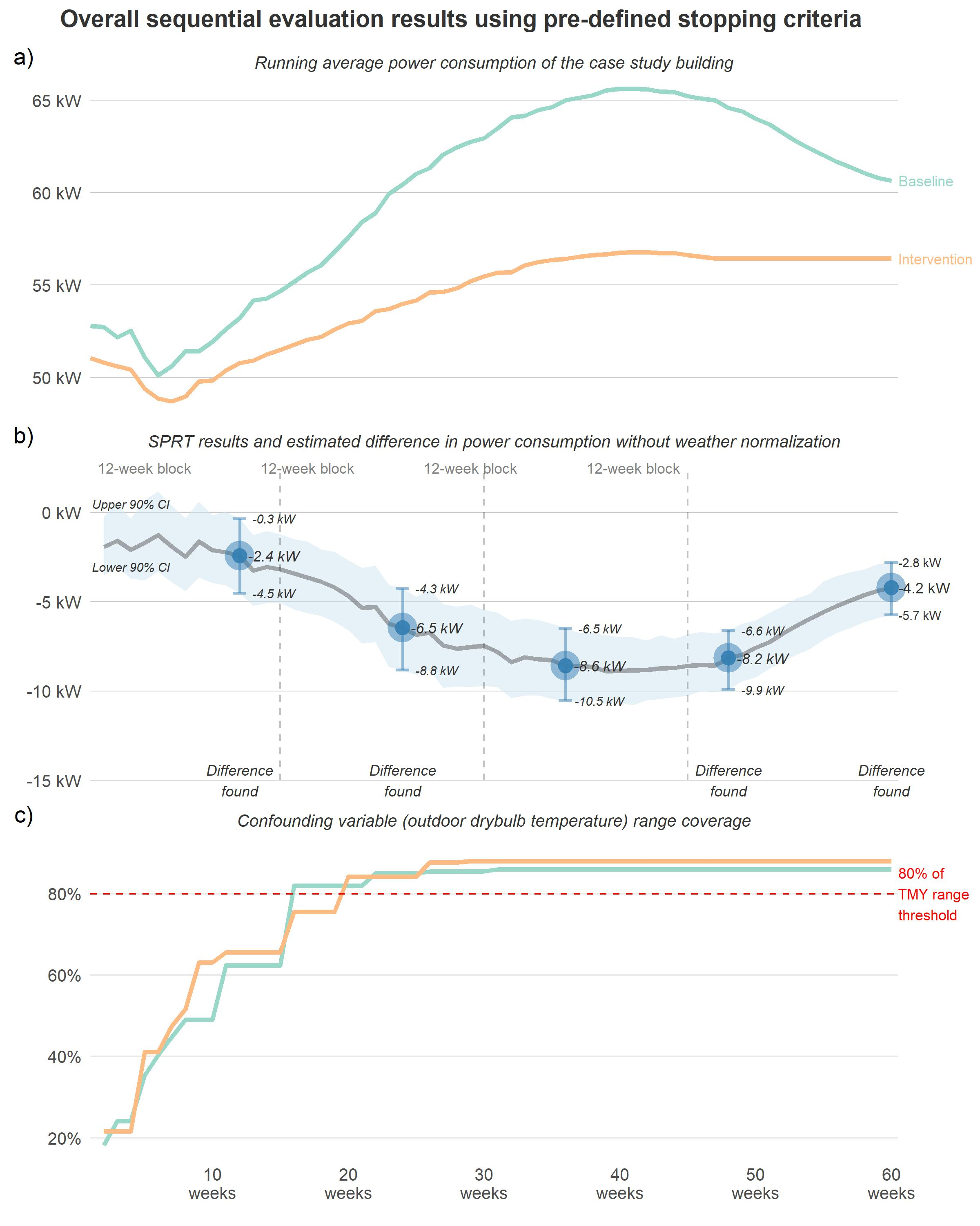

Figure 4.1: Comprehensive results summary of the proposed M&V method applied to the case study throughout a total of 60 weeks

As figure 4.1 indicates, the running average of power consumption shows more savings from the intervention strategy during warmer outdoor weather in general. This also corresponds to the SPRT results shown in the middle of the plot. The difference between baseline measurements and intervention measurements was detected early in week 12. However, since outdoor weather has not reached the 80% threshold range of the typical weather, we need to continue the M&V. Around week 25, the temperature measured in sampled intervention days covered 80% of its typical range and we report a 9 kW savings at the end of this blocking period (i.e. week 30). If this is a real project, and the analyst follows the steps outlined in the standards, week 30 is around the mid-point of baseline collection assuming no interruptions or delays. If the analyst applies the novel randomized M&V and the building owner or the control service company wishes to keep sampling to week 60, the estimated energy savings can be detected with a further decreased uncertainty range indicated by the bandwidth of the blue ribbon in the SPRT plot.

# 5 Comparison between conventional M&V method

In this section, we demonstrate how random sampling between baseline and intervention strategy is more reliable than the conventional M&V method. Building performance frequently changes in response to changes in how the building is occupied or operated. The changes - those that are unrelated to the intervention being evaluated - cause the savings estimate to be less accurate, even if the modeling accuracy satisfies the minimum requirements from the standards. Sampling randomly, and frequently, throughout the entire distribution reduces the impact of these events on the reliability of the savings estimate. We highlight this by exploring three different scenarios.

## 5.1 Scenario A: A discrete non-routine event

One common and typical non-routine event in an energy-saving M&V project isa change in occupancy, or a substantial change in occupant behavior. This is because occupancy has a substantial influence on building energy consumption but is not related to the purpose of testing the intervention control. In reality, it is unusal to have occupancy measurements (compared to other independent variables such as outdoor temperature and therefore) when a analyst fits a regression model (e.g. TOWT), thus, the analyst normally assumes that occupancy remains unchanged throughout the study. ASHRAE G14 and IPMVP only require the analyst to check for the coefficient of the variation of the root mean square error (CVRMSE) and normalized mean square error (NMSE) of a fitted baseline model. Thus, if occupancy changes after the retrofit implementation, the analyst can still obtain an ‘accurate’ baseline model with qualified CV(RMSE) but it is biased due to the unrelated change event being overlooked. The novel M&V method, on the other hand, resolves this by sampling randomly and frequently throughout the full distribution of occupancy over the full study period.

Consider a scenario (Scenario A), where one tenant in a high rise office building moves out during the M&V study period, vacating one floor of the building. We expect the impact of non-routine events such as these to be balanced in sampled baseline days and intervention days if we sample randomly with equal probability. This means if occupancy is notably different over say, a 4 week period, the randomized M&V will sample approximately 2 weeks with baseline strategy and 2 weeks with intervention strategy. Therefore, the energy savings can still represent the intervention’s true effect. Under conventional M&V, either the baseline or the intervention estimate will be affected by this difference in occupancy.

To illustrate one example of this scenario, we model a simplified situation where the 12-month baseline occurs under stable occupancy, and after the retrofit implementation, the energy consumption increased by 10 kW for each metered interval from April to September because of increased occupancy (e.g. temporary stay for visiting purpose) and that the analyst was not aware of this change in occupancy.

# Generate schedule for the post-intervention period  
schedule <- blocking(start_date = "2022-01-01",  
 n_weeks = 48,   
 n_seasons = 4,   
 seed = 390,   
 searches = 20,   
 jumps = 20,   
 treatments = 2,   
 consec = 1)  
  
df_schedule <- data.frame(strategy = schedule$schedule$strategy,  
 datetime = schedule$schedule$date)  
  
df_base_sch <- df_base %>%   
 left_join(df_schedule, by = "datetime") %>%   
 fill(strategy, .direction = "down") %>%  
 filter(datetime >= as.Date("2022-01-01"))   
  
df_interv_sch <- df_interv %>%   
 left_join(df_schedule, by = "datetime") %>%   
 fill(strategy, .direction = "down") %>%  
 filter(datetime >= as.Date("2022-01-01"))   
  
# Apply occupancy changes  
df_base_alt <- df_base_sch %>%  
 mutate(power = ifelse(month(datetime) >= 4 & month(datetime) < 10, power + 10, power))  
  
df_interv_alt <- df_interv_sch %>%   
 mutate(power = ifelse(month(datetime) >= 4 & month(datetime) < 10, power + 10, power))  
  
df_hourly_sch <- bind_rows(df_base_alt %>% filter(strategy == 1), df_interv_alt %>% filter(strategy == 2)) %>%   
 arrange(datetime) %>%   
 mutate(power = ifelse(month(datetime) >= 4 & month(datetime) < 10, power + 10, power))

# Visualization  
ggplot() +  
 geom_point(data = df_base_sch, aes(x = datetime, y = power, color = "Biased baseline"), size = 0.2, alpha = 0.1) +  
 geom_smooth(data = df_base_sch, aes(x = datetime, y = power, color = "Biased baseline")) +  
 geom_point(data = df_base_alt, aes(x = datetime, y = power, color = "True baseline"), size = 0.2, alpha = 0.1) +  
 geom_smooth(data = df_base_alt, aes(x = datetime, y = power, color = "True baseline")) +  
 geom_point(data = df_interv_alt, aes(x = datetime, y = power, color = "True interv"), size = 0.2, alpha = 0.1) +  
 geom_smooth(data = df_interv_alt, aes(x = datetime, y = power, color = "True interv")) +  
 scale_x_datetime(date_breaks = "2 months",  
 date_labels = "%b") +  
 scale_y_continuous(expand = c(0, 0),   
 labels = number_format(suffix = " kW")) +  
 scale_color_manual(values = ls_colours) +  
 labs(x = NULL,   
 y = NULL,  
 color = NULL,   
 title = "Energy measurements in the post-retrofit period") +  
 theme(panel.grid.major.y = element_line(colour = "grey80", size = 0.25),  
 legend.direction = "horizontal",  
 legend.position = "bottom",  
 plot.margin = margin(t = 2, r = 7, b = 2, l = 2, unit = "mm"))

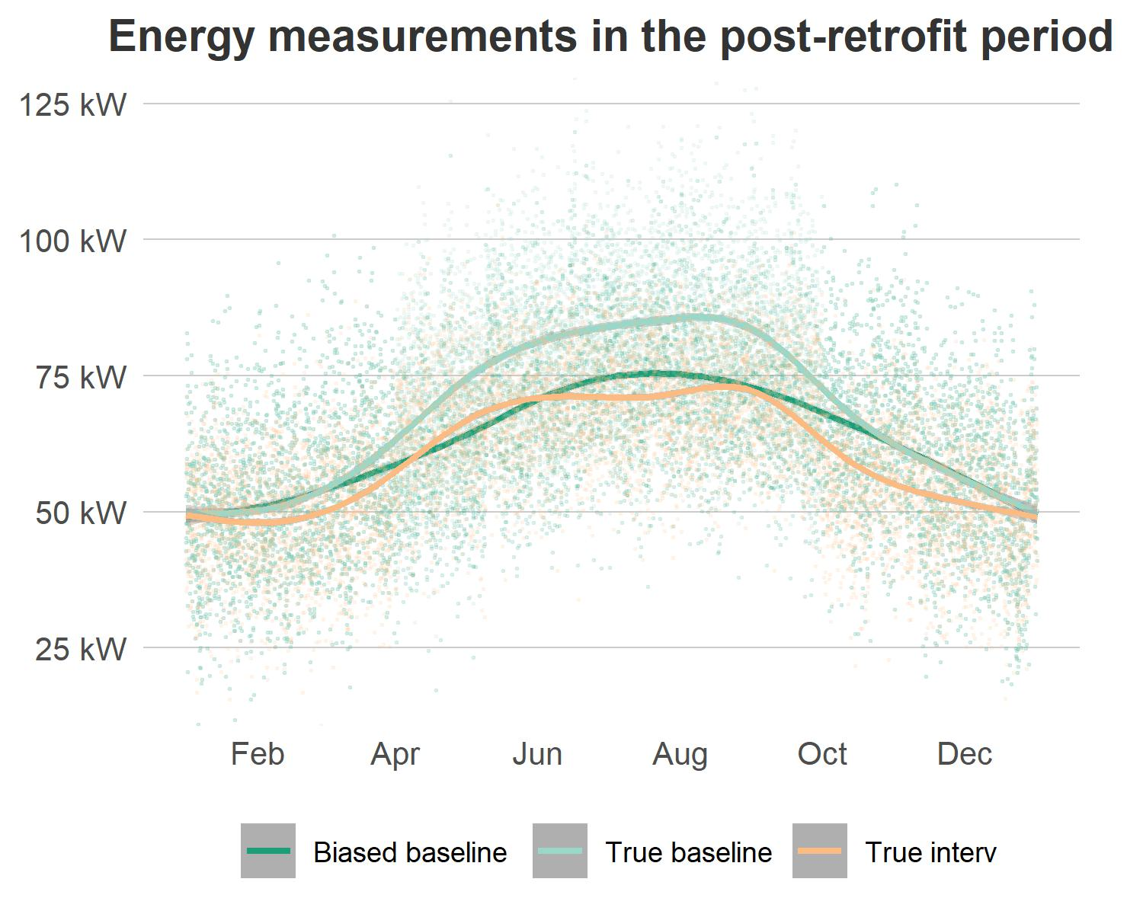

Figure 5.1: Simulated baseline and intervention energy under a discrete non-routine event (Biased baseline indicates analyst’s estimation without prior knowledge about the increase in occupancy. The true baseline and true intervention include the impact of occupancy increase).

If the analyst follows the steps described in G14 and IPMVP, they would start baseline measurements 12 months prior to the control retrofit implementation and fit an outdoor weather and time-dependent regression model using collected metered data as the baseline. Then the building manager enables the intervention control in the Building Automation System (BAS) and configures the existing baseline control as a backup when the intervention fails for safekeeping. Figure 5.1 shows what happens after implementing the intervention, there is a 10 kW increase in HVAC power output due to a higher occupancy in the case study building. The biased baseline represents the analyst’s estimation of the projected baseline in the post-retrofit period using modeling results. The figure shows from April to September, it deviates from the true baseline. Although the analyst has accurate intervention measurements, the savings calculated as the difference in mean values between baseline and intervention are underestimated by the conventional method.

As a comparison, if the analyst follows the steps of the novel randomized M&V described in the manuscript, they would configure both control strategies in the BAS and switch back and forth between them depending on the pre-determined schedule. Even though the analyst has no prior knowledge about the energy consumption increase due to a higher occupancy over that 6 month period, there is a decent chance that each control strategy has sampled 3 months with a balanced day-of-week category. Therefore, the savings calculated as the difference-in-mean are far less biased by the non-routine events. The results shown in figure 5.2 demonstrate that the conventional pre-/post- method is likely to provide unreliable effect estimation if the analyst can not adjust for non-routine events, but the novel randomized method is robust and requires no additional assumptions or modeling effort.

# saving calculation  
FS_true <- (sum(df_base_alt %>% .$power) - sum(df_interv_alt %>% .$power)) / (sum(df_base_alt %>% .$power)) * 100  
  
FS_new <- (mean(df_hourly_sch %>% filter(strategy == 1) %>% .$power) - mean(df_hourly_sch %>% filter(strategy == 2) %>% .$power)) / (mean(df_hourly_sch %>% filter(strategy == 1) %>% .$power)) * 100  
  
FS_conv <- (sum(df_base_sch %>% .$power) - sum(df_interv_alt %>% .$power)) / (sum(df_base_sch %>% .$power)) * 100  
  
df_FS <- data.frame(  
 values = c(FS_true, FS_conv, FS_new),  
 category = factor(c("True", "Conventional M&V", "Randomized M&V"), levels = c("True", "Conventional M&V", "Randomized M&V"))  
)  
  
df_FS %>%   
 ggplot() +  
 geom_col(aes(x = category, y = values),   
 alpha = 0.6,   
 position = "identity") +  
 geom_text(aes(x = category, y = values, label = paste0(round(values, digits = 1), "%")),   
 position = position_nudge(y = -0.5),  
 size = 4) +  
 scale_y_continuous(expand = c(0, 0),   
 label = number_format(suffix = "%")) +  
 labs(title = "Estimated fractional savings\nby different methods",   
 x = NULL,   
 y = NULL) +  
 theme(legend.direction = "horizontal",  
 legend.position = "bottom",  
 plot.margin = margin(t = 2, r = 7, b = 2, l = 2, unit = "mm"))

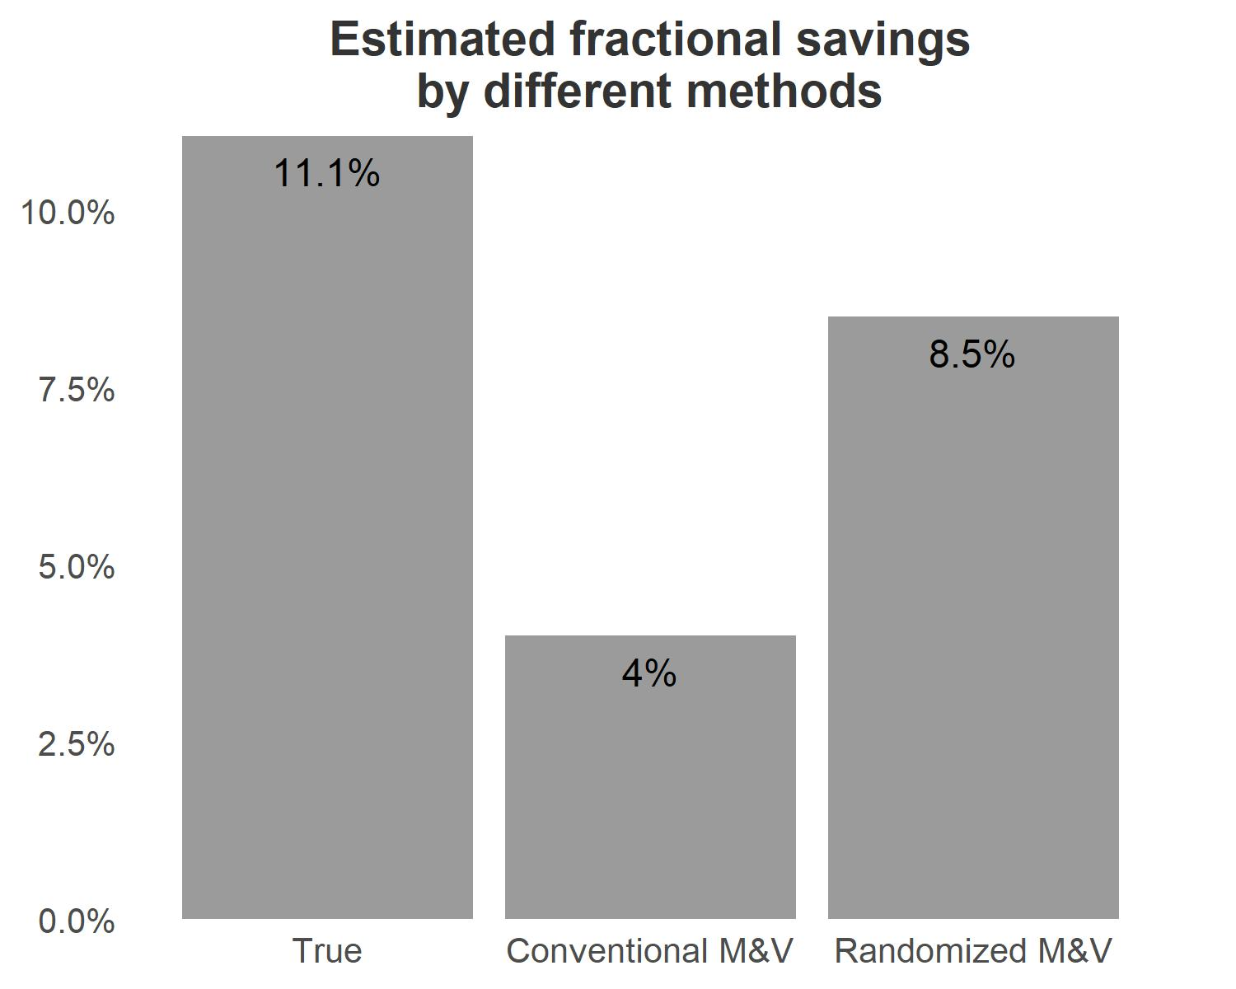

Figure 5.2: Comparison of savings estimation between conventional method and novel method proposed in the paper.

## 5.2 Scenario B: Continuous baseline change due to HVAC component degradation

A baseline can also change continuously over time, which makes it even harder to detect. One example is filter being gradually loaded in a AHU, increasing fan power due to increased static pressure to overcome the increased resistance of air passing through the filter. In this scenario, if the building manager changes the air filter before starting the M&V and the analyst chooses to use the conventional pre-/post-type analysis, the energy measured 12 months later in the post-retrofit period should correspond to a higher baseline due to increased fan energy as the particle accumulates in the filter. Here, the conventional M&V method will underestimate the intervention energy-saving effect. If the analyst chooses to use the novel random sampling M&V, the change in baseline can be documented in sampled baseline measurements.

In this scenario, we simulated a situation where the fan power gradually increased due to accumulated particles in the filter. We assume the fan power accounts for 25% of the HVAC electricity consumption and due to clogging, static pressure increases gradually by 30% over the course of the study period. The relationship between fan power and static pressure can be roughly estimated as $P∼ Q^{3}*ΔP$, which means the fan power would also increase from 100% to 120%. We demonstrate such increase is omitted by the conventional method in the post-retrofit period where only the control intervention is measured.

# Generate schedule for the post-intervention period  
schedule <- blocking(start_date = "2022-01-01",  
 n_weeks = 48,   
 n_seasons = 4,   
 seed = 390,   
 searches = 20,   
 jumps = 20,   
 treatments = 2,   
 consec = 1)  
  
df_schedule <- data.frame(strategy = schedule$schedule$strategy,  
 datetime = schedule$schedule$date)  
  
  
df_base_sch <- df_base %>%   
 filter(datetime >= as.Date("2022-01-01"))  
  
df_interv_sch <- df_interv %>%   
 filter(datetime >= as.Date("2022-01-01"))

gradi_week <- 1 / 48  
df_base_alt <- df_base_sch %>%  
 mutate(week = interval(min(datetime), datetime) %>% as.numeric('weeks') %>% floor()) %>%  
 mutate(ratio = gradi_week * week) %>%  
 mutate(delta_fan = power * 0.25 * 0.3 * ratio) %>%  
 mutate(power = power + delta_fan)  
  
df_interv_alt <- df_interv_sch %>%  
 mutate(week = interval(min(datetime), datetime) %>% as.numeric('weeks') %>% floor()) %>%  
 mutate(ratio = gradi_week * week) %>%  
 mutate(delta_fan = power * 0.25 * 0.3 * ratio) %>%  
 mutate(power = power + delta_fan)  
  
ggplot() +  
 geom_point(data = df_base_sch, aes(x = datetime, y = power, color = "Biased baseline"), size = 0.2, alpha = 0.1) +  
 geom_smooth(data = df_base_sch, aes(x = datetime, y = power, color = "Biased baseline")) +  
 geom_point(data = df_base_alt, aes(x = datetime, y = power, color = "True baseline"), size = 0.2, alpha = 0.1) +  
 geom_smooth(data = df_base_alt, aes(x = datetime, y = power, color = "True baseline")) +  
 geom_point(data = df_interv_alt, aes(x = datetime, y = power, color = "True interv"), size = 0.2, alpha = 0.1) +  
 geom_smooth(data = df_interv_alt, aes(x = datetime, y = power, color = "True interv")) +  
 scale_x_datetime(date_breaks = "2 months",  
 date_labels = "%b") +  
 scale_y_continuous(expand = c(0, 0),   
 labels = number_format(suffix = " kW")) +  
 scale_color_manual(values = ls_colours) +  
 labs(x = NULL,   
 y = NULL,  
 color = NULL,   
 title = "Energy measurements in the post-retrofit period") +  
 theme(legend.direction = "horizontal",  
 legend.position = "bottom",  
 plot.margin = margin(t = 2, r = 7, b = 2, l = 2, unit = "mm"))

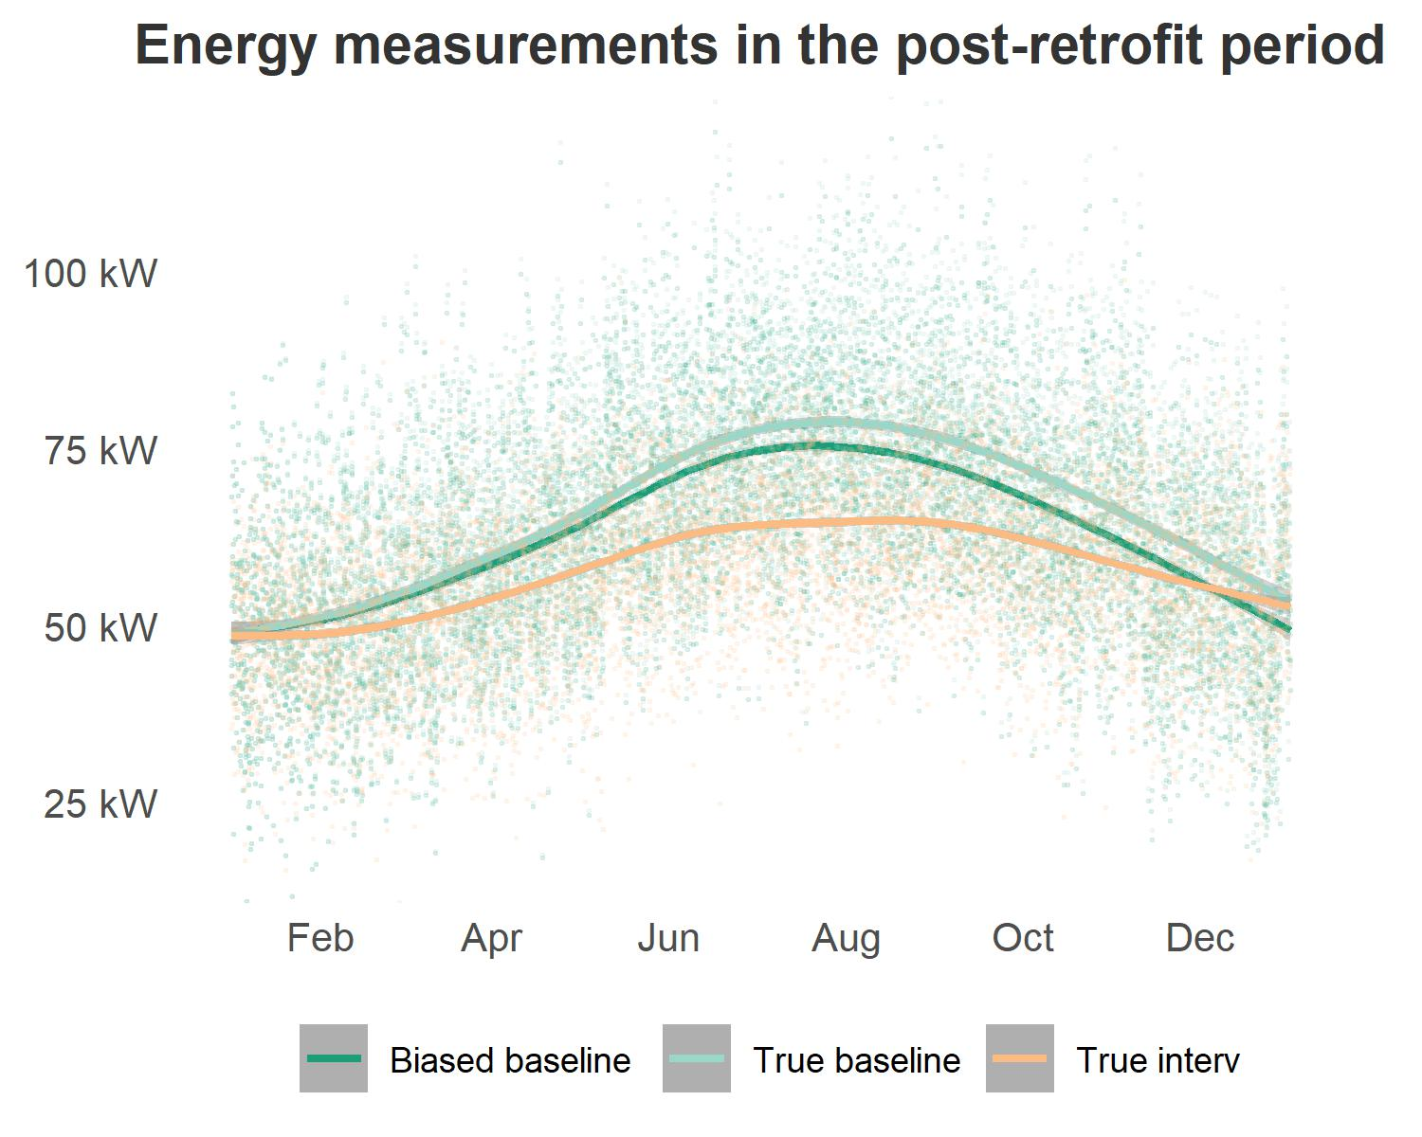

Figure 5.3: Simulated baseline and intervention energy under filter clogging scenario (Biased baseline indicates analyst’s estimation without prior knowledge about the fan power increase since the conventional method has no measure of baseline in the post-retrofit period).

The above figure 5.3 shows all types of measurements in the post-retrofit period in this scenario. Similarly, if the analyst follows the conventional method, they can measure the true intervention with increased fan energy. However, the analyst can only obtain the biased baseline without any knowledge or measure of how much fan energy has increased due to clogging filters. And the figure shows a significant amount of savings are underestimated by the conventional method.

# True M&V savings  
FS_true <- (mean(df_base_alt %>% .$power) - mean(df_interv_alt %>% .$power)) / (mean(df_base_alt %>% .$power)) * 100  
  
# Conventional M&V savings (biased)  
FS_conv <- (mean(df_base_sch %>% .$power) - mean(df_interv_alt %>% .$power)) / (mean(df_base_sch %>% .$power)) * 100  
  
# Noevl M&V savings   
df_base_sch <- df_base %>%   
 left_join(df_schedule, by = "datetime") %>%   
 fill(strategy, .direction = "down") %>%   
 filter(datetime >= as.Date("2022-01-01")) %>%   
 filter(strategy == 1)  
  
df_interv_sch <- df_interv %>%   
 left_join(df_schedule, by = "datetime") %>%   
 fill(strategy, .direction = "down") %>%   
 filter(datetime >= as.Date("2022-01-01")) %>%   
 filter(strategy == 2)  
  
FS_new <- (mean(df_base_sch %>% .$power) - mean(df_interv_sch %>% .$power)) / (mean(df_base_sch %>% .$power)) * 100  
  
df_FS <- data.frame(  
 values = c(FS_true, FS_conv, FS_new),  
 category = factor(c("True", "Conventional M&V", "Randomized M&V"), levels = c("True", "Conventional M&V", "Randomized M&V"))  
)  
  
df_FS %>%   
 ggplot() +  
 geom_col(aes(x = category, y = values),   
 alpha = 0.6,   
 position = "identity") +  
 geom_text(aes(x = category, y = values, label = paste0(round(values, digits = 1), "%")),   
 position = position_nudge(y = -0.5),  
 size = 4) +  
 scale_y_continuous(expand = c(0, 0),   
 label = number_format(suffix = "%")) +  
 labs(title = "Estimated fractional savings\nby different methods",   
 x = NULL,   
 y = NULL) +  
 theme(legend.direction = "horizontal",  
 legend.position = "bottom",  
 plot.margin = margin(t = 2, r = 7, b = 2, l = 2, unit = "mm"))

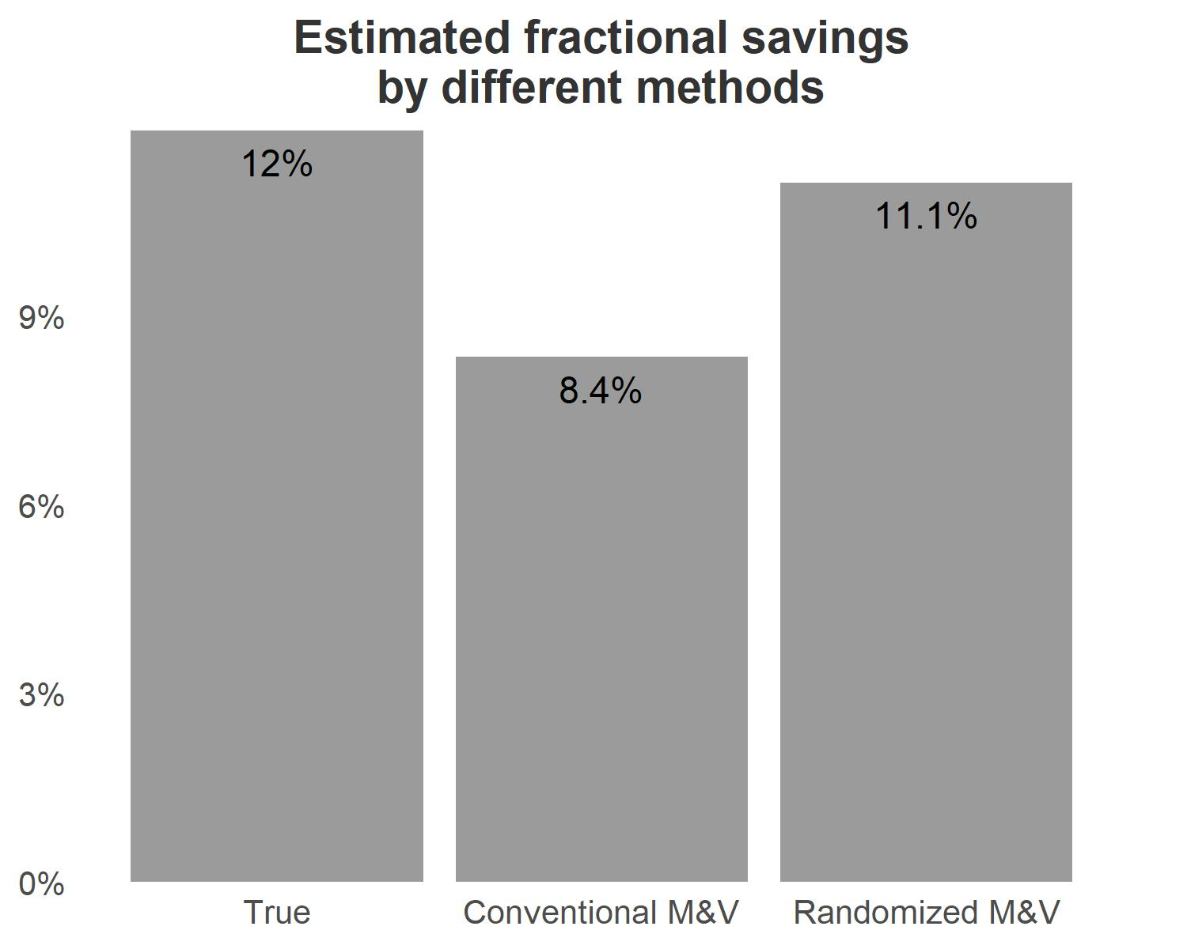

Figure 5.4: Saving estimation comparison between true savings and the two methods (conventional M&V method: no prior knowledge of filter clogging and does not measure baseline, and the novel randomized M&V method: no prior knowledge of filter clogging but measures updated baseline).

The saving estimation shown in figure 5.4 implies that the conventional M&V significantly underestimates the intervention energy-saving effect due to a lack of measurements in the post-retrofit duration. We demonstrate that unless the analyst has prior knowledge about the filter condition and has sub-meters connected to the fan in the AHU, otherwise it is challenging to detect and quantify. The figure shows with only half of the baseline measured (a 50%/50% sampling ratio), the savings can be estimated much more accurately.

## 5.3 Scenario C: Missing data due to network transmission failure

The above scenarios both assume no missed data occured, but in real projects, a common issue is missing data due to a wide range of conditions. For example, either the network system failing which precluded data collection, or an operator needing to disable the HVAC system (or part of it) for repair. In these cases, we expect a chunk of data missing from the measurement set. If network transmission failure occurs during the cooling season, rendering measurements irrecoverable for two or three weeks, the conventional method would require the baseline to be re-calibrated until the next cooling season in the following year. Furthermore, this delay will also postpone the implementation of the planned intervention leading to a much longer M&V timeline.

In this scenario, we assume that there is a 1-month period of missing measurements in the base year. We demonstrate how the random sampling method can still provide accurate estimation. Furthermore, as missing data occurs randomly in the real world, we randomly choose a two-week period and re-shuffle for 100 trials and compare the mean estimated savings with the true savings. Since we created the measurement set at the beginning, we can determine what the true saving is, and by measuring the deviation between the two, we can assess how reliable this novel M&V is.

# Define the number of hours in two weeks  
set.seed(1700)  
  
n_weeks <- 4  
hours <- n_weeks * 7 * 24  
  
# Define number of tests  
n_tests <- 100  
FS_new <- array(data = 0, dim = n_tests)  
  
df_hourly_sch <- df_hourly %>% filter(datetime < as.Date("2021-01-01") + weeks(60))  
df_base_sch <- df_base %>% filter(datetime < as.Date("2021-01-01") + weeks(60))  
df_interv_sch <- df_interv %>% filter(datetime < as.Date("2021-01-01") + weeks(60))  
  
for (i in 1:n_tests){  
 random_start <- sample(1:(8760 - hours), 1)  
  
 # Generate end index  
 random_end <- random_start + hours - 1  
   
 df_hourly_shuff <- df_hourly_sch  
   
 # Randomly erase energy consumption  
 df_hourly_shuff$power[random_start:random_end] <- NA  
   
 FS_new[i] <- (mean(df_hourly_shuff %>% filter(strategy == 1) %>% .$power, na.rm = T) - mean(df_hourly_shuff %>% filter(strategy == 2) %>% .$power, na.rm = T)) / (mean(df_hourly_shuff %>% filter(strategy == 1) %>% .$power, na.rm = T)) * 100  
   
}  
  
# True savings:  
FS_true <- (sum(df_base_sch %>% .$power, na.rm = T) - sum(df_interv_sch %>% .$power, na.rm = T)) / (sum(df_base_sch %>% .$power, na.rm = T)) * 100  
  
# Conventional method  
# FS_conv <- (sum(df_base_alt %>% .$power, na.rm = T) - sum(df_interv_alt %>% .$power, na.rm = T)) / (sum(df_base_alt %>% .$power, na.rm = T)) * 100  
  
  
FS_df <- data.frame(FS = FS_new)

FS_df %>%   
 ggplot(aes(x = FS)) +  
 geom_histogram(bins = 10, alpha = 0.5) +  
 scale_x_continuous(expand = c(0, 0),   
 labels = number_format(suffix = "%")) +  
 geom_vline(aes(xintercept = FS_true, color = "True savings"), lty = "dashed") +  
 geom_vline(aes(xintercept = mean(FS_new), color = "Mean estimated savings"), lty = "dashed") +  
 labs(color = NULL,   
 title = "Repeated analysis of average intervention effect\n(with randomly selected missing days)",  
 x = "Estimated fractional savings",  
 y = "Frequency") +  
 theme(legend.direction = "horizontal",  
 legend.position = "bottom",  
 plot.margin = margin(t = 2, r = 7, b = 2, l = 2, unit = "mm"))

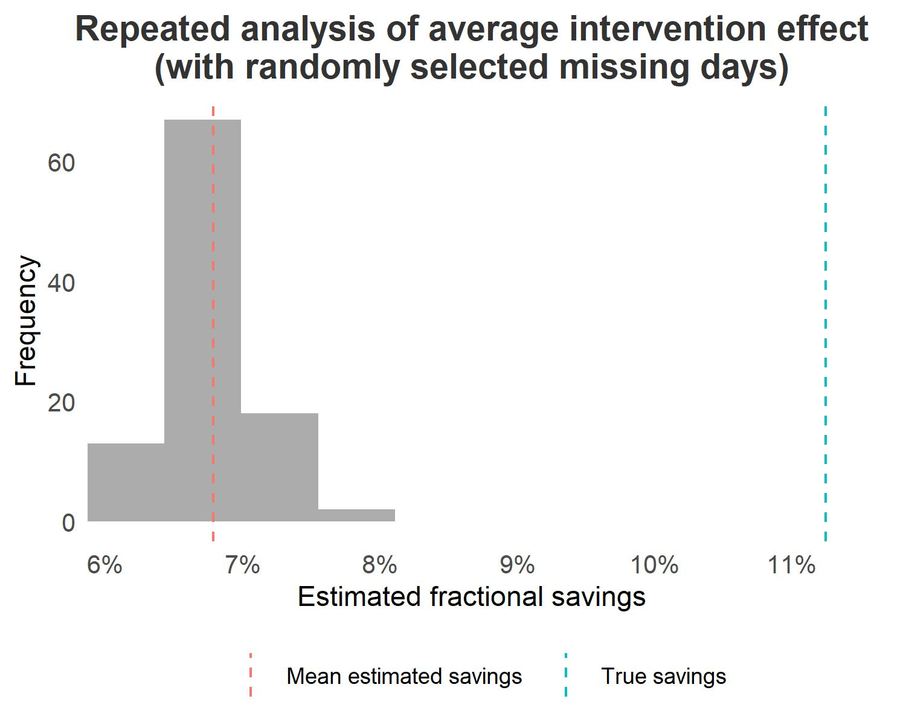

Figure 5.5: Saving estimation comparison between true savings and the mean estimated savings after 100 trials with random 2-month data drop.

The above figure 5.5 shows that the deviation between the mean estimated saving and the true saving is less than 1%. Although the variance of the estimation is slightly larger, and this is because the intervention effect varies with the time of the year and so the saving estimation can be higher/lower compared to the true savings depending on which period of time missing data occurs. But in general, the random sampling method is robust.