


Vulcan 2020 – WP15 Software Controls

SRS300 HVPSU Requirements

 | Project | Doc Type | Work Package | Number | Version | Status
 | Vulcan2020 | SP | WP15 | 1 | 0

Created By: Georgia Briggs
CR Number:

Contents
1 Purpose 3
1.1 Terminology 3
1.2 Abbreviations and definitions 3
2 SRS300 HVPSU Overview 4
3 Requirements 5
3.1 SRS HVPSU IOC 5
3.2 SRS HVPSU GUI 6
3.3 Personal safety 6

Revision History

Revision | Date | Reason
1 | 21/08/25 | First draft
1.1 | 25/09/25 | Review with GB, DC
1.2 | 04/11/2025 | Review and demo with GB, DC
1.2.1 | 14/01/2026 | Progress updated by GB
1.3 | 16/01/2026 | Review and demo with GB, CA, TS

Purpose

This specification details requirements for the SRS300 IOC and GUI, to be developed by the Software Controls group.

There are multiple models of the device, requiring different specifications. There are multiple detectors that they may supply voltage to such as Thompson ion spectrometer, Diamond detector, Neutron detector or MCP.

Terminology

IOC - EPICS based Input/Output Control software provided by the CLF software controls team to interface with the Vulcan 20-20 system hardware.

GUI - Phoebus or Blazor based graphical user interface

“Shall” – indicates mandatory requirements

“Should” – indicates suggested requirements

TBC – indicates requirements that are To Be Confirmed

Abbreviations and definitions
SRS Stanford Research Systems
GUI Graphical User Interface
HVPSU High Voltage Power Supply Unit
HV High Voltage
PSU Power Supply Unit
DC Direct Current
IOC Input Output Controller - based on EPICS
MCP Multichannel Plate

SRS300 HVPSU Overview

The architecture of the SRS system is shown in figure 1. It comprises of the SRS High Voltage Power Supply Units (HVPSUs), which will apply a voltage between two plates, to be used to encourage a flow of electrons on a detector, placed in or near the target chamber.
There are multiple models of the SRS HVPSU (PS310, PS350, PS370, PS375) each requiring unique settings and limitations. There are also multiple detectors for which the SRS HVPSUs will be used.

The diagram in Figure 1 reflects the architecture for the SRS300 series which consists of the GUI and IOC which communicates with the ethernet to serial converter via ethernet which in turn communicates to the SRS HVPSU via RS232. The SRS will then supply the appropriate high voltage to the detector.

The GUI and IOC shall be developed by the software controls team allowing communication and control of the SRS HVPSU. It shall be responsible for capturing and displaying status and ramping process information such as present voltage and current as well as instructing the SRS on current, voltage, polarity and ramping settings.

Relevant settings for the ethernet to serial converter include the port, for which settings must be changed accordingly, and the baud rate, which should be approximately 9600. An example of correct setup for the Lantronix ethernet to serial converter is provided in Figure 2.

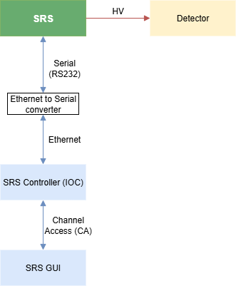
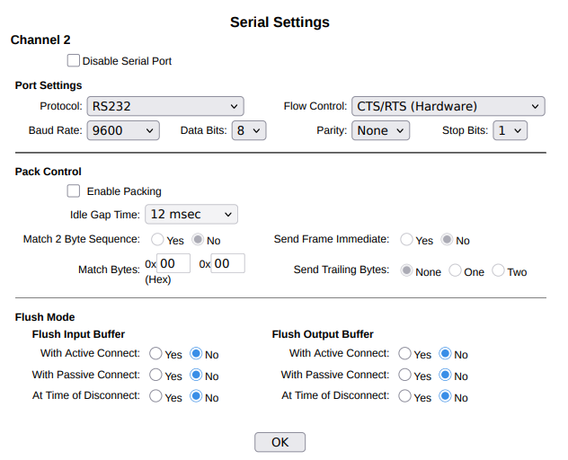

Example Lantronix configuration
Version 1 20 Aug 2025
SRS300 Architecture
Version 1 19 Aug 2025
Figure 2 Example Lantronix (Ethernet to serial converter) configuration

Figure 1 SRS300 HVPSU Architecture

Requirements

SRS HVPSU IOC
Ref | Requirement | Status | Test  (See test doc)
1. | Software control shall produce an IOC to communicate with and control an SRS HVPSU | Done  16/01/2026
2. | The IOC shall include templates for each model with settings reflecting their respective limits:  - SRS PS310: +/-12 V to 1.25 kV DC PSU, 1 mA  - SRS PS350 +/-100 V to 5 kV DC PSU, 1 mA  - SRS PS370 -100 V to - 20 kV PSU, 500 uA  - SRS PS375 +100 V to +20 kV, 500 uA | Done  18/12/2025 | Partial block  Tests 10.0  Note: Currently tested on only 370 and 375 due to issues with connection to 310.
3. | The IOC should be capable of setting the following information:
3.1. | A means to set desired voltage for the HVPSU to charge to. | Done  30/09/2025 | Done  Test 2.1
3.2. | A means, within a submenu, to set voltage limit (which, at default, should be set depending on SRS model). | Done  19/11/2025 | Done  Tests 8.0
3.3. | A means, within a submenu, to set current limit and current trip limit (which, at default, should be set depending on SRS model). | Done  19/11/2025 | Done  Tests 8.0
3.4. | A means to set the time that the device will take to ramp up to the desired voltage. | Done  30/09/2025 | Done  Test 2.4
3.5. | A means to toggle the high voltage on/off. (the device must be powered on/off manually) | Done  04/11/2025 | Done  Tests 6.1, 6.3
3.6. | A means to reset the unit, removing the high voltage and setting the GUI to a safe set of default settings. | Done  04/11/2025 | Done  Test 5.1
3.7. | A means to clear any trips that may have occurred. | Done  04/11/2025 | Done  Test 5.4
4. | The IOC shall ramp up based on input of desired voltage and time. | Done  30/09/2025 | Done  Tests 1.0, 1.1 & 2.0
5. | The IOC should capture the curve of the voltage and current (for display purposes). | Done  21/11/2025 | Done  Tests 4.0 &9.0
6. | The IOC shall monitor SRS status information from the status poll byte including voltage trips, current trips and current limit reached. | Done  26/11/2025 | Done  Tests 7.0
7. | The IOC shall monitor voltage regularly (every 0.1 seconds for EPAC) to confirm voltage level is present and not tripped. | Done  20/11/2025 | Done  Tests 3.0
8. | The IOC shall monitor current flow detected by the SRS to confirm there hasn’t been an overcurrent trip, and to warn if there is risk of one. | Done  24/11/2025 | Done  Test 9.1
9. | Data collected by the IOC (including Voltage, Current and trip events) shall be archived for data management. | Done  15/01/2026 | Done  Test 12.2
10. | The IOC shall monitor voltage polarity. | Done  18/12/2025 | Partial block  Tests 10.0  See note on Req 2
11. | The IOC shall allow for “friendly names” to be assigned to devices using some naming convention. | Done  16/01/2026 | Done  Tests 12.3
12. | The IOC should allow for the user to save preset values of ramping settings that can be loaded in. | Done  11/12/2025 | Done  Tests 11.0
13. | The IOC should keep track of when output voltage is at target voltage | Done  16/01/2026 | Done  Tests 3.5
(To display on a suitable GUI)

SRS HVPSU GUI
Ref | Requirement | Status | Test
1. | An SRS HVPSU GUI shall be developed, providing a means to control the SRS300 HVPSU IOC and display the status of the device. | Done  16/01/2026
2. | The GUI shall support the different settings depending on the model of the device. | Done  18/12/2025 | Done  Tests 10.0
3. | The GUI shall provide the following controls:
3.1 | A desired voltage level and limit within a submenu (referencing PVs as defined by the IOC (3.1,3.2)). | Done  19/11/2025 | Done  Tests 2.1& 8.0
3.2 | A desired current limit within a submenu (referencing PVs as defined by the IOC (3.3). | Done  19/11/2025 | Done  Tests 8.0
3.3 | On and off button for the High voltage (3.5) | Done  24/11/2025 | Done  Tests 6.0
3.4 | A reset button as defined by the IOC (3.6, 3.7). | Done  04/11/2025 | Done  Test 5.1
3.5 | A button to begin the ramp to the desired voltage. | Done  30/09/2025 | Done  Tests 2.0
3.6 | A button to clear trips (3.7) | Done  04/11/2025 | Done  Test 5.4
4 | The GUI shall display the following information:
4.1. | Text boxes representing voltage and current information and settings including polarity settings (dependent on model). | Done  07/11/2025 | Done  Test 3.4
4.2. | LEDs showing SRS status information including overvoltage trips, overcurrent trips and when current is above limit. | Done  04/12/2025 | Done  Tests 7.0
4.3 | Any user input errors that may occur such as the requested change in voltage being below step size. | Done  25/11/2025 | Done  Tests 1.0.3, 1.0.5, 1.1.4, 1.1.5
5 | The GUI should display a graph showing the current voltage, hence showing the ramp up period. | Done  04/11/2025 | Done  Tests 4.0
6. | The GUI should display a graph of the present current on the same graph as the voltage, however with a separate axis. | Done  21/11/2025 | Done  Tests 9.0
7. | The GUI shall display user nickname/description for the device (11) | Done  16/01/2026 | Done  Tests 12.3

