Heclib.lib Notes for Intel Fortran Compiler 9.1
January 2007

Debug library is named heclibd.lib
Release version is heclibr.lib

Primary Compiler Settings:
- Fortran External Procedures
- Calling Convention – STDCALL, REFERENCE
- Name Case Interpretation – Lower Case
- Append Underscore to External Names – Yes

These are set to be able to use the library with mixed languages (C, Java) and to have the code as similar as possible to that on Unix.

Properties for Fortran External Procedures (both debug and release):

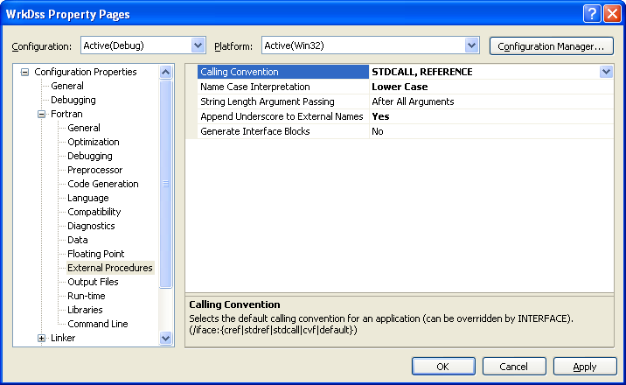
You may need to save local variables. DSS has been tested with and without saving. Some of the catalog routines save locals. Generally, disk I-O overpowers any lost speed due to saving locals, so we just leave it on.

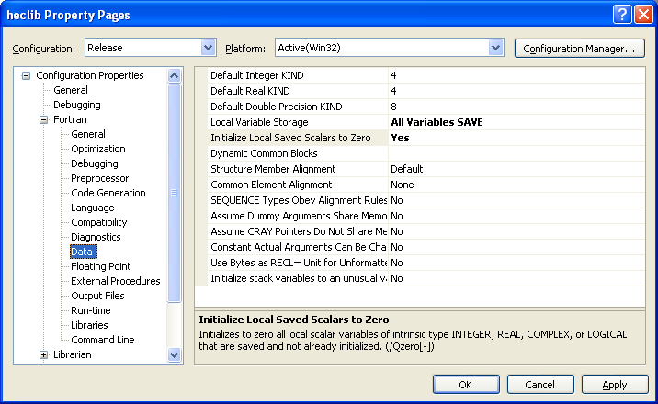

As of now, we ignore libcmt to avoid multiply defined symbols

Linking Example:

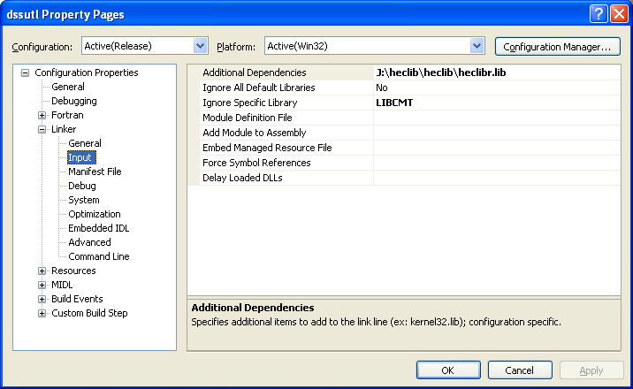

Final Command line example:

