
M365 Assessment Easy Mode
How to export your user list and product list from the Microsoft 365 admin center
If you can't run the Centre assessment script, you can still give us what we need for a license review by exporting two lists from the Microsoft 365 admin center. It takes about 10 minutes and nothing needs to be installed.

What you'll send us
File | Where it comes from | How many
users_<date> <time>.csv | Users > Active users > Export users | One
Products_<date-time>.csv | Billing > Your products > Export to CSV | One for each billing account

Before you start
- Sign in to the Microsoft 365 admin center at admin.microsoft.com with an account that has Global Reader or Global Administrator. A billing role (Billing Administrator or Billing Reader) can also see the billing pages.
- If the left menu looks short, select Show all at the bottom of it.
- Use a computer, not a phone. Files go to your browser's normal Downloads folder.
- The red numbered markers on each screenshot show what to click, in order.

Part 1: Export the user list
- In the left menu, select Users > Active users (1).
- Clear the search box and leave the filter set on Commonly used so everyone is included.
- Select Export users (2).
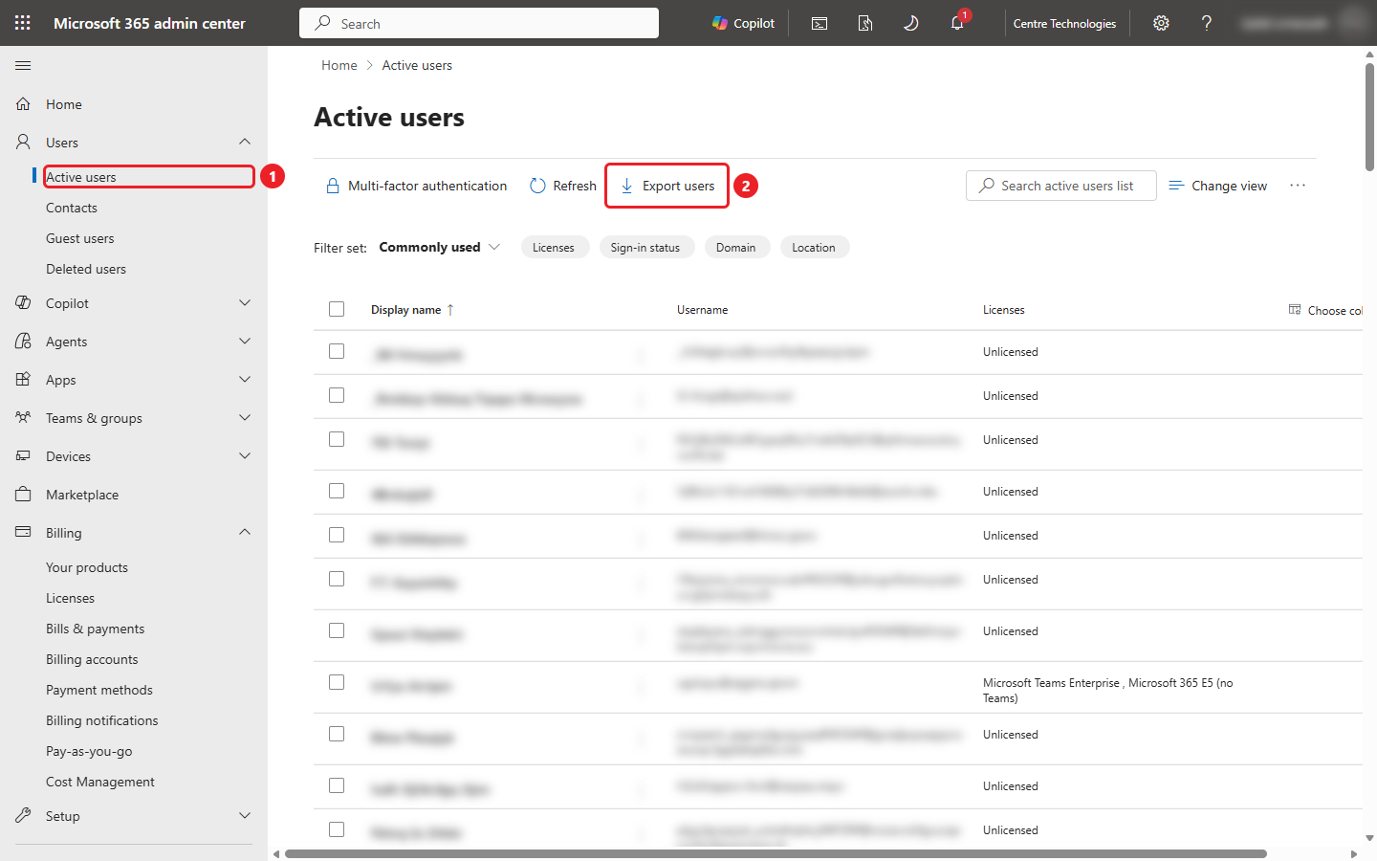
Figure 1. Active users page. Select Export users.
- In the Export active users box, select Continue (3).
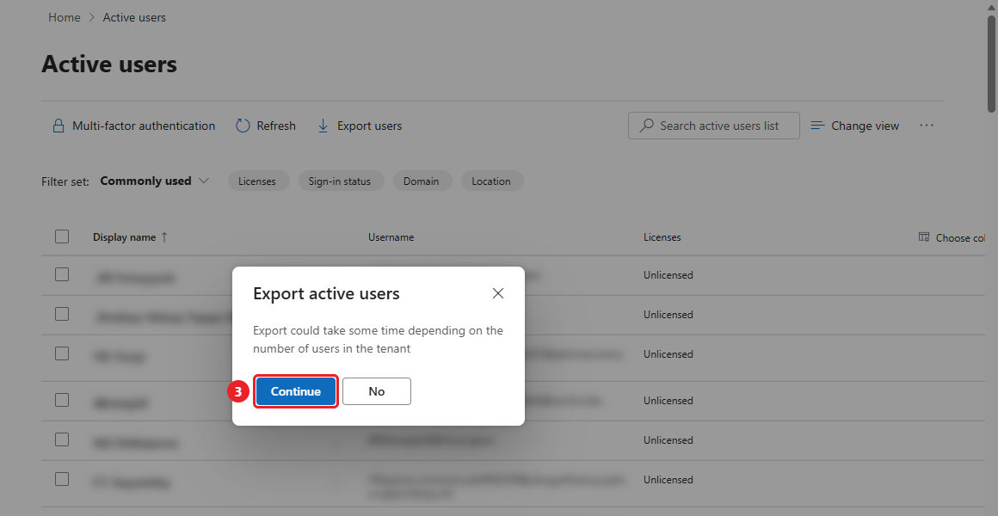
Figure 2. Export active users confirmation.
- Your browser downloads a file named like users_10_22_2026 3_02_16 PM.csv. In large tenants this can take a minute or two, so keep the page open until it appears.

Part 2: Count your billing accounts
Microsoft shows products one billing account at a time, so you need to know how many you have before exporting them.
- In the left menu, select Billing > Billing accounts (1).
- Count the rows (2) and note the Billing account type of each one. Common types are Microsoft Customer Agreement (MCA), Microsoft Online Subscription Agreement (MOSA), Enterprise Agreement (EA) and Microsoft Partner Agreement (licenses bought through a partner).
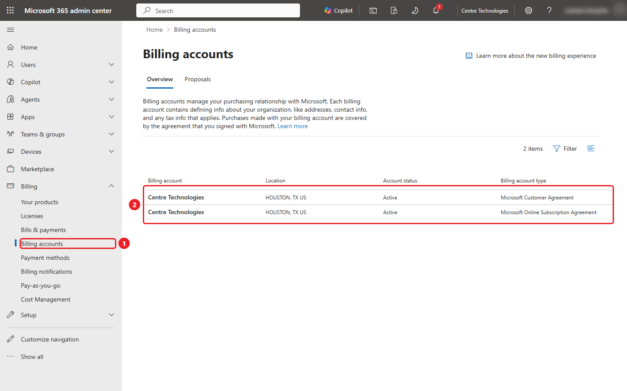
Figure 3. Billing accounts page. This tenant has two: one MCA and one MOSA.
If there is only one row, you'll do one product export in Part 3. If there are two or more, you'll do one export per row.

Part 3: Export products per billing account
- In the left menu, select Billing > Your products (1).
- Look at Billing account view (2). It tells you which billing account is on screen, for example (MCA).
- Leave the filters as they are. The defaults include active, expired and disabled subscriptions, which is what we want.
- Select Export to CSV (3).
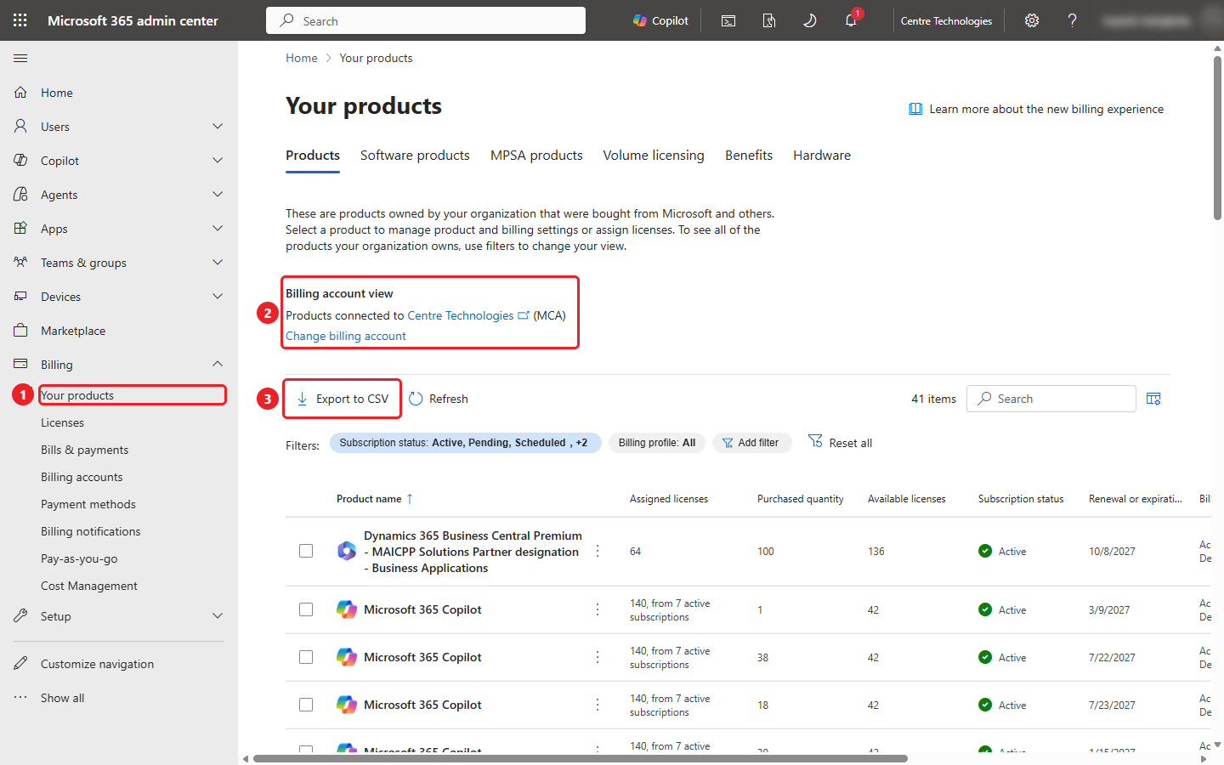
Figure 4. Your products page showing the MCA billing account.
- In the Export a list of products box, select Continue (4). Your browser downloads a file named like Products_2026-10-22T10_01_21-05_00.csv.
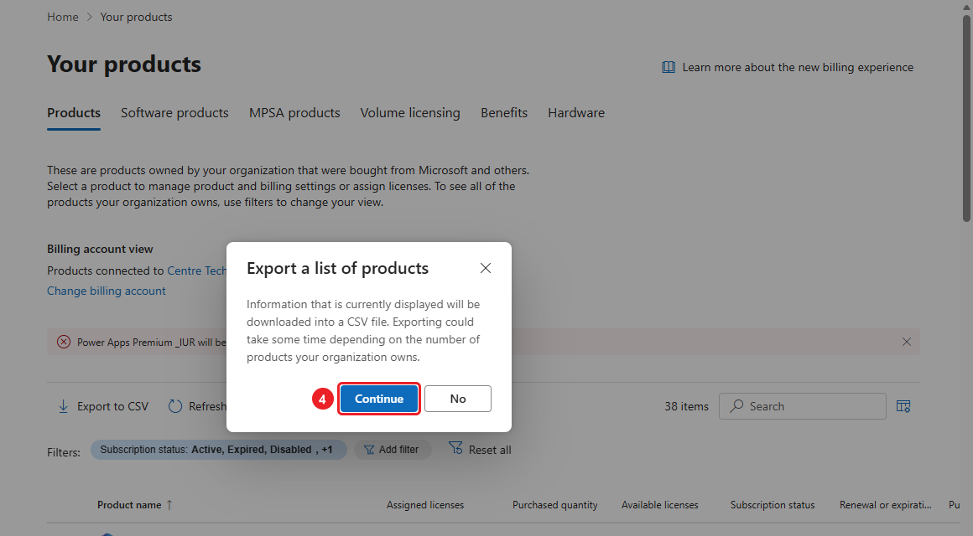
Figure 5. Export a list of products confirmation.

Repeat for each additional billing account
- Select Change billing account under Billing account view.
- In the panel, select the next billing account in the list (5), then select Save (6). Don't select Set as default.
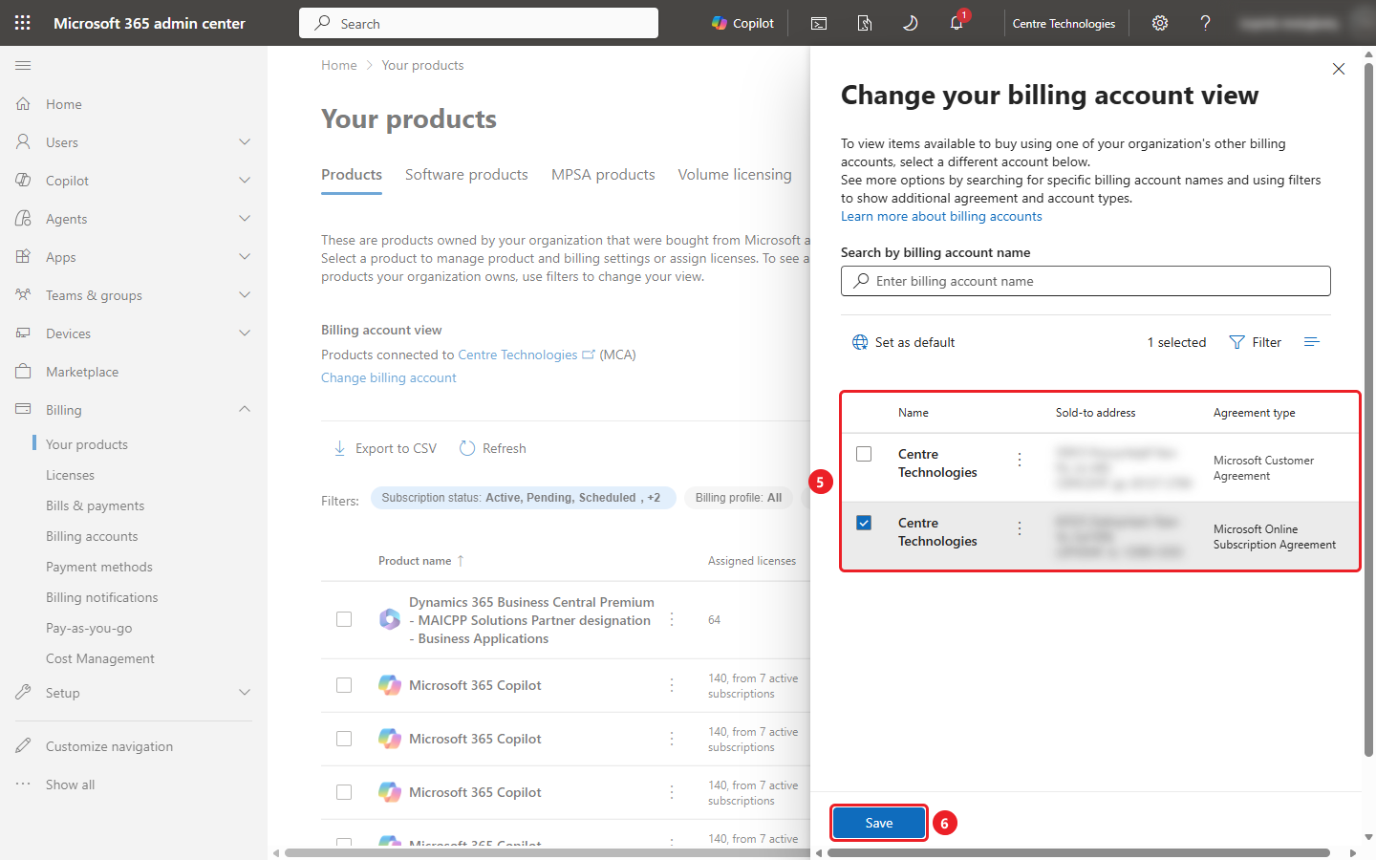
Figure 6. Change your billing account view panel with the second account selected.
- Billing account view now shows the account you picked, for example (MOSA). Select Export to CSV (7), then Continue.
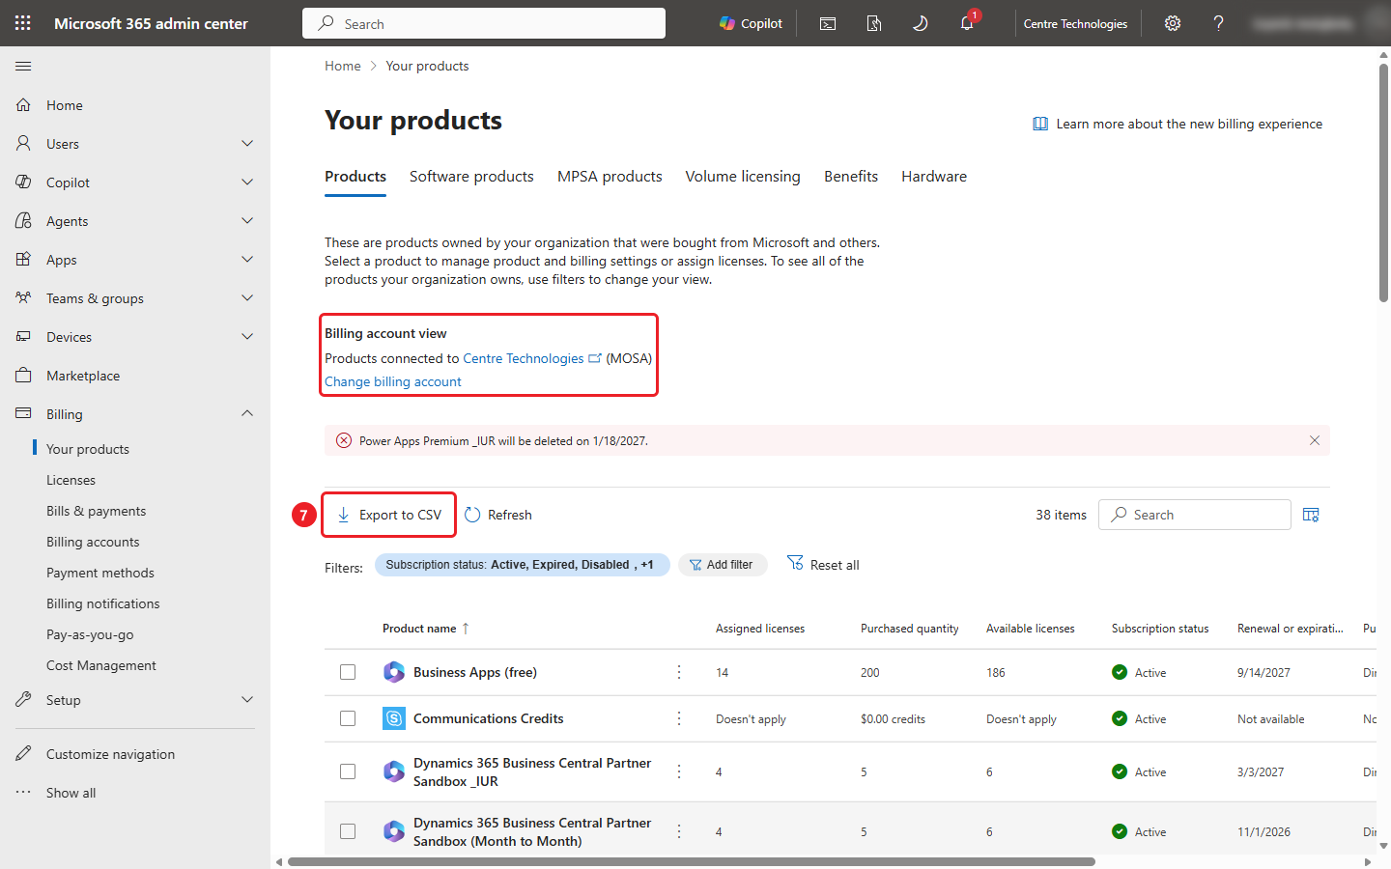
Figure 7. Your products page now showing the MOSA billing account.
- Repeat steps 6 to 8 until you have one Products file for every billing account you counted in Part 2.
Enterprise Agreement accounts are hidden by default. If Part 2 showed an Enterprise Agreement, or you know you have one, select Filter in the Change your billing account view panel and tick Enterprise Agreement so it appears in the list.
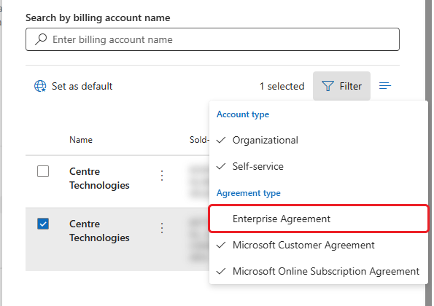
Figure 8. Filter menu in the billing account panel. Enterprise Agreement is unticked by default.
Reloading the page switches the view back to your default billing account. Check the Billing account view line before each export.

Part 4: Send the files to Centre
You should now have:
- One users CSV file
- One Products CSV file per billing account
Send them to your Centre contact using the secure file share link they provided. The user list contains names, email addresses and phone numbers, so please don't post it anywhere public.

Troubleshooting
What you see | What to do
Export users or the Billing menu is missing | Your account doesn't have a high enough role. Ask a Global Administrator to run the export or assign you Global Reader.
Billing accounts says "You have no billing accounts" | Your role can't read billing. Global Reader, Billing Reader or Billing Administrator is needed.
No Change billing account link | You only have one billing account. One product export is enough.
Nothing downloads after Continue | Wait a minute, then check your Downloads folder and your browser's download bar for a blocked download.

Screenshots come from a real tenant with names, usernames, addresses and the signed-in user blurred.

