GRIEVANCE MANAGEMENT MODULE · ARCHITECTURE

Grievance Process Architecture
How the module is wired end to end: the components that talk to each other, the business domains that own the data, and the message-by-message flow of the three processes that move a case through the system.

1. Component Architecture
Every actor, client, and backend service in the module, wired by the request and event traffic that actually crosses between them.
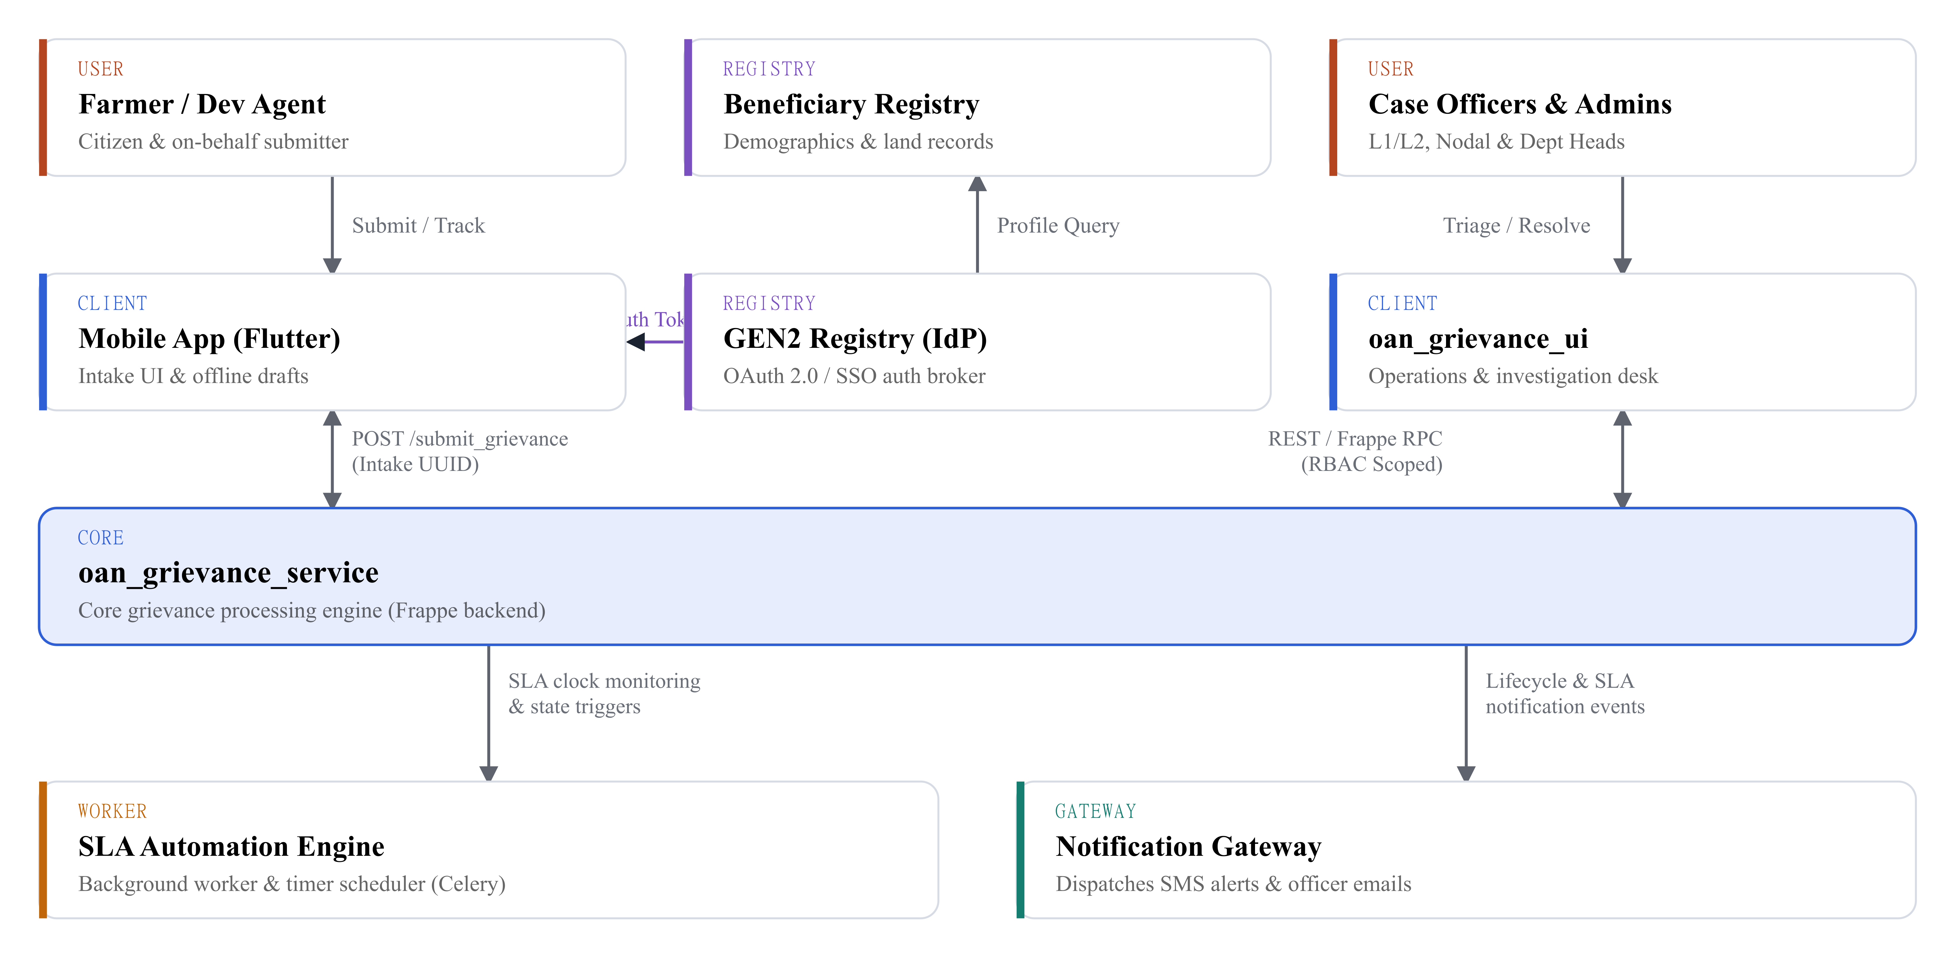
Duplex arrows (arrowheads on both ends) mark the two synchronous REST/RPC channels into oan_grievance_service; every other arrow is one-way. GEN2 Registry’s lifeline is short-lived — it exits once the Mobile App has an identity token, which is why it never reaches the core service directly.
■ User — Farmer/DA, Case Officers & Admins ■ Registry / IdP — Beneficiary Registry, GEN2
■ Client / Core — Mobile App, oan_grievance_ui, oan_grievance_service
■ Worker — SLA Automation Engine ■ Gateway — Notification Gateway

2. Functional Domains
The same system, cut a different way — five functional domains, each owning its own DocTypes and a named actor. The arrows are the only things allowed to cross a boundary.
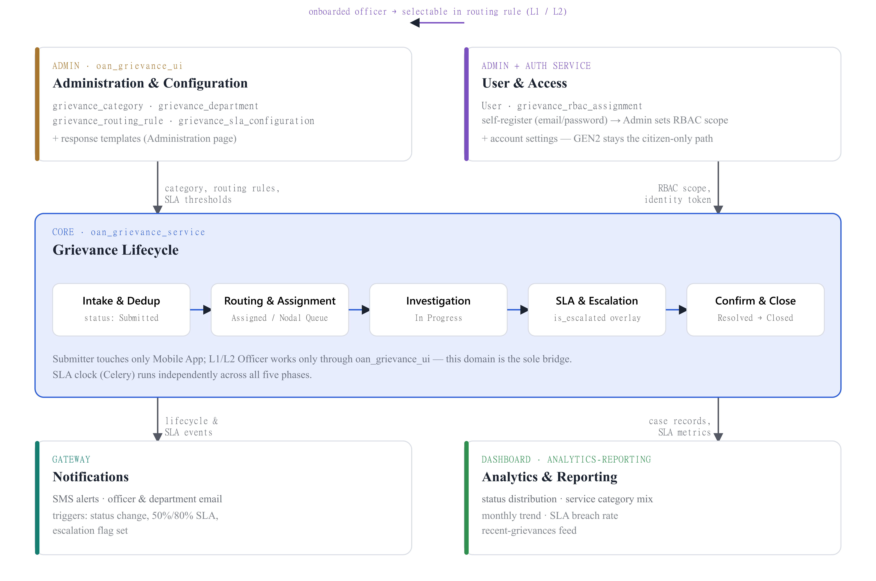
Two setup domains — Administration & Configuration, User & Access — feed the central Grievance Lifecycle, which in turn drives Notifications and Analytics & Reporting. The top connector is the one explicit cross-link between setup domains: an onboarded officer becomes immediately selectable inside a routing rule.
■ Administration & Configuration ■ User & Access
■ Grievance Lifecycle (core) ■ Notifications ■ Analytics & Reporting

Administration & Configuration | Admin-only, via oan_grievance_ui. Defines taxonomy, department routing, and SLA policy before any grievance is filed — grievance_category, grievance_department, grievance_routing_rule, grievance_sla_configuration, plus response templates.
User & Access | Officers self-register (email + password) and Admin layers on scope after — User and grievance_rbac_assignment bound to Region/Department/Category — with account settings alongside. Citizen identity is a separate path entirely: Farmers and Development Agents authenticate externally via GEN2 Registry OAuth/SSO.
Grievance Lifecycle | The one domain every actor touches. The submitter reaches it only through the Mobile App; officers work it only through oan_grievance_ui. Five phases — Intake, Routing, Investigation, SLA & Escalation, Confirmation — with an SLA clock running independently throughout.
Notifications & Analytics | Notifications dispatches SMS and email off lifecycle and SLA events. Analytics has no configuration of its own — it’s a read model over the same case data, surfaced as status distribution, category mix, monthly trend, and SLA breach rate.

3. Sequence Flows
The three processes that actually move data through the module — who calls whom, in what order, and which DocType gets written at each step.

Flow A — Service Category, Department & SLA Configuration
Admin-only, through oan_grievance_ui. Four phases, each ending in a write to its own DocType.
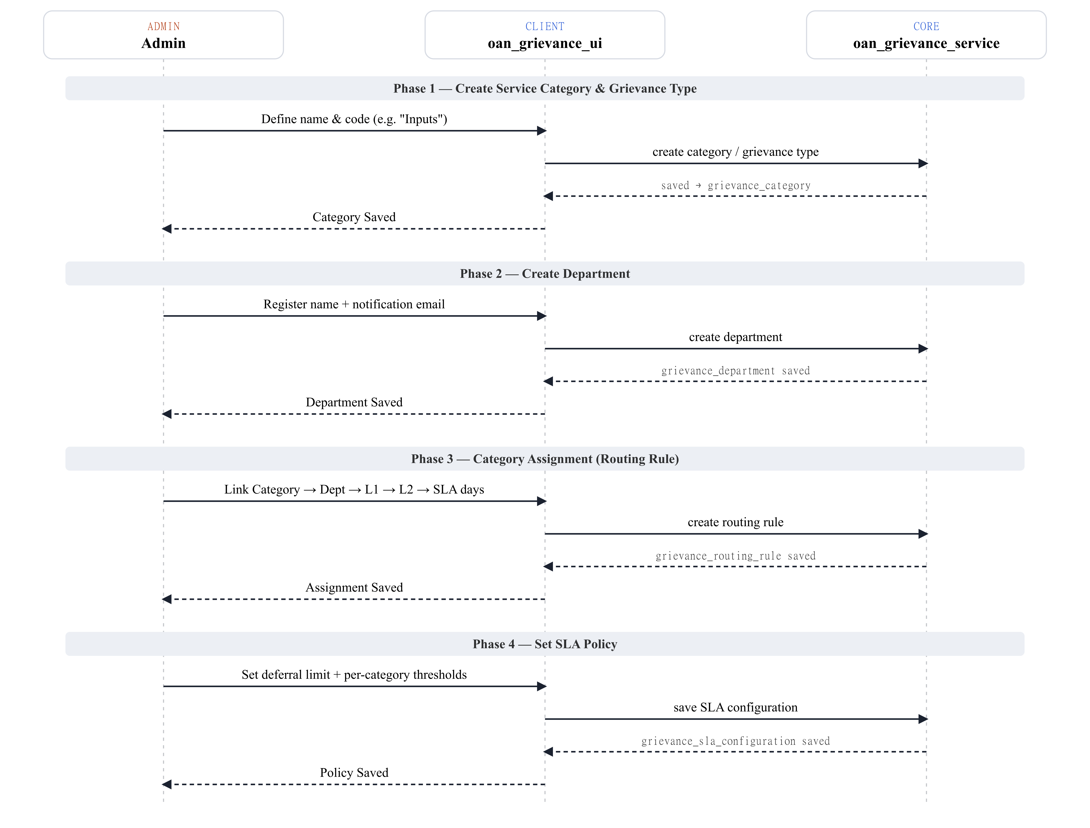
Solid arrows are requests, dashed arrows are the acknowledgements that follow. oan_grievance_ui is the only component that ever calls oan_grievance_service here — no mobile app, no submitter.

Flow B — Officer Onboarding (L1 / L2 / Department Head)
Internal staff provisioning, separate from the citizen identity path in Flow C. Ends with the new officer selectable back in Flow A’s routing rules.
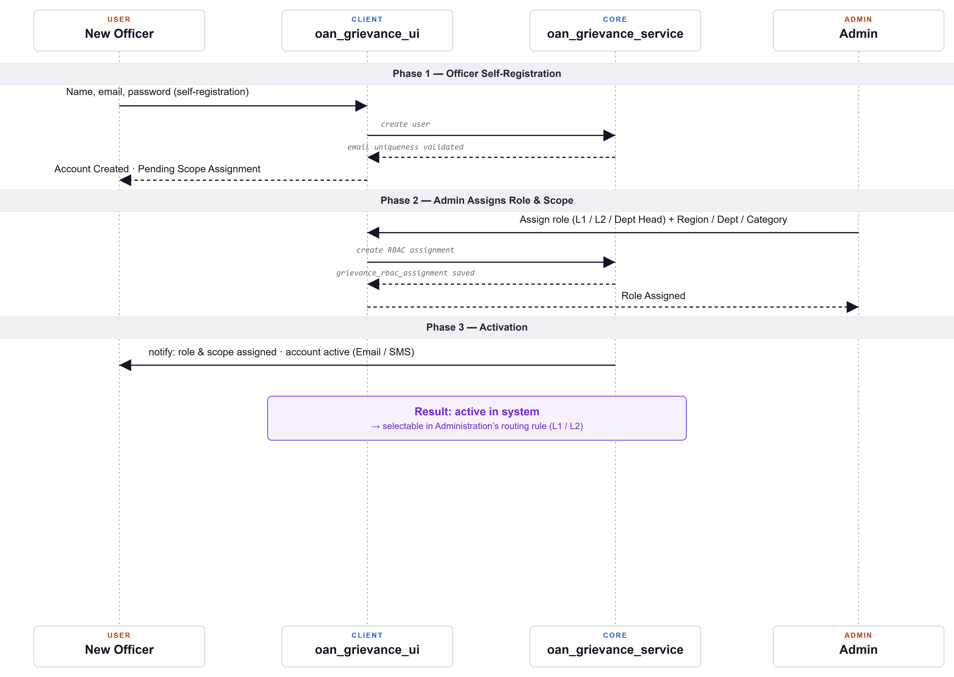
Phase 3 is the one place this flow talks past oan_grievance_ui — invitation and activation happen directly between the core service and the new officer.

Flow C — Grievance Submission → Resolution
The end-to-end case lifecycle — every component from the architecture diagram appears here at least once, and the SLA clock runs independently for the whole thing.
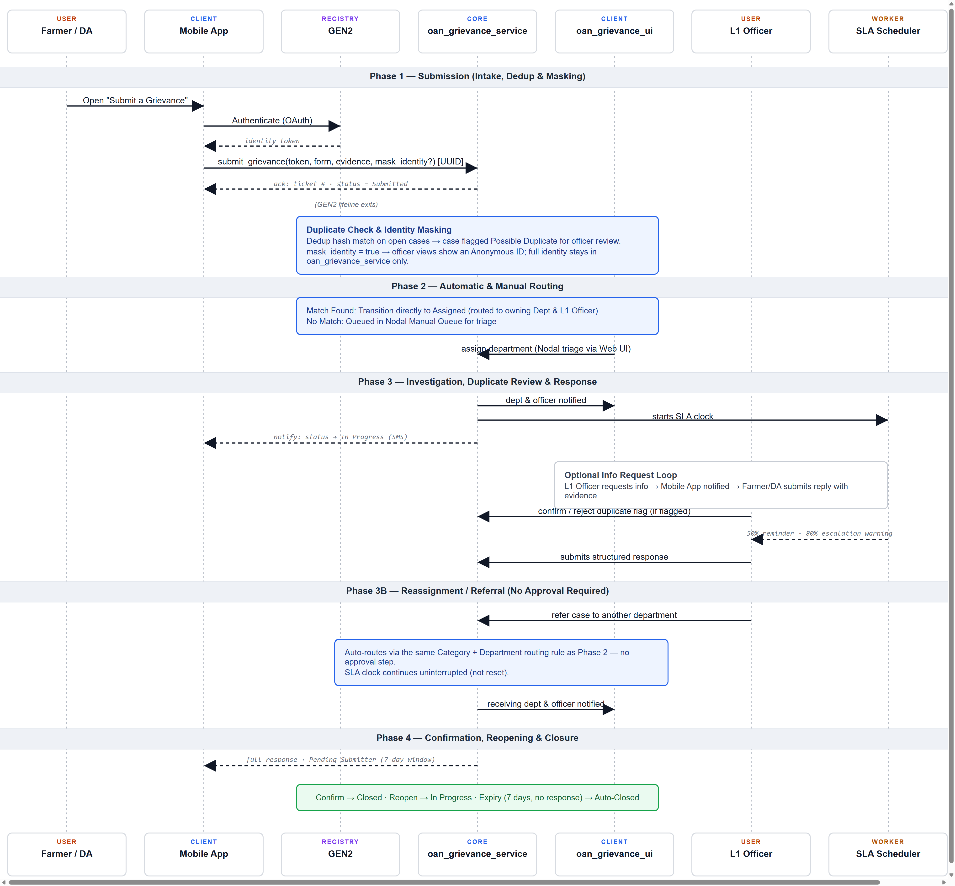
Escalation is an overlay flag (is_escalated) rather than its own lifecycle state — it tracks audit history without resetting the SLA clock or breaking phase progression.

