Panel Randomizer Manual

V1.0/25-07-2018

**LimeSurvey offers a way to pre-fill questions, using GET variables in the url of particular survey. This application uses this feature to send student number and branching number to specified questions. When the respondent has filled out his/her ID in Panel Randomizer, the respondent is directed to the survey, by an url that contains these (extra) GET variables**

1. Create a survey in LimeSurvey (optional: with different groups)
2. Put one or two questions in the first group to be prefilled by the URL of Panel Randomizer: for student number and (optional) for branching. These questions can be made 'hidden' optionally
3. Optional: create other groups that will be shown if the answer on the branching question is 1 to ... [number of groups]. Fill out in 'relevance equation' of this group: [questionid]==[rotation number]. For example V002==1. In this case this particular group will only show when the question V002 was prefilled with 1 by the forwarding url made by Panel Randomizer. (illustration below)

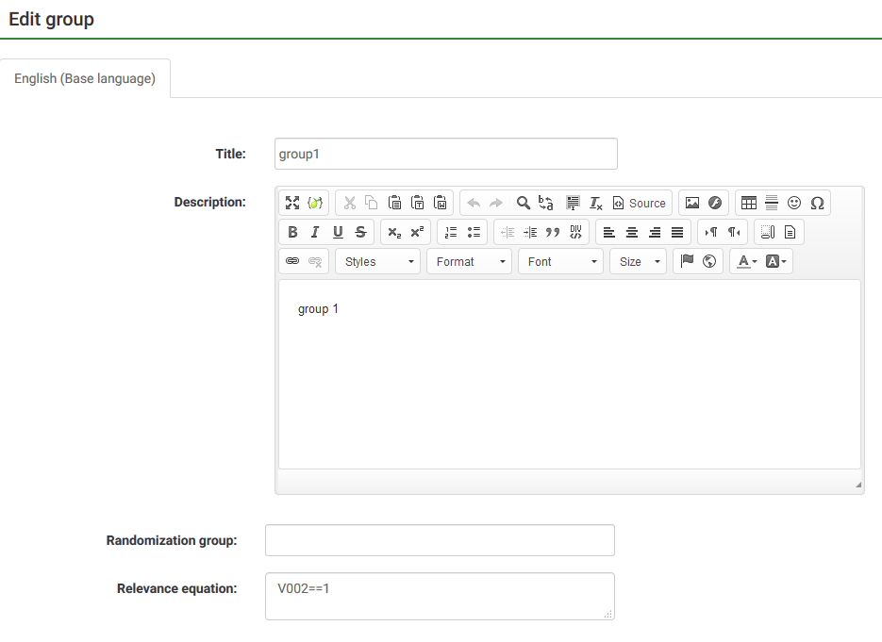

1. Go to 'Panel integration' in LimeSurvey.

(For LimeSurvey 2.50: Tab Survey properties->General settings & texts->General Options->Panel integration)

(LimeSurvey 3.x uses another menu. ‘Panel Integration’ is somewhere else to be found)

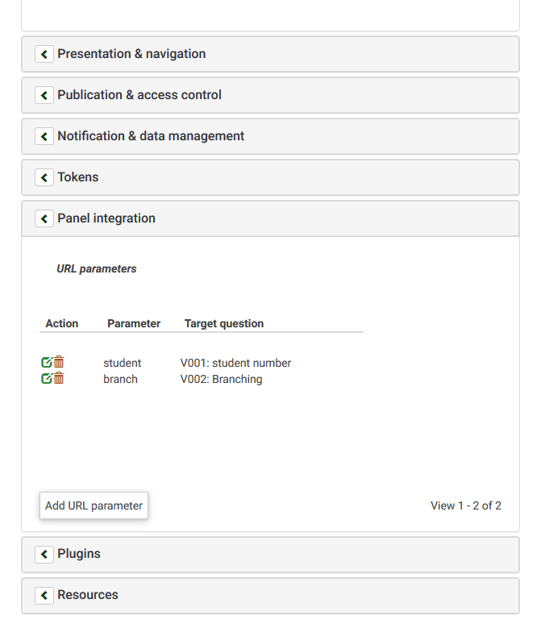

Add the url parameters that are used for prefilling the answers. Choose a parameter name for the student number parameter that needs to be taken from the url and assign the parameter to the target question from step 2.  
Choose a name for the branching parameter and assign the parameter to the target question for the branching from step 2.

1. Enter the Admin of Panel Randomizer. (<https://panel-randomizer.hum.uu.nl/admin/>)
2. Right from 'Surveys' choose 'add'.

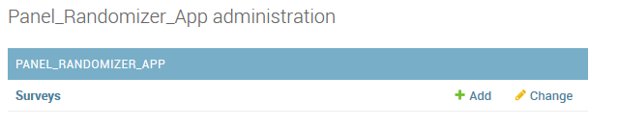

1. Fill out in the new screen:

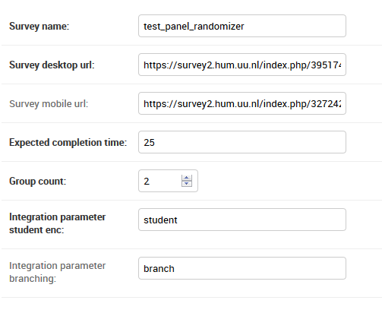

(above data are from the example survey)

* + A survey name (required). This name will be used as the last part of the link for the respondents. The complete link will be: https://panel-randomizer.hum.uu.nl/test_panel_randomizer. Now all your settings for this particular survey will be retrieved when a respondent clicks this link.
  + Survey desktop url (required). This is the url you see in your LimeSurvey that you plan for desktop users under 'Survey URL'. Panel Randomizer will generate this url, enriched with extra GET variables.

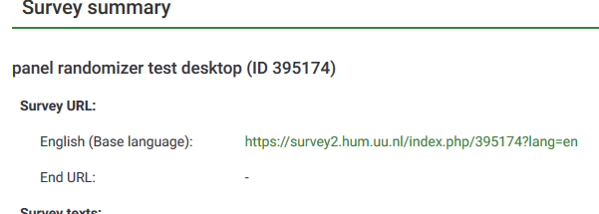

* + Survey mobile url (optional). The LimeSurvey url you plan for the users of mobile devices.
  + Expected completion time. This will be shown on the welcome screen of Panel Randomizer
  + Group count. The number of groups that need to be rotated. The group number is passed as a GET variable (integer) in the forwarding URL generated by Panel Randomizer. For every new respondent this integer will be incremented with 1 until the max number is reached, and starts again at 1.
  + Integration parameter student enc (required). The parameter name you choose (in step 4) in LimeSurveys 'panelintegration' to save the (encrypted) student number. Please fill out the exact same name. The encrypted student number will be passed as a GET variable in the URL to LimeSurvey with this name. I.e when you choose the name 'student' in panel integration as the url parameter that pre-fills the student number question, please fill out the same name here. The redirecting URL to LimeSurvey will then contain this: '&student=[encrypted number]'
  + Integration parameter branching (optional). The parameter name you choose in LimeSurveys 'panel integration' to save the answer needed for showing a particular group. Please fill out the exact same name. I.e when you choose the name 'branch' in panel integration as the url parameter that pre-fills the question that decides which group of questions is shown next, fill out 'branch' here as well. In the generated url the GET parameter will then contain this: '&branch=1', and a '1' will be filled as the question answer in LimeSurvey. For the next respondent the number will be '2' until the number you filled in 'Group count' is met.
  + click 'save'

1. Go to <https://panel-randomizer.hum.uu.nl/test_panel_randomizer/>

(Replace ‘test_panel_randomizer’ with the survey name you just entered).

In order to test the connection to your LimeSurvey survey, use as a student number: '123'. This number is (for the moment) available for testing purposes and will not be saved in the database. (Other numbers will allow only for one entry).

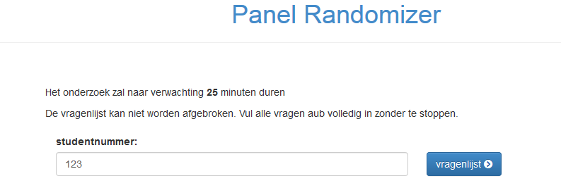

1. When you get 'Onderzoeksnaam ontbreekt of is onjuist', the survey name was not found. Perhaps you forgot to add the name of the survey you just created in the admin, or misspelled it. Please use a slash (/) and the survey name after the base url in the browser address bar

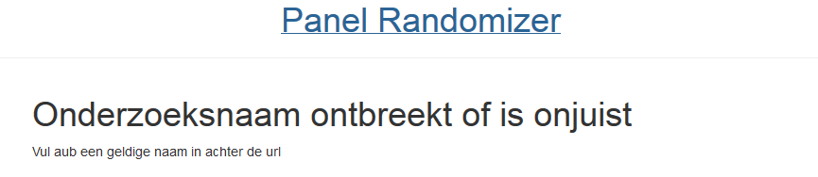

1. To add a YouTube video, you need to add two lines of code to a question:

<script src="https://panel-randomizer.hum.uu.nl/static/panel_randomizer_app/js/YouTube_helper.js" async></script>

<div class="single-play-video" data-video-url="https://www.youtube.com/watch?v=9RTaIpVuTqE" id="video_player1"> </div>

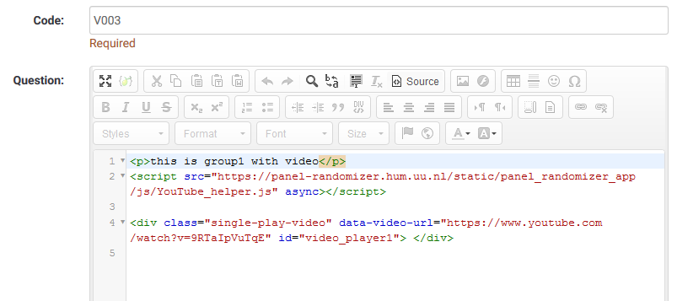

Click ‘Source’ in the edit window of the question. This will show all code.

The first line starting with <script> will retrieve the java script code that calls youtube_helper.js  
The second line will place a YouTube player, which will start automatically playing the video you entered.

You can copy/paste the code above. The url after 'data-video-url=' needs to be adjusted for the aimed video.