NEMO: NEuron MOrphological analysis tool
The aim of this tool is to perform a dynamic quantitative microstructural analysis of neurons.
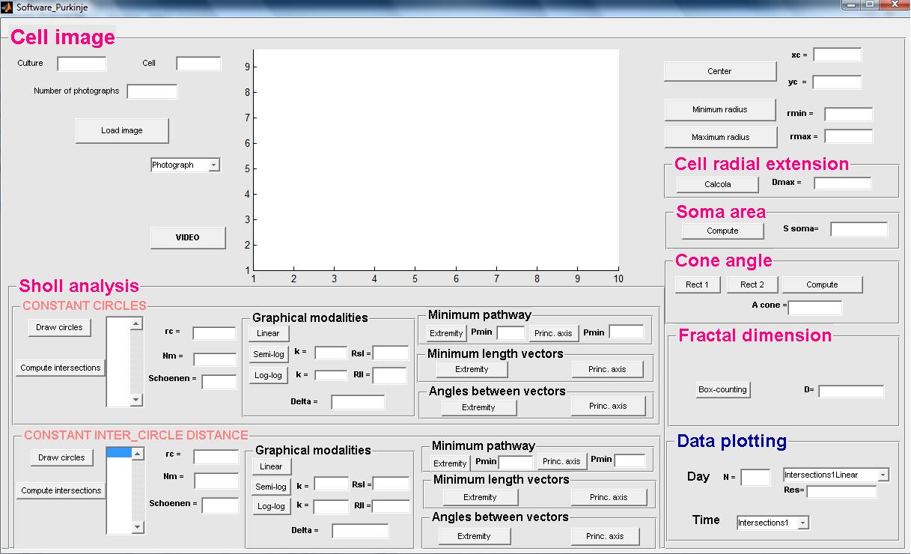
Images to be loaded
The analysis is performed on images of different cells extracted from different cultures. All the images are contained in a database made up of folders one of each relative to a culture (call them “01”, “02”…)and subfolders relative to each cell (call them “0101”, “0102”, “0201”….). Each of these subfolders contain photographs of a cell acquired in different days of culture and the skeletons obtain from this images. Images are named like this: x_number of culture _number of cell_number of photograph_number of day of culture where x is p for photograph, b for binary and s for skeleton.

How to start the program
The first step is to open the folder in which your image is and open the first photograph: the skeleton of the cell is visualized. Then you press “Start analysis” and start the morphological analysis. Images of the cell are loaded and analyzed in succession: when you load the first images all the callback are executed and then the second image is loaded until all the images have been analyzed.
Clicking on the button “Video” you can see the succession of all the images of a cell acquired in different days of culture.

Sholl analysis
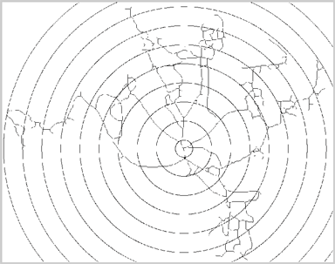
The Sholl analysis allow to analyze the dendritic structure of the neuron by drawing a reference system made of circles around the cell. To start this analysis you have to select with a click of mouse the center of cell and the minimum radius of the circles. Two kind of reference systems are drawn: one with a constant number of circles and one with a constant inter-circles distance. For each of the two systems the number of intersection per circle is computed. For each cell also the critical radius, the maximum number of intersection and the Schoenen index are measured. The semi-log method
and the log-log method of the Sholl analysis are applied and the relative parameters are computed.

Minimum pathway, minimum length vectors and angles between vectors
All these measures are computed on the pathway between the center and the extremity of the cell and on the pathway between the extremity of the center and the principal axis of the cell: this one must be selected with a click of the mouse for two times (one for each reference system).

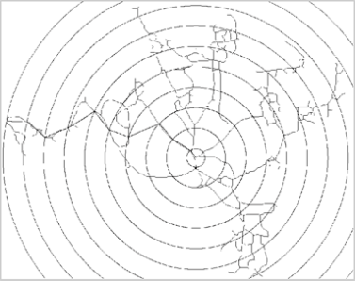

Radial extension
This measure is automatically computed after you select for three times the center of the cell.

Soma size
For the calculation of this feature the photograph of the cell instead of the skeleton is automatically visualized. The soma is approximated to an ellipse so you have to select, by a click of mouse, the extremity of the two principal axis.
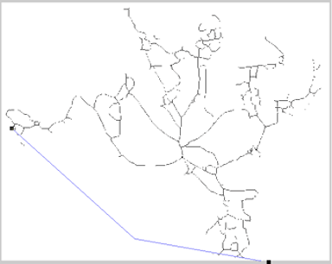

Cone angle
The angle of the con in which the cell is enclosed. If the cell has a radial extension this quantity is set to a value of 360°C. You give the software this indication by clicking with the right button of mouse. Otherwise we have to select the vertex with the click of mouse and then position in the correct way the two half-line that form the cone.

Fractal dimension
The fractal dimension of the cell is automatically compute by the box-counting method.

Data matrix
All the feature extracted from different images of a single cell in different days are collected in a three-dimensional data matrix 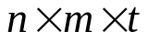where n is the number of cells, m are the variables and t are the days.
A folder named “Datamatrix” is automatically created and contained data relative to all neurons of the culture”
All the data matrix relative to different cells, also from different cultures, can be add in a single structure and data can be analyzed in a graphical way.

