

**MDW ServiceMix Cookbook – Table of Contents**

**Prerequisites:**

**Eclipse with the MDW Plug-In**

Get ready for MDW OSGi development.

**ServiceMix OSGi Container (4.4.1 or 5.1.0)**

Install locally for custom development capabilities.

**Project Setup:**

**1. Create a Local MDW Project**

Use the MDW Plug-In wizard to build a workflow-faceted Java project.

**2. Build Your Workflow Project**

And package your Java code for deployment into the container.

**3. Deploy Your Workflow Bundle**

Install MDW and your workflow bundle in ServiceMix.

**Workflow Development:**

**1. Create a Workflow Process**

Build a basic process definition.

**2. Run Your Process through Designer**

Execute your process using test data.

**3. Consume a Web Service**

Use the Document Web Service adapter activity to invoke a SOAP web service.

**4. Implement a Custom Activity**

Create your own Java-based activity implementor.

**5. Expose Your Process to External Systems**

Register an MDW service-oriented Event Handler to launch your process.

**6. Explore Dynamic Java**

Create a Dynamic Java workflow asset and reference it as a process variable.

**WebApp Development:**

**1. Create a Web Page to Capture User Input**

Use the plug-in wizard to create an XHTML workflow asset.

**2. Create a Standalone Custom Page**

Build a completely independent page which accesses a managed bean.

**3. Create a Process Launch Page**

Use a custom page to capture input and kick off a workflow process.

**4. Customize List Columns and Filters**

Integrate your business data in TaskManager.

**5. Override Default TaskManager Resources**

Make the standard TaskManager look exactly the way you want.

**6. Design a Report and Access it through the Web**

Create a BIRT report based on workflow data.

**MDW ServiceMix Cookbook – Prerequisites**

Contents Next

**Eclipse with the MDW Plug-In**

**Set Up Eclipse on Your PC:**

* Make sure you have Java Runtime 6 installed on your computer:
  + [**http://www.oracle.com/technetwork/java/javase/downloads**](http://www.oracle.com/technetwork/java/javase/downloads)
* Install Eclipse Luna (4.4.x). The easiest way to get Eclipse with all the necessary dependencies is to grab the prepackaged version from this shared location:
  + **\\eldnp1515dm4.ad.qintra.com\union_station\IT\MDW\eclipse**

This Eclipse package includes all the required dependencies except the MDW Plug-In itself. All the necessary features and plug-ins from eclipse.org (Web Tools Platform, Data Tools Platform, Maven Support, Modeling Framework, EPF Rich Text Feature, and [Business Intelligence and Reporting Tools](http://www.eclipse.org/birt)) are incorporated into this bundle.

* Launch Eclipse. Here’s an example command line that includes appropriate JVM memory settings for running and debugging:

**C:\eclipse_4.4.1\eclipse.exe -vm C:\jdk1.6.0_18\bin\javaw.exe -vmargs -Dsun.lang.ClassLoader.allowArraySyntax=true -Xms512m -Xmx1024m -XX:MaxPermSize=256m**

* Install the latest version of the MDW Plug-In via Eclipse Software Updates (Help > Install New Software > Add > **http://lxdenvmtc143.dev.qintra.com:6101/MdwPlugin** > Install).

**Optional Plug-Ins:**

* Groovy Eclipse Plug-In (Groovy script syntax highlighting, auto-complete, etc.)

**http://dist.springsource.org/release/GRECLIPSE/e4.4**

* Quantum DB Plug-In (Database querying)

**http://quantum.sourceforge.net/update-site**

**MDW ServiceMix Cookbook – Prerequisites**

Previous Contents Next

**ServiceMix OSGi**

Start with a vanilla installation of your OSGi container.

**Supported OSGi Containers:**

* ServiceMix 4.4.1 (for MDW 5.2.x) or 5.1.0 (for MDW 5.5.x):
  + [**http://servicemix.apache.org/downloads.html**](http://servicemix.apache.org/downloads.html) **or**
  + **\\eldnp1515dm4.ad.qintra.com\union_station\IT\MDW\ServiceMix**

**[Note: In the following steps, it is strongly suggested that you create a** [**separate container instance**](http://cshare.ad.qintra.com/sites/MDW/Developer%20Resources/Environment/ServiceMix/create_smx_instance_steps.txt) **for running ServiceMix. In that case INSTANCE_HOME refers to your Fuse instance location. If you're running the root server then INSTANCE_HOME refers to your Fuse installation directory.]**

* Add the following lines to INSTANCE_HOME/etc/system.properties:

runtimeEnv=dev

* Add the MDW and Archiva repositories to org.ops4j.pax.url.mvn.repositories in INSTANCE_HOME/etc/org.ops4j.pax.url.mvn.cfg:

(Note: Add these repository URLs **before** any existing URLs, and be careful to include the appropriate commas and line continuation backslashes)

http://archiva.corp.intranet/archiva/repository/mdw, \

http://archiva.corp.intranet/archiva/repository/development, \

http://archiva.corp.intranet/archiva/repository/snapshots@snapshots, \

* Start ServiceMix. Later you'll learn how to launch and debug ServiceMix from Eclipse, but for now just execute SERVICEMIX_HOME/bin/servicemix.bat (root level) or INSTANCE_HOME/bin/karaf.bat (instance level).
* MDW depends on a number of OSGi bundles, some of which are custom versions hosted in the Archiva Maven repository. These can be easily installed via the mdw-dependencies feature through the following commands in the ServiceMix karaf console:
  + For MDW 5.2.x:

**addUrl mvn:com.centurylink.mdw/mdw/5.2.xx/xml/dependencies**

**features:install mdw-dependencies**

* + For MDW 5.5.x:

**addUrl mvn:com.centurylink.mdw/mdw/5.5.xx/xml/dependencies**

**features:install mdw-smx-dependencies**

* MDW also needs a JMS connection factory. The steps for installing the JMS provider are different for ServiceMix 4.4 versus ServiceMix 5.1:
  + ServiceMix 4.4.1:
    1. Start the activemq-core and Aries transaction manager bundles by following these one-times steps:

**list | grep activemq-core**

**start 53 (replace 53 with the activemq-core bundle ID)**

**list | grep Aries**

**start 59 (replace 59 with the Aries bundle ID)**

* + 1. Deploy the MDW ActiveMQ broker configuration by saving the following XML file into your instance's **deploy** directory:

[**http://cshare.ad.qintra.com/sites/MDW/Developer%20Resources/Environment/ServiceMix/Example%20ActiveMQ%20Config/mdw-activemq.xml**](http://cshare.ad.qintra.com/sites/MDW/Developer%20Resources/Environment/ServiceMix/Example%20ActiveMQ%20Config/mdw-activemq.xml)

* ServiceMix 5.1.0:

1. Install the ActiveMQ Blueprint feature by typing the following in the Karaf console:

**addurl mvn:org.apache.activemq/activemq-karaf/5.10.0/xml/features**

**features:install activemq-blueprint**

1. Download the MDW ActiveMQ broker configuration by saving the following XML file into your instance's **etc** directory:

[**http://cshare.ad.qintra.com/sites/MDW/Developer%20Resources/Environment/ServiceMix/Example%20ActiveMQ%20Config/activemq.xml**](http://cshare.ad.qintra.com/sites/MDW/Developer%20Resources/Environment/ServiceMix/Example%20ActiveMQ%20Config/activemq.xml)

* Shutdown your server by typing "shutdown" and then confirming in the karaf command console.
  + MDW ServiceMix Resources

On the MDW SharePoint site, there are a number of example artifacts and an FAQ describing common issues that can occur when deploying your workflow app on ServiceMix. Refer to these resources if you encounter problems while working through this tutorial.

[**http://cshare.ad.qintra.com/sites/MDW/Developer%20Resources/Environment/ServiceMix**](http://cshare.ad.qintra.com/sites/MDW/Developer%20Resources/Environment/ServiceMix)

**MDW Database:**

* MDW stores workflow definition and runtime data in an Oracle database. Supported versions are Oracle 10g and 11g. For development you can point to the shared MDW cloud environment. Otherwise you will need to configure an instance of Oracle with the MDW db schema. Details are outlined in the following SharePoint location:
  + [**http://cshare.ad.qintra.com/sites/MDW/Developer Resources/MDW Database**](http://cshare.ad.qintra.com/sites/MDW/Developer%20Resources/MDW%20Database)

**MDW ServiceMix Cookbook – Project Setup**

Previous Contents Next

**1. Create a Local MDW Workflow Project**

Local projects in MDW allow you to create custom Activity Implementors and External Event handlers, and to override package-level configuration settings locally. Local projects require that a supported container be installed. The [MDW Cloud Development Tutorial](http://cshare/sites/MDW/Developer%20Resources/Tutorials/MdwCloudDevelopmentTutorial.html) provides an in-depth comparison between local and remote cloud projects.

You can start with a preexisting Java project and convert it to an MDW workflow project. The following steps assume that you're starting with a clean workspace. If instead you already have a Java project that you wish to convert, you can launch the conversion wizard by right-clicking on the project in Package Explorer view and selecting Configure > Convert to MDW Workflow Project. Make sure to click the "Additional configuration required..." link to execute the setup wizard (which will be similar in appearance to the screenshots below). Note: converting an existing Java Project does not automatically create artifacts such as the pom.xml Maven build file. For this reason if you convert an existing project it's recommended that you also generate a from-scratch example project for reference.

**Launch the Workflow Project Wizard:**

* From the Eclipse menu select File > New > Project... > MDW Projects > Local Workflow Project. Type a project name and select the Apache ServiceMix container, and then click Next.

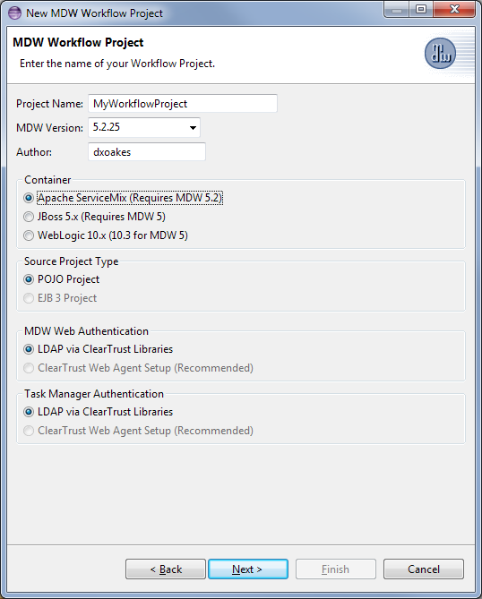

* Populate the container-specific Server Settings page. If you're using a specific container instance other than the root, enter the instance path for the Server Location. The SSH port should match the value specified in etc/org.apache.karaf.shell.cfg. The default ServiceMix user/password for root-level containers is smx/smx; for instance-level containers it's karaf/karaf.

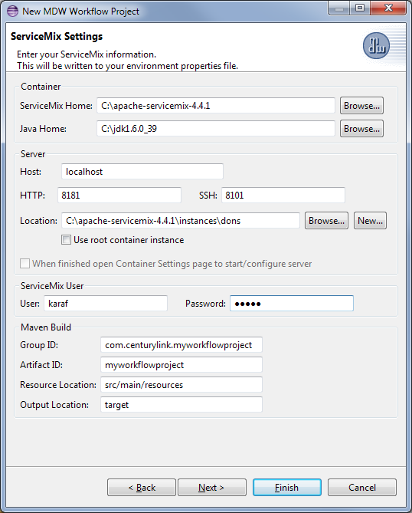

* Enter the connection information for your MDW database. The default values correspond to the MDW Development Cloud Sandbox environment.

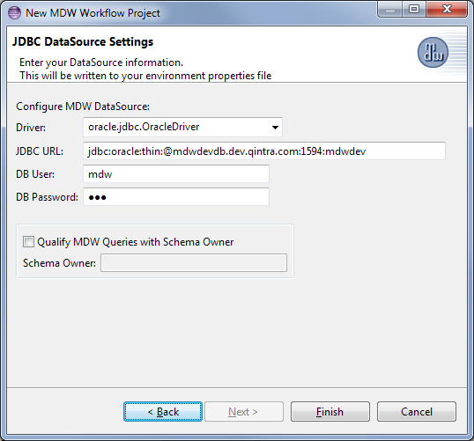

* When you click Finish the wizard will create a Java project with the MDW Workflow project facet. If you have the Maven M2E plug-in installed (recommended), the project will also be configured for Maven build integration.
* One way to deploy an OSGi bundle into ServiceMix is to manually copy it into the "deploy" directory in your container instance. However, during iterative development it is more convenient to integrate with the Eclipse build process so that your changes can be published automatically. For this we'll use the Eclipse Servers view (Window > Show View > Other > Server > Servers).
* Right-click in Servers view and select New > Server. Select Apache > ServiceMix 4.4 for the server type. The server name can be anything, but if you ever use multiple servers in the same workspace it's handy to reference your project name and/or instance name.

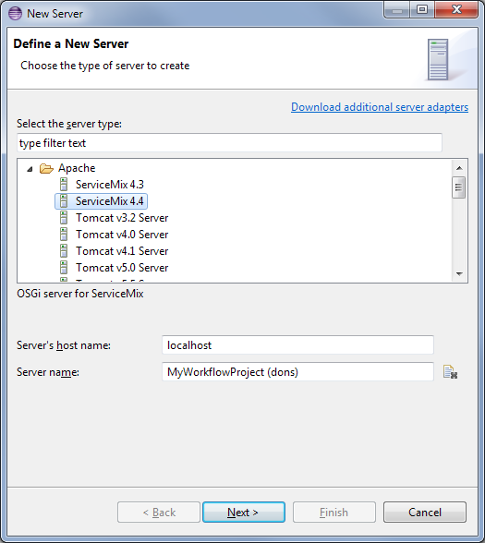

* Click Next and enter the location of your ServiceMix installation.

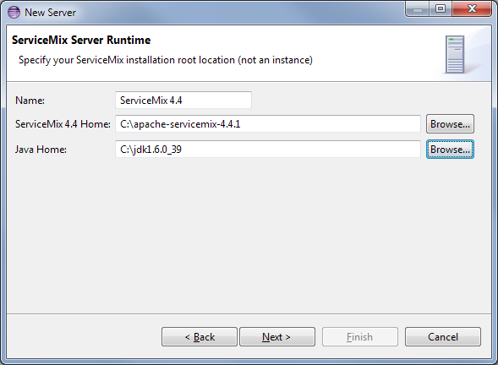

* Click Next again to configure your ServiceMix server instance.

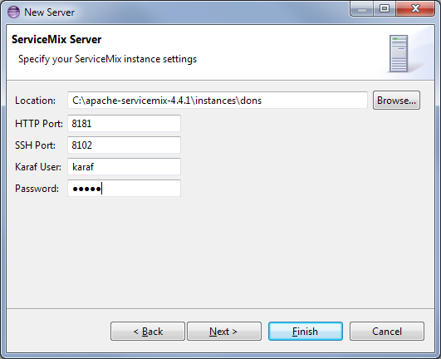

* Click Next one more time. Since you’ve not built your project yet, do not select anything to be added to the Server yet in the Add and Remove page. Click Finish.

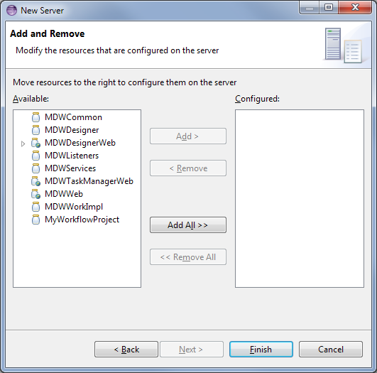

* With this in place you can start and stop ServiceMix from within Eclipse (output is to the Server Console view). Start the server by right-clicking and selecting Start from the menu.

**MDW ServiceMix Cookbook – Project Setup**

Previous Contents Next

**2. Build Your Workflow Project**

At this point you have a plain, empty ServiceMix instance up and running. The console output is displayed in the MDW Server Console view.

**Perform the Maven Build for Your Project:**

* In Eclipse Package Explorer view, right-click on the pom.xml file at the root of your project and select Run As > Maven Build. Since this is the first time the project's been built, you'll be prompted to enter a goal in the launch configuration dialog. Enter "package" as your goal for now.

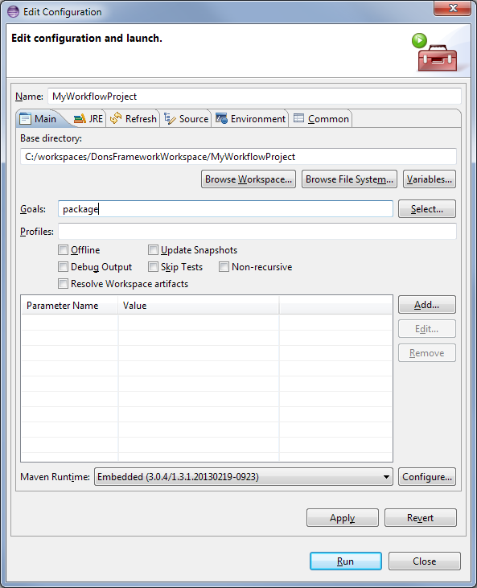

This produces your bundle jar file in the target directory of your project. You can inspect the generated jar file in this directory along with its MANIFEST.MF to get a feel for how the OSGi bundle is packaged. The Maven build also merges the mdw property file template (src/main/resources/deploy/config/com.centurylink.mdw.cfg) with your environment-specific settings (src/main/resources/deploy/env.properties.dev), and writes the output to the etc directory of your ServiceMix instance. This configuration file is required by the MDW Framework runtime engine.

If you have the Maven plug-in for Eclipse installed, you can perform your builds directly through the Eclipse mechanism (ctrl-B). A one-time step that may be required to synchronize your Eclipse project build path with your pom.xml dependencies is to right-click on the project in Package Explorer and select Maven > Update Project Configuration.

**MDW ServiceMix Cookbook – Project Setup**

Previous Contents Next

**3. Deploy Your Workflow Bundle**

It's apparent from your project's pom.xml build file that your bundle has dependencies on the MDW Framework bundles. So before you can deploy you'll need to install the MDW feature (which includes all the required bundles).

**Install the MDW Feature:**

* Open a ServiceMix shell window. This can be accomplished by clicking on the deploy.gif ("Client Shell") toolbar icon on the Server Console view in Eclipse (the same view that displays the ServiceMix STDOUT output). Note: if you did not choose to start ServiceMix in Step 1, or if you've shut down the server in the meantime, you can start it now by right-clicking on the project in Package Explorer and selecting Run As > Start MDW Server Runner (or by right-clicking on the project in Process Explorer and selecting Run).
* In the client shell window run these ServiceMix shell commands to install the MDW OSGi Bundles. Replace 5.2.xx with your MDW version. (Anytime you upgrade to a new MDW build, you'll need to uninstall the previous feature and install the updated one).
  + For MDW 5.2.x

Install the MDW feature in karaf:

**addUrl mvn:com.centurylink.mdw/mdw/5.2.xx/xml/features**

**features:install mdw**

Test access in your browser:

[**http://localhost:8181/MDWTaskManagerWeb**](http://localhost:8181/MDWTaskManagerWeb)

* For MDW 5.5.x

Install the MDW feature in karaf:

**addUrl mvn:com.centurylink.mdw/mdw/5.5.xx/xml/features**

**features:install mdw**

Test access in your browser:

[**http://localhost:8181/MDWHub**](http://localhost:8181/MDWHub)

* Shutdown ServiceMix by clicking on thestop.gif ("Stop") toolbar icon in the Server Console view (which will automatically close your ServiceMix client shell window).

**Deploy Your Workflow Bundle in ServiceMix:**

* Right-click on your server in Servers view and select Add and Remove… from the menu. Add your workflow project to the configured elements.

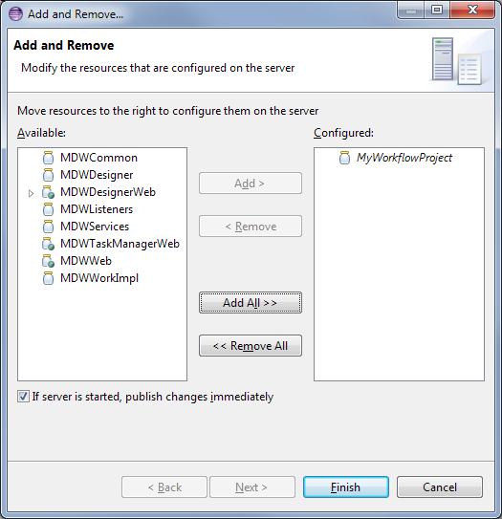

* When you make changes to your project’s source code, an Eclipse build will trigger an automatic hot deployment to ServiceMix. Test a code change by opening the WorkflowBundleActivator.java file that was generated by the workflow project wizard. Edit the logging output in the start() method so that it says something different, then save (if Eclipse autobuild is in effect the save triggers a build automatically; otherwise type ctrl-b to build). A Maven build is NOT required. Within a few seconds ServiceMix should pick up your change and redeploy, and you'll see your modified logging output when the bundle is activated.
* Aside from whatever custom logging you've added, you should see something like the following in the Server Console view:

[(i)20120705.11:50:09.671 ~21] Starting workflow bundle com.centurylink.myservicemix

[(i)20120705.11:50:10.343 ~21] Registering com.centurylink.mdw.common.provider.ActivityProvider with unique alias 'myservicemixActivities' from bundle com.centurylink.myservicemix

[(i)20120705.11:50:10.343 ~21] Registering com.centurylink.mdw.common.provider.EventHandlerProvider with unique alias 'myservicemixEventHandlers' from bundle com.centurylink.myservicemix

[(i)20120705.11:50:10.343 ~21] Registering com.centurylink.mdw.common.provider.VariableTranslatorProvider with unique alias 'myservicemixVariableTranslators' from bundle com.centurylink.myservicemix

[(i)20120705.11:50:10.343 ~21] Startup complete for workflow bundle com.centurylink.myservicemix

Note: for subsequent server startups, to prevent premature deployment of your workflow bundle (before the MDW bundles have successfully deployed), it's a good idea to set a bundle startup level in the ServiceMix Karaf console. The syntax is as follows:

**bundle-level <my_bundle_id> 90**

(This one-time step sets your bundle's startup level to 90, greater than the range of startup levels specified in the mdw feature install file).

**MDW ServiceMix Cookbook – Workflow Development**

Previous Contents Next

**1. Create a Workflow Process**

**Open the Designer Perspective in Eclipse:**

* From the Eclipse menu select Window > Open Perspective > Other > MDW Designer.
* For detailed documentation covering Designer functionality, refer to the User Guide:
  + [**http://cshare.ad.qintra.com/sites/MDW/User%20Documentation/MDW%20Designer%20User%20Guide.doc**](http://cshare.ad.qintra.com/sites/MDW/User%20Documentation/MDW%20Designer%20User%20Guide.doc)

**Ensure Permissions:**

* To follow the steps in this section of the Tutorial you need to be granted the appropriate roles in the MDW database you're pointed to. You can view your current privileges by clicking on the Permissions property tab for the project. An administrator can grant you the appropriate access using the MDW Task Manager webapp. For a detailed discussion of this topic, refer to the "Roles and Permissions" section of the [MDW Designer User Guide](http://cshare.ad.qintra.com/sites/MDW/User%20Documentation/MDW%20Designer%20User%20Guide.doc).

**Create a Workflow Package:**

* Expand the project tree in Process Explorer. This triggers Designer to load the high-level definition data contained in the environment. The MDW development cloud sandbox database contains quite a few process definitions and workflow artifacts so this may take a minute or so to complete.
* The top-level branches in the project tree represent workflow packages. Your work should be incorporated in a dedicated package, which will be used for managing resources. For further details refer to the Eclipse Cheat Sheet (Help > Cheat Sheets > MDW Workflow > Importing, Exporting and Versioning).
* Create your workflow package by right-clicking on your workflow project in Process Explorer and selecting New > MDW Package. Note: best practice is to ensure that your package name does not contain spaces since it may incorporate dynamic Java or Groovy resources.

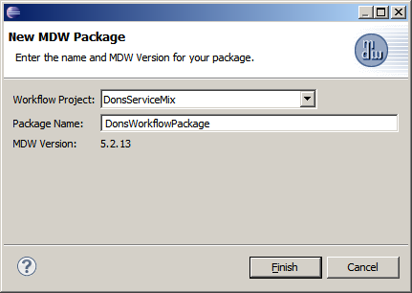

**Create the Process:**

* Right-click on your new package in Process Explorer and select New > MDW Process. Enter the process name and description, and click Finish.

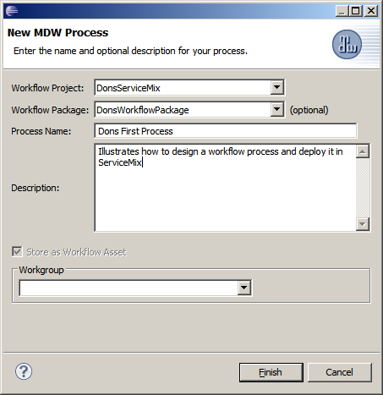

**Add some Variables:**

* In the Properties View, select the Variables tab for the process and add an input variable (orderDoc) and two local variables (orderNumber and validationResult) with types as depicted below.

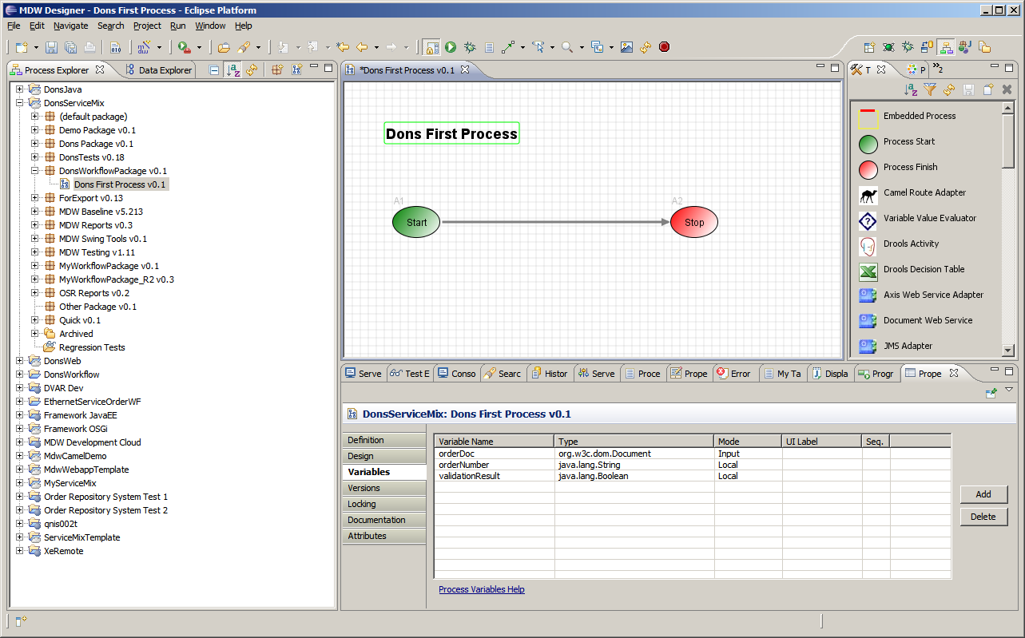

**Add Custom Logic with Groovy Script:**

* From the Toolbox View, drag the activity whose icon is labeled "Execute Script" onto your canvas and insert it into your process flow between the Start and Stop activities. Change the label for this new activity to say "Perform Validation".

*Tip: To draw a link (or "transition" in MDW terminology) between activities on the designer canvas, hold down the Shift key on your keyboard, Click on the upstream activity, and continue holding down the mouse left click button while Dragging the cursor to the downstream activity ("shift-click-drag").*

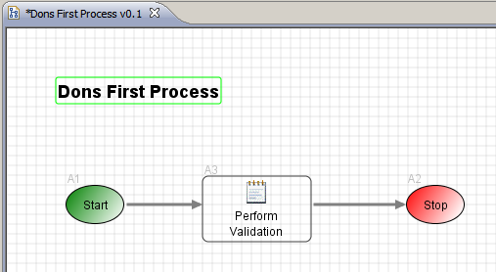

* Right-click on the activity and select Edit Script from the menu. The default scripting language for MDW is Groovy (although you can change this in Script property tab for the activity). Update the Groovy script for your activity to resemble the following:

**import** org.w3c.dom.Node;

Node orderNumNode = orderDoc.getFirstChild().getFirstChild().getNextSibling();

orderNumber = orderNumNode.getFirstChild().getNodeValue();

validationResult = orderNumNode.getLocalName().equals("orderNumber");

**return** validationResult;

When you save the updated Groovy scrip you'll be presented with a message dialog reminding you that your process definition should be saved to persist your local changes back to the cloud. And when you save the process definition your lock on the process may be released. If this happens the canvas will take on the appearance of a read-only process. Locking is the mechanism Designer uses to prevent multiple simultaneous modifications. If required you can re-lock the process from the Properties view Locking tab.

**Add Multiple Activity Outcomes:**

* Add another outbound transition from your "Perform Validation" activity. Assign Result Code values of "true" and "false" to the respective outgoing transitions as illustrated below. Save your process definition. The return value from your Groovy script drives which of these two transitions will be traversed at runtime. Save your process design with these changes.

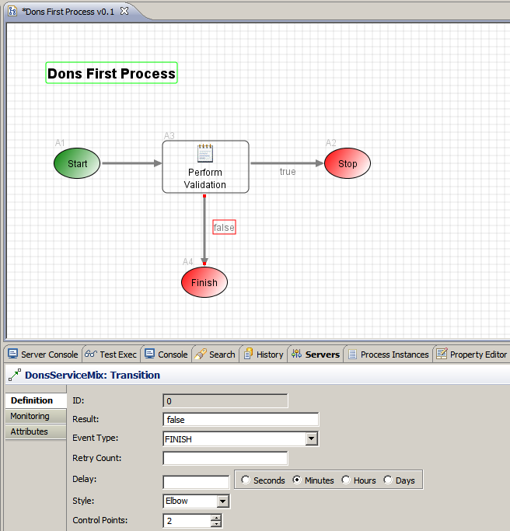

**MDW ServiceMix Cookbook – Workflow Development**

Previous Contents Next

**2. Run Your Process through Designer**

**Display the Launch Configuration Dialog:**

* Right-click on your process in Process Explorer view and Select Run. Designer will present the launch dialog and open a connection to ServiceMix to confirm that the server is running (required for launching a process).

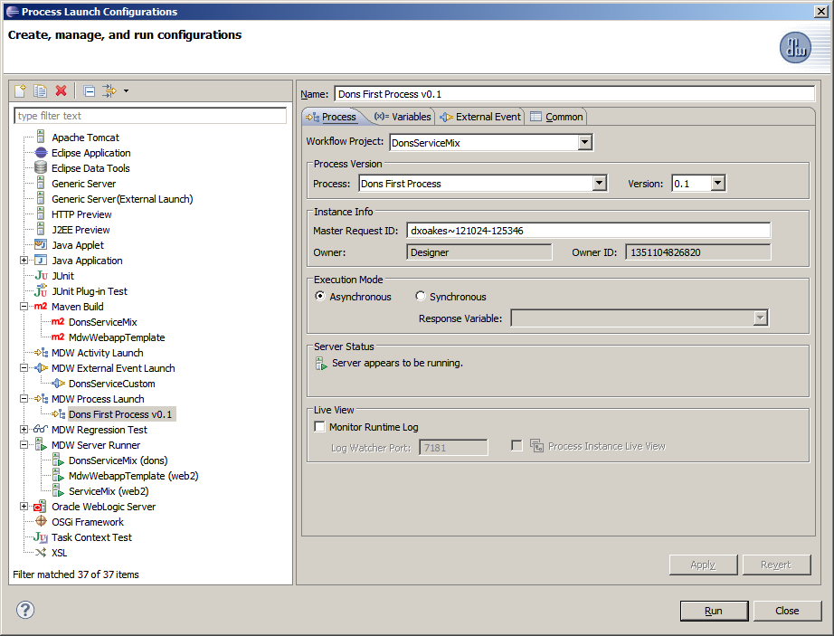

**Populate the Input Variable:**

* Select the Variables tab in the launch dialog, and populate the orderDoc variable with the following content.

<order>

<orderNumber>N12345678</orderNumber>

</order>

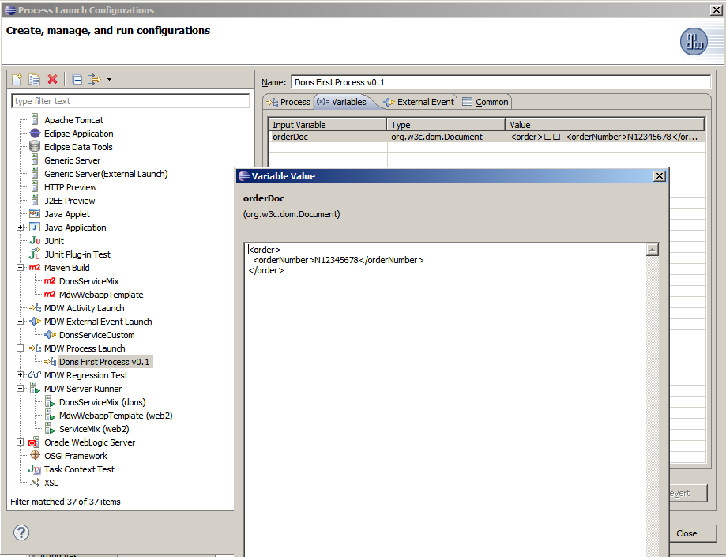

**Launch and View an Instance:**

* Click Run on the launch dialog to run an instance of your process. You can open the process instance by right-clicking on your process in Process Explorer view and selecting View Instances. The latest instance will appear at the top of the Process Instances view, and you can double-click on the instance to open its runtime view. In the process instance view you should see that the new instance traversed down the happy path with a validation outcome equal to 'true'.
* Click on the Variables tab in the Properties view for the process instance to inspect the runtime variable values.

**Dynamically Change Script Code and Rerun:**

* Change the Groovy source so that validation expects an order number that begins with a digit:

validationResult = orderNumNode.getLocalName().equals("orderNumber") && Character.*isDigit*(orderNumber.charAt(0));

* Save your process, and launch by right-clicking and selecting Run. Your previous value for orderDoc should be remembered. Click the Run button on the launch dialog. This time when your process instance finishes executing, the validation result should reflect 'false'. Note that for your source code changes to take effect you did not need to republish or redeploy; the changes were automatically picked up and dynamically compiled by the runtime engine.

**MDW ServiceMix Cookbook – Workflow Development**

Previous Contents Next

**3. Consume a Web Service**

MDW comes with the Document Web Service Activity for consuming document-style services hosted by external providers. In this exercise we'll invoke the GetEmployee service hosted in the MDW Development Cloud (and this service itself is implemented as an MDW workflow process; the sections ahead describe how to create and expose a service process).

**Use the Document Web Service Activity:**

* Open the same process definition you started building in the sections above. Add another String variable called customerId, and an Integer variable called discountPercent. Edit the script in Perform Validation to assign the customerId variable according to a node in the input document:

customerId = orderNumNode.getNextSibling().getNextSibling().getFirstChild().getNodeValue();

* Drag the Document Web Service activity onto the design canvas and insert it downstream of Perform Validation. Label the web service activity "Check Employee", and give it two separate outcomes corresponding to true and false, just like the validation activity.

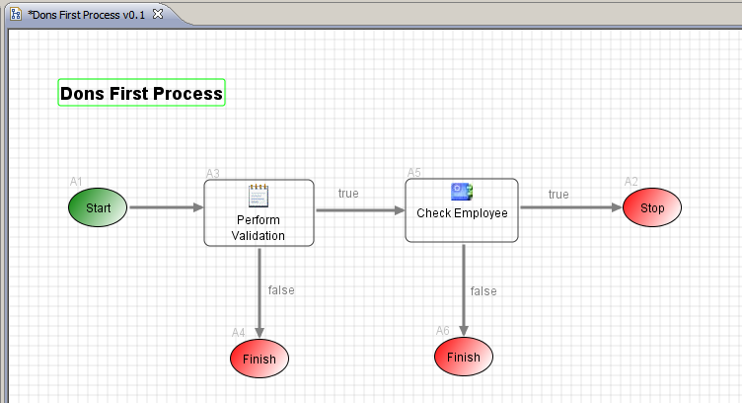

On the Design tab of the service, set the Endpoint/WSDL URL to : http://lxdenvmtc143.dev.qintra.com:7021/MDWWeb/SOAP.

**Add Pre and Post Script:**

* In adapter activities such as the Document Web Service activity, you can associate script to be executed before and after the service call. Prescript can be used to build the service request, and postscript can be used for processing the response. Double-click on the Check Employee activity and select the Script property tab. Edit the prescript to return a request that includes the customerId variable:

**return** '''<GetEmployee>

<sapId>''' + customerId + '''</sapId>

</GetEmployee>''';

* Add new process variables to hold the service request (name=employeeServiceRequest, type=com.centurylink.mdw.model.StringDocument) and response (name=employeeServiceResponse, type=org.w3c.dom.Document). On the Design tab of the Check Employee web service activity, select these new variables in the Request Variable and Response Variable dropdowns respectively. Edit the postscript so that it assigns a value to discountPercent based on the response:

**import** org.w3c.dom.Node;

**import** org.w3c.dom.NodeList;

NodeList nodes = employeeServiceResponse.getFirstChild().getChildNodes();

String firstName = **null**;

String lastName = **null**;

**for** (**int** i = 0; i < nodes.getLength(); i++)

{

Node node = nodes.item(i);

**if** ("firstName".equals(node.getLocalName()))

firstName = node.getFirstChild().getNodeValue();

**else** **if** ("lastName".equals(node.getLocalName()))

lastName = node.getFirstChild().getNodeValue();

}

**if** (firstName != **null** && lastName != **null**)

{

println 'Found employee: ' + firstName + ' ' + lastName;

discountPercent = 10;

**return** **true**;

}

**else**

{

println 'Employee not found: ' + customerId;

discountPercent = 0;

**return** **false**;

}

**Save and Run Your Process:**

* Save the modified process. When prompted, elect to "Save as new minor version". Whenever a process design that has runtime instances is changed structurally (new activities or transitions), it is highly recommended that you increment the version number so that Designer can correctly display runtime data in the process instance view.
* Right-click on a blank spot in the designer canvas and select Run to open the launch configuration dialog. On the Variables tab change the value for orderDoc to include a valid orderNumber (with a digit as the first character), and also your CenturyLink SAP ID for the customerId:

<order>

<orderNumber>012345678</orderNumber>

<customerId>DHO115360</customerId>

</order>

* Right-click again on a blank spot and select View Instances. Double-click the instance to open it. It should reflect that the service was invoked, your SAP ID was found, and the discountPercent variable should be set to 10. Double-click on the Check Employee activity in the process instance. On the Instance property tab, double-click on the instance row to display the raw SOAP request and response:

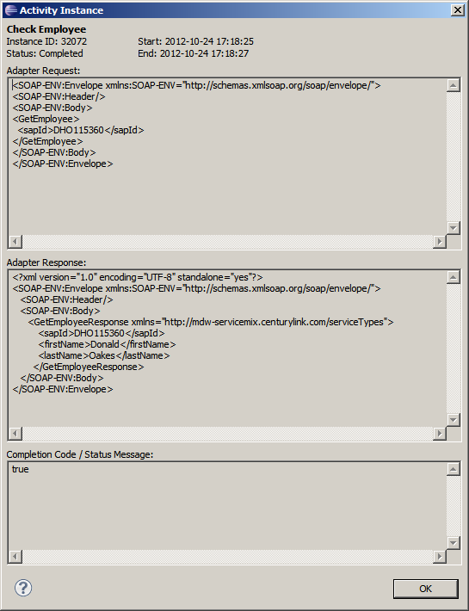

**MDW ServiceMix Cookbook – Workflow Development**

Previous Contents Next

**4. Implement a Custom Activity**

**Run the Activity Creation Wizard:**

* Expand your project in Process Explorer view. If you don't already have a workflow package for your work, create one by selecting File > New > MDW Package from the menu. Right-click on your package and select New > Activity > General Activity.
* Note the distinction between your workflow package and the Java package that appears in the following screenshot. Your workflow package contains your processes, assets and dynamic code. The Java package for your custom implementor resolves to the location of the generated source code in your local Java project on your hard drive.
* When you click Finish the wizard will generate a skeleton activity implementor and register it in the database so that it will appear in the Toolbox for inclusion in your processes.

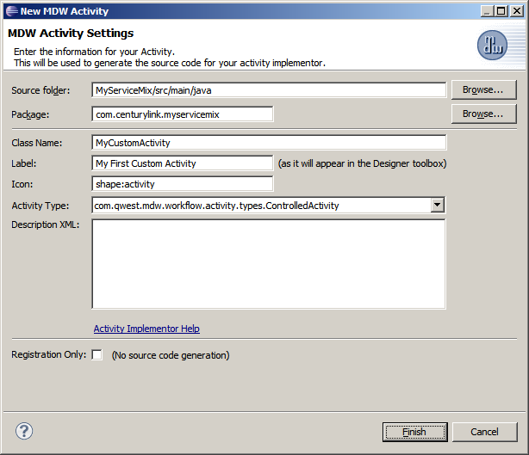

* Edit the generated Java code for your activity and save.

**package** com.centurylink.myservicemix;

**import** com.centurylink.mdw.common.utilities.logger.StandardLogger.LogLevel;

**import** com.centurylink.mdw.common.utilities.timer.Tracked;

**import** com.centurylink.mdw.workflow.activity.DefaultActivityImpl;

**import** com.centurylink.mdw.activity.ActivityException;

@Tracked(LogLevel.*TRACE*)

**public** **class** MyCustomActivity **extends** DefaultActivityImpl

{

@Override

**public** **void** execute() **throws** ActivityException

{

**this**.loginfo("Doing something important...");

}

}

**Add Your Custom Activity to a Process:**

Open Designer Perspective and find your process definition from Step 2. From the Toolbox view drag your new custom activity onto the Designer canvas and position it upstream of the existing script activity. Change the activity label from the default value and save the process.

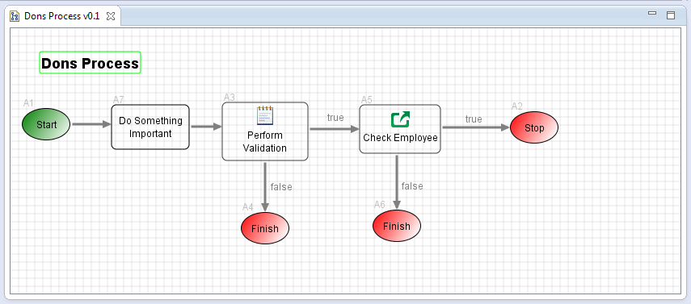

**Run the Modified Process:**

* Perform an Eclipse build (either by autobuild or ctrl-b) and wait until the Server Console displays the registration output for your bundle's ActivityProvider (which indicates that your updated bundle has finished deploying).
* Right-click on the process and select Run to open the launch dialog. After the process instance is launched you should see the custom activity log output in your Server Console view.

**MDW ServiceMix Cookbook – Workflow Development**

Previous Contents Next

**5. Expose Your Process to External Systems**

**Create an MDW Service Process:**

* Right-click on your workflow package in Process Explorer view and select New > MDW Process. Name your process something like "My Service Process" and click Finish. In the design canvas, right click on the process title and select Show Properties. Then on the Design property tab for your process check the box labeled "Service Process". In MDW terminology this designates your process as one that runs synchronously and is able to generate a response in real time. For more background on Service Processes, click on the context help link "Process Configuration Help".

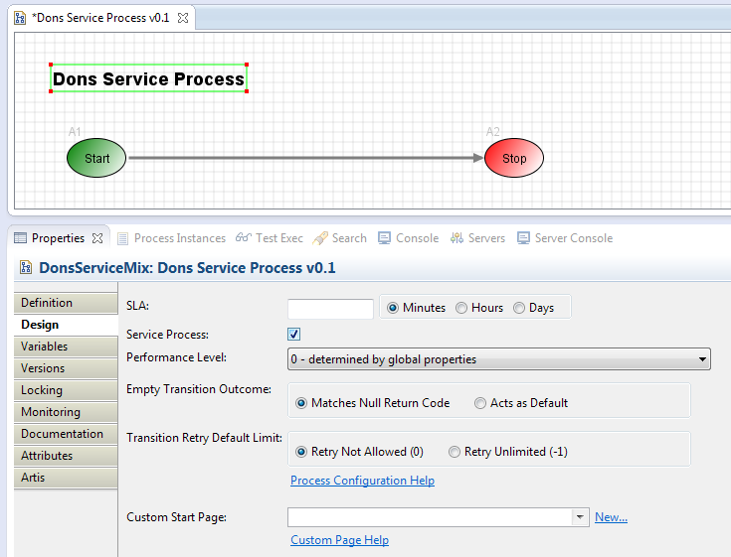

* Add two process variables of type org.w3c.dom.Document, an Input variable called "request" and an Output variable called "response".

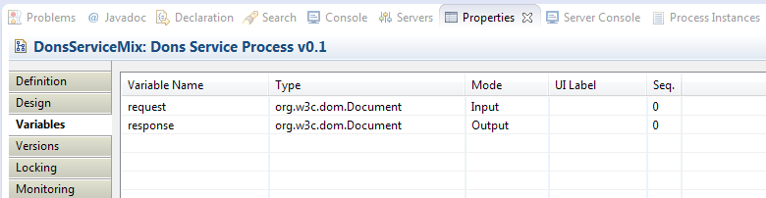

* Drag a Dynamic Java activity from the Toolbox view onto your canvas, label it "Hello Response", and insert it into your flow between the Start and Stop activities. On the Java property tab for this activity, select "response" as writable. Click "Edit Java Code" and paste the following to overwrite the body of the execute() method (you'll learn more about Dynamic Java in the following section).

**public** Object execute(Map<String,Object> variables) **throws** JavaExecutionException

{

**try**

{

// use XPath to select elements

org.w3c.dom.Document request = (org.w3c.dom.Document)variables.get("request");

javax.xml.xpath.XPath xpath = javax.xml.xpath.XPathFactory.*newInstance*().newXPath();

// get the root node name

javax.xml.xpath.XPathExpression expr = xpath.compile("/");

org.w3c.dom.NodeList nodeList =

(org.w3c.dom.NodeList)expr.evaluate(request, javax.xml.xpath.XPathConstants.*NODESET*);

String rootName = nodeList.item(0).getChildNodes().item(0).getLocalName();

// get the 'name' value

expr = xpath.compile("//name");

nodeList = (org.w3c.dom.NodeList)expr.evaluate(request, javax.xml.xpath.XPathConstants.*NODESET*);

String name = nodeList.item(0).getChildNodes().item(0).getNodeValue();

String reply = "<" + rootName + "Response>\n " + "<reply>Hello, " + name + "!</reply>\n" +

"</" + rootName + "Response>";

variables.put("response", com.centurylink.mdw.xml.DomHelper.*toDomDocument*(reply));

**return** **null**;

}

**catch** (Throwable t)

{

**throw** **new** JavaExecutionException(t.getMessage(), t);

}

}

* The "request" variable is implicitly bound to the contents of the incoming service request. The "response" variable that this code populates is the basis for what will be returned to external systems that invoke your workflow process through a service call.
* Before exposing your process as a service, you can test it in Designer using a process launch configuration (right-click and select Run…). Populate the "request" input variable with a value like the following (substitute your name in both the root element name and the child node value).

<HelloDon>

<name>Don Oakes</name>

</HelloDon>

* On the launch configuration Process tab, select the Synchronous radio button. In the Response Variable dropdown select "response", so that the Designer plug-in will display your generated response in the console.

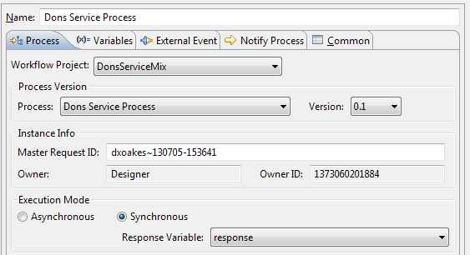

* The response displayed in the Process Launch Response console should look something like this:

<HelloDonResponse>

<reply>Hello, Don Oakes!</reply>

</HelloDonResponse>

* If you encounter a NoClassDefFoundError for a class in package *javax.xml.xpath*, then you'll need to add this to the Import-Package declaration in your pom.xml build file. Once you've successfully launched your service process, view the latest instance to confirm the values for the request and response variables.

**Create an External Event Handler:**

* MDW services are registered using a protocol-neutral mechanism based on the request document content. This registration is what we refer to as an External Event Handler (later you'll learn how to use an alternate registration method based on Apache Camel routes). Once you register an event handler, then by default it's exposed over all the available transport channels that MDW supports (SOAP, REST, JMS, etc). For more information about this mechanism, refer to Help Topic: MDW Designer Help > Coding and Development > Listeners and External Event Handlers.
* Right-click on your workflow package in Process Explorer view and select New > External Event Handler. For the Handler Action type the name of the service process you created in the previous step. For the Message Pattern enter an XPath expression that matches your request document. In effect, you are telling MDW to launch your service process whenever it receives a request whose document content matches the configured message pattern. Note that if a request is received that matches multiple registered event handlers, then it is undefined which of those handlers will be invoked. For this reason it is imperative that you make the XPath expression unique so that it does not match requests it is not intended to handle (and therefore hijack those requests from their intended handler).

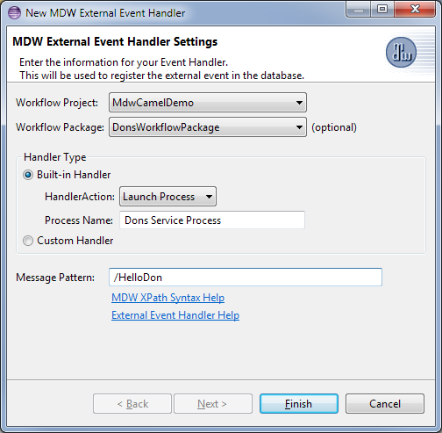

* In Process Explorer view your event handler appears labeled as its associated message pattern. You can test it by right-clicking on it and selecting Run, and then filling in the External Event Request in the launch dialog. When you run this way Designer submits the request document over HTTP to the MDW RESTful listener, so it not only tests your process flow but it also tests your Event Handler registration as well.

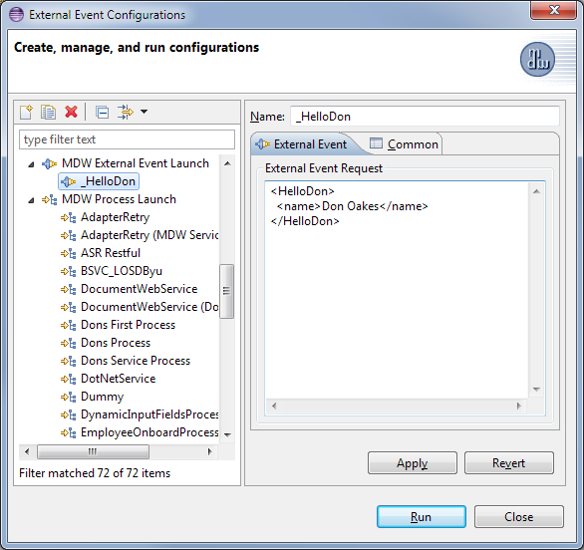

* After successfully invoking your External Event Handler, you should see the expected response in the console view, and you should also find that a new instance of your service process was created.

**Implement a SOAP Web Service:**

* The easiest way to expose your process as a SOAP service is to create a document-style WSDL workflow asset that describes it. In Process Explorer view, right-click on your workflow package and select New > XML Document. Name it something appropriate for your service, and select the language as WSDL.

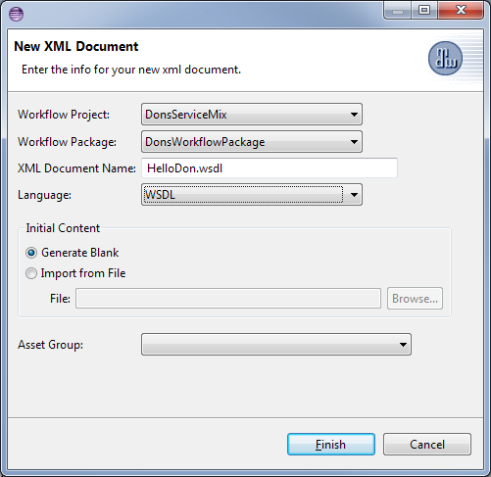

* Edit the content of your WSDL to look something like the following (with appropriate substitutions based on your request and response).

<?xml version=*"1.0"* encoding=*"UTF-8"*?>

<wsdl:definitions

name=*"wsdl-first"*

xmlns:wsdl=*"http://schemas.xmlsoap.org/wsdl/"*

xmlns:soap=*"http://schemas.xmlsoap.org/wsdl/soap/"*

xmlns:xsd=*"http://www.w3.org/2001/XMLSchema"*

xmlns:xsi=*"http://www.w3.org/2001/XMLSchema-instance"*

xmlns:tns=*"http://mdw-servicemix.centurylink.com"*

targetNamespace=*"http://mdw-servicemix.centurylink.com"*>

<wsdl:types>

<xsd:schema>

<xsd:element name=*"HelloDon"*>

<xsd:complexType>

<xsd:sequence>

<xsd:element

name=*"name"*

type=*"xsd:string"* />

</xsd:sequence>

</xsd:complexType>

</xsd:element>

<xsd:element name=*"HelloDonResponse"*>

<xsd:complexType>

<xsd:sequence>

<xsd:element

name=*"reply"*

type=*"xsd:string"* />

</xsd:sequence>

</xsd:complexType>

</xsd:element>

</xsd:schema>

</wsdl:types>

<wsdl:message name=*"HelloDonRequest"*>

<wsdl:part

name=*"payload"*

element=*"HelloDon"* />

</wsdl:message>

<wsdl:message name=*"HelloDonResponse"*>

<wsdl:part

name=*"payload"*

element=*"HelloDonResponse"* />

</wsdl:message>

<wsdl:portType name=*"Hello"*>

<wsdl:operation name=*"Hello"*>

<wsdl:input message=*"tns:HelloDonRequest"* />

<wsdl:output message=*"tns:HelloDonResponse"* />

</wsdl:operation>

</wsdl:portType>

<wsdl:binding

name=*"HelloSOAPBinding"*

type=*"tns:Hello"*>

<soap:binding

style=*"document"*

transport=*"http://schemas.xmlsoap.org/soap/http"* />

<wsdl:operation name=*"Hello"*>

<wsdl:input>

<soap:body use=*"literal"* />

</wsdl:input>

<wsdl:output>

<soap:body use=*"literal"* />

</wsdl:output>

</wsdl:operation>

</wsdl:binding>

<wsdl:service name=*"HelloService"*>

<wsdl:port

binding=*"tns:HelloSOAPBinding"*

name=*"soap"*>

<soap:address location=*"${MDWFramework.MDWDesigner/services.url}/SOAP/DonsWorkflowPackage/HelloDon.wsdl"* />

</wsdl:port>

</wsdl:service>

</wsdl:definitions>

* Note that this URL is parameterized in the WSDL <soap:address> so that at runtime it will be substituted with the appropriate base URL for the specific environment where it's served from
* Once you save the WSDL you should be able to access it in your browser from a location similar to:

<http://localhost:8181/MDWWeb/SOAP/DonsWorkflowPackage/HelloDon.wsdl>

**Invoke Your Service:**

* The MDW WebTools includes a utility that you can use to test your service. Access the WebTools in your browser through a URL like this:

<http://localhost:8181/MDWWeb>

Click on the HTTP Poster navigation link (if you don't see this link you'll need to be granted Site Admin permissions for the environment where you're testing). The submittal URL for HTTP Poster defaults to the MDW REST endpoint, so change the context root from REST to SOAP as illustrated in the screenshot below. Populate the Message Body with something like the following:

<?xml version=*"1.0"* encoding=*"UTF-8"*?>

<soap:Envelope xmlns:soap=*"http://schemas.xmlsoap.org/soap/envelope/"*>

<soap:Body>

<HelloDon>

<name>Donald</name>

</HelloDon>

</soap:Body>

</soap:Envelope>

Click on the Send Message button, and your service process should be executed and you should see a SOAP response like in this screenshot:

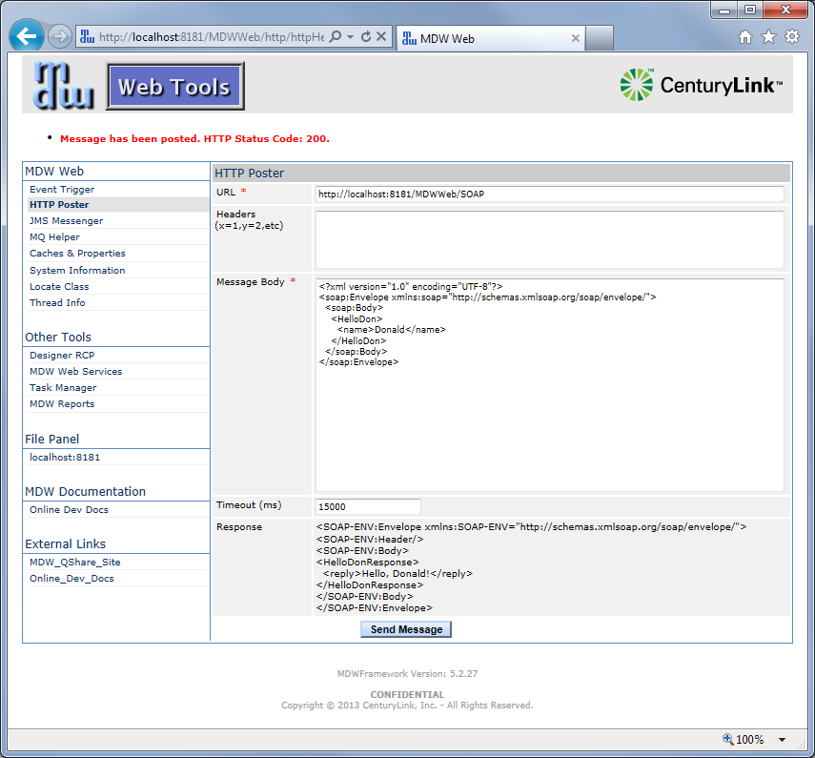

If you have trouble getting Site Admin access, or you prefer to use another tool like SoapUI or SOAtest, you can accomplish the same thing by just making sure the endpoint URL is like that in the screenshot and that your request content inside the SOAP body matches your registered External Event Handler.

**Register Your Service through a Camel Route:**

* [Apache Camel](http://camel.apache.org) is an "integration framework" that enables you to link together services through declarative route definitions. As an alternative to the traditional MDW External Event Handler registration described above, you may choose to expose your service through a Camel route. The advantages of this include the advanced [transport](http://camel.apache.org/transport.html) and [filtering](http://camel.apache.org/message-filter.html) capabilities that Camel supports. For example, Camel goes beyond the basic XPath message filtering provided by MDW event handlers to enable filtering according to request header values or even by complex scripting language expressions.
* Among other ways, a Camel route can be defined using a Spring configuration file. When you ran the MDW Eclipse wizard to create your workflow project back in Project Setup, a Spring config file named bundle-context.xml was generated for you under src/main/resources/META-INF/spring. This file gets embedded into the META-INF directory of your workflow bundle. You could declare your MDW Camel route in bundle-context.xml, but then you'd be missing out on one of the major benefits of using MDW: dynamicism. Instead, we'll create a separate child Spring configuration as a workflow asset that can be changed without requiring that your bundle be redeployed. In fact, Spring configuration assets in MDW can be used to inject any Spring-enabled entity into your OSGi bundle context.
* Right-click on your workflow package in Process Explorer view, and select New > Camel Route. Name your route and make sure and select " Standalone Route" for the Language.

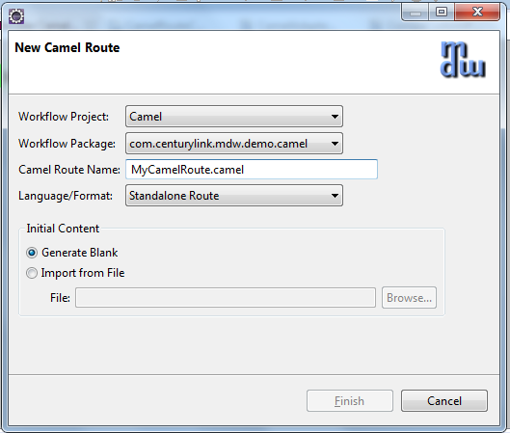

Then update the generated content with something like the following and save:

<?xml version=*"1.0"* encoding=*"UTF-8"*?>

<beans xmlns=*"http://www.springframework.org/schema/beans"*

xmlns:xsi=*"http://www.w3.org/2001/XMLSchema-instance"*

xmlns:osgi=*"http://www.springframework.org/schema/osgi"*

xmlns:ctx=*"http://www.springframework.org/schema/context"*

xmlns:camel=*"http://camel.apache.org/schema/spring"*

xsi:schemaLocation=*"http://www.springframework.org/schema/beans http://www.springframework.org/schema/beans/spring-beans-2.5.xsd*

*http://www.springframework.org/schema/osgi http://www.springframework.org/schema/osgi/spring-osgi-1.0.xsd*

*http://www.springframework.org/schema/context http://www.springframework.org/schema/context/spring-context.xsd*

*http://camel.apache.org/schema/spring http://camel.apache.org/schema/spring/camel-spring.xsd"*>

<camel:camelContext xmlns=*"http://camel.apache.org/schema/spring"* xmlns:foo=*"http://centurylink.com/foo"*>

<!-- MDW REST Web Service to Launch a Process -->

<route>

<from uri=*"mdw:REST/HelloDon"*/>

<to uri=*"mdw:process?name=Dons Service Process"* pattern=*"InOut"* />

</route>

</camel:camelContext>

<!-- MDW camel component -->

<bean id=*"mdw"* class=*"com.centurylink.mdw.camel.MdwComponent"* />

</beans>

The sole route declared within this camelContext tells the MDW Camel component to register a REST-based web service and launch Dons Service Process when invoked. In order for the "mdw:" URI pattern to be supported, the MDW component bean is declared. Notice that with the "from" URI in an MDW Camel route you have the option of specifying a specific endpoint URL path (REST/HelloDon), in contrast to the standard MDW External Event handler which all use the same endpoint.

* In order for the framework to identify the correct parent Spring app context to associate with your asset, you'll need to set a configuration parameter to tie your workflow package to your OSGi bundle. Right-click on your workflow package in Process Explorer and select Show Properties. Select the Configuration property tab and under Environments click the Add button and enter the name "dev". Add a property named OsgiBundleSymbolicName and under dev assign the value from the <bundle.symbolicName> element in your project's pom.xml build file.

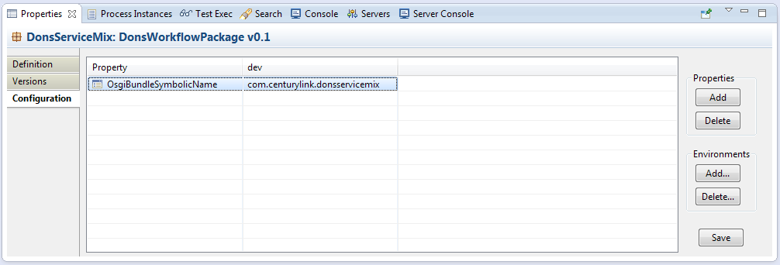

Click the Save button to persist this package configuration setting for your dev environment.

**Invoke Your Service through REST:**

* In order to make use of MDW Camel support, you'll need to add the following dependency to your pom.xml build file:

<dependency>

<groupId>com.centurylink.mdw</groupId>

<artifactId>mdw-camel</artifactId>

<version>${mdw.version}</version>

</dependency>

Also, since all the wiring magic is done by reflection, you'll need to explicitly add the following import under the <Import-Package> section:

<Import-Package>

com.centurylink.mdw.camel,

...

Then perform a Maven build to pick up this new dependency.

* Also, since mdw-camel is an optional feature, you'll need to install it by typing the following command at the karaf command prompt:

**features:install mdw-camel**

* As before with your SOAP request, you can use the MDW WebTools HTTP Poster facility to submit your REST request to the server. The URL should include the path you assigned in the "from" URI in your Camel route Spring asset.

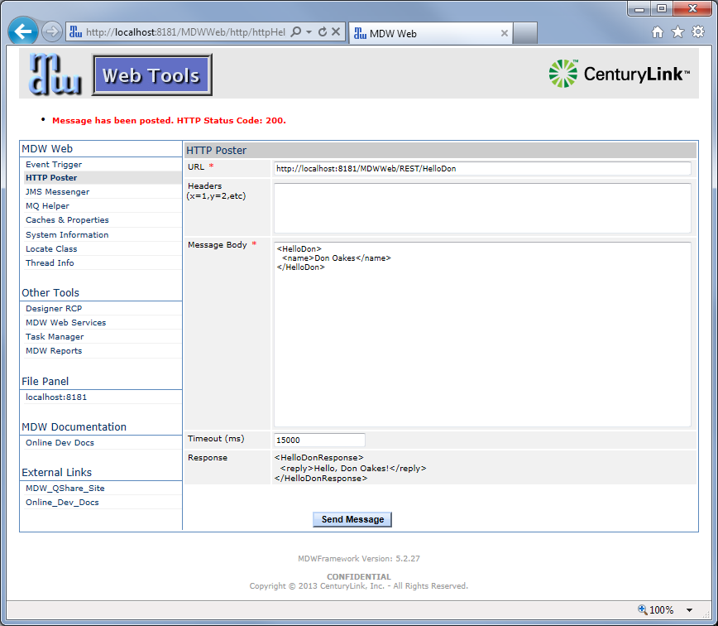

**MDW ServiceMix Cookbook – Workflow Development**

Previous Contents Next

**6. Explore Dynamic Java**

Dynamic Java gives you the ability to incorporate custom Java logic in your workflow without having to redeploy your OSGi bundle every time this logic changes. This gives you the flexibility to rapidly respond to changing business requirements. Dynamic Java artifacts are examples of MDW Workflow Assets, which are resources that can be changed on the fly as part of an agile development procedure. Naturally this power is meant to be used in a responsible and accountable manner. To this end all workflow assets provide a common set of features, including:

* LDAP-based authorization control
* Versioning with comments, history, archiving and rollback
* Asset locking to prevent simultaneous modification
* Rigorous audit logging to track user changes
* Import and export procedures for migrating between environments
* Custom attributes allow user-configurable options such as

In the steps below you'll use Dynamic Java to perform the logic in an activity and to populate a process variable based on a custom object type.

**Create Java Source Asset:**

* Expand your project in Process Explorer view, right-click on your workflow package and select New > Java Source. Name the Java Source class something like "DonsOrder", and Click Finish to create a skeletal implementation.

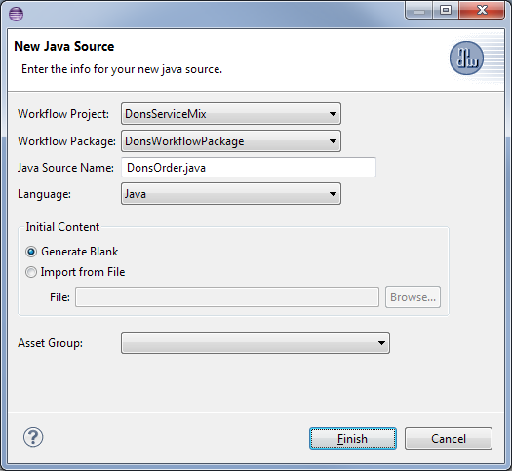

* Populate the class definition with the following to require that order numbers begin with a numeric digit, and save (electing to keep the asset locked and not to increment the version).

**package** DonsWorkflowPackage;

**import** org.w3c.dom.Document;

**import** org.w3c.dom.Node;

**public** **class** DonsOrder **implements** java.io.Serializable

{

**private** String orderNumber;

**public** String getOrderNumber()

{

**return** orderNumber;

}

**private** String customerId;

**public** String getCustomerId()

{

**return** customerId;

}

**private** **boolean** valid;

**public** **boolean** isValid()

{

**return** valid;

}

**private** String error;

**public** String getError()

{

**return** error;

}

**public** DonsOrder(Document orderDoc)

{

Node orderNumNode = orderDoc.getFirstChild().getFirstChild().getNextSibling();

**this**.orderNumber = orderNumNode.getFirstChild().getNodeValue();

**this**.customerId = orderNumNode.getNextSibling().getNextSibling().getFirstChild().getNodeValue();

}

**public** **boolean** validate()

{

**if** (!Character.*isDigit*(orderNumber.charAt(0)))

{

valid = **false**;

error = "Order numbers must begin with a numeric digit";

}

**else**

{

valid = **true**;

error = **null**;

}

**return** valid;

}

**public** String toString()

{

**return** "orderNumber=" + orderNumber + " customerId=" + customerId;

}

**public** **boolean** equals(Object o)

{

**if** (!(o **instanceof** DonsOrder))

**return** **false**;

DonsOrder order = (DonsOrder)o;

**return** orderNumber.equals(order.orderNumber) && customerId.equals(order.customerId);

}

}

**Use a Dynamic Java Activity:**

* Open the non-service process definition you created back in steps 1 through 3. Add a local process variable of type "java.lang.Object" and call it "order". Delete the orderNumber, customerId and validationResult variables since the order state is now encapsulated in your Dynamic Java object.
* Drag a Dynamic Java Activity from the toolbox and insert it at the beginning of your flow (immediately downstream of the Start activity). Name it "Parse Order Request". On the Java property tab for this activity, make the order object variable writable.

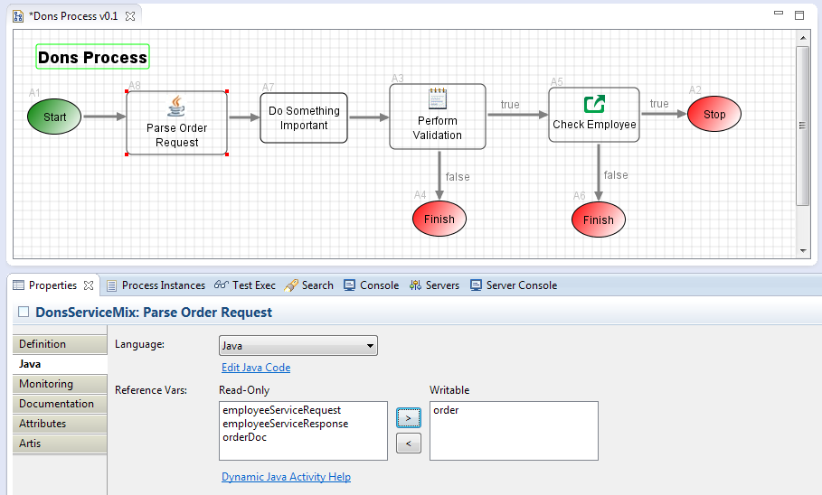

* On the same tab click the "Edit Java Code" hyperlink, and override the **execute()** method as follows:

**public** Object execute(Map<String, Object> variables) **throws** JavaExecutionException

{

DonsOrder order = **new** DonsOrder((org.w3c.dom.Document)variables.get("orderDoc"));

System.*out*.println("order number: " + order.getOrderNumber());

variables.put("order", order);

**return** **null**;

}

The return value from this method drives the subsequent process flow, just as with the script activity. A null return value indicates that the process should traverse the default (no-label) outbound transition.

* Update the "Perform Validation" script activity with the following simplified code which takes advantage of the behavior of your Dynamic Java object.

**boolean** result = order.validate();

**if** (!result)

System.*out*.println("Validation error: " + order.getError());

**return** result;

**Save and Execute your Process:**

* Save your process with an incremented version, and run it with something like the following order input document so that validation will fail.

<order>

<orderNumber>A12345678</orderNumber>

<customerId>DHO115360</customerId>

</order>

* Right-click somewhere in the design canvas and select View Instances. View the most recent process instance to confirm that it followed the expected path. Click on the Variables property tab and double-click the order variable to see its value. Note: the value displayed is governed by your toString() implementation. In Dynamic Java objects you should always implement toString() and equals() methods.

**MDW ServiceMix Cookbook – WebApp Development**

Previous Contents Next

MDW comes with a fully functional TaskManager webapp geared for end-user interaction with workflow processes through Manual Task activities. Usage is described in the [TaskManager User Guide](http://cshare.ad.qintra.com/sites/MDW/User%20Documentation/TaskManagerUserGuide.doc). This out-of-the-box (or standard) TaskManager is specifically designed to be extended, and allows for multiple degrees of customization. At a basic level, you can customize the display for a particular task as discussed in Step 1 below. However, you can also expose a completely customized TaskManager by overriding default resources as in Step 5. Any TaskManager page, template, image, stylesheet, managed bean, action controller, etc. can be overridden with a custom version. This enables you to leverage any prebuilt Task Manager functionality while delivering a completely customized webapp to suit your specific needs.

**1. Create a Web Page to Capture User Input**

**Add a Manual Task to the Process:**

* Start with the workflow process you built in the preceding Workflow Development section of this guide. Drag a Custom Manual Task activity onto the design canvas and insert it into the 'false' outcome path from the validation Script activity. Label the manual task activity something like "Dons Manual Acknowledge". In the Properties view for the activity, select the Design tab and set the task name to something like "Dons Acknowledgement". Set Task Due In to 8 hours. Click the Workgroups tab and select at least one workgroup to which you belong.
* Add two more local variables to the process: ackDate (with type=java.util.Date) and ackComment (with type=java.lang.String).

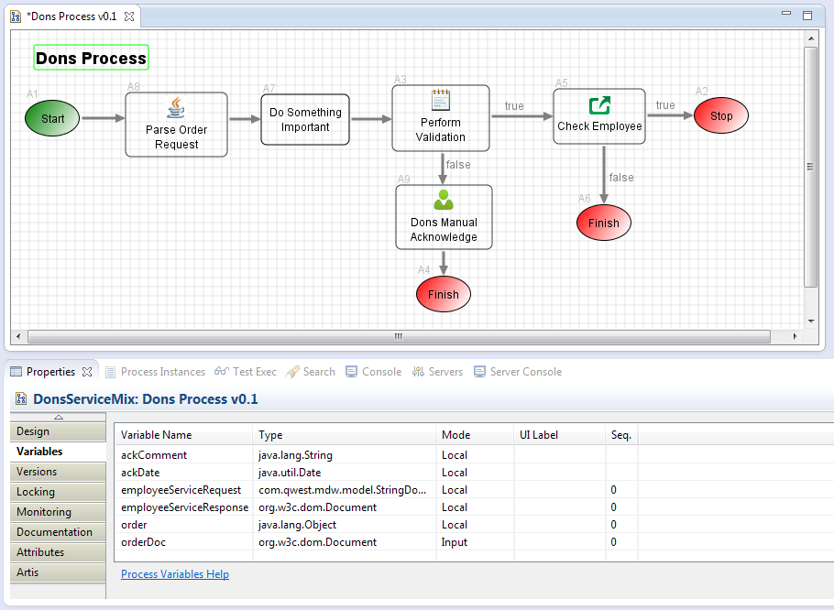

* When you save your process you'll be prompted to increment the version. Since this process already has instances, and in the meantime you've changed it structurally (by adding activities and transitions), it's highly recommended that you increment the version number when saving.

**Create a Custom Web Page:**

* A custom web page is an example of a [Workflow Asset](http://lxdenvmtc143.dev.qintra.com:7021/MDWWeb/doc/workflowAssets.html). The MDW plug-in provides a wizard-based interface for creating different types of workflow assets. To create a JSF Facelet-format custom page, right-click on your package in Process Explorer and select New > Page. Enter a page name like donsOrderAck.xhtml (by convention, it's nice to use .xhtml in your page name, but it's not strictly necessary since the engine recognizes the page type by the selected Language). Select customTaskContent as the page template, and click Finish.

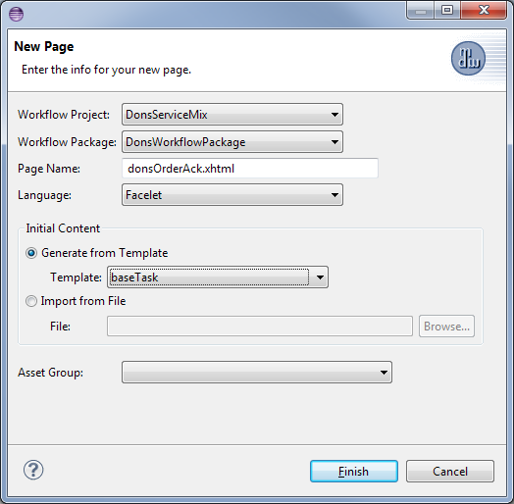

* Paste the following contents into your new Facelet page and then save. This page illustrates usage of the implicit "process" managed bean. This represents the workflow process associated with the manual task, and provides two-way access to the process variable values. Another implicit bean that's useful in the context of a manual task is named "task". This is an instance of the framework class FullTaskInstance, and provides access to standard task-related values such as Due Date.

<?xml version=*"1.0"* encoding=*"ISO-8859-1"* ?>

<!DOCTYPE html PUBLIC "-//W3C//DTD XHTML 1.0 Transitional//EN" "http://www.w3.org/TR/xhtml1/DTD/xhtml1-transitional.dtd">

<html

xmlns=*"http://www.w3.org/1999/xhtml"*

xmlns:ui=*"http://java.sun.com/jsf/facelets"*

xmlns:f=*"http://java.sun.com/jsf/core"*

xmlns:h=*"http://java.sun.com/jsf/html"*

xmlns:mdw=*"http://www.centurylink.com/mdw/jsf"*

xmlns:rich=*"http://richfaces.org/rich"*

xmlns:a4j=*"http://richfaces.org/a4j"*>

<ui:composition template=*"/facelets/layout/baseTask.xhtml"*>

<ui:define name=*"taskData"*>

<rich:panel header=*"Order Acknowledgement"* styleClass=*"mdw_defaultPanel"* style="width:*800px*;">

<h:panelGrid columns=*"2"* width=*"100%"* cellpadding=*"6"* cellspacing=*"2"* columnClasses=*"mdw_label,mdw_value"*>

<h:outputLabel for=*"orderNum"* value=*"Order Number:"*/>

<h:outputText id=*"orderNum"* value=*"#{process.variables.order.orderNumber}"* style="font-weight:*bold*" />

<h:outputLabel for=*"ackDate"* value=*"Date:"* />

<rich:calendar id=*"ackDate"* value=*"#{process.variables.ackDate}"* inputClass=*"mdw_value"* inputStyle=*"margin-top:-2px;"* buttonClass=*"mdw_calendarBtn"* />

<h:outputLabel for=*"ackComments"* value=*"Details:"* />

<h:inputTextarea id=*"ackComments"* wrap=*"off"* value=*"#{process.variables.ackComment}"* rows=*"6"* styleClass=*"mdw_textAreaInput"* style="width:*680px*;" />

</h:panelGrid>

</rich:panel>

</ui:define>

</ui:composition>

</html>

* Save the XHTML page, return to your process design, select the manual task, and display the Design tab in its Properties view. In the Custom Page dropdown select the page you just created. Save the process.

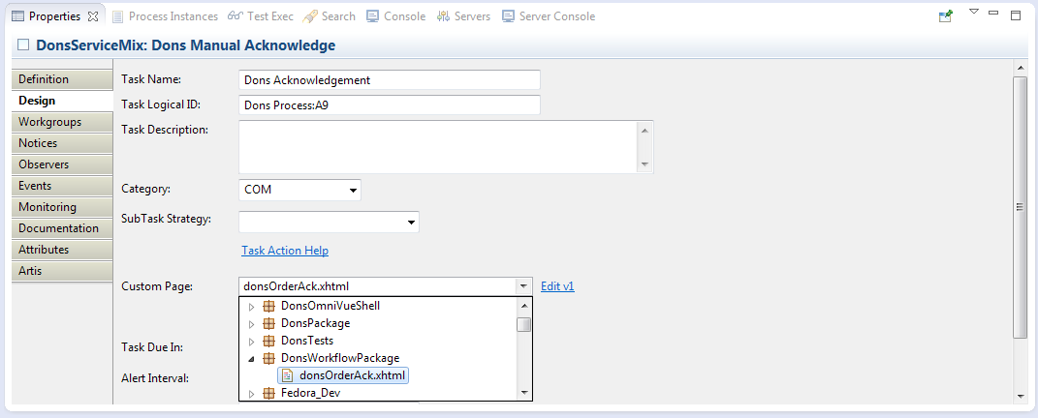

**Launch the Process to View your Custom Page:**

* Run the process so that it flows to the new manual task activity. View the latest instance and you'll see that execution has halted awaiting user input through your custom page.
* Access TaskManager by right-clicking on the top-level workflow project in Process Explorer view and selecting Web > Task Manager.
* If you've not already done so, click the Admin tab to add yourself to a workgroup associated with the manual task in your process (user-group relationships are cached in the browser session, so you'll need to close your browser and relaunch to pick up any changes).
* Click on the Workgroup Tasks tab in Task Manager. Locate the newly-created instance, click its checkbox, select Claim in the Action menu.

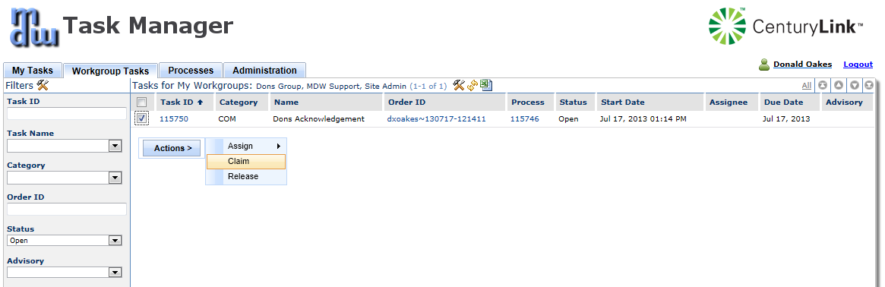

* You'll be navigated to the My Tasks tab where you should see the instance you just claimed. Click on the Task ID link for the row to view the custom page. Enter values in the Order Acknowledgement section, and select Complete in the Task Action menu.

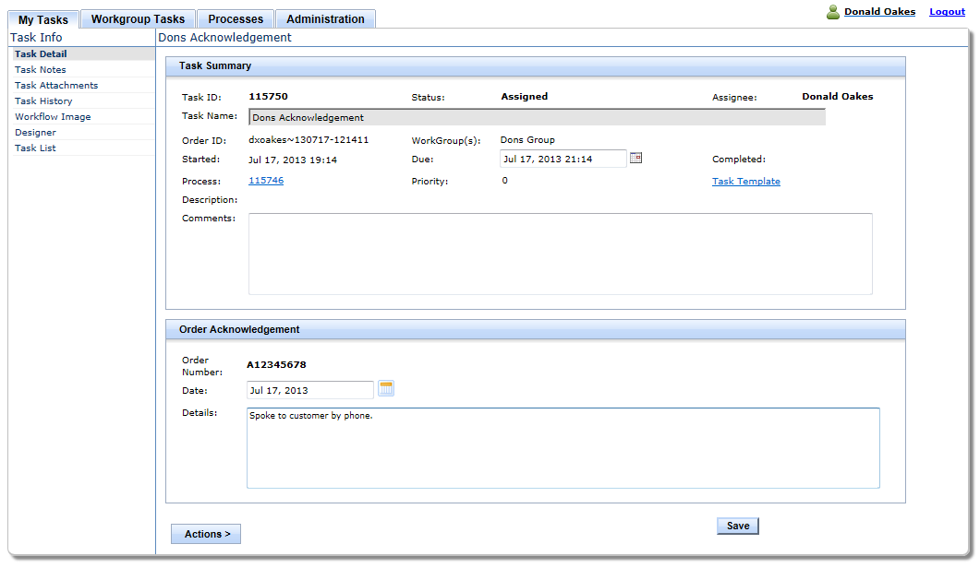

* Return to Designer Perspective in Eclipse, right click in the process instance and select "Refresh". Flow should have progressed beyond the manual task activity. View the variables tab to confirm that the values you entered for ackDate and ackComments are reflected.

**MDW ServiceMix Cookbook – WebApp Development**

Previous Contents Next

**2. Create a Standalone Custom Page**

Your requirements may call for webapp functionality that has nothing to do with standard TaskManager. You can create custom pages that don't depend on MDW at all. You have the ability to access workflow process data if desired, and to leverage the stylesheets and templates provided by TaskManager. But you can also start completely from scratch if you'd like, or you can mix-and-match to leverage MDW but with a web user interface that you develop from the ground up.

**Create a Managed Bean Dynamic Java Object:**

* The secret to including custom logic in your webapp is Dynamic Java. Within your custom pages you can use the standard Java expression language syntax to access and update any data that needs to be displayed by leveraging the JSF Managed Bean annotations. Right-click on your workflow package in Process Explorer and select New > Java Source. Name your Dynamic Java source asset something like "DonsHelper.java" and click Finish. Add the following JSF annotations to the generated class:

@ManagedBean(name="donsHelper")

@SessionScoped

**public** **class** DonsHelper **implements** java.io.Serializable

{

This declares your class to be a JSF managed bean in session scope with a logical name of "donsHelper". You'll probably notice right away that these annotations are not recognized by the Java compiler in Eclipse. They are provided by the Java ServerFaces API, which until now has not been a part of your project. Add the following dependency in your pom.xml build file:

<dependency>

<groupId>javax.faces</groupId>

<artifactId>javax.faces-api</artifactId>

<version>2.0</version>

<scope>provided</scope>

</dependency>

Once you've saved your pom.xml, Eclipse should be able to discover the necessary imports if you open your Dynamic Java class and type Ctrl-Shift-O (or Source > Organize Imports).

* Now add the following declarations and methods inside your Dynamic Java class and save:

**private** String something;

**public** String getSomething()

{

**return** something;

}

**public** **void** setSomething(String something)

{

**this**.something = something;

}

**public** Object doSomething()

{

System.*out*.println("something: " + something);

javax.faces.context.FacesContext facesContext =

javax.faces.context.FacesContext.*getCurrentInstance*();

facesContext.addMessage(**null**, **new** javax.faces.application.FacesMessage("Did something."));

**return** **null**;

}

MDW scans for managed beans on TaskManager startup, so to pick up and compile your Dynamic Java, you'll need to restart the mdw-taskmgr bundle from karaf:

**list | grep mdw**

**restart <taskmgr_bundleid>**

**Create a Custom Page that Uses Your Managed Bean:**

* Right-click on your workflow package in Process Explorer and select New > Page. Name it something like donsPage.xhtml, select "blank" as the template, and click Finish. Paste in some content like the following (substituting the logical name of your helper bean in the expressions):

<?xml version=*"1.0"* encoding=*"ISO-8859-1"* ?>

<!DOCTYPE html PUBLIC "-//W3C//DTD XHTML 1.0 Transitional//EN" "http://www.w3.org/TR/xhtml1/DTD/xhtml1-transitional.dtd">

<html

xmlns=*"http://www.w3.org/1999/xhtml"*

xmlns:ui=*"http://java.sun.com/jsf/facelets"*

xmlns:f=*"http://java.sun.com/jsf/core"*

xmlns:h=*"http://java.sun.com/jsf/html"*

xmlns:a4j=*"http://richfaces.org/a4j"*

xmlns:rich=*"http://richfaces.org/rich"*

xmlns:mdw=*"http://www.centurylink.com/mdw/jsf"*>

<ui:composition>

<rich:panel header=*"Very Important"*>

<h:form>

<h:outputLabel for=*"somethingInput"* value=*"Something:"*/>

<h:inputText id=*"somethingInput"* value=*"#{donsHelper.something}"* /> <br/>

<h:commandButton value=*"Do Something"* action=*"#{donsHelper.doSomething}"* style="margin:*5px*" />

</h:form>

</rich:panel>

<h:messages style="color:*red*;font-weight:*bold*;" />

</ui:composition>

</html>

* Save your page and access it in your browser by right-clicking on it in Process Explorer and selecting Run. **Note**: when you save a workflow asset in Designer, this triggers a server cache refresh. Due to the proliferation of workflow assets in the MDW sandbox environment, this can take some time (during which you'll see output in your Server Console view). Any changes you make to your page are dynamically applied, but they may not be reflected in your browser until the server cache refresh has completed.
* Enter a value for the text input in your form and click the button. You should see a message indicating that your action was performed on the server.

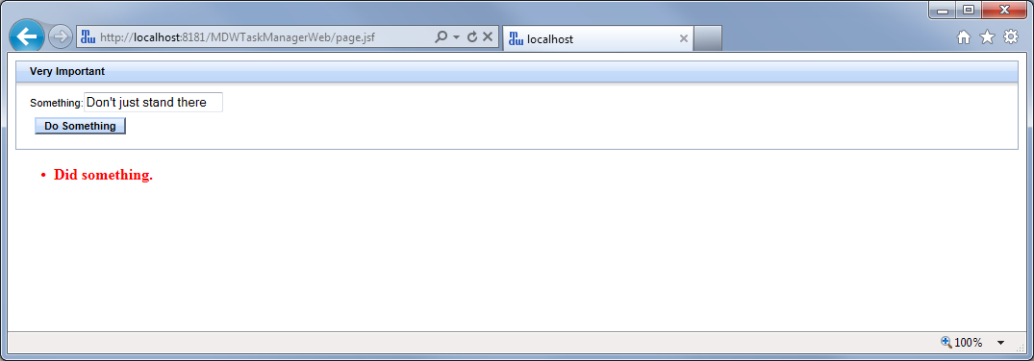

In your Server Console view you should also be able to see output showing the captured value for the user-entered data.

**Use Custom Layout Templates and Web Resources:**

* TODO.

**Add a Custom Navigation Outcome:**

* TODO.

**MDW ServiceMix Cookbook – WebApp Development**

Previous Contents Next

**3. Create a Process Launch Page**

**View the Auto-Generated Process Launch Page:**

* TODO.

**Create a Custom Page for Launching a Process**

* TODO.

**MDW ServiceMix Cookbook – WebApp Development**

Previous Contents Next

**4. Customize List Columns and Filters**

**TODO**

**MDW ServiceMix Cookbook – WebApp Development**

Previous Contents Next

**5. Override Default TaskManager Resources**

**TODO**

**MDW ServiceMix Cookbook – WebApp Development**

Previous Contents

**6. Design a Report and Access it through the Web**

MDW uses the [BIRT open-source reporting framework](http://www.eclipse.org/birt). BIRT includes a report-designer plug-in for Eclipse, as well as an embeddable runtime that enables reports to be displayed in an MDW webapp.

**Create a BIRT Report Based on the Tasks Data Template:**

* To create a new BIRT Report, right-click on your package and select New > Report. Name the report, select the Tasks data template, and then click finish.

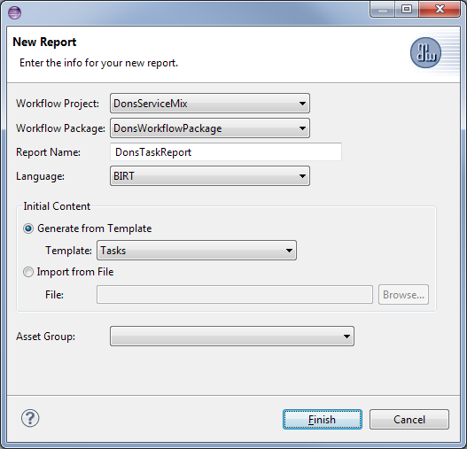

* The wizard will create a basic manual tasks report. You'll notice that there are a couple of new views available in the Designer perspective: the Data Explorer and Palette views:

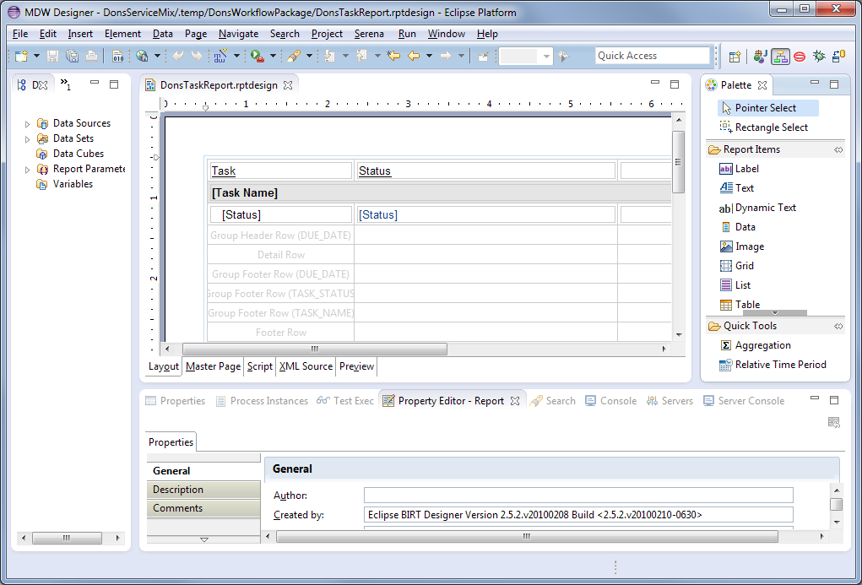

You'll use these views in building your report design. Comprehensive documentation is available under help topic BIRT Report Developer Guide. However, we'll walk through a few of the basic steps.

**Confirm the Data Source and Data Set for your Report:**

* The report creation wizard set up an initial Data Source based on the database connection parameters for your workflow project. To view these parameters, expand the Data Sources element in Data Explorer view and double-click on the MDWDataSource.

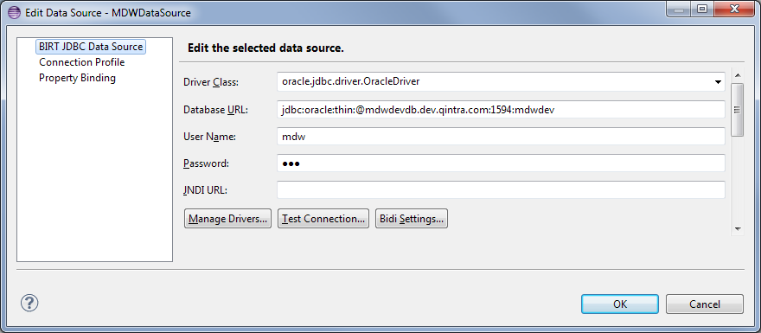

* Because you chose the Tasks template, the wizard also created an initial task-centric dataset. Expand the Data Sets element and double-click on the MDWDataSet. You'll see the SQL query which selects the raw task data. In the Data Set dialog, select Preview Results node for a quick glimpse at the actual result set that will be used to generate the report.

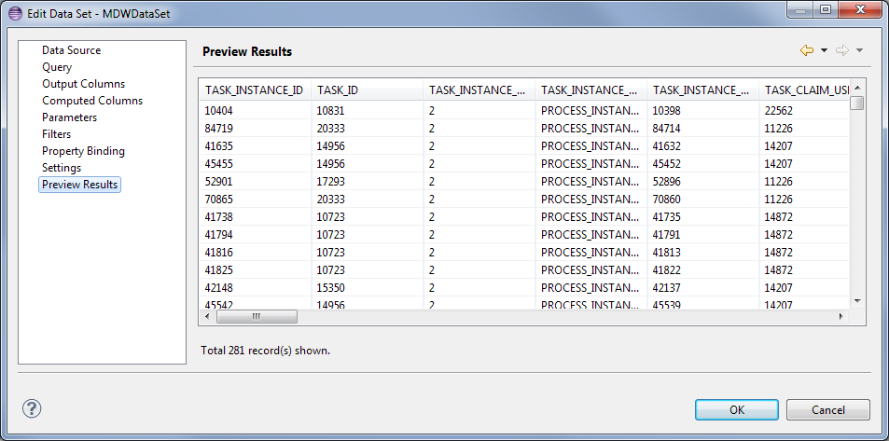

**Preview the Unmodified Report:**

* In the lower portion of the main Report Design editor, there are a number of tabs to enable editing of different aspects of the report. Click on the Preview tab to see what the out-of-the-box report looks like. This prebuilt report includes a single user-entered parameter, Start Date. The first time you preview the report you'll be prompted to enter a value, and you can just leave the default. This report demonstrates some aggregation techniques, so you'll notice that each type of manual task is summarized according to how many instances exist for each status.

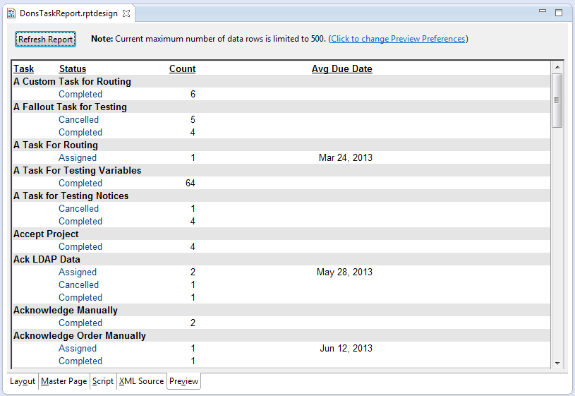

If you scan the report output you should be able to locate instances of the manual tasks you created in Step 1 of this section. Note that only tasks which have been assigned appear in this report.

**View the Report through the Web:**

* End users generally access reports via the web. To enable this capability you'll need to install the optional mdw-reports feature from the karaf command line:

**features:install mdw-reports**

* Once this feature is installed you can view your report in your browser by right-clicking on it in Process Explorer and selecting Run. User-entered parameters are captured in the Filters panel, and the most-recently entered values are remembered as browser cookies. Values for filters can also be passed as URL parameters. This enables custom webapps to embed links which drill directly into a report with pre-specified values depending on the context.

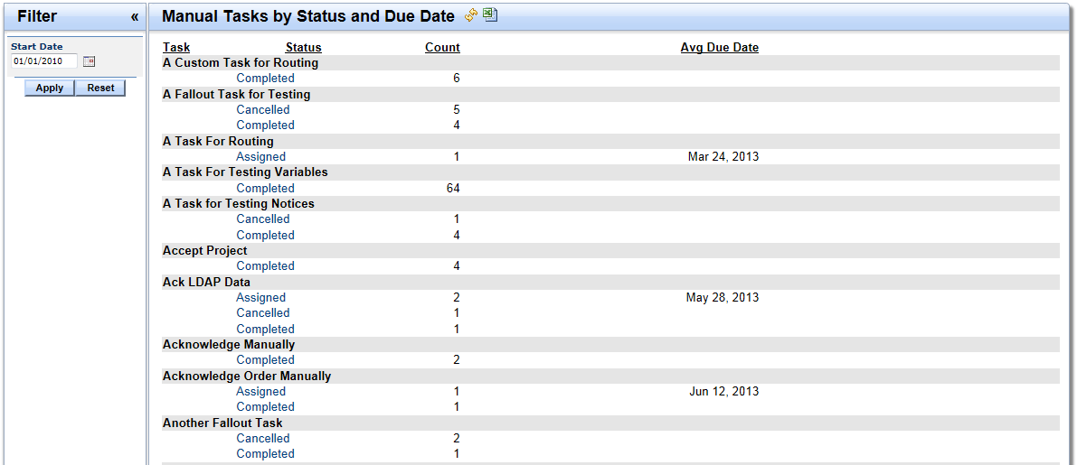

**Modify the Report to Show Oldest Due Date:**

* In Designer perspective, click on the layout tab at the bottom of the Report Design editor. Double-click on the column heading labeled "Avg Due Date". Change the label to read "Oldest Due Date".
* Find the aggregation cell called "Due Date Agg" and double-click it to open the Aggregation Builder dialog. Select "MIN" in the Function dropdown.

Select the Preview tab in the editor, which will prompt you to save the report workflow asset. The preview should reflect your changes. Changes are picked up by the web viewer dynamically, without needing to redeploy or refresh. You can also verify your changes in your browser by right-clicking on the report and selecting Run.