

**mdwdemo**

**Prerequisites:**

**Eclipse with the MDW Plug-In**

Get Started with BPM Cloud Development.

**Get the mdwdemo Project:**

**1: Add the Git Repository**

Add the Centurylink Labs MDW repository in Eclipse.

**Set Up Access to the mdwdemo Sample Project in Eclipse**

Contents Next

**Eclipse with the MDW Plug-In**

**Set Up Eclipse on Your PC:**

* Make sure you have Java Runtime 7 or 8 installed on your computer:
  + [**http://www.oracle.com/technetwork/java/javase/downloads**](http://www.oracle.com/technetwork/java/javase/downloads)
* Install Eclipse Mars (4.5.x) or Luna (4.4.x). The easiest way to get Eclipse with all the necessary dependencies is to grab the prepackaged version from this shared location:
  + **\\eldnp1515dm4.ad.qintra.com\union_station\IT\MDW\eclipse**

This Eclipse package includes all the required dependencies except the MDW Plug-In itself. All the necessary features and plug-ins from eclipse.org are incorporated into this bundle (Eclipse for JavaEE Developers plus [Business Intelligence and Reporting Tools](http://www.eclipse.org/birt), and the EPF Rich Text Feature).

* Launch Eclipse. Here’s an example command line that includes appropriate JVM memory settings for running and debugging:

**C:\eclipse_4.5.0\eclipse.exe -vm C:\jdk1.8.0_60\bin\javaw.exe -vmargs -Dsun.lang.ClassLoader.allowArraySyntax=true -Xms512m -Xmx1024m -XX:MaxPermSize=256m**

* Install the latest version of the MDW Plug-In via Eclipse Software Updates (Help > Install New Software > Add > **http://lxdenvmtc143.dev.qintra.com:6101/MdwPlugin** > Install).
* Make sure Eclipse has a Java 7 or 8 Installed JRE available in your workspace (Window > Preferences > Java > Installed JREs).

**Optional Plug-Ins:**

* Groovy Eclipse Plug-In (Groovy script syntax highlighting, auto-complete, etc.)

**http://dist.springsource.org/release/GRECLIPSE/e4.5**

**Get the mdwdemo Project**

Previous Contents

**1. Add the Git Repository**

The mdwdemo workflow project is hosted in the [CenturyLink Labs](https://labs.ctl.io/) MDW Git Repository. If you prefer to use command line Git, clone the repository from **https://8.22.8.164/mdw/mdwdemo.git** using credentials **mdw/ldap_0123**.

**Disable Git SSL Verification in Eclipse:**

* Our SSL certificate is self-signed and is not trusted by Git. Therefore, the first step is to disable (at least temporarily) SSL verification. From the Eclipse menu, select Window > Preferences > Team > Git > Configuration > Add Entry…
* Create an entry like this:

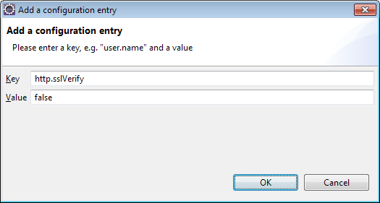

**Clone the mdwdemo Project into Your Workspace:**

* Access the Git Repositories view by selecting Window > Show View > Other > Git > Git Repositories:
* Copy the repository URL into your clipboard: https://8.22.8.164/mdw/mdwdemo.git.
* Right-click in Git Repositories view and select Paste Repository Path or URI.
* Enter **mdw** for the User and **ldap_0123** for the Password:

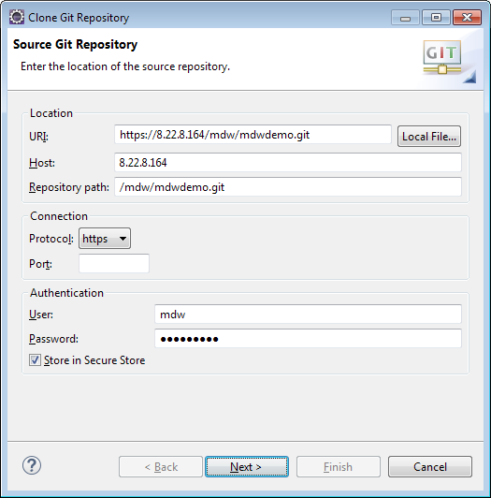

* Click Next and make sure the **master** branch is selected:

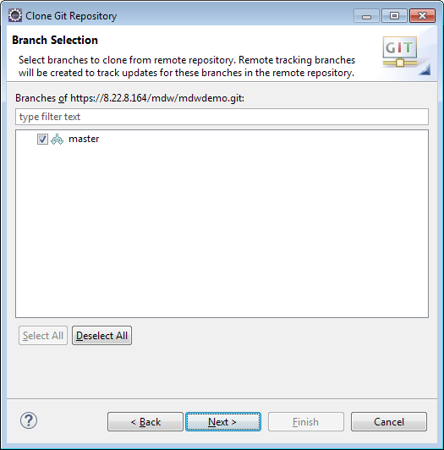

* Click Next again. Point to your workspace/mdwdemo for the Destination Directory. Check "Import all existing Eclipse projects after clone finishes". Then click Finish.

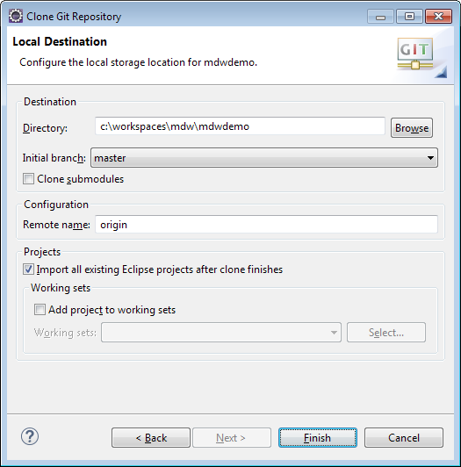

**MDW Designer Perspective:**

* To best view the workflow assets, switch to Designer Perspective (Window > Perspective > Open Perspective > Other > MDW Designer).
* In Process Explorer view expand the mdwdemo project to see the included workflow packages.

Previous Contents