- Analizirati CreateDatabase skriptu i izvršiti je
- Kreirati paket za load CustomerInformation.txt u tablicu stgCustomerInformation (loadstgCustomerInformation.dtsx)
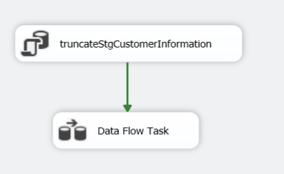
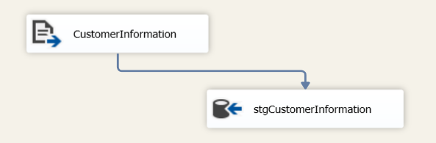

- Kreirati paket za load dimCustomer DimCustomerSCD.dtsx

- Potrebno je podesiti izvore podataka.
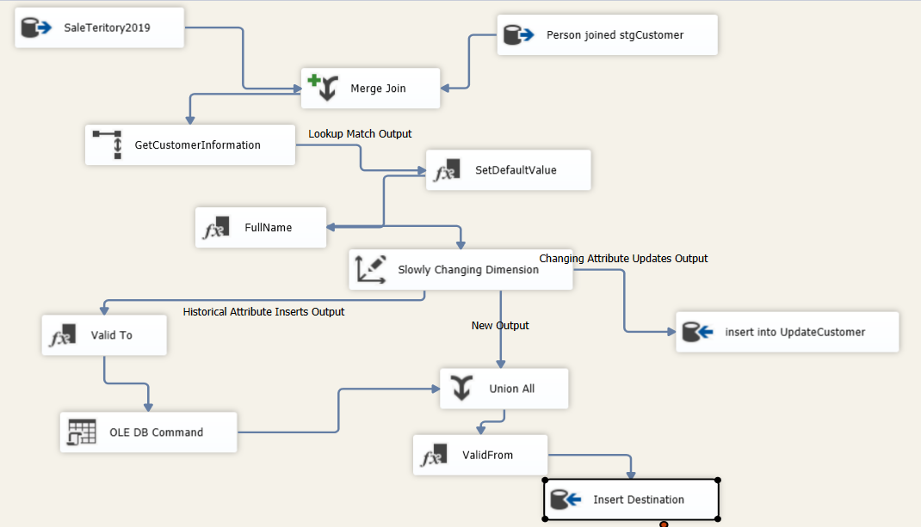

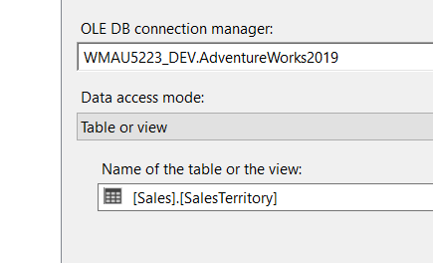

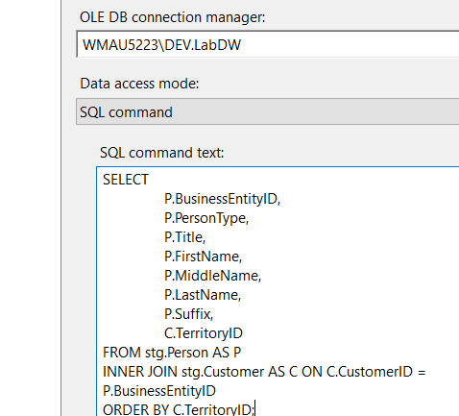

SELECT
P.BusinessEntityID,
P.PersonType,
P.Title,
P.FirstName,
P.MiddleName,
P.LastName,
P.Suffix,
C.TerritoryID
FROM stg.Person AS P
INNER JOIN stg.Customer AS C ON C.CustomerID = P.BusinessEntityID
ORDER BY C.TerritoryID;

- Dodati Merge Join
Merge Join – ulazi moraju biti sortirani. Sortirati se može preko alata za sortiranje 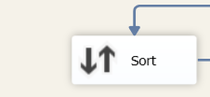

Ili preko ShowAdvancedEditora, Inputs and Outputs Properties

IsSorted=True
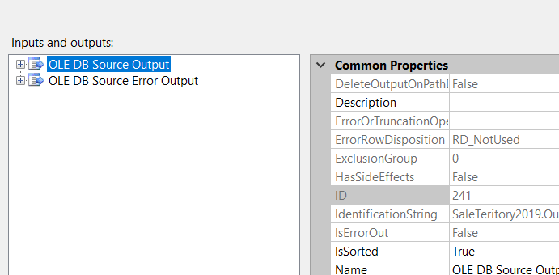

Sortira se prema TerritoryID – SortKeyPosition=1
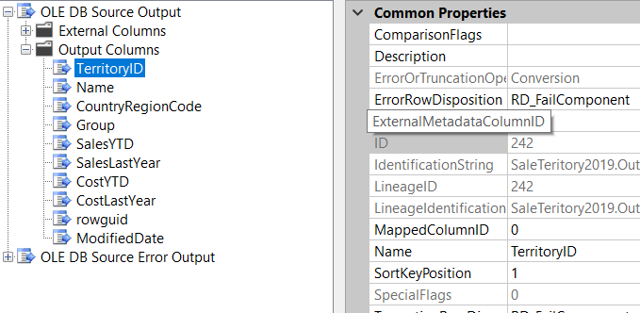

- Navedeno napraviti za oba ulaza

- Konfigurirati MergeJoin
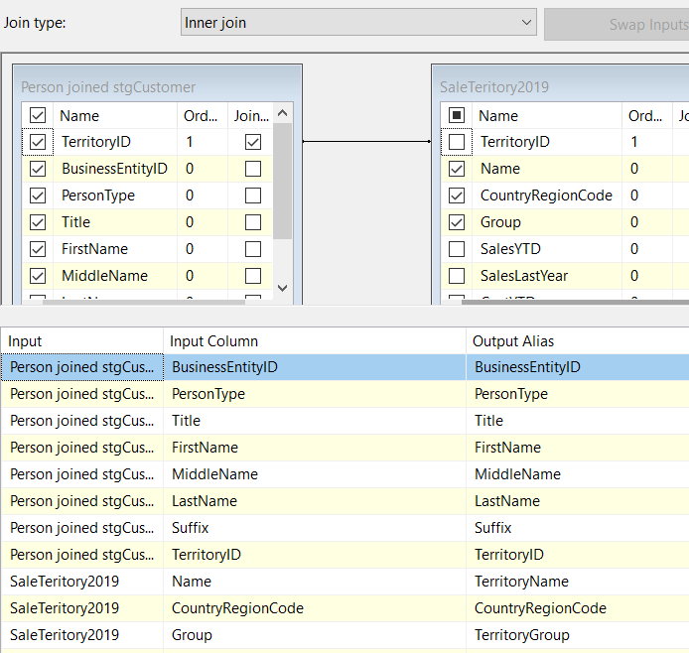

- Dodati lookup da bi mogli iz tablice CustomerInformation dovući dio polja
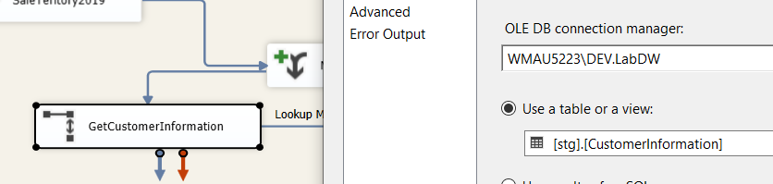
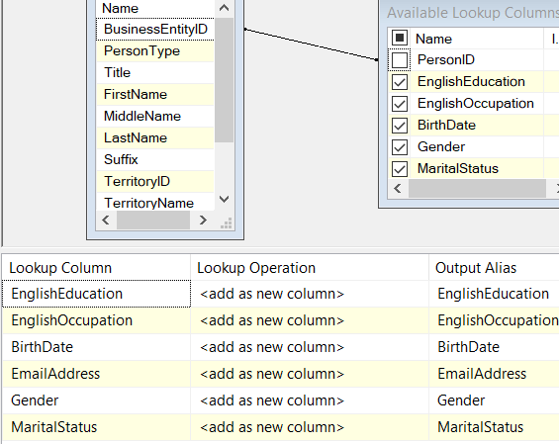

- Nakon što su podešeni izvori za sve atribute dimenzije Customer potrebno je postaviti vrijednosti za polja koja imaju Null vrijednosti atributa
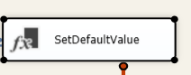
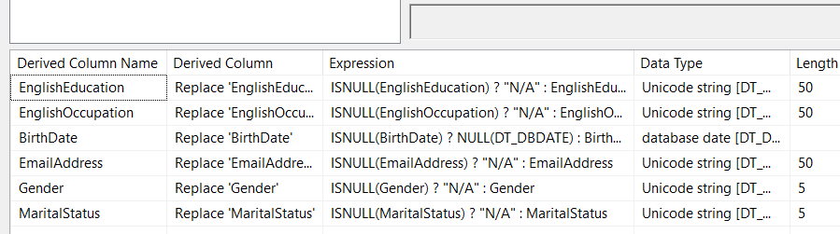

Npr
ISNULL(EnglishEducation) ? "N/A" : EnglishEducation
ISNULL(BirthDate) ? NULL(DT_DBDATE) : BirthDate

- Kreirati novu kolonu FullName
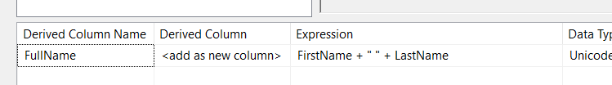

- Dodati SCD
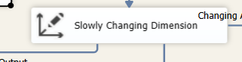
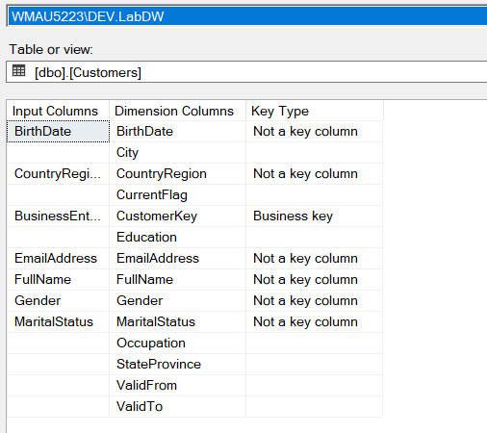
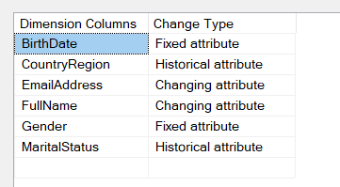
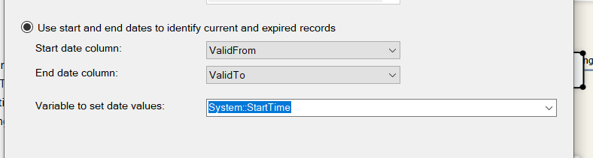

- Podesiti mapinje kod inserta podataka u dbo.Customer
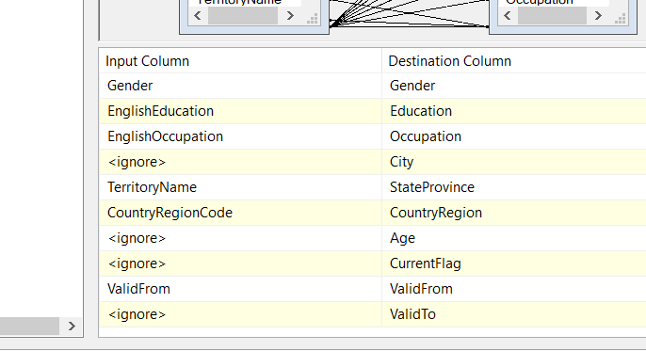

- Umjesto OLE Command za update dimenzije Customer atribute za koje se ne prati povijest promjena upisati u tablicu UpdateCustomer. Podesiti mapiranje

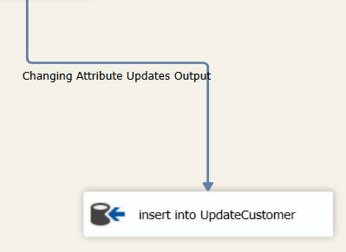
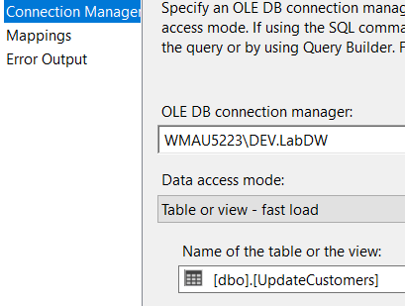
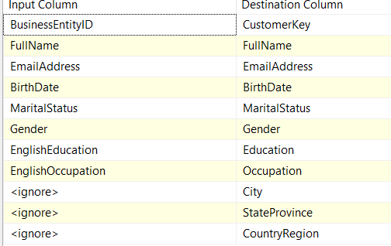

- ControlFlow
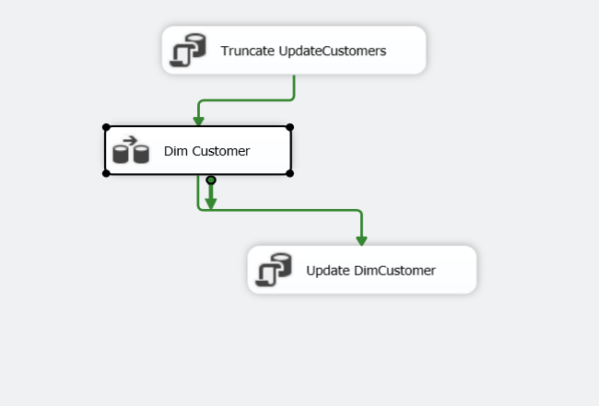

UPDATE C
SET
FullName = U.FullName,
EmailAddress = U.EmailAddress
FROM dbo.Customers AS C
INNER JOIN dbo.UpdateCustomers AS U ON U.CustomerKey = C.CustomerKey;

PROVJERA:
SELECT
CustomerDwKey,
CustomerKey,
FullName,
MaritalStatus,
Gender,
CountryRegion,
ValidFrom,
ValidTo
FROM dbo.Customers
WHERE CustomerKey IN (15001, 14996, 14997);

UPDATE stg.Customer
SET TerritoryID = 4
WHERE
CustomerID IN (15001, 14996, 14997);

Izvršiti paket i ponoviti gornji SELECT.
Rezultati bi trebali biti kako je ispod prikazano
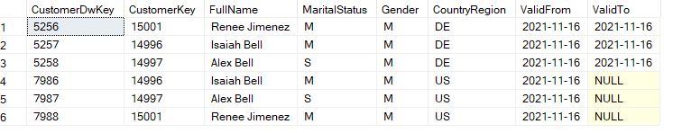

- Kreirati paket za Inkrementali Load Fact tablice CustomerNew

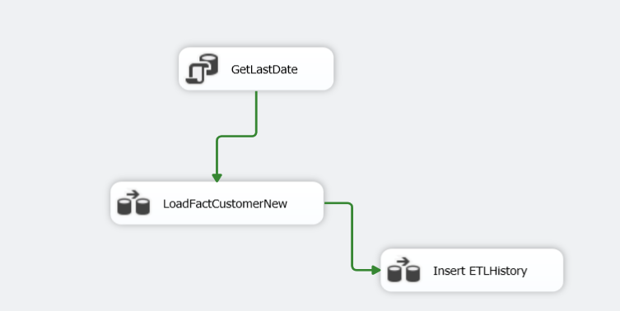

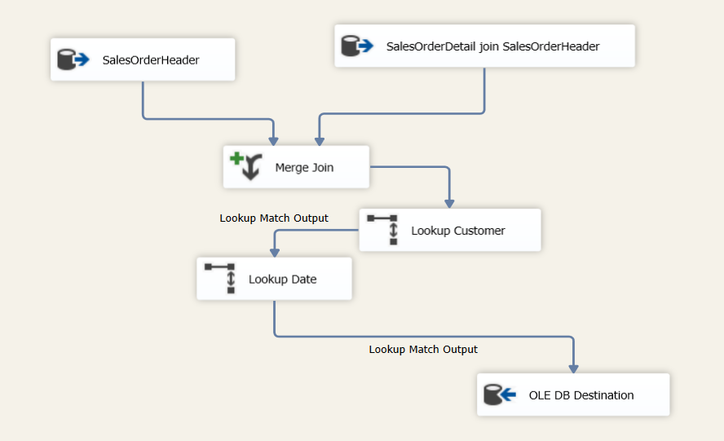

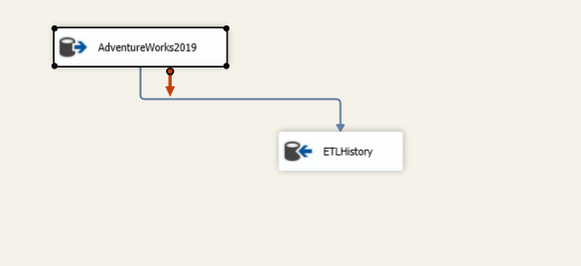
- Spremanje u varijablu zadnje datume koji je importiran
select max([LastDateInserted]) as LastDate from [dbo].[ETLHistory]

- Kreiranje Varijablli
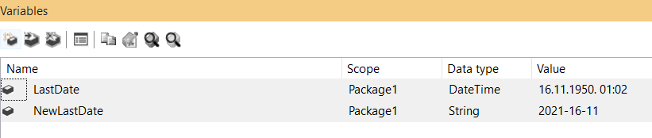

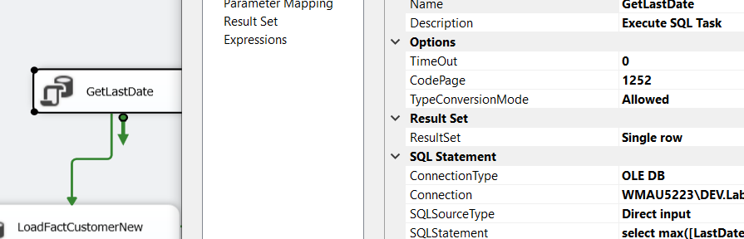

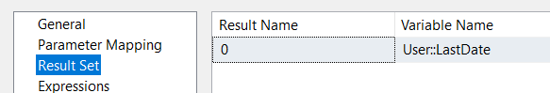

- Podešavanje SalesOrderHeader
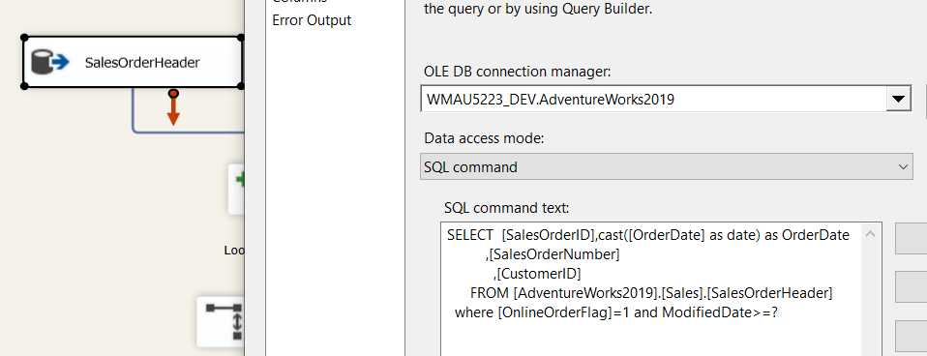

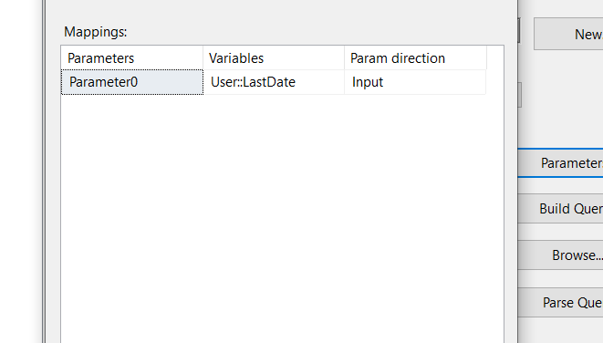
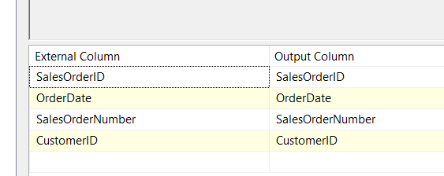

- Podešavanje SalesOrderDetail
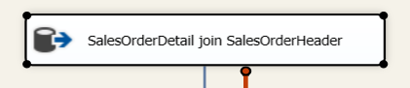
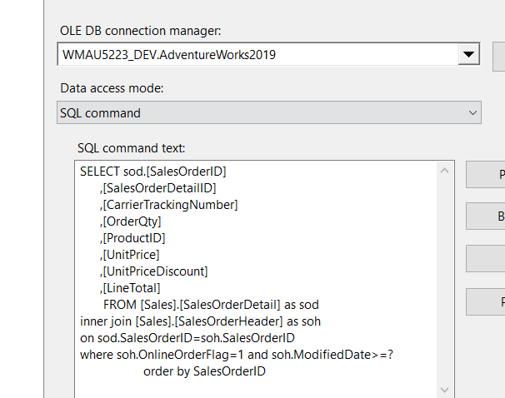
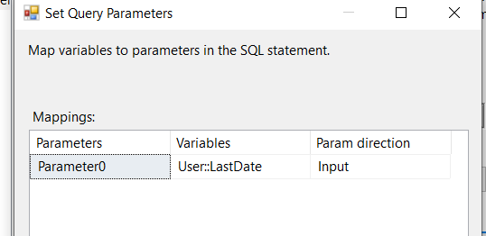

- Podešavanje MergeJoin
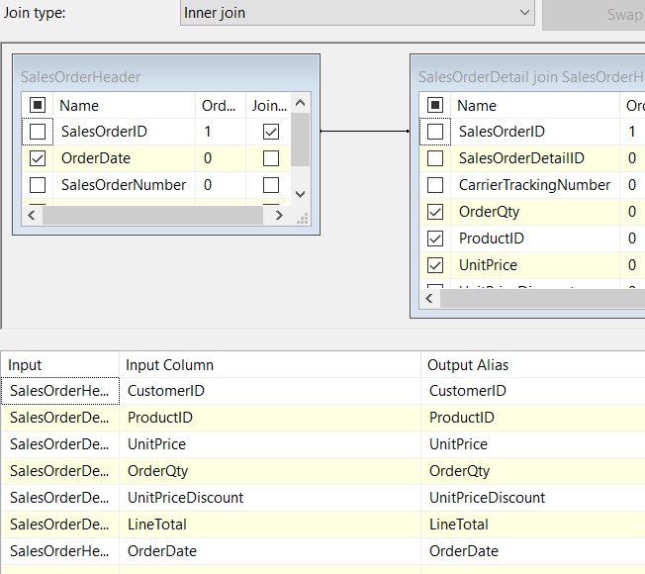
- Podešavanje LookupCustomer
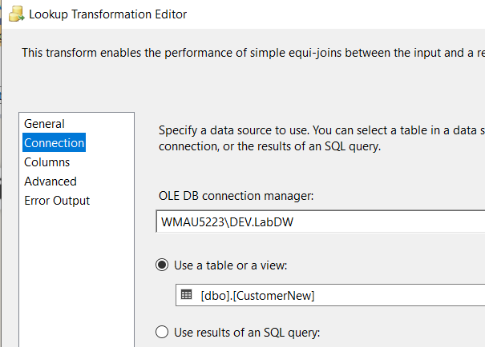
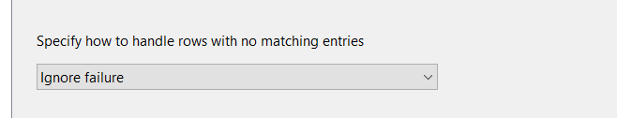
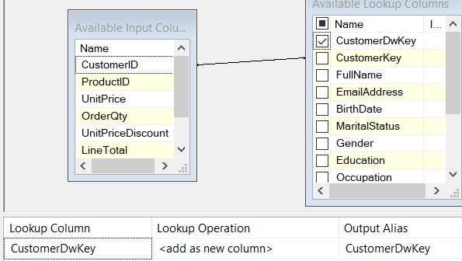

- Podešavanje LookupDate
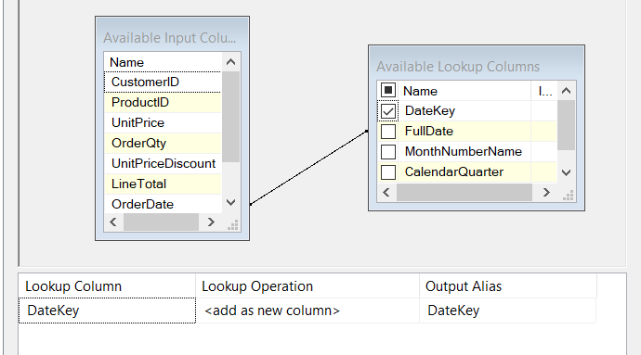

- Mapiranje za OLEDB destination
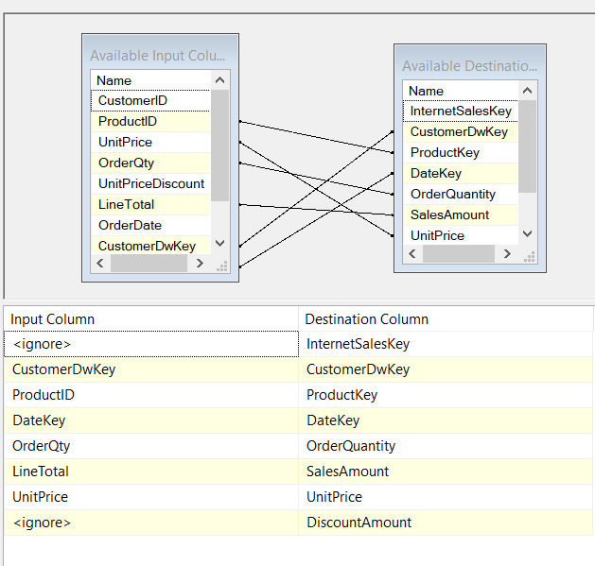

- Podešavanje
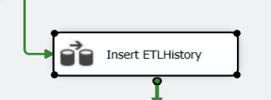

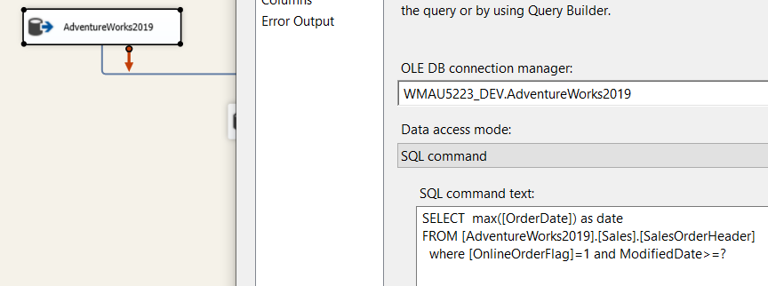

- Podešavanje
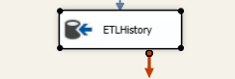
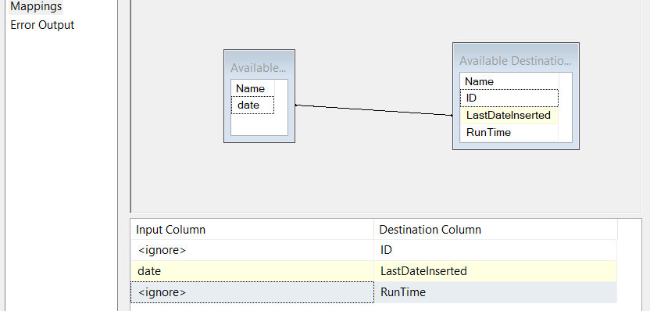

- Izvršiti Paket

PROVJERA
USE [AdventureWorks2019]
GO

INSERT INTO [Sales].[SalesOrderHeader]
([RevisionNumber],[OrderDate]
,[DueDate]
,[ShipDate]
,[Status]
,[OnlineOrderFlag]
,[PurchaseOrderNumber]
,[AccountNumber]
,[CustomerID]
,[SalesPersonID]
,[TerritoryID]
,[BillToAddressID]
,[ShipToAddressID]
,[ShipMethodID]
,[CreditCardID]
,[CreditCardApprovalCode]
,[CurrencyRateID]
,[SubTotal]
,[TaxAmt]
,[Freight]
,[Comment]
,[rowguid]
,[ModifiedDate])
VALUES(8,'2020-10-10','2020-10-11','2020-10-12',5,1,null,'AAA',11001,null,null,13618,13618,1,null,null
,null,100,6,2,null,NEWID(),'2020-10-11')

ALTER TABLE [Sales].[SalesOrderDetail] DROP CONSTRAINT [DF_SalesOrderDetail_UnitPriceDiscount]
GO
ALTER TABLE [Sales].[SalesOrderDetail] DROP CONSTRAINT [FK_SalesOrderDetail_SpecialOfferProduct_SpecialOfferIDProductID]
GO
DROP TRIGGER [Sales].[iduSalesOrderDetail]
GO

INSERT INTO [Sales].[SalesOrderDetail]
([SalesOrderID]
,[CarrierTrackingNumber]
,[OrderQty]
,[ProductID]
,[SpecialOfferID]
,[UnitPrice]
,[UnitPriceDiscount]
,[rowguid]
,[ModifiedDate])
VALUES
(75125, '4911-403C-98',2,511,1,50,0, newid(),'2020-10-11')

Use LABDW
GO
INSERT INTO [dbo].[Dates]
([DateKey]
,[FullDate]
,[MonthNumberName]
,[CalendarQuarter]
,[CalendarYear])
VALUES('20201010', '2020-10-10', '11 November', 4,2020)
INSERT INTO [dbo].[Dates]

([DateKey]
,[FullDate]
,[MonthNumberName]
,[CalendarQuarter]
,[CalendarYear])
VALUES('20201011', '2020-10-11', '11 November', 4,2020)

