smartTrade POS Pro
Training manual
Scenario-based training and assessment for every role

Odelia Enterprise · October 2026

This manual teaches the system by doing. Every section is a set of scenarios: a short situation, the exact clicks, and what you should see when it worked. At the end of each role there is an assessment the trainer can run to confirm the trainee is ready for a live shift.
Use it together with user_guide.md, which describes every screen in reference form. This manual does not repeat those descriptions; it tells you what to do and how to check it.
A printable Word version with screenshots is in TRAINING_MANUAL.docx. Rebuild it after editing this file with python3 docs/training_manual/build_docx.py (needs pip install python-docx).

Contents
Right-click → Update field
If the contents list is empty, right-click it and choose Update Field (Word), or use Tools → Update All (LibreOffice).

How to use this manual
For trainers
1. Set up a training copy of the shop (section 0). Never train on the live database or the live ZRA device.
2. Pick the role chapter for the trainee. Work through the scenarios in order; later ones depend on earlier ones.
3. Run the assessment at the end of the chapter. Record pass/fail against each checkpoint.
4. Sign off on the competency sheet (section 11).
For trainees
- Read the scenario, do it yourself, then compare your screen with the Expected result.
- If the result is different, read If it goes wrong before asking.
- Do not skip the scenarios marked Must pass.
Conventions
- Bold is something you click or type exactly.
- Code is an address, a setting, or a value shown on screen.
- Expected result is what the screen must show when the step is correct.
- ZMW figures in the scenarios are examples. Use the training catalog prices.

0. Trainer set-up (before the first session)

0.1 Training environment
Item | Setting for training
Database | A copy restored from backup, or the seeded demo database. Never the live shop.
License tier | Enterprise so every feature is visible. Drop to Lite or Pro at the end to show lockouts.
ZRA | Leave the training copy Not initialized, or point ZRA_VSDC_URL at a sandbox device with a sandbox serial. Never the production serial.
V-SIAS | The training V-SIAS instance, or skip the inspection scenarios.
Printer | Any printer, or print to PDF.

0.2 Training accounts
Create these on Management → Users & Staff before the session. Use simple passwords for training and delete the accounts afterwards.
Username | Role | Primary workstation
train_admin | Administrator | All Locations (HQ)
train_mgr | Manager | Main Bar
train_cashier | Cashier | Main Bar
train_bar | Bartender | Main Bar
train_waiter | Waiter | Main Bar
train_chef | Head chef | Kitchen
train_cook | Chef | Kitchen

The developer account is the one seeded with the system. Only the trainer uses it.

0.3 Training catalog
Make sure the catalog has at least:
- Three drinks with stock at Main Bar (one at 0 stock to show the grey tile).
- One product with price 0.00 (open price).
- One food dish with a recipe of two raw ingredients, and those ingredients in stock at Kitchen.
- One raw ingredient marked Raw material (hidden).
- One product with no UNSPSC code (to demonstrate the ZRA rejection).
- One member registered with a phone number.
- Two locations that can sell (Main Bar, Restaurant), one Kitchen, one Warehouse that is a Goods receiver.
- One vendor.
- Two tables in Table Settings (Pro+).

0.4 Devices for the session
At least one PC and one phone or tablet on the same network. Half of the scenarios in this manual have a mobile variant; the phone is how waiters, chefs, and managers on the floor will use the system.

1. Everyone: signing in, the shell, and the phone

Scenario 1.1 — Sign in and find your home page
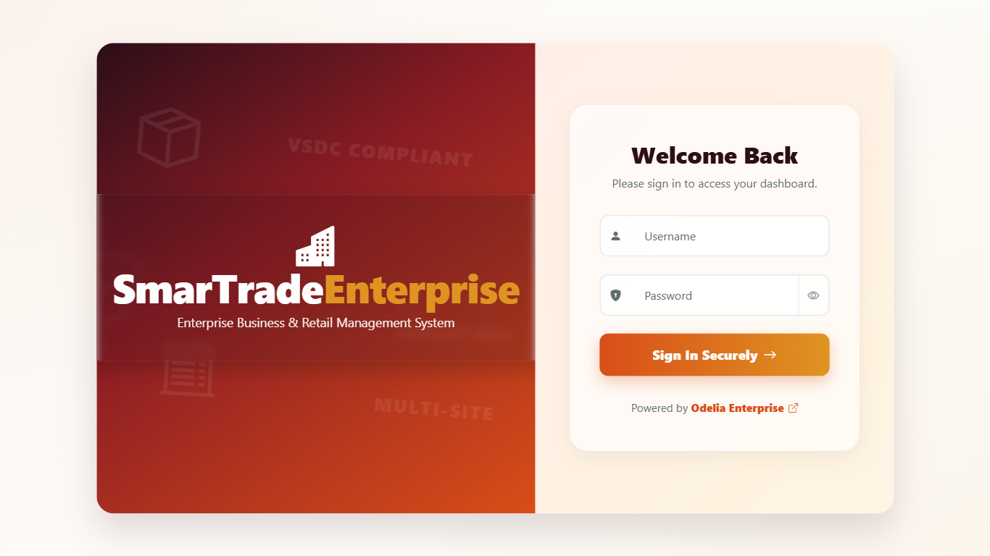
Figure 1 — The sign-in screen.
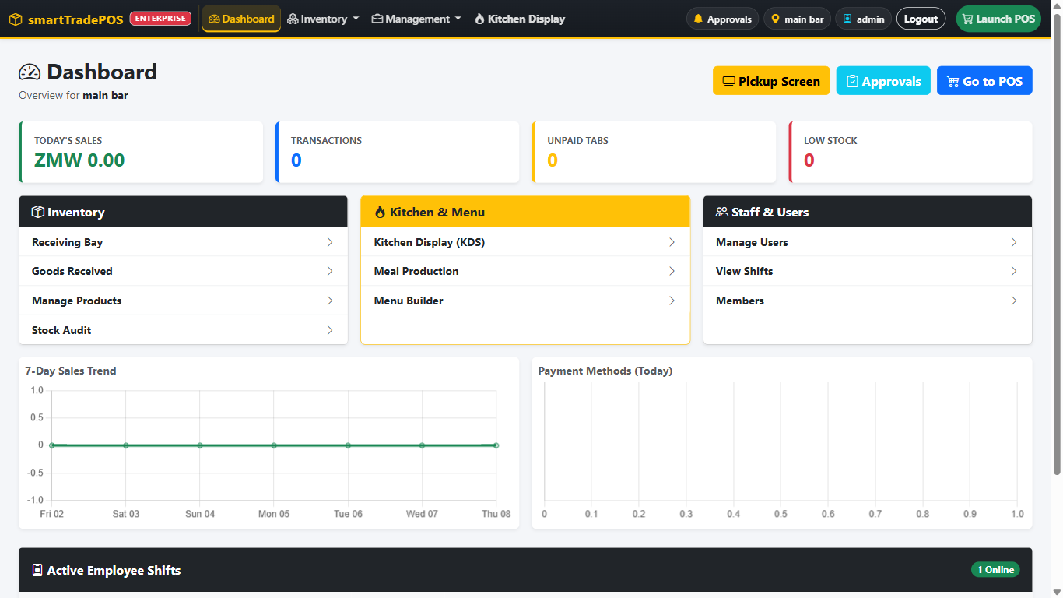
Figure 2 — Manager and administrator home: the Dashboard with quick links and Launch POS.
1. Open http://<shop-pc>:8090 on the PC.
2. Sign in as train_cashier.
Expected result: the POS opens. There is no Dashboard. The top bar shows the station name, Payout, X-Read, End, Exit.
3. Exit, then sign in as train_mgr.
Expected result: the Dashboard opens. The navbar shows Dashboard, Inventory, Management, Kitchen Display, and a green Launch POS.
4. Logout, then sign in as train_chef.
Expected result: Meal Production opens. The navbar shows Live KDS Screen, Recipe/Prep Log, Menu Builder, Stock Levels. There is no POS button.
If it goes wrong: a chef landing on the POS means the tier is Lite or Pro. Kitchen roles need Pro+ or Enterprise.

Scenario 1.2 — Forced password change
1. As train_admin, edit train_cashier on Users & Staff and set a new password.
2. Sign in as train_cashier.
Expected result: if the account is flagged to change password, the Change Password screen appears and Cancel is hidden. Enter the current password, a new one of at least 6 characters, confirm, and save. The POS then opens.
3. Try a 4-character password.
Expected result: it is rejected.

Scenario 1.3 — Know where you are (active page)
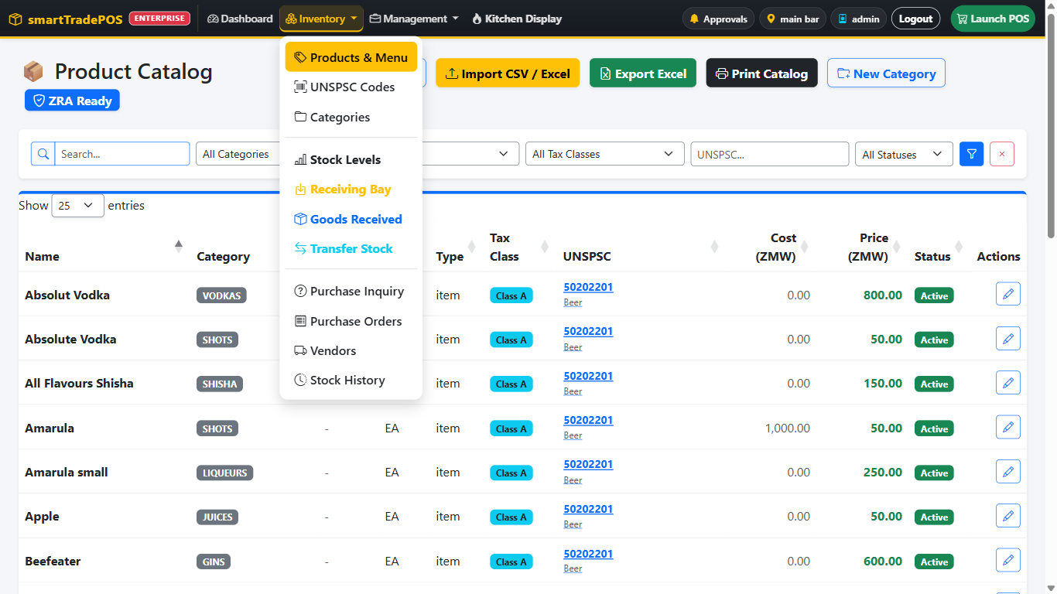
Figure 3 — Active page: Inventory is highlighted and Products & Menu has the yellow background.
1. As train_mgr, open Inventory → Products & Menu.
Expected result: Inventory in the navbar is highlighted yellow with an underline. Open the Inventory menu: Products & Menu has a yellow background.
2. Open Management → Master Reports.
Expected result: the highlight moves to Management, and Master Reports is the yellow entry.

Scenario 1.4 — The navbar on a phone
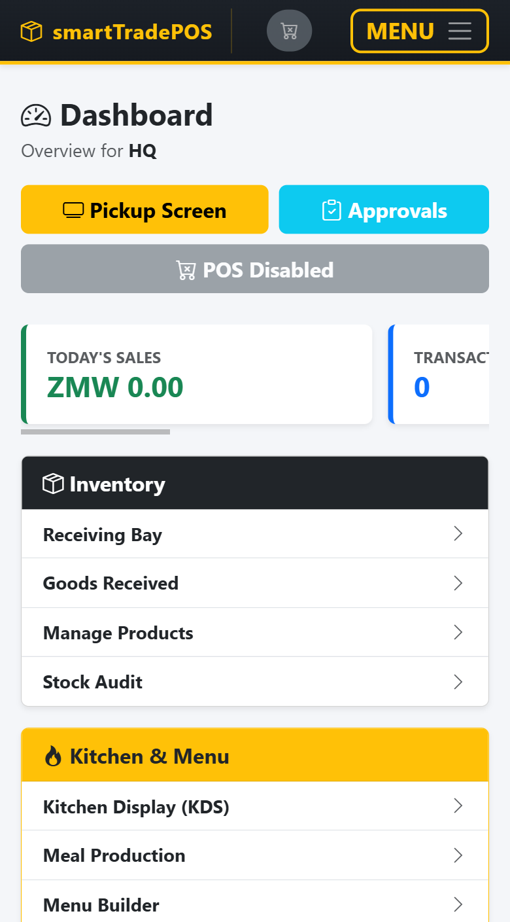 | 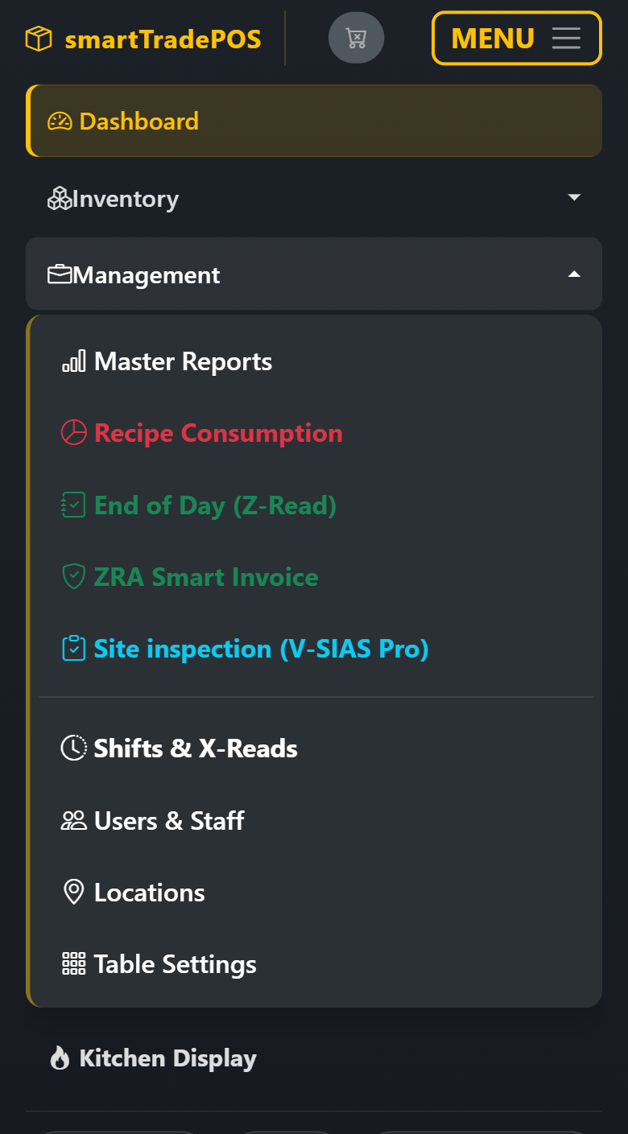
Figure 4 — The phone navbar closed (left) and with Menu open and Management expanded (right).
1. On the phone, open http://<shop-pc>:8090 and sign in as train_mgr.
Expected result: the brand is on the left, a green POS pill and a Menu button on the right.
2. Tap Menu.
Expected result: a dark panel drops down. Dashboard is a single row. Inventory and Management have a chevron. The bottom holds Approvals, the workstation chip, your name, and Logout, all full width.
3. Tap Inventory, then Management.
Expected result: Inventory expands with a yellow left rail; when you tap Management, Inventory folds and Management opens. Only one is open at a time.
4. Tap Stock Levels.
Expected result: the panel closes by itself and Stock Levels loads.
5. Tap the green POS pill.
Expected result: the POS opens directly, without opening the menu.
If it goes wrong: no POS pill means the current workstation has POS enabled off (the pill shows grey and crossed) or the user is a chef.

Scenario 1.5 — Switching workstation
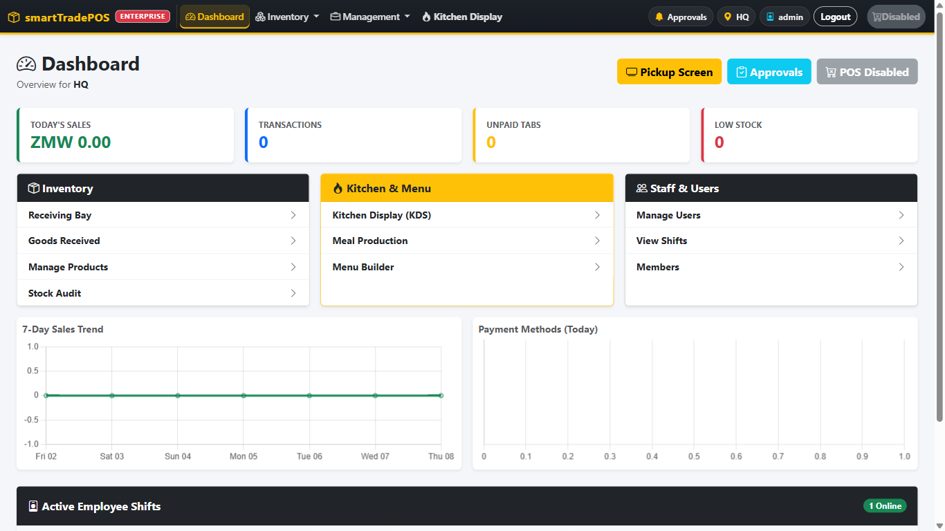
Figure 5 — Select Workstation: the current station has the yellow border.
1. As train_admin on the PC, click the pin chip in the navbar.
Expected result: Select Workstation lists every location. The current one has a yellow border.
2. Pick Restaurant, confirm Switch.
Expected result: the chip now says Restaurant. The dashboard figures change to that station.
3. As train_mgr, look for the same chip.
Expected result: managers see the chip too, but location edits they save elsewhere are queued for the developer. On the POS, the pencil next to the station name lists only sellable locations.

2. Cashier and bartender
Sign in as train_cashier for this chapter. Use train_mgr on a second device (or the trainer types the manager credentials) for every authorization.

Scenario 2.1 — Open a shift (Must pass)
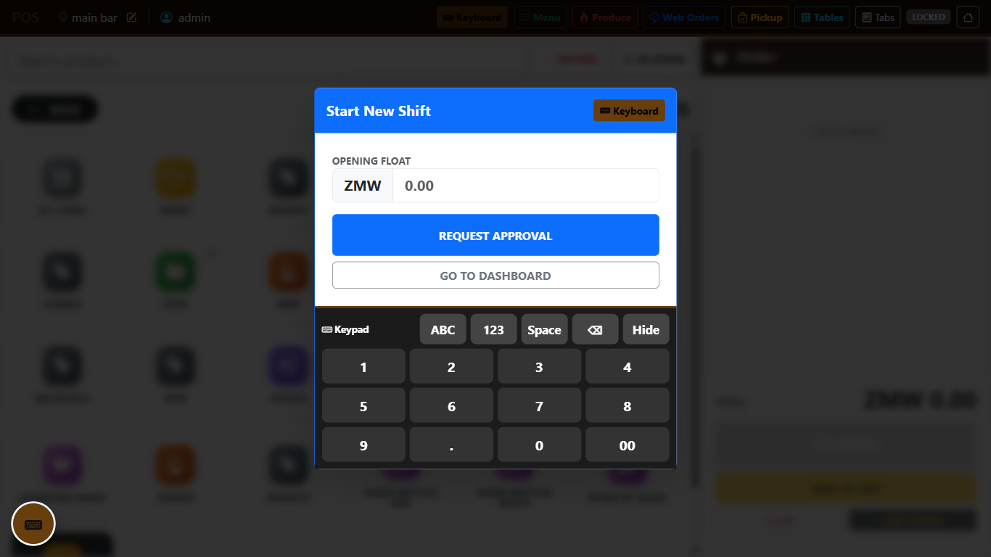
Figure 6 — Start New Shift with the opening float and REQUEST APPROVAL.
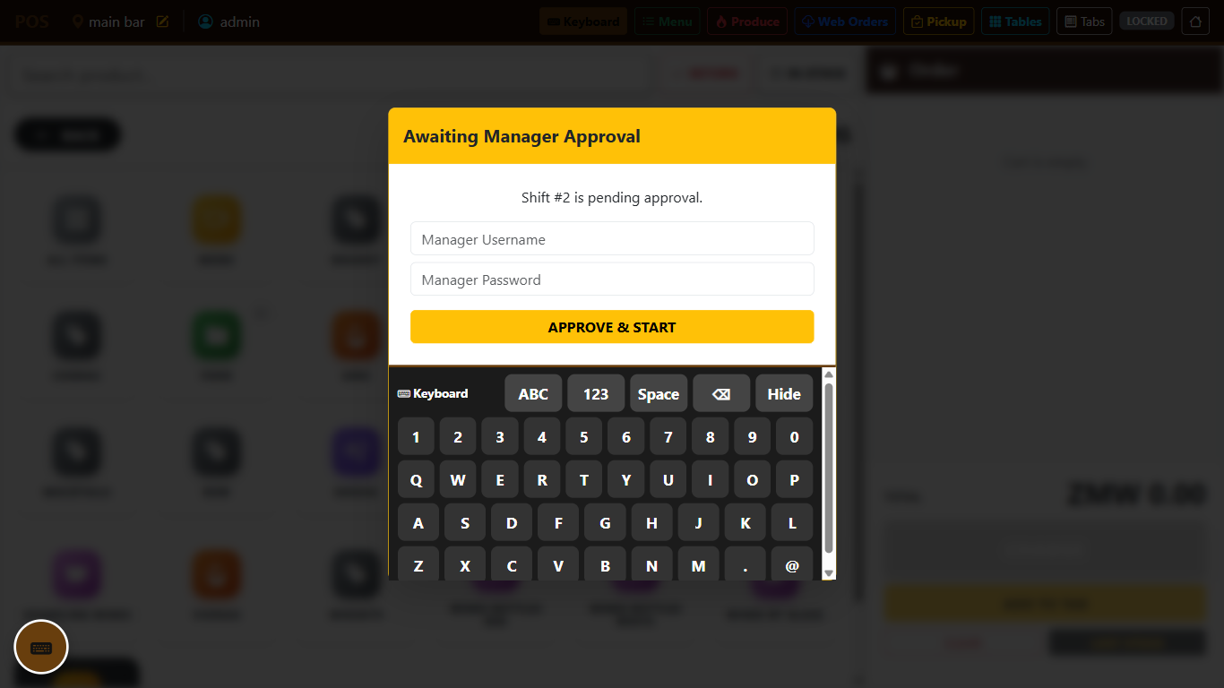
Figure 7 — Awaiting Manager Approval: the manager types their credentials here.
Situation: it is 08:00, the drawer has ZMW 500 in float.
1. The product grid is blurred and Start New Shift is on screen.
2. Enter 500 as the opening float. Tap REQUEST APPROVAL, then confirm Request in the pop-up.
Expected result: the box changes to Awaiting Manager Approval with the shift number.
3. Manager enters train_mgr and the password, confirms Approve.
Expected result: the blur lifts, the grid is live, the top bar shows the shift is open.
If it goes wrong: "Open a shift before checkout" at any later point means the shift was never approved or was ended.

Scenario 2.2 — Simple cash sale (Must pass)
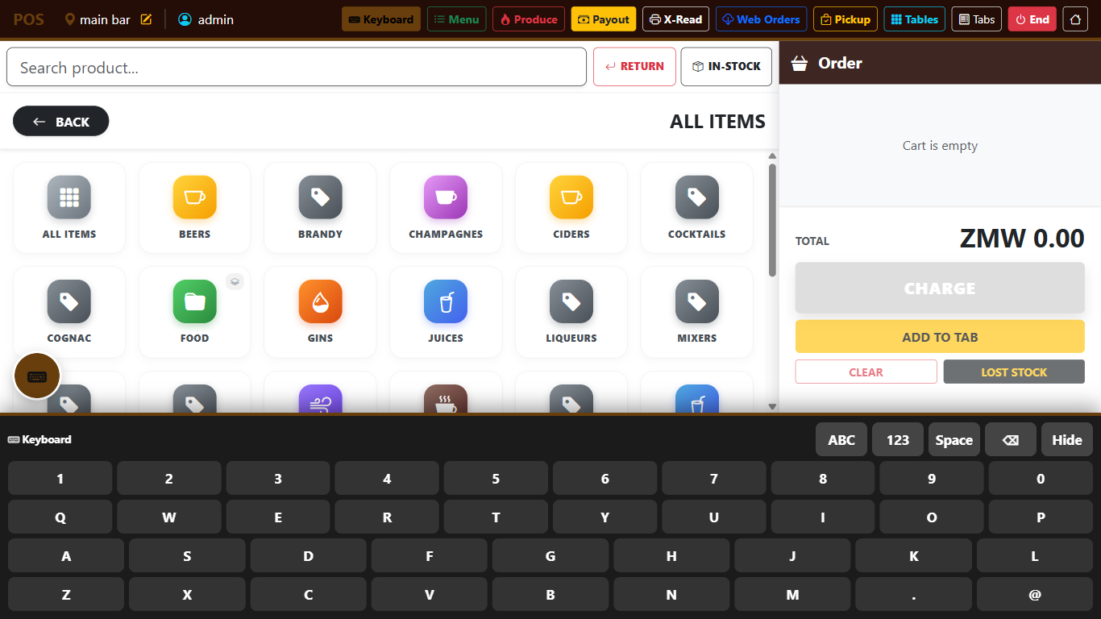
Figure 8 — The live POS: categories on the left, the Order panel with CHARGE, ADD TO TAB, CLEAR and LOST STOCK on the right.
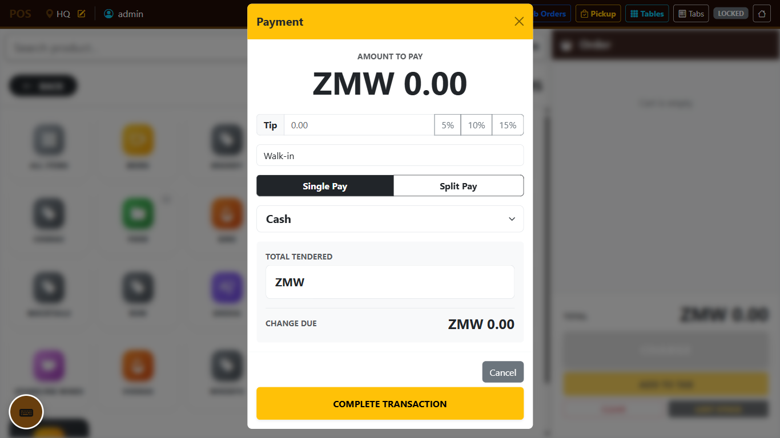
Figure 9 — The Payment window: tip, customer name, Single/Split pay, method, tendered and change.
Situation: a customer buys two Mosi and one Fanta, pays ZMW 100 cash.
1. Tap Beverages, then Lagers, then Mosi. Tap Mosi again. Tap Back, then Soft drinks, then Fanta.
Expected result: the cart shows Mosi × 2 and Fanta × 1 with a running total.
2. Tap CHARGE. Payment method Cash. Tendered 100. Tap COMPLETE TRANSACTION, then confirm Complete in the pop-up.
Expected result: a receipt opens for printing with the change shown. The cart is empty. Stock Levels for Main Bar show Mosi down by 2 and Fanta by 1.

Scenario 2.3 — Out of stock
1. Find the product the trainer set to 0 stock.
Expected result: the tile is grey and does nothing when tapped.
2. Add a product with stock 3 and tap + four times.
Expected result: quantity stops at 3. The till will not oversell this station.
3. Switch on In-stock.
Expected result: the grey tile disappears from the grid.

Scenario 2.4 — Search and open price
1. Type the first letters of a product into Search product.
Expected result: the grid filters live.
2. Tap the 0.00 product.
Expected result: Custom Amount asks for the price. Enter 35 and add.
Expected result: the cart line shows ZMW 35.00.

Scenario 2.5 — Card, mobile money, and split pay (Must pass)
Situation: total ZMW 180. Customer pays ZMW 100 by Airtel Money and the rest by cash.
1. Ring the items. Charge.
2. Choose Split pay. First row Airtel Money, amount 100. Add payment method, second row Cash, amount 80.
Expected result: the remaining balance reaches 0.00 and Complete becomes available. The receipt lists both payments.
3. Ring another sale and pay the whole thing by Card.
Expected result: no tendered/change step; the receipt shows Card.
4. Ring another and use a split row Other named Bank transfer.
Expected result: the receipt shows "Bank transfer".

Scenario 2.6 — Tip and customer name
1. Ring a sale. In the payment window, tap 10%.
Expected result: the tip field fills with 10% of the total and the total due updates.
2. Type Mrs Banda into Customer Name. Complete.
Expected result: the receipt shows Mrs Banda and a tip line.

Scenario 2.6a — Tip given after the bill is paid (Must pass)
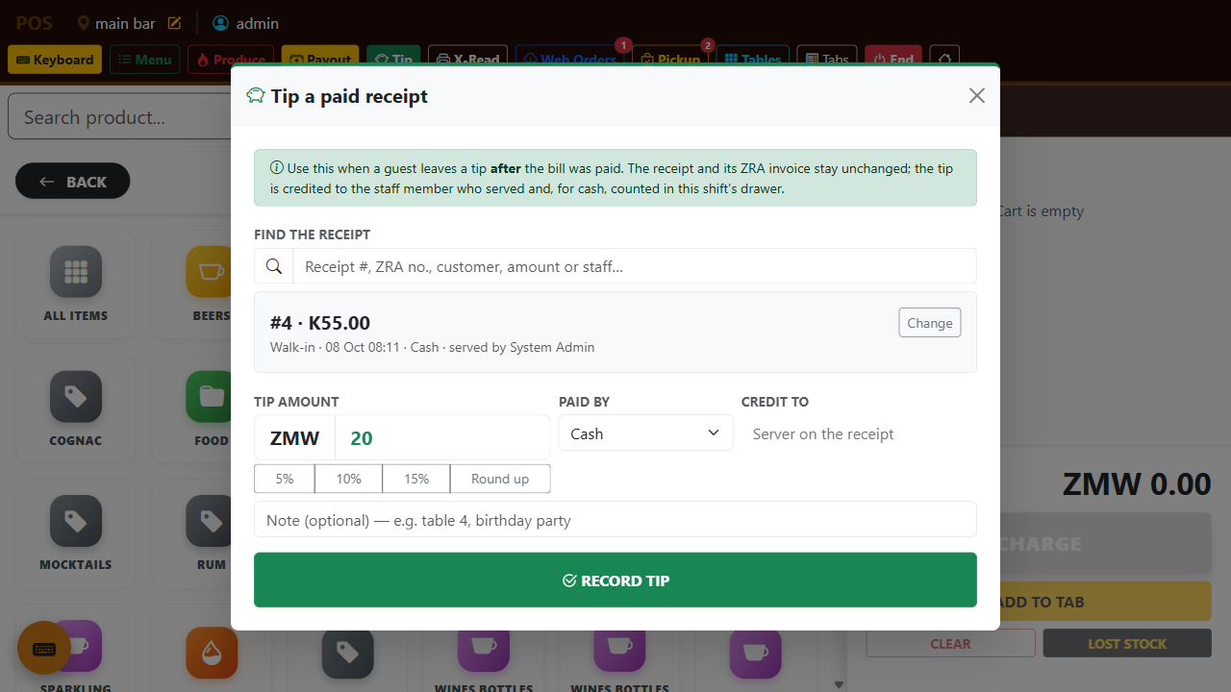
Figure 10 — Tip a paid receipt: search the receipt, enter the tip, choose how it was paid and who gets it.
Situation: Mrs Banda paid and left. Five minutes later she comes back and hands the cashier ZMW 20 "for the service".
1. Tap the green Tip button in the POS toolbar.
2. In Find the receipt, type Banda (or the receipt number, the amount, or the cashier's name). Tap the matching receipt.
Expected result: the receipt's number, time, total, and server appear in the grey box. The amount field and quick buttons (5%, 10%, 15%, Round up) become active.
3. Enter 20, Paid by Cash, Credit to the cashier who served. Save.
Expected result: "Tip recorded". The original receipt and its ZRA invoice are unchanged. The X-Read now shows a Tips after payment line and the expected cash is 20 higher.
4. Try to tip the same way with the amount empty, or without choosing a receipt.
Expected result: the form refuses; nothing is saved.

Scenario 2.6b — Surcharge with a reason (Must pass)
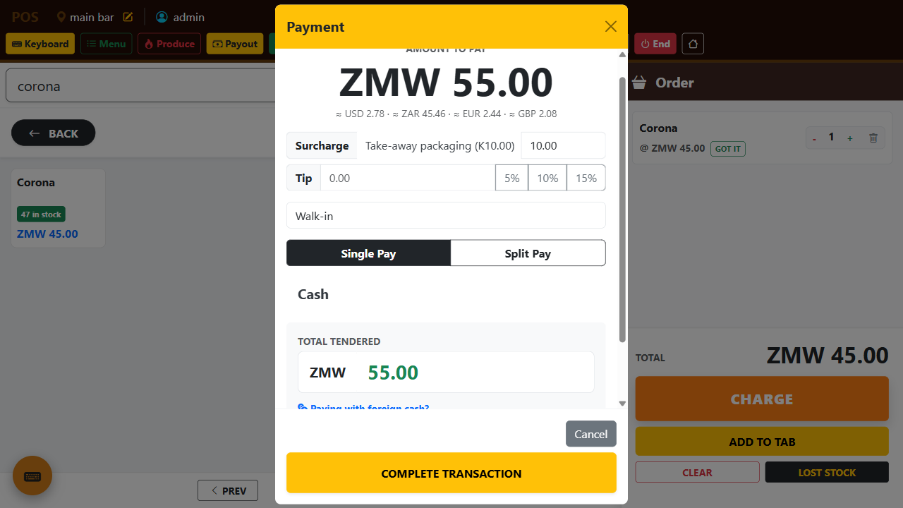
Figure 11 — The Payment window with a surcharge reason selected: the total, the foreign-currency equivalents and the tendered amount all update.
Situation: a guest finishes a meal and asks for the leftovers to be packed.
1. Ring the sale. In the payment window, open the Surcharge drop-down and pick Take-away packaging (the administrator's list; type to search it).
Expected result: the surcharge amount fills with that reason's default and the total due goes up by the same amount.
2. Change the amount to 8. Complete the sale.
Expected result: the receipt shows a Surcharge — Take-away packaging line of ZMW 8. On Master Reports → Tips & Surcharges, the reason appears with 1 receipt and ZMW 8.
3. Ring another sale, choose Other, type Late-night service, amount 15.
Expected result: the typed reason prints on the receipt and shows in the report under its own name.

Scenario 2.6c — Paying with foreign cash (when Currency is enabled)
Situation: a tourist pays a ZMW 198 bill with a USD 20 note.
1. In the payment window, tap Paying with foreign cash?. Choose USD, type 20.
Expected result: the kwacha equivalent (about ZMW 396 at a rate near 19.8) fills the Total tendered box and the change is shown in ZMW. The small line under the total shows the amount due in the enabled currencies.
2. Complete the sale.
Expected result: the receipt is in kwacha; the sale is a normal cash sale in reports.

Scenario 2.6d — Card or mobile money through Flutterwave (when Payments is enabled)
1. Ring a sale. Choose Flutterwave (Card / Mobile Money).
Expected result: a panel appears with Mobile money and Card buttons. If test keys are in use the panel is marked TEST MODE.
2. Mobile money: pick the network, type the guest's number, Send MoMo prompt.
Expected result: status changes to Waiting for the customer; the guest approves on the phone; the panel turns green "Flutterwave confirmed the payment". Tap Complete transaction.
3. Card: tap Card / other; a Flutterwave window opens. In the sandbox use the test card shown in Settings → Payments.
Expected result: the window closes on success, the panel turns green, and Complete finishes the sale. A declined card shows Declined; take another payment method.

Scenario 2.7 — Member sale (Pro and above)
1. Attach the training member (search by phone).
Expected result: a blue bar says Member: <name> and the customer name is locked to the member.
2. Switch 10% OFF on. Charge.
Expected result: the total is reduced by 10%. The discount appears in the Discounts tile on Master Reports.

Scenario 2.8 — Clear the cart
1. Add two items. Tap CLEAR.
Expected result: a confirmation. Keep leaves the cart; Clear empties it.

Scenario 2.9 — Payout (Must pass)
Situation: the manager sends the cashier to buy ZMW 50 of ice.
1. Payout. Amount 50, reason Ice. Confirm Authorize.
2. Enter manager credentials.
Expected result: "Payout logged". The X-Read now shows a payout line and the expected drawer is 50 lower.

Scenario 2.10 — Lost stock (Pro and above)
Situation: a bottle of Mosi broke.
1. Add Mosi to the cart. Tap LOST STOCK.
2. Enter manager credentials. Authorize.
Expected result: "Waste logged". The cart is empty. Stock Levels show Mosi down by 1. No sale appears on the Receipts report. The Inventory Audit Trail shows a waste row.

Scenario 2.11 — Return against an invoice (Must pass)
Situation: the customer from 2.2 brings back one Fanta.
1. Switch Return on. The invoice list opens. Filter by the sale number from 2.2 and select it.
2. Choose the Fanta line, quantity 1.
3. Charge. Enter manager credentials. Pick ZRA refund reason → Wrong product. Complete.
Expected result: a credit note receipt (negative total). Stock for Fanta goes up by 1. On Master Reports the ticket carries a red Refund badge.
4. Try to return two more Fanta against the same invoice.
Expected result: refused. The system will not credit more than the invoice still has left.
If it goes wrong: a return rung without picking an invoice is a POS return with no original Smart Invoice. ZRA cannot accept it. Always select the invoice first.

Scenario 2.12 — X-Read
1. X-Read.
Expected result: a window with opening float, sales by payment method, payouts, and expected drawer. PRINT X-READ prints it. The shift stays open.

Scenario 2.13 — End the shift (Must pass)
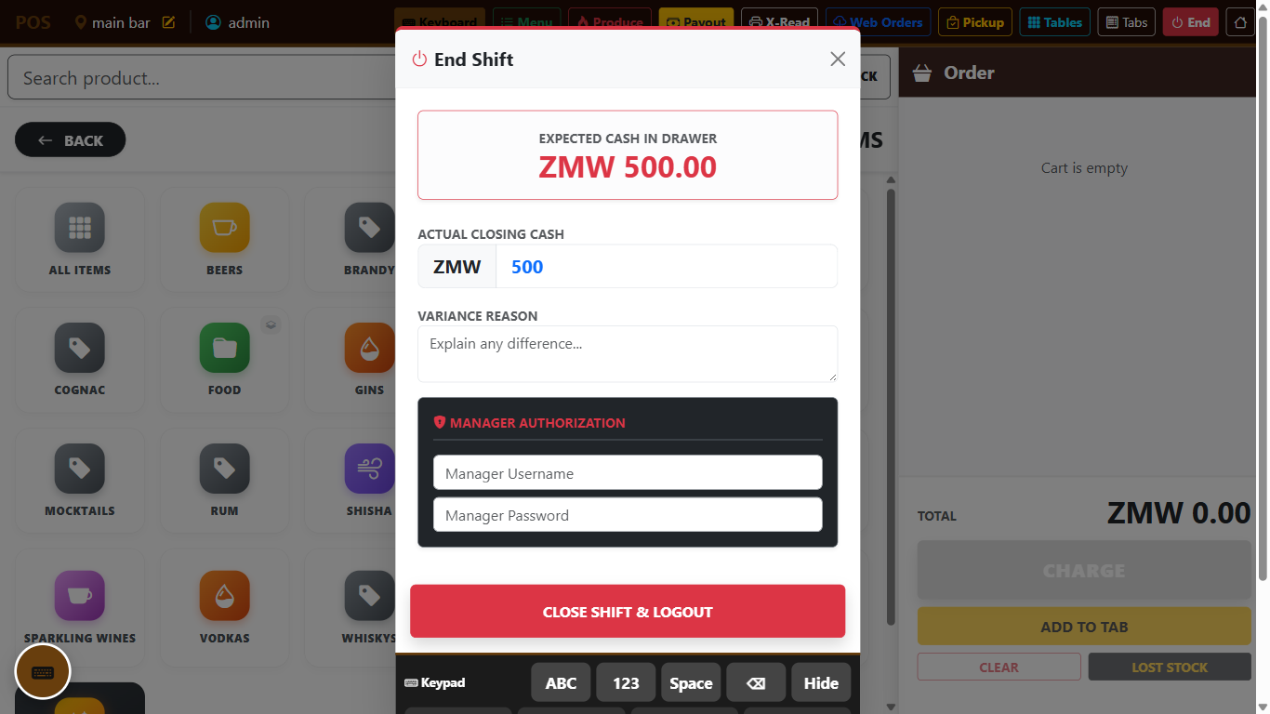
Figure 12 — End Shift: counted cash, variance reason and manager authorization.
Situation: 17:00. Actual cash counted is ZMW 1,180; expected is ZMW 1,200.
1. End. Enter counted cash 1180. Explain the difference in variance reason (e.g. "short ZMW 20, under investigation").
2. Enter manager credentials. Tap CLOSE SHIFT & LOGOUT, then confirm End shift in the pop-up.
Expected result: the cashier is signed out (a manager is returned to the Dashboard). Signing in again shows the station blurred with Start New Shift. Shifts & X-Reads shows the shift as closed with the variance.

Assessment — cashier / bartender
# | Checkpoint | Pass
C1 | Requests a shift with the right float and waits for approval
C2 | Rings a mixed sale using categories and search
C3 | Explains why a tile is grey and why + stops
C4 | Completes cash with correct change, card, mobile money, and a split
C5 | Attaches a member and applies 10%
C5a | Records a tip against an already-paid receipt and finds it on the X-Read
C5b | Adds a surcharge with the right reason and explains where it shows
C5c | Takes foreign cash and gives change in kwacha (if enabled)
C6 | Logs a payout with reason and manager auth
C7 | Logs lost stock and shows it in Stock Levels, not in Receipts
C8 | Returns against the original invoice with a reason, and explains why a free-standing return is wrong
C9 | Prints an X-Read without closing
C10 | Ends the shift with the counted cash and a variance note

3. Waiter
Sign in as train_waiter. Needs Pro or above; tables need Pro+.

Scenario 3.1 — Start a tab
Situation: two guests sit down and order drinks first.
1. Ring two drinks. From the cart, choose Add to Tab → New tab, name it Table 4, assign table T4 (Pro+). Confirm.
Expected result: the cart is empty. Tabs shows "Table 4" with two lines. On Tables, T4 is red (occupied).

Scenario 3.2 — Food with Got it / Later (Pro+)
1. Open the tab from Tabs. Add a dish from a Food category.
Expected result: the line shows Got it and Later.
2. Tap Later.
Expected result: the dish is sent to the kitchen. The KDS (section 5) shows a red ticket with this order number and your name.
3. Add a second dish and tap Got it (the guest already received it from the pass).
Expected result: nothing goes to the kitchen; the line is marked collected.

Scenario 3.3 — Pickup
1. Wait for the kitchen to mark the first dish Done.
Expected result: the red pickup badge on the POS shows 1.
2. Open Pickup. Mark the dish collected.
Expected result: the badge drops to 0.

Scenario 3.4 — Transfer or merge lines between tabs
Situation: one guest moves to Table 6.
1. Tabs → Transfer / Merge. Source tab Table 4. Tick one drink. Destination: new tab Table 6. Confirm Transfer.
Expected result: Table 4 has one line fewer; Table 6 exists with that line.

Scenario 3.5 — Close a tab with split payment
1. Open Table 4 → Charge. Pay half by Card and half by Cash.
Expected result: receipt printed, tab gone from Tabs, T4 green again on the floor plan.

Scenario 3.6 — Pending payment
1. Ring a sale and choose payment Pending.
Expected result: the order becomes a tab with no money taken. It shows in the Dashboard's Unpaid Tabs count.

Scenario 3.7 — Web orders (Enterprise)
1. Ask the trainer to drop a test online order for Main Bar.
2. Web Orders (or the ⋯ menu → Web Orders).
Expected result: the order is listed with a badge count. Open it.
Expected result: its lines are in the cart; pay it with Online.

Assessment — waiter
# | Checkpoint | Pass
W1 | Opens a named tab assigned to a table
W2 | Fires food with Later and recognises the ticket on KDS
W3 | Uses Got it correctly for a plate already served
W4 | Collects from Pickup and clears the badge
W5 | Moves lines between tabs
W6 | Settles a tab with split pay and sees the table free up
W7 | Takes an online order and pays it with Online

4. Head chef and chef
Sign in as train_chef (head chef). Pro+ or Enterprise.

Scenario 4.1 — Build a dish and its recipe (head chef)
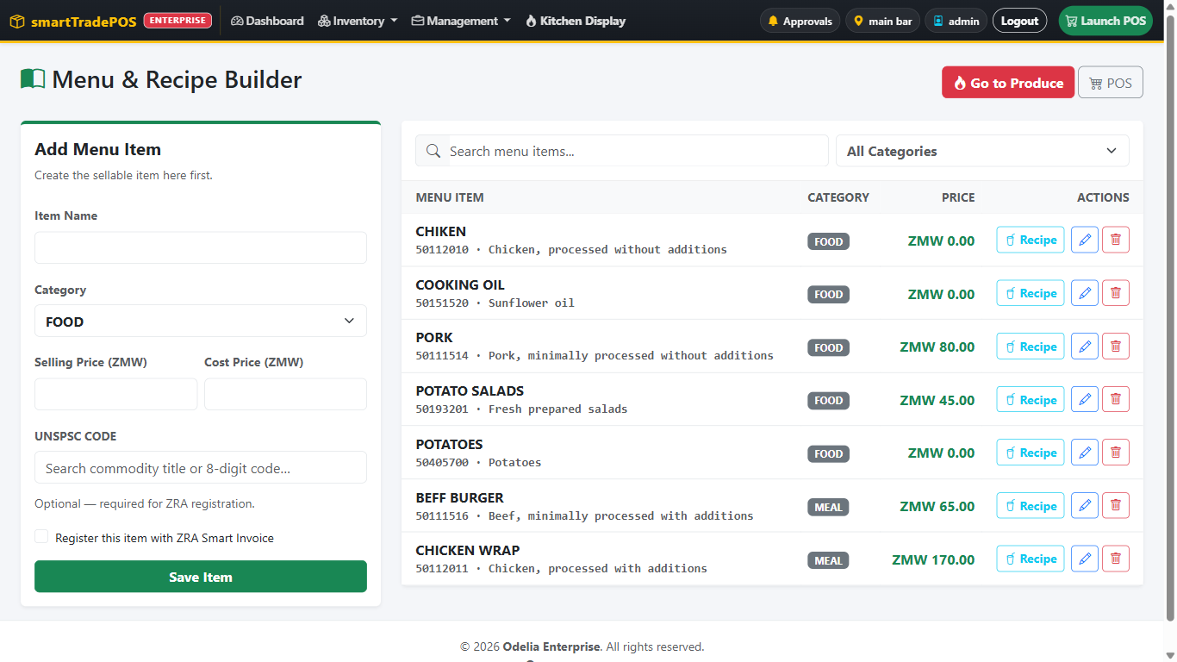
Figure 13 — Menu Builder: dishes and their recipes.
1. Menu Builder. Add Chicken & chips: Food category, selling price 85.
2. Save the recipe: Chicken portion 1, Chips (raw potatoes) 0.25 kg.
Expected result: the dish appears on the menu list with its ingredients. On the POS it appears under Food; the raw potatoes do not appear as a tile.
If it goes wrong: "Assign a UNSPSC code before registering the item with ZRA" means the dish saved locally but was not registered with ZRA. Add a level-4 code on the product and save again (Enterprise).

Scenario 4.2 — Check what is on hand and produce (Must pass)
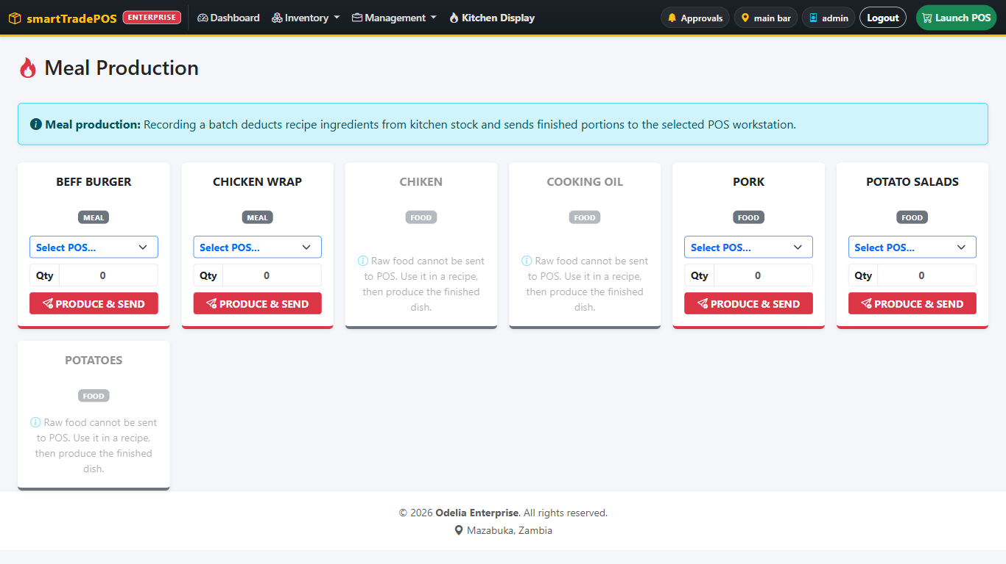
Figure 14 — Meal Production: pick the dish, the destination station and the quantity.
Situation: lunch starts in an hour; the bar has no Chicken & chips on hand.
1. Meal Production. Pick Chicken & chips. Choose workstation Main Bar.
Expected result: the card says None on hand in red.
2. Quantity 10. Confirm Produce & send.
Expected result: Kitchen stock of chicken portions is down 10 and potatoes down 2.5 kg. Main Bar shows 10 Chicken & chips. The card now says 10 on hand in green.
3. Try to produce 100.
Expected result: refused or capped when ingredients are insufficient.

Scenario 4.3 — Raw food cannot go straight to the till
1. Try to produce the raw ingredient itself to Main Bar.
Expected result: not allowed. Only finished dishes with recipes can be sent to a till.

Scenario 4.4 — Work the kitchen display (chef)
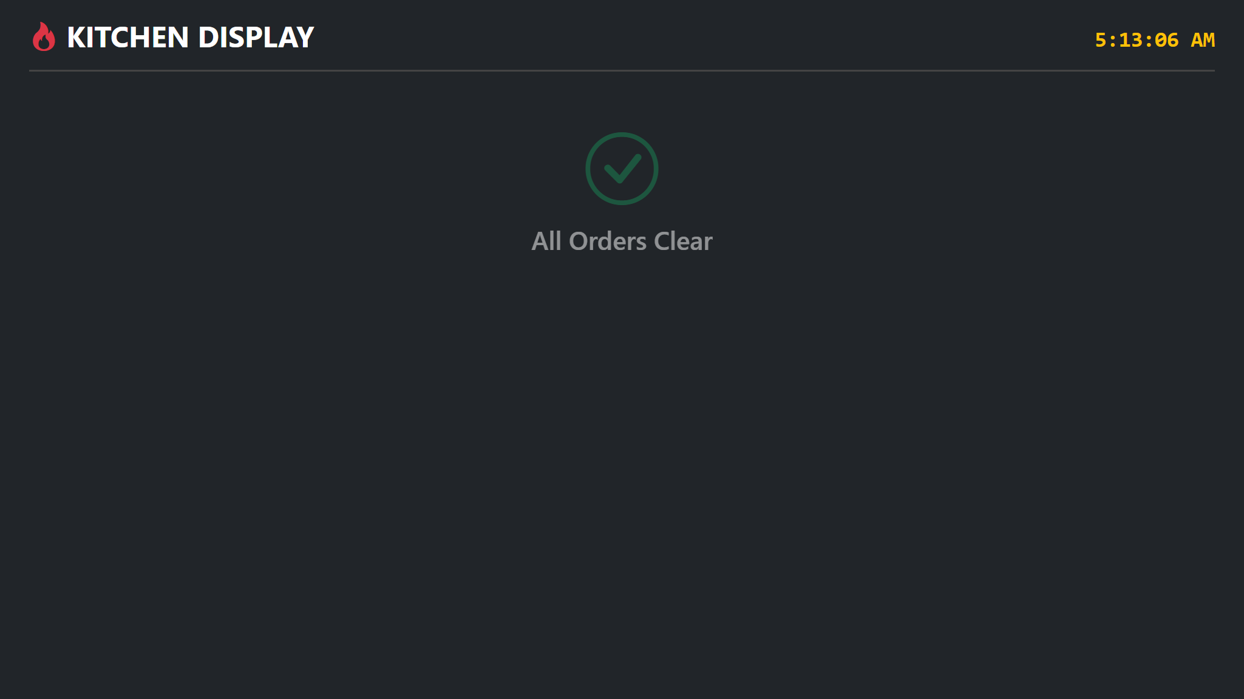
Figure 15 — Kitchen Display with nothing waiting: All Orders Clear.
Sign in as train_cook on the kitchen screen.
1. Have the waiter fire a dish with Later (scenario 3.2).
Expected result: a ticket with a red header shows the order number, who sent it, and minutes elapsed.
2. Tap Cook on the line. Confirm.
Expected result: the header turns yellow.
3. Tap Done. Confirm.
Expected result: the ticket clears; the waiter's Pickup badge increments. "All orders clear" shows when nothing is waiting.

Scenario 4.5 — Chefs and stock
1. As train_cook, open Stock Levels.
Expected result: you can filter and look. Entering a physical count and saving is refused: "Kitchen staff have view-only access to stock."

Scenario 4.6 — Recipe consumption report (head chef)
1. Management → Recipe Consumption (head chef has this; the chef does not). Set today's date and the Kitchen location.
Expected result: chicken and potatoes used by 4.2 are listed with quantities. The sales ledger is not involved.
2. Sign in as train_cook and try the same address.
Expected result: sent back to Meal Production.

Assessment — kitchen
# | Checkpoint | Pass
K1 | Creates a dish with a two-ingredient recipe
K2 | Reads on-hand before deciding batch size
K3 | Produces to the correct station and verifies both stock movements
K4 | Explains why raw stock cannot be produced to a till
K5 | Moves a KDS ticket Cook → Done
K6 | Knows that chefs view stock but do not post counts
K7 | Head chef reads Recipe Consumption for a day

5. Manager
Sign in as train_mgr. Everything a cashier does, plus the chapters below. Managers do all approvals in chapters 2 and 3; make sure they have practised typing their credentials on another person's screen without leaving it.

5.1 Staff and shifts

Scenario 5.1.1 — Create a user (Must pass)
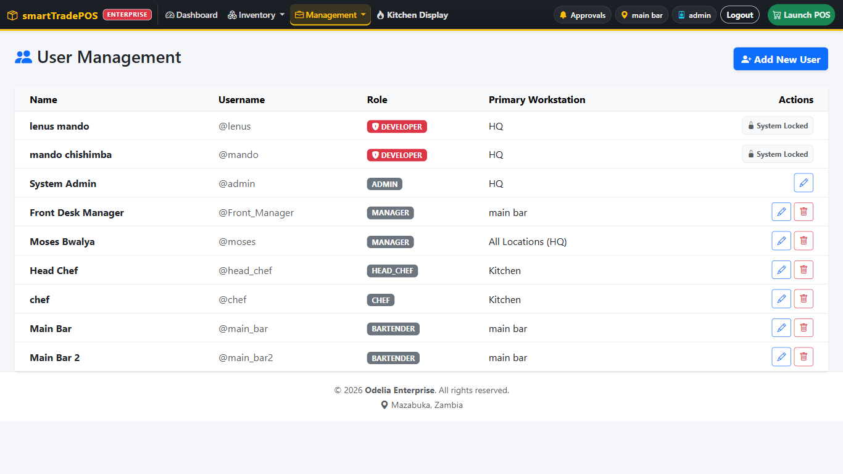
Figure 16 — Users & Staff with Add New User.
1. Management → Users & Staff → Add New User. Full name, username temp_cashier, role Cashier, workstation Restaurant, password. Save.
Expected result: the user appears in the list.
2. Try the same username again.
Expected result: "That username is already in use."
3. Edit the user, leave the password blank, change the workstation.
Expected result: the workstation changes; the password is unchanged (sign in to prove it).

Scenario 5.1.2 — Delete versus deactivate
1. Delete temp_cashier before they have sold anything.
Expected result: the account is removed.
2. Try to delete train_cashier, who has sales.
Expected result: the account is deactivated, not removed. History is kept.
3. Try to delete your own signed-in account.
Expected result: "You cannot delete the signed-in account."

Scenario 5.1.3 — Approve, review, and close shifts from the office
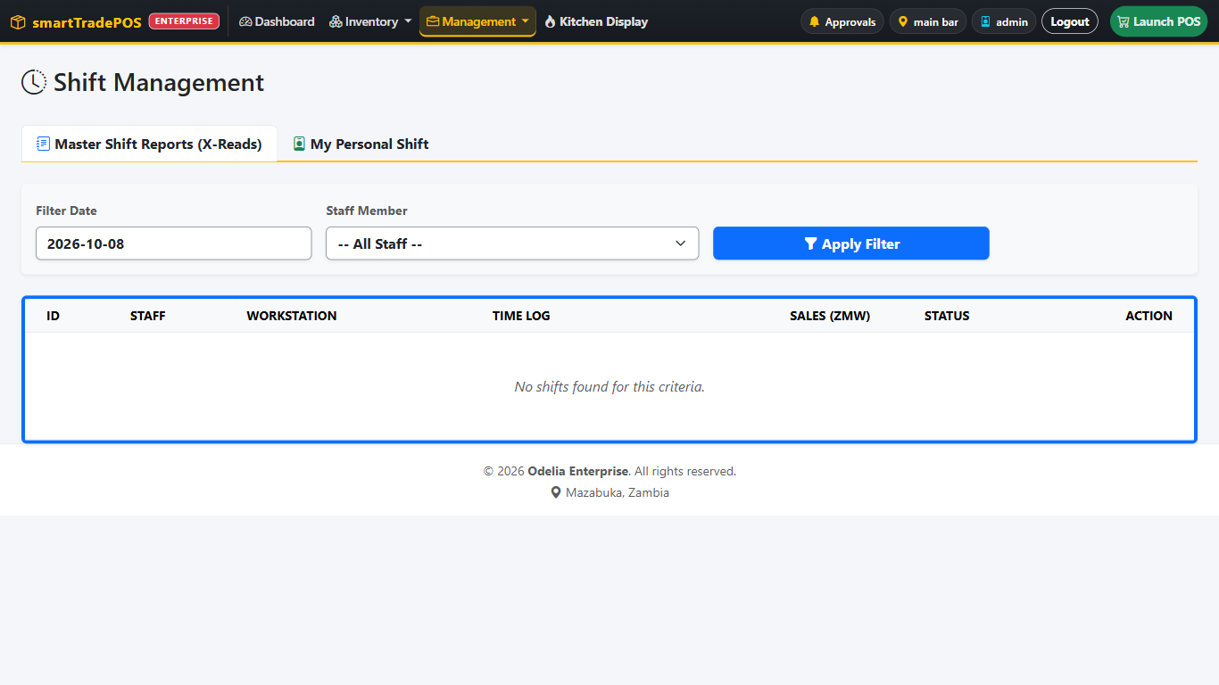
Figure 17 — Shifts & X-Reads: pending and closed shifts.
1. Have train_cashier request a shift. On your PC, Management → Shifts & X-Reads.
Expected result: the pending shift is listed; approve it there.
2. Open Master Shift Reports, filter by today and train_cashier. Open the shift.
Expected result: the paid sales for that shift are listed. Print shift prints the X-Read.
3. The dashboard Active shifts card shows the same shift with a button into its sales.

5.2 Catalog and stock

Scenario 5.2.1 — Add a product correctly for ZRA (Must pass on Enterprise)
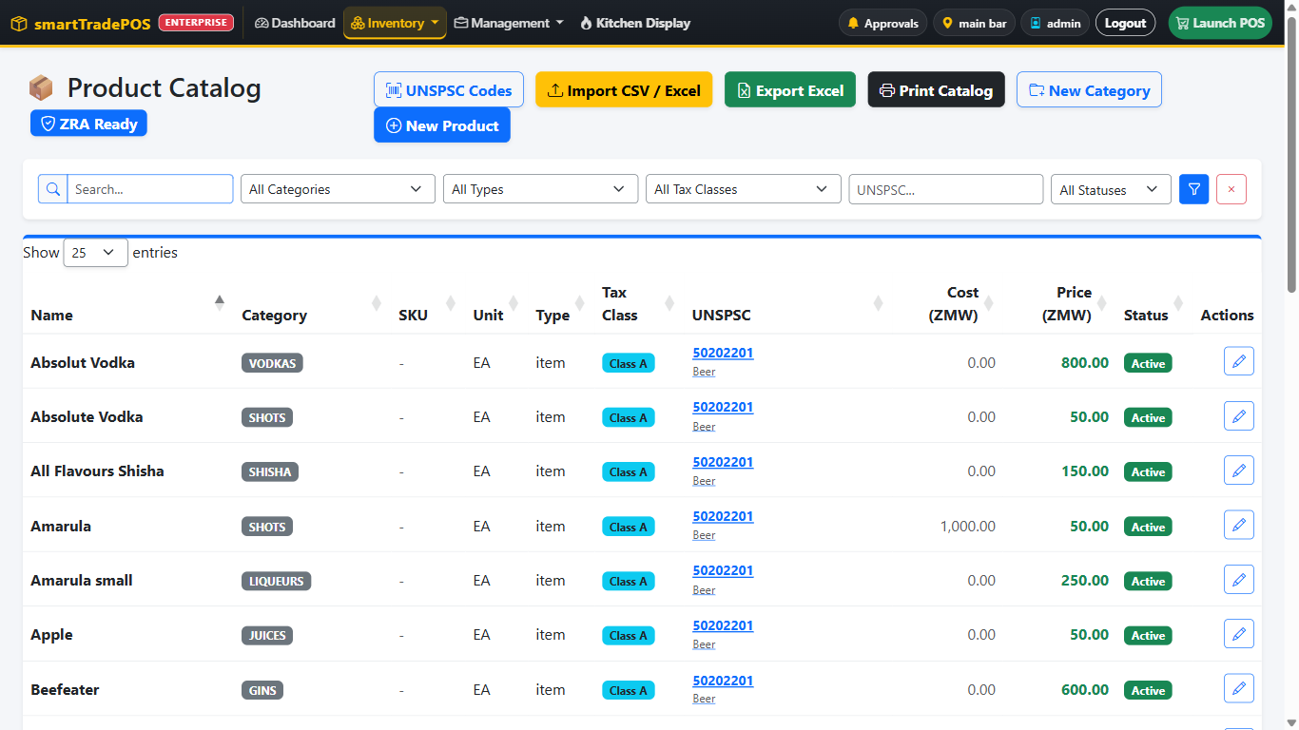
Figure 18 — Product Catalog with filters for category, type, tax class, UNSPSC and status.
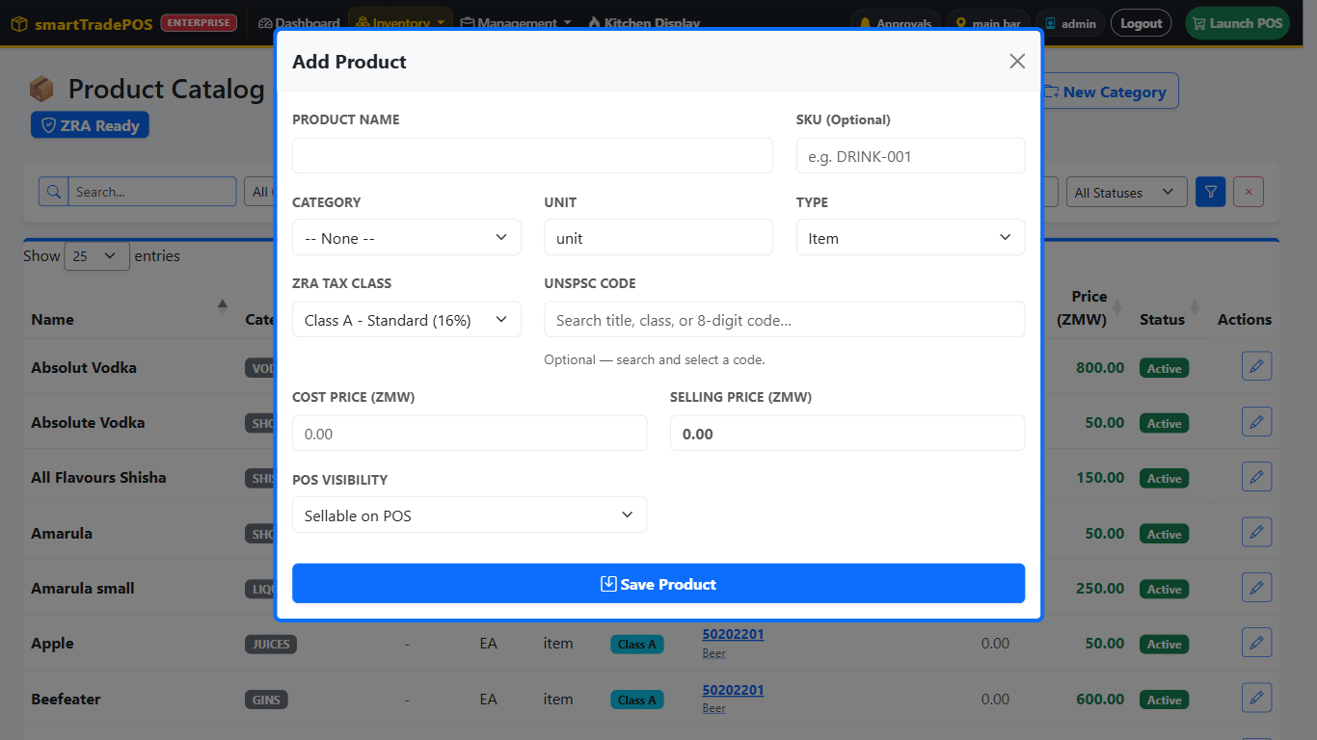
Figure 19 — Add Product: tax class and UNSPSC code sit next to each other.
1. Inventory → Products & Menu → New Product. Name Castle Lite 330ml, SKU, category Lagers, unit, type Item, cost 12, price 25, POS visibility Sellable on POS.
2. ZRA tax class Class A - Standard (16%). UNSPSC code: type beer and pick the level-4 code (for example 50202201). Save Product.
Expected result: the product saves. The Unsynced products count on the ZRA page goes up by one until Register products is run.
3. Add a second product and leave UNSPSC blank.
Expected result: it saves, but it will be rejected when registered with ZRA ("Item class must be a level-4 UNSPSC"). Fix it before go-live.

Scenario 5.2.2 — Categories and routing
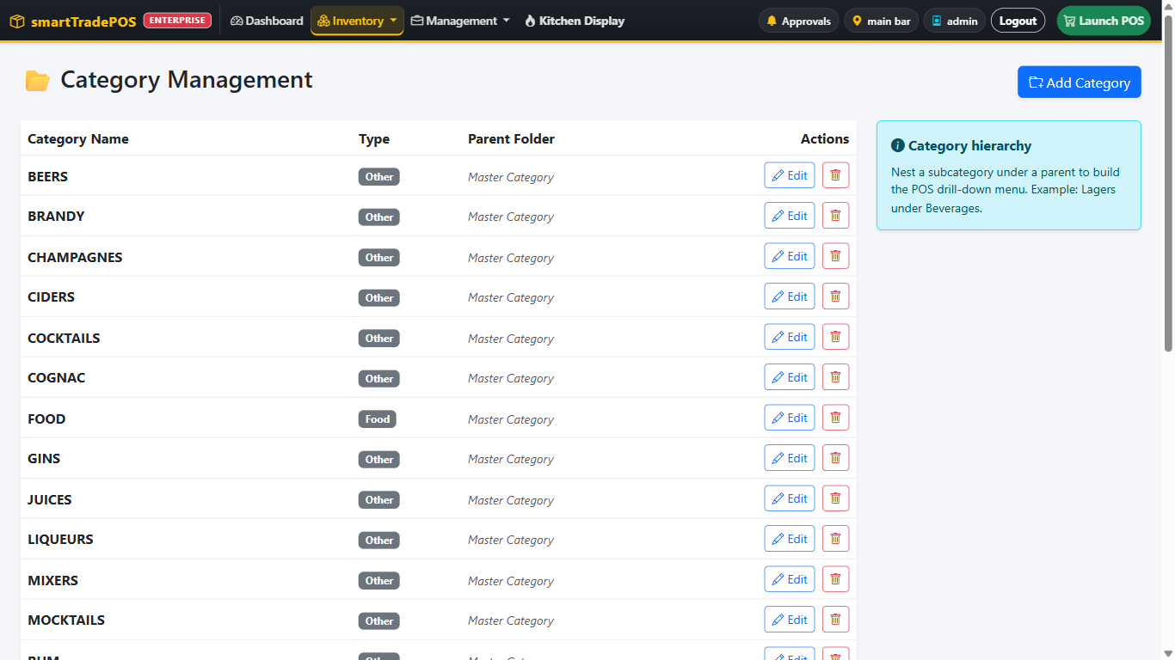
Figure 20 — Categories with their routing type and parent.
1. Inventory → Categories. Add Desserts, type Food / Meal, parent Food.
Expected result: on the POS, Food drills down to Desserts. Items in it show Got it / Later (Pro+).
2. Try to delete Food while Desserts exists.
Expected result: "Remove subcategories before deleting this category."

Scenario 5.2.3 — Stock take (Must pass)
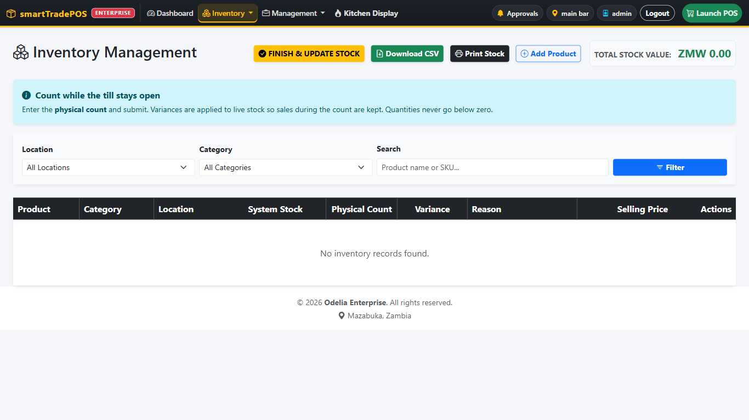
Figure 21 — Stock Levels: filter by location, enter physical counts.
Situation: month-end count at Main Bar. The system says 48 Mosi; you count 46.
1. Inventory → Stock Levels. Location Main Bar. On Mosi, physical count 46, reason Month-end count. Finish & update stock.
Expected result: Mosi shows 46. Inventory Audit Trail shows a stock-take row of −2 by you.
2. Have a cashier sell one Mosi during your count, then save a count that was made before the sale.
Expected result: the adjustment is applied to live stock, so the sale is not lost.
3. Enter a count that would take quantity below zero.
Expected result: the quantity stops at zero.

Scenario 5.2.4 — Audit trail
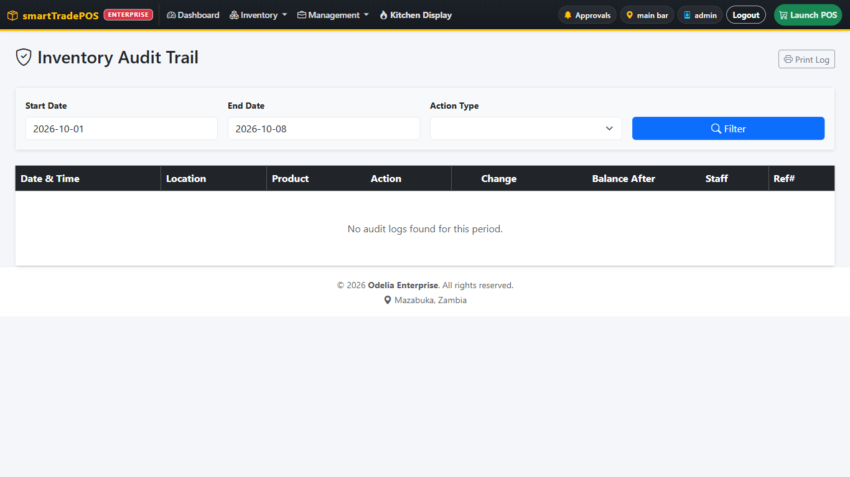
Figure 22 — Inventory Audit Trail filtered by action.
1. Inventory Audit Trail (index.php?page=audit). Filter today, action waste.
Expected result: the broken Mosi from 2.10 is listed with the cashier, the station, −1, and the quantity after.
2. Filter sale, produce, transfer, grv, stock_take in turn.
Expected result: each shows the rows from this training day.

5.3 Purchasing

Scenario 5.3.1 — Vendor
1. Inventory → Vendors → Add New Vendor: name, contact, phone.
2. Try to delete a vendor that has a GRV.
Expected result: "This vendor has GRV records and cannot be deleted."

Scenario 5.3.2 — Inquiry → order → receive (Must pass)
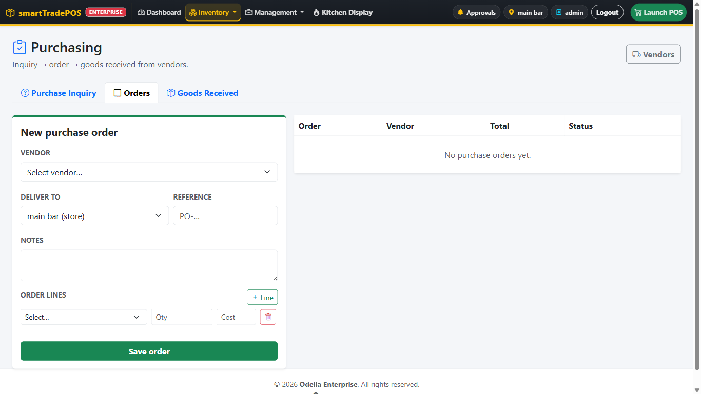
Figure 23 — Purchasing: Purchase Orders tab.
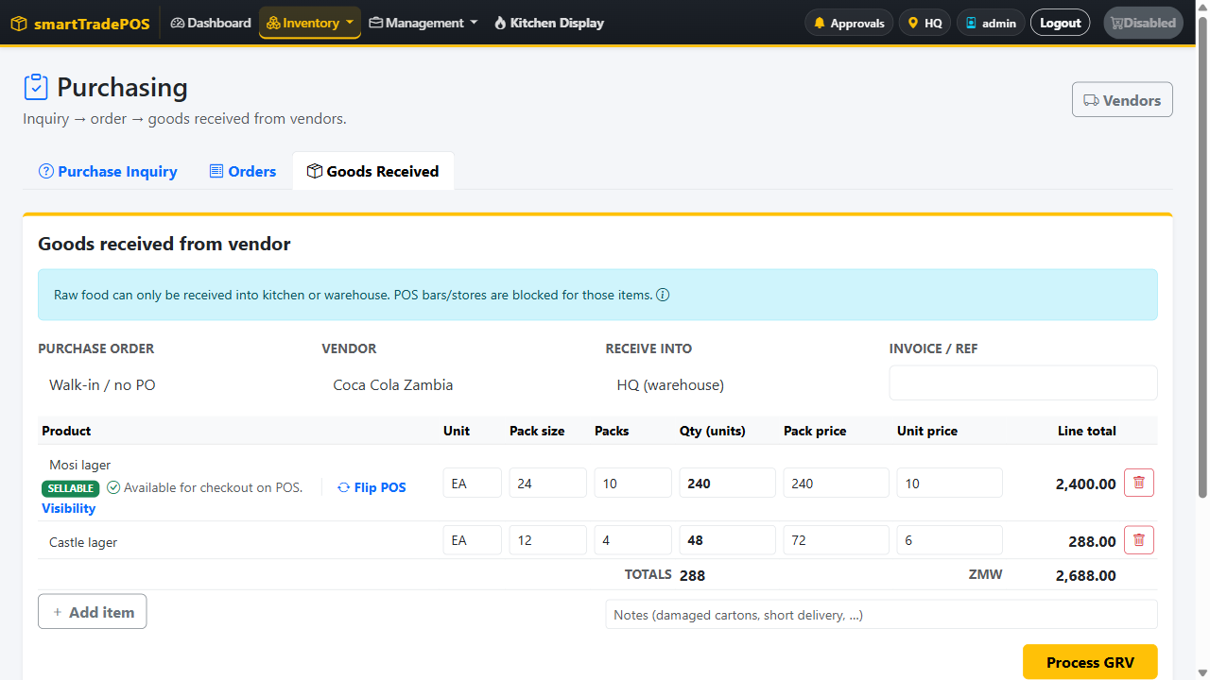
Figure 24 — Goods Received in packs: 10 packs of 24 at K240 become 240 units at K10.00; 48 units with pack size 12 become 4 packs at K72.
Situation: you need 10 cases of Mosi at the Warehouse.
1. Purchasing → Purchase inquiry → New. Location Warehouse, vendor optional, needed-by next week, line Mosi × 240. Save.
2. Open it → Convert.
Expected result: a purchase order is created with the same lines.
3. Purchase orders: open it, set vendor (required), reference PO-TRAIN-01. Save.
4. Goods arrive. Receive.
Expected result: Goods Received opens with the order loaded.
5. On the GRV line, set Pack size 24, Packs 10, Pack price 240. Supplier reference INV-554. Post.
Expected result: as you type, Qty (units) becomes 240, Unit price K10.00, Line total K2,400, and the footer shows 240 units / K2,400. After posting, Warehouse stock of Mosi +240, the product's cost price is K10.00, the audit trail shows a GRV row, and the PO is marked received. The GRV appears under Recent goods received; tap it to see the packs, units, and prices.
5a. Start another GRV line for Fanta: type Qty (units) 48 with pack size 12, then type Unit price 6.
Expected result: Packs becomes 4 and Pack price becomes 72. Changing the pack price back to 60 makes the unit price 5.00. The numbers always agree with each other.
6. Try to receive into Main Bar.
Expected result: refused unless Main Bar is a Goods receiver location.

Scenario 5.3.3 — Cancel an order
1. Create a second order and Cancel it.
Expected result: status Cancelled; it cannot be received.

Scenario 5.3.4 — Receiving bay (V-SIAS)
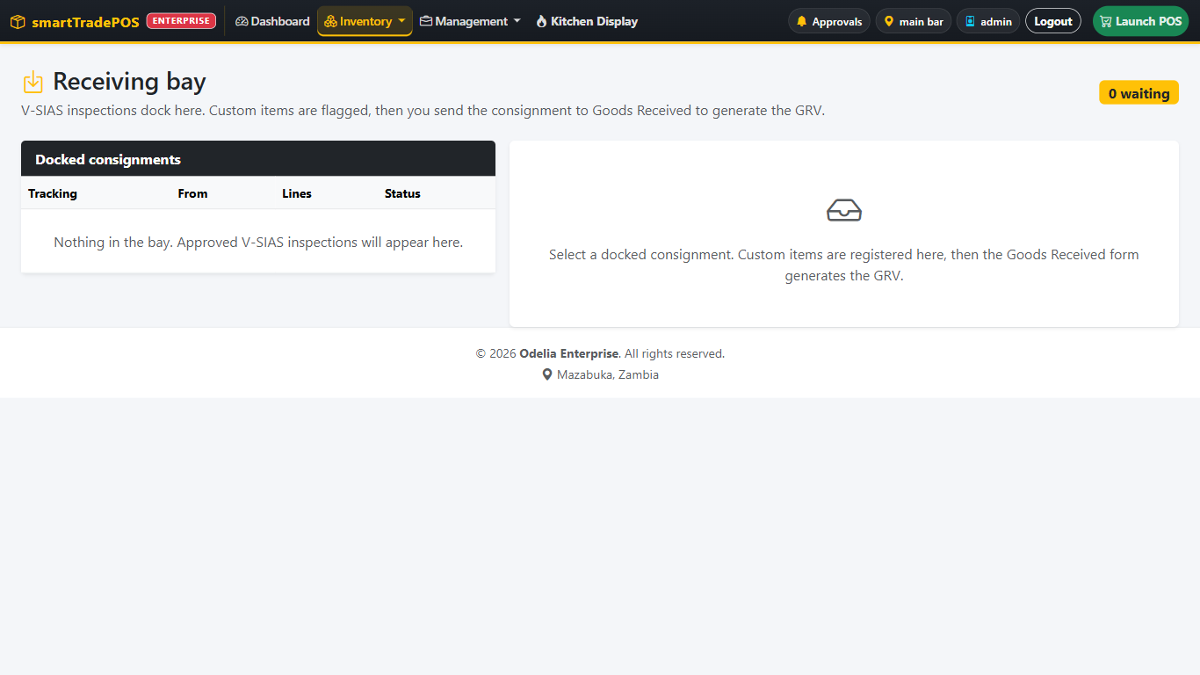
Figure 25 — Receiving Bay: V-SIAS consignments waiting to be booked.
1. Have the trainer send a V-SIAS consignment to the shop.
2. Inventory → Receiving Bay.
Expected result: the dock shows tracking code, source, line count, status. The navbar Inventory menu shows a count badge on Receiving Bay.
3. Open it, flag any non-catalog line, Send to GRV, post.
Expected result: stock booked; the dock is cleared from the bay.
4. On another dock, Cancel dock.
Expected result: it disappears without booking stock.

5.4 Transfers

Scenario 5.4.1 — Bar requests stock from the warehouse (Must pass)
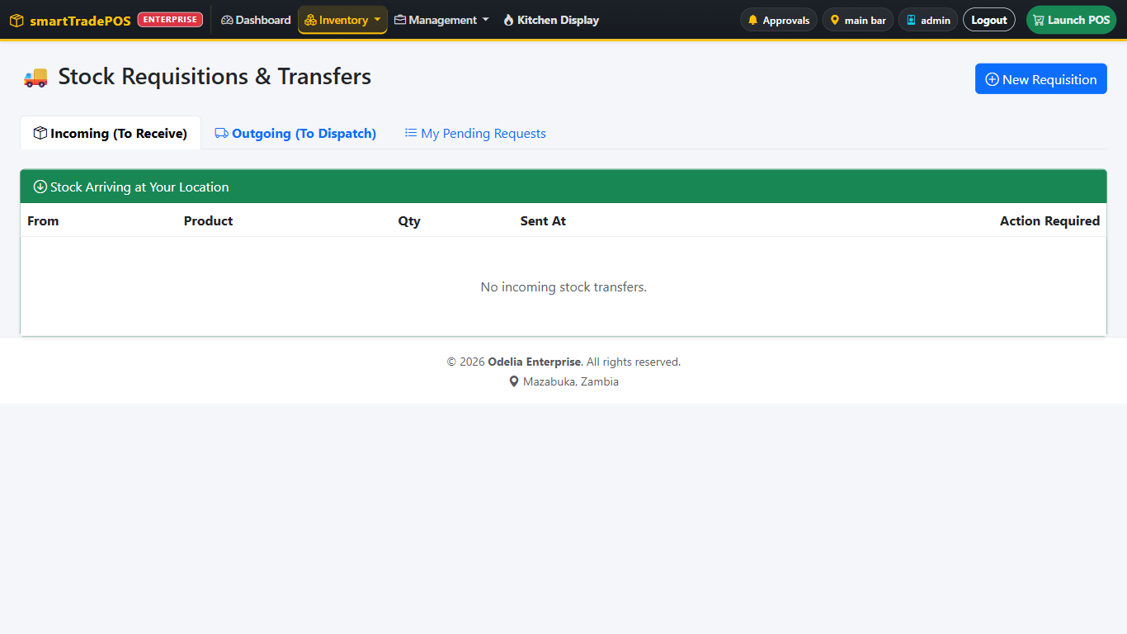
Figure 26 — Stock Requisitions & Transfers: Incoming, Outgoing and My Pending Requests.
1. As train_cashier on the POS: Stock request → New Requisition. Destination Main Bar, source Warehouse, Mosi × 48.
Expected result: it appears under My Pending Requests. Stock has not moved.
2. As train_mgr at the Warehouse: Transfer Stock → Outgoing (To Dispatch). The request is listed. Dispatch.
Expected result: Warehouse Mosi −48. If V-SIAS is in the path, the inspection asks for Issuer and Checked by, a dispatch note, and a seal photo. Without V-SIAS, dispatch completes directly.
3. As train_cashier: Incoming (To Receive) shows the transfer. Accept stock.
Expected result: with V-SIAS, the inspection opens and Receive stays locked until approved; it collects Deliverer and Receiver. After approval, Main Bar Mosi +48.
4. Try to dispatch with quantity 0.
Expected result: "Quantity must be greater than zero."

Scenario 5.4.2 — Approvals panel
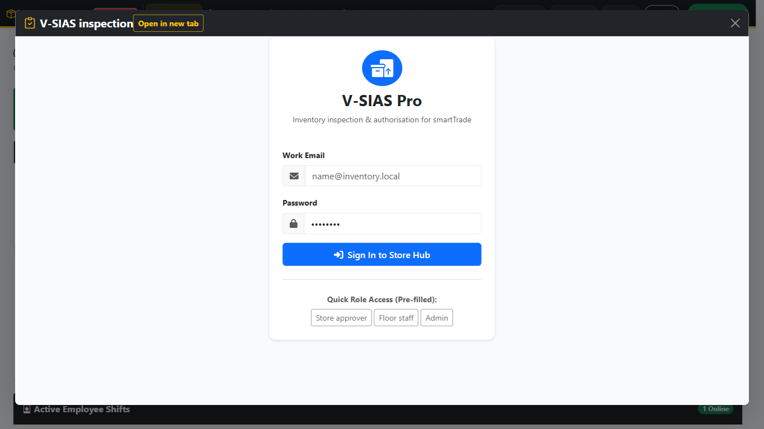
Figure 27 — The Approvals panel showing the V-SIAS sign-in, with Open in new tab at the top.
1. As train_mgr, click the bell Approvals.
Expected result: a panel opens over the page with the V-SIAS pending list. The first time it asks for your V-SIAS login.
2. If the panel is blank or says the content is blocked, click Open in new tab.
Expected result: the same list opens in a new browser tab.
3. Approve the pending inspection in V-SIAS.
Expected result: the panel closes and the Transfers page reloads; the badge count drops.

5.5 Reports and end of day

Scenario 5.5.1 — Read today's trading (Must pass)
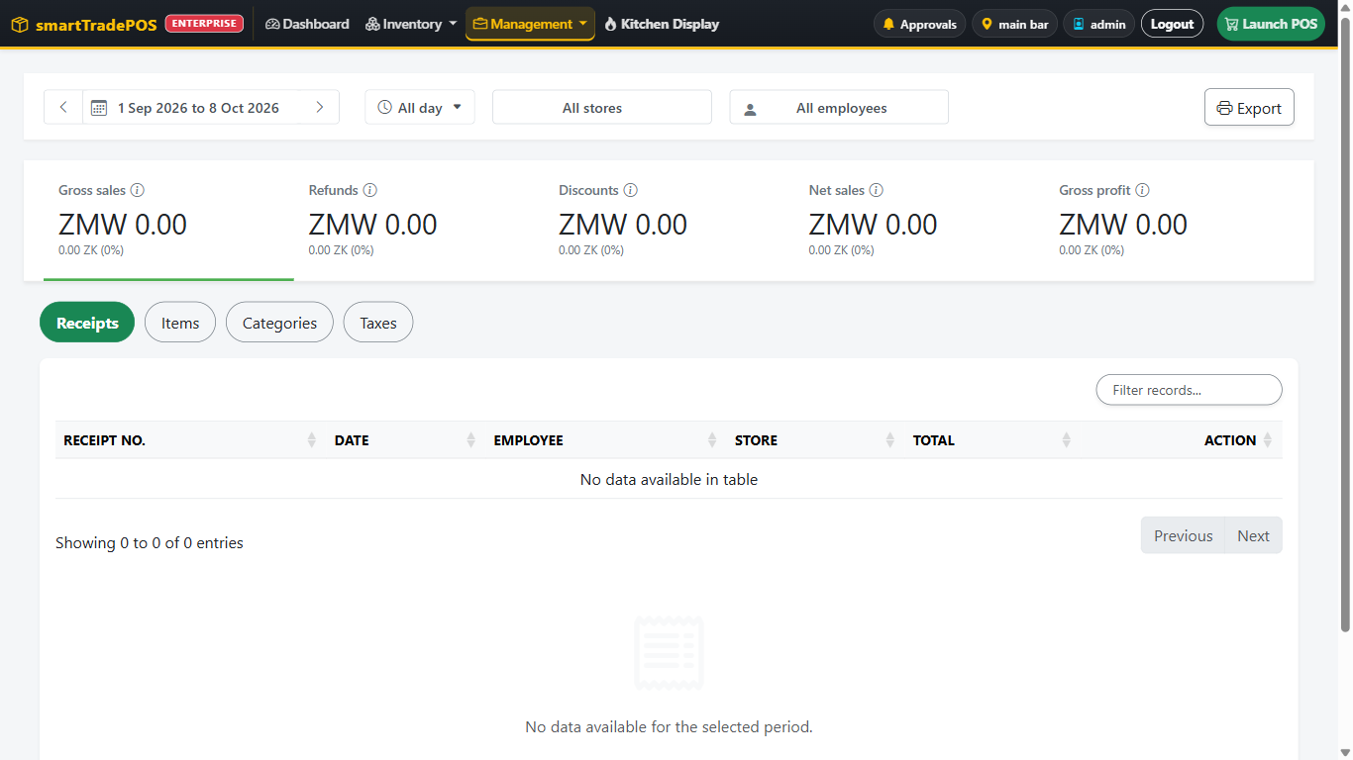
Figure 28 — Master Reports: date range, store and employee filters, the five tiles and the Receipts tab.
1. Management → Master Reports. The range defaults to today.
Expected result: the five tiles reflect this training day. Receipts lists each sale; the return from 2.11 carries a red Refund badge. Refunds tile equals that credit note.
2. Tap a receipt row.
Expected result: the line breakdown opens; voided/refunded lines are labelled.
3. View on a row.
Expected result: the printable receipt opens in a window.

Scenario 5.5.2 — Filters
1. Change All employees to train_cashier.
Expected result: only that cashier's receipts remain; the tiles recalculate.
2. Change All stores to Restaurant.
Expected result: the list empties if no sales were made there.
3. Click ‹.
Expected result: both dates move back one day and the page reloads.

Scenario 5.5.2a — Tips and surcharges by staff
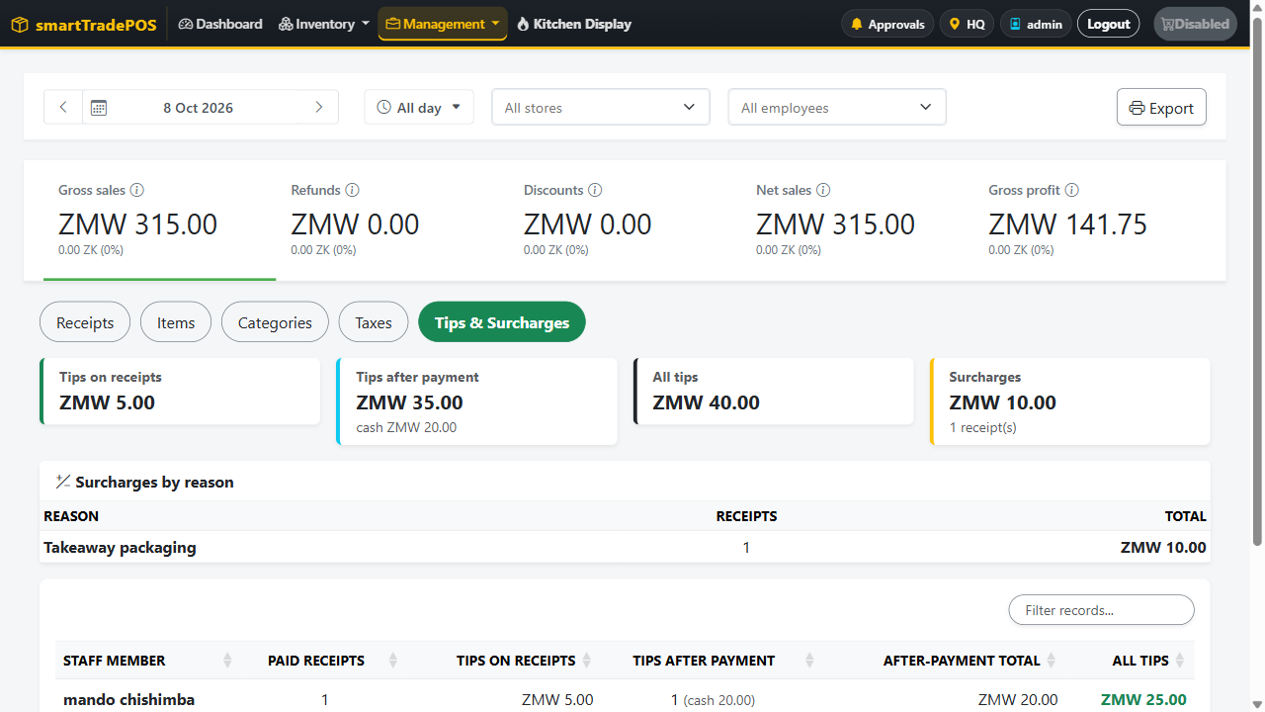
Figure 29 — Master Reports → Tips & Surcharges: tiles, surcharges by reason, and tips per staff member.
1. Open the Tips & Surcharges tab.
Expected result: four tiles — tips on receipts, tips after payment (with the cash part), all tips, surcharges. A table lists surcharges by reason (Take-away packaging and Late-night service from 2.6b). Below it, one row per staff member with their receipts, tips on receipts, tips after payment, and total.
2. Find the cashier from 2.6a.
Expected result: their Tips after payment column shows 1 (cash 20.00) and their total includes it. This is the figure Payroll pulls in when tips are included in pay.
4. Tap the date range and pick the whole week.
Expected result: the range shows the two dates and the report covers the week.

Scenario 5.5.3 — Items, Categories, Taxes
1. Items.
Expected result: Mosi is near the top by revenue, with items sold and gross sales.
2. Categories.
Expected result: Lagers, Soft drinks, Food, and Uncategorized if any product has no category.
3. Taxes. Tap the VAT row.
Expected result: the drilldown lists each receipt with taxable amount and tax at 16%. Print Breakdown prints only that list.

Scenario 5.5.4 — Refund from reports
1. Receipts → red arrow icon on a paid sale.
Expected result: the Refund screen lists remaining quantities per line. Pick quantities, a ZRA refund reason, confirm.
Expected result: stock restored, credit note posted, the sale shows as refunded. "Nothing left to refund on this ticket" appears if you try again on a fully refunded sale.

Scenario 5.5.5 — Export
1. Export.
Expected result: print preview with the header "Sales Summary", category, period, and generated time. The filter bar and tabs are not printed.

Scenario 5.5.6 — Reports on a phone
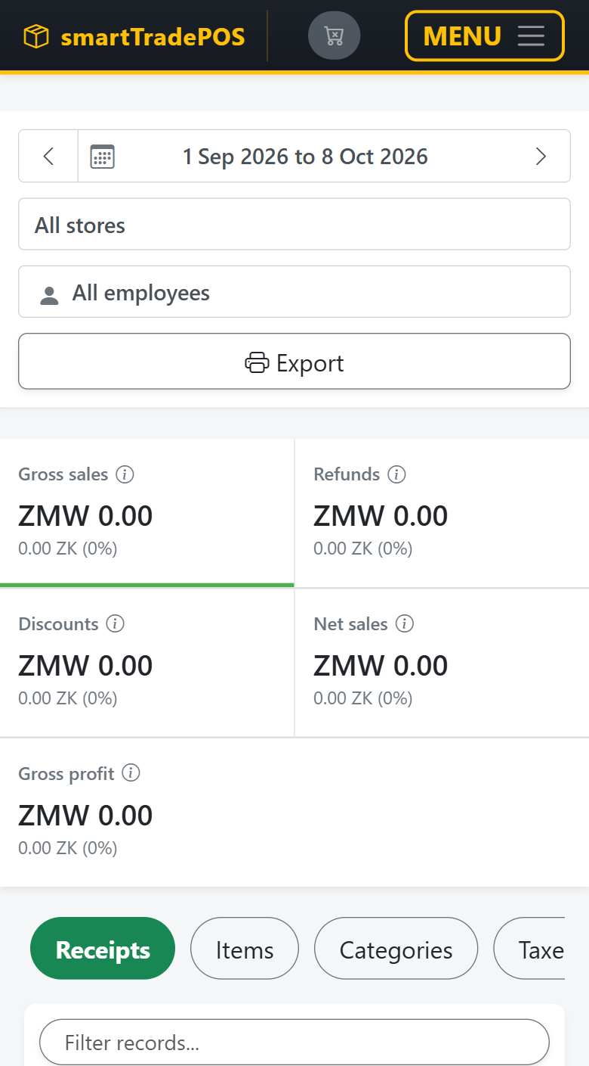
Figure 30 — Master Reports on a phone: full-width filters, two-column tiles, scrolling tab pills.
1. Open Master Reports on the phone.
Expected result: the date range spans the full width with arrows at the edges; store and employee are full-width; Export is a full-width button. Tiles form two columns with Gross profit across the bottom. Tab pills scroll sideways. Each receipt is a card with labelled values and a full-width View and Refund. Tapping a card opens the breakdown full screen.

Scenario 5.5.7 — Z-Read (Must pass)
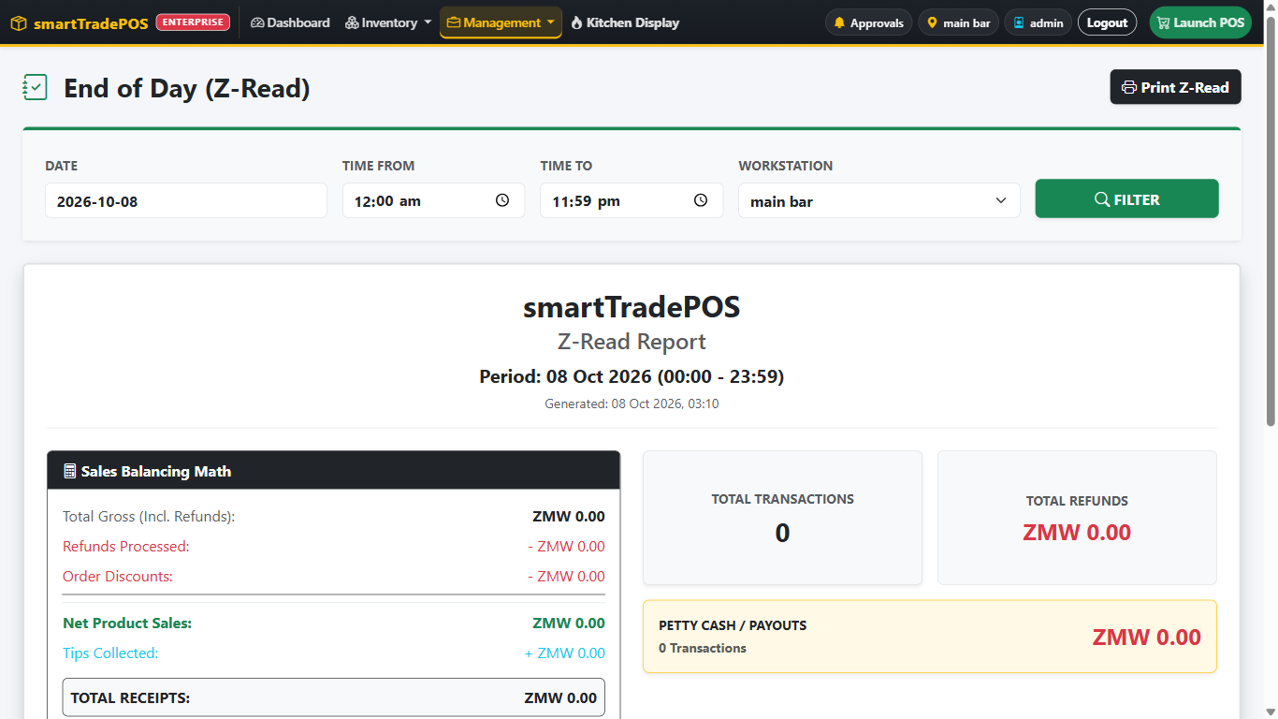
Figure 31 — End of Day (Z-Read).
Situation: closing the day.
1. Every station has ended its shift (scenario 2.13).
2. Management → End of Day (Z-Read). Date today, time 00:00 to 23:59, workstation Main Bar. Filter.
Expected result: totals by payment method and sales for the window. Print Z-Read prints only the report.
3. Repeat for Restaurant.
4. On Enterprise, open ZRA Smart Invoice.
Expected result: Pending sales is 0. If not, read section 6.

5.6 Members
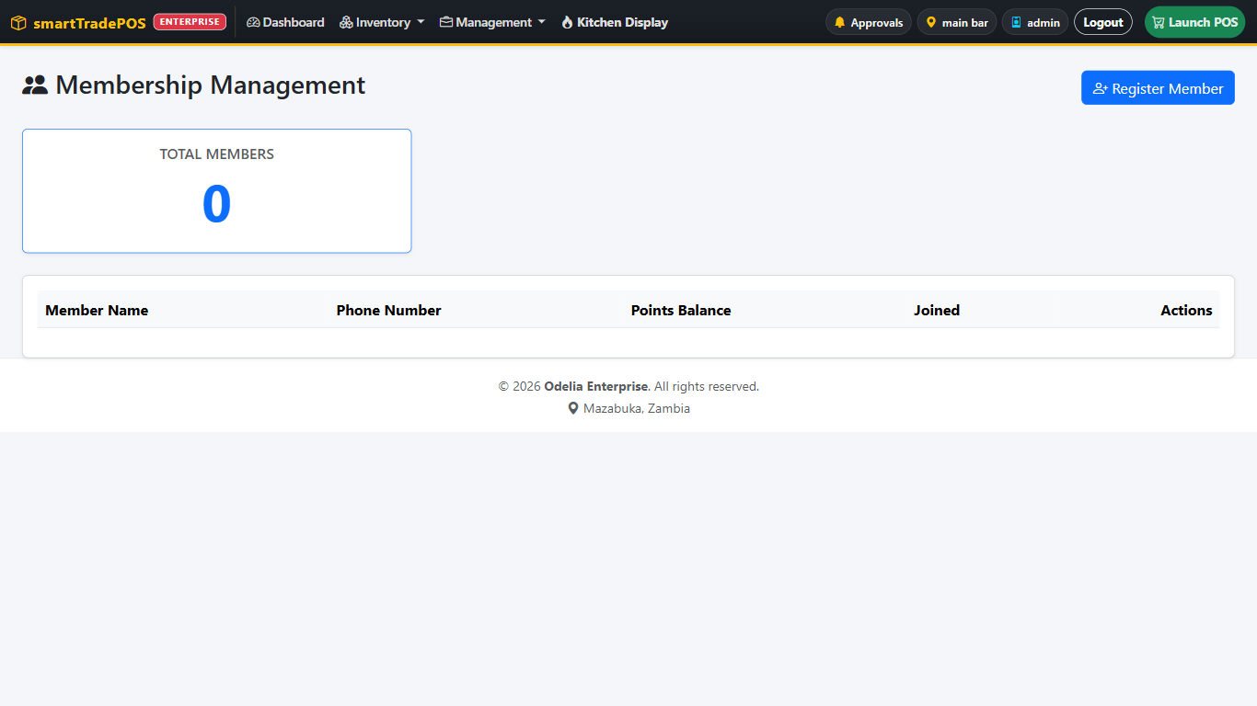
Figure 32 — Members with Register Member.
1. Members (dashboard → Staff & Users → Members, or index.php?page=members). Register Member: Chanda with phone 0977000001.
2. Register another person with the same phone.
Expected result: refused; the phone is the member's ID.
3. History on Chanda after the sale in 2.7.
Expected result: the sale is listed; the points balance has moved.

5.7 Locations and tables

Scenario 5.7.1 — Location edit queued for the developer
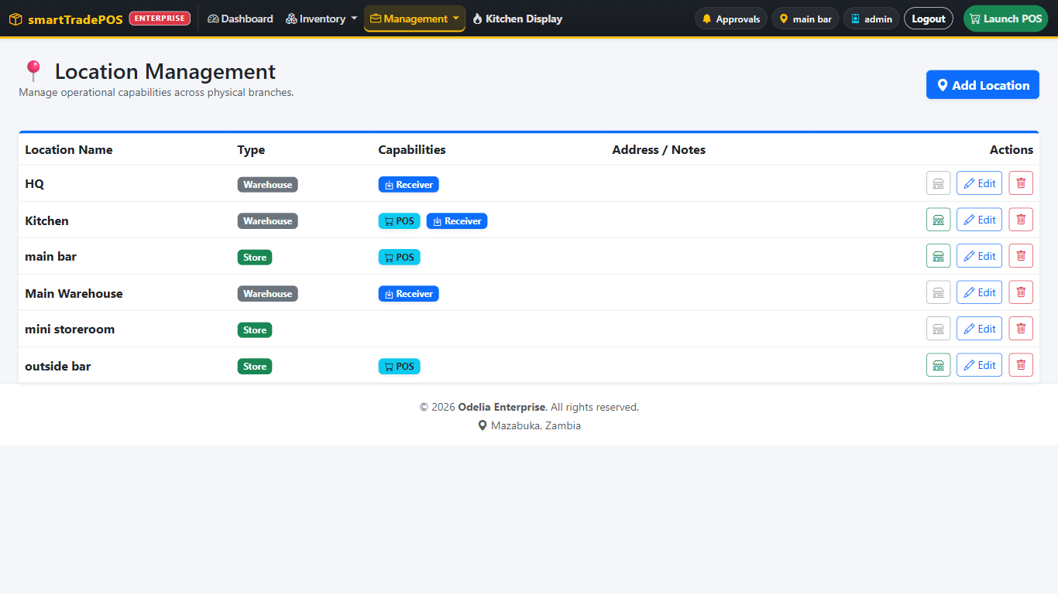
Figure 33 — Locations: POS and Goods receiver flags per location.
1. Management → Locations. Edit Restaurant: tick Goods receiver. Save.
Expected result: the row is highlighted as pending. The Management menu shows a warning badge. Nothing changes until the developer approves (scenario 7.2).

Scenario 5.7.2 — Table settings (Pro+)
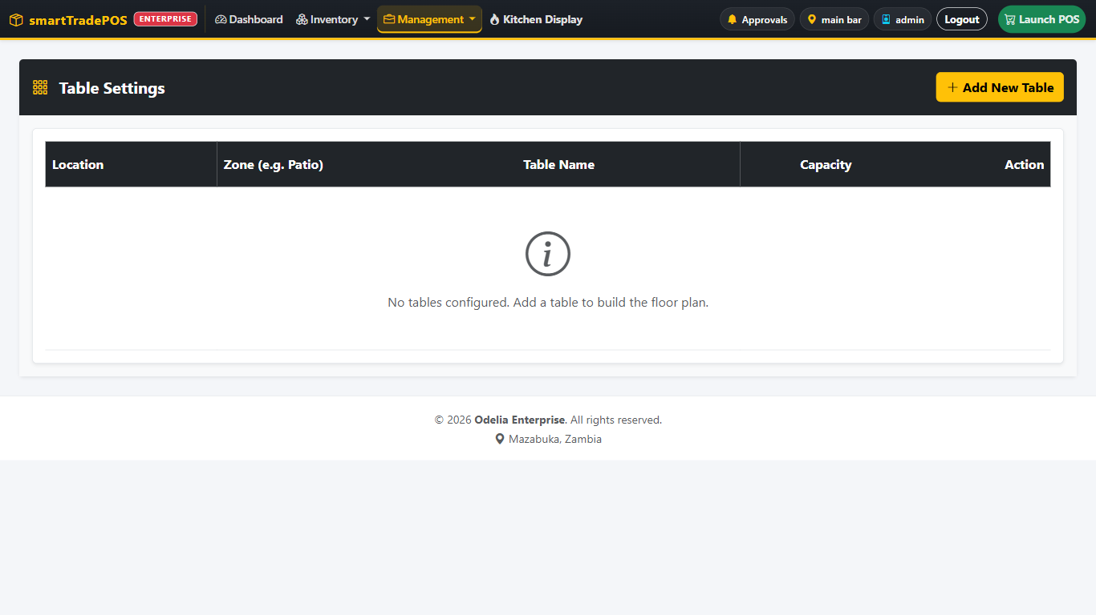
Figure 34 — Table Settings with Add New Table.
1. Management → Table Settings → Add New Table. Name T7, zone Patio, capacity 4, location Restaurant.
Expected result: T7 appears green on the POS floor plan at Restaurant.

5.8 Searchable drop-downs (all screens)

Scenario 5.8.1 — Find without scrolling
1. Goods Received: click the Product box on a line and type mos.
Expected result: the list narrows to Mosi while you type. Type the product's SKU or barcode instead — it still finds it.
2. Vendors box: type part of the contact person's name or phone.
Expected result: the vendor is found even though only the company name is displayed.
3. Users & Staff → primary workstation box: type ware.
Expected result: Warehouse is the only option left. Press Enter to pick it; press Esc or clear the text to see everything again.

5.9 Payroll
Sign in as train_manager (or admin). Needs the training staff from 0.2.

Scenario 5.9.1 — Statutory rules
1. Management → Payroll → Statutory rules.
Expected result: PAYE bands 0–5,100 at 0%, to 7,100 at 20%, to 9,200 at 30%, above at 37%; NAPSA 5% capped; NHIMA 1%; 26 working days; tips included in pay but not taxed (switch on Tips are subject to PAYE if your accountant says otherwise).
2. In Quick PAYE check type 8,000.
Expected result: PAYE 670 on a taxable 8,000 (0 + 400 + 270). Nothing is saved by the check.

Scenario 5.9.2 — Components and employee (Must pass)
1. Components → Add: Housing allowance, earning, fixed, 500, taxable. Add Staff loan, deduction, fixed, 0 (amount set per person).
2. Employees → Add: the training cashier. Link to the train_cashier login, pay type Monthly, basic 8,000, NRC, NAPSA and NHIMA numbers, bank. Under standing components set Housing 500 and Staff loan 500. Save.
Expected result: the employee is listed as active with their pay type and basic.

Scenario 5.9.3 — Pay run (Must pass)
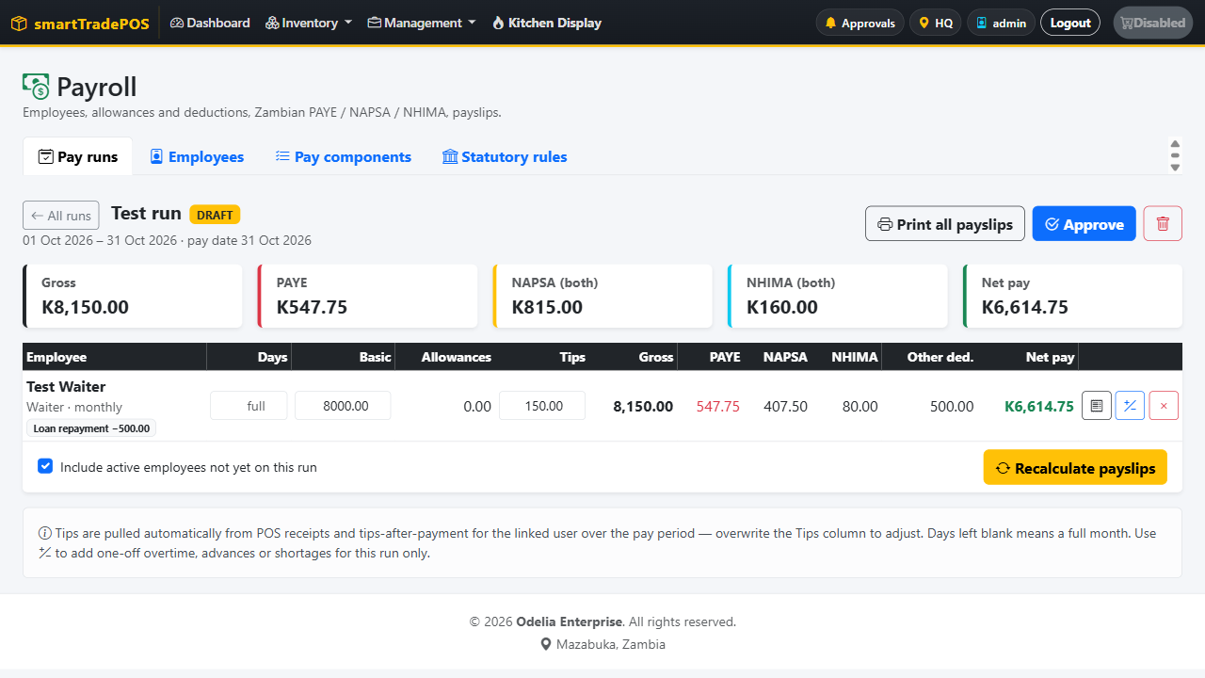
Figure 35 — A draft pay run: editable days, basic and tips per employee; PAYE, NAPSA, NHIMA and net pay recalculated.
1. Pay runs → New run: title Training month, this calendar month, pay date the 25th. Create.
Expected result: the run opens in Draft with one slip per active employee. The cashier's Tips box already holds the tips from 2.6 and 2.6a.
2. Set the cashier's Days worked to 26. Recalculate.
Expected result (without tips): gross 8,500 (8,000 + 500 housing); NAPSA employee 425; taxable 8,075; PAYE 692.50; NHIMA 80; loan 500; net 6,802.50. Employer NAPSA 425 and NHIMA 80 are shown separately.
3. Set days worked to 13 and recalculate.
Expected result: basic halves to 4,000 and everything below it reworks.
4. Tap Adjustments on the slip, add an earning Overtime 300, apply, recalculate.
Expected result: gross rises by 300; the slip lists Overtime as its own line.
5. Approve.
Expected result: the inputs lock; Mark paid and Reopen appear. Delete is gone.
6. Print payslips.
Expected result: one page per employee with earnings, deductions, employer contributions, and net pay. Printing a single slip works from the slip row.
7. Mark paid.
Expected result: status Paid, and an expense for the total net pay is booked at the run's location.
8. Try to delete a paid run.
Expected result: refused; only drafts can be deleted.

5.10 Customer ordering portal (Enterprise)

Scenario 5.10.1 — Switch it on
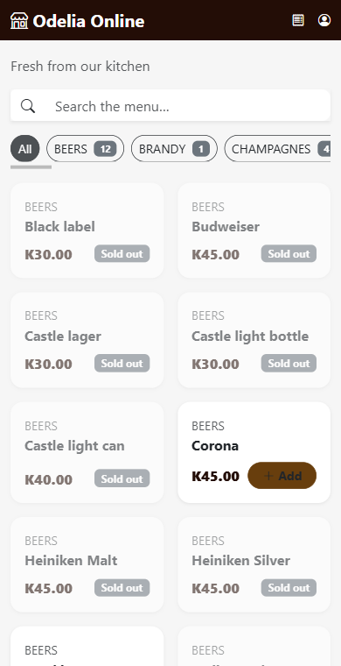 | 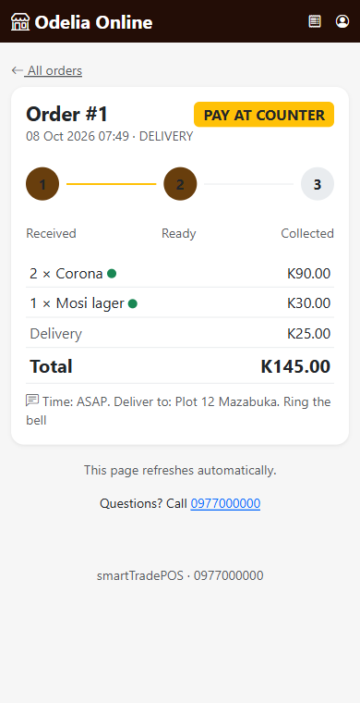
Figure 36 — The customer portal on a phone: the menu with Add buttons (left) and an order's status tracker (right).
1. Management → System Settings → Customer ordering. Enable, pick Main Bar as the fulfilling location, title Training Café Online, delivery fee 25, tick pay at counter and delivery. Save. Open page.
Expected result: a mobile-styled page in the shop's colours with the menu. Only sellable items in stock at Main Bar appear.

Scenario 5.10.2 — Customer orders (play the customer)
1. Add 2 × Fanta and 1 × Mosi. Open the basket, Checkout.
2. Register: name Jane Customer, phone 0977 123 456, PIN 1234.
Expected result: registration refuses a number that is not a Zambian mobile (must start 07/09 and be 10 digits). After registering, you are back at checkout.
3. Choose Delivery, type an address, Pay at counter, place the order.
Expected result: "Order received" with the order number and a status tracker; the total includes the delivery fee. My orders lists it.

Scenario 5.10.3 — Shop receives it
1. On the POS at Main Bar, the Web Orders badge shows 1. Open it.
Expected result: the order shows PAY AT COUNTER, order type Delivery, phone and time, and the lines. Stock for Fanta and Mosi has already gone down.
2. Pull it into the sale and charge as cash.
Expected result: a normal receipt; the customer's tracker moves to handed over.
3. Repeat 5.10.2 with Pay online (Flutterwave test keys needed).
Expected result: the customer pays in the Flutterwave window; the POS shows PAID ONLINE. When the items are ready, Hand Over (Paid) replaces Checkout and completes the sale without taking money.

Assessment — manager
# | Checkpoint | Pass
M1 | Creates, edits, and understands deactivate vs delete
M2 | Approves a shift from Shifts & X-Reads and opens its sales
M3 | Adds a sellable product with tax class and level-4 UNSPSC
M4 | Builds a nested category with the right routing type
M5 | Posts a stock take and finds it in the audit trail
M6 | Runs inquiry → order → GRV and verifies stock at the receiver
M7 | Dispatches and accepts a transfer, including the V-SIAS steps when present
M8 | Opens Approvals, signs in to V-SIAS, falls back to Open in new tab if needed
M9 | Reads Receipts/Items/Categories/Taxes and explains each tile
M10 | Refunds from reports with a ZRA reason
M11 | Produces a Z-Read per station and checks the ZRA pending queue
M12 | Knows which of their actions need the developer's approval
M13 | Posts a GRV in packs and explains units, unit price, and line total
M14 | Reads the Tips & Surcharges tab and reconciles it with the X-Read
M15 | Creates an employee, runs payroll, checks PAYE/NAPSA/NHIMA, prints payslips
M16 | Receives a web order on the POS and hands over a prepaid one

6. ZRA Smart Invoice (Enterprise) — administrator and manager
Train this on a sandbox device only. The live device must be initialized once, by the person doing go-live, following ZRA_GO_LIVE.md.

Scenario 6.1 — Read the page
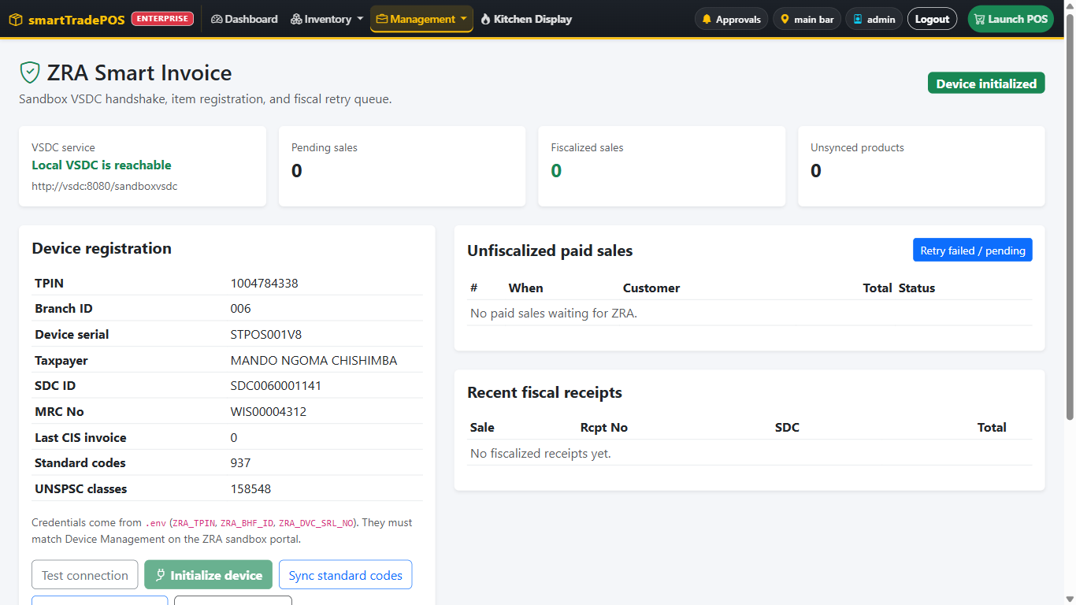
Figure 37 — ZRA Smart Invoice after Test connection (902): tiles, device card and action buttons.
1. Management → ZRA Smart Invoice.
Expected result: four tiles: VSDC service, Pending sales, Fiscalized sales, Unsynced products. A device card with TPIN, branch, serial, taxpayer, SDC ID, MRC. Unfiscalized paid sales. Recent fiscal receipts.
2. Match the badge to the SDC ID.
Expected result: Device initialized with an SDC ID present; Not initialized when empty.

Scenario 6.2 — Test connection (safe, repeatable)
1. Test connection.
Expected result: a green message (000 "Succeeded" or 902 "Device is already initialized") and the hint "Next: Sync standard codes." Either is fine.
2. Read the table in the user guide (section 11.1) for a red or amber message. The 404 "Smart Invoice app is not deployed" and the 999 "unreachable" messages are support issues, not something to fix by clicking Initialize.

Scenario 6.3 — Initialize (once, trainer only, sandbox serial)
1. With the badge on Not initialized, Initialize device. Confirm.
Expected result: SDC ID and MRC fill in, badge turns green, the button becomes disabled.
Explain to trainees why the button is disabled afterwards and why they must never click it on a live till or recreate the vsdc container.

Scenario 6.4 — Codes, classes, products (Must pass)
1. Sync standard codes.
Expected result: Standard codes count > 0.
2. Sync UNSPSC classes.
Expected result: "Stored N classification(s)"; UNSPSC classes count > 0.
3. Register products.
Expected result: "Synced N item(s)". The product from 5.2.1 step 3 (blank UNSPSC) is listed as failed with its class code. Fix it on the product form and register again until Unsynced products is 0.

Scenario 6.5 — A sale fiscalizes on its own
1. Ring a paid cash sale on the POS.
2. Open the receipt.
Expected result: SDC ID, receipt number, signature, and a QR appear at the bottom. On the ZRA page, Fiscalized sales +1 and the sale is under Recent fiscal receipts. The QR opens the ZRA portal page for that invoice.

Scenario 6.6 — A sale that failed
1. Trainer: stop the vsdc container, ring a paid sale, start it again.
Expected result: the sale sits under Unfiscalized paid sales with status failed and the error under the badge. Pending sales = 1.
2. Push on that row.
Expected result: it fiscalizes and leaves the list.
3. Repeat with two failed sales and use Retry failed / pending.
Expected result: "Retried 2 sale(s): 2 synced…".

Scenario 6.7 — Credit notes
1. Return an item against the fiscalized sale from 6.5 (scenario 2.11).
Expected result: the credit note fiscalizes and cites the original receipt number. Trying to credit more than the original has left gives a 931 message that says Do not retry.

Assessment — ZRA
# | Checkpoint | Pass
Z1 | Reads the four tiles and the badge correctly
Z2 | Uses Test connection and interprets 000 / 902 / 404 / 999
Z3 | States when Initialize is and is not allowed
Z4 | Runs codes → classes → products and clears unsynced items
Z5 | Finds SDC ID and QR on a receipt
Z6 | Clears a failed sale with Push or Retry after reading the error
Z7 | Explains why a return must cite the original invoice

7. Developer
The developer account is the trainer's own. These scenarios are demonstrated, not practised by shop staff.

Scenario 7.1 — System settings
1. Management → System Settings. Change Business name, add a receipt header line (TPIN, address) and footer. Save.
Expected result: the navbar brand and the next receipt show the new text.
2. Change the three colours.
Expected result: the POS picks them up on the next load.

Scenario 7.1a — Surcharge reasons (administrator or developer)
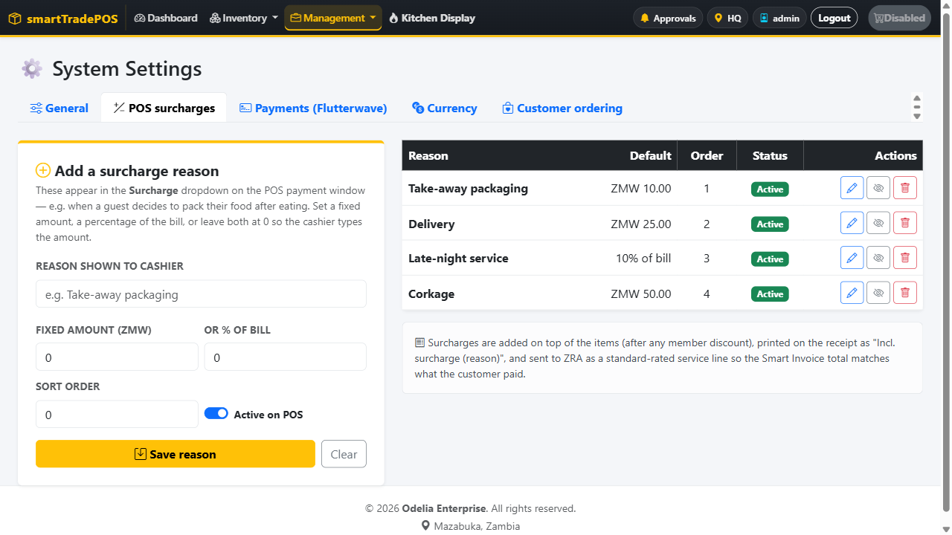
Figure 38 — POS surcharge reasons: add a reason with a fixed amount or a percent; edit, hide or delete from the table.
1. Management → POS Surcharge Reasons. Add Take-away packaging, default amount 10. Add Late-night service, default 5%. Save each.
Expected result: both appear in the table and in the POS surcharge drop-down on the next sale. Switching one off hides it from the POS without deleting past sales that used it.

Scenario 7.1b — Payments (Flutterwave test keys)
1. Management → Payments & Currency → Payments (Flutterwave). Enable, paste the test public, secret, encryption keys and the webhook hash. Save. Test keys.
Expected result: "Keys accepted" and the badge TEST MODE. Copy the webhook URL into the Flutterwave dashboard. The POS now offers Flutterwave as a payment method (scenario 2.6d). Only the first characters of saved keys are shown on the page.

Scenario 7.1c — Currency
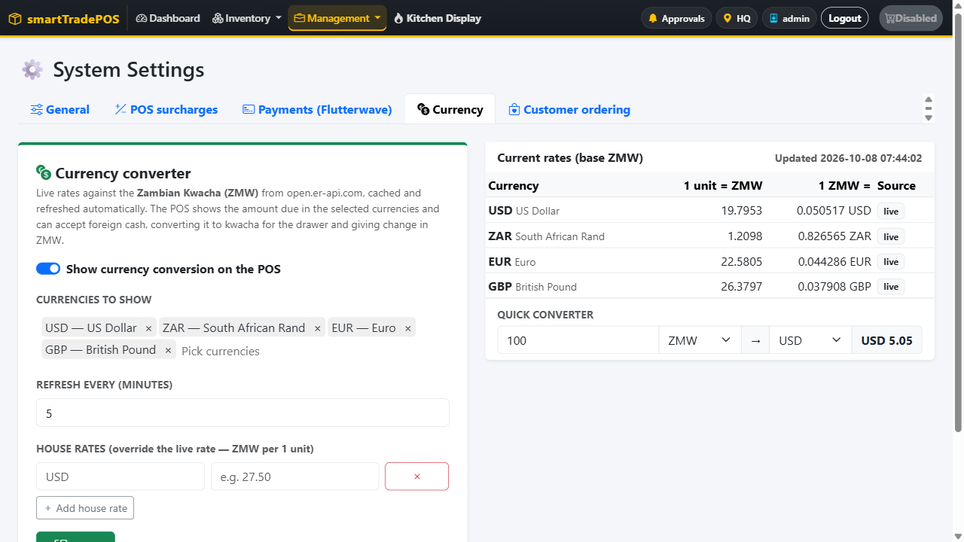
Figure 39 — Currency settings: live kwacha rates, currencies shown on the POS, house rates and the quick converter.
1. Currency tab. Enable, tick USD, ZAR, EUR, GBP, refresh every 60 minutes. Refresh live rates now.
Expected result: the table shows live kwacha rates and the time they were fetched. Set a house rate for USD (e.g. 20.00) and save.
Expected result: the USD row shows the house rate as the one in use; the POS converts with it (scenario 2.6c). Remove it to go back to live.
2. In the quick converter type 100 USD → ZMW.
Expected result: the kwacha amount at the rate in use.

Scenario 7.2 — Approve a location edit
1. Management → Locations → Review Pending Edits. The edit from 5.7.1 is listed. Approve.
Expected result: the row is no longer highlighted; the Management badge disappears; Restaurant is now a Goods receiver.
2. Reject a second pending edit.
Expected result: the location reverts to its saved values.

Scenario 7.3 — Location rules
1. Try to delete a location that still has stock.
Expected result: "This location still has stock and cannot be deleted."
2. Try to delete one with sales history.
Expected result: "This location has sales history and cannot be deleted."

Scenario 7.4 — License tier walk-through
1. Set tier Lite. Sign in as train_waiter.
Expected result: no Tabs, no split pay, no Got it/Later, no Pickup. Opening index.php?page=members shows "This feature requires Pro or higher."
2. Set Pro. Sign in as train_chef.
Expected result: chef lands on the POS, not the kitchen. page=kds shows "This feature requires Pro+ or Enterprise."
3. Set Pro+. Sign in as train_mgr.
Expected result: kitchen screens return; ZRA Smart Invoice is not on the Management menu for the manager (it is for admin and dev).
4. Set Enterprise.
Expected result: ZRA on the menu for managers, Web Orders and the Online payment method on the POS, ZRA tax class on the product form.

Scenario 7.5 — License lockout
1. Set a lockout date of yesterday. Save.
Expected result: immediately, train_cashier sees the full-screen "License expired" page and can only sign out. train_mgr is redirected to Reports and can open Reports, Z-Read, receipts, and print shifts, but any save is blocked. The developer is unaffected.
2. Clear the date.
Expected result: normal access returns.

8. Mobile and tablet scenarios (all roles)
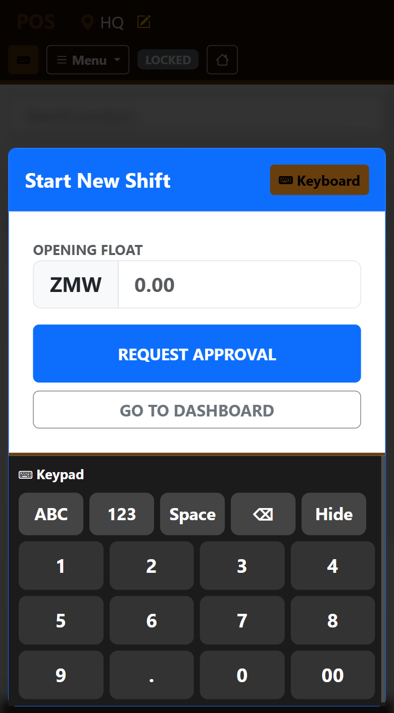
Figure 40 — The POS on a phone: the Start New Shift dialog before the station opens.
Run these on the phone. They confirm the floor staff can work without a PC.
# | Scenario | Expected result
P1 | Waiter signs in, taps the green POS pill | POS opens without opening the menu
P2 | Manager taps Menu, opens Management, taps Master Reports | Panel closes; reports load
P3 | Manager opens Master Reports and swipes the tab pills | Receipts, Items, Categories, Taxes scroll sideways
P4 | Manager taps a receipt card | Breakdown opens full screen; Close returns
P5 | Manager taps ‹ twice | Range moves back two days
P6 | Manager taps Export | Print dialog with the report header
P7 | Chef opens Live KDS Screen on a tablet | Tickets fill the screen; Cook/Done are large enough to tap
P8 | Manager taps Approvals | Panel opens; if blocked, Open in new tab works
P9 | Cashier opens Stock request and creates a requisition | Appears under My Pending Requests
P10 | Manager opens the Dashboard | Stat tiles scroll sideways; buttons are full width

9. Problem-solving drills
Give the trainee the symptom only. They must find the cause and the right action.
Symptom | Cause | Correct action
Product grid is blurred | No open shift at this station | Request a shift; manager approves
"Open a shift before checkout" | Shift ended or never approved | Same as above
Tile is grey | Zero stock at this station | Transfer in, produce (dishes), or GRV
+ stops at a number | On-hand limit | Same as above
Launch POS reads "POS Disabled" | Location has POS enabled off | Change station, or ask the developer to enable it
Return refused: no original Smart Invoice | Return rung without picking the invoice | Switch Return on and select the invoice first
Return refused: exceeds original | Already credited | Do not retry; refund the right receipt
Sale missing from Receipts but stock went down | Lost stock (waste) was used | Check Audit Trail, action waste
ZRA badge green but 404 red message | Smart Invoice app not deployed in the device | Call support; do not Initialize
ZRA 999 | Device container stopped | Call support
ZRA 899 after 902 | Keystore lost | New serial per go-live guide; do not Initialize the old one
Register products: item failed with class code | Blank or family-level UNSPSC | Assign a level-4 code; register again
Approvals panel "content is blocked" | Browser refuses the frame | Open in new tab
Management menu has a warning badge | Location edit awaiting developer | Developer: Review Pending Edits
Chef lands on the POS | Tier below Pro+ | Developer sets tier
"License expired" page | Lockout date passed | Developer clears or extends the date
Category cannot be deleted | Has products or subcategories | Move products / delete children first
Vendor cannot be deleted | Has GRVs | Keep it; deactivate by convention
Transfer "must go through V-SIAS inspection" | Dispatch/receive attempted around V-SIAS | Use Dispatch / Accept stock, complete the inspection
Receipts report empty for a store | Filter set to a station with no sales | Switch to All stores

10. Daily and periodic routines (checklists)

Opening (cashier + manager)
- ☐ Count the float; request shift with that amount
- ☐ Manager approves
- ☐ Check the pickup badge and Tabs for anything left overnight
- ☐ Enterprise: ZRA page shows Local VSDC is reachable

During service
- ☐ Payouts logged with a reason at the moment the cash leaves
- ☐ Breakages written off with Lost stock, not a sale
- ☐ Returns always against the original invoice with a reason
- ☐ Waiters use Later for food that must be cooked, Got it for food already served

Closing (cashier + manager)
- ☐ X-Read reviewed; variances explained
- ☐ Shift ended with counted cash
- ☐ Z-Read printed per station
- ☐ Enterprise: ZRA pending sales = 0, or each pending row has been read and Pushed
- ☐ Unpaid tabs reviewed

Weekly (manager)
- ☐ Stock take on fast movers; adjustments carry a reason
- ☐ Audit trail review for waste and stock takes
- ☐ Unsynced products = 0 on the ZRA page
- ☐ Reports for the week: Items and Categories, exported

Monthly (manager + developer)
- ☐ Payroll run created, tips checked, approved, payslips printed, marked paid
- ☐ Full stock take
- ☐ Recipe Consumption against production
- ☐ User list reviewed; leavers deactivated
- ☐ Pending location edits cleared
- ☐ Backups verified (README)

11. Competency sign-off
Trainee | Role | Chapter assessments passed | Mobile drills passed | Trainer | Date

A trainee is cleared for a live shift when every Must pass scenario for their role is marked passed and the problem-solving drills relevant to that role have been answered correctly.

