Soble kernels
Gx (detects vertical edges Gy (detects horizontal edges
-1 | 0 | 1
-2 | 0 | 2
-1 | 0 | 1
-1 | -2 | -1
0 | 0 | 0
1 | 2 | 1

For each pixel:
- Take the 3x3 neighborhood around the pixel
- Convolve with Gx to get horizontal derivative:
  - $g_{x}= I * G_{x}$
- Convolve with Gy to get vertical derivative:
  - $g_{y}= I * G_{y}$
Computing edge strength:
- $Magnitude =√g_{x}^{2}+g_{x}^{2}$
Computing Edge Direction:
- $θ=\tan^{-1}\left(\frac{g_{y}}{g_{x}}\right)$
- The gradient direction points toward the direction of greatest intensity increase
- The edge itself is perpendicular to this direction
Flat shading: compute normals and color for each polygon
Gouraud shading: Compute normals and color for each vertex, interpolate between
Phong shading: compute color for each pixel
Unsharp masking:
1. Blur image → I_blur
2. highpass = I – I_blur
3. I_sharp = I + k·highpass
Boosts edges; sharpening filter
Convolution: flip kernel; I*K
Correlation: no flip; I⋆K
Practice: usually correlation for speed; symmetric kernels make flip irrelevant.
Brightness = I + b; Contrast = I * g;
Gamma correction: $I_{out}=I_{in}^{1/γ}$; undo Gamma: $I_{linear}= I_{encoded}^{γ}$
LHS – pos rotations are clockwise
1 | 0 | 0 | 0
0 | Cos | -sin | 0
0 | Sin | Cos | 0
0 | 0 | 0 | 1
Cos | 0 | Sin | 0
0 | 1 | 0 | 0
-sin | 0 | Cos | 0
0 | 0 | 0 | 1
Rot (2D, 3DX, 3DY, 3DZ) matrix:
Cos | -sin | 0
Sin | Cos | 0
0 | 0 | 1
Cos | -sin | 0 | 0
Sin | Cos | 0 | 0
0 | 0 | 1 | 0
0 | 0 | 0 | 1

1 | 0 | 0 | Tx
0 | 1 | 0 | Ty
0 | 0 | 1 | Tz
0 | 0 | 0 | 1
Sx | 0 | 0 | 0
0 | Sy | 0 | 0
0 | 0 | Sz | 0
0 | 0 | 0 | 1
1 | 0 | 0 | 0
0 | 1 | 0 | 0
0 | 0 | 0 | 0
0 | 0 | 0 | 1
Translation Matrix: Scale matrix: Orthographic:

1 | 0 | 0 | 0
0 | 1 | 0 | 0
0 | 0 | 1 | 0
0 | 0 | 1/f | 0
Perspective:

FOV = 2arctan(sensor_size/2f) ;; x’ = fx/z, y’ = fy/z
Polygon normal: n = (v2 – v1) X (v3 – v2) / length of numerator
e3 = (P_at – P_from) / length of numerator
e1 = (e3 X v_up) / length of numerator
e2 = (e1 X e3) / length of numerator
1 | 0 | 0 | -cx
0 | 1 | 0 | -cy
0 | 0 | 1 | -cz
0 | 0 | 0 | 1
1 | 0 | 0 | 0
0 | 1 | 0 | 0
0 | 0 | 1 | 0
0 | 0 | 1/f | 0
World to Camera:
e11 | e12 | e13 | 0
e21 | e22 | e23 | 0
e31 | e32 | e33 | 0
0 | 0 | 0 | 1

Zoom = 1/tan(fov/2); AR = X/Y = zoomy/zoomx
Zoomx | 0 | 0 | 0
0 | Zoomy | 0 | 0
0 | 0 | (f+n)/(f-n) | (-2nf)/(f-n)
0 | 0 | 1 | 0
Xc
Yc
Zc
1
Clip Matrix (scales visible x, y, and z to [-1,1], and performs projection):
x
Y
Z
w

=

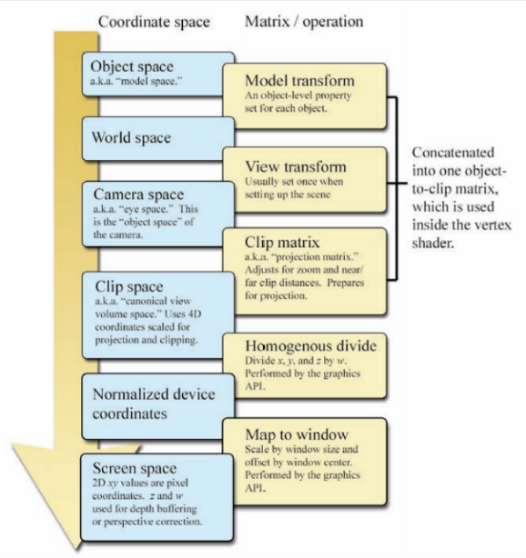
To Screen space:
Width/2 | 0 | Width/2
0 | -height/2 | Height/2
0 | 0 | 1

Phong:
I_{tot} = k_{a} I_{a} O_{d} + k_{d} I_{p} O_{d} (N . L) + k_{s} I_{p} O_{s} (v . r)^{k_gls}
Simple diffuse model: I_{d} = k_{d} I_{p} O_{d} (N . L)
Specular reflections: I_{s} = k_{s} I_{p} O_{s} (V . R)^{k_gls}
Reflection direction: R + L = 2(L . N)N
Ambient reflections: I_{a} = k_{a} I_{a} O_{d}
We need:
• Ip - the color of the point light source:
• Ia - the color of the ambient light in the scene
• L - the direction to the light source
• n - the normal at the point we are rendering
• v - the direction to the view position
• The material properties of the object:
• Od - the diffuse color of the object
• Os - the specular color of the object
• kd - the diffuse coefficient
• ks - the specular coefficient
• ka - the ambient coefficient
• kgls - the glossiness coefficient
Back-face culling: cull if dot(n, view_dir) >= 0
Nyquist rate = 2 * f_max
Minimum sampling frequency required to avoid aliasing.
If $f_{s}< 2 f_{m}$→ aliasing occurs (high frequencies appear as lower).
Homography:
[x' y' w']^T = H [x y 1]^T
Final coords: (x'/w', y'/w')
H is 3×3; defines mapping between two planes.
Includes perspective effects (not affine).
Line forms:
Y-intercept: y = mx + b
Parametric: P(t) = P0 + t(P1-P0) or P(t) = P0 + t d (d = direction vector of line)
Normal-distance: p • n = d (p=point on line, n=normal to line, d=distance from origin
Implicit: p • n – d = 0
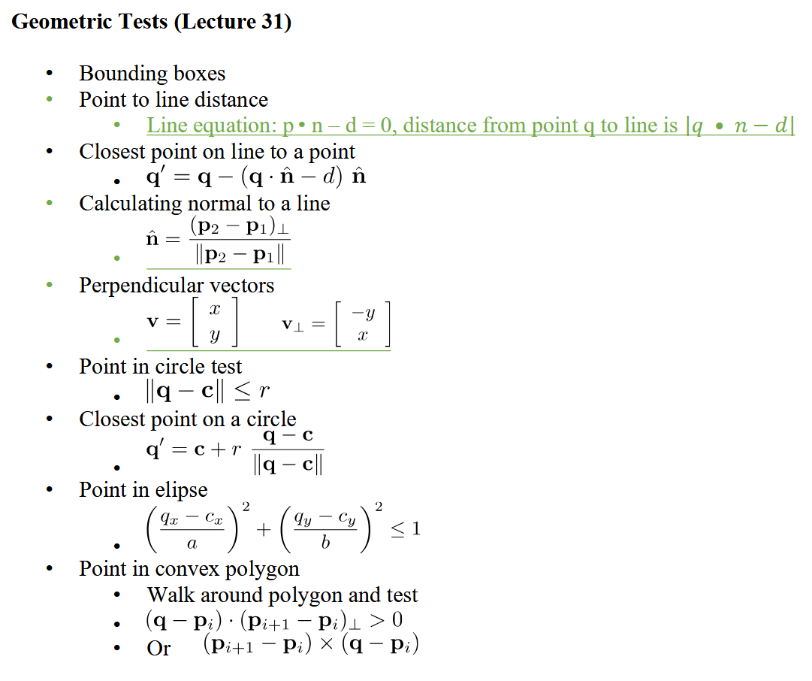
SNR = signal power / noise power
Shot noise: Poisson; noise ≈ √N; relative noise = 1/√N
Higher resolution → fewer photons/pixel → more noise
Shorter exposure → fewer photons → more noise
Tradeoff: spatial resolution vs temporal resolution vs noise
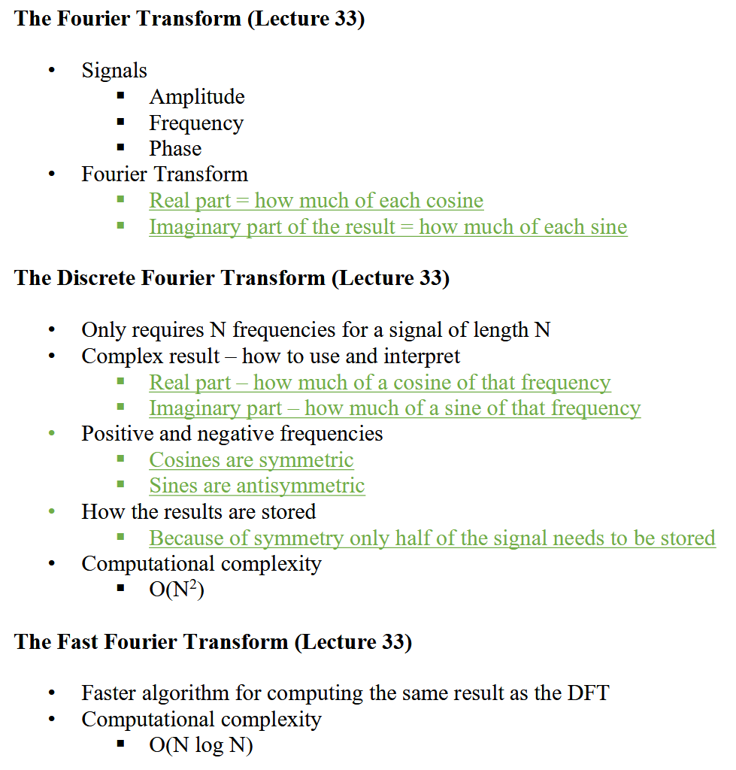
Filtering:
Low pass: $H\left(u\right)= e^{-\frac{1}{2}u^{2}/u_{c}^{2}}$
High-pass: 1 – low-pass
High boost: 1- high-pass
FT: signal = sum of sinusoids (cos=real, sin=imag)
DFT: O(N^2)
FFT: O(N log N)
2D FFT: O(N^2 log N)
Low freq = smooth; high freq = edges
Convolution ↔ multiplication (Convolution Theorem)
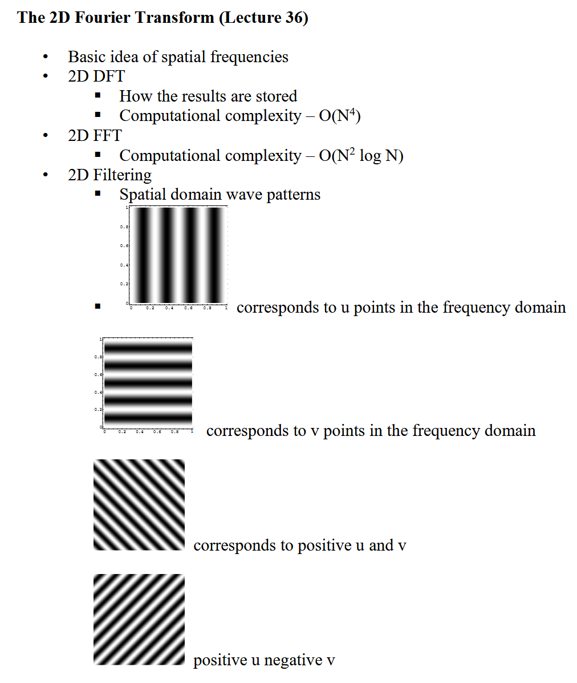
Convolution in one domain (time/spatial or frequency) is equivalent to multiplication in the other and vice versa
Moiré: interference pattern from aliasing between fine spatial patterns.

