7402 Assignment 1
Aing Ragunathan A00765949

Task 1:

Alice’s Adventures in Wonderland:
a : 9846 distribution: 0.0797828376954866
b : 1757 distribution: 0.014237095859330686
c : 3028 distribution: 0.024536099181589822
d : 5491 distribution: 0.04449396321205737
e : 15441 distribution: 0.125119520298193
f : 2385 distribution: 0.019325824487480756
g : 2948 distribution: 0.023887853496475164
h : 7915 distribution: 0.06413580747103152
i : 8669 distribution: 0.07024552305323718
j : 235 distribution: 0.0019042217000243091
k : 1291 distribution: 0.010461064743537802
l : 5227 distribution: 0.042354752451179
m : 2469 distribution: 0.020006482456851146
n : 8066 distribution: 0.06535937120168545
o : 9496 distribution: 0.07694676282310996
p : 1988 distribution: 0.016108905275099263
q : 223 distribution: 0.0018069848472571104
r : 6648 distribution: 0.05386921643302812
s : 7280 distribution: 0.05899035734543392
t : 12241 distribution: 0.09918969289360667
u : 3990 distribution: 0.03233125354509359
v : 972 distribution: 0.0078761850741431
w : 2956 distribution: 0.02395267806498663
x : 179 distribution: 0.0014504497204440483
y : 2589 distribution: 0.020978850984523133
z : 80 distribution: 0.0006482456851146585
total = 123410
total distribution = 1.0

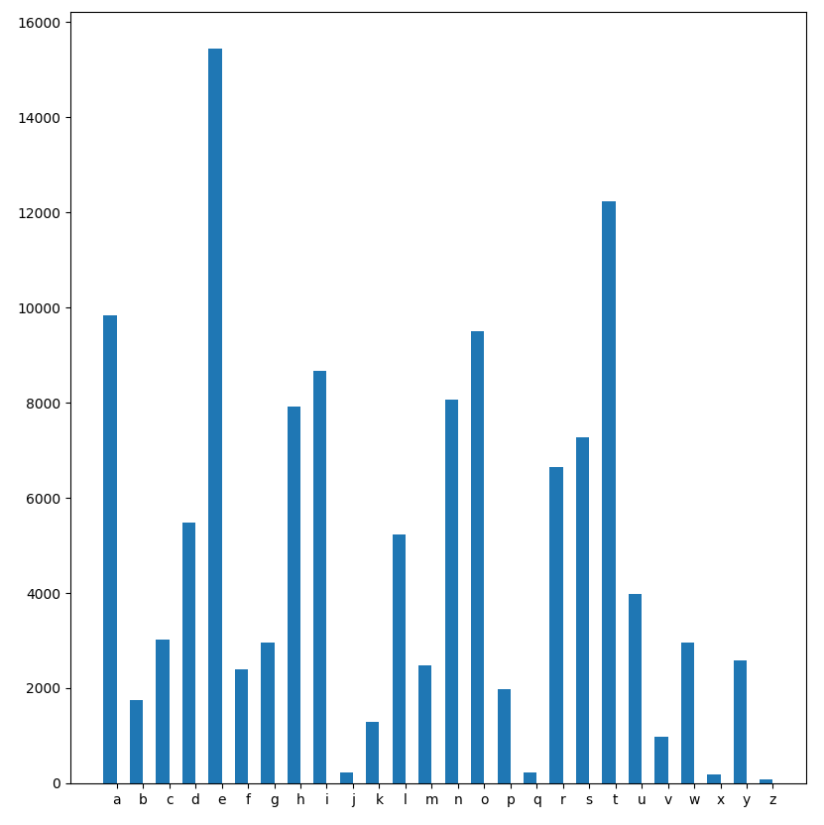
Alice’s Adventures in Wonderland
Figure 1.0

Moby Dick:
a : 79235 distribution: 0.08163978140094627
b : 17212 distribution: 0.017734384015562408
c : 23319 distribution: 0.024026731400121994
d : 38853 distribution: 0.04003218813366524
e : 119333 distribution: 0.12295475527127055
f : 21261 distribution: 0.02190627112217478
g : 21285 distribution: 0.021930999521917606
h : 63768 distribution: 0.06570335811668508
i : 66702 distribution: 0.06872640498524539
j : 1176 distribution: 0.0012116915873984075
k : 8223 distribution: 0.008472567961885294
l : 43369 distribution: 0.04468524868527341
m : 23697 distribution: 0.024416203696071483
n : 66781 distribution: 0.06880780263439885
o : 70790 distribution: 0.07293847574143986
p : 17886 distribution: 0.018428839908340065
q : 1581 distribution: 0.0016289833330585734
r : 53586 distribution: 0.05521233452579172
s : 65145 distribution: 0.06712215005192963
t : 89894 distribution: 0.09262228193672827
u : 27203 distribution: 0.028028610758502447
v : 8730 distribution: 0.008994955406452464
w : 22540 distribution: 0.02322408875846948
x : 1063 distribution: 0.001095262038609275
y : 17230 distribution: 0.017752930315369526
z : 638 distribution: 0.0006573632931634217
total = 970544
total distribution = 1.0
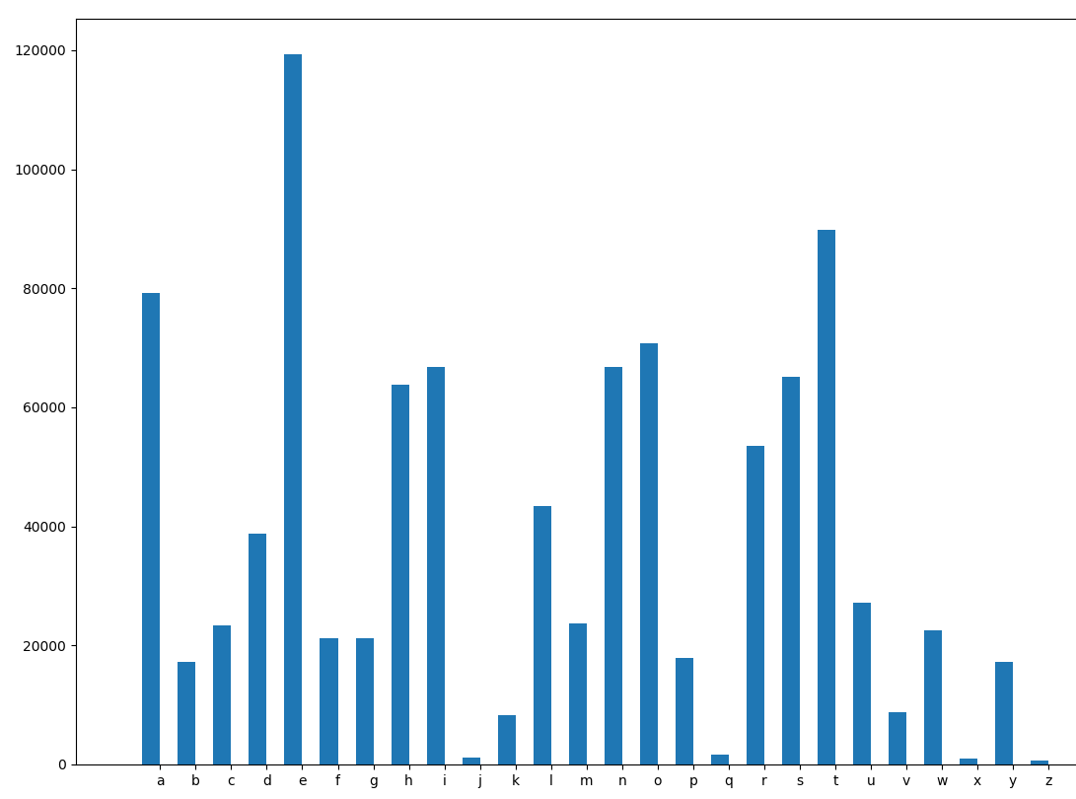
Moby Dick
Figure 1.1

Comparison:
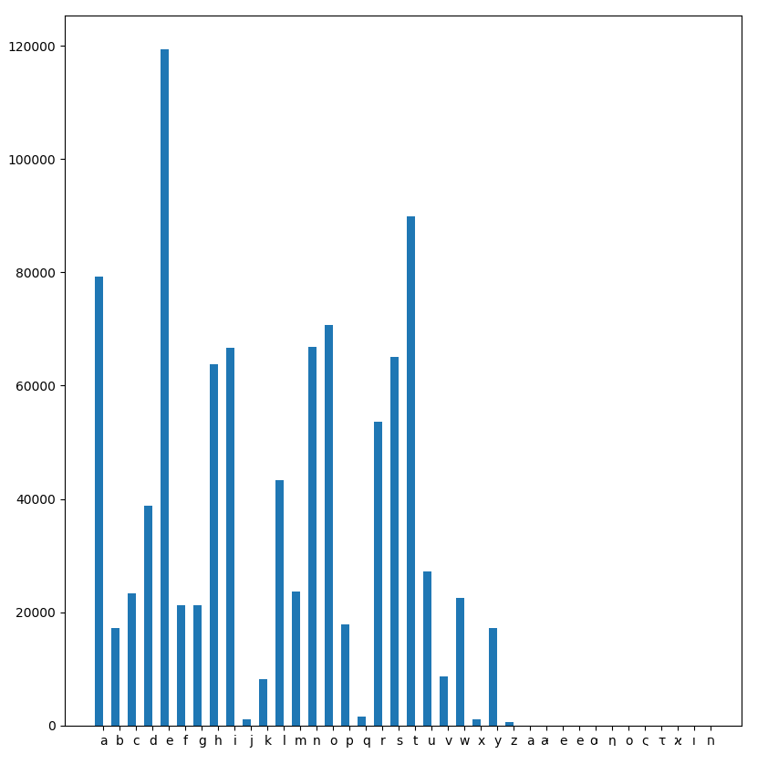
Moby Dick
Figure 1.2
Figure 1.3
Alice’s Adventures in Wonderland
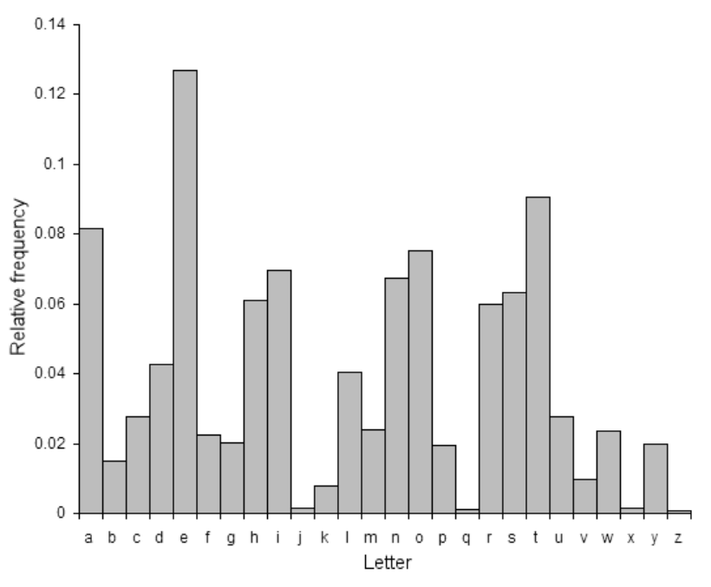
Distribution of the 26 letters in an average English text
The two graphs representing the distribution of characters between Alice’s Adventures in Wonderland, Moby Dick and the 26 letters in an average English text graph look almost identical. This distribution shows that there could be a very strong relationship between the frequency of letters used in a piece of text regardless of the author. Furthermore, if the text were to be encrypted by something like the Caesar cipher, it could be trivial to decrypt it with a simple analysis of letter frequencies to find the number of shifts in a key

Figure 1.4

Task 2:

Alice’s Adventures in Wonderland Encrypted
a : 223 distribution: 0.0018069848472571104
b : 6648 distribution: 0.05386921643302812
c : 7280 distribution: 0.05899035734543392
d : 12241 distribution: 0.09918969289360667
e : 3990 distribution: 0.03233125354509359
f : 972 distribution: 0.0078761850741431
g : 2956 distribution: 0.02395267806498663
h : 179 distribution: 0.0014504497204440483
i : 2589 distribution: 0.020978850984523133
j : 80 distribution: 0.0006482456851146585
k : 9846 distribution: 0.0797828376954866
l : 1757 distribution: 0.014237095859330686
m : 3028 distribution: 0.024536099181589822
n : 5491 distribution: 0.04449396321205737
o : 15441 distribution: 0.125119520298193
p : 2385 distribution: 0.019325824487480756
q : 2948 distribution: 0.023887853496475164
r : 7915 distribution: 0.06413580747103152
s : 8669 distribution: 0.07024552305323718
t : 235 distribution: 0.0019042217000243091
u : 1291 distribution: 0.010461064743537802
v : 5227 distribution: 0.042354752451179
w : 2469 distribution: 0.020006482456851146
x : 8066 distribution: 0.06535937120168545
y : 9496 distribution: 0.07694676282310996
z : 1988 distribution: 0.016108905275099263
total = 123410
total distribution = 1.0
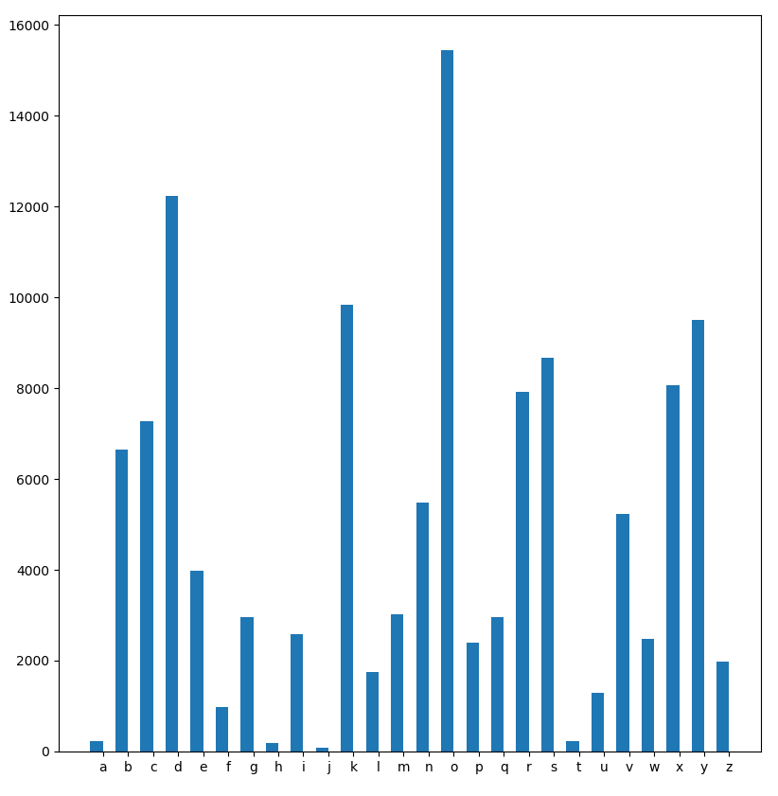
Alice’s Adventures in Wonderland Encrypted
Figure 2.0

Moby Dick Encrypted:
a : 1581 distribution: 0.0016289833330585734
b : 53586 distribution: 0.05521233452579172
c : 65145 distribution: 0.06712215005192963
d : 89894 distribution: 0.09262228193672827
e : 27203 distribution: 0.028028610758502447
f : 8730 distribution: 0.008994955406452464
g : 22540 distribution: 0.02322408875846948
h : 1063 distribution: 0.001095262038609275
i : 17230 distribution: 0.017752930315369526
j : 638 distribution: 0.0006573632931634217
k : 79235 distribution: 0.08163978140094627
l : 17212 distribution: 0.017734384015562408
m : 23319 distribution: 0.024026731400121994
n : 38853 distribution: 0.04003218813366524
o : 119333 distribution: 0.12295475527127055
p : 21261 distribution: 0.02190627112217478
q : 21285 distribution: 0.021930999521917606
r : 63768 distribution: 0.06570335811668508
s : 66702 distribution: 0.06872640498524539
t : 1176 distribution: 0.0012116915873984075
u : 8223 distribution: 0.008472567961885294
v : 43369 distribution: 0.04468524868527341
w : 23697 distribution: 0.024416203696071483
x : 66781 distribution: 0.06880780263439885
y : 70790 distribution: 0.07293847574143986
z : 17886 distribution: 0.018428839908340065
total = 970544
total distribution = 1.0
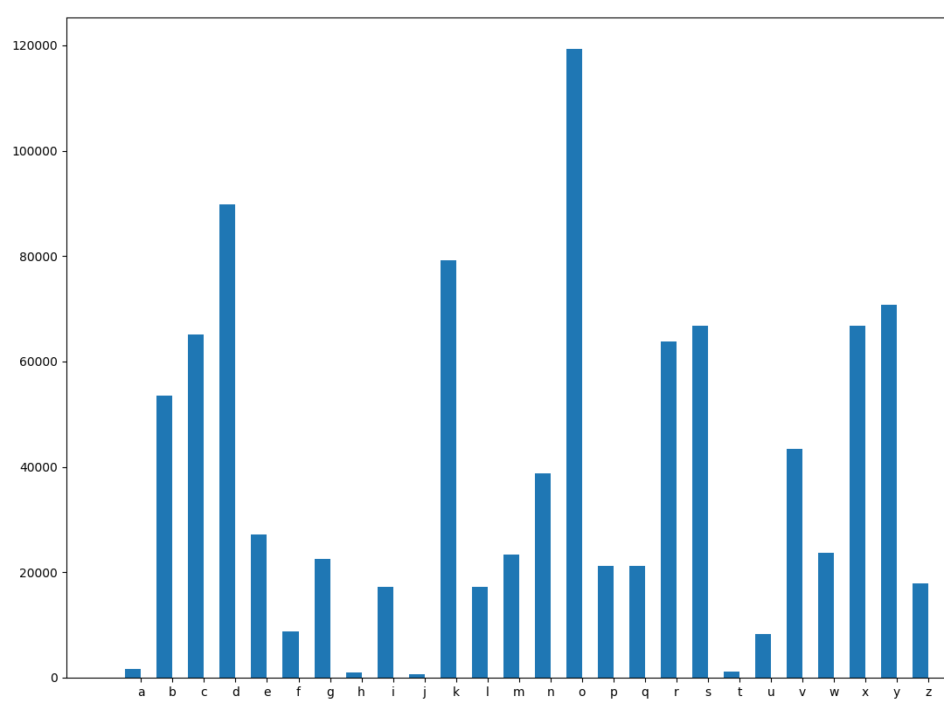
Moby Dick Encrypted
Figure 2.1

Calculate conditional probabilities:

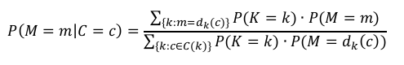
Alice’s Adventures in Wonderland
Figure 2.2
Character analysis | Conditional Probability
P(M=e|c_{i}) c_{i} ∈C | 0.004812289242238193
P(M=t|c_{i}) c_{i} ∈C | 0.003814988188215641
P(M=a|c_{i}) c_{i} ∈C | 0.003068570680595638
P(M=i|c_{i}) c_{i} ∈C | 0.0027017508866629685
P(M=o|c_{i}) c_{i} ∈C | 0.0029594908778119216
P(M=n|c_{i}) c_{i} ∈C | 0.002513821969295594

Moby Dick
Table 2.0
Character analysis | Conditional Probability
P(M=e|c_{i}) c_{i} ∈C | 0.004729029048895021
P(M=t|c_{i}) c_{i} ∈C | 0.003562395459104933
P(M=a|c_{i}) c_{i} ∈C | 0.0031399915923440874
P(M=i|c_{i}) c_{i} ∈C | 0.0026433232686632843
P(M=o|c_{i}) c_{i} ∈C | 0.0028053259900553793
P(M=n|c_{i}) c_{i} ∈C | 0.0010780234907116326
The conditional probabilities (see Table 2.0) represent the chances of any given encrypted value to be a certain character, the specific formula used is stated above in figure 2.2. There is a 0.5% chance that any given character in the cipher text file is a an ‘e’, 0.4% chance that it is a ‘t’ and so on given a key with a 1/26 chance and a valid cipher. As expected, the ranking of the conditional probability of each of these characters follows their frequency rankings in the plain text files. This is clear evidence that the specific Caesar cipher algorithm used, reveals a significant amount of information about the plain text. The conditional probabilities determined above could be very useful in identifying the plain text and cipher text pairing since a frequency analysis could be made on the cipher text (see figure 2.0) to easily determine the number of shifts made in the Caesar cipher or key.
Table 2.1

