7402 Assignment 1 Testing
Aing Ragunathan A00765949

Usage:
$ python a1.py -m <plain text file> -c <cipher text file> -o <output csv file>
e.g. python a1.py -m alice.txt -c alice_encoded.txt -o alice_results.csv

Testing:
Task | Input | Output
Print frequency of each character in plain text file | python a1.py -m alice.txt -c alice_encoded.txt -o alice_results.csv | 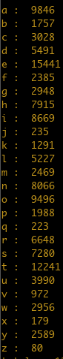
Print frequency of each character in cipher text file | python a1.py -m alice.txt -c alice_encoded.txt -o alice_results.csv | 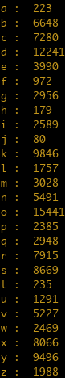
Print distribution of each character in plain text file | python a1.py -m alice.txt -c alice_encoded.txt -o alice_results.csv | 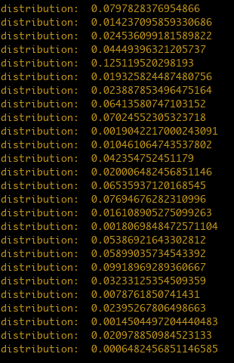
Print distribution of each character in cipher text file | python a1.py -m alice.txt -c alice_encoded.txt -o alice_results.csv
Verify distribution of characters in plain text is equal to 1 | python a1.py -m alice.txt -c alice_encoded.txt -o alice_results.csv
Verify distribution of characters in cipher text is equal to 1 | python a1.py -m alice.txt -c alice_encoded.txt -o alice_results.csv
Create csv file with character distributions of plain text and cipher text | python a1.py -m alice.txt -c alice_encoded.txt -o alice_results.csv | 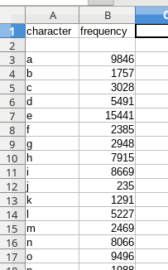
Create graph for plain text’s character frequency | python a1.py -m alice.txt -c alice_encoded.txt -o alice_results.csv | 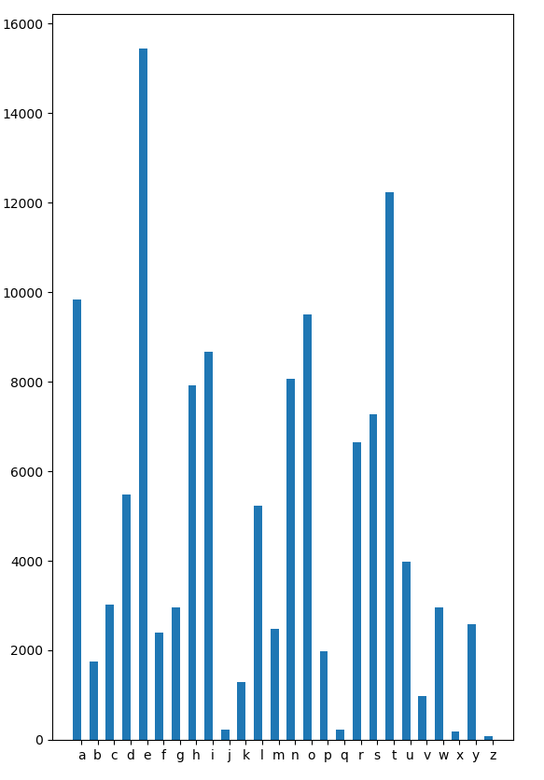
Create graph for cipher text’s character frequency | python a1.py -m alice.txt -c alice_encoded.txt -o alice_results.csv | 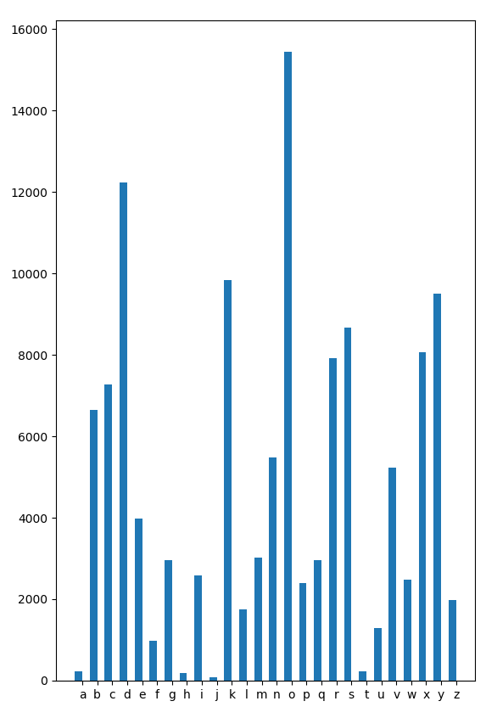
Print conditional probabilities of e, t, a, i, o, u | python a1.py -m alice.txt -c alice_encoded.txt -o alice_results.csv | 