**Rainwater Harvesting Problem Statement**

Apoorvaa has created an elevated roof. She wants to know how much water can she save during rain.

Given n non negative integers representing the elevation map where width of every bar is 1, Find the maximum water that she can save.

Explanation for the Sample input Testcase:  
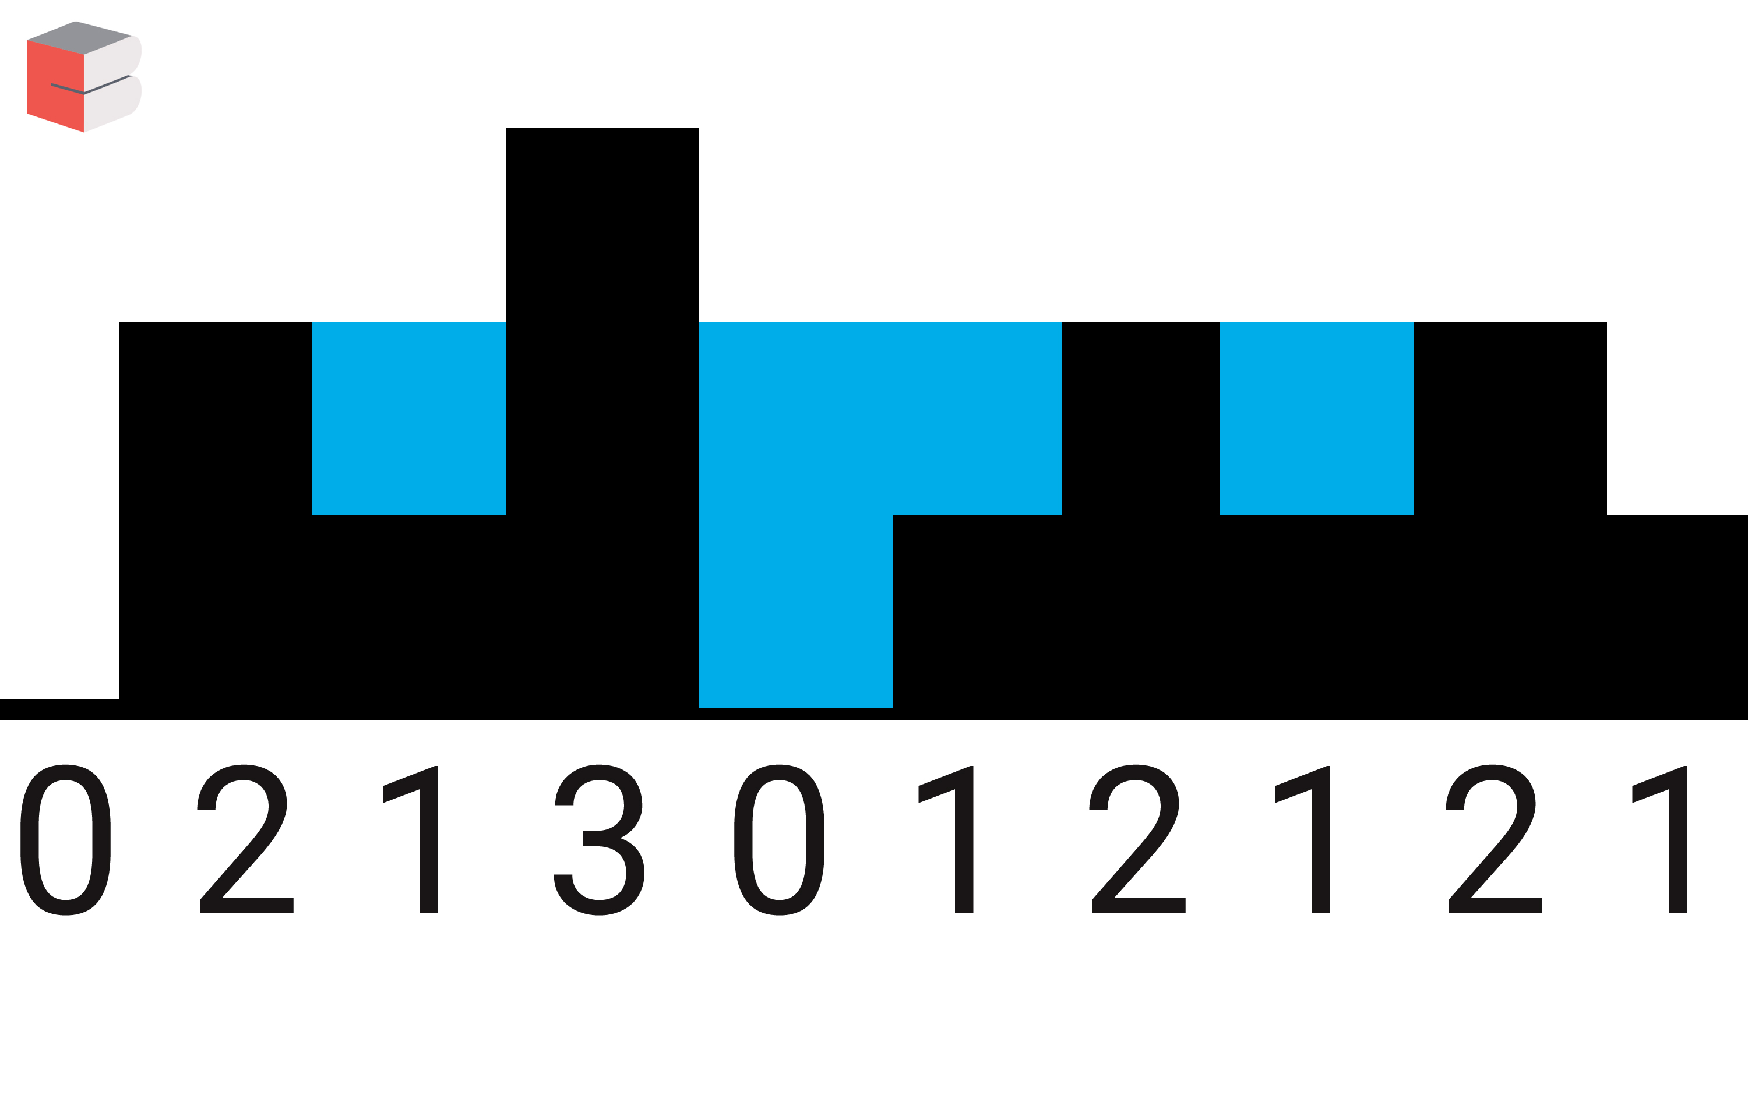

So the total units of water she can save is 5 units

**Input Format**

First line contains an integer n. Second line contains n space separated integers representing the elevation map.

**Constraints**

1 <= N <= 10^6

**Output Format**

Print a single integer containing the maximum unit of waters she can save.

**Sample Input**

100 2 1 3 0 1 2 1 2 1

**Sample Output**

5

**Explanation**

Refer to the image for explanation. Count the number of cells having water in them.