Applied R in the Classroom

JD Long & Dusty Turner

## Abstract

## Introduction

The Father of Modern Econometrics, Adam Smith, once frustratingly stated:

The discipline of colleges and universities is in general contrived, not for the benefit of the students, but for the… ease of the masters.[1]

Adam Smith is making the claim that methods of instruction used by professors are those which are easiest for the instructor, but not necessarily what is best for the student. This is understandable, as research and other administive demands force instructors to rely on tried teaching techniques which are familiar to the teacher and not what will equip the student to be most successful in their career.

The authors of this article will make the case that the R open sourse statistical programming languge can bridge this gap between a Smith’s proverbial teacher’s ease and a student’s benefit. As R continues to be one of the more popular coding languages for statistical analysis with ever increasing technical support, the barriar for entry keeps falling. There are many tools available in R which can aide the teaching process to get students loading and exploring data quickly with manageable overhead for the instructor. With ample open source support, a wide acceptance in industry, and many additional features to explore and present data, teaching with R both satisfies the ease for the instructor and has long term benefit for the students.

This is something we are certain Adam Smith would be proud of.

## The R Ecosystem

The advantages to using R whether in an academic setting or industry are myriad. Since R and all the tooling we discuss below are open source, they have no financial costs to adoption. In addition, R has a very rich ecosystem of add-on packages that expand R and add functionality. These packages add features ranging from libraries to connect to commercial database systems to implementation of new machine learning algorithms.

### CRAN

The online home of R is the Comprehensive R Archive Network, CRAN. CRAN is where a new user can download R and access packages that expand the functionality of R. There are currently more than 10,000 R packages hosted on CRAN for free download. Some new users to R are overwhelmed by the sheer volume of packages. To help make sense of the CRAN ecosystem, CRAN has published CRAN Task Views which organize popular packages into categories of use (e.g. econometrics or spatial statistics). The task views are written and maintained by a subject matter expert. There are more than 35 such task views which can help new R users make sense of the packages availiable in their areas of interest and know which packages are recommended by an expert in their domain of interest. This can give instructors and students a curated view into packages that might match their interests or field of study: <https://cran.r-project.org/web/views/>

### RStudio

When R is downloaded from CRAN, it comes with an engine for executing R code along with a few core packages for doing statistical analysis and graphics. Collectivly these tools are refered to as “Base R”. Base R comes with a basic text editor for editing and executing R scprits. However most users quickly discover that writing R code is easier wiht an integrated developemnt environment (IDE). The most popular IDE for R is RStudio whcih we highly recommend for teaching.

RStudio desktop can be downloaded for free from RStudio.com. In additon to the desktop IDE, RStudio makes a server based IDE for using R on remote machines. RStudio server also is availiable in a professional version that offers more features such as authentication and collaborative editing. RStudio offers its professional tools to academics for free. Go to <https://www.rstudio.com/pricing/academic-pricing/> for more info.

For many instructors, the freely availiable RStudio.cloud service (<http://rstudio.cloud>) greatly simplifies instruction by providing a fully functional and configured R and RStudio environment running on cloud hosted hardware. For the rest of this article we will exclusivly use RStudio.cloud in our examples. Instructors can set up projects in RStudio.cloud and share those projects with students to simplify distributing course material.

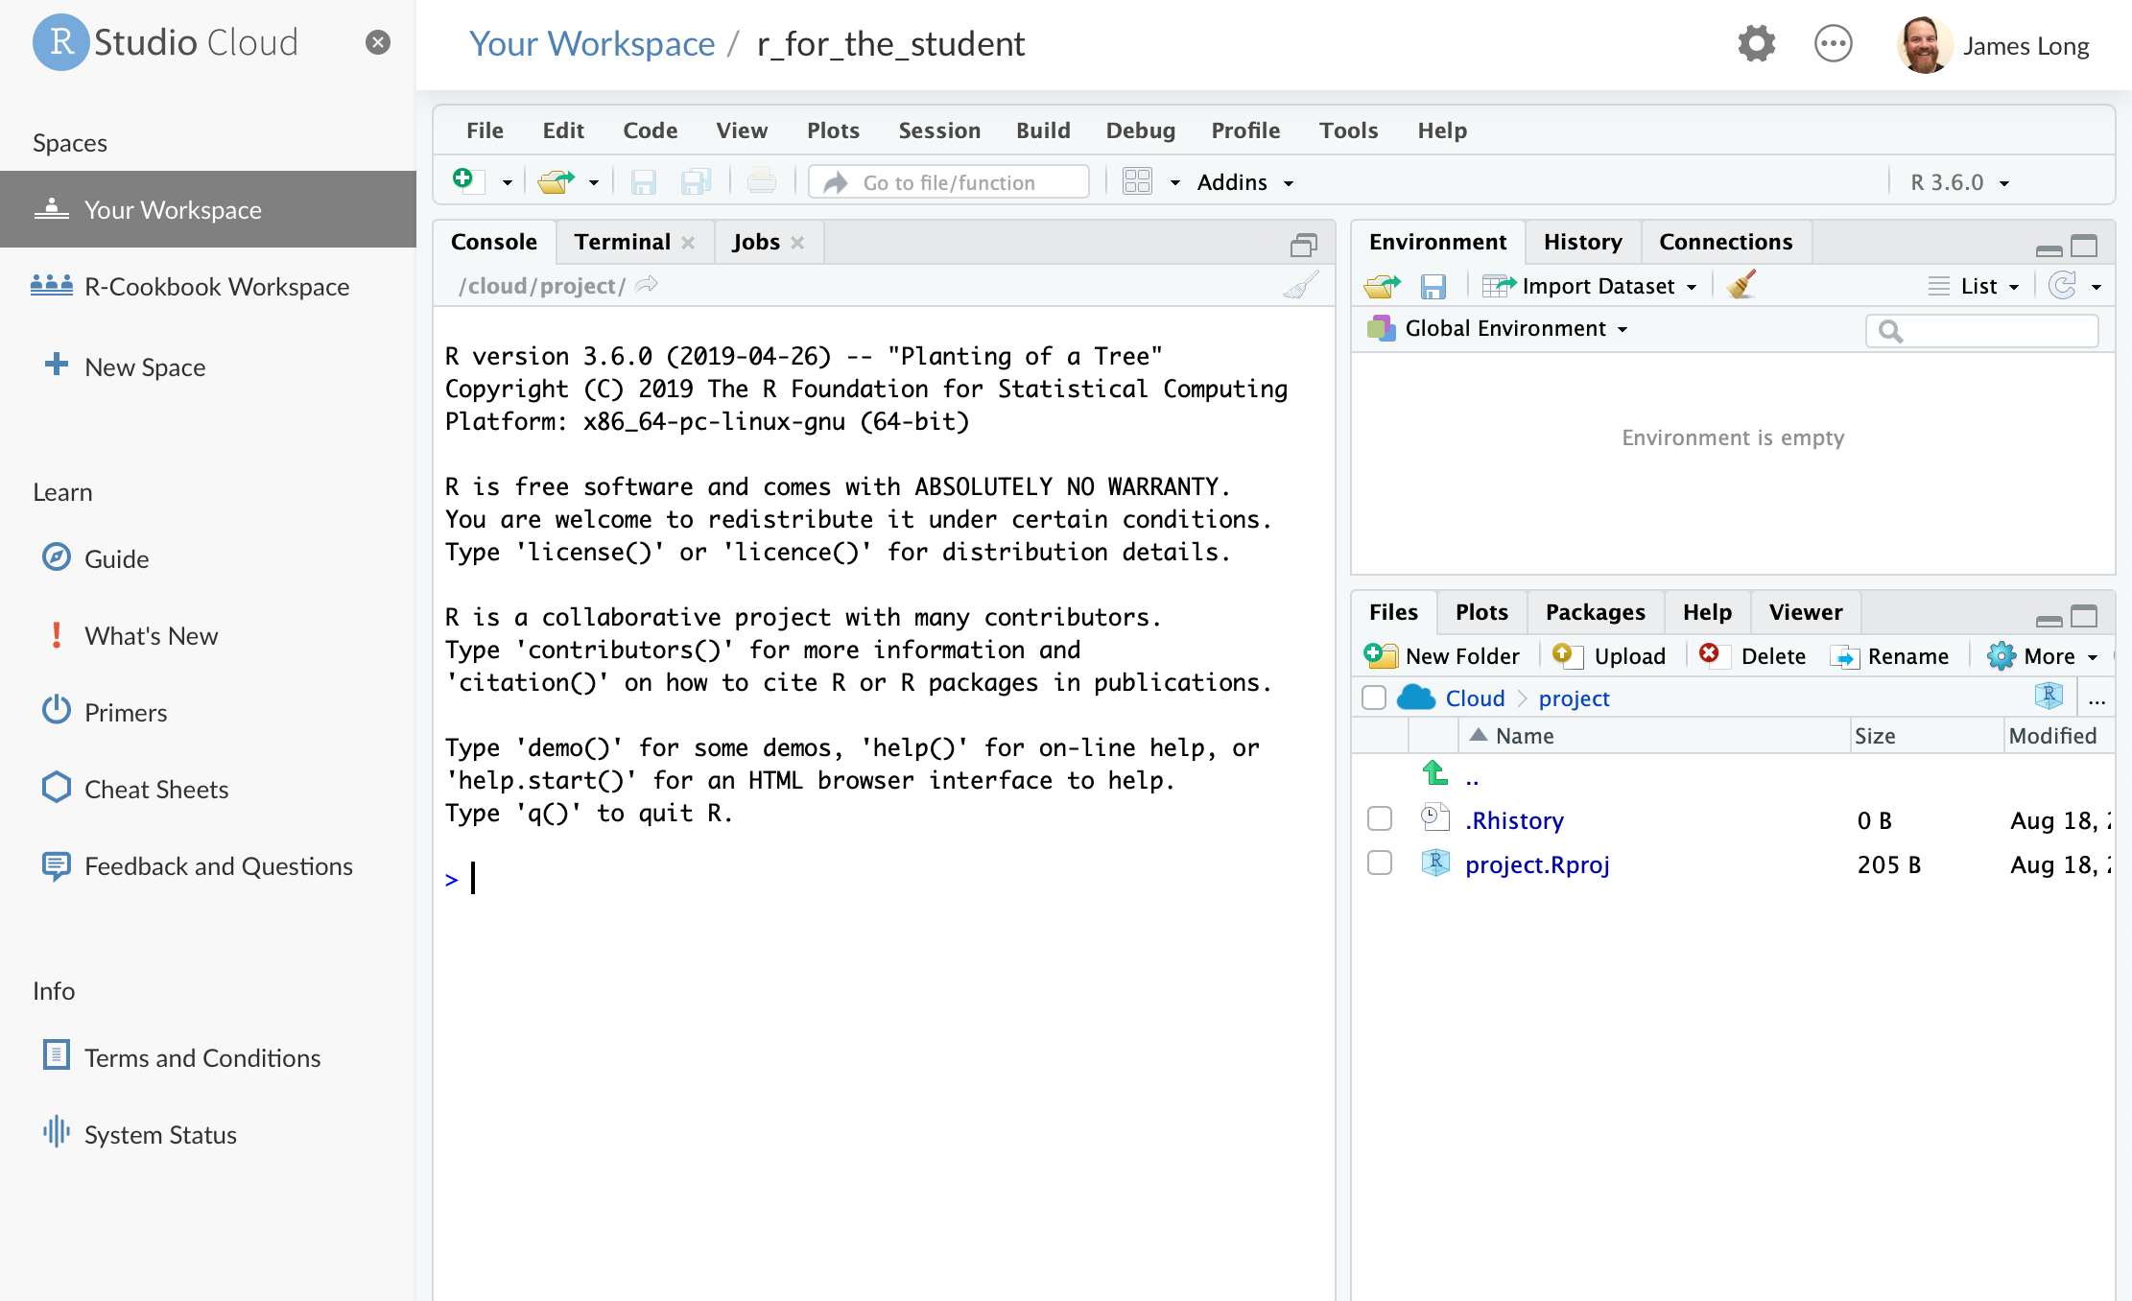

RStudio.cloud

Instructors who don’t want to use the cloud solutions, or can’t because of connectivity restrictions, can download and install R and RStudio on local hardware. For details on downloading and installing, see section 1.1 in R Cookbook Second Edition, available online at <https://rc2e.com/gettingstarted#recipe-id001>.

### Projects

RStudio introduces a powerful organizational tool called an RStudio Project. Projects help you by doing the following:

* Storing RStudio project settings
* Restoring window position in RStudio so when you return to a project you can pick up exactly where you left off
* Setting the working directory

RStudio creates a project file with an *.Rproj* extension in the project directory. RStudio also creates a hidden directory, *.Rproj.user*, for temporary files related to your project.

We’ve found that helping students organieze their files using projects from the start helps them build good practices and prevent lost files and file path related issues that can flummox new learners. Although instructors should expect to teach the basics of absolute and relative file paths, as this concept is sometimes new to learners and can slow learning.

### Tidyverse

In addition to the RStudio IDE, the RStudio company supports the development of a number of open source packages designed to work together to make R easier to use and faster to learn. These libraries are collectivly known as the “Tidyverse”. The most concise definition of the Tidyverse comes directly from its originator and core maintainer, Wickham:

The tidyverse is a set of packages that work in harmony because they share common data representations and API design. The tidyverse package is designed to make it easy to install and load core packages from the tidyverse in a single command. The best place to learn about all the packages in the tidyverse and how they fit together is [*R for Data Science*](http://r4ds.had.co.nz).

(<https://blog.rstudio.com/2016/09/15/tidyverse-1-0-0/>)

The authors have had very good experiences with introducing learners to the Tidyverse from the very beginning of the learning journey because these tools help learners see very quick successes which, in turn, keeps them engaged in the learning process. The popular plotting package ggplot2 and the data manipulation package dplyr are both core Tidyverse packages.

The Tidyverse meta-package, like any CRAN package, can be installed from the R Console:

install.packages("tidyverse")

#### Tidyverse Packages

When a user installs the Tidyverse, 19 packages are installed. Then when the user loads the tidyverse using library(tidyverse) a core subset of 8 packages are loaded into R. To use any of the pacakges not loaded with the core Tidyverse a user must explicitly load those packages (e.g. library(readxl)) or call the packages using the package name prefix (e.g. readxl::read_xlsx() to run the read_xlsx() function from the readxl package).

The packages listed below are in the “Core Tidyverse” and get loaded with library(tidyverse).

***Core Tidyverse***

ggplot2: data visualisation  
dplyr: data manipulation  
tidyr: data reshaping  
readr: data import  
purrr: functional programming  
tibble: tidy dataframes  
stringr: string manipulation  
forcats: factor use

***Additional Tidyverse***

There are 11 additional Tidyverse packages that get installed, but not automatically loaded. These add specialized functions for more specialized uses.

hms: time manipulation lubridate: date manipulation  
modelr: model building  
broom: output manipulation  
feather: reading / writing data haven: reading / writing data httr: accessing html jsonlite: JSON manipulation readxl: reading Excel files rvest: scrape html data xml2: Data inport

More info on each can be found at <https://tidyverse.tidyverse.org>

## Harnessing The Power of R, Tidyverse, and other Helpful Packages

In the following sections, we will highlight some of the features of R and the tidyverse and how they can be useful in a classroom setting while teaching new students. The reader will notice the authors use many packages to support their analysis and recommend teachers do the same when instructing students. These prebuilt, add-on packages make syntax simple, easy to interpret, and less intimidaing for new users.

### Loading Data (Gapminder)

To aide our instructions, we will explore the Gapminder data set. The Gapminder dataset is created by the Gapminder Foundation which is a non-profit which promots sustainable global development. <https://www.gapminder.org>

Showing students how to load in example data is a crucial first step. Data can be easily loaded from the local file system:

library(tidyverse)  
gapminder <- read_csv("01_data/gapminder.csv")

Or directly from a URL:

As a quick aside, a common stumbling block for students is executing lines of code. RStudio makes this simple. Ctrl + Enter (for Windows) or Command+Enter (for MAC) will execute the line of code where the cursor currently exists. Students can also execute multiple lines of code by highliting the desired code and pressing Ctrl + Enter (or Command+Enter).

Once the student reads the the data into R, the environment tab in the top right of the computer will reflect that the data is loaded.

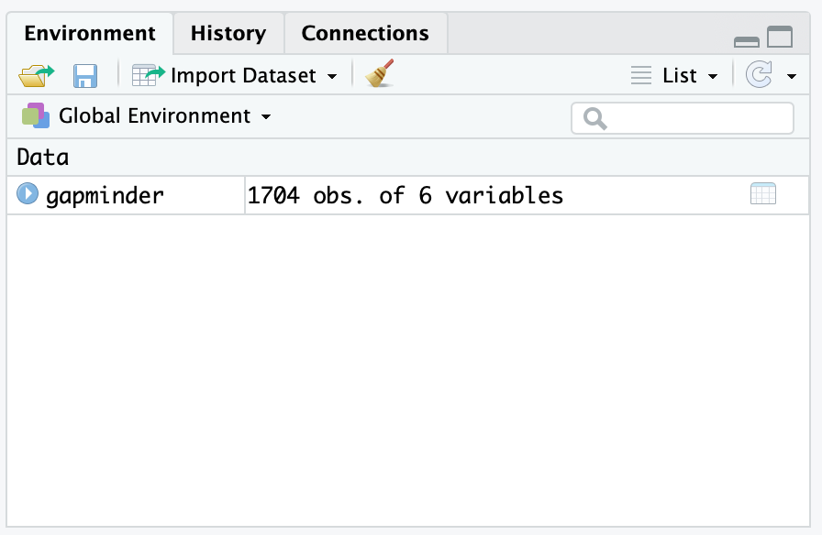

Environment With Gapminder Data

### Initial Data Exploration

Simply outputting the code can tell students a bundle of information about the data just loaded. Lets look at the output below.

gapminder

## # A tibble: 1,704 x 6  
## country continent year lifeExp pop gdpPercap  
## <chr> <chr> <dbl> <dbl> <dbl> <dbl>  
## 1 Afghanistan Asia 1952 28.8 8425333 779.  
## 2 Afghanistan Asia 1957 30.3 9240934 821.  
## 3 Afghanistan Asia 1962 32.0 10267083 853.  
## 4 Afghanistan Asia 1967 34.0 11537966 836.  
## 5 Afghanistan Asia 1972 36.1 13079460 740.  
## 6 Afghanistan Asia 1977 38.4 14880372 786.  
## 7 Afghanistan Asia 1982 39.9 12881816 978.  
## 8 Afghanistan Asia 1987 40.8 13867957 852.  
## 9 Afghanistan Asia 1992 41.7 16317921 649.  
## 10 Afghanistan Asia 1997 41.8 22227415 635.  
## # ... with 1,694 more rows

From the output above, one can see the gapminder dataset is a tibble consisting of 1,704 observational units with 6 columns of information. When reading in data, the read_csv command identifies the most likely class of data for each column lists the class below the column name. We can see that we have a mix of characters and doubles. A tibble is a Tidyverse take on R’s traditional data.frame. We’ve found that it usually is sufficient to tell students that tibble is a table. Since the goal is to get students using data to *do* things we often don’t spend excessive time on definitions and instead focus on getting students doing something interesting.

Students also notice that printing out the data does not provude all the information they would like to know. One can see that the data has information about countries, but are they all Afghanistan? Likely no, as you can see there are 1,694 more rows and they probably are not all Afghanistan. Lets look at other ways to understand the data.

We recommend using the skim command from the skimr library. You may need to download the skimr package from CRAN.

install.packages("skimr")

library(skimr)  
kable(skim(gapminder))

Skim summary statistics  
n obs: 1704  
n variables: 6

Variable type: character

|  |  |  |  |  |  |  |  |
| --- | --- | --- | --- | --- | --- | --- | --- |
| variable | missing | complete | n | min | max | empty | n_unique |
| continent | 0 | 1704 | 1704 | 4 | 8 | 0 | 5 |
| country | 0 | 1704 | 1704 | 4 | 24 | 0 | 142 |

Variable type: numeric

|  |  |  |  |  |  |  |  |  |  |  |  |
| --- | --- | --- | --- | --- | --- | --- | --- | --- | --- | --- | --- |
| variable | missing | complete | n | mean | sd | p0 | p25 | p50 | p75 | p100 | hist |
| gdpPercap | 0 | 1704 | 1704 | 7215.33 | 9857.45 | 241.17 | 1202.06 | 3531.85 | 9325.46 | 113523.13 | <U+2587><U+2581><U+2581><U+2581><U+2581><U+2581><U+2581><U+2581> |
| lifeExp | 0 | 1704 | 1704 | 59.47 | 12.92 | 23.6 | 48.2 | 60.71 | 70.85 | 82.6 | <U+2581><U+2582><U+2585><U+2585><U+2585><U+2585><U+2587><U+2583> |
| pop | 0 | 1704 | 1704 | 29601212.32 | 106157896.74 | 60011 | 2793664 | 7023595.5 | 19585221.75 | 1318683096 | <U+2587><U+2581><U+2581><U+2581><U+2581><U+2581><U+2581><U+2581> |
| year | 0 | 1704 | 1704 | 1979.5 | 17.27 | 1952 | 1965.75 | 1979.5 | 1993.25 | 2007 | <U+2587><U+2583><U+2587><U+2583><U+2583><U+2587><U+2583><U+2587> |

This gives students a much better view of the data. skim seperates the data by class and provides important information for each data type. We find that the skim function gives students the quickest and best description of the data. Other options of presenting detailed information about the data include the summary(gapminder), glimse(gapminder), and str(gapminder)

In the output above, for each class of data (character/numeric), skim provides how many missing, complete, and total (n) observations for each column.

For the character class, skim provides additional information about each column. This includes the min/max length of each character string as well as the number of unique (n_unique) observations.

For the numeric class, skim provides mean, standard deviation (sd), and percentile breaks (p0, p25,…,p100). It also provides a small histogram to help visualize the distribution of your numeric data (hist).

This likely does not satisfy the students’s desire to understand the data as we still do not understand which countries are in the data among other curiosities. We will provide more indepth methods of understanding the data in the plotting and Exploratory Data Analysis (EDA) section after we look briefly at the 6 dplyr verbs that allow students to begin rapidly understanding the data.

### dplyr Verbs

Almost any time a student wors with data, they will need to manipulate that data in some way. In this next section, we will introduce the main 6 dplyr verbs to help wrangle data to gain additional insight. These verbs, select, filter, mutate, group_by, summarize, arrange are explained in detail below.

In order to motivate a student’s use of the aformentioned verbs, we’ll look to answer the following question:

**What is the average GDP per country since 1980?**

#### Verb 1: select

To begin, we only need to work with certain columns. The relevent columns to this question are country, year, pop, and gdpPercap. We can make this selection using the select function. The first argument in the select function is the data we which to select from. The subsequent arguments are the names of the columns from the data we wish to select. In the code below, we save our selected columns into a new tibble called gapminder_selected.

gapminder_selected = select(gapminder, country, year, pop, gdpPercap)  
gapminder_selected

## # A tibble: 1,704 x 4  
## country year pop gdpPercap  
## <chr> <dbl> <dbl> <dbl>  
## 1 Afghanistan 1952 8425333 779.  
## 2 Afghanistan 1957 9240934 821.  
## 3 Afghanistan 1962 10267083 853.  
## 4 Afghanistan 1967 11537966 836.  
## 5 Afghanistan 1972 13079460 740.  
## 6 Afghanistan 1977 14880372 786.  
## 7 Afghanistan 1982 12881816 978.  
## 8 Afghanistan 1987 13867957 852.  
## 9 Afghanistan 1992 16317921 649.  
## 10 Afghanistan 1997 22227415 635.  
## # ... with 1,694 more rows

Once we view the data, we see that we now have 1704 rows with 4 columns.

#### Verb 2: filter

To further answer our question, we need to filter our data down to the years of interest. We can achieve this goal using the filter function. Like the select function, the first argument in the filter function is the data and subsequent argument is the logical statement of which you wish to filter. In the code below, we filter our selected data and save our filtered data into a new tibble called gapminder_filtered.

gapminder_filtered = filter(gapminder_selected, year >= 1980)  
gapminder_filtered

## # A tibble: 852 x 4  
## country year pop gdpPercap  
## <chr> <dbl> <dbl> <dbl>  
## 1 Afghanistan 1982 12881816 978.  
## 2 Afghanistan 1987 13867957 852.  
## 3 Afghanistan 1992 16317921 649.  
## 4 Afghanistan 1997 22227415 635.  
## 5 Afghanistan 2002 25268405 727.  
## 6 Afghanistan 2007 31889923 975.  
## 7 Albania 1982 2780097 3631.  
## 8 Albania 1987 3075321 3739.  
## 9 Albania 1992 3326498 2497.  
## 10 Albania 1997 3428038 3193.  
## # ... with 842 more rows

Once we view the data, we see that our data now consist of years since 1980.

#### Verb 3: mutate

The next step in answering our question is creating a column that contains the information of interest. The mutate function creats new columns according to a specific function that we provide. To answer our question, we need to determine the GDP in each year. To find the GDP, we need to multiply the gdpPercap by the pop. Similar to the previous two verbs, the first argument in the mutate function is the data. Subsequent arguments are columns you wish to create with corresponding formulas. In the code below, we mutate our filtered data and save our mutated data into a new tibble called gapminder_mutated.

gapminder_mutated = mutate(gapminder_filtered, GDP = gdpPercap * pop)  
gapminder_mutated

## # A tibble: 852 x 5  
## country year pop gdpPercap GDP  
## <chr> <dbl> <dbl> <dbl> <dbl>  
## 1 Afghanistan 1982 12881816 978. 12598563401.  
## 2 Afghanistan 1987 13867957 852. 11820990309.  
## 3 Afghanistan 1992 16317921 649. 10595901589.  
## 4 Afghanistan 1997 22227415 635. 14121995875.  
## 5 Afghanistan 2002 25268405 727. 18363410424.  
## 6 Afghanistan 2007 31889923 975. 31079291949.  
## 7 Albania 1982 2780097 3631. 10094200603.  
## 8 Albania 1987 3075321 3739. 11498418358.  
## 9 Albania 1992 3326498 2497. 8307722183.  
## 10 Albania 1997 3428038 3193. 10945912519.  
## # ... with 842 more rows

Once we view the data, we see the new column, GDP, has been added to the end of our tibble.

#### Verb 4: group_by

The next step in answering our question will be to group our data by the topic of interest. In this instance, since we want to know GDP by country, we need to group or data by country. A way to conceptualize this step is to think of placing each group of data into a specific room. In subsequent steps we will apply a function to each group (or room) of data. Just like the previous verbs, the first argument in the group_by function is the data. The following arguments are the columns you wish to group by. In the code below, we group our mutated data and save our grouped data into a new tibble called gapminder_grouped.

gapminder_grouped = group_by(gapminder_mutated, country)   
gapminder_grouped

## # A tibble: 852 x 5  
## # Groups: country [142]  
## country year pop gdpPercap GDP  
## <chr> <dbl> <dbl> <dbl> <dbl>  
## 1 Afghanistan 1982 12881816 978. 12598563401.  
## 2 Afghanistan 1987 13867957 852. 11820990309.  
## 3 Afghanistan 1992 16317921 649. 10595901589.  
## 4 Afghanistan 1997 22227415 635. 14121995875.  
## 5 Afghanistan 2002 25268405 727. 18363410424.  
## 6 Afghanistan 2007 31889923 975. 31079291949.  
## 7 Albania 1982 2780097 3631. 10094200603.  
## 8 Albania 1987 3075321 3739. 11498418358.  
## 9 Albania 1992 3326498 2497. 8307722183.  
## 10 Albania 1997 3428038 3193. 10945912519.  
## # ... with 842 more rows

The reader will notice that there apears to be no change to the data. This is mostly true as we have simply told R that we would like to apply future functions over each group of data instead of over the entire tibble. The only difference in output is the a note explaining the what the data has been grouped into and the number of groups. In this case, it explains the data is grouped by country and that there are 142 groups.

#### Verb 5: summarise

Next, in order to determine the average GDP by country, we need to apply a function to each group we have identified. In this instance, we will need to take the average GDP over each continent. Since we’ve already grouped by country, we simply need to apply the summarise function. Like the previous verbs, the first argument in the summarise function is the data. The following arguments are the function you would like to apply to each group. In the code below, we summarise our grouped data and save our summarised data into a new tibble called gapminder_summarised.

gapminder_summarised = summarise(gapminder_grouped, AVG_GDP = mean(GDP))  
gapminder_summarised

## # A tibble: 142 x 2  
## country AVG_GDP  
## <chr> <dbl>  
## 1 Afghanistan 16430025591.  
## 2 Albania 13062766192.  
## 3 Algeria 148613140752.  
## 4 Angola 28940373965.  
## 5 Argentina 353071702131.  
## 6 Australia 477639321504.  
## 7 Austria 225388780040.  
## 8 Bahrain 12397050418.  
## 9 Bangladesh 119954904364.  
## 10 Belgium 271944511091.  
## # ... with 132 more rows

We now have an answer to our question. The tibble above shows the average GDP per country since 1980.

#### Verb 6: arrange

However, we can refine our data to provide more understanding. Currently, our data is sorted alphabetically by country. This does not provide much insight. We can use the arrange function to sort the data by average GDP; both assending and descending. Like all other verbs, the first argument in the arrange function is the data. The following argument is the column you wish to sort by. In the code below, we arrange our summarised data and save our arranged data into a new tibble called gapminder_arranged.

gapminder_arragned = arrange(gapminder_summarised, AVG_GDP)  
gapminder_arragned

## # A tibble: 142 x 2  
## country AVG_GDP  
## <chr> <dbl>  
## 1 Sao Tome and Principe 213138942.  
## 2 Comoros 585013190.  
## 3 Guinea-Bissau 788263198.  
## 4 Gambia 806874307.  
## 5 Djibouti 894915489.  
## 6 Liberia 1274437021.  
## 7 Lesotho 2041066151.  
## 8 Equatorial Guinea 2131596160.  
## 9 Eritrea 2545841271.  
## 10 Central African Republic 2670573945.  
## # ... with 132 more rows

We see, from the output above, the countries with the smalled average GDP since 1980.

It may be more interesting, however, to sort the average GDP in descending order so we can learn the countries with the highest average GDP. To do this we simply place a - sign in front of AVG_GDP in the call above.

gapminder_arragned_descending = arrange(gapminder_summarised, -AVG_GDP)  
gapminder_arragned_descending

## # A tibble: 142 x 2  
## country AVG_GDP  
## <chr> <dbl>  
## 1 United States 9.20e12  
## 2 Japan 3.28e12  
## 3 China 2.96e12  
## 4 Germany 2.20e12  
## 5 United Kingdom 1.48e12  
## 6 France 1.48e12  
## 7 India 1.39e12  
## 8 Italy 1.33e12  
## 9 Brazil 1.27e12  
## 10 Mexico 9.26e11  
## # ... with 132 more rows

#### Simplifying Code with the Pipe Operator: %>%

After helping learners see how each function works we can introduce the pipe operator (%>%) that can be used to chain together commands and pass the results of one functiopn directly into the next function. This can result in very logical data manipulation steps that are easy to learn and easy to understand:

gapminder_arragned_descending_chained =  
 gapminder %>%  
 select(country, year, pop, gdpPercap) %>%  
 filter(year >= 1980) %>%  
 mutate(GDP = gdpPercap * pop) %>%  
 group_by(country) %>%  
 summarise(AVG_GDP = mean(GDP)) %>%  
 arrange(-AVG_GDP)  
  
gapminder_arragned_descending_chained

## # A tibble: 142 x 2  
## country AVG_GDP  
## <chr> <dbl>  
## 1 United States 9.20e12  
## 2 Japan 3.28e12  
## 3 China 2.96e12  
## 4 Germany 2.20e12  
## 5 United Kingdom 1.48e12  
## 6 France 1.48e12  
## 7 India 1.39e12  
## 8 Italy 1.33e12  
## 9 Brazil 1.27e12  
## 10 Mexico 9.26e11  
## # ... with 132 more rows

Some students may struggle to grasp this coding technique. It may be helpful to explain the pipe in the following way: A pipe takes the result of the previous fuction and ‘pipes’ it into the first argument of the next function. In that way, we can chain together our verbs to manipulate and gain insight on the data.

### Plotting and Exploratory Data Analysis (EDA)

From the preceeding example, you can see how to gain insight from data by manipulating the tibble with dplyr verbs. A more helpful way to gain insight from data is by viewing it graphically. We’ll go over plotting basics.

#### esquisse

Typically before building any models or doing other analysis, students benefit from learning to do basic exploritory data analysis (EDA). One tool for getting students a quick win with learning data visualization is to use ggplot2 with the helper package esquisse to give them a graphical user interface that helps them write ggplot2 code.

Since esquisse is a CRAN package, it can be installed by running install.packages("esquisse"). After installation, esquisse shows up in the *Addins* menu of RStudio:

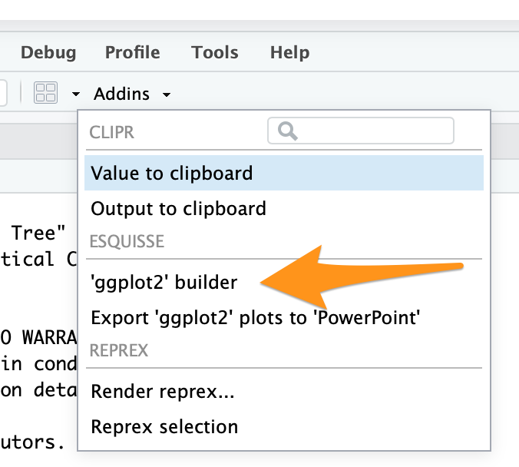

Addins menue

The 'ggplot2' builder menu option opens the graphical interface for building ggplot2 graphics using a helper UI. Below is how the esquisse interface appears with the gapminder data selected:

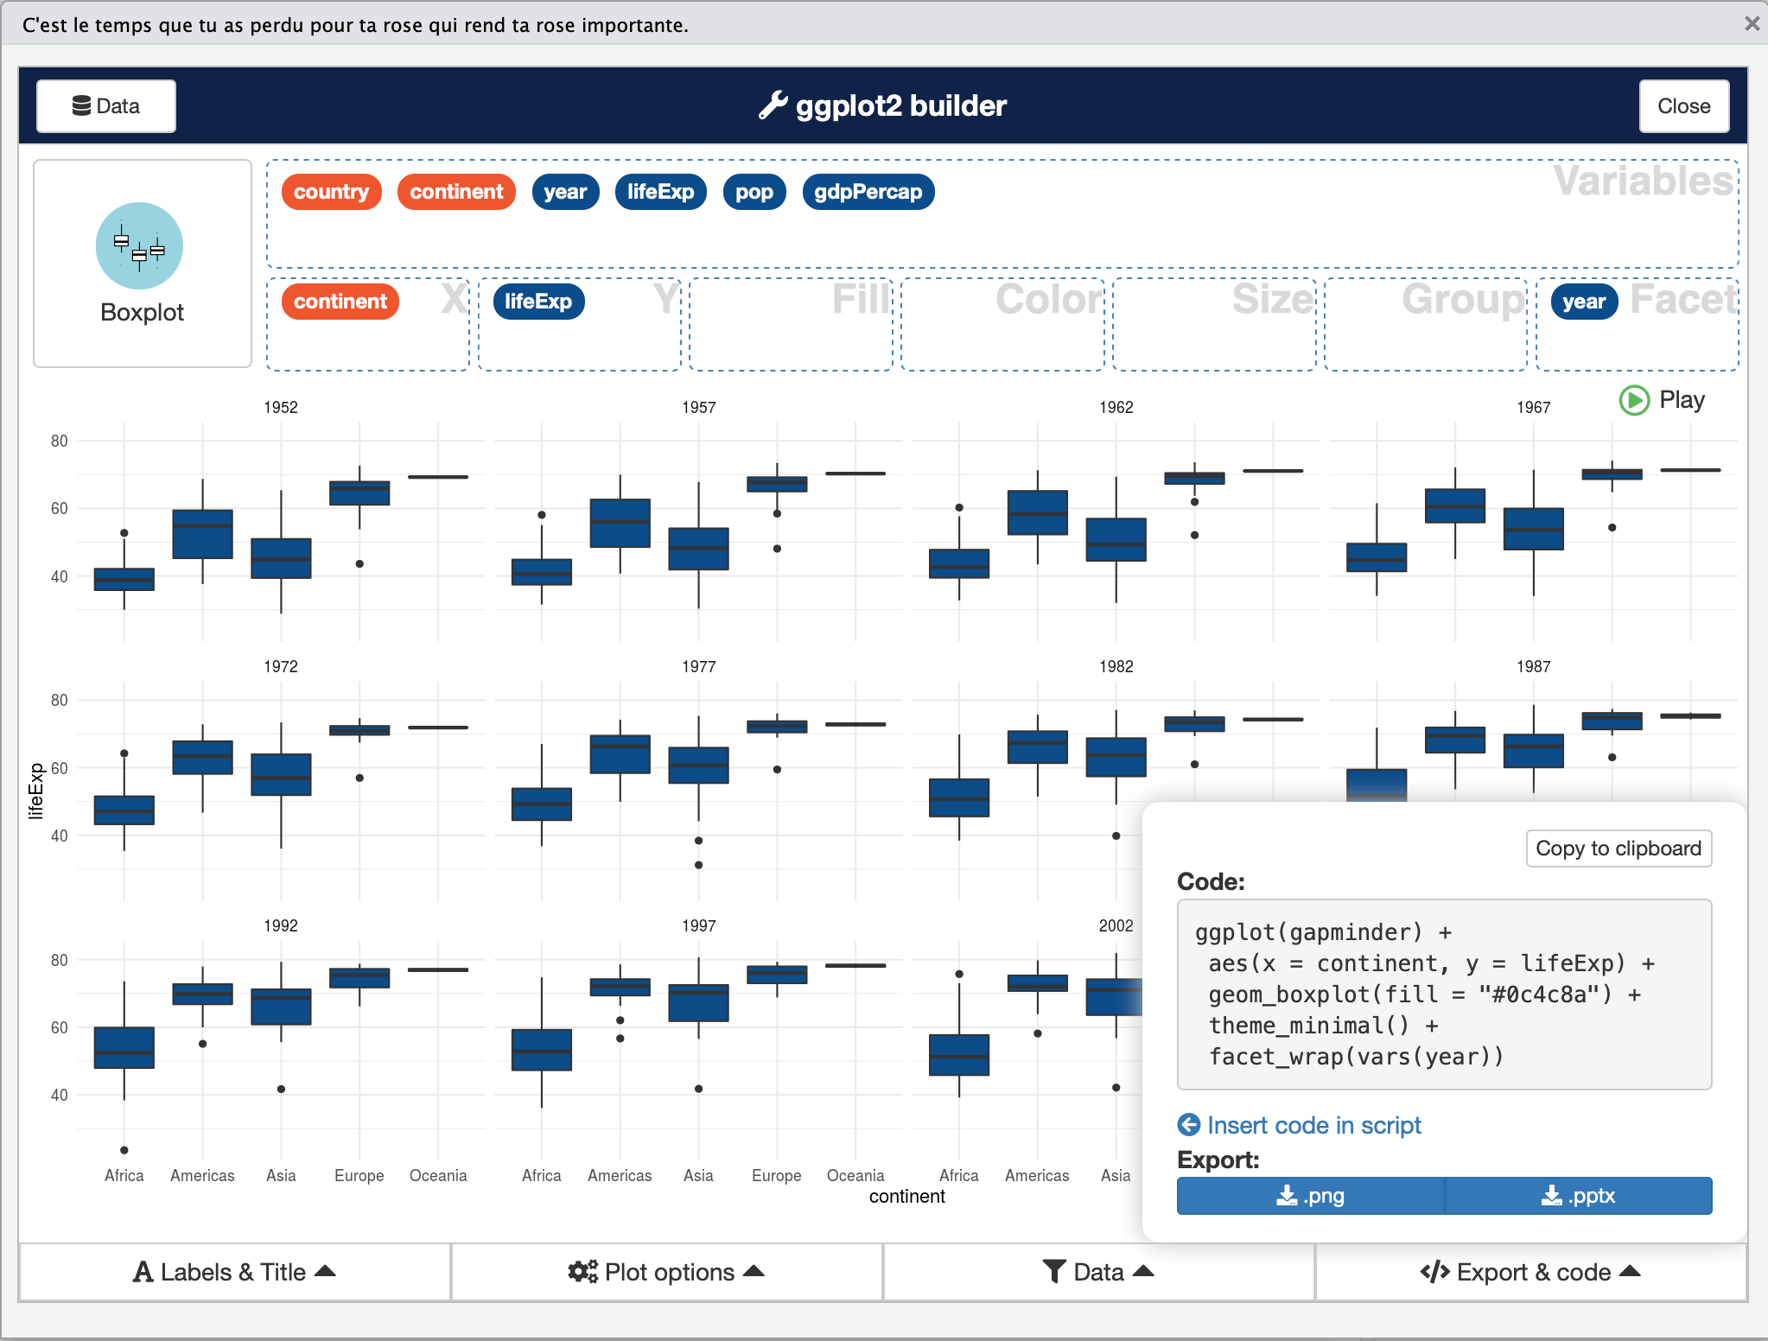

esquisse UI

The strength of esquisse is that it produces the ggplot2 code that allows the R learner to see how they can build the syntax themselves in the future. This gives students an increadible learning boost that reduces the likelyhood that they will get stuck when trying to make their first ggplot2 figures. For more information about esquisse see the project CRAN web site: <https://cran.r-project.org/web/packages/esquisse/readme/README.html>

#### ggpairs

A supplemental technique to explore data is to look at a pairs plot. The GGally package provides a powerful tool with simple syntax that provide the user with a massive amount of clearly organized information about the data. Install the library with install.packages("GGally").

A pairs plot does a good job of visualizing relationships between continuous variables or factors with a few levels. In gapminder data, there are 142 different countries. For this pairs plot, we will remove the country column for this visualization.

library(GGally)  
gapminder %>%  
 select(-country) %>%  
 ggpairs()

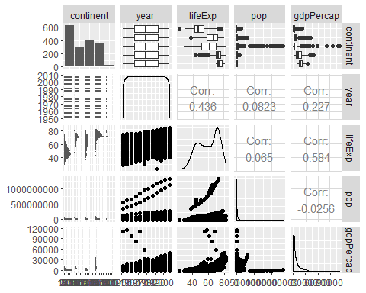

There is much to glean from the pairs plot. We see that this tool provies pairwise plot and coorelations between continuous vaiabes and histograms and boxplots between discrete and continuous variables.

Briefly, we can see that there is an increasing life expectancy and population as year increases as well as several countries that seperate themselves from the pack. An easily createable pairs plot like this can spingboard studetns into further analysis which we’ll highlight in the next section.

### Regression

One of the more common statistical tools students learn in Econometrics is Linear Regression. It happens to be one of many tools in R’s arsonel.

In the base stats package and with one additional library, R offers easy to execute and simple to understand tools to execute everything we would expect a student to learn in linear regression.

To highlight these tool, lets explore the linear relationship between several variables and life expectancy (lifeExp) in the Gapminder data.

#### Simple Linear Regression

To execute linear regression, we need to specify two arguments in the lm function: The formula and the data. As you can see in the example below, our formula is in the format y~x - pronounced y by x. As expected, the data is equal to gapminder.

model1 = lm(formula = lifeExp ~ gdpPercap, data = gapminder)

R executes this command and saves it as model1. To retrieve our simple linear regression model, we place model1 in the summary command below.

summary(model1)

##   
## Call:  
## lm(formula = lifeExp ~ gdpPercap, data = gapminder)  
##   
## Residuals:  
## Min 1Q Median 3Q Max   
## -82.754 -7.758 2.176 8.225 18.426   
##   
## Coefficients:  
## Estimate Std. Error t value Pr(>|t|)   
## (Intercept) 53.95556088 0.31499494 171.29 <0.0000000000000002 ***  
## gdpPercap 0.00076488 0.00002579 29.66 <0.0000000000000002 ***  
## ---  
## Signif. codes: 0 '***' 0.001 '**' 0.01 '*' 0.05 '.' 0.1 ' ' 1  
##   
## Residual standard error: 10.49 on 1702 degrees of freedom  
## Multiple R-squared: 0.3407, Adjusted R-squared: 0.3403   
## F-statistic: 879.6 on 1 and 1702 DF, p-value: < 0.00000000000000022

As you can see from the output, the student sees pertinent information about the model to include the equation, a small summary of the residuals, regression coefficients, P Values, and familiar model evaluation statistics such as $R^{2}$ and Adjusted $R^{2}$.

Adjusting the linear model is simple. Should we desire to add another factor to the model, we can do it simply by adding it to the formula like the example below.

model2 = lm(formula = lifeExp ~ gdpPercap + year, data = gapminder)  
summary(model2)

##   
## Call:  
## lm(formula = lifeExp ~ gdpPercap + year, data = gapminder)  
##   
## Residuals:  
## Min 1Q Median 3Q Max   
## -67.262 -6.954 1.219 7.759 19.553   
##   
## Coefficients:  
## Estimate Std. Error t value Pr(>|t|)   
## (Intercept) -418.42425945 27.61713769 -15.15 <0.0000000000000002 ***  
## gdpPercap 0.00066973 0.00002447 27.37 <0.0000000000000002 ***  
## year 0.23898275 0.01397107 17.11 <0.0000000000000002 ***  
## ---  
## Signif. codes: 0 '***' 0.001 '**' 0.01 '*' 0.05 '.' 0.1 ' ' 1  
##   
## Residual standard error: 9.694 on 1701 degrees of freedom  
## Multiple R-squared: 0.4375, Adjusted R-squared: 0.4368   
## F-statistic: 661.4 on 2 and 1701 DF, p-value: < 0.00000000000000022

Lastly, R’s linear model function is flexible enought to easily add interaction terms. Teaching using this syntax is a simple and easy to demonstrate. To add an interaction term between gdpPercap and year, we add a colin between the independent variables.

model3 = lm(formula = lifeExp ~ gdpPercap + year + gdpPercap:year, data = gapminder)  
summary(model3)

##   
## Call:  
## lm(formula = lifeExp ~ gdpPercap + year + gdpPercap:year, data = gapminder)  
##   
## Residuals:  
## Min 1Q Median 3Q Max   
## -54.234 -7.314 1.002 7.951 19.780   
##   
## Coefficients:  
## Estimate Std. Error t value Pr(>|t|)  
## (Intercept) -353.222539884 32.673833697 -10.811 < 0.0000000000000002  
## gdpPercap -0.008754192 0.002547055 -3.437 0.000602  
## year 0.206000927 0.016528783 12.463 < 0.0000000000000002  
## gdpPercap:year 0.000004754 0.000001285 3.700 0.000222  
##   
## (Intercept) ***  
## gdpPercap ***  
## year ***  
## gdpPercap:year ***  
## ---  
## Signif. codes: 0 '***' 0.001 '**' 0.01 '*' 0.05 '.' 0.1 ' ' 1  
##   
## Residual standard error: 9.658 on 1700 degrees of freedom  
## Multiple R-squared: 0.442, Adjusted R-squared: 0.441   
## F-statistic: 448.8 on 3 and 1700 DF, p-value: < 0.00000000000000022

#### Linear Regression Modeling Assumptions

One of the staples of teaching linear regression is helping students determine if their model meets the four assumptions necessary for a linear model to be valid:

1. Independent Observations
2. Normal Errors
3. Consistant Variance
4. Linear Relationships

Independent Observations:

To determine independence, we must know how the data was collected. There are likely independence issues as the data for each country in the Gapminder collection are likely influenced by each other. We’ll acknowledge this and proceed on with the other assumptions.

Other Assumptions:

To verify the other assumptions, we need to create two plots. The residual plots and a qqplot.

To create the plots, we’ll rely on the lindia[2] package that makes diagnostic plots easy. If you do not have it installed already, execute install.packages("lindia).

library(lindia)

## Warning: package 'lindia' was built under R version 3.6.1

model2 %>%  
 gg_diagnose(plot.all = TRUE, boxcox = TRUE)

## `stat_bin()` using `bins = 30`. Pick better value with `binwidth`.

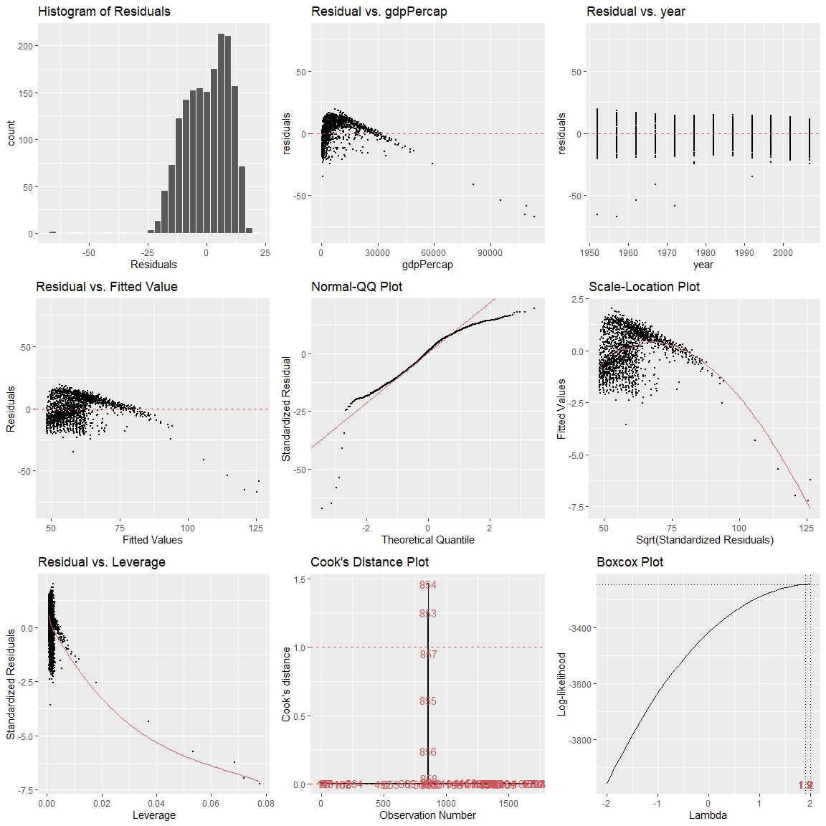

This command provides students a one stop shop for all diagnistic plots to evaluate assumption.  
Normal Errors:

From the plots, we see that our normality is slightly skewed in the positive direction and gdpPercap appears to be the culprit. The qqplot also supports this conclusion as the observed standardized residuals are more extreme than what we would expect if the residuals followed the ideal theoretical z distirubtion.

Constant Variance:

Variance of the residuals appears to remain constant at all levels of each x variable.

Linear Relationships:

The linearity assumption, however, seems to be violated at the gdpPercap and we also see evidence of this in the residuals vs fitted plot.

#### Transformations and Residual Revaluation

From our previous critique, studetns should have all the information avilable to them to make decisions about how to improve their model. To improve our analysis, we’ll apply a transformation on gdpPercap to improve linearity and normality of errors. A tranformation on the y variable is not necessary as we have no issues with constant variance and the Boxcox plot shows no value of lambda maximizes the log-liklihood of our model.

modeladj = lm(formula = lifeExp ~ log(gdpPercap) + year, data = gapminder)  
summary(modeladj)

##   
## Call:  
## lm(formula = lifeExp ~ log(gdpPercap) + year, data = gapminder)  
##   
## Residuals:  
## Min 1Q Median 3Q Max   
## -27.2291 -3.8454 0.6065 4.7737 17.8644   
##   
## Coefficients:  
## Estimate Std. Error t value Pr(>|t|)   
## (Intercept) -391.051354 19.418290 -20.14 <0.0000000000000002 ***  
## log(gdpPercap) 7.770320 0.138084 56.27 <0.0000000000000002 ***  
## year 0.195569 0.009927 19.70 <0.0000000000000002 ***  
## ---  
## Signif. codes: 0 '***' 0.001 '**' 0.01 '*' 0.05 '.' 0.1 ' ' 1  
##   
## Residual standard error: 6.877 on 1701 degrees of freedom  
## Multiple R-squared: 0.7169, Adjusted R-squared: 0.7165   
## F-statistic: 2153 on 2 and 1701 DF, p-value: < 0.00000000000000022

Since our coeficients are still significant, we will take a look at the diagnostic plots to see if our assumptions are more plausible. R makes it easy to repeat the same plots on the new model.

library(lindia)  
modeladj %>%  
 gg_diagnose(plot.all = TRUE, boxcox = TRUE)

## `stat_bin()` using `bins = 30`. Pick better value with `binwidth`.

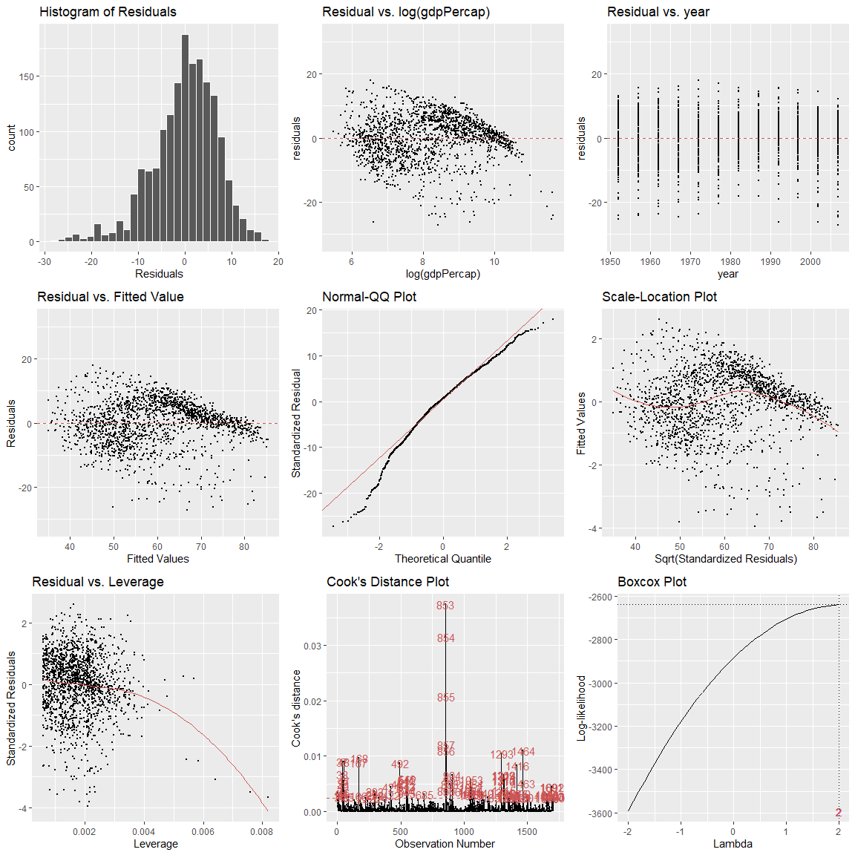

While there is more work to be done to validate this model, we can see that our transformation has improved the normality of erros and has improved the linearity of gdppercap.

R makes this analysis easy for the student as the work is easily reproducable to other models, succint in its coding and output, and visually appealing.

## Conclusion

R is awesome! You should teach with it for several reasons:

Free, easily accessable (unless you are on a government network), reproducable, relativly easy…

–>

# Bibliography

Smith, Adam, and Alan B. Krueger. “The Wealth of Nations.” Bantam Classics, 2003.

1. Smith and Krueger, “The Wealth of Nations.”
2. **???**