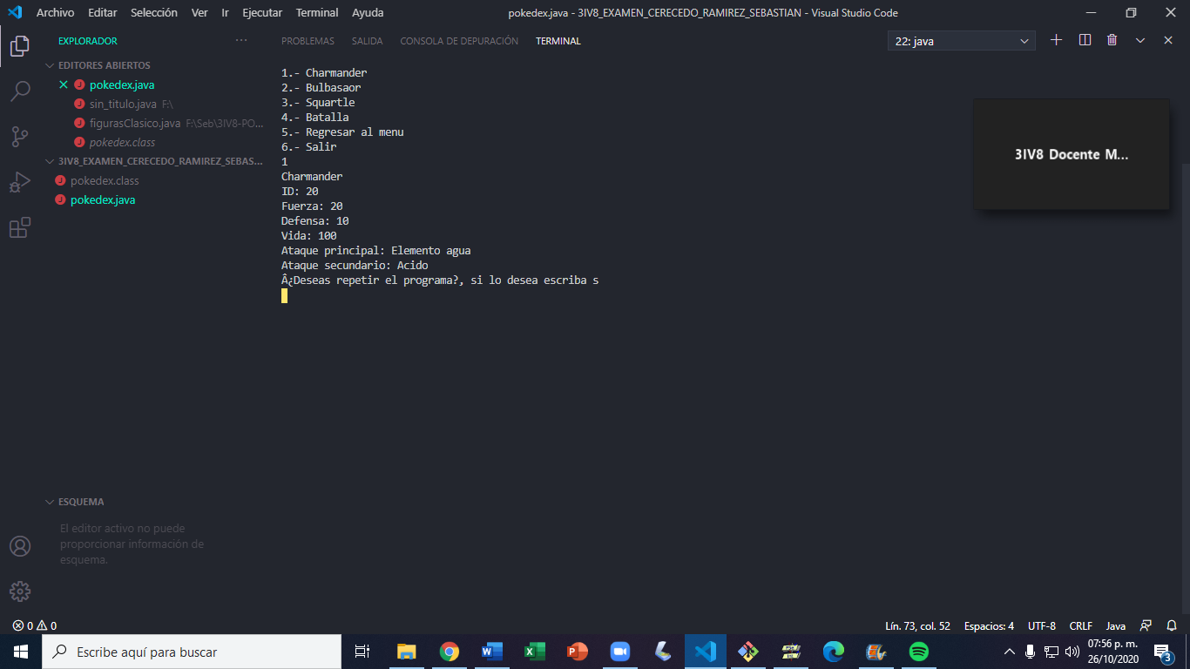

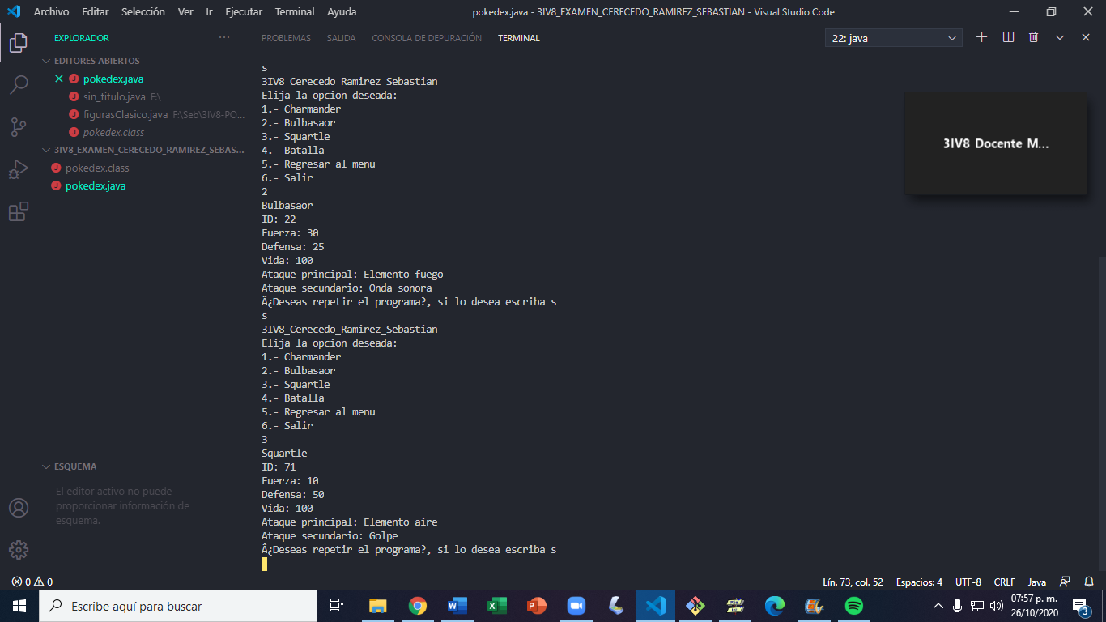

<https://github.com/CerecedoRamirezSebastian/3IV8-Cerecedo-Ramirez-Sebastian>