Assignment 5 Interactive Map

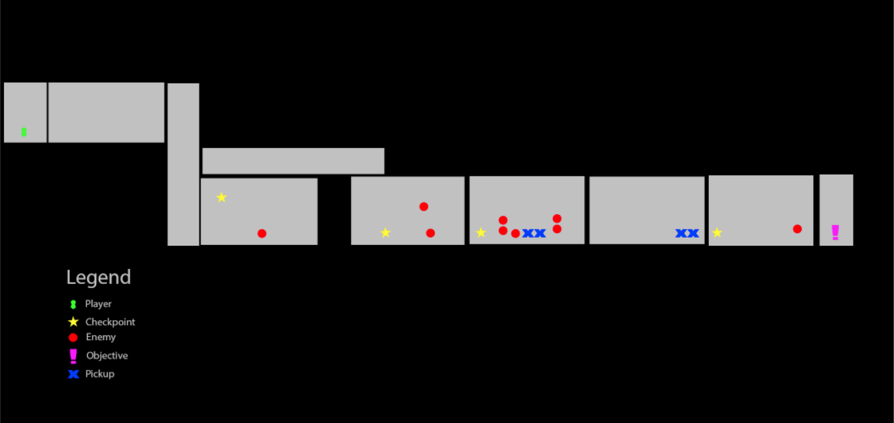

Legend

Grey square: A room

Player: Shows where the player is.

Checkpoint: Show where a respawn checkpoint is. Click on one to teleport to that location.

Enemy: Shows where enemies are

Objective: Mission goal location

Pickup: Show the location of a pickup. E.g. Ammo, Health