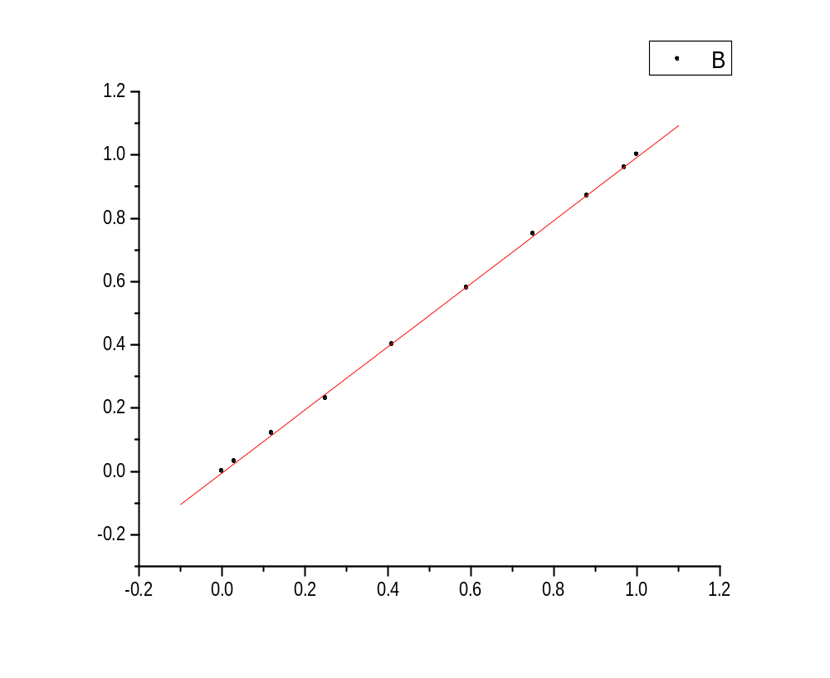
Linear Regression for Data1_B:
Y = A + B * X

Parameter Value Error
------------------------------------------------------------
A -0.00472 0.0039
B 0.99745 0.00627
------------------------------------------------------------

R SD N P
------------------------------------------------------------
0.99984 0.00734 10 <0.0001
------------------------------------------------------------

