迈克尔逊测量铜的热膨胀
一、相关术语
干涉，波长，折射率，光速，位相，虚光源，光子
二、实验原理
借助迈克尔逊干涉仪测量黄铜的热膨胀。当环境温度的改变会带来固体的长度变化，从而导致干涉仪的其中一路的光程发生变化，从而引起干涉条纹的吞吐
三、实验设备
光学平台 氦氖激光 调整支架 反射镜 干板夹 5:5的分束器 f=20mm的透镜 白屏 带测试杆的加热设备 电源 数字万用表 热电偶 数字式温度测量仪
四、设备搭建
如下图
用分离元件搭建迈克尔逊干涉仪，其中一个反射镜镜与待测的金属杆相连，当环境温度变化时，即将光程差引入光路。
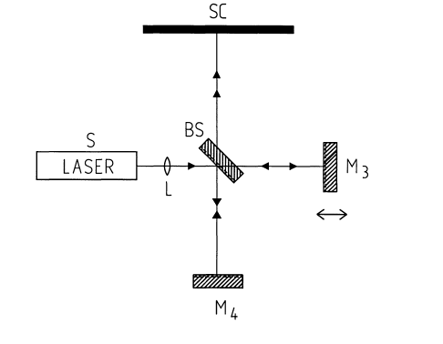
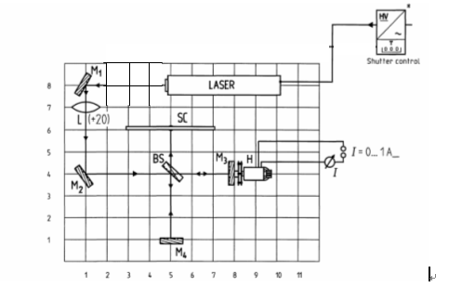

――开始时透镜L不需要放入光路中。
――使用M1和M2，调整光路，使光线沿y、x轴传播。
――中间装有黄铜杆的加热装置已固定在磁性基座中，它的一端旋上的是平面镜M3.另一端是与加热电源相连，在调整光路的过程中，不许开启加热电源，以免温度过高，对人身和仪器造成伤害。
――将加热装置放置到干涉仪的光路中。平面镜M3应与光线垂直，且反射到M2上的光点与原有的光点重合。
――放置分束镜BS，其金属面朝向M2，使一部分光沿原方向入射到镜M3，另一部分沿垂直方向入射到镜M4。
――对M4进行细调。使光屏上的光点重合。
――放置扩束镜L，在屏上应该显示出干涉环，微调M4，使干涉图样中的圆环中心位于光场的中心。
――将热电偶的探头保护套旋下，并将探头从样品的后端插入，要保证其插入到位。小心！探头受力后易变形。
――开启加热电源，调节电压，控制串入的数字万用表上所显示的电流值，保证电流值为0.8A。此时，显示样品温度在上升。
――观测热电偶的温度值，要求最高温度不超过45℃ ，然后关闭电源，停止加热，一直要等到显示的温度值呈现下降的趋势。
――当数字温度计显示一个新值时（如40℃），即可以对条纹的改变量（最大20～30）开始计数，直到另外一个温度值。记录下温度的变换范围和相应的条纹改变值。要求记录5组数据。
――实验结束后，将热电偶的探头从样品的后端移出，并旋上保护套。
三、实验原理
借助迈克尔逊干涉仪装置中的两个镜，光线被引进干涉仪。通过改变一个支路的过程，测量铜的膨胀系数。
If two Waves having the same frequency , but different amplitudes and different phases are coincident at one location , they superimpose to
The resulting can be described by the followlng : 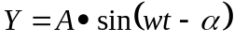
w ith the amplitude 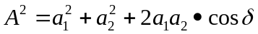 (1)
and the phase difference 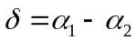
In a Michelson interferometer , the light beam is split by a half-silvered glass plate into two partial beams ( amplitude splitting ) , reflected by two mirrors , and again brought to interference behind the glass plate . Since only extensive luminous spots can exhibit circular interference frings ,the light beam is expanded between the laser and the glass plate by a lens L .
If one replaces the real mirror M3 with its virtual image M3 /, , Which is formed by reflection by the glass plate , a point P of the real light source appears as the points P/ , and P " of the virtual light sources L_{l} and L₂ · Due to the different light paths , using the designations in Fig 2
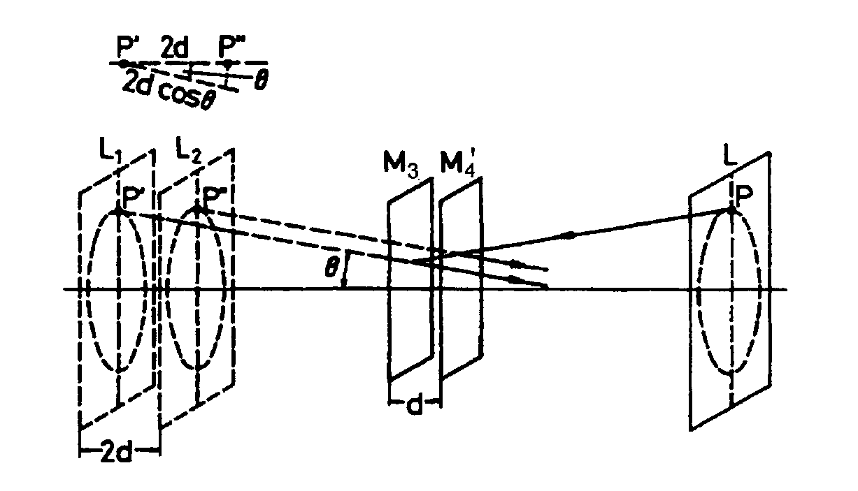
, 图 2
the phase difference is given by : 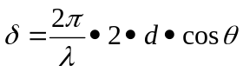 （2）
is the wavelength of the laser ljght used .
According to ( 1 ) , the intensity distribution for 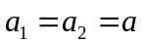 is
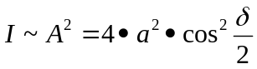 (3)
Maxima thus occur when is equal to a multiple of ,hence with ( 2 )
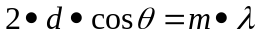；m=1，2，….. ( 4 )
i. e . there are circular fringes for selected , fixed values of m , and d , since remains constant. If one alters the position of the movable mirror M₃ , such that d,,for example ,decreases , according to ( 4 ) , since m is indeed constant for this ring .Thus ,a ring disappears each time d is reduced by 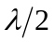. For d = 0 the circular fringe pattern disappears . If the surfaces of mirrors M₄ and M₃ are not parallel in the sense of Fig . 2, one obtains curved fringes , which gradually change into straight fringes at d = 0 .
固体的纵向热膨胀
If one change the temperature of a solid body uniformly,the volume Vchanges .this behaviour is normally described by a thermal equation of state:
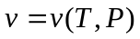
where 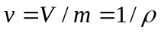 is the specific volume,m the Masse and 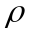the density of the material. The specific volume v is thus a function of the temperature T and the pressure p.Since the specific volume of solid bodies only changes slightly with temperature and pressure,it is sufficient to consider the series expansion of the thermal equation of state only up to its linear member:
(5)
In this context the coefficients are given by :
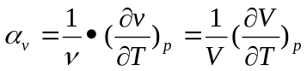
for the coefficient of thermal expansion and
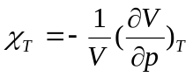
for the isothermal compressibility.
The thermal expandion can be considered as follows:
As the consequence of a uniform temperature change of a sphere of radius
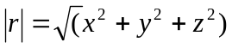
will generally anisotropically deform into an ellipsoid . In the pross the co-ordinates on a point(x,y,z) transform to (x+dx,y+dy,z+dz) in accordance with
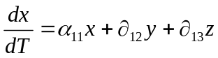
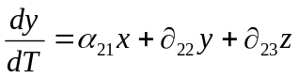
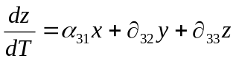
with 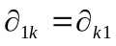;k=1,2,3 and i=1,2,3
In vectorial notation ,the following linear relationship is true:
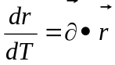
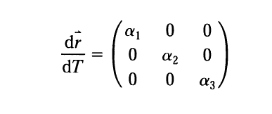
where is a symmetrical tensor of the second degree .In the selection of the main dilatation axes,one obtains the following as co-ordinate axes:

In cubic lattice structures of crystals the tensor becomes a scalar quantity .
To measure the diffra,ction n of air , an air-filled cell with plane- parallel boundaries is used . The diffraction index n of a gas is a linear function of the pressure P . For pressure P = 0 an absolute vacuum exists so that n=1.
四、数据记录及处理
将干涉条纹的变换量和温度的初始值记录在表格中。
T₀(℃ ) | T₁(℃) | 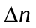 | (K⁻¹)
黄铜样品的初始程度 l₀=5cm
长度的改变量：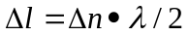
热膨胀系数： 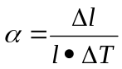 其中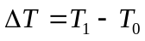 参考值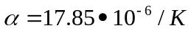
五、思考题

