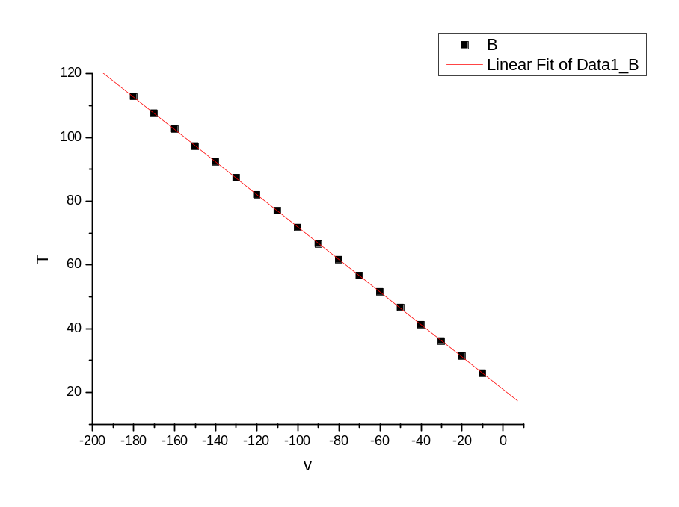
[2008-10-7 22:14 "/Graph1" (2454746)]
Linear Regression for Data1_B:
Y = A + B * X

Parameter Value Error
------------------------------------------------------------
A 20.88627 0.06085
B -0.50997 5.62128E-4
------------------------------------------------------------

R SD N P
------------------------------------------------------------
-0.99999 0.12373 18 <0.0001
------------------------------------------------------------
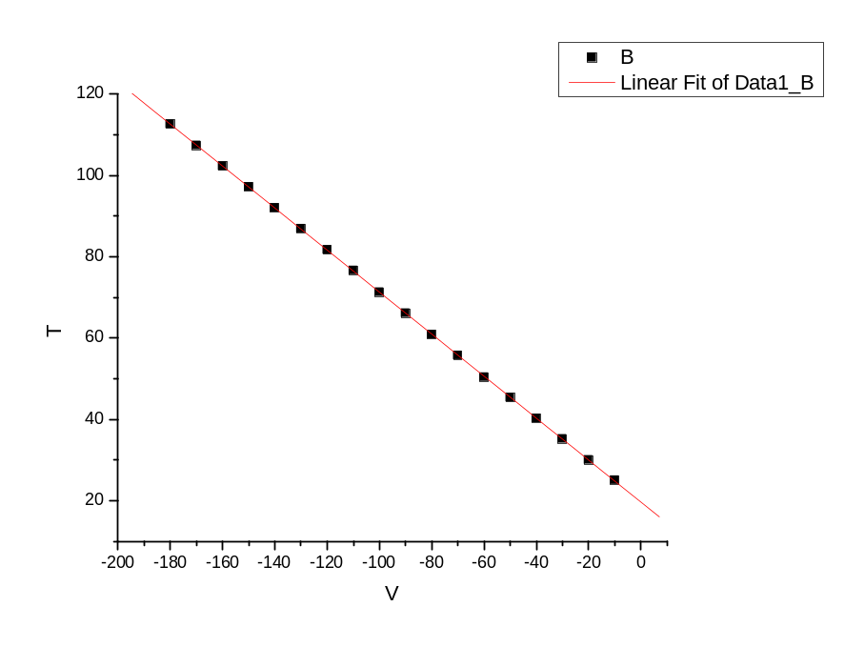
[2008-10-7 22:23 "/Graph1" (2454746)]
Linear Regression for Data1_B:
Y = A + B * X

Parameter Value Error
------------------------------------------------------------
A 19.6085 0.05724
B -0.51681 5.28797E-4
------------------------------------------------------------

R SD N P
------------------------------------------------------------
-0.99999 0.1164 18 <0.0001
------------------------------------------------------------

