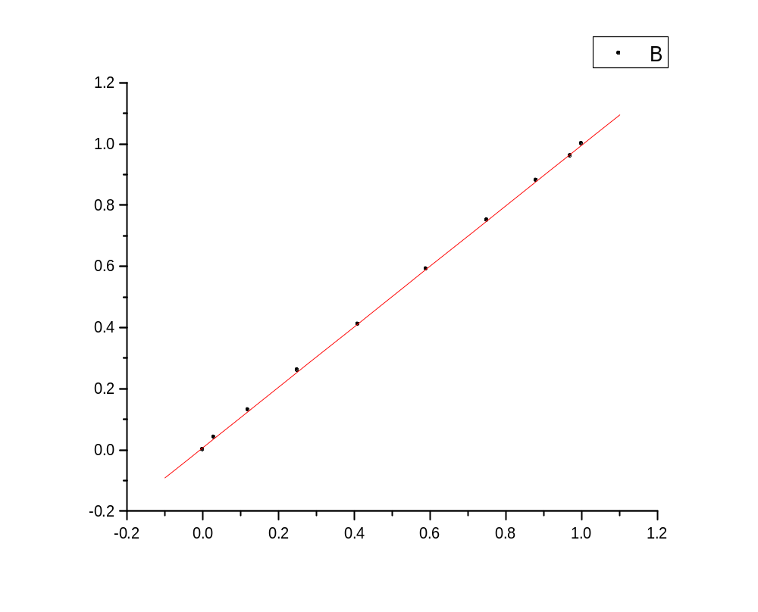
Linear Regression for Data1_B:
Y = A + B * X

Parameter Value Error
------------------------------------------------------------
A 0.00772 0.00252
B 0.98856 0.00405
------------------------------------------------------------

R SD N P
------------------------------------------------------------
0.99993 0.00475 10 <0.0001
------------------------------------------------------------

