用迈克尔逊干涉仪空气的折射率
PB07210137 昝涛
一、实验目的
用分离的光学元件构建一个迈克尔逊干涉仪。
通过降低空气的压强测量其折射率。
二、仪器和光学元件
光学平台；HeNe激光；调整架，35x35mm；平面镜，30x30mm；磁性基座；分束器50:50；透镜，f=+20mm；白屏；玻璃容器，手持气压泵，组合夹具，T形连接，适配器，软管，硅管
三、实验原理
借助迈克尔逊干涉仪装置中的两个镜，光线被引进干涉仪。通过改变光路中容器内气体的压强，推算出空气的折射率。
If two Waves having the same frequency , but different amplitudes and different phases are coincident at one location , they superimpose to
The resulting can be described by the followlng : 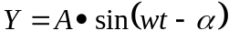
w ith the amplitude 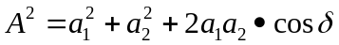 (1)
and the phase difference 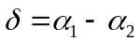
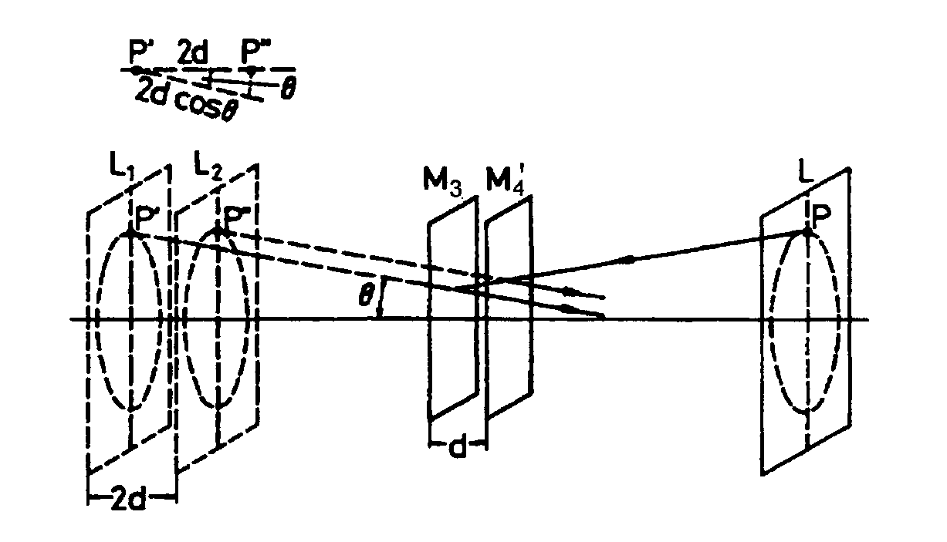
In a Michelson interferometer , the light beam is split by a half-silvered glass plate into two partial beams ( amplitude splitting ) , reflected by two mirrors , and again brought to interference behind the glass plate . Since only large luminous spots can exhibit circular interference fringes , the Iight beam is expanded between the laser and the glass plate by a lens L .
If one replaces the real mirror M3 with its virtual image M3 /, , Which is formed by reflection by the glass plate , a point P of the real light source appears as the points P/ , and P " of the virtual light sources L_{l} and L₂ · Due to the different light paths , using the designations in Fig . 2 , 图 2
the phase difference is given by : 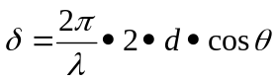 （2）
is the wavelength of the laser ljght used .
According to ( 1 ) , the intensity distribution for 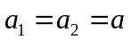 is
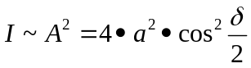 (3)
Maxima thus occur when is equal to a multiple of ,hence with ( 2 )
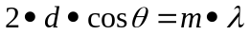；m=1，2，….. ( 4 )
i. e . there are circular fringes for selected , fixed values of m , and d , since remains constant ( see Fig . 3 ) . If one alters the position of the movable mirror M₃ ( cf.Fig.1 ) such that d,e.g.,decreases , according to ( 4 ) , the ciroular fringe diameter would also diminish since m is indeed defined for this ring . Thus , a ring disappears each time d is reduced by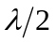. For d = 0 the ciroular fringe pattern disappears . If the surfaces of mirrors M₄ and M₃ are not parallel in the sense of Fig . 2, one obtains curved fringes , which gradually change into straight fringes at d = 0 .
空气衍射系数的确定
To measure the diffraction n of air , an air-filled cell with plane- parallel boundaries is used . The diffraction index n of a gas is a linear function of the pressure P . For pressure P = 0 an absolute vacuum exists so that n=1.
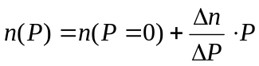 (5)
From the measured date ,the difference quotient 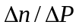 is f irst determined :
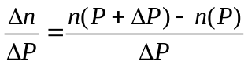 (6)
The following is true for the optical path length d : d = 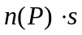 (7)
Where s = 2·l is the geometric length of the evacuated cell and n ( P ) is the diffraction index of the gas present in the chamber . l is the lenght of the gas column in the glass cell . The fact that the path is traversed twice due to the reflect- ion on the mirror M4 is to be taken into consideration. Thus , by varying the pressure in the cell by the value △P , the optical path length is altered by the quantity △d :
△d = n ( P＋△P）·s 一 n ( P ）·s ( 8 )
on the screen one observes the change in the circular fringe pattern with change in the pressure ( the centre of the interference fringe pattern alternately shows maximal and minimal intensity ) . Proceeding from the ambient pressure Po,one observes the N-fold resetting of the initial position of the interference pattern (i.e. , establishment of an intensity minimum in the ring’s centre ) until a specific pressure value P has been reached . A change from minimum to minimum corresponds to a change of the optical path length by the wavelength ．Between the pressures P and P＋ △P the optical wavelength thus changes by
△d = ( N ( P＋△P）一N ( P )）·入 ( 9 )
From (8) and (9) and under consideration of the fact that the cell is traversed twice by the light (s=2·l) , it follows :
n ( P＋△P）一n ( P)=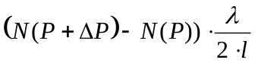 (10)
and with(6) and 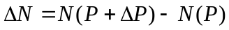 the following results : 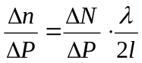
四、实验步骤
- 装置建立和调整：
注：下文括号中的数字表示的坐标仅适用于开始阶段的粗调。
a)参照图1摆放元件，使用调整镜M1(1,8)和镜M2(1,4)调整光路时，光线要沿着平台上的直线延伸。
b) 最初不需要放置分束器BS,光线直射M3（9,4）, 被M3反射后的光线能够和M2上初始光点重合。然后放置分束器在(6,4)，BS的镀膜面朝向镜M2，这样一部分的光仍然可无阻碍的到达M3，另外的光射到M4(6,1)。
d)现在屏SC(6,6)上出现两个光点，调整M4使它们重合，此时观测到的应是一个轻微抖动的亮点。放置透镜L在(1,7)，屏上出现干涉条纹，细调M4能够使干涉图象为一组同心圆环。
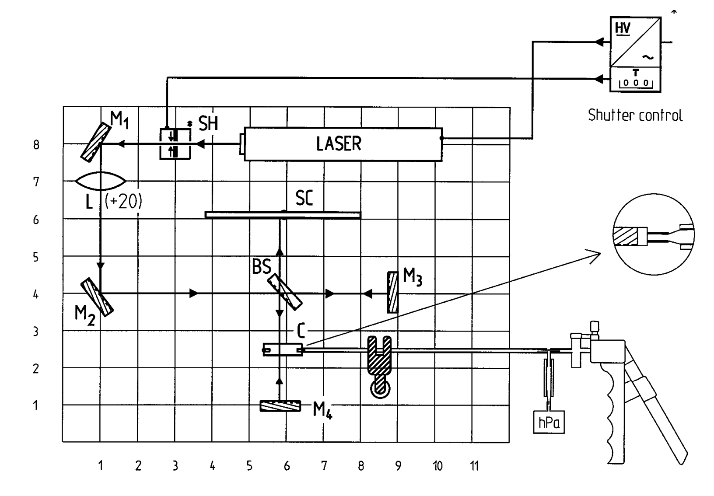
图 1
2、实验
a)将容器c放置在（6,2.5）处，且其前后表面要和M4及BS间的光线传播方向垂直，容器的前后表面请不要用手接触，以保持表面光洁。
b)手持压力泵与软管相连，通过夹具固定在磁性基座(8.5,1.5)上，接到容器c的一个开口处，c的另一个开口端已封闭。
c)使用压力泵改变容器内的压强，当压力计的示数达到一个稳定值后，将压力计静置在一边（避免外界干扰），此时干涉圆环将逐渐吞缩，直至压力计的读数为0，在表格中记录下圆环的吞缩个数（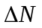）和相应的压强改变值（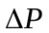）。
d)继续改变容器内的压强，记录干涉圆环的变化数量和相应的压强值，要求记录至少五组。计算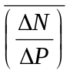。
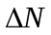 | 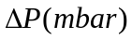 | 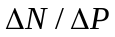
e）由公式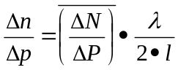 和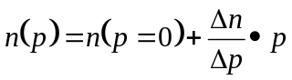推算P下的空气折射率，并算其误差。其中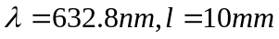，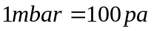,在一个标准大气压下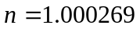
五、数据处理：

1 | 130 | 7.692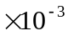
3 | 390 | 7.692
3 | 388 | 7.732
4 | 470 | 8.511
4 | 485 | 8.247

中令p=1.013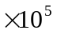pa=1.013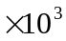mbar得
误差(|1.000256-1.000264|/1.22256)*100%=-8.0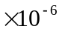
六、思考题
- 影响气体折射率的因素有那些？
答：影响气体折射率的因素主要有：温度，湿度，压强，气体组成成分。

