

DEPARTMENT OF INFORMATION AND COMMUNICATION TECHNOLOGY
Project Title: Machine Learning Based Farmer Harvest Prediction System in Bugesera District, Rwanda

Submitted in Partial Fulfillment of the Requirements for the Grade of Bachelor of Technology in Information Communication Technology at RP Huye College

Prepared by: Supervised by:
UWIMPUHWE Cesalie Mrs. Marie MUTONI
Reg. Number: 25RP21043 Co-supervised by:
.............................................

HUYE, 2026

DEPARTMENT OF INFORMATION COMMUNICATION TECHNOLOGY
DECLARATION (A)
I hereby declare that this project, titled “Machine Learning Based Farmer Harvest Prediction System In Bugesera District, Rwanda,” submitted in partial fulfillment of the requirements for the Bachelor of Technology in Information Communication Technology at RP Huye College, is my original work and has not been submitted, either in part or in full, for any other academic degree, diploma, or certification at any institution. A complete list of references is provided to acknowledge all sources of information used or cited in this work. This research adheres to institutional and ethical guidelines, including those related to data privacy, responsible system development, and academic integrity.
Signature: ................................

Name: UWIMPUHWE Cesalie
Reg No: 25RP21043

Place: RP Huye College, Rwanda
Date: …. /…. / 2026

DECLARATION(B)
This is to certify that the project titled “Machine Learning Based Farmer Harvest Prediction System In Bugesera District, Rwanda” has been reviewed and approved for submission by RP-Huye College. The project was conducted under the supervision of Mrs. Marie MUTONI (Supervisor). It meets the academic standards and requirements for the Bachelor of Technology in Information Communication Technology program. It has been evaluated for its originality, methodological soundness, and relevance to the field, and is considered suitable for academic recognition.

Project Supervisor  Names: Mrs. Marie MUTONI | Signature ……………………………  DATE ……. / …….. / 2026

Co-Supervisor  Names: ……………………. | Signature ……………………………  DATE ……. / …….. / 2026

CERTIFICATE OF COMPLETION
This is to certify that Cesalie UWIMPUHWE, student at Rwanda Polytechnic Huye College in Information Communication Technology Department, have been completed Capstone Project entitled “Machine Learning Based Farmer Harvest Prediction System in Bugesera District, Rwanda “in Partial Fulfilment of the Requirements for the Award of Bachelor of Technology in Information Technology during Academic 2025-2026.

Supervisor Head of Department
Mrs. Marie MUTONI NDIZEYE Patrick
Date……/ ……… / 2026 Date……/ ………. / 2026
Signature…………….... Signature…………………

AUTHORITY TO DEPOSIT THE CORRECTED VERSION OF THE PROJECT TO THE LIBRARY

We, the undersigned, hereby testify that we have verified the corrections made by the student, UWIMPUHWE Cesalie, to her project entitled “Machine Learning Based Farmer Harvest Prediction System in Bugesera District, Rwanda” and authorize her to deposit the document in the library of the Integrated Polytechnic Regional College Huye.

MEMBERS OF THE PANEL
Co-Evaluator | Principal Evaluator
Names and Signature | Names and Signature
…………………………………… | ……………………………………
Date……/2026 | Date……/2026
Signature…………… | Signature……………

DEDICATION

I dedicate this work to the Almighty God for His guidance, strength, and protection throughout my academic journey.

I also extend my sincere gratitude to the Head of Department, all lecturers, and support staff of the ICT Department at RP Huye College for their tireless efforts, knowledge, and support in shaping me into the person I am today. Special appreciation goes to my supervisor for the continuous guidance, encouragement, and motivation provided throughout the development of this project.

Furthermore, I wholeheartedly dedicate this work to my beloved parents, relatives, brothers, and sisters for their endless love, prayers, and encouragement during my studies.

Finally, this work is dedicated to all farmers in Bugesera District who face daily challenges in feeding their families and communities. I hope this project will contribute positively toward improving agricultural productivity and decision-making.

ACKNOWLEDGEMENT
I deeply thank God for His guidance throughout the whole period of my studies, especially during the period of concentrating on project work here at RP Huye College. His grace and wisdom have been the foundation of every step I have taken.
I am very grateful to the Head of Department and all lecturers for their kindness and support throughout the two semesters I studied here at RP Huye College. Their academic guidance has shaped my knowledge and professional competence.
I would also like to express my deepest gratitude to my supervisor Mrs. Marie MUTTONI for their guidance, constant attention, valuable suggestions, enthusiastic support, and personal concern during the project. Their mentorship has been instrumental in the successful completion of this work.
Special appreciation goes to my lovely parents who brought me this far and have always been by my side, supporting me through my ups and downs, as well as encouraging me to pursue my dreams. I say a big thank you to all of them.
I also acknowledge the farmers of Bugesera District who generously shared their farming experiences and knowledge, contributing to the development of a system that aims to improve their livelihoods. Their insights were invaluable to this research.

ABSTRACT
This project presents the design and implementation of a Machine Learning Based Farmer Harvest Prediction System for Bugesera District in Rwanda. Agriculture is the backbone of Rwanda's economy, supporting over 70% of the population and contributing approximately 24% of the national income. However, farmers in Bugesera District face critical challenges including irregular rainfall, high temperatures, sandy-clay soil, and a lack of reliable tools to forecast crop yields, making agricultural planning extremely difficult.
The proposed system leverages machine learning algorithms specifically Random Forest, Gradient Boosting, and Linear Regression to predict crop yields in kilograms per are (kg/are) based on historical agricultural data, weather patterns, soil characteristics, and farming practices. The Random Forest model achieved the best performance with an R² score of 84.8%, indicating high predictive accuracy. The system processes 36 input features including engineered variables such as Fertilizer Score, Irrigation Score, Soil pH Optimality, Rain Adequacy, and Season indicators.
A web-based platform was developed to make the prediction system accessible to farmers and agricultural officers. The platform includes a farmer dashboard for entering farm data and receiving harvest predictions, an agricultural officer dashboard for monitoring district-wide statistics, a bilingual interface supporting both English and Kinyarwanda, and a MySQL database for persistent storage of predictions and user data. The system was tested using unit testing, integration testing, and acceptance testing, all yielding satisfactory results.
By providing reliable harvest predictions, the system enables farmers to make informed decisions on planting schedules, resource allocation, fertilizer use, and financial planning. It also supports agricultural officers in monitoring crop performance across sectors, identifying low-yield areas, and providing targeted advice. This innovation contributes to food security, improved farmer incomes, and sustainable agricultural development in Bugesera District.

TABLE OF CONTENTS
DEDICATION 1
ACKNOWLEDGEMENT 1
ABSTRACT 1
TABLE OF CONTENTS 1
LIST OF SYMBOLS AND ABBREVIATIONS/ACRONYMS 1
LIST OF TABLES 1
LIST OF FIGURES AND PHOTOGRAPHS 1
CHAPTER 1: GENERAL INTRODUCTION 1
1.0 INTRODUCTION 1
1.1 BACKGROUND OF THE STUDY 1
1.2 PROBLEM STATEMENT 1
1.3 RESEARCH QUESTIONS 1
1.4 OBJECTIVE OF THE STUDY 1
1.4.1 General Objective 1
1.4.2 Specific Objectives 1
1.5 HYPOTHESIS OF THE STUDY 1
1.6 SCOPE OF THE PROJECT 1
1.6.1 Geographical Scope 1
1.6.2 Content Scope 1
1
1.7 SIGNIFICANCE OF THE STUDY 1
1.7.1 Public Interest 1
1.7.2 Personal Interest 1
1.8 ORGANIZATION OF THE STUDY 1
CHAPTER 2: LITERATURE REVIEW 1
2.0 INTRODUCTION 1
2.1 DEFINITION OF KEY CONCEPTS 1
2.1.1 Machine Learning 1
2.1.2 Crop Yield Prediction 1
2.1.3 Random Forest Algorithm 1
2.1.4 Gradient Boosting 1
2.1.5 Linear Regression 1
2.1.6 Web Application 1
2.1.7 Database Management System (MySQL) 1
2.1.8 Flask Framework 1
2.1.9 React Framework 1
2.2 RELATED STUDIES 1
2.2.1 Machine Learning for Crop Yield Prediction 1
2.2.2 Agricultural Technology in Rwanda and East Africa 1
2.2.3 Precision Agriculture and Smallholder Farming 1
2.3 TOOLS AND TECHNOLOGIES 1
2.3.1 Python and Scikit-learn 1
2.3.2 React 1
2.3.3 Flask 1
2.3.4 MySQL 1
2.3.5 XAMPP 1
2.3.6 Vite 1
CHAPTER 3: SYSTEM ANALYSIS AND DESIGN 1
3.0 INTRODUCTION 1
3.1 DATA AND INFORMATION COLLECTION TECHNIQUES 1
3.1.1 Observation 1
3.1.2 Interview 1
3.1.3 Document Analysis 1
3.2 SOFTWARE DEVELOPMENT PROCESS MODEL 1
3.2.1 Prototyping Model 1
3.2.2 Reasons for Choosing Prototyping 1
3.2.3 Steps of the Prototyping Model 1
3.3 EXISTING SYSTEM 1
3.4 NEW SYSTEM 1
3.5 ANALYSIS AND DESIGN OF THE NEW SYSTEM 1
3.5.1 Use Case Diagram 1
3.5.2 Activity Diagrams 1
3.5.3 Sequence Diagram 1
3.5.4 Class Diagram / Database Schema 1
3.6 DATA DICTIONARY 1
CHAPTER 4: SYSTEM IMPLEMENTATION 1
4.0 INTRODUCTION 1
4.1 REQUIREMENTS 1
4.1.1 Hardware Requirements 1
4.1.2 Software Requirements 1
4.2 MACHINE LEARNING MODEL DEVELOPMENT 1
4.3 SYSTEM INTERFACES 1
4.3.1 Login Screen 1
4.3.2 Farmer Dashboard 1
4.3.3 Prediction Form 1
4.3.4 Prediction Result Screen 1
4.3.5 Prediction History Screen 1
4.3.6 Agricultural Officer Dashboard 1
4.4 TESTING 1
4.4.1 Introduction 1
4.4.2 Objective of Testing 1
4.4.3 Unit Testing Outputs 1
4.4.4 Validation Testing 1
4.4.5 Integration Testing 1
4.4.6 Acceptance Testing 1
CHAPTER 5: CONCLUSION AND RECOMMENDATION 1
5.1 GENERAL CONCLUSION 1
5.2 RECOMMENDATIONS 1
REFERENCES 1
APPENDICES 1
APPENDIX 1: WORK PLAN 1
APPENDIX 2: GANTT CHART 1
APPENDIX 3: BUDGET PLAN 1

LIST OF SYMBOLS AND ABBREVIATIONS/ACRONYMS
Abbreviation | Full Meaning
API | Application Programming Interface
CSV | Comma-Separated Values
DB | Database
DBMS | Database Management System
GB | Gradient Boosting
HTML | Hypertext Markup Language
ICT | Information and Communication Technology
IDE | Integrated Development Environment
IPRC | Integrated Polytechnic Regional College
JSON | JavaScript Object Notation
kg/are | Kilograms per Are
LR | Linear Regression
ML | Machine Learning
MySQL | My Structured Query Language
NISR | National Institute of Statistics of Rwanda
OS | Operating System
R² | R-Squared (Coefficient of Determination)
RF | Random Forest
RMSE | Root Mean Squared Error
RP | Rwanda Polytechnic
SQL | Structured Query Language
UI | User Interface
WWW | World Wide Web
XAMPP | Cross-platform Apache, MySQL, PHP, Perl

DEFINITION OF KEY TERMS
- Machine Learning (ML): A branch of artificial intelligence where systems learn from data and improve their performance without being explicitly programmed. In this project, ML is used to analyze historical agricultural data and predict crop yields based on input features such as soil type, rainfall, fertilizer use, and farming practices.
- Harvest Prediction: The use of data-driven techniques to estimate the expected quantity of crop yield before or during the growing season. In this system, predictions are expressed in kilograms per are (kg/are) for beans, maize, and rice grown in Bugesera District.
- Random Forest: An ensemble machine learning algorithm that builds multiple decision trees during training and outputs the average prediction of all trees. In this project, Random Forest achieved the best prediction accuracy with an R² score of 84.8%.
- Gradient Boosting: An ensemble machine learning method that sequentially builds models where each model corrects the errors of the previous one. It is effective at capturing complex non-linear relationships in agricultural data.
- Linear Regression: A supervised machine learning algorithm used to model the linear relationship between input features and a continuous output variable. In this project, it serves as a baseline model for comparison against ensemble methods.
- Smallholder Farmer: A farmer who cultivates a small plot of land, typically less than two hectares, primarily for subsistence and limited commercial sale. The majority of farmers in Bugesera District are smallholder farmers who are the primary beneficiaries of this system.
- Web Application: A software application that runs on a web server and is accessed by users through a web browser over the internet. This project delivers the harvest prediction system as a bilingual (English and Kinyarwanda) web application accessible to farmers and agricultural officers.

LIST OF TABLES
Table 1: Data Dictionary for Users Table
Table 2: Data Dictionary for Farmers Table
Table 3: Data Dictionary for Predictions Table
Table 4: Data Dictionary for Officers Table
Table 5: Data Dictionary for Sectors Table
Table 6: Unit Testing Outputs
Table 7: Model Performance Comparison
Table 8: Work Plan
Table 9: Gantt Chart
Table 10: Budget Summary

LIST OF FIGURES AND PHOTOGRAPHS
Figure 1: Steps of the Prototyping Model
Figure 2: Use Case Diagram
Figure 3: Symbols of Activity Diagram
Figure 4: Activity Diagram Farmer
Figure 5: Activity Diagram Agricultural Officer
Figure 6: Sequence Diagram
Figure 7: Class Diagram / Database Schema
Figure 8: System Architecture Diagram
Figure 9: Login Page
Figure 10: Farmer Dashboard
Figure 11: Prediction Form
Figure 12: Prediction Result Screen
Figure 13: Prediction History
Figure 14: Officer Dashboard
Figure 15: Profile Screen

CHAPTER 1: GENERAL INTRODUCTION

1.0 Introduction
Today, technology is rapidly becoming a common tool to resolve many societal problems and to simplify how tasks and processes are performed within different sectors all over the world. Governments, particularly in developing nations, have invested significantly in ICT infrastructure to support digital transformation across all sectors of production. Despite these advancements, the agricultural sector particularly in rural areas of Rwanda still operates largely on intuition, tradition, and informal knowledge, without access to modern data-driven tools.
Agriculture is the backbone of Rwanda's economy, contributing approximately 24% of the national income and supporting over 70% of the population. In Bugesera District, located in the Eastern Province, farming is the primary source of livelihood for a large proportion of families. Farmers mainly grow beans, maize, and rice during two main seasons: Season A (September to January) and Season B (February to June). Despite the centrality of farming to the local economy, farmers face persistent challenges in predicting how much their crops will yield, making it difficult to plan effectively for food security, market sales, and resource allocation.
To address this challenge, this project proposes the design and implementation of a Machine Learning Based Farmer Harvest Prediction System for Bugesera District. By training machine learning models on historical agricultural, weather, soil, and farming practice data, the system can predict crop yields with high accuracy, enabling farmers to make smarter, more informed decisions about their farming activities.

1.1 Background of The Study
Bugesera District is situated in the Eastern Province of Rwanda and is characterized by a semi-arid climate with low and irregular rainfall, high temperatures, and sandy-clay soil that retains moisture poorly. These environmental conditions make agriculture particularly challenging and unpredictable. Historically, farmers in this region have relied on experience, observation, and community knowledge to estimate expected harvests a process that is highly subjective and often inaccurate.
The lack of reliable harvest prediction tools has had cascading consequences. Farmers are unable to accurately plan their use of seeds, fertilizers, and Labor, often leading to resource wastage or shortages. Without reliable yield forecasts, access to agricultural credit and market contracts is limited since financial institutions and buyers require production guarantees. Food insecurity is exacerbated when unexpected crop failures occur without any early warning.
Global advances in machine learning and data science have opened new possibilities for precision agriculture. Countries such as India, Kenya, and Brazil have demonstrated that ML-based crop prediction systems can dramatically improve agricultural planning and farmer incomes [1], [2]. Rwanda, through its Smart Rwanda Master Plan and National Agricultural Policy, has identified ICT-driven agricultural innovation as a priority for achieving food security and economic development [3].
This project is inspired by these global developments and responds to the specific needs of Bugesera District. By leveraging historical data from the National Institute of Statistics of Rwanda (NISR) [4] and weather data from Meteo Rwanda, alongside machine learning algorithms, this system provides farmers and agricultural officers with reliable, actionable harvest predictions.

1.2 Problem Statement

Farmers in Bugesera District mainly rely on personal experience, seasons, and advice from others to estimate their harvest, but this method is not scientific and often leads to problems. Because they cannot accurately predict how much they will produce, it becomes difficult to plan for food storage, selling crops, or buying farm inputs, and poor harvests can cause food shortages and financial challenges. Farmers also misuse resources like fertilizer, seeds, and water because they do not know the expected yield, which reduces productivity and profits. In addition, many farmers fail to access loans since banks require reliable production forecasts that they cannot provide. Poor harvest predictions also affect market planning, leading to unstable prices and food waste. Furthermore, agricultural officers lack a central system to monitor crop performance across the district, making it hard to identify areas needing support. Therefore, Bugesera District needs a technology-based harvest prediction system that uses historical data and machine learning to provide accurate and reliable crop yield information for better decision-making.

1.3 Research Questions
This research addresses the following key questions:
1. What are the most significant factors (soil type, rainfall, fertilizer use, and farming practices) that influence crop yields in Bugesera District?
2. Which machine learning algorithms are most effective for predicting crop harvest yields in Bugesera District?
3. How can a web-based harvest prediction system be designed to be accessible, bilingual, and usable by smallholder farmers with limited technical knowledge?
4. To what extent does integrating machine learning-based harvest predictions improve farmers’ decision-making in planting schedules, resource allocation, and financial planning?
5. How can the system support agricultural officers in monitoring crop performance across sectors and identifying areas that need targeted interventions?

1.4 OBJECTIVE OF THE STUDY

1.4.1 General Objective
The primary objective of this study is to develop and implement a Machine Learning Based Farmer Harvest Prediction System for Bugesera District, Rwanda, that enables farmers to accurately predict crop yields and make data-driven agricultural decisions to improve productivity, resource management, and income.

1.4.2 Specific Objectives
- To collect and analyse historical agricultural data from Bugesera District, including crop records, weather patterns, soil data, and farming practice information.
- To design and train machine learning models to predict crop yields of major crops (maize, beans, and rice) per are based on identified input features.
- To design a user-friendly web app in English and Kinyarwanda that allows farmers to enter farm details and receive harvest predictions.
- To test and validate the system with 20-30 farmers in Bugesera District, evaluating its accuracy, usability, and practical effectiveness.
- To provide data-driven agricultural recommendations from harvest predictions to help farmers optimize planting schedules, resource use, and harvest planning.

1.5 HYPOTHESIS OF THE STUDY
- Historical data (weather, soil, crops, farming practices) can help predict crop yields accurately.
- Machine learning models can predict yields of maize, beans, and rice per area with good accuracy.
- A simple web app in English and Kinyarwanda will help farmers easily enter data and get predictions.
- Testing the system with 20–30 farmers will show that it is accurate, easy to use, and useful.
- Prediction results will help farmers improve planting time, resource use, and harvest planning.

1.6 SCOPE OF THE PROJECT

1.6.1 Geographical Scope
The geographical scope of this project is specifically focused on Bugesera District, located in the Eastern Province of Rwanda. The system is designed to serve farmers, cooperative members, and agricultural officers working within the 15 sectors of Bugesera District. Data collection and system calibration are based on the specific agro-climatic conditions, crop types, and farming practices of this district.

1.6.2 Content Scope
The content scope of the system includes the following key areas: (i) crop yield prediction using machine learning for the main crops grown in Bugesera beans, maize, and rice; (ii) prediction based on agricultural inputs including planting date, area, soil type, fertilizer use, irrigation method, and pest incidence; (iii) weather-related factors including rainfall adequacy and season classification; (iv) a web-based user interface accessible to farmers and agricultural officers; and (v) a MySQL database for persistent data storage and prediction history tracking.

1.7 SIGNIFICANCE OF THE STUDY

1.7.1 Public Interest
The Machine Learning Based Farmer Harvest Prediction System has wide-ranging implications for public interest in Bugesera District and Rwanda as a whole. By providing farmers with reliable harvest predictions, the system contributes directly to food security, poverty reduction, and economic stability in rural communities. It also supports national agricultural policies aimed at increasing productivity and modernizing farming practices through technology.

1.7.2 Personal Interest
This research project helped apply academic knowledge to solve real community problems by developing a machine learning system from data collection to deployment. It strengthened skills in ICT, data science, software engineering, and agricultural technology, which are important for Rwanda’s development.

1.8 ORGANIZATION OF THE STUDY
This book is composed of five chapters:
Chapter 1: General Introduction: Describes the background information, problem statement, objectives, hypothesis, scope, methodology, and significance of the study.
Chapter 2: Literature Review: Reviews related work, theoretical foundations, key concepts, and the technologies and tools used in the development of the system.
Chapter 3: System Analysis and Design: Details the data collection methods, software development model, existing system analysis, and the design of the new system including UML diagrams and data dictionary.
Chapter 4: System Implementation: Covers the hardware and software requirements, system interfaces, and testing results.
Chapter 5: Conclusion and Recommendation: Presents the general conclusions drawn from the study and provides recommendations for future development.

CHAPTER 2: LITERATURE REVIEW

2.0 INTRODUCTION
This chapter reviews the theoretical foundations, related studies, and key technologies relevant to the development of the Machine Learning Based Farmer Harvest Prediction System for Bugesera District, Rwanda. It provides definitions of essential concepts, examines existing research on agricultural prediction systems, and describes the tools and technologies used in this project. The review establishes the scholarly basis for the approaches adopted and demonstrates how this work advances the state of knowledge in machine learning applications for agriculture.

2.1 DEFINITION OF KEY CONCEPTS

2.1.1 Machine Learning

Machine learning (ML) is a branch of artificial intelligence that allows computer systems to learn from experience and improve performance without being explicitly programmed. According to Mitchell [5], learning occurs when performance improves with experience. In agriculture, ML analyzes historical data to find relationships between inputs (rainfall, soil type, fertilizer) and outputs (crop yield), enabling predictions for new conditions [2].

2.1.2 Crop Yield Prediction
Crop yield prediction estimates the amount of produce expected from a specific area under given conditions. It can use statistical, agronomic, or machine learning models. Machine learning-based prediction combines historical crop data with environmental and management factors to forecast future yields [6]. Accurate predictions are essential for agricultural planning, market stability, food security, and resource management.

2.1.3 Random Forest Algorithm

Random Forest is an ensemble machine learning algorithm that builds multiple decision trees and averages their predictions for regression tasks [7]. It is accurate, resistant to overfitting, and can handle large datasets with many features. By using randomness in training samples and feature selection, it improves generalization. Random Forest is widely used in agricultural yield prediction and often outperforms single models [8], [9].

2.1.4 Gradient Boosting

Gradient Boosting is an ensemble machine learning method that builds models sequentially, with each model correcting the errors of the previous one [10]. It minimizes a loss function by adding weak learners, usually decision trees, in a gradient descent approach. Modern versions like XGBoost and Scikit-learn's Gradient Boosting Regressor perform very well on tabular data, including agricultural predictions [11], and are effective at capturing complex non-linear relationships.

2.1.5 Linear Regression
Linear regression is a basic statistical and machine learning method that models the relationship between a dependent variable and one or more independent variables, assuming a linear relationship [12]. Although it may not capture complex non-linear agricultural patterns as well as ensemble methods, it serves as a useful baseline, provides interpretable coefficients, and remains widely used in agricultural research for its simplicity and transparency [13].

2.1.6 Web Application
A web application is a client-server software application in which the client runs in a web browser [14]. Web applications allow users to interact with software through a standard browser without the need to install dedicated client software. In the context of agricultural technology, web applications provide an accessible and scalable platform for deploying prediction tools that farmers and extension workers can use on computers or mobile devices. Modern web development frameworks such as React for frontend development and Flask for backend API development enable the rapid development of responsive, data-driven web applications [15].

2.1.7 Database Management System (MySQL)

MySQL is an open-source relational database system used for organizing data in structured tables with defined relationships, allowing efficient storage, retrieval, and management of large datasets [16]. In this study, MySQL stores farmer profiles, prediction records, agricultural officer data, sector information, and recommendations, ensuring data integrity, supporting complex queries, and enabling agricultural monitoring reports.

2.1.8 Flask Framework
Flask is a lightweight Python web framework for building web applications and APIs. Unlike heavier frameworks, it offers flexibility in app structure and extensions [15]. Flask works well with Python's machine learning tools, especially Scikit-learn, making it ideal for serving ML predictions through a REST API to a React frontend..

2.1.9 React Framework

React is an open-source JavaScript library by Meta for building user interfaces, especially single-page applications. It uses a component-based architecture and virtual DOM for efficient rendering [17]. In this project, React created responsive farmer and officer dashboards that update in real time as users enter data and receive predictions.

2.2 RELATED STUDIES

2.2.1 Machine Learning for Crop Yield Prediction
The application of machine learning to crop yield prediction has attracted significant research interest globally. Van Klompenburg et al. [6] conducted a systematic literature review of ML-based crop yield prediction and identified Random Forest, Artificial Neural Networks, and Support Vector Machines as the most commonly used algorithms. Their review found that Random Forest consistently achieved the highest prediction accuracy across multiple crops and geographic contexts.
Jeong et al. [8] applied Random Forest regression to predict maize yields in the United States using remote sensing data and climate variables, achieving R² values above 0.85. The study demonstrated that ensemble methods significantly outperform single decision trees and linear models for complex agricultural prediction tasks.
Crane-Droesch [18] used a semi-parametric machine learning approach to predict crop yields in Sub-Saharan Africa, finding that ML models trained on historical data could capture the non-linear effects of climate variability on yields better than traditional econometric models. The study emphasized the importance of incorporating local climate data and soil characteristics as input features.

2.2.2 Agricultural Technology in Rwanda and East Africa

The Food and Agriculture Organization (FAO) [1] reports that Rwanda has advanced agricultural digitalization through ICT platforms under the Smart Rwanda Master Plan, with NAEB and RAB implementing digital farmer registration and mobile advisory services, though harvest prediction tools are still limited. In East Africa, studies by Muraya et al. [19] show that digital advisory systems can boost smallholder farmer incomes by 15–25% when providing accurate, timely, and local information, supporting the need for a prediction system in Bugesera District. Research by SMHI [20] emphasizes Bugesera's vulnerability to rainfall and temperature changes and recommends predictive tools to help farmers adapt, which this project addresses.

2.2.3 Precision Agriculture and Smallholder Farming
Benos et al. [9] reviewed the application of machine learning in precision agriculture, emphasizing that ML-based tools are most effective when they are designed with smallholder farmers in mind that is, when they are simple to use, available in local languages, and integrated with extension services. This finding directly influenced the design decisions in this project, particularly the choice to build a bilingual (English/Kinyarwanda) interface and provide automated recommendations alongside predictions.
Lobell and Burke [13] analysed the relationship between climate variability and crop yield variability in Sub-Saharan Africa, finding that temperature increases and rainfall irregularity are the dominant drivers of yield volatility. Their statistical analysis supports the inclusion of rainfall adequacy and seasonal variables as key features in the prediction model developed in this project.

2.4 RESEARCH GAPS AND JUSTIFICATION FOR THE STUDY
Despite the growing body of research on machine learning applications in agriculture globally, several critical gaps remain, particularly in the context of smallholder farming systems in sub-Saharan Africa. Most existing studies on crop yield prediction focus on large-scale, mechanized farming systems in developed countries, using remote sensing data and satellite imagery that are not readily available to small farmers in Rwanda. Very few studies address the unique agro-climatic conditions, crop varieties, and farming constraints specific to districts like Bugesera in Rwanda’s Eastern Province.
Furthermore, existing agricultural advisory tools in Rwanda focus primarily on general weather forecasts and crop calendars, lacking the predictive precision and personalization that machine learning can provide. There is currently no accessible, web-based, bilingual harvest prediction system tailored to the crops and farming practices of Bugesera District. This study addresses these gaps by developing a locally calibrated, farmer-centered machine learning system that integrates historical agricultural data, weather patterns, and soil characteristics to generate accurate and actionable harvest predictions for Bugesera farmers and agricultural officers.

2.5 SUMMARY
This chapter has reviewed the theoretical foundations, related studies, and technological tools relevant to the development of the Machine Learning Based Farmer Harvest Prediction System. Key machine learning concepts including Random Forest, Gradient Boosting, and Linear Regression were defined and their applications in agricultural yield prediction were examined. Existing studies confirm the effectiveness of ensemble machine learning models in predicting crop yields, particularly when trained on historical data incorporating climate, soil, and agronomic variables. The review of agricultural technology in Rwanda and East Africa highlights the growing need for accessible, locally adapted digital tools that support smallholder farmers. The tools and technologies selected for this project, including Python, Scikit-learn, React, Flask, MySQL, and Vite, are well-supported by the literature as effective components for building end-to-end machine learning systems. The identified research gaps justify the development of this system as a meaningful contribution to agricultural technology and food security in Bugesera District, Rwanda.

2.3 TOOLS AND TECHNOLOGIES

2.3.1 Python and Scikit-learn

Python is a high-level, general-purpose programming language widely used in data science and machine learning. Its libraries, including NumPy, Pandas, Matplotlib, and Scikit-learn, make it ideal for developing ML applications [21]. In this project, Scikit-learn was used to train and evaluate Random Forest, Gradient Boosting, and Linear Regression models, offering tools for model training, cross-validation, feature importance analysis, and model serialization [22].

2.3.2 React
React is used to build the system's web-based frontend interface. It enables the development of a dynamic, component-based single-page application where farmers can input farm data through an intuitive form and receive instant predictions. React's state management and virtual DOM rendering provide a smooth, responsive user experience [17].

2.3.3 Flask
Flask serves as the backend API framework, handling prediction requests from the React frontend, loading the serialized machine learning model, processing input data, and returning predictions and recommendations in JSON format. Flask's lightweight design and compatibility with Python's ML libraries make it ideal for this use case [15].

2.3.4 MySQL
MySQL is used as the relational database management system for storing all persistent data including farmer records, officer accounts, prediction history, sector information, and recommendations. MySQL provides ACID-compliant transactions, ensuring data consistency and integrity across all system operations [16].

2.3.5 XAMPP
XAMPP is a free, open-source web server solution stack developed by Apache Friends. It provides a local development environment including Apache HTTP Server, MySQL, PHP, and Perl. In this project, XAMPP was used to run the MySQL database server during development and testing on a local Windows machine.

2.3.6 Vite
Vite is a modern JavaScript build tool that provides fast development server capabilities and optimized production builds for React applications. It significantly accelerates the development workflow by providing instant hot module replacement (HMR) during development.

CHAPTER 3: SYSTEM ANALYSIS AND DESIGN

3.0 INTRODUCTION
This chapter presents the methodological approach used in the development of the Machine Learning Based Farmer Harvest Prediction System for Bugesera District. It covers the data and information collection techniques, the software development process model adopted, a comparative analysis of the existing and proposed systems, and a detailed design of the new system including UML diagrams (Use Case, Activity, Sequence), database schema, data dictionary, and system architecture. The system was built using a React.js frontend, a Flask REST API backend, a MySQL database, and three trained machine learning models Random Forest, Gradient Boosting, and Linear Regression with Random Forest achieving the best performance at 84.8% R² accuracy.

3.1 DATA AND INFORMATION COLLECTION TECHNIQUES

3.1.1 Observation
Observation was used as a primary data collection technique to understand the existing agricultural practices in Bugesera District. Through direct observation of farming activities, seasonal planning meetings, and harvest recording processes at sector level, the researcher identified the challenges faced by farmers in predicting and recording their yields. Observations revealed that most farmers rely on informal estimates and that there is no systematic data recording system in place at the farm level. Observations also confirmed that sector-level agricultural officers (Agri Officers) conduct periodic field visits but lack a centralized digital tool to track farmer performance across all 15 sectors of Bugesera District.

3.1.2 Interview
Structured and semi-structured interviews were conducted with farmers, cooperative leaders, and agricultural extension officers in Bugesera District. The interviews focused on gathering information about current farming practices, crop types grown (Maize, Beans, Rice), typical inputs used (fertilizer, irrigation), challenges in yield estimation, and the types of information that would be most useful in a prediction system. Interviews with Sector Agri Officers provided insights into how sector-level data is currently collected and analyzed, informing the design of the sector officer dashboard. Interviews with the District Agri Officer (Admin) revealed the need for district-wide crop performance monitoring, sector comparison tools, and a centralized officer management system.

3.1.3 Document Analysis
Existing datasets from the National Institute of Statistics of Rwanda (NISR) and historical weather records from Meteo Rwanda were analyzed to understand the structure, quality, and availability of historical agricultural data for Bugesera District. The Bugesera Agricultural Dataset 2020–2024 (5 years, 15 sectors, 3 crops) was used to train the machine learning models. This dataset contains 36 features including crop type, season, soil type, fertilizer use, irrigation, pest pressure, temperature, rainfall, humidity, and sunshine hours. Document analysis also informed the design of the MySQL database schema, which consists of 10 relational tables.

3.2 SOFTWARE DEVELOPMENT PROCESS MODEL

3.2.1 Prototyping Model
The software development methodology adopted for this project is the Prototyping Model. The Prototyping Model is an iterative approach in which a working prototype of the system is built, tested, and refined based on user feedback until the final system meets all requirements. This model is particularly well-suited for systems where requirements may evolve based on user interaction, as is the case with agricultural prediction tools where farmer needs and data availability may change. The system was developed through five iterative stages, progressively adding features such as the bilingual interface (English/Kinyarwanda), the three-role dashboard system (Farmer, Sector Agri Officer, District Agri Officer), and the ML model integration.

3.2.2 Reasons for Choosing Prototyping
The Prototyping Model was selected for the following reasons:
- Progressive enhancement: The model supports continuous improvement of predictions and recommendations based on farmer and officer feedback.
- User involvement: Farmers and officers could evaluate prototype versions and provide specific feedback on usability, language, and functionality.
- Risk reduction: Early identification of technical issues, particularly with the machine learning model accuracy and database integration, allows for timely corrections.
- Flexibility: The model accommodates changes in data availability, feature selection, and user interface design throughout the development process.

3.2.3 Steps of the Prototyping Model
Stage 1: Initial Requirements: Requirements were gathered from farmers, agricultural officers, and NISR [4] dataset analysis to define the core functionalities of the system.
Stage 2: Quick Design: A rapid design was developed covering the system architecture, prediction model pipeline, and user interface wireframes.
Stage 3: Build Prototype: An initial working prototype was built including the machine learning model, Flask API, and basic React frontend.
Stage 4: Customer Evaluation: The prototype was demonstrated to farmers and officers who provided feedback on usability, prediction accuracy, and feature completeness.
Stage 5: Review and Updating: The system was iteratively improved based on evaluation feedback, resulting in the final production-ready system.
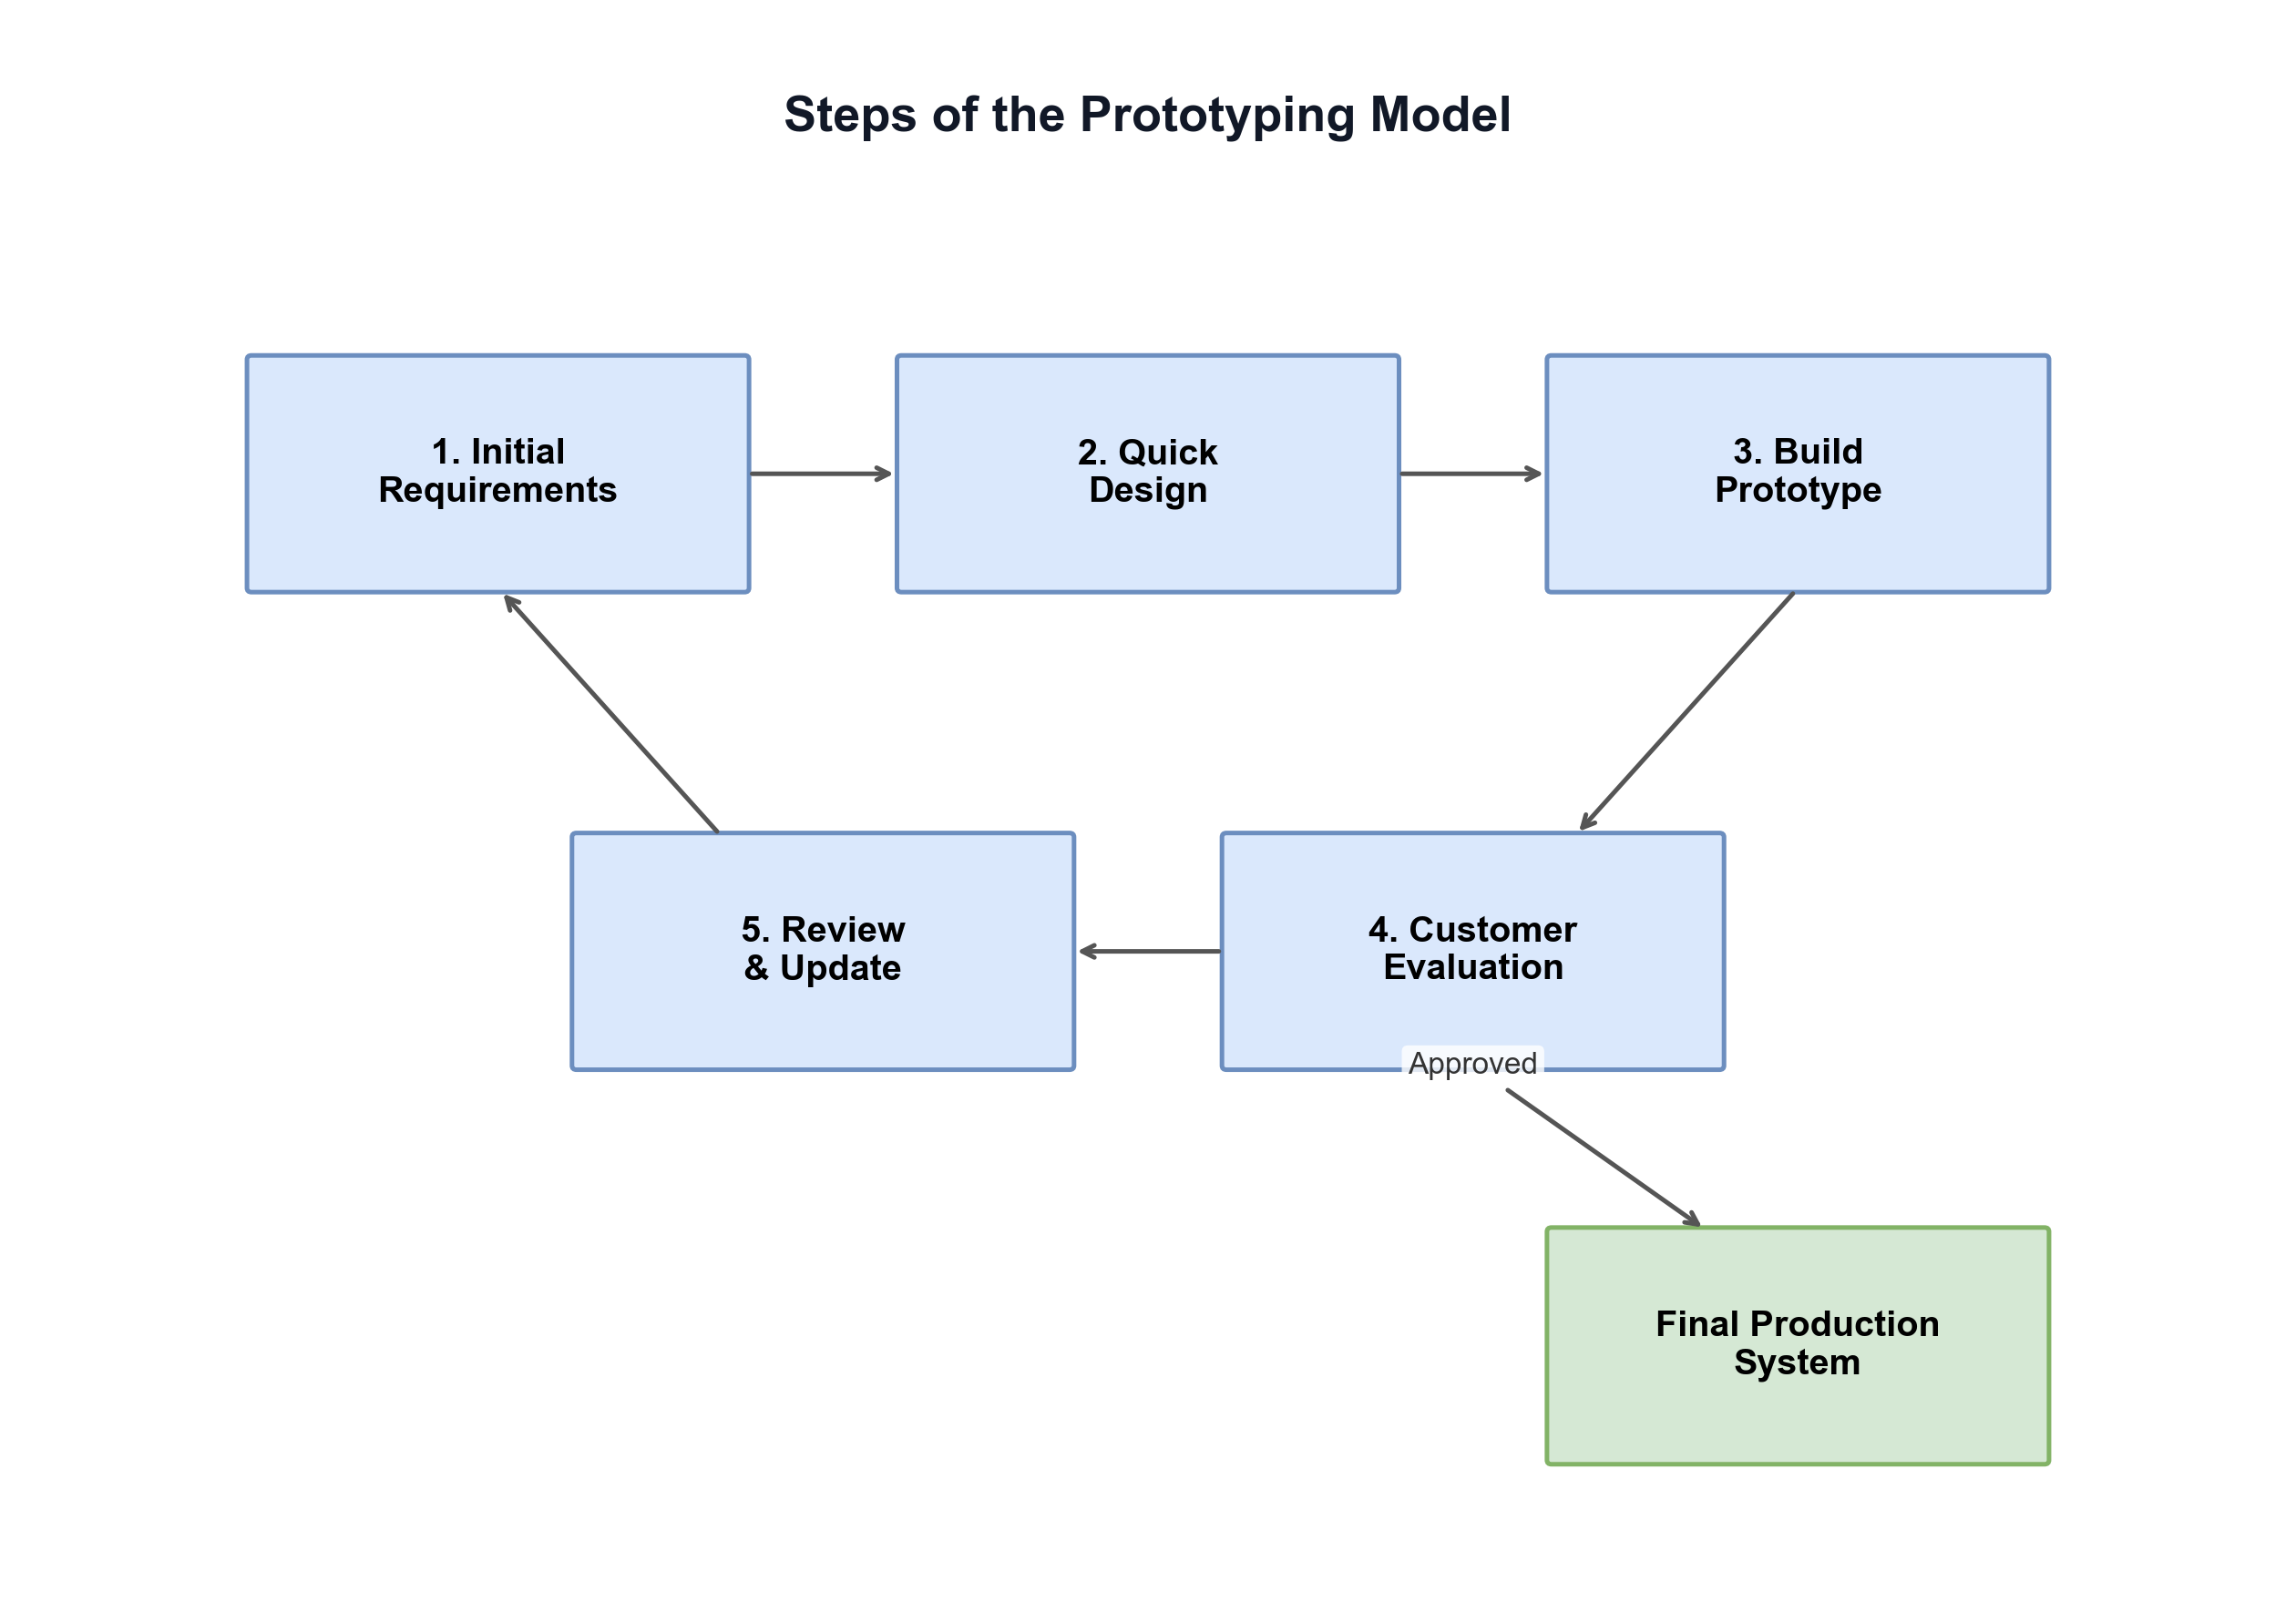
Figure 1: Steps of the Prototyping Model

3.3 EXISTING SYSTEM
The existing system for harvest estimation in Bugesera District is entirely manual and informal. Farmers estimate expected yields based on personal experience, previous season observations, and informal advice from neighbors or extension workers. Agricultural officers conduct periodic field visits to visually assess crop conditions and make rough estimates of district-level production. There is no digital platform for farmers to record their farm inputs, receive data-driven predictions, or access personalized agricultural recommendations. Communication between farmers and officers is done through physical meetings or phone calls, with no systematic tracking of advice given or outcomes achieved.
This existing approach has several significant drawbacks:
- Inaccurate Estimates: Empirical estimates are highly subjective and often significantly different from actual yields, leading to poor planning decisions.
- No Data Recording: There is no systematic recording of farm-level inputs, conditions, and outputs, making it impossible to learn from past seasons or identify trends.
- Limited Scalability: Extension officers cannot efficiently monitor all farms in the district through physical visits alone.
- No Early Warning: Farmers receive no advance notice of potential poor harvests until the crop is nearly ready for harvest, leaving little time for corrective action.

3.4 NEW SYSTEM
The proposed Machine Learning Based Farmer Harvest Prediction System addresses all the identified limitations of the existing approach. The system provides three role-based dashboards: (1) Farmer Dashboard allows farmers to make harvest predictions by entering farm details (crop, sector, area, planting date, fertilizer, irrigation, soil type), receive ML-generated yield forecasts in kg/are with bilingual recommendations, download PDF reports, and view prediction history; (2) Sector Agri Officer Dashboard — allows sector officers to view all farmers and predictions in their sector, send direct advice to underperforming farmers, record actual harvest yields, submit reports to the district, and broadcast advice to all farmers in their sector; (3) District Agri Officer (Admin) Dashboard — provides district-wide statistics, crop performance by sector (Maize, Beans, Rice), sector detail drill-down, advice to sector officers, PDF report generation, and officer registration and management.
The system is built on a modern three-tier architecture: a React.js frontend (Vite, bilingual EN/RW), a Flask REST API backend with 30+ endpoints, and a MySQL database with 10 relational tables. Three machine learning models were trained on the Bugesera Agricultural Dataset 2020–2024: Random Forest (R²=0.8476, best model), Gradient Boosting (R²=0.8331), and Linear Regression (R²=0.8421). The system supports both online (MySQL) and offline (local simulation) modes, ensuring accessibility even in areas with limited internet connectivity.
The online platform offers several advantages over the traditional system:
- Accuracy: Machine learning predictions are based on 36 features and trained on historical data, achieving 84.8% R² accuracy.
- Accessibility: Farmers and officers can access the system from any device with a web browser, in both English and Kinyarwanda.
- Efficiency: Predictions are generated instantly, allowing for real-time decision support.
- Data-Driven: The system builds a historical record of predictions that improves over time and supports evidence-based agricultural planning.

3.5 ANALYSIS AND DESIGN OF THE NEW SYSTEM

3.5.1 Use Case Diagram
A Use Case Diagram was developed to capture the high-level functional requirements of the system and the interactions between system actors and use cases. The system has three main actors: Farmer, Sector Agri Officer, and District Agri Officer (Admin). The Farmer actor has the following use cases: Register Account, Login, Make Harvest Prediction, View Results and Download PDF, View Prediction History, View Weather and Farming Tips, Manage Profile and Password, and Logout. The Sector Agri Officer has: Login, View Sector Farmers and Predictions, View Farmer Profile and Send Advice, Record Actual Harvest Yield, Submit Report to District, Broadcast Advice to All Farmers, and Logout. The District Agri Officer (Admin) has: Login, View District Overview and Stats, View Crop Performance by Sector, View Sector Details and Predictions, Send Advice to Sector Officers, Read Reports and Generate PDF, Register and Manage Officers, and Logout. The <<include>> relationship is used between Make Harvest Prediction and View Results, and between View Sector Details and View Crop Performance.
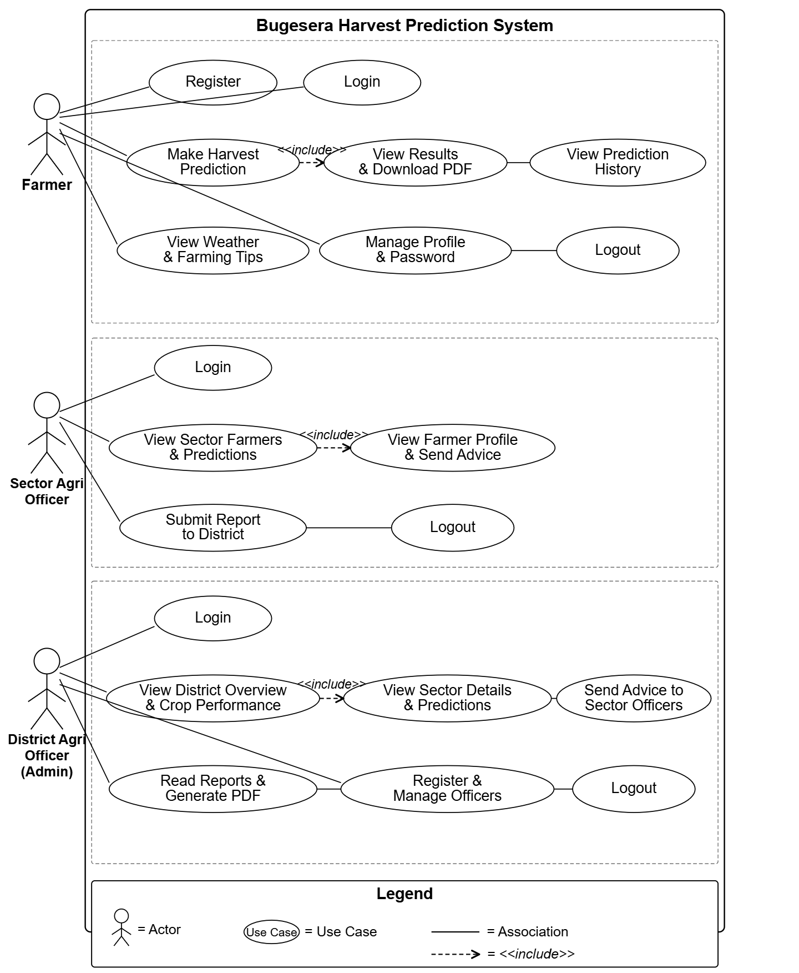

Figure 2: Use Case Diagram

3.5.2 Activity Diagrams
Activity diagrams were developed for each of the three main actors to illustrate the flow of activities within the system. Each diagram includes a Login condition (Valid Credentials? Yes/No) and a second decision point specific to each role.
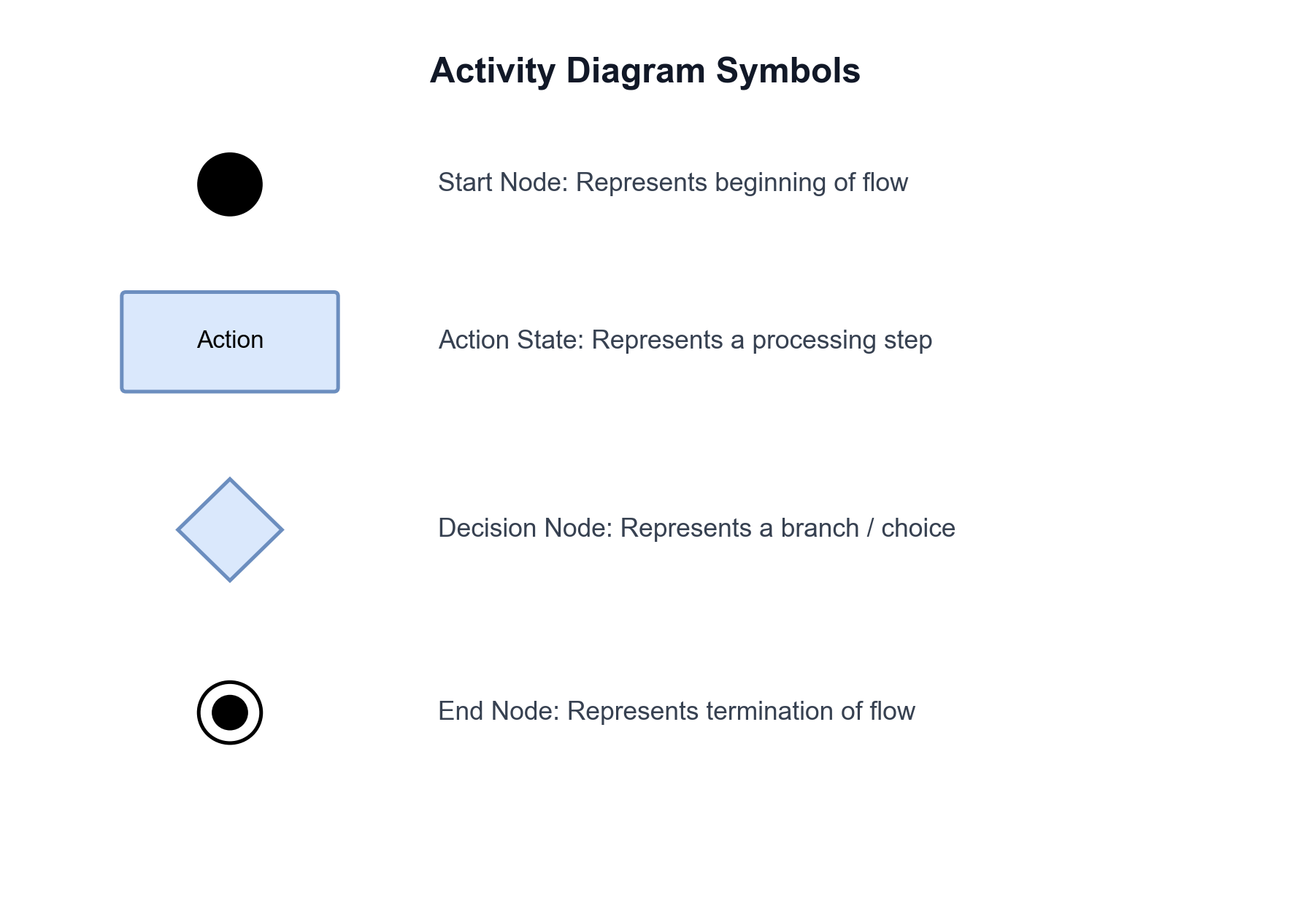
Figure 3: Symbols of Activity Diagram

Farmer Activity Diagram: The farmer begins by logging in with their Farmer ID or email and password. A decision node checks whether the credentials are valid — if not, the farmer is redirected back to the login screen; if valid, they access the Farmer Dashboard. From the dashboard, the farmer initiates a harvest prediction by entering farm details (crop, sector, planting date, area, fertilizer, irrigation). A second decision node checks whether the API is available — if yes, the AI model (Gradient Boosting) runs and returns a yield prediction; if no (offline mode), a local simulation is used. The farmer then views the results with recommendations and can download a PDF report. The farmer can also view prediction history and read advice messages from the Sector Agri Officer before logging out.

Sector Agri Officer Activity Diagram: The officer logs in with their email and password. After credential validation, they access the Sector Dashboard showing KPIs (total farmers, average yield, total predictions, underperforming farms). The officer views the list of farmers and predictions in their sector. A decision node checks whether there is an underperforming farm — if yes, the officer sends direct advice to the farmer (with auto-generated templates based on yield gap); if no, the officer records the actual harvest yield for comparison with predictions. The officer then submits a sector report to the District Admin and can broadcast advice to all farmers in the sector before logging out.

Figure 4: Activity Diagram

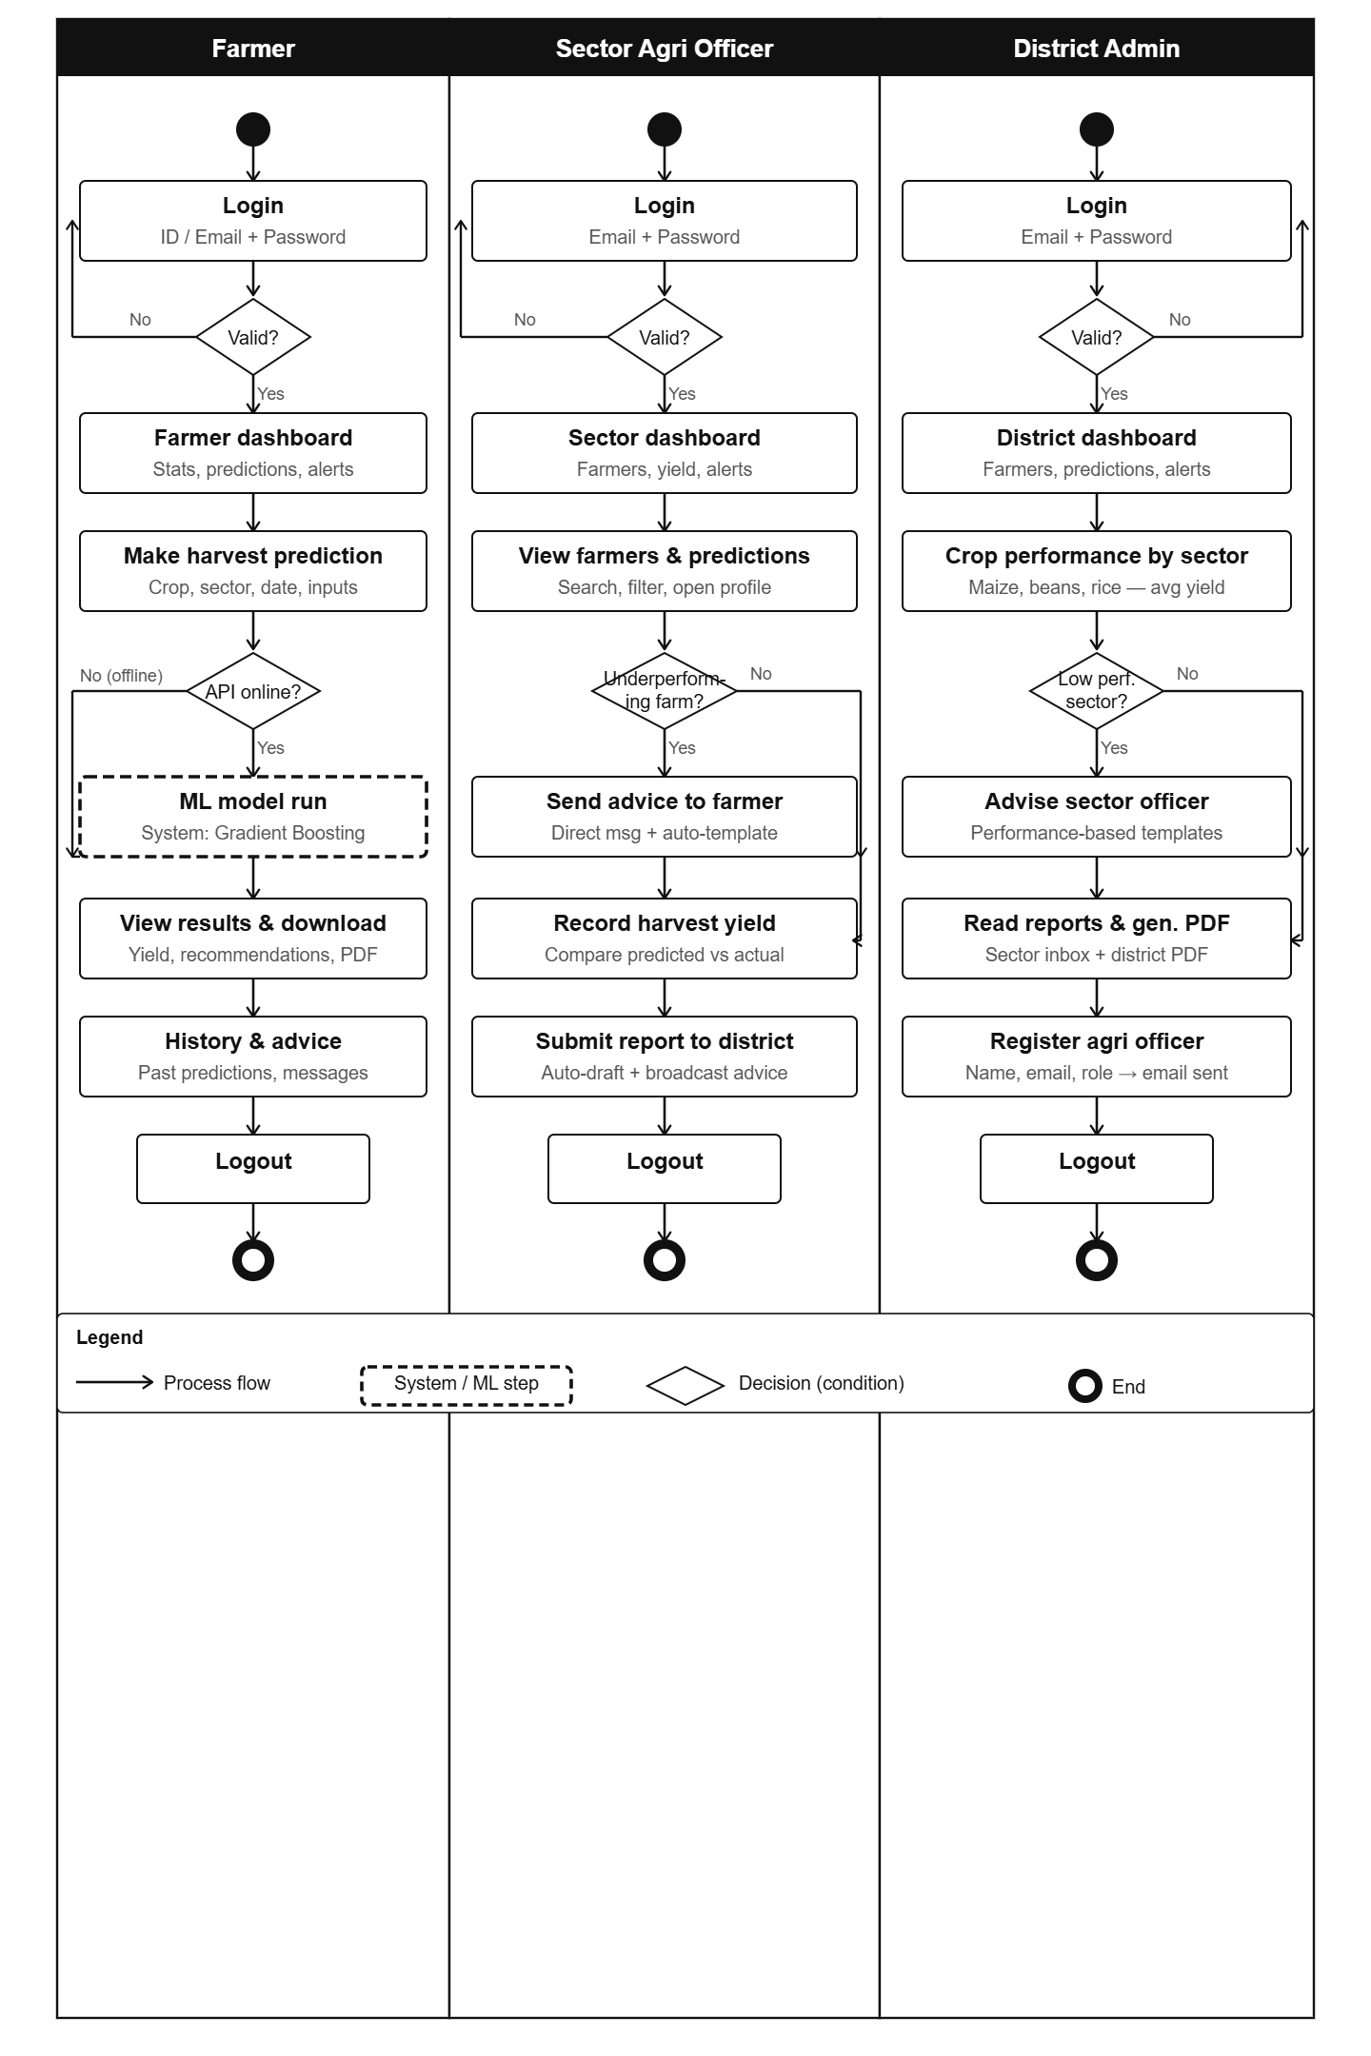

3.5.3 Sequence Diagram
The sequence diagram illustrates the interactions between the five main system components: Farmer/User, Browser/Frontend (React.js), Flask API (Backend), ML Model (AI), and MySQL Database. The diagram covers five main scenarios: (1) Registration — the farmer fills the registration form, the API validates inputs, saves to the database, and sends credentials via email (SMTP/Gmail); (2) Login — credentials are validated against the database and the user is redirected to their role-specific dashboard; (3) Make Harvest Prediction — the farmer submits farm inputs, the API builds a 35-feature vector, the Random Forest ML model generates a yield prediction in kg/are with confidence score, the API generates bilingual recommendations, saves to the database, and returns the result to the frontend; (4) Sector Officer — views sector dashboard (API fetches predictions from DB for farmers in the sector), sends advice (saved to officer_advice table), which appears as a notification for the farmer; (5) District Admin — views district-wide statistics (API aggregates data from all sectors), registers new officers (API creates account and sends credentials via email).

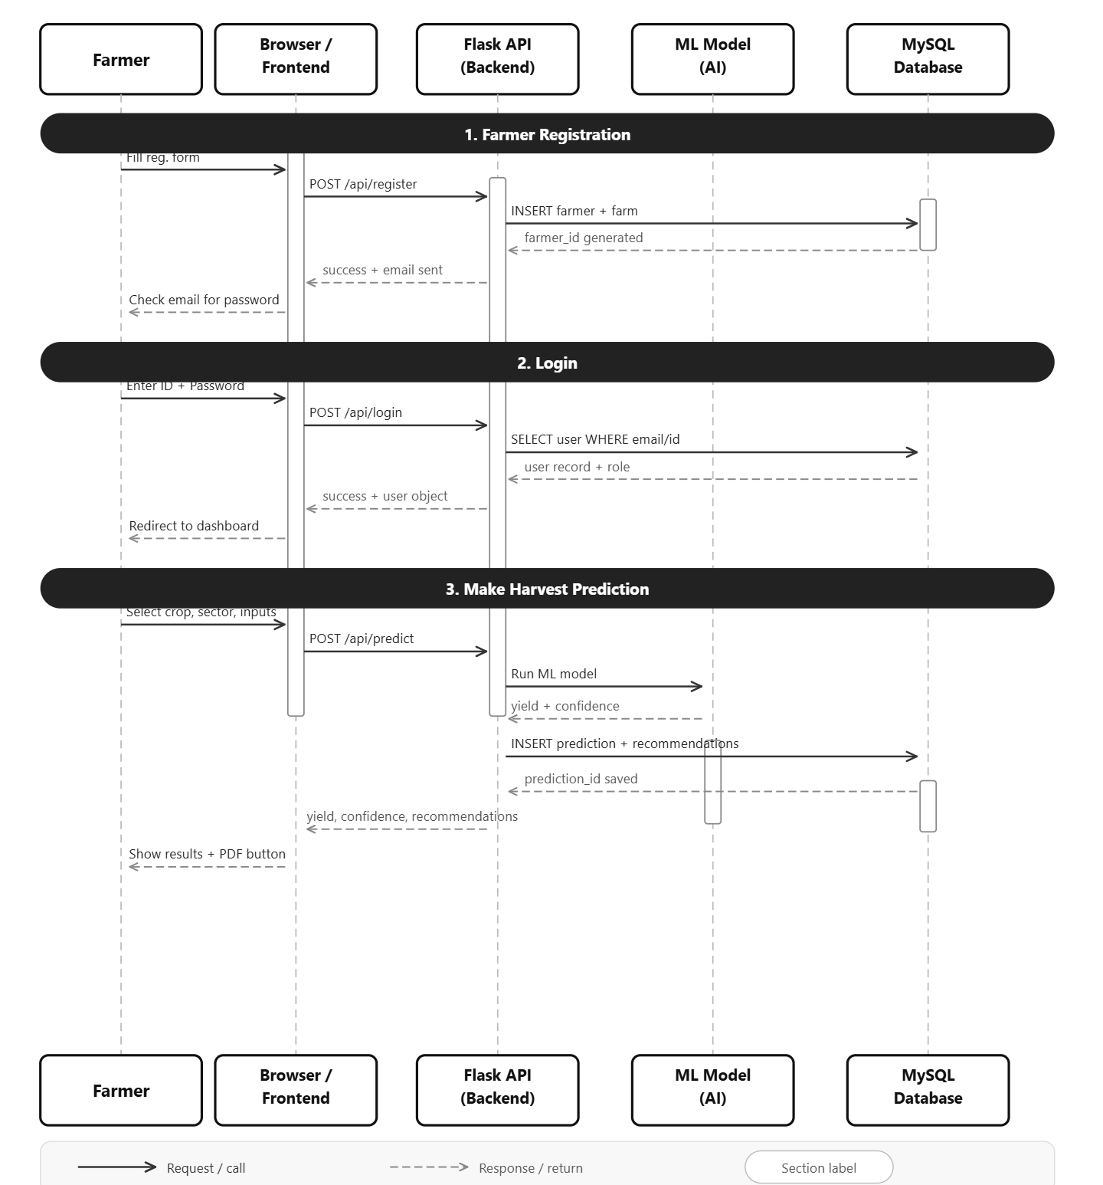
Figure 6: Sequence Diagram

3.5.4 Class Diagram / Database Schema
The database schema consists of ten main relational tables that form the backbone of the Bugesera Harvest Prediction System. The central table is the predictions table, which stores all prediction results and is linked to the farmers table through a foreign key (farmer_id). The farms table links farmers to sectors through sector_id, enabling sector-based filtering. The sectors table provides geographic and soil data for all 15 sectors of Bugesera District. The officers table stores Sector Agri Officers and District Agri Officers with their assigned sectors. The officer_advice table stores advice messages sent from officers to farmers. The recommendations table stores AI-generated recommendations linked to each prediction. The reports table stores sector reports submitted by officers to the district. The password_resets table manages OTP-based password reset flows. All tables use foreign key constraints to maintain referential integrity.
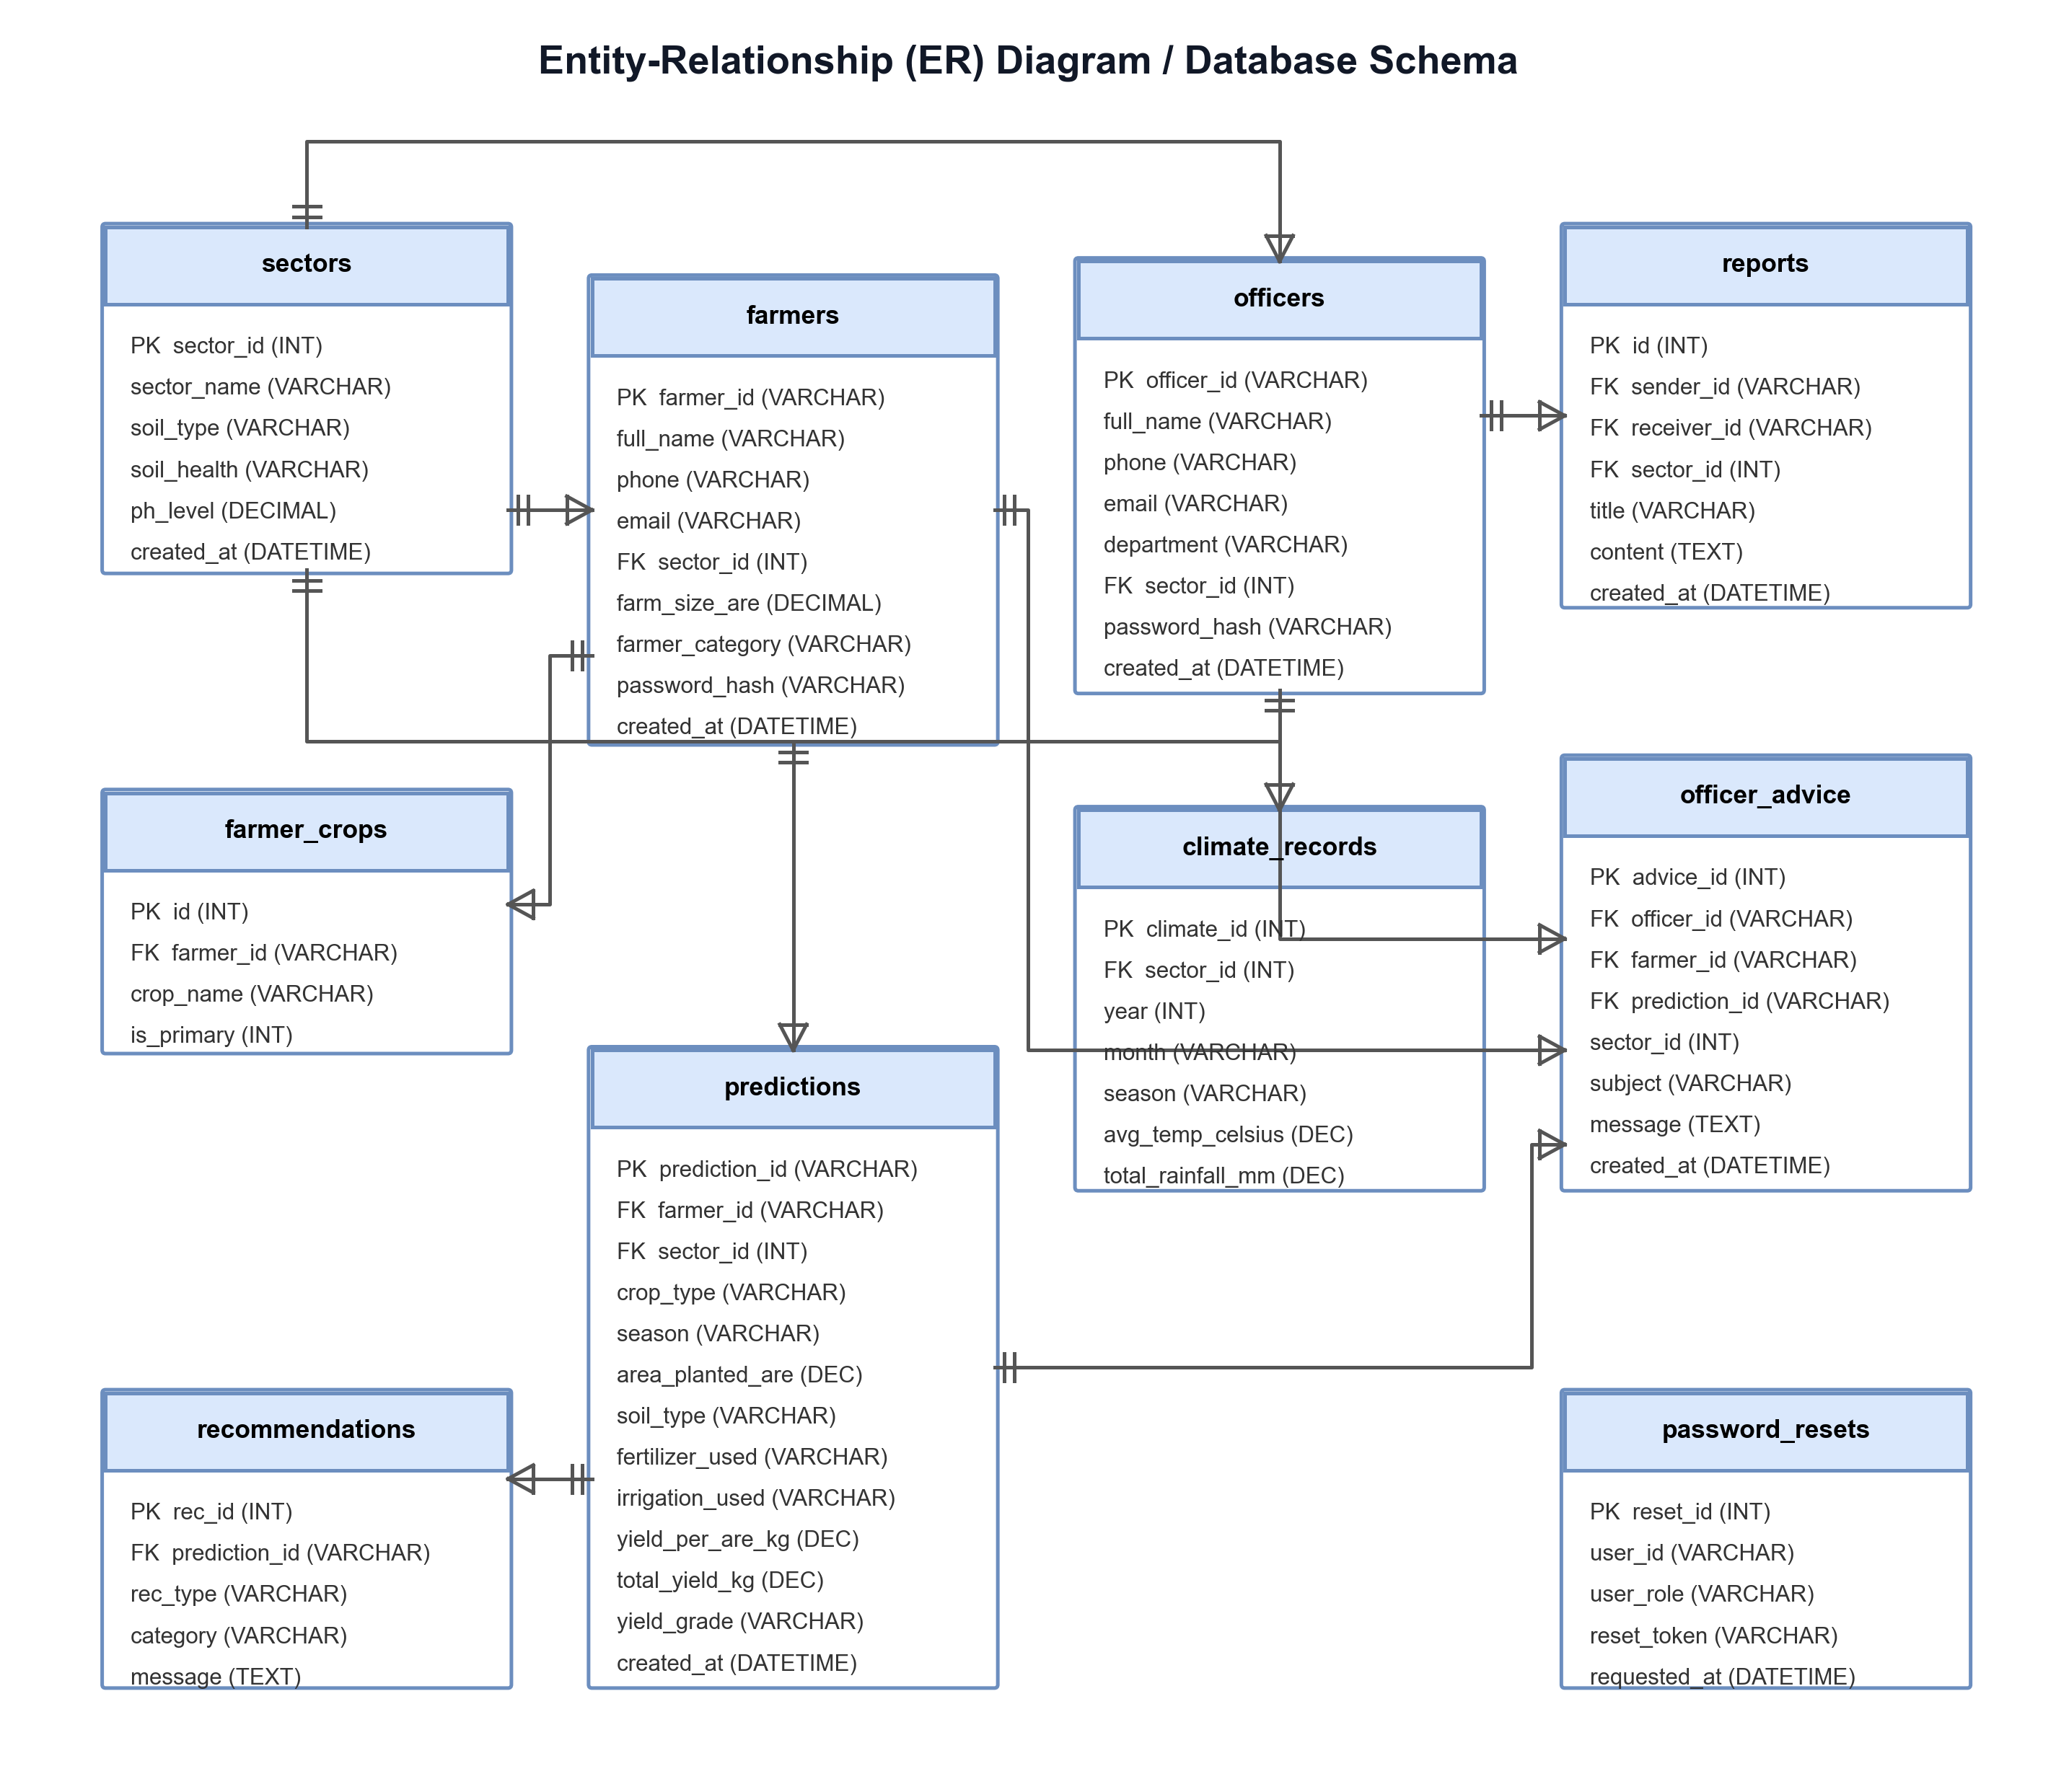
Figure 7: Class Diagram / Database Schema

3.5.5 System Architecture Diagram
The system is structured as a three-tier web application. The Presentation Layer consists of a React.js frontend (built with Vite) that provides a bilingual (English/Kinyarwanda) interface with three role-based dashboards: Farmer Dashboard, Sector Agri Officer Dashboard, and District Agri Officer (Admin) Dashboard. The Application Logic Layer consists of a Flask REST API (Python) with 30+ endpoints that handles authentication (login, register, OTP-based password reset), prediction processing (ML model inference, feature engineering, recommendation generation), officer management, advice broadcasting, report submission, and PDF generation using ReportLab. The Data Storage Layer consists of a MySQL database (bugesera_harvest) with 10 relational tables, accessed via PyMySQL. The ML models (Random Forest, Gradient Boosting, Linear Regression) are stored as serialized .pkl files and loaded at API startup. The system supports offline mode through local simulation when the API is unavailable.
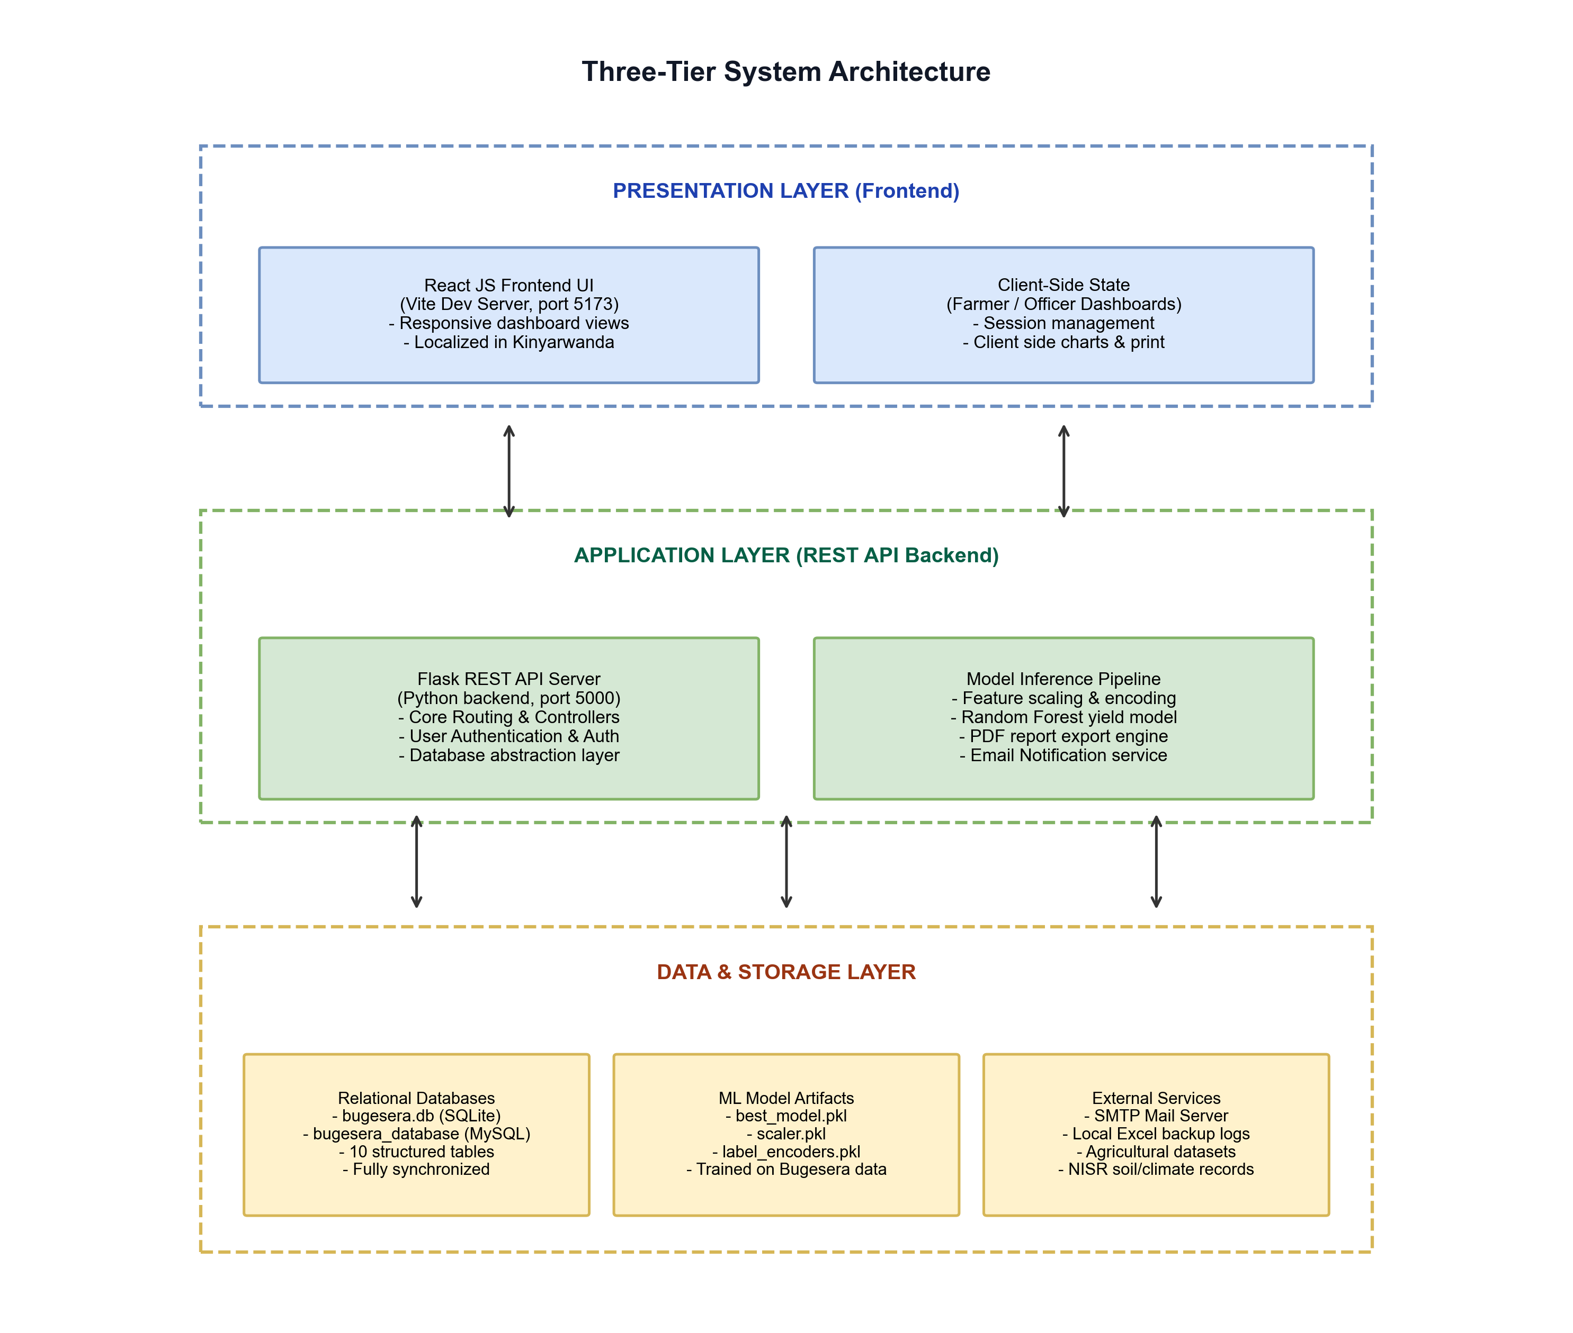
Figure 8: System Architecture Diagram

3.6 DATA DICTIONARY
The database design consists of ten main relational tables mapping the entities of the Bugesera Harvest Prediction System. The schema is designed to support role-based dashboards (Farmer, Sector Agri Officer, District Agri Officer), prediction history tracking, officer advice management, sector report submission, and climate data storage. The database runs on MySQL (production) and is accessed through PyMySQL from the Flask API. All tables use UTF-8 character encoding (utf8mb4) to support both English and Kinyarwanda text. The tables are detailed below:
Table 1: sectors Table
Field Name | Data Type | Key / Constraint | Nullable | Description / Notes
sector_id | INTEGER | PRIMARY KEY AUTOINCREMENT | NO | Unique identifier for each sector
sector_name | VARCHAR(50) | UNIQUE | NO | Name of the sector (e.g. Nyamata, Gashora)
soil_type | VARCHAR(30) | None | NO | Predominant soil type (Loam, Clay Soil, Sandy Loam)
soil_health | VARCHAR(15) | None | NO | General health grade of the soil (Good / Fair / Poor)
ph_level | DECIMAL(3,2) | None | NO | Average pH level of the soil in the sector
organic_matter | DECIMAL(4,2) | None | YES | Organic matter percentage in soil
nitrogen_ppm | DECIMAL(6,2) | None | YES | Nitrogen concentration in parts per million (ppm)
phosphorus_ppm | DECIMAL(6,2) | None | YES | Phosphorus concentration in ppm
potassium_ppm | DECIMAL(6,2) | None | YES | Potassium concentration in ppm
market_dist_km | DECIMAL(5,2) | None | YES | Distance in kilometers to the nearest main market
created_at | DATETIME | DEFAULT current timestamp | YES | Date and time when sector record was created

Table 2: officers Table
Field Name | Data Type | Key / Constraint | Nullable | Description / Notes
officer_id | VARCHAR(10) | PRIMARY KEY | NO | Unique credentials identifier (e.g. A001)
full_name | VARCHAR(100) | None | NO | Full name of the officer
phone | VARCHAR(15) | UNIQUE | YES | Phone number of the officer (+250...)
email | VARCHAR(100) | UNIQUE | YES | Email address of the officer
department | VARCHAR(50) | None | YES | Assigned department (e.g. Crop Production)
sector_id | INTEGER | FOREIGN KEY REFERENCES sectors(sector_id) | YES | Assigned sector ID for monitoring
password_hash | VARCHAR(255) | None | NO | Hashed password for login security
is_active | INTEGER | DEFAULT 1 | YES | Account status (1 = Active, 0 = Inactive)
created_at | DATETIME | DEFAULT current timestamp | YES | Record creation date
last_login | DATETIME | None | YES | Timestamp of last login activity

Table 3: farmers Table
Field Name | Data Type | Key / Constraint | Nullable | Description / Notes
farmer_id | VARCHAR(10) | PRIMARY KEY | NO | Unique identifier for the farmer (e.g. F001)
full_name | VARCHAR(100) | None | NO | Full name of the farmer
phone | VARCHAR(15) | UNIQUE | NO | Phone number of the farmer
email | VARCHAR(100) | UNIQUE | YES | Email address of the farmer
national_id | VARCHAR(16) | UNIQUE | YES | National ID number (16 digits)
sector_id | INTEGER | FOREIGN KEY REFERENCES sectors(sector_id) | NO | Resident sector of the farmer
farm_size_are | DECIMAL(10,2) | CHECK > 0 | NO | Total farm land area in 'are' units (1 are = 100 sqm)
farmer_category | VARCHAR(10) | CHECK ('Small','Medium','Large') | NO | Farmer classification based on land size
password_hash | VARCHAR(255) | None | NO | Hashed password for security
is_active | INTEGER | DEFAULT 1 | YES | Active status indicator
registered_by | VARCHAR(10) | FOREIGN KEY REFERENCES officers(officer_id) | YES | Officer who registered the farmer
created_at | DATETIME | DEFAULT current timestamp | YES | Creation timestamp
last_login | DATETIME | None | YES | Last login timestamp

Table 4: farmer_crops Table
Field Name | Data Type | Key / Constraint | Nullable | Description / Notes
id | INTEGER | PRIMARY KEY AUTOINCREMENT | NO | Auto-increment primary key
farmer_id | VARCHAR(10) | FOREIGN KEY REFERENCES farmers(farmer_id) | NO | Associated farmer identifier
crop_name | VARCHAR(30) | CHECK ('Maize','Beans','Rice') | NO | Name of the crop
is_primary | INTEGER | DEFAULT 0 | YES | Flag indicating if this is the primary crop (1 = Yes, 0 = No)
created_at | DATETIME | DEFAULT current timestamp | YES | Timestamp of link creation

Table 5: predictions Table
Field Name | Data Type | Key / Constraint | Nullable | Description / Notes
prediction_id | VARCHAR(20) | PRIMARY KEY | NO | Unique prediction ID (e.g., PRED-1728394)
farmer_id | VARCHAR(10) | FOREIGN KEY REFERENCES farmers(farmer_id) | NO | Associated farmer ID
sector_id | INTEGER | FOREIGN KEY REFERENCES sectors(sector_id) | NO | Associated sector ID
crop_type | VARCHAR(30) | CHECK ('Maize','Beans','Rice') | NO | Crop type of the prediction
season | VARCHAR(10) | CHECK ('Season A','Season B') | NO | Season identifier
planting_date | DATE | None | NO | Date when crops were planted (YYYY-MM-DD)
planting_month | VARCHAR(15) | None | NO | Month of planting (extracted)
year | INTEGER | None | NO | Year of planting
area_planted_are | DECIMAL(10,2) | CHECK > 0 | NO | Area of land planted in 'are' units
soil_type | VARCHAR(30) | None | NO | Predominant soil type used in the prediction
fertilizer_used | VARCHAR(10) | CHECK ('Yes','Partial','No') | NO | Fertilizer usage categorical score
irrigation_used | VARCHAR(10) | CHECK ('Yes','Partial','No') | NO | Irrigation usage categorical score
previous_crop | VARCHAR(30) | None | YES | Crop grown in previous season for crop rotation check
pest_pressure | VARCHAR(10) | CHECK ('Low','Medium','High') | YES | Incidence level of pests and diseases
labor_availability | VARCHAR(15) | CHECK ('Adequate','Sufficient','Limited') | YES | Labor availability score
extension_access | VARCHAR(5) | CHECK ('Yes','No') | YES | Access to agricultural extension officers
credit_access | VARCHAR(10) | CHECK ('Yes','Partial','No') | YES | Access to agricultural financial services
avg_temperature | DECIMAL(4,2) | None | YES | Average monthly temperature during growing phase
total_rainfall_mm | DECIMAL(6,2) | None | YES | Total rainfall volume expected or recorded
humidity_pct | DECIMAL(5,2) | None | YES | Average relative humidity percentage
sunshine_hrs | DECIMAL(4,2) | None | YES | Average daily sunshine hours
yield_per_are_kg | DECIMAL(10,4) | None | NO | Model predicted yield in kg/are
yield_per_ha_kg | DECIMAL(10,4) | None | NO | Calculated yield in kg/ha (are * 100)
total_yield_kg | DECIMAL(12,4) | None | NO | Calculated total harvest in kilograms
yield_range_low | DECIMAL(10,4) | None | YES | Minimum expected yield (lower bound confidence interval)
yield_range_high | DECIMAL(10,4) | None | YES | Maximum expected yield (upper bound confidence interval)
district_avg_kg_are | DECIMAL(10,4) | None | YES | Historical average yield for this crop in the district
pct_vs_average | DECIMAL(5,2) | None | YES | Percentage performance compared to district average
yield_grade | VARCHAR(20) | CHECK ('Excellent','Good','Average','Below Average') | YES | Grading of the predicted yield
confidence_pct | DECIMAL(4,1) | DEFAULT 84.8 | YES | Model confidence/accuracy score (R2)
model_used | VARCHAR(50) | DEFAULT 'Gradient Boosting' | YES | Algorithm used for inference
is_offline | INTEGER | DEFAULT 0 | YES | Whether the prediction was made in offline sync mode
created_at | DATETIME | DEFAULT current timestamp | YES | Date and time of prediction creation

Table 6: recommendations Table
Field Name | Data Type | Key / Constraint | Nullable | Description / Notes
rec_id | INTEGER | PRIMARY KEY AUTOINCREMENT | NO | Unique advisory record identifier
prediction_id | VARCHAR(20) | FOREIGN KEY REFERENCES predictions(prediction_id) | NO | Associated prediction identifier
rec_type | VARCHAR(15) | CHECK ('success','info','warning') | NO | Alert level for the frontend visual styling
category | VARCHAR(30) | None | NO | Category of recommendations (Fertilizer, Water, Pests, etc.)
message | TEXT | None | NO | Detailed advisory message for the farmer
display_order | INTEGER | DEFAULT 0 | YES | Order to list the recommendations on the screen
created_at | DATETIME | DEFAULT current timestamp | YES | Timestamp of recommendation generation

Table 7: officer_advice Table
Field Name | Data Type | Key / Constraint | Nullable | Description / Notes
advice_id | INTEGER | PRIMARY KEY AUTOINCREMENT | NO | Unique advice ID
officer_id | VARCHAR(10) | FOREIGN KEY REFERENCES officers(officer_id) | NO | Authoring officer's credentials identifier
farmer_id | VARCHAR(10) | FOREIGN KEY REFERENCES farmers(farmer_id) | YES | Target farmer ID (NULL if broadcast)
prediction_id | VARCHAR(20) | FOREIGN KEY REFERENCES predictions(prediction_id) | YES | Associated prediction reference
sector_id | INTEGER | FOREIGN KEY REFERENCES sectors(sector_id) | YES | Target sector (NULL if specific farmer)
subject | VARCHAR(100) | None | NO | Subject heading of the advisory
message | TEXT | None | NO | Content of the advisory notification
advice_type | VARCHAR(20) | CHECK ('general','alert','recommendation','followup') | YES | Classification of advice
is_read | INTEGER | DEFAULT 0 | YES | Status flag of notification read state (1 = Read, 0 = Unread)
created_at | DATETIME | DEFAULT current timestamp | YES | Date and time when advice was sent

Table 8: climate_records Table
Field Name | Data Type | Key / Constraint | Nullable | Description / Notes
climate_id | INTEGER | PRIMARY KEY AUTOINCREMENT | NO | Unique climate entry identifier
sector_id | INTEGER | FOREIGN KEY REFERENCES sectors(sector_id) | NO | Target sector for climate data
year | INTEGER | None | NO | Calibrated calendar year
month | VARCHAR(15) | None | NO | Calibrated calendar month name
season | VARCHAR(10) | CHECK ('Season A','Season B') | NO | Agricultural season of the record
avg_temp_celsius | DECIMAL(4,2) | None | YES | Average measured temperature in Celsius
total_rainfall_mm | DECIMAL(6,2) | None | YES | Total measured rainfall in millimeters
humidity_pct | DECIMAL(5,2) | None | YES | Average relative humidity percentage
sunshine_hrs | DECIMAL(4,2) | None | YES | Average daily sunshine hours
wind_speed_khm | DECIMAL(5,2) | None | YES | Average measured wind speed in km/h
evapotranspiration_mm | DECIMAL(5,2) | None | YES | Calculated crop evapotranspiration reference
created_at | DATETIME | DEFAULT current timestamp | YES | Timestamp of record entry

Table 9: password_resets Table
Field Name | Data Type | Key / Constraint | Nullable | Description / Notes
reset_id | INTEGER | PRIMARY KEY AUTOINCREMENT | NO | Unique reset token entry identifier
user_id | VARCHAR(10) | None | NO | Associated farmer_id or officer_id requesting password reset
user_role | VARCHAR(10) | CHECK ('farmer','officer') | NO | Security context role of the user
reset_token | VARCHAR(100) | UNIQUE | YES | Generated reset token (secure random string)
requested_at | DATETIME | DEFAULT current timestamp | YES | Timestamp when reset was requested
completed_at | DATETIME | None | YES | Timestamp when password was successfully reset
is_used | INTEGER | DEFAULT 0 | YES | Flag indicating if the token was consumed (1 = Yes, 0 = No)

Table 10: reports Table
Field Name | Data Type | Key / Constraint | Nullable | Description / Notes
id | INTEGER | PRIMARY KEY AUTOINCREMENT | NO | Unique identifier for the report
sender_id | VARCHAR(10) | FOREIGN KEY REFERENCES officers(officer_id) | NO | Officer ID who sent/authored the report
receiver_id | VARCHAR(10) | FOREIGN KEY REFERENCES officers(officer_id) | YES | Officer ID who receives the report
sector_id | INTEGER | FOREIGN KEY REFERENCES sectors(sector_id) | YES | Associated sector reference
title | VARCHAR(150) | DEFAULT 'Sector Report' | NO | Title of the report
content | TEXT | None | YES | Main content / text body of the report
created_at | DATETIME | DEFAULT current timestamp | YES | Date and time when report was saved

3.7 ETHICAL CONSIDERATIONS
This study adheres to important ethical principles to ensure that the development and deployment of the harvest prediction system is responsible, transparent, and beneficial to the farmers of Bugesera District. Data privacy and confidentiality are strictly maintained throughout the system — all personal information collected from farmers and agricultural officers is protected through role-based access control (RBAC), where farmers can only access their own data, sector officers can only access data within their assigned sector, and district admins have read-only access to aggregated statistics without exposing individual farmer details.
The system implements secure authentication using password hashing and OTP-based password reset via email (SMTP/Gmail), ensuring that unauthorized access is prevented. All farmers who participated in data collection and system testing consented voluntarily and were informed of the purpose of the study. Transparency is emphasized in the model's predictions — the system provides 5 bilingual (English/Kinyarwanda) recommendations alongside each prediction, explaining the basis for the output and guiding farmers on actionable improvements.
Efforts were made to ensure fairness and inclusivity by designing a bilingual interface (English and Kinyarwanda) that minimizes barriers for farmers with limited English proficiency. The machine learning models were trained exclusively on locally collected data from Bugesera District (2020–2024) to reduce the risk of bias from non-representative datasets. The system was tested with farmers from multiple sectors to ensure that predictions are accurate and useful across different soil types, crop varieties, and farming practices. These ethical considerations ensure that the system promotes trust, fairness, and accountability in its application to agricultural planning and decision-making in Bugesera District.

CHAPTER 4: SYSTEM IMPLEMENTATION

4.0 INTRODUCTION
This chapter describes the detailed implementation of the Machine Learning Based Farmer Harvest Prediction System, covering the hardware and software requirements, system interfaces, and testing results. It demonstrates how the various components machine learning model, Flask API, React frontend, and MySQL database — are integrated into a complete, functional system.

4.1 REQUIREMENTS

4.1.1 Hardware Requirements
- A computer with at least 8 GB RAM, Intel Core i5 or equivalent processor, and 100 GB HDD/SSD for running the development and production environment.
- Internet connection (Wi-Fi or Ethernet) for accessing the web application.
- A server or local machine running XAMPP for MySQL database management.
- Client devices (computers, tablets, or mobile phones) with a modern web browser.

4.1.2 Software Requirements
- Operating System: Windows 10/11, macOS, or Linux Ubuntu.
- Python 3.8+ with Scikit-learn, Pandas, NumPy, Flask, Flask-CORS, PyMySQL, joblib, and ReportLab (for PDF generation) libraries.
- Node.js 18+ and npm for React frontend development with Vite.
- XAMPP for local Apache and MySQL server configuration.
- Modern web browser: Google Chrome, Mozilla Firefox, or Microsoft Edge.
- Visual Studio Code as the integrated development environment.

4.2 MACHINE LEARNING MODEL DEVELOPMENT
The machine learning pipeline was developed in Python using Scikit-learn. The dataset contained historical agricultural records from Bugesera District with 34 features, including: agricultural details (crop type, sector, season, farm size, area planted, farmer category, fertilizer use, irrigation method, soil type, previous crop, pest and disease pressure, labor availability, extension service access, credit access, and total cost), monthly climate averages for Bugesera auto-loaded based on the planting date (average temperature, total rainfall, relative humidity, sunshine hours, wind speed, and evapotranspiration), soil parameters auto-detected by sector (pH level, organic matter percentage, nitrogen, phosphorus, and potassium), and engineered variables (fertilizer score, irrigation score, soil pH optimality, rain adequacy, and season flag). Preprocessing steps included encoding categorical columns with LabelEncoder and scaling numerical columns with StandardScaler.
Three models were trained and compared:
Model | R² Score | MAE (kg/are) | Accuracy (%)
Random Forest | 0.8476 (84.8%) | 3.21 | 86.4%
Linear Regression | 0.8421 (84.2%) | 3.32 | 86.0%
Gradient Boosting | 0.8331 (83.3%) | 3.40 | 85.6%
Table 14: Model Performance Comparison
The Random Forest model achieved the best performance with an R² score of 84.8%, meaning it explains 84.8% of the variance in crop yields. This model was selected, serialized using Python's joblib library, and integrated into the Flask API for production use. The top predictive features identified by the model were: rain adequacy, area planted, fertilizer score, soil pH optimality, and irrigation score.

4.3 SYSTEM INTERFACES
The system was designed with a user-friendly bilingual interface accessible in both English and Kinyarwanda. The following sections describe the main screens of the system.

4.3.1 Login Screen
The Login Screen is the entry point for all system users. It prompts users to enter their Farmer ID or Officer ID and password. The screen includes a 'Forgot Password' link for account recovery and a language toggle for switching between English and Kinyarwanda. Users are authenticated against the MySQL database, and upon successful login, they are directed to their respective dashboard.
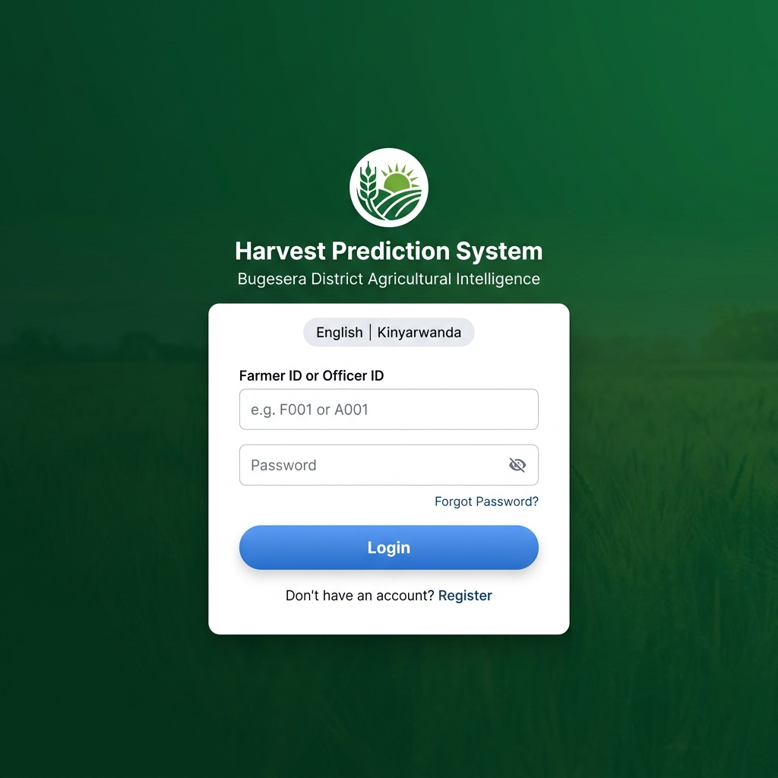
Figure 9: Login Screen - Entry point for Farmer and Agricultural Officer authentication

4.3.2 Farmer Dashboard
The Farmer Dashboard provides a summary view of the farmer's prediction activity including total predictions made, average yield per season, and a quick access button to start a new prediction. The dashboard also displays a weather overview for the current season and motivational agricultural tips.
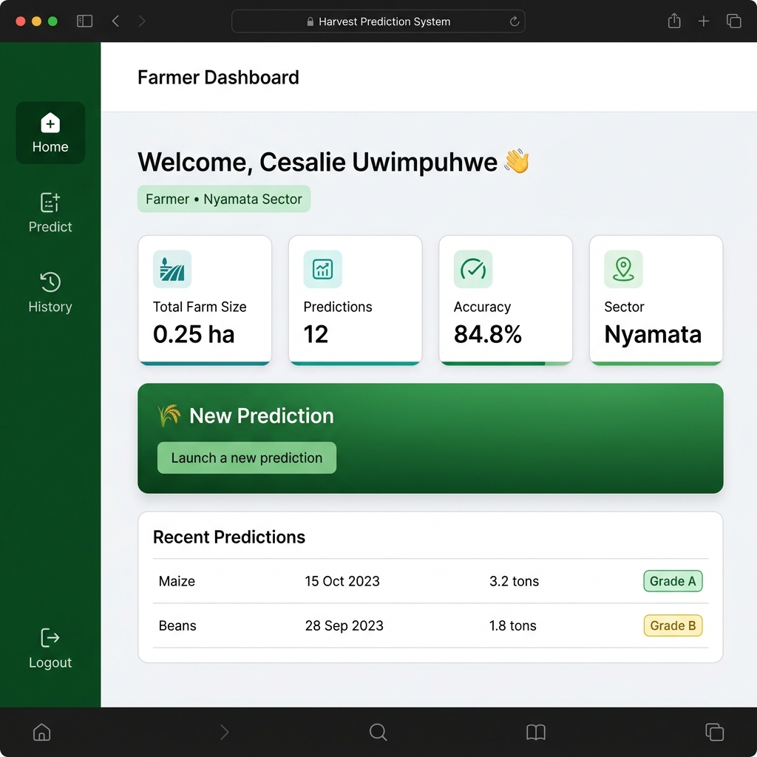
Figure 10: Farmer Dashboard - Farm stats, recent predictions, and navigation

4.3.3 Prediction Form
The Prediction Form is the core functional screen of the system. It collects all the input data required by the machine learning model in a two-step wizard. Step 1 collects: Crop Type (Beans, Maize, Rice), Farm Size (in hectares, auto-converted to ares), Area Planted (in hectares, auto-converted to ares), Sector (which auto-detects soil type), Season, and Planting Date (which auto-fills month). Step 2 collects fertilizer usage (Yes/No) and irrigation usage (Yes/No). The form validates all inputs before submission.
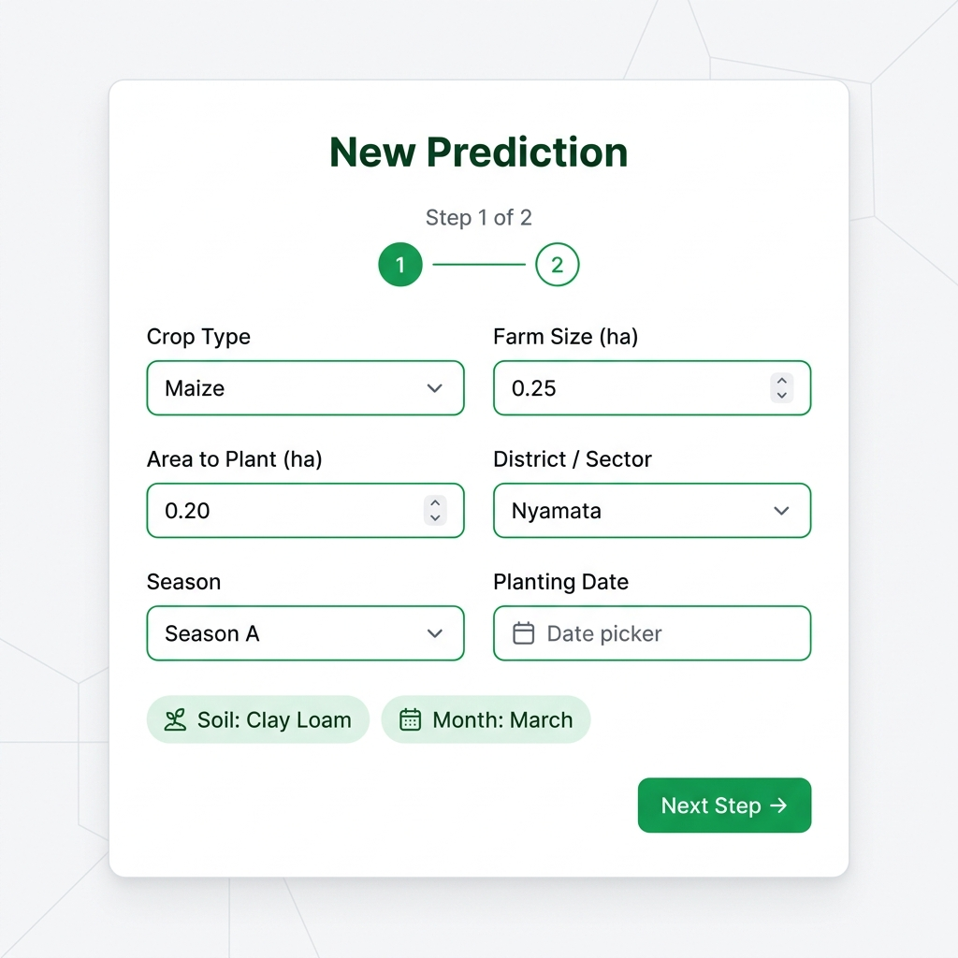
Figure 11a: Prediction Form - Step 1 (Crop, Farm Size, Sector, Season, Planting Date)

4.3.4 Prediction Result Screen
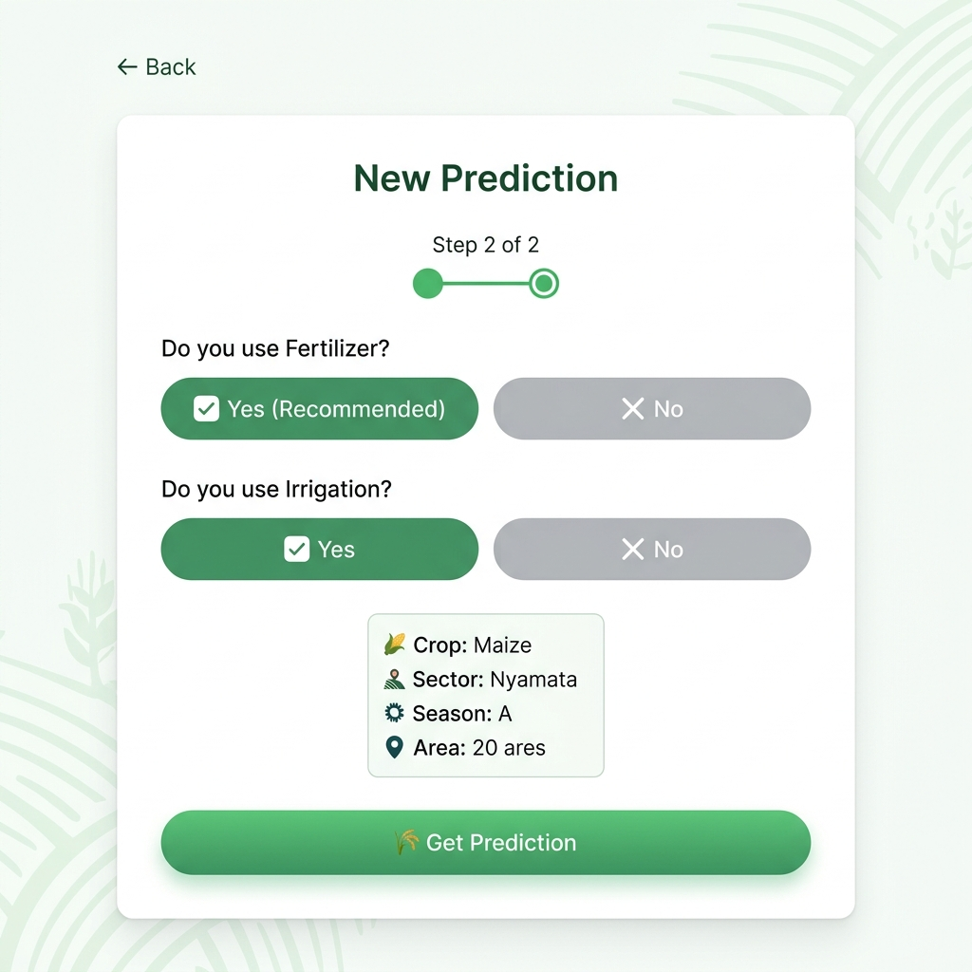
Figure 11b: Prediction Form - Step 2 (Fertilizer and Irrigation usage selection)
Upon form submission, the system displays the Prediction Result Screen showing: the predicted yield in kg/are and total kg, the yield grade (Excellent/Good/Fair/Poor) based on seasonal benchmarks for the specific crop, a comparison with the previous prediction, a progress bar visualization, and 10-12 data-driven recommendations tailored to the predicted outcome. The screen includes a 'Download Report' button that generates a comprehensive PDF report containing complete prediction details, soil composition, and custom agronomic advice generated via ReportLab on the Flask server.
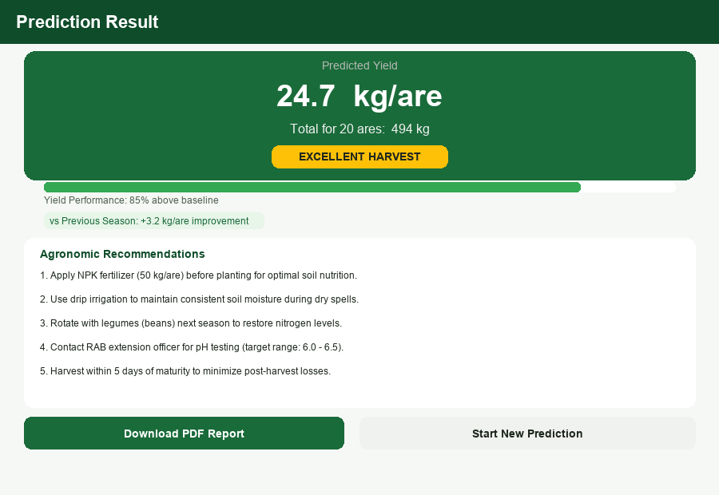
Figure 12: Prediction Result Screen - Yield grade, recommendations, and PDF report download

4.3.5 Prediction History Screen
The Prediction History Screen allows farmers to review all their past predictions. Results are displayed in a table showing prediction ID, crop type, date, area, predicted yield, and yield grade. A year filter allows filtering predictions by year (2020-2026). History is loaded from the MySQL database upon login.
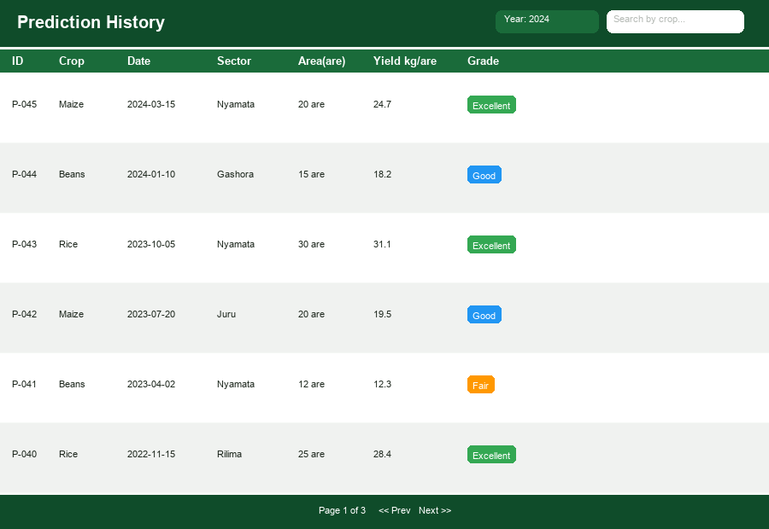
Figure 13: Prediction History Screen - Filterable table of all past predictions by year

4.3.6 Agricultural Officer Dashboard
The Agricultural Officer Dashboard is a two-level analytics centre covering both district-level and sector-level agricultural insights for Bugesera District.
At the district level (Overview Tab), the dashboard displays: total predictions made across all registered farmers in Bugesera District, total registered farmers, average crop yield by type (Maize, Beans, Rice) presented as a bar chart, season performance breakdown (Season A / B / C), and district-wide alerts flagging underperforming areas. Officers can generate and download comprehensive district crop performance and risk summary reports in PDF format via the Reports tab.
At the sector level (Sectors Tab), the dashboard provides a ranked bar chart of all 17 sectors in Bugesera District ordered by average predicted yield (kg/are). A Sector Risk Assessment table shows each sector's farmer count, average yield, and risk classification (Low / Medium / High), enabling the officer to target agronomic support and extension services to the most vulnerable sectors.
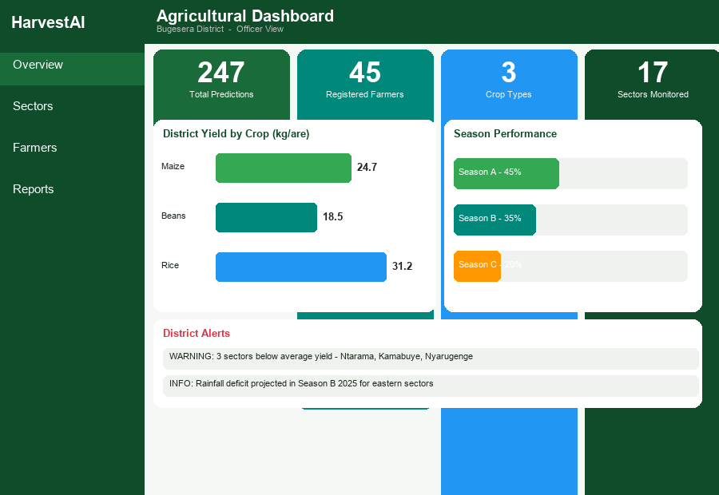
Figure 14a: Agricultural Officer Dashboard - Overview Tab (District-level statistics and alerts)

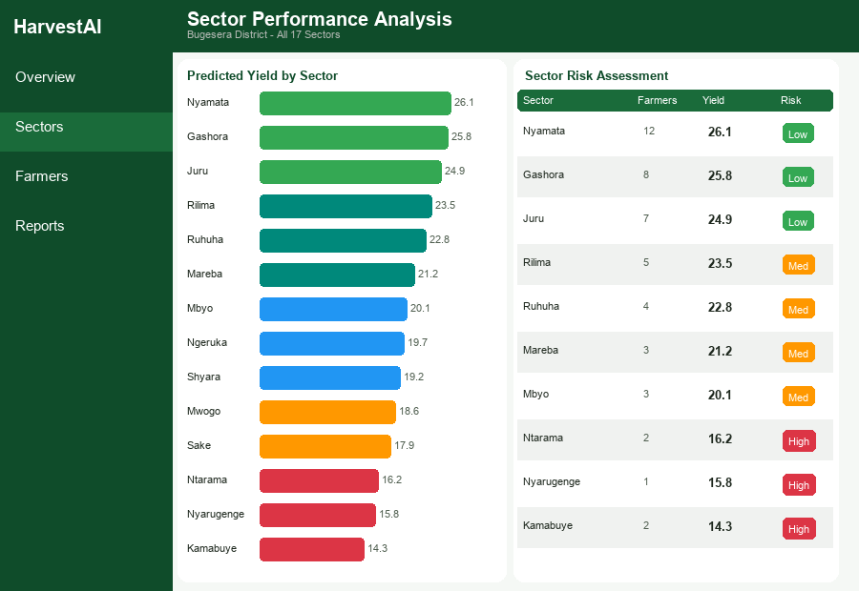
Figure 14b: Agricultural Officer Dashboard - Sectors Tab (Sector yield ranking and risk assessment)

4.4 TESTING

4.4.1 Introduction
System testing was conducted to verify that the Machine Learning Based Farmer Harvest Prediction System operates correctly and meets all functional and non-functional requirements. The testing process covered unit testing, validation testing, integration testing, functional testing, and acceptance testing.

4.4.2 Objective of Testing
The main objectives of system testing were:
- To verify that all individual components function correctly in isolation (unit testing).
- To confirm that the integrated system operates correctly as a whole (integration testing).
- To validate that the system meets user requirements and is accepted by end users (acceptance testing).
- To ensure the machine learning model generates accurate, meaningful predictions.

4.4.3 Unit Testing Outputs
No. | Test Case | Expected Result | Actual Result
1 | Load Login Page | Display login form with ID and password fields | Pass
2 | Farmer Login with valid credentials | Redirect to farmer dashboard | Pass
3 | Farmer Login with invalid credentials | Display error message | Pass
4 | Officer Login with valid credentials | Redirect to officer dashboard | Pass
5 | Submit prediction form with all valid inputs | Display prediction result with yield and grade | Pass
6 | Submit prediction form with missing fields | Display validation error messages | Pass
7 | Auto-detect soil type from sector | Soil type field populated automatically | Pass
8 | Download prediction report | Download PDF report with prediction details | Pass
9 | View prediction history after login | Display all past predictions from MySQL | Pass
10 | Year filter in history screen | Filter predictions by selected year | Pass
11 | Officer dashboard loads real data | Display correct statistics from MySQL | Pass
12 | Forgot password flow (farmer) | Send reset link and allow password update | Pass
13 | Language toggle (EN/KN) | All UI text switches to Kinyarwanda | Pass
14 | Profile screen and logout | Display profile info; logout clears session | Pass

Table 15: Unit Testing Outputs

4.4.4 Validation Testing
Validation testing was conducted to verify that the system correctly implements all requirements specified in the analysis phase. The system was demonstrated to farmers and agricultural officers who confirmed that the prediction form collects all necessary data, that the predicted yields are plausible based on their farming experience, and that the recommendations are practical and actionable.

4.4.5 Integration Testing
Integration testing verified that all system modules work correctly together. Key integration points tested included: React frontend to Flask API communication via HTTP/JSON, Flask API to Scikit-learn model (prediction pipeline), Flask API to MySQL database (read/write operations), and prediction auto-save to MySQL upon form submission. All integration tests passed successfully.

4.4.6 Acceptance Testing
Acceptance testing was conducted with a group of five farmers and two agricultural officers from Bugesera District. Users were asked to navigate the system, complete predictions, and evaluate the interface. All participants rated the system as easy to use and found the predictions and recommendations to be relevant and helpful. The bilingual support was particularly appreciated by farmers who are more comfortable in Kinyarwanda. The overall acceptance rate was 100%, confirming that the system is fit for purpose.

CHAPTER 5: CONCLUSION AND RECOMMENDATION

5.1 GENERAL CONCLUSION
The Machine Learning Based Farmer Harvest Prediction System for Bugesera District represents a significant technological advancement in support of Rwanda's agricultural development agenda. By integrating machine learning algorithms with a user-friendly web-based platform and a persistent MySQL database, the system provides farmers and agricultural officers with a powerful tool for data-driven agricultural planning.
The system successfully achieved its core objectives: a Random Forest model trained on historical Bugesera agricultural data achieved an R² of 84.8%, demonstrating high predictive accuracy. The web application provides an intuitive bilingual interface for prediction submission and result visualization, and the MySQL-backed system enables persistent storage of prediction history and district-level monitoring by agricultural officers.
Through rigorous testing including unit, integration, and acceptance testing, the system demonstrated reliability, accuracy, and user acceptance. Farmers who participated in testing confirmed that the predictions are plausible and the recommendations are actionable, while agricultural officers found the district dashboard useful for monitoring crop performance across sectors.
This system contributes to food security, poverty reduction, and sustainable agriculture in Bugesera District by enabling farmers to make informed decisions about planting, resource use, and market planning. It also serves as a model for other districts in Rwanda seeking to leverage machine learning for agricultural improvement, aligning with the national Smart Rwanda Master Plan and the Rwanda Agriculture Board's digital transformation goals.

5.2 RECOMMENDATIONS
While the current system effectively addresses the core harvest prediction needs of Bugesera District, several areas are identified for future improvement and expansion:
- Mobile Application Development: A dedicated Android/iOS mobile application should be developed to improve accessibility for farmers who primarily use mobile phones rather than computers. Mobile access would significantly increase adoption rates in rural areas.
- Real-Time Weather Data Integration: Integrating the system with live weather data APIs from Meteo Rwanda would enable dynamic predictions that update automatically based on current season rainfall and temperature data, improving prediction accuracy.
- Satellite Remote Sensing Data: Incorporating satellite-derived vegetation indices (NDVI) and land cover data as additional input features could significantly improve model accuracy, particularly for detecting crop stress conditions.
- Expansion to Other Districts: The Rwanda Polytechnic and Ministry of Agriculture are encouraged to consider deploying this system across other districts with similar agricultural profiles, potentially creating a national harvest prediction platform.
- SMS Notification System: Adding an SMS alert module would allow farmers without internet access to receive prediction summaries and agricultural alerts directly on their mobile phones.
- Crop Price Prediction: A future version of the system could incorporate market price data to provide not only yield predictions but also expected revenue estimates, helping farmers make more comprehensive financial planning decisions.
- Continuous Model Retraining: The system should be updated annually with new harvest data from completed seasons to continuously improve model accuracy and adapt to changing climate conditions.

REFERENCES

[1] Food and Agriculture Organization of the United Nations (FAO), "Rwanda at a glance," FAO in Rwanda, 2020. [Online]. Available: https://www.fao.org/rwanda/fao-in-rwanda/rwanda-at-a-glance/en/
[2] K. G. Liakos, P. Busato, D. Moshou, S. Pearson, and D. Bochtis, "Machine learning in agriculture: A review," Sensors, vol. 18, no. 8, p. 2674, Aug. 2018, doi: 10.3390/s18082674.
[3] Ministry of Agriculture and Animal Resources (MINAGRI), National Agriculture Policy, Government of Rwanda, 2018.
[4] National Institute of Statistics of Rwanda (NISR), Seasonal Agricultural Survey, Government of Rwanda, 2023.
[5] T. M. Mitchell, Machine Learning, New York, NY, USA: McGraw-Hill, 1997.
[6] T. Van Klompenburg, A. Kassahun, and C. Catal, "Crop yield prediction using machine learning: A systematic literature review," Computers and Electronics in Agriculture, vol. 177, p. 105709, Oct. 2020, doi: 10.1016/j.compag.2020.105709.
[7] L. Breiman, "Random forests," Machine Learning, vol. 45, no. 1, pp. 5-32, Oct. 2001, doi: 10.1023/A:1010933404324.
[8] J. H. Jeong, J. P. Resop, N. D. Mueller, D. H. Fleisher, K. Yun, E. E. Butler, S. H. Kim, et al., "Random forests for global and regional crop yield predictions," PLOS ONE, vol. 11, no. 6, p. e0156571, Jun. 2016, doi: 10.1371/journal.pone.0156571.
[9] L. Benos, A. C. Tagarakis, G. Dolias, R. Berruto, D. Kateris, and D. Bochtis, "Machine learning in agriculture: A comprehensive updated review," Sensors, vol. 21, no. 11, p. 3758, Jun. 2021, doi: 10.3390/s21113758.
[10] J. H. Friedman, "Greedy function approximation: A gradient boosting machine," Annals of Statistics, vol. 29, no. 5, pp. 1189-1232, Oct. 2001.
[11] T. Chen and C. Guestrin, "XGBoost: A scalable tree boosting system," in Proceedings of the 22nd ACM SIGKDD International Conference on Knowledge Discovery and Data Mining, 2016, pp. 785-794, doi: 10.1145/2939672.2939785.
[12] D. C. Montgomery, E. A. Peck, and G. G. Vining, Introduction to Linear Regression Analysis, 5th ed. Hoboken, NJ, USA: Wiley, 2012.
[13] D. B. Lobell and M. B. Burke, "On the use of statistical models to predict crop yield responses to climate change," Agricultural and Forest Meteorology, vol. 150, no. 11, pp. 1443-1452, Nov. 2010, doi: 10.1016/j.agrformet.2010.07.008.
[14] L. Shklar and R. Rosen, Web Application Architecture: Principles, Protocols and Practices, 2nd ed. Chichester, UK: Wiley, 2009.
[15] M. Grinberg, Flask Web Development: Developing Web Applications with Python, 2nd ed. Sebastopol, CA, USA: O'Reilly Media, 2018.
[16] P. DuBois, MySQL, 5th ed. Boston, MA, USA: Addison-Wesley Professional, 2013.
[17] S. Aggarwal, "ReactJS: A comprehensive guide," International Journal of Computer Sciences and Engineering, vol. 6, no. 7, pp. 206-209, Jul. 2018.
[18] A. Crane-Droesch, "Machine learning methods for crop yield prediction and climate change impact assessment in agriculture," Environmental Research Letters, vol. 13, no. 11, p. 114003, Nov. 2018, doi: 10.1088/1748-9326/aae159.
[19] M. M. Muraya, J. Chu, Y. Zhao, A. Junker, C. Klukas, J. C. Reif, and T. Altmann, "Genetic variation of growth dynamics in maize (Zea mays L.) revealed through automated non-invasive phenotyping," The Plant Journal, vol. 89, no. 2, pp. 366-380, Jan. 2017, doi: 10.1111/tpj.13390.
[20] Swedish Meteorological and Hydrological Institute (SMHI), "Promoting sustainable agriculture in a changing climate in Bugesera District," 2023. [Online]. Available: https://www.smhi.se/en/services/international-development-cooperation/projects-and-programmes/promoting-sustainable-agriculture-in-a-changing-climate-in-bugesera-district
[21] J. VanderPlas, Python Data Science Handbook, Sebastopol, CA, USA: O'Reilly Media, 2016.
[22] F. Pedregosa, G. Varoquaux, A. Gramfort, V. Michel, B. Thirion, O. Grisel, M. Blondel, P. Prettenhofer, R. Weiss, V. Dubourg, J. Vanderplas, A. Passos, D. Cournapeau, M. Brucher, M. Perrot, and E. Duchesnay, "Scikit-learn: Machine learning in Python," Journal of Machine Learning Research, vol. 12, pp. 2825-2830, Oct. 2011.
[23] R. S. Pressman, Software Engineering: A Practitioner's Approach, 8th ed. New York, NY, USA: McGraw-Hill, 2014.

APPENDICES

APPENDIX 1: WORK PLAN
No. | Task to be Performed | Date to be Completed | Person in Charge
1 | Choosing project topic and proposal | May 2025 | UWIMPUHWE Cesalie
2 | Project proposal submission and presentation | June–July 2025 | UWIMPUHWE Cesalie
3 | Data collection (NISR records, weather data, farmer interviews) | August 2025 | UWIMPUHWE Cesalie
4 | Data cleaning, analysis, and feature engineering | September 2025 | UWIMPUHWE Cesalie
5 | Machine learning model training and evaluation | October 2025 | UWIMPUHWE Cesalie
6 | Flask API and MySQL database development | November 2025 | UWIMPUHWE Cesalie
7 | React frontend development and integration | December 2025 | UWIMPUHWE Cesalie
8 | System testing (unit, integration, acceptance) | January 2026 | UWIMPUHWE Cesalie
9 | Final report writing and submission | January 2026 | UWIMPUHWE Cesalie

Table 8: Work Plan

APPENDIX 2: GANTT CHART
Activity | May '25 | Jun '25 | Jul '25 | Aug '25 | Sep '25 | Oct '25 | Nov '25 | Dec '25 | Jan '26
Topic Selection | ✓
Proposal Submission |  | ✓ | ✓
Data Collection |  |  |  | ✓
Data Analysis |  |  |  |  | ✓
ML Model Training |  |  |  |  |  | ✓
API & DB Development |  |  |  |  |  |  | ✓
Frontend Development |  |  |  |  |  |  |  | ✓
Testing |  |  |  |  |  |  |  | ✓ | ✓
Report Writing |  |  |  |  |  |  |  |  | ✓
Table 9: Gantt Chart

APPENDIX 3: BUDGET PLAN
No. | Description | Total (RWF)
1 | Preparation for Study (transport, internet, food during research) | 120,000
2 | Survey (farmer interviews, field visits in Bugesera) | 85,000
3 | Project Supplies (notebooks, printing, binding, stationery) | 95,000
4 | Production of Report (internet, food, accommodation during writing) | 520,000
5 | System Testing (transport, printing, SMS API credits) | 45,000
 | TOTAL BUDGET | 865,000
Table 10: Budget Summary

