EURODYN 2026
XIII International Conference on Structural Dynamics
M. Beer, C. Papadimitriou, H. Jensen, J. Chen, M. Broggi, J. Behrensdorf (eds.)
Hannover, Germany, 27.09.–01.10 2026

DIGITAL TWIN-BASED WIND LOAD ASSESSMENT OF A GDR HERITAGE BUILDING UNDER CLIMATE CHANGE

Cesar Fernando Gamba Tiusaba1, Itzel Sandoval Maldonado1, Keangsinh Taing1, Eva Griebl1 and Anastasia Athanasiou1
1Faculty of Civil and Environmental Engineering, Bauhaus-Universität Weimar Marienstraße 13, 99423 Weimar, Germany
e-mail: {cesar.fernando.gamba.tiusaba, itzel.sandoval.maldonado, keangsinh.taing, anastasia.athanasiou}@uni-weimar.de, eva griebl@live.de

Keywords: Structural Health Monitoring, Digital Twin, GDR heritage building, wind load assessment, ambient vibration, fast Fourier transform.

Abstract. Climate change is intensifying extreme weather events, placing unprecedented stress on existing infrastructure. Many buildings constructed during the German Democratic Republic (GDR) period are approaching or exceeding their design service life, creating an urgent need for effective structural health monitoring (SHM), model calibration, and forecasting capabilities. Commercial SHM systems are often prohibitively expensive, reliant on proprietary Software- as-a-Service platforms, and operate as black-box solutions with limited transparency. This research addresses these challenges through two complementary methodological approaches:
(i) the development of low-cost, open-source IoT sensor units based on ESP32 microcontrollers equipped with MEMS tri-axial accelerometers for measuring structural accelerations in the 𝑥-, 𝑦-
, and 𝑧-directions, and (ii) the integration of the collected data within a Digital Twin framework for wind load assessment. The sensor system was designed, assembled, programmed, and deployed in situ at the Jakobsplan residential complex in Weimar, Germany — a representative GDR-era prefabricated reinforced-concrete panel building. Ambient vibration measurements were processed using Fast Fourier Transform (FFT) analysis to identify the dominant natural frequencies of the structure. The results demonstrate that the custom sensor platform achieves data quality sufficient for operational modal analysis at a fraction of commercial system costs, providing an accessible and replicable approach for monitoring heritage buildings under climate change-induced wind loads.

Introduction
Climate change is intensifying extreme wind events across Central Europe [1], imposing wind demands that increasingly exceed the design assumptions of mid-to-late twentieth century structures. This is particularly critical for Plattenbau buildings prefabricated reinforced-concrete (RC) panel structures erected throughout the German Democratic Republic~(GDR) between 1960 and 1990 whose panel-to-panel mortar joints and steel tie-rod connections exhibit uncertain long-term performance under cyclic wind loading.

The subject of this investigation is the Jakobsplan residential complex in Weimar, Germany (Figure 3), a representative GDR-era Plattenbau block currently exceeding its originally intended service life and still in active residential use. The combination of structural aging and changing wind-load projections motivates the development of affordable, continuous Structural Health Monitoring (SHM).

Operational Modal Analysis (OMA) extracts modal parameters natural frequencies, mode shapes, and damping ratios from ambient vibration measurements under normal service conditions, without artificial excitation. Integrated within a Digital Twin framework, these parameters enable real-time model updating, scenario testing, and predictive maintenance. Commercial SHM systems offering such capabilities remain prohibitively expensive for most building owners; however, open-source IoT platforms based on MEMS accelerometers have matured sufficiently to deliver scientifically sound data quality at a fraction of the cost.

Methodology
The research follows two integrated methodological approaches, summarized in Figure 1.The first approach covers the overall framework linking the physical structure, the custom sensor
platform, and the Digital Twin model. The second approach details a localized development focused on the sensor hardware, its deployment, and data acquisition, without direct integration into the Digital Twin model. Both approaches are designed to be replicable and scalable, with the aim of providing a practical blueprint for similar monitoring initiatives in other buildings and contexts.

(a)
(b)
Figure 1: Methodological approaches: (a) Full Digital Twin workflow with real-time data acquisition, database integration, and model updating; (b) Standalone data acquisition and post- processing workflow for offline analysis.

Digital Twin framework
The conceptual foundation of this work is the Digital Twin paradigm, illustrated in Figure 2. A Digital Twin is a virtual replica of a physical system that enables real-time monitoring, analysis, and decision-making through a closed feedback loop connecting four main components.

The Physical Twin encompasses the real-world assets under study objects (buildings and infrastructure), processes (operational workflows), and systems (interconnected structural com- ponents). Data collection forms the bridge between the physical and digital worlds: sensors, IoT devices, and measurement instruments continuously capture data from the physical twin and feed it into the digital entity. The Digital Entity (Virtual Twin) is the computational replica, built on representative models (3D geometry, BIM, simulation models), a data management layer for storage and organisation of incoming records, and data analytics modules for processing and interpretation (statistical methods, machine learning). Finally, the Services, Information and Decision stage translates insights from the digital entity into actionable outputs that are fed back to influence the physical twin, closing the loop. At the centre of the cycle sits the principle of human-centric design, emphasising that all stages ultimately serve human decision-makers.

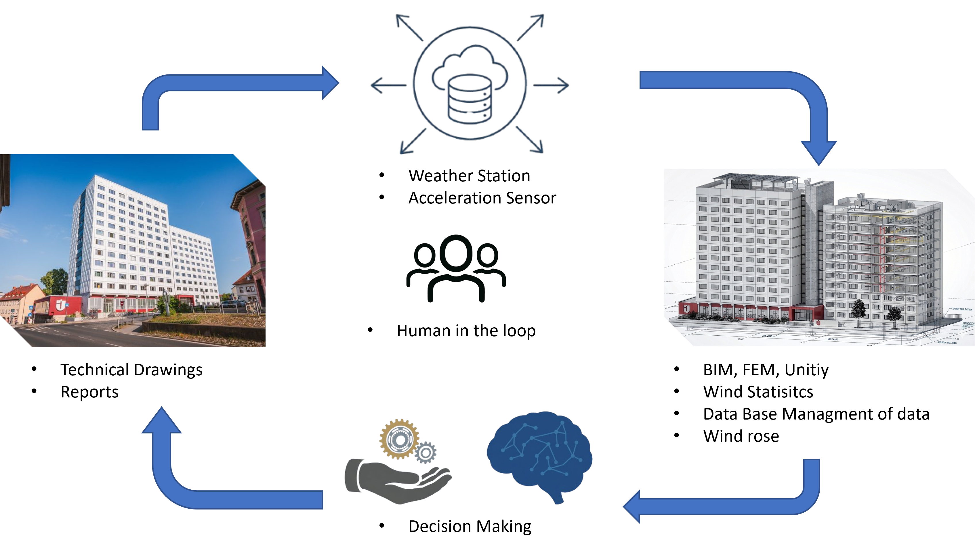
Figure 2: Digital Twin framework

Signal processing and FFT analysis
The recorded acceleration signals were transformed into the frequency domain using the Fast Fourier Transform (FFT), as given by Equation 1,

$X\left(f_{k}\right)= \sum_{n=0}^{N-1}{x\left(n\right)*e^{-\frac{j2πkn}{N}}}, k=0,1,…,N-1$ (1)

where 𝑥 (𝑛) is the 𝑛-th discrete acceleration sample, 𝑁 is the total number of samples, and $f_{k}=\frac{kf_{s}}{N}$ is the frequency corresponding to bin k at sampling frequency $f_{s}$. The dominant peaks in the resulting spectrum were identified as the principal natural frequencies (modes) of the structure.

Case Study
  - Physical Twin of the Jakobsplan building
[To be completed by Singh.] …… add info on the building, literature, anticipated periods and collapse mechanisms

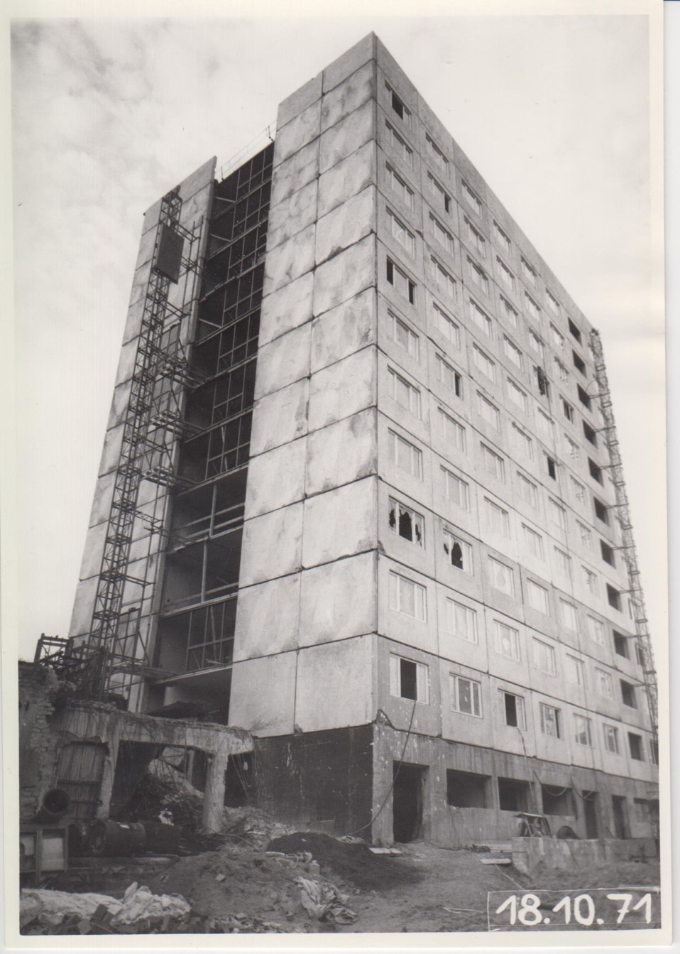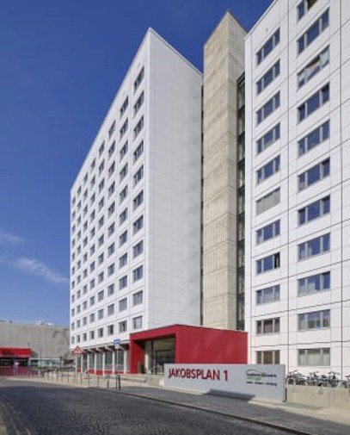
(a) (b)
Figure 3: Jakobsplan building, Weimar — a) Exterior view of the Jakobsplan complex during construction (1971); b) Exterior view of the Jakobsplan complex after renovation (current state)

Data Collection
[To be completed by Itzel.]

Weather Station
[To be completed by Itzel. here info about the wind conditions in Weimar, rose wind, analysis etc...]

Sensor node design and assembly
Three hardware platforms were evaluated for low-cost ambient-vibration data acquisition, each paired with a suitable acceleration sensor. The primary platform is the Nordic Thingy:53, a dedicated IoT prototyping module based on the Nordic nRF5340 dual-core SoC, which integrates an ADXL362 ultra-low-power three-axis MEMS accelerometer (Analog Devices) providing tri- axial linear acceleration; data are transmitted wirelessly via Bluetooth Low Energy 5.2. The second platform, used in Methodological Approach 2, consists of a Raspberry Pi Zero W a single-core 1 GHz single-board computer with 512 MB RAM and 802.11n Wi-Fi running a full Linux environment connected to an external MPU-6050 six-axis MEMS IMU via I2C at up to 1 kHz sampling rate. In this configuration the Raspberry Pi Zero W acts as both the sensor controller and the local data logger, transmitting the collected records over the local network. In Methodological Approach 1, a Raspberry Pi 3B serves as the central gateway, managing either Thingy:53 or MPU-6050 nodes; its quad-core 1.2 GHz processor and 1 GB RAM provide the processing capacity required for real-time data routing and storage, and data are forwarded using the MQTT protocol with Mosquitto as the message broker. As an additional low-cost alternative, an ESP32 dual-core 240 MHz microcontroller with integrated Wi-Fi and Bluetooth was coupled

with the MPU-6050 via I2C to broaden the comparison of sensor-platform combinations. For the purposes of this study, only the accelerometer channels 𝑎_{𝑥}, 𝑎_{𝑦}, and 𝑎_{𝑧} were used across all platforms, with a full-scale range set to ± 2 𝑔. The assembled devices are illustrated in Figure 4.
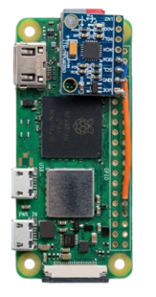  (a) | 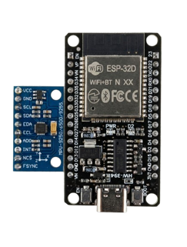  (b) | 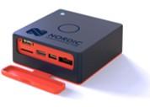  (c)
Figure 4: Assembly of the low-cost IoT sensor a) Raspberry Pi Zero W and MPU-6050 module; b) ESP32 microcontroller with MPU-6050 tri-axial accelerometer; c) Thingy - 53.

Firmware and data acquisition
The firmware for the Thingy:53 nodes was written in C using the nRF Connect SDK and manages the following tasks: (1) accelerometer initialisation and configuration; (2) timestamped sample acquisition at 400 Hz; (3) local buffering in SRAM; and (4) periodic data transmission to the Raspberry Pi 3B gateway via Bluetooth Low Energy 5.2. A companion Python application running on the Raspberry Pi 3B handled device management and forwarded the received data to a Mosquitto MQTT broker. For the Raspberry Pi Zero W / MPU-6050 nodes, the acquisition and transmission pipeline was implemented entirely in Python: the script reads accelerometer samples over I2C at 400 Hz and publishes them directly to the same MQTT broker over Wi- Fi. This client–broker architecture decouples data collection from storage and post-processing, and allows multiple nodes to operate simultaneously without mutual interference. All raw acceleration records were persisted in a PostgreSQL relational database, with a schema designed to store timestamped tri-axial acceleration samples indexed by node identifier and measurement session.

Sensor placement in the Jakobsplan building
Sensor positions were selected to try to capture the dominant translational and torsional modes of the building. The nodes were mounted at representative floor levels along the height of the structure, with the sensors rigidly fixed to the concrete slab surfaces to ensure good kinematic

coupling and to minimize measurement artefacts from local resonances of the mounting system. The exact positions and the corresponding coordinate system are detailed in Figure 5.

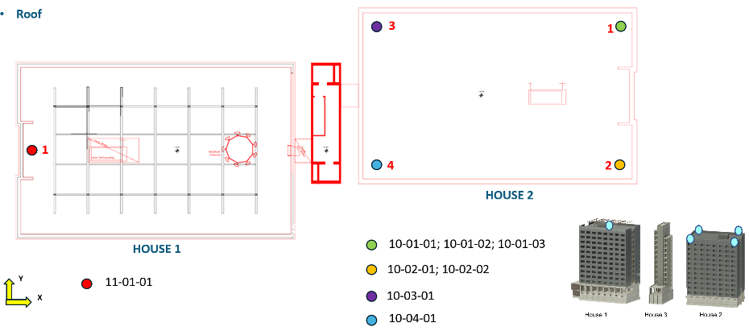
(a)
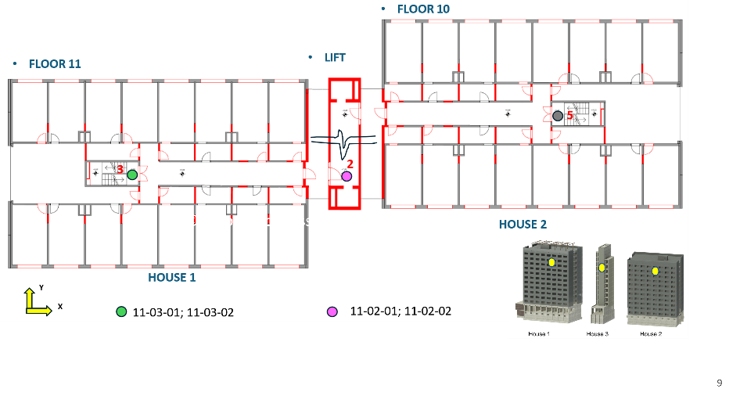
(b)
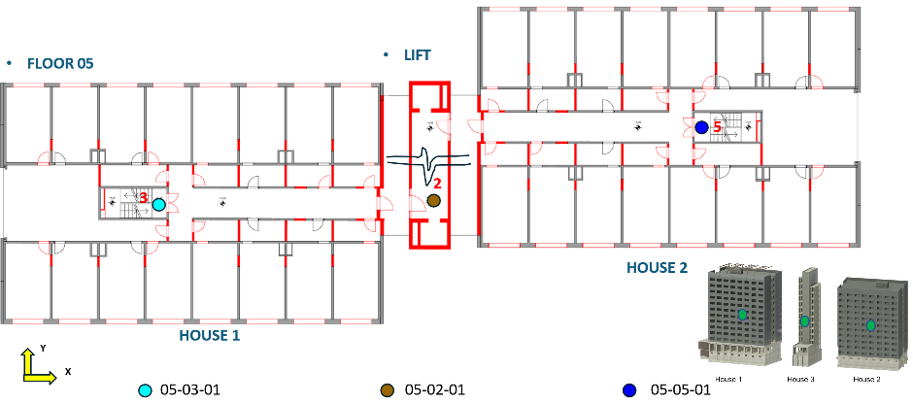
(c)
Figure 5: Sensor positions: a) Roof plan; b) Floor 10 and 11; c) Floor 5.

Virtual Twin
[To be completed Singh BIM and FEM model.]

Wind statistics
[To be completed by Itzel.]

Database Management and Visualization
The database infrastructure described in this section corresponds to the full Digital Twin work- flow (Methodological Approach 1, Figure 1 a), which implements real-time data acquisition, centralized storage, and continuous model updating.

Database Architecture. The sensor data management system employs PostgreSQL as the re- lational database management system (RDBMS), hosted on a centralized server. The database implements a normalized schema designed to accommodate multi-sensor, multi-channel time- series data from the distributed IoT sensor network described in the previous sections.

Database Schema. The schema follows a hierarchical relational structure organized into the following entities:
      - Project: Top-level organizational entity containing project metadata (name, owner).
      - Object: Physical structures or monitoring locations associated with projects.
      - SensorType: Classification of sensor hardware (e.g., Accelerometer), including version information.
      - Sensor: Individual sensor instances identified by unique identifiers (e.g., BP-NT-53-AC-01), linked to objects and sensor types.
      - Channel: Measurement channels associated with sensor types (e.g., 𝑎_{𝑥}, 𝑎_{𝑦}, 𝑎_{𝑧} for tri- axial accelerometers), including physical units.
      - NumericalValue: Primary data storage table containing the floating-point measurement value, channel identifier, timestamp, and sensor reference.
Data Ingestion Pipeline. The system implements a real-time streaming architecture using the MQTT protocol. Thingy:53 sensors transmit data via BLE to a Raspberry Pi gateway, which publishes to a Mosquitto MQTT broker. A Python bridge buffers data in batches of 10,000 records for bulk insertion into PostgreSQL, maximizing throughput at 400 Hz per sensor.

Visualization and Unity Integration. For real-time visualization, the Unity game engine con- nects to the PostgreSQL database to retrieve and render sensor data within a three-dimensional representation of the Jakobsplan building. Unity queries the database to obtain time-series acceleration data, which is then mapped to visual representations of structural motion within the 3D environment. This integration enables real-time monitoring and interactive visualiza- tion of structural vibrations, providing an intuitive interface for stakeholders to observe sensor measurements in the spatial context of the monitored structure.

Data Processing
[To be completed by Itzel.]

Mode | Description | Direction | 𝑓_{𝑛} (Hz)
1 | First translational (longitudinal) | 𝑥 | —
2 | First translational (transverse) | 𝑦 | —

Table 1: Natural frequencies identified from ambient vibration measurements at the Jakobsplan building.
put fft and PSD

Human Loop and decision making
[To be completed by Anastasia.]

Conclusions and future work
[To be completed.]

Acknowledgements
[To be completed.]

REFERENCES
[1] L. G. Severino et al. “Projections and uncertainties of winter windstorm damage in Europe in a changing climate”. In: Natural Hazards and Earth System Sciences 24.5 (2024),
pp. 1555–1578. doi: 10 . 5194 / nhess - 24 - 1555 - 2024. url: https : / / nhess . copernicus.org/articles/24/1555/2024/.

