INTRODUCTION TO MACHINE LEARNING

EXERCISE 5



Teacher:
Benno Stein

Group:
Group 2

Submitted by:

Cesar Fernando Gamba Tiusaba
Abhishek Dilip Patil
Asmae Mehdizadeh

Exercise 1:
(a) Name these concepts:
(a1) $x∣A$
The projection operator: it returns the component (feature value) of a feature vector $x$that corresponds to feature $A$.
(a2) $T$
A decision tree: a finite tree with a distinguished root node, used to classify feature vectors into classes.
(a3) $t$
A node of a decision tree $T$; it can be a non-leaf node (with a splitting) or a leaf node (assigned a class).
(a4) $X(t)$
The subset of feature vectors represented by node $t$; i.e., all $x∈X$that are filtered by the path from the root to $t$.
(a5) $D(t)$
The subset of examples represented by node $t$:
$D(t)=\{(x,c)∈D∣x∈X(t)\}$.
(a6) $\text{leaves}(T)$
The set of all leaf nodes of the decision tree $T$.
(a7) $ι$
An impurity function: a symmetric function defined on class probability distributions that is minimal for pure class distributions and maximal for uniform class distributions.
(a8) Weighted external path length
The sum of the lengths of all root-to-leaf paths, where each path length is weighted by the number of examples classified by that leaf.

(b) Name this expression: X = {x ∈ X : x|A ∈ B} ∪ {x ∈ X : x|A ̸∈ B}
Binary splitting induced by a nominal feature
This expression denotes a binary splitting of the feature space $X$induced by a nominal feature $A$, where the domain of $A$is partitioned into a subset $B⊂dom(A)$and its complement.
(c) What are the three requirements of an impurity function?
An impurity function $ι:[0,1]^{k}→R$must satisfy the following three properties:
(1) it attains its minimum at pure class distributions,
(2) it is symmetric with respect to its arguments, and
(3) it attains its maximum at the uniform class distribution.
(d) What is the hypothesis space of decision trees?
The hypothesis space of decision trees is the set of all possible decision trees that can be constructed over the example set $D$, each representing a classifier $T:X→C$.
(e) What is the search space of the ID3 algorithm?
The search space of the ID3 algorithm consists of all decision trees that can be formed by recursively selecting features for splitting, i.e., all trees over the given feature set that respect monothetic splits.
(f) What is the difference between the inductive bias of the candidate elimination algorithm and that of the ID3 algorithm? Hint: search bias and restriction bias.
The candidate elimination algorithm employs a restriction bias, since it assumes that the target concept can be represented perfectly within the given hypothesis space and therefore restricts learning to hypotheses that are fully consistent with the training data.
In contrast, the ID3 algorithm employs a search bias, as it searches the hypothesis space of decision trees heuristically using a greedy strategy based on information gain, without restricting the hypothesis space to only perfectly consistent hypotheses.

Exercise 2: Decision Trees
Construct by hand decision trees corresponding to each of the following Boolean formulas. The examples (x, c) ∈ D consist of a feature vector x where each component corresponds to one of the Boolean variables (A, B, . . .) used in the formula, and each example corresponds to one interpretation (i.e. assignment of 0/1 to the Boolean variables). The target concept c is the truth value of the formula given that interpretation. Assume the set D contains examples with all possible combinations of attribute values.
Hint: It may be helpful to write out the set D for each formula as a truth table.
- A ∧ ¬B

- A XOR B

- A ∨ (B ∧ C)

- (A ∧ B) ∨ (C ∧ D)

Exercise 3 : Impurity Functions
Let D be a set of examples over a feature space X and a set of classes C = {c1, c2, c3, c4}, with |D| = 24. Consider the following illustration of two possible decision trees, T1 and T2 – the colours represent the classes present in each subset D(ti) represented by node ti,j of Ti; the numbers denote how many examples of each class are present.
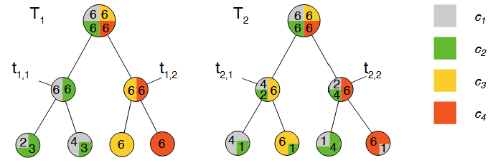
- First, consider only the first split that each of the two trees makes: compute ∆ι(D, (t_{1,1}), D(t_{1,2})}) and ∆ι(D, {D(t_{2,1}), D(t_{2,2})}) with (1) the misclassification rate $ι_{misclass}$ and (2) the entropy criterion $ι_{entropy}$ as splitting criterion.

- $ι_{misclass}=1-\frac{6}{24}=1-\frac{1}{4}=\frac{3}{4}$
For T₁ $ι_{misclass}=0.5$
Weighted impurity after split = 0.5
$Δι_{misclass}\left(T_{1}\right)=\frac{3}{4}-\frac{1}{2}=\frac{1}{4}$

For T₂ $ι_{misclass}=0.5$
$$Δι_{misclass}\left(T_{2}\right)=\frac{3}{4}-\frac{1}{2}=\frac{1}{4}$$
Both have the same $ι_{misclass}=\frac{1}{4}$

- $ι_{entropy}\left(D\right)=2$
For T₁ $ι_{entropy}=1$
Weighted impurity after split = 1
$$Δι_{entropy}\left(T_{1}\right)=1$$

For T₂ $ι_{entropy}=-\left(\frac{1}{3}\log_{2}{\frac{1}{3}+\frac{1}{6}\log_{2}{\frac{1}{6}+\frac{1}{2}\log_{2}{\frac{1}{2}}}}\right)≈1.459$
$$Δι_{entropy}\left(T_{2}\right)=2-1.459=0.541$$

Therefore T₁ is better with higher impurity reduction.

- If we compare T1 and T2 in terms of their misclassification rate on D, which one is the better decision tree?

Error(T₁) =5/24≈0.208.
Error(T₂​) =4/24≈0.167.
T₂​ is better by training misclassification rate.

- Assuming the splits shown are the only possibilities, which of T1 or T2 would the ID3 algorithm construct, and why?

Since ${Δι}_{entropy}\left(T_{1}\right)=1$ and ${Δι}_{entropy}\left(T_{2}\right)0=0.541$
ID3 choses T₁ as the first split (even thought T₂ ends up with slightly lower training error)
Exercise 4 : Decision Trees (5+0=5 Points)
Given is the following dataset to classifiy whether a dog is dangerous or well-behaved in character:
- Use the ID3 algorithm with ιentropy as the impurity function to determine the tree T.
Target classes:
- well-behaved (W)
- dangerous (D)
Counts:
- W = 4
- D = 3
- Total = 7
(a) Constructing the decision tree using ID3 and entropy (5 Points)
Step 1: Entropy of the full dataset
$$H(C)=-\frac{4}{7}{log⁡}_{2}\frac{4}{7}-\frac{3}{7}{log⁡}_{2}\frac{3}{7}≈0.985$$
Step 2: Information gain for each feature
Feature: Size
Size | W | D
small | 3 | 1
big | 1 | 2

- $H(C∣Size=small)≈0.811$
- $H(C∣Size=big)≈0.918$
$$H(C∣Size)=\frac{4}{7}⋅0.811+\frac{3}{7}⋅0.918≈0.857 \\ IG(Size)=0.985-0.857=0.128$$
Feature: Color
Color | W | D
brown | 1 | 0
black | 1 | 2
white | 1 | 1
red | 1 | 0
- brown → entropy = 0
- red → entropy = 0
- white → entropy = 1
- black → entropy ≈ 0.918
$$H(C∣Color)=\frac{3}{7}⋅0.918+\frac{2}{7}⋅1≈0.679 \\ IG(Color)=0.985-0.679=0.306$$

Feature: Fur
Fur | W | D
ragged | 2 | 1
smooth | 0 | 2
curly | 2 | 0
- ragged → entropy ≈ 0.918
- smooth → entropy = 0
- curly → entropy = 0
$$H(C∣Fur)=\frac{3}{7}⋅0.918=0.394 \\ IG(Fur)=0.985-0.394=0.591$$
Best split: Fur (highest information gain)
Final Decision Tree $T$
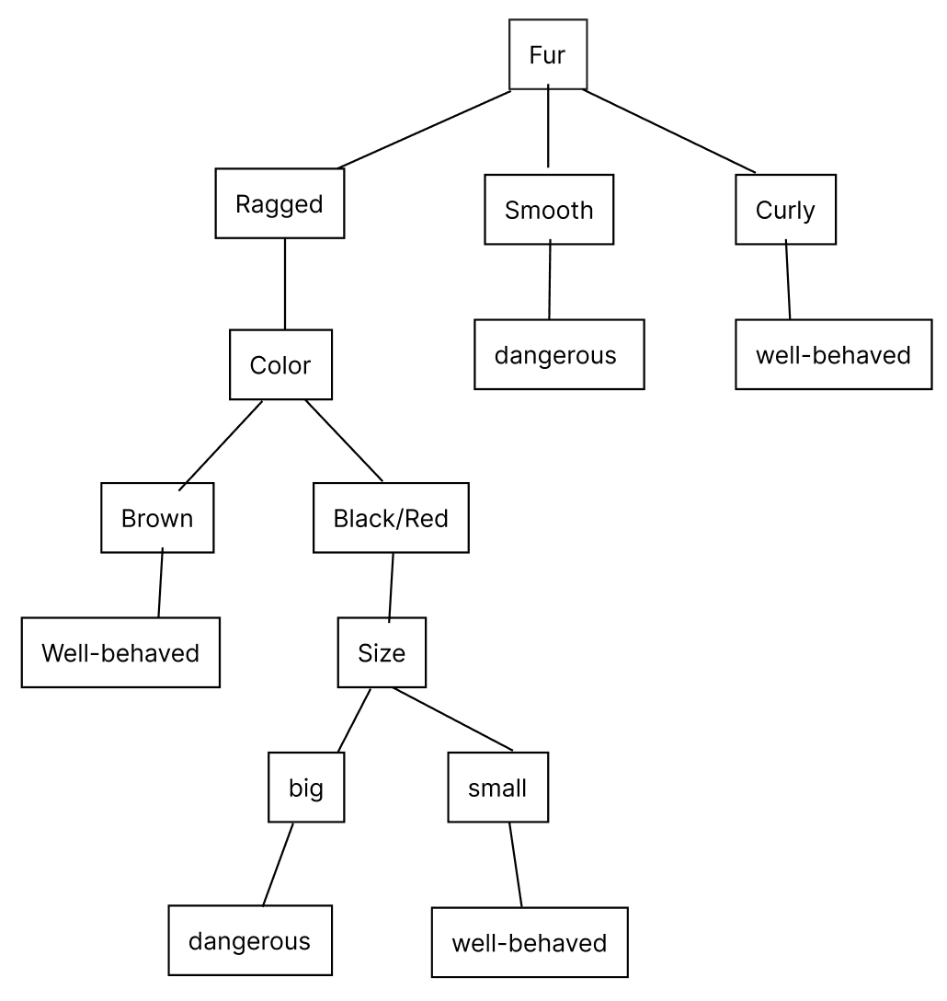

(b) Classify the new example (Color=black, Fur=ragged, Size=small) using T.
New example:
(Color = black, Fur = ragged, Size = small)
Classification path:
- Fur = ragged
- Color = black
- Size = small
Result: well-behaved

Exercise 5: Decision Tree Pruning
(a) Definition of decision tree pruning and its importance (1 Point)
Decision tree pruning is the process of removing parts of a fully grown decision tree (typically subtrees) in order to reduce overfitting and improve the tree’s ability to generalize to unseen data. The idea is to replace complex subtrees with leaf nodes when this simplification does not increase, or even reduces, the error on unseen or validation data.
Pruning is important because decision tree construction algorithms tend to prefer larger trees, which fit the training data increasingly well but may perform worse on test data. This behavior leads to overfitting, where training accuracy increases monotonically with tree size, while test accuracy eventually decreases. Pruning counteracts this by controlling model complexity and selecting a tree that better balances training performance and generalization.
(b) Comparison of approaches to counter overfitting (2 Points)
(i) Stopping during tree construction (pre-pruning)
Description
Stopping during tree construction means terminating the splitting process early based on predefined criteria, instead of growing a complete tree. Common stopping criteria include:
- Minimum size of the data at a node
- Purity of the node’s data
- Minimum impurity reduction achieved by a split
Advantages
- Computationally efficient, since the tree is never fully grown.
- Prevents the creation of very large trees from the beginning.
Disadvantages
- Choosing appropriate thresholds is difficult:
  - Too small thresholds result in oversized trees.
  - Too large thresholds may prevent useful splits.
- Perfect purity cannot be expected with noisy data.
- Impurity reduction cannot be reliably extrapolated with respect to tree height, making early decisions potentially suboptimal.

(ii) Pruning after tree construction (post-pruning)
Description
Pruning after tree construction first builds a sufficiently large tree and then removes subtrees bottom-up. A common method is reduced error pruning, which evaluates whether replacing a subtree with a leaf improves or maintains performance on a validation set.
This approach typically involves splitting the dataset into training, validation, and test sets. Pruning decisions are guided by validation error rather than training error.
Advantages
- Allows the algorithm to explore complex structures first.
- Pruning decisions are based on observed generalization performance.
- Generally leads to better model selection than early stopping.
Disadvantages
- Requires additional data for validation, which may be problematic for small datasets.
- Locally optimal pruning decisions do not always lead to the globally best tree.
- Some pruned trees may not be directly comparable in the pruning-induced ordering.
Which approach is generally preferred?
pruning after tree construction is generally preferred. This is because early stopping relies on local heuristics that are hard to tune and may prevent beneficial splits, whereas post-pruning evaluates simplifications based on actual generalization behavior, typically using a validation set.

Exercise 6:

Consider the set of training examples describing mushrooms, and the simple one-level decision tree given below:

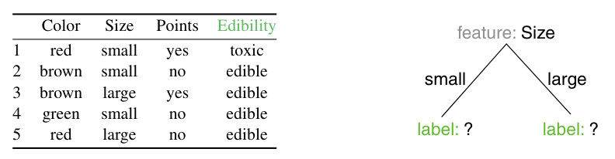
(a) Determine the labels of all nodes using the given cost function.

The cost function is defined as:
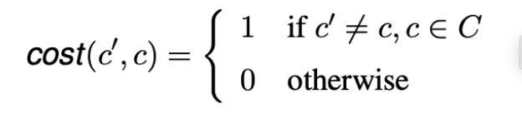
1. Training Data:
• Edibility: “toxic” or “edible.”
• Nodes split by “Size” into small and large.
2. Determine labels:
• For each leaf node, assign the most common label from the corresponding subset. If there’s a tie, any label can be assigned.
3. Subsets:
• Size = small: Instances 1, 2, 4 → Toxic: 1, Edible: 2. Majority: Edible.
• Size = large: Instances 3, 5 → Toxic: 1, Edible: 1. Tie, assign any (e.g., Edible).

(b) Devise a new cost function

The new cost function is designed to heavily penalize the classification of toxic mushrooms as edible. It can be expressed as:

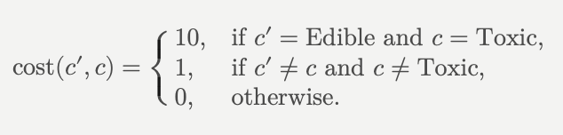

The goal is to design a cost function that penalizes classifying a toxic mushroom as edible more heavily than other errors
This ensures that misclassifying toxic mushrooms has a much higher penalty than other types of errors.

(c) Compute the misclassification costs

For the given decision tree and training data:
Original Cost Function:
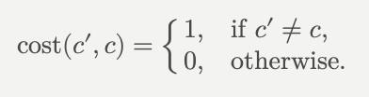
• Misclassification costs:
• Small subset: 1 toxic misclassified → Cost = 1
• Large subset: 1 toxic misclassified → Cost = 1
• Total Cost: 1 + 1 = 2
New Cost Function:
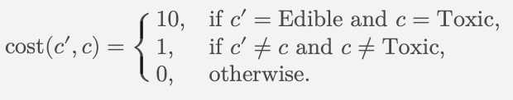
• Misclassification costs:
• Small subset: 1 toxic misclassified → Cost = 10
• Large subset: 1 toxic misclassified → Cost = 10
• Total Cost: 10 + 10 =20

Exercise 7: Argument Quality Prediction with CART Decision Trees
In this exercise, you will implement the CART algorithm for constructing decision trees for argument quality prediction. To make the implementation less complex, we will assume all features are numeric, and not consider nominal or ordinal features. Submit the file with your predictions for the test set along with your other solutions.
Download and use these files from Moodle (the tsv files are the same as in the last sheet):
• features-train-cleaned.tsv: Feature vectors for each example in the training set.
• features-test-cleaned.tsv: Feature vectors for each example in the test set.
• quality-scores-train-cleaned.tsv: Quality scores for each example in the training set.
• programming_exercise_decision_trees.py: Template for the programming exercise. It
contains function stubs for each function mentioned below. The template contains code from our solution from the last exercise sheet that we can re-use. The program should be used like this with
the files above:
python3 programming_exercise_decision_trees.py
features-train-cleaned.tsv quality-scores-train-cleaned.tsv
features-test-cleaned.tsv
• requirements.txt: Requirements file for the template; can be used to install dependencies.
(a) Implement a function most_common_class to find the most common class in the dataset.
(b) Implement a function gini_impurity that computes the Gini index for the given set of example.
classes C (slide ML:VI-79).
(c) Implement a function gini_impurity_reduction that computes the Gini impurity reduction of a binary split (slide ML:VI-50).
(d) Implement a function possible_thresholds that returns all possible thresholds for splitting the example set X along the given feature. Pick thresholds as the mid-point between all pairs of distinct, consecutive values in ascending order.
(e) Implement a function find_best_split that finds the best split based on the Gini impurity reduction for the given set of examples X and the given set of classes C.
(f) Implement the id3_cart function to construct a CART decision tree with the modified ID3 algorithm (slides ML:VI-109, ML:VI-22). The function should return the root node of the tree.
(g) Implement a function train_and_predict. This function should train the model on the training
set and return the predictions for the test set. What is the misclassification rate on the training set?
If you would like to improve your model, here are some hints of what you could try:
• Modify the train_and_predict function to split the training set into a training and a validation set. Use the validation set to find the best depth for the CART algorithm.
• Implement a stopping criterion from slide ML:VI-129 to avoid overfitting.
• Implement the pruning algorithm from slide ML:VI-130 to avoid overfitting

The code can be found in the attached files.

