INTRODUCTION TO MACHINE LEARNING

EXERCISE 1



Teacher:
Benno Stein

Group:
Group 2

Submitted by:

Cesar Fernando Gamba Tiusaba
Abhishek Dilip Patil
Asmae Mehdizadeh

Exercise 1: Machine learning (general)
- Define the terms “supervised learning”, “unsupervised learning”, and “reinforcement learning”.

Supervised learning: type of learning that use labelled data to train model, with the goal to have a model that can differentiate new data base in the training process with the training data set.

Unsupervised learning: The model is trained with an unlabelled data set; the goal is to identify patterns in the train data in order to cluster / differentiate new data. All this process is made without the guidance of the user.

Reinforcement Learning: the model learns to make decisions by taking actions in an environment, the model receives feedback from the user in form of “Penalties” or “rewards” based on the actions of the model. The model adjusts its behaviour to maximize the correct predictions (“rewards”).

- Determine the learning paradigm (supervised, unsupervised, reinforcement) for the following tasks:

- Diagnosing diseases from medical scans:
Supervised learning → It is used labelled image data set (scan images with diagnosis) to train the model.
- Robot arm learning to grasp objects through feedback:
reinforced learning → The robot (the machine learning model that controls the robot) received a penalty or a reward based on performance.
- Grouping customers by purchasing behaviour:
Unsupervised learning → The model is trained with unlabelled data in order to find hidden patterns and tendencies.
- Discovering topics in a large corpus of research papers:
Unsupervised learning → The idea is to find hidden patterns / structures without labels.
- Self-driving car:
Reinforced learning, supervised learning → The model is initially trained on labelled data using supervised learning, while reinforcement learning is employed to further enhance safety and efficiency. Ultimately, the system makes decisions by combining knowledge from labelled examples with a reward-and-penalty feedback mechanism.
- Spam filtering:
Supervised learning → This task relies on labeled emails (spam or not spam) to train a model to classify incoming messages.

Exercise 2: Specification of Learning Tasks
The following picture from the lecture slides describes the relationship between Real World and Model World, when it comes to the specification of learning tasks.
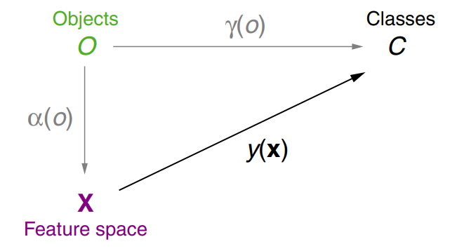
Assume you are building a machine learning system that predicts whether a wine sample is of high or low quality. For the following list, decide which symbol from the picture most closely matches the given list item:
- A cellar containing hundreds of wine bottles of different types.
O Objects

- A table listing for each wine its measured values of acidity, sugar, alcohol, and pH.
X Feature space

- A professional sommelier who can accurately rate any wine as “high-quality” or “low-quality.”
γ(o) Ideal classifier (a human) for real-world objects.

- A laboratory instrument that measures chemical features like acidity, sugar, and alcohol content.
α(o) Model formation function.

- The set {HighQuality, LowQuality}
C Classes

- The machine learning model you are trying to train that predicts wine quality from its measured features.
y(x) Classifier (model function) to be learned.
Exercise 3: Machine learning (general)
Throughout the programming labs, we will work on the task of text regression: given a text, predict whether it was written by a human or an AI. The dataset comprises multiple text genres, such as news articles, Wikipedia intro texts, or fanfiction. The main purpose of this exercise is to get familiar with the dataset that we will be using throughout the labs. Each group member has to read 5 texts and label each of them as written by a human or a large language model (LLM).
- Annotate your part of the dataset. To get the annotation data, use the “[annotation]” button on Moodle schedule. Click on “Guidelines” and read them carefully before annotating. After annotating, click “save” to download your annotations. Add the downloaded json files to the zip file that you submit to Moodle. Note: To get points for this exercise, all group members have to submit their annotations.

See the File called “Answers_Human_AI”attached to this report.

- Look back to the exercise 2. Which symbol in the picture corresponds to the role that you are playing? Which symbol corresponds to the functions that you implement in this exercise?

In this exercise we are the ideal classifier we based on a set of objects (O) asses γ(O) to get a set of classes (we are γ), in this scenario we classified Human or AI generated texts.
$$Objects \left(O\right)→γ\left(O\right)→Classes(C)$$

- Implement a program to extract the features from texts, such as the number of sentences and the average word length. Come up with 3 additional features that you think might be useful for this task. The program should take a text as an input and output a CSV file with columns corresponding to the five features and rows corresponding to texts.

See the python file called “DataNL_Extraction.py”
Exercise 4: Rule-Based Learning
The examples of a training set for a classification problem are described by the values of the attributes A1, . . ., Ap and the related concepts C = {0, 1}. For the attributes A1, . . ., Ap there are in each case m1, . . . , mp values, e.g. ai,1, . . . , ai, mi for Ai . The hypothesis space contains the conjunctions of restrictions for the attributes: “A1 has value a1,j1 and . . . and Ap has value ap,jp ”. A question mark in a hypothesis denotes a wildcard for the respective attribute domain. The hypothesis space does also contain the empty hypothesis ⊥, which assigns all examples to the concept 0.
- Determine the number n(p) of all possible examples for this problem.
$$n\left(p\right)=m_{1}×m_{2}×…×m_{p}=\prod_{i=1}^{p}{m_{i}}$$

- Determine the number |Hp| of different hypotheses.
$$\left|H_{p}\right|=\left(\prod_{i=1}^{p}{\left(m_{i}+1\right)}\right)+1$$

- How will the above answers change, if an additional attribute Ap+1 with mp+1 values is added? Derive a recursion formula
$$n\left(p+1\right)=m_{p+1}n\left(p\right), with n\left(0\right)=1$$

$$\left|H_{p+1}\right|=\left(\prod_{i=1}^{p+1}{\left(m_{i}+1\right)}\right)+1$$

$$\left|H_{p+1}\right|=\left(m_{p+1}+1\right)\left(\left|H_{p}\right|-1\right)+1, with \left|H_{0}\right|=2$$

Exercise 5: Rule-Based Learning (Practice)
Given is the following training set D, which you have obtained as co-driver by observing your friend:
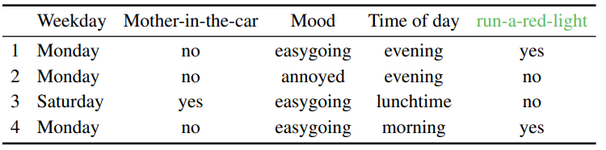
Let the set H contain hypotheses that are built from a conjunction of restrictions for attribute-value combinations; e. g. (Monday, yes, ?, ?).
- Apply the Find-S algorithm for the example sequence 1, 2, 3, 4.

The most specific hypothesis $h=(∅,∅,∅,∅)$.
- Seq 1 — positive: (Monday, no, easygoing, evening) ⇒ set
$h=(\text{Monday},\text{ no},\text{ easygoing},\text{ evening})$.
- Seq 2 — negative: ignore.
- Seq 3 — negative: ignore.
- Seq 4 — positive: (Monday, no, easygoing, morning).
Compare to current $h$.
Final $h=(\text{Monday},\text{ no},\text{ easygoing},\text{ ?})$.
- Apply the Candidate-Elimination algorithm for the example sequence 1, 2, 3, 4, and identify the boundary sets HS and HG.

Initialize:
- $S=\{(∅,∅,∅,∅)\}$
- $G=\{(?,?,?,?)\}$
Seq 1: positive (Monday, no, easygoing, evening)
- $S=\{(\text{Monday},\text{no},\text{easygoing},\text{evening})\}$
- G = $\{(?,?,?,?)\}$
Seq 2: negative (Monday, no, annoyed, evening)
After ex2:
- S = { (Monday, no, easygoing, evening) }
- G = { (?, ?, easygoing, ?) }
Seq 3: negative (Saturday, yes, easygoing, lunchtime)
- S = { (Monday, no, easygoing, evening) }
- G = { (Monday, ?, easygoing, ?), (?, no, easygoing, ?), (?, ?, easygoing, evening) }
After Seq 4: positive (Monday, no, easygoing, morning)
Final boundary sets after all 4 sequences:
- HS (specific boundary) = { (Monday, no, easygoing, ?) }
- HG (general boundary) = { (Monday, ?, easygoing, ?), (?, no, easygoing, ?) }
- What is the version space HD for this example?

The version space is:
HD = { (Monday, no, easygoing, ?), (Monday, ?, easygoing, ?), (?, no, easygoing, ?) }

Exercise 6: Rule-Based Learning (Background)
- Can a version space HD contain hypotheses that are neither in the set HS nor in the set HG? If so, how?

Yes, the version space $VS_{H,D}$can include intermediate hypotheses that are neither in $S_{H}$nor $G_{H}$. These are hypotheses that are more general than some members of $S_{H}$and more specific than some members of $G_{H}$, and they are still consistent with the training data.

- For any two hypotheses y1(), y2(), y1() ̸= y2(), from the set HS of a version space HD holds (check all that apply):
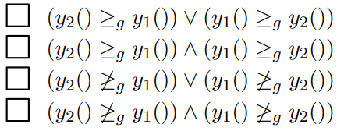
- (y2() ≥g y1()) ∨ (y1() ≥g y2()) False.
If one were more general than the other, the more general one could not be in $S_{H}$(because $S_{H}$contains most specific consistent hypotheses). So distinct elements of $S_{H}$need not be comparable.
- (y2() ≥g y1()) ∧ (y1() ≥g y2()) False.
That would imply equality, contradicting $y_{1}≠y_{2}$.
- (y2() ̸≥g y1()) ∨ (y1() ̸≥g y2()) True.
At least one of the “not more general” relations must hold (indeed in fact both hold for most cases).
- (y2() ̸≥g y1()) ∧ (y1() ̸≥g y2()) True (in general).
Distinct members of $S_{H}$are typically pairwise incomparable under the generality order, so neither is more general than the other.

- Which of the two algorithms Find-S and Candidate-Elimination has a stronger inductive bias? Explain your answer.

Find-S has a stronger inductive bias as it picks the single most specific consistent hypothesis, ruling out many others. Candidate-Elimination is weaker in bias since it keeps all hypotheses consistent with the data within the version space.

