INTRODUCTION TO MACHINE LEARNING

EXERCISE 4



Teacher:
Benno Stein

Group:
Group 2

Submitted by:

Cesar Fernando Gamba Tiusaba
Abhishek Dilip Patil
Asmae Mehdizadeh

Exercise 1: Gradient Descent
- Name one difference between the perceptron training rule and the gradient descent method.
A key difference is that the perceptron training rule updates the weights only for misclassified examples and does not minimize a differentiable error function, whereas gradient descent updates the weights by minimizing a differentiable error function using its gradient.
The perceptron relies on a threshold (step) function, which makes its error function non-differentiable, while gradient descent requires a continuous and differentiable error function.
- What are the main requirements for the hypothesis space and error function for gradient descent to be successfully applied?

- For gradient descent to be successfully applied, the hypothesis space must be continuous and differentiable with respect to its parameters, allowing smooth changes of the model weights.
- The error function must be continuous and differentiable, since gradient descent computes partial derivatives of the error with respect to the weights in order to determine the update direction. If the error surface or the hypothesis function is not differentiable, gradient-based optimization is not applicable.

- Name the key difference between the algorithm of batch gradient descent (BGD) and the algorithm of incremental gradient descent (IGD).
The fundamental difference between BGD and IGD lies in how and when the gradient is computed and applied to update the model parameters.

1. Batch Gradient Descent (BGD)
In Batch Gradient Descent, the weight update is computed using the entire training dataset at once. In each iteration, BGD:
  - Evaluates the model on all examples $(x,c)∈D$,
  - Accumulates the gradients (or residual-based updates) over the full dataset,
  - Performs one single weight update per iteration based on the global loss.
Formally, for squared loss, the update direction corresponds to the negative gradient of the global loss function:
$$Δw=-η ∇L_{2}(w)=η\sum_{(x,c)∈D}{(c-}w^{T}x) x$$
Algorithmically, the update step happens after looping over all training examples.
Implications:
- Uses the exact gradient of the global loss.
- Produces stable and smooth convergence.
- Computationally expensive for large datasets, since each iteration requires a full pass over $D$.

2. Incremental Gradient Descent (IGD)
In Incremental Gradient Descent, the weights are updated after each single training example.
- For every example $\left(x , c\right)$:
  - The pointwise loss is computed,
  - The gradient of this single-example loss is calculated,
  - The weight vector is immediately updated:
$$Δw=η(c-w^{T}x) x$$
Thus, IGD performs many small updates within one pass over the dataset, instead of one aggregated update at the end
Implications:
- Approximates the batch gradient using local, example-wise updates.
- Faster and more memory-efficient for large datasets.
- The update direction is noisier but can help avoid poor local minima.
- Closely related to the delta rule / LMS rule and forms the basis of SGD.
Exercise 2: Perceptron Learning (2 Points) Consider two perceptrons, y0() and y1(), both defined by the function heaviside( Pp j=0 wjxj ). Both perceptrons have identical weights except for the bias term: w0 = 0 for y0() and w0 = 1 for y1(). Determine if one of the perceptrons, y0() or y1(), is more general than the other (as defined in the lecture units on concept learning). If one is more general, specify which one and explain your answer.
Yes, $y_{0}()$is more general than $y_{1}()$.
Both perceptrons use the same weights except for the bias term. The decision function is
$$y(x)=\text{heaviside }\left(\sum_{j=0}^{p}{w_{j}}x_{j}\right)$$with $x_{0}=1$.
- For $y_{0}()$, $w_{0}=0$, so the decision boundary is
$$\sum_{j=1}^{p}{w_{j}}x_{j}=0$$
which is a hyperplane passing through the origin.
- For $y_{1}()$, $w_{0}=1$, the boundary becomes
$$\sum_{j=1}^{p}{w_{j}}x_{j}+1=0$$which is a shifted hyperplane with a fixed offset.
Why is $y_{0}()$more general than $y_{1}()$?
- In concept learning, a hypothesis is more general if it accepts a superset of instances.
- $y_{0}()$has no fixed bias shift, so it imposes fewer constraints on the decision boundary.
- $y_{1}()$has a fixed positive bias, which requires extra evidence from the input to classify an example as positive.
- Any example classified as positive by $y_{1}()$will also be classified as positive by $y_{0}()$.
- However, $y_{0}()$can classify additional examples as positive that $y_{1}()$cannot.
Therefore, the set of positives of $y_{1}()$is a subset of those of $y_{0}()$, and $y_{0}()$is more general than $y_{1}()$.
Exercise 3 : Backpropagation (2 Points) In the early slides ML:IV-9, the Perceptron uses the Heaviside step function. In the MLP section ML:IV-66, this is replaced by the Sigmoid function σ(z). Explain the primary mathematical reason for this switch in the context of the Backpropagation algorithm.
The primary mathematical reason for replacing the Heaviside step function with the sigmoid function in MLPs is that backpropagation requires differentiable activation functions.
- The Heaviside step function is not differentiable (its derivative is zero almost everywhere and undefined at the threshold).
As a result, gradients cannot be computed, and gradient-based learning is impossible.
- The sigmoid function $σ(z)$is continuous and differentiable everywhere, with a well-defined derivative:
$$σ^{'}(z)=σ(z)(1-σ(z))$$This allows gradients to be propagated backward through the network using the chain rule.
Because backpropagation relies on computing partial derivatives of the loss with respect to weights in all layers, the sigmoid function enables error signals to flow backward, while the Heaviside function blocks learning.
Therefore, the switch is necessary to make backpropagation mathematically feasible.

Exercise 7: Parameters of the Multilayer Perceptrons
In this exercise, you analyze the number of weights (parameters) of multilayer perceptrons. We use the notation from the lecture (e.g., slide ML:IV-104), where multilayer perceptrons have d layers, p attributes, hidden layer i with li units, and an output layer with k units.

- Let d = 4, p = 6, l1 = 4, l2 = 4, l3 = 2, and k = 3. Draw the graph of the multilayer perceptron.
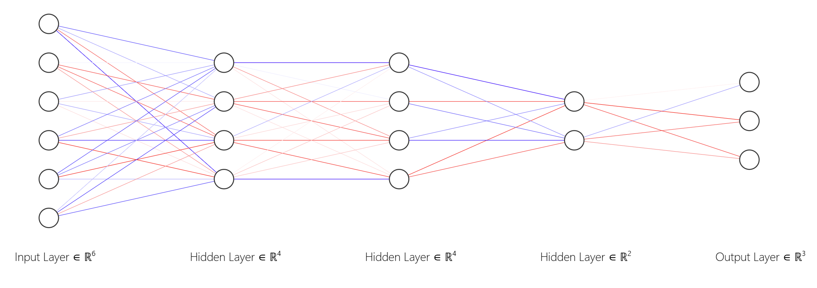

- Calculate the number of weights in the multilayer perceptron of (a).

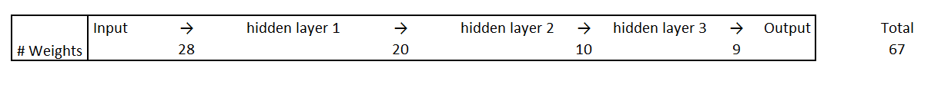
Total amount of weights = 67

For each perceptron you calculate the number of weights + bias with the amount of preceptrons in the next layer.

- Calculate the number of weights in the multilayer perceptron of (a) but with each li doubled, i.e., l1 = 8, l2 = 8, l3 = 4. Has the number of weights doubled as well?

Total amount of weights = 179

- Let f(p, l1, . . . , ld−1, k) be a function that computes the number of weights in the general case. Write down an expression for f.
$$f\left(p, l_{1}, …, l_{d-1}, k\right)=\left(p+1\right)*l_{1}+\left(l_{d-1}+1\right)*k+\sum_{i=1}^{d-2}{\left(l_{i}+1\right)*l_{i+1}}$$
Exercise 8: P Classification with Neural Networks
In this exercise, you will implement a two-layer perceptron for predicting whether a given text was written by a human or generated by a language model. Download and use these files from Moodle (the tsv files are the same as in the last sheet):
- features-train.tsv: Feature vectors for each example in the training set.
- features-test.tsv: Feature vectors for each example in the test set.
- labels-train.tsv: Labels for each example in the training set indicating the class is_human (C = {True, False})
- programming_exercise_neural_networks.py: Template containing function stubs for the exercise. Use it with the files above as follows:
- python3 programming_exercise_neural_networks.py
- features-train.tsv
- labels-train.tsv
- features-test.tsv
- predictions-test.tsv
- requirements.txt: Requirements file for the template; can be used to install dependencies.
- Implement a function encode_class_values to encode class values as vectors c ∈ {0, 1}k (see slide ML:IV-100).
- Implement a function predict_probabilities that, given Wh and Wo, predicts the class probabilities for each example of a dataset.
- Implement a function predict that, given Wh and Wo, predicts the class for each example of a dataset (as the one with the highest probability).
- Implement a function train_multilayer_perceptron that fits a multilayer perceptron using the IGD Algorithm (slide ML:IV-100). Like in the last exercise sheet, make sure to return the misclassification rate on both training and validation set for plotting, but this time also return the weights after each iteration (for task (e)).1
- Select the model (iteration) that achieved the best misclassification rate on the validation set and use it to predict the label for each example in the test set (features-test.tsv). Write the predictions as one column to a file predictions-test.tsv and submit that along with your other solutions.
- Which lines of your code would you need to change from two classes to three? Mark each of them with the comment “# change for 3 classes”.
If you would like to improve your model, here are some suggestions:
- Try experimenting with adjusting various hyperparameters of the model (e.g. learning rate, number of hidden units, etc).
- Try to decrease the learning rate with each iteration.
- Try to implement one of the feature scaling methods explained in this video by Andrew Ng.
- Implement k-fold cross-validation instead of using a single hold-out in order to get a more robust estimate of your model’s performance on the unseen data.
- Expand your implementation to support perceptrons with more than two layers. Hint: the parameter l can be replaced by a list of layer sizes; the weight matrices for the hidden layers can also be stored in a list.

