INTRODUCTION TO MACHINE LEARNING

EXERCISE 2



Teacher:
Benno Stein

Group:
Group 2

Submitted by:

Cesar Fernando Gamba Tiusaba
Abhishek Dilip Patil
Asmae Mehdizadeh

- Exercise 1 : Machine Learning Basics (0.5+0.5+0.5+0.5+0.5+0.5=3 Points) (a) Name these five concepts: x, x, X, X, X $x_{j}$: a single feature value (the j-th component of a feature vector).
- $x$: a feature vector / data instance (e.g., $(x_{1},…,x_{p})$).
- $X :$feature space, domain of the feature vectors.
- $X$: multiset of feature vectors
- $X$: multivariate random variable whose instances are feature vectors.
A multivariate random variable (or random vector) is a collection of several random variables whose values are unknown due to uncertainty or because they haven't been observed yet. These variables are grouped together because they describe different aspects of the same underlying system or statistical entity.

(b) Hypothesis space $H$of linear regression with $p$features
A linear regression hypothesis has the form:
$$h_{w,b}(x)=w_{1}x_{1}+w_{2}x_{2}+⋯+w_{p}x_{p}+b$$
So the hypothesis space is the set of all possible linear functions with $p$features:
$$\boxed{H=\{ h(x)=\sum_{j=1}^{p}{}w_{j}x_{j}+b | w_{1},…,w_{p}∈R, b∈R\}}$$
Another equivalent and more compact vector form:
$$\boxed{H=\{ h(x)=w^{⊤}x+b∣w∈R^{p}, b∈R\}}$$

(c) Explain the Bayes error.
The Bayes classifier (or Bayes optimal classifier) assigns each feature vector $x$to the class $c$that has the highest probability under the true data-generating distribution $p(c,x)$. However, even this optimal classifier can still make mistakes.
Bayes error occurs whenever a single feature vector can correspond to multiple classes with non-zero probability. This happens when the correct class depends on additional variables that are not included in $x$, or when the mapping from features to classes is inherently random.

c) How can one reduce the Bayes error?
In theory: it cannot be reduce with a better model, because it is irreducible.
In practice, it can be reduced only by changing the data-generating process, e.g.:
- Collect more informative features
- Reduce measurement noise
- Improve label quality / relabel noisy data
- Add relevant variables or sensors
- Use more precise problem definitions
We cannot reduce Bayes error simply by training a more complex ML model.

(e) Give an example of a dataset D1 with (label) noise: D1 = {. . $\begin{matrix}D_{1}=\{ & ((1,0),0), ((1,0),1), ((1,0),0), ((1,0),1), \\ & ((2,1),1), ((2,1),1), ((2,1),0), \\ & ((0,1),1), ((0,1),1), ((0,1),0), \\ & ((3,2),0), ((3,2),1), \\ & ((5,5),1), ((5,5),1), ((5,5),0) \}\end{matrix}$

Label noise occurs when the same feature vector corresponds to multiple labels:
- (1,0) appears with labels 0 and 1 → noise
- (2,1) appears with labels 1 and 0 → noise
- (0,1) appears with labels 1 and 0 → noise
- (3,2) appears with labels 0 and 1 → noise
- (5,5) appears with labels 1 and 0 → noise

(f) Stratified sample of size 6 from dataset $D2$
Dataset:$D_{2}=\{(x_{1},c_{1}),(x_{2},c_{2}),(x_{3},c_{3}),(x_{4},c_{2}),(x_{5},c_{2}),(x_{6},c_{3}),(x_{7},c_{1}),(x_{8},c_{3}),(x_{9},c_{2}),(x_{10},c_{2}),(x_{11},c_{3}),(x_{12},c_{2})\}$
Count labels:
- Class c1: $x_{1},x_{7}$→ 2 items
- Class c2: $x_{2},x_{4},x_{5},x_{9},x_{10},x_{12}$→ 6 items
- Class c3: $x_{3},x_{6},x_{8},x_{11}$→ 4 items
Total = 12
We need sample size = 6 → take 50% of each class:
- From c1: take 1 item
- From c2: take 3 items
- From c3: take 2 items
One possible stratified sample:
D2,tr​={(x1​,c1​), (x2​,c2​), (x4​,c2​), (x9​,c2​), (x3​,c3​), (x8​,c3​)}
(Any valid stratified sample with the same proportions is fine.)

Exercise 2: Probabilistic Foundation of the True Misclassification Rate
Consider a sample space Omega = {o {1}, o{2}, o{3}, o{4}, o{5}, o{6}} with six outcomes; i.e., each elementary event {o{i}} corresponds to observing one of six distinct objects. Let X subset R ^ 2 be a feature space, C = {0, 1} be of two classes, and P be a probability measure defined on {P}. Further, let X: Omega -> X and C : Omega -> C be two random variables defined according to this table:
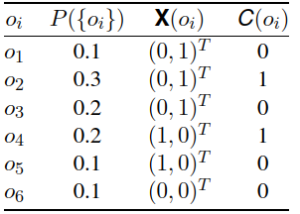
- Specify the joint distribution function p(x, c) := P (X=x, C=c) by completing this table:
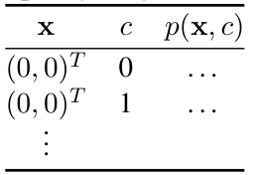
x | c | p(x,c)
(0,0)ᵀ | 0 | 0.1
(0,0)ᵀ | 1 | 0
(0,1)ᵀ | 0 | 0.3
(0,1)ᵀ | 1 | 0.3
(1,0)ᵀ | 0 | 0.1
(1,0)ᵀ | 1 | 0.2

- Specify the Bayes classifier y*() by completing this table (potentially more than one correct answer):
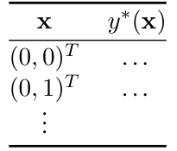
x | y*(x)
(0,0)ᵀ | 0
(0,1)ᵀ | 0 or 1 (equal probability)
(1,0)ᵀ | 1

- Specify the true misclassification rate Err ∗ of the Bayes classifier.
Err∗=x∑​c∑​p(x,c)⋅I(y∗(x)=c)
✔ Case 1: $x=(0,1)$
We predicted: either 0 or 1
We pick 0 (the instructor may choose either; both are valid).
Let’s assume $y^{*}(x)=0$.
True probabilities:
- $p((0,1),0)=0.3$
- $p((0,1),1)=0.3$
- Misclassified class = 1→ Misclassification contributes:$0.3$
✔ Case 2: $x=(1,0)$, predicted 1
True probabilities:
- $p((1,0),0)=0.1$
- $p((1,0),1)=0.2$
- Misclassified class = 0 → contributes:$0.1$
✔ Case 3: $x=(0,0)$, predicted 0
True:
- all probability mass: 0.1 on class 0
Total Bayes error
$$Err^{*}=0.3+0.1+0=0.4$$
This result matches the alternative max-form:
$${\text{Err}}^{*}=\sum_{x}{}(p(x)-\underset{c}{max⁡}p(x,c))$$
which gives $(0.6-0.3)+(0.3-0.2)+(0.1-0.1)=0.3+0.1+0=0.4$.

Exercise 3: Evaluating Effectiveness
Consider the following family of classification models:
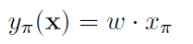
where w ∈ {1,−1} is a model parameter learned from data, and π ∈ {1, . . . , p} is a hyperparameter selected manually beforehand. During training, the parameter w is chosen according to the simple learning algorithm shown on the left:
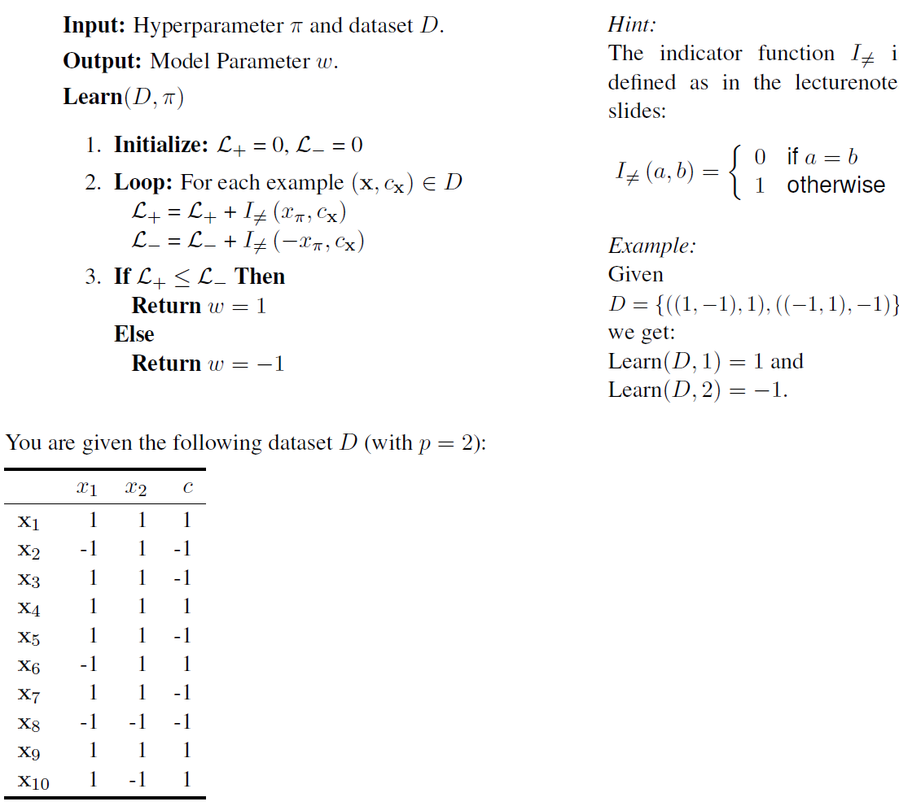
- Let the hyperparameter π be fixed at π = 1. Using the algorithm Learn given above, train a classifier y1() on all of D, and determine the training error Err(y1(),D).

$$L_{+}=4 ,L_{-}=6 ,so L_{+}≤L_{-} ,w=1$$
Training error = 0.4

- Let Dtest = {x8, x9, x10} be the test set. Leaving π = 1 as before, train classifier y′1 () on Dtr = D \ Dtest and determine the holdout error Err(y′1 (),Dtest ).

$$L_{+}=4 ,L_{-}=3 ,so L_{+}≤L_{-} ,w=-1 \\ x_{8}=-1, y=1≠c=-1(error) \\ x_{9}=1, y=-1≠c=1(error) \\ x_{10}=1, y=-1≠c=1(error)$$
Holdout error = 1

- Let Dval 1 = {x1, x2, x3, x4} and Dval 2 = {x5, x6, x7} be the sets used for model selection with k = 2 validation sets (see slides). Determine π∗, and then determine the holdout error for yπ∗().

- π=1
train: 5-7, validate: 1-4
w=-1, 0 errors.
Validate 3 wrong of 4
Holdout error = 0.75

train: 1-4, validate: 5-7
w=1, 1 errors.
Validate 3 wrong of 3
Holdout error = 1

Average error = (0.75+1)/2 = 0.875

- π=2
train: 5-7, validate: 1-4
w=-1, 1 errors.
Validate 2 wrong of 4
Holdout error = 0.5

train: 1-4, validate: 5-7
w=1, 2 errors.
Validate 1 wrong of 3
Holdout error = 0.333

Average error = (0.5+0.333)/2 = 0.416

- Selecting π=2

- On all 7 points w = 1, 3 errors

Holdout error on x8, x9, x10 is 1/3 = 0.333

Exercise 4: Receiver Operating Characteristic (ROC)
Consider the binary classification scenario of spam mail detection with two classes: mail is spam (c = 1,“positive”) and mail is not spam (c = 0 “negative”).
- Look up (e.g., on Wikipedia) the following six concepts and define them for the spam mail scenario: true positive, false positive, false negative, true negative, false positive rate, true positive rate.
True positive: Is the scenario where the model in correctly detects and classifies the data.
False Positive: Is the scenario where the model wrongly classified negative data as positive.
False Negative: Is the scenario where the case is positive but is wrongly classify as negative.
True Negative: is the scenario where a negative case is classified correctly as negative.
- Consider a large dataset D for spam mail detection with balanced class distribution, i.e., P(C = 0) = P(C = 1) = 0.5. Calculate the (expected) false positive rate and true positive rate foreach of these classifiers:
Case |  | Real | model
TP | → | + | +
FP | → | - | +
FN | → | + | -
TN | → | - | -

$$TPR=\frac{TP}{TP+FN} ;FPR=\frac{FP}{TN+FP}$$
For the examples we use a dataset a hypothetical value of 100 items. Where 1 is spam and 0 is not spam.

- A classifier that classifies every mail as spam.
$$TPR=\frac{100}{100+0}=1=100\% FPR=\frac{100}{100+0}=1=100\%$$
- A classifier that classifies every mail as not spam.
$$TPR=\frac{0}{100+0}=0=0\% FPR=\frac{0}{100+0}=0=0\%$$
- A classifier that classifies every mail correctly.
$$TPR=\frac{50}{50+0}=1=100\% FPR=\frac{0}{50+0}=0=0\%$$

- A classifier that classifies every mail incorrectly.
$$TPR=\frac{0}{0+100}=0=0\% FPR=\frac{100}{100+0}=1=100\%$$
- A classifier that classifies every mail randomly with equal class probability.
$$TPR=\frac{50}{50+50}=0.5=50\% FPR=\frac{50}{50+50}=0.5=50\%$$

- Now assume the plot on the left hand side shows D with spam examples (c = 1) represented as + and non-spam examples (c = 0) represented as −. Consider two classifiers yπ(x) for π ∈ {1, 2} which use a threshold w0 to classify instances solely based on either x1 or x2:
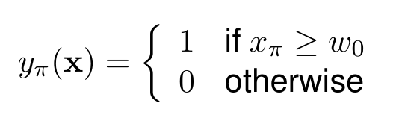
As one continuously increases w0 from 0 to 1, both classifiers change from classifying every mail as spam to classifying no mail as spam, with the true positive rate and false positive rate changing accordingly. This continuous change of rates for a classifier corresponds to a line in the false positive rate / true positive rate scatter plot (empty plot on the right hand side), which is known as receiver operating characteristic (ROC) curve. Roughly sketch the ROC curves of y1 and y2.

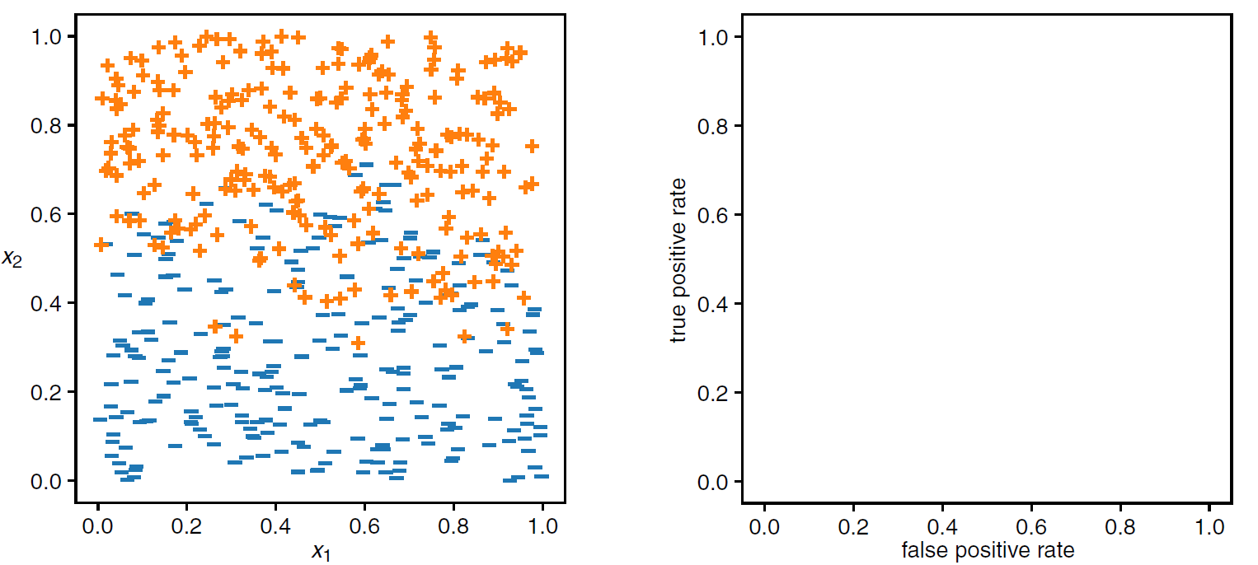
$$y_{2}(x_{2},c)$$
$$y_{1}(x_{1},c)$$

- Based on the ROC curves you sketched in (c), which classifier do you prefer? Argue solely based on the ROC curves!

Based solely on the ROC curves, y₂ is clearly superior because it maximizes the true positive rate while minimizing the false positive rate, whereas y₁ offers no advantage over random classification.
Exercise 5: Linear Regression
This table describes four electric cars by their battery age, total kilometers driven, and remaining battery capacity (in %) of their original capacity:
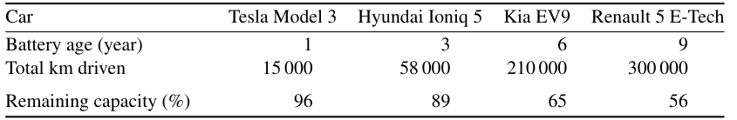

Calculations done in the excel file: exercise 5.xlsx
- Determine the linear regression weights wi for predicting the remaining capacity using only the battery age.

w0 = 101.898
w1 = -5.347

- Extrapolate the expected average remaining capacity for the Kia EV9 (age = 6 years) using the model from (a).

Expected average remaining capacity = 69.8163

- Consider the total kilometers driven as an additional variable and repeat (a) and (b) under this setting.

w0 = 95.842
w1 = 1.630
w2 = -0.000186

Expected average remaining capacity = 66.598

- Draw a scatter plot of the data points and the linear regression for a variable of your choice (i.e.,either battery age or total km driven on the x-axis).

- Discuss the problems and pitfalls of extrapolation
Extrapolation assumes that observed pattern will continue outside the range of the known data. This may not be true and give misleading results.
Exercise 6: Basic Data Analysis and Linear Regression
For programming exercises like this one, write code in Python 3.10 or later. Submit all code that you write. You are restricted to built-in Python modules and functions, except NumPy, Pandas, and (for plotting) matplotlib or seaborn. We provide data in tab-separated-value (TSV) format – you can use the built-in csv library’s DictReader and DictWriter with delimiter=’\t’ or Pandas read_csv and to_csv functions with sep=’\t’ for reading and writing.
Download and use these files from Moodle:
- features-train.tsv: Feature vectors for each example in the training set
- labels-train.tsv: Labels for each example in the training set indicating the class is_human (C = {True, False})
- features-test.tsv: Feature vectors for each example in the test set

- Select two features (e.g. num_words and num_characters) and plot a scatterplot for the examples in the training set between the two features. Color the points according to the class is_human. Submit the plot.
- Implement the LMS algorithm and use it to compute the weight vector (w0, w1, w2) and add the line of best fit to your plot from (a). Submit your algorithm implementation and the updated plot.
- Compute the residual sum of squares (RSS) for the weight vector from (b).
- Use the weight vector from (b) to classify each example in the test set for is_human (C = {True, False}). Write the predicted classes to a predictions-test.tsv in the same format as the labels-train.tsv (columns id and is_human). Submit the file with the predictions.
The code can be found in the LinearRegression.py file. Below, you can find the plot of the 2 selected features with the labels/target, as well as the error vs. epochs plot. Also attached to the document is the predictions-test.tsv file, which shows the predictions made by the trained model on the test dataset. As conclusion it is possible to see that after 50 Epochs the model is not improving the accuracy.
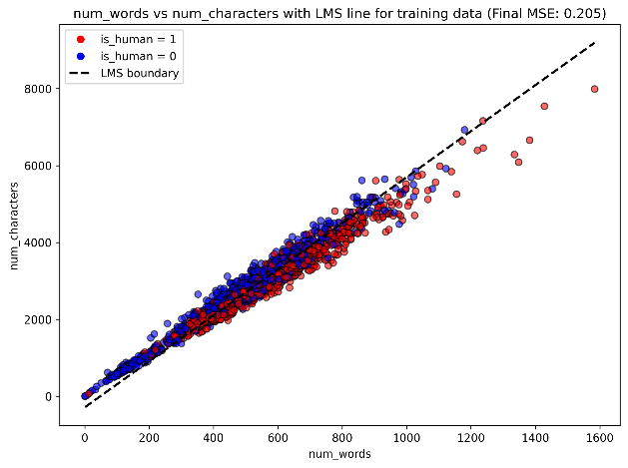 | 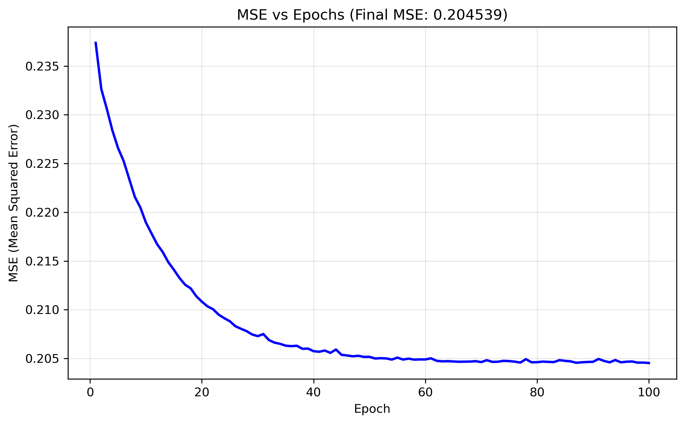
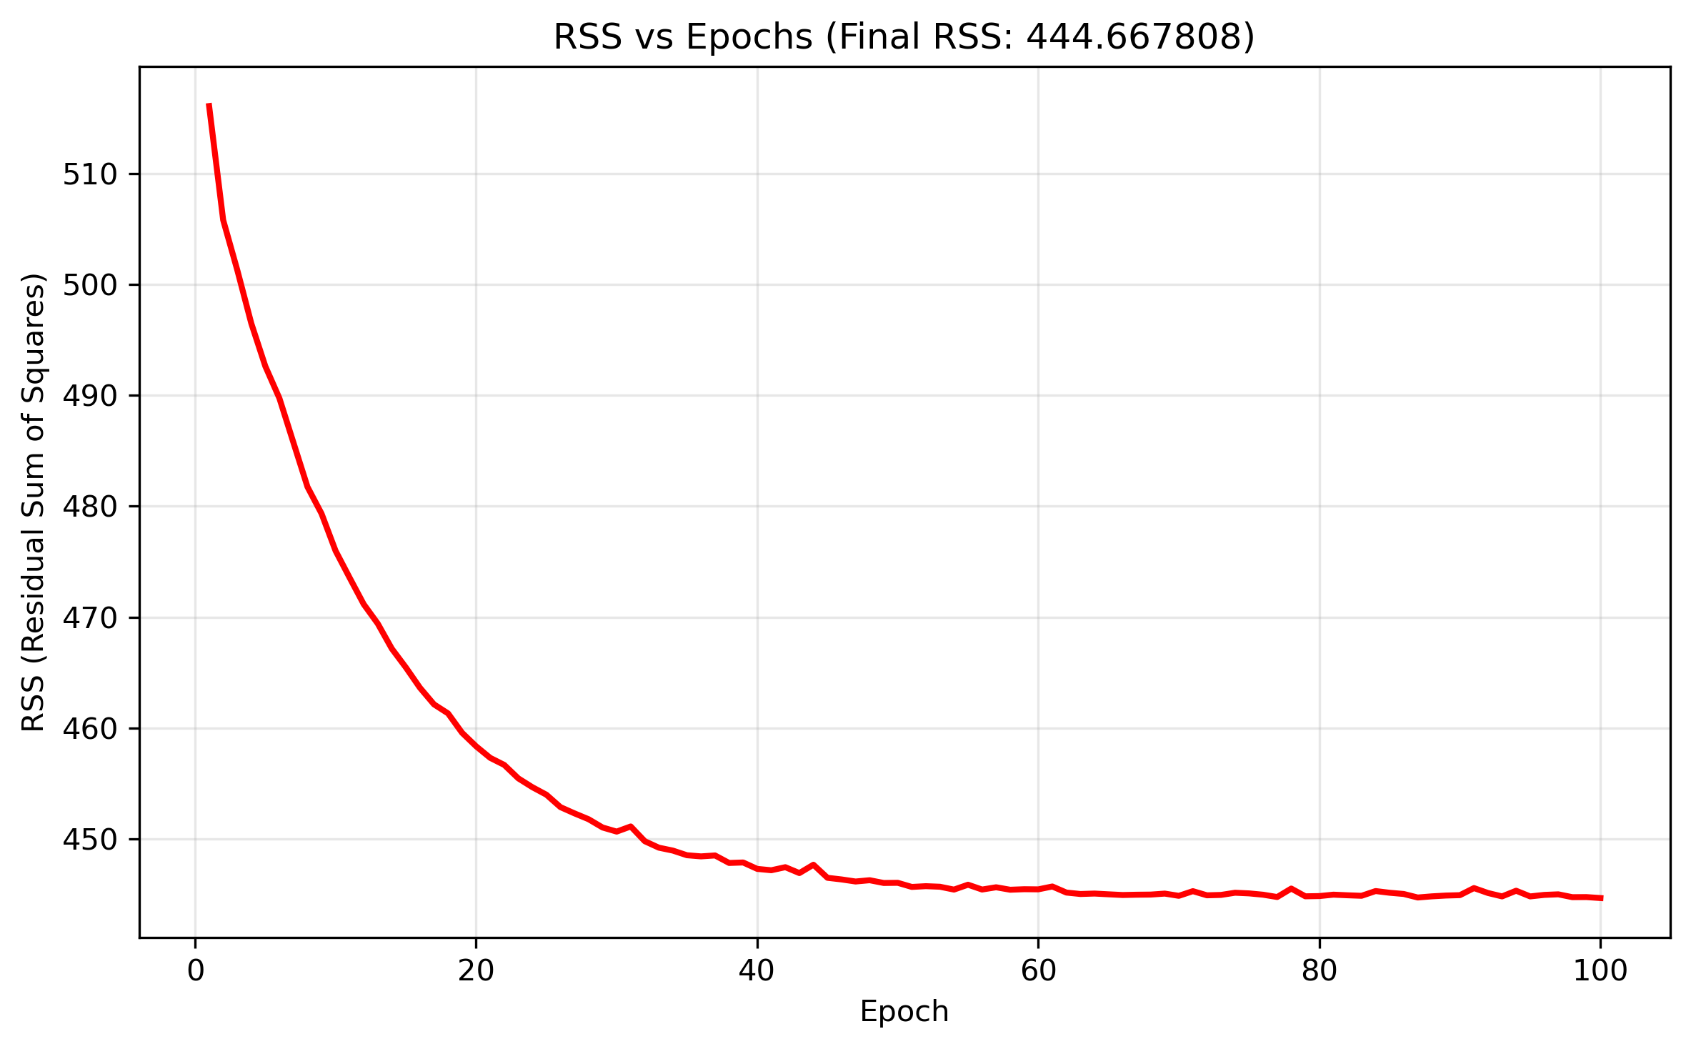

Weights | LMS weights (standardized): | LMS weights (original space)
W0 | 0.500 | 0.258
W1 | 0.969 | 0.005
W2 | -0.860 | -0.000873

