**Just Jam**

Final Deliverable

SWE 5003 - Fall 2022

**Cesar Villarreal** - [cvillarr@students.kennesaw.edu](mailto:cvillarr@students.kennesaw.edu)

**David Ma** - [dma@students.kennesaw.edu](mailto:dma@students.kennesaw.edu)

**Todd Spainhour** - [tspainh1@students.kennesaw.edu](mailto:tspainh1@students.kennesaw.edu)

**Abstract**

A common question musicians ask is, “Where can I find other artists to collaborate with?” We set out to help answer this by creating Just Jam, an app that connects like-minded musicians with others in their area. It's a music-focused, social media platform tailor-made for musicians seeking to group up and jam out. Just Jam’s core functionality allows users to easily search and join jam sessions or quickly create their own with session settings tuned for the perfect collaboration. This document covers Just Jam’s product vision statements, personas, user stories, use cases, non-functional requirements, as well as a focused description of the data and entities involved.

**Introduction**

*Consolidated Vision Statement*

Just Jam is for musicians who want to collaborate and create jam sessions with local musicians. The Just Jam software is a social platform that focuses on finding and creating jam sessions. Unlike applications that focus on national appeal, our product will focus on the community of local musicians, events and shows in order to match users with the most compatible jam mates. Within the next ten years we envision ourselves as a platform leader in social applications catered to musicians.

*Target Customers*

Just Jam is for musicians of all skill levels and users come from all walks of life. They share a love for creating music. Just Jam users thrive when collaborating with others and love to do it often. They are familiar with utilizing modern technology and are willing to try new software when they believe it will bring value to their lives.

*Statement of Need/Opportunity*

For musicians, it is becoming increasingly hard to locate compatible jam mates. Furthermore, they are spending time with planning details, rather than maximizing jam sessions. Just Jam will solve this need by automating the planning, scheduling, and search process. Just Jam will make this easy, quick and user friendly with only a few clicks.

*Name and Software Type*

Just Jam is a commercial user-oriented software product that will be available on all devices and on the go with its mobile app. The unique name not only establishes a brand, but it also gives potential users a point of reference about the app’s focus on creating music. Just Jam will share some similarities with dating apps as it will allow the user to create a profile and search for local musicians to jam with.

*Key Benefits*

Wherever you may be, the Just Jam software will reduce the time-consuming task of searching, planning, and scheduling by streamlining the process of forming jam sessions with other musicians. Utilizing user-oriented algorithms, Just Jam can drastically shorten the length of time between finding a group and jamming with them. Just Jam offers event and session reminders, merchandise to support local musicians, music news and allows the artist to join local groups based on their genre and location. Share music files, update profiles and other settings to assemble your perfect group. After a few easy clicks, any musician can grab their instrument and join a local jam session.

*Key Competition*

There’s no shortage of music sharing communities online, but our key competition would need to have a focus on connecting musicians together. Fuzz is a free mobile app with a community of just under 16,000 users. BandFinder would be another competitor. Although their site doesn’t look too flashy, they do have a simple search functionality to help find the type of musician you’re looking for. They also have calendar integration on each person’s profile. Other bigger competitors could be ReverbNation and SoundCloud, but they don’t focus on forming jam sessions with people in your area.

*Key Differentiation*

Unlike our competitors, Just Jam focuses on the local music scene connecting nearby artists together. It’s easy, intuitive, and compatible with any lifestyle. The algorithms help you search and pinpoint the perfect person to complete your desired sound. Just Jam provides a platform for jam sessions as well as a voice and audience to local artist events and shows.

**Personas**

*John Philip*

John Philip is a 24-year-old full-time student at the University of Georgia. He lives in Savannah and works as a part-time waiter at a coffee shop. He is very busy with his studies and his part-time job. He cannot spend too much time searching for connections with musicians. He is looking for a way to easily join an online community so that he can connect with other musicians in the area. His goal is to gain some clout and increase his chances of playing in bigger cities such as Atlanta.

*Jimmy McGill*

Jimmy McGill is a 47-year-old owner of a music store who lives in Albuquerque, New Mexico. He knows how to play some instruments, but unfortunately does not know how to play every instrument that he has in his store. He is looking for a way to create jam sessions based on instrument needs. That way he can connect with musicians who know how to play those instruments since his goal is to create video content from these jam sessions to promote his music store.

*Louise Wexler*

Louise Wexler is 35 years old and lives in Denver, Colorado. She is a high school band director who is interested in recruiting musicians with top level experience for her classical music band. She is looking for a way to join a jam session that plays classical music in the Denver area. Her goal is to play with these other classical musicians so she can gauge whether to recruit them for her band.

*Alex Castillo*

Alex Castillo is a 29-year-old percussion specialist currently working at Guitar Center. He lives in Seattle, Washington, and plays the drums during his free time. As an aspiring musician who plays multiple instruments, he is looking for a way to discover jam sessions in the area that he can join. He is not really set a specific musical genre or musical instrument. His goal is to build connections to jam on the weekends for fun, and perhaps create a band in the future.

*Sol Park*

Sol Park is a 27-year-old who lives and works in Tampa, Florida. He works as a software engineer full time, and mixes music and deejays in his free time. He is looking to connect with other musicians for live recordings and jam sessions. His goal is to get their perspectives on his song mixes after the meet up sessions. He wants to be in a group chat with the jam session members so they can communicate even when they are not together.

**User Stories**

US-01

As a full-time student with a part-time job, I would like to be able to join an online community for musicians, so I find connections without investing too much time searching for them. – John Philip

US-02

As a music store owner who unfortunately does not know how to play every instrument, I would like to be able to create jam sessions and specify the instruments I need for these jam sessions. – Jimmy McGill

US-03

As a high-school band director, I would like to be able to search for jam sessions in the classical genre that can play certain instruments with top-level experience so that I can recruit them for my classical music band. – Louise Wexler

US-04

As a percussion specialist at Guitar Center who enjoys playing the drums in my free time, I would like to explore jam sessions in my city, that I may be interested in jamming with on weekends for fun. – Alex Castillo

US-05

As a software engineer who likes to mix music and deejay in my free time, I would like to be able to communicate with other musicians by group chat after live recordings and sessions so that they can give me different perspectives on my song mixes. – Sol Park

**Use Cases**

**US-01**

As a full-time student with a part-time job, I would like to be able to join an online communication for musicians, so I find connections without investing too much time searching for them. – John Philip

US-01 UC-01 – Creating a Just Jam account

Step 1 – User launches Just Jam application

Step 2 – User clicks on “Register”

Step 3 – User enters registration information (name, address, email address, phone number)

Step 4 – User enters username & password according to username/password rules

Step 5 – User receives registration email and activates account

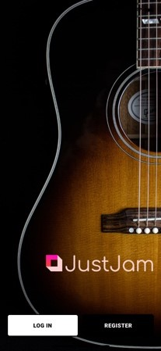 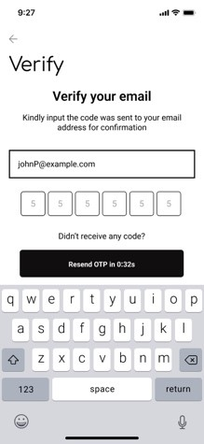

US-01 UC-02 – Logging into Just Jam account

Step 1 – User launches Just Jam application

Step 2 – User enters valid user name & password

Step 3 – User clicks on “Log In”

Step 4 – User is prompted with multi-factor authentication for secure log in (optional)

Step 5 – User is directed to the “Home” screen

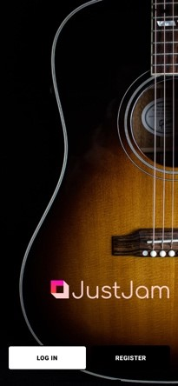 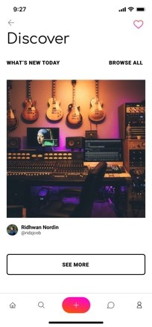

**US-02**

As a music store owner who unfortunately do not know how to play every instrument, I would like to be able to create jam sessions, and specify the instruments I need for these jam sessions. – Jimmy McGill

US-02 UC-01 – Creating jam session

Step 1 – User clicks on “Create a jam session”

Step 2 – User sets the name of the jam session

Step 3 – User sets the levels of experience for one or more instrument(s)

Step 4 – User sets the genre(s) of the jam session

Step 5 – User sets the location and meeting time of the jam session

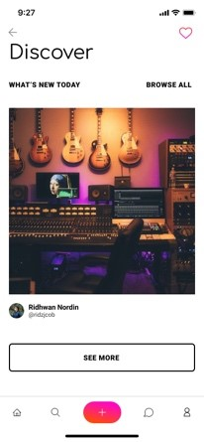

US-02 UC-02 – Adding musician to jam session

Step 1 – User sees list of musicians interested in joining jam session

Step 2 – User skips musician profile by swiping left

Step 3 – User adds musician profile by swiping right

Step 4 – Musician is added to jam session

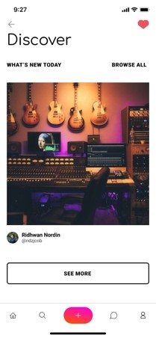 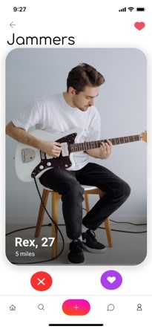 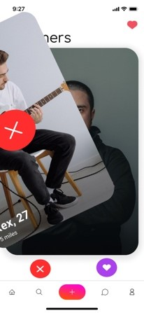

**US-03**

As a high-school band director, I would like to be able to search for jam sessions in the classical genre within the Denver, Colorado area that can play certain instruments with top level experience so that I can recruit them for my classical music band. – Louise Wexler

US-03 UC-01 – Searching for jam session and requesting to join jam session

Step 1 – User clicks on “Look for jam session”

Step 2 – User is presented with options to explore jam sessions in the area or search for jam session

Step 3 – User chooses to search for jam sessions and sets search parameters (instrument, genre, levels of experience, proximity of the jam sessions, etc.)

Step 4 – Jam sessions matching search parameters are displayed to user

Step 5 – User swipes right to add oneself to jam session

Step 6 – Request to join jam session is sent to creator

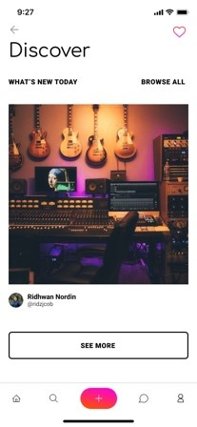 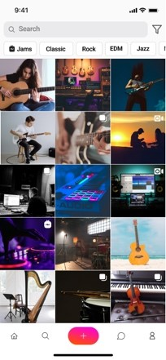

**US-04**

As a percussion specialist at Guitar Center who enjoy playing the drums on my free time, I would like to explore jam sessions in Seattle, Washington that I may be interested in jamming with on weekends for fun. – Alex Castillo

US-04 UC-01 – Explorer for potential jam sessions in the area

Step 1 – User clicks on “Look for jam session”

Step 2 – User is presented with options to explore jam sessions in the area or search for jam session

Step 3 – User chooses to explore jam sessions, and sees list of jam sessions in the area

US-04 UC-02 – Viewing jam session member profiles

Step 1 – User clicks on “Look for jam session”

Step 2 – User browses or search for potential jam sessions

Step 3 – User selects a jam session and clicks on jam session member to view member profile

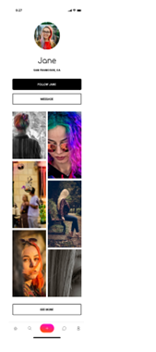

**US-05**

As a software engineer who likes to mix music and deejay on my free time, I would like to be able to communicate with other musicians by group chat after live recordings and sessions so that they can give me different perspectives on my song mixes. – Sol Park

US-05 UC-01 – Using jam session group chat

Sep 1 – User creates jam session and the group chat for jam session

Step 2 – User adds musicians to jam session

Step 3 – User is able to send group messages to all the musicians in the jam session

US-05 UC-02 – Receiving group chat notification

Step 1 – User logs into Just Jam application and is in the jam session

Step 2 – User is notified the number of unread messages in the group chat since the last log in

Step 3 – User views the chat messages and the notification of unread messages is reset to 0

**Data Description**

Below are the 7 entity categories with the attributes for each category. The user information category for storing user-specific information during account creation and a UserID is assigned to each user account. The address category is a separate entity from user information, because a jam session can designate an address as the jam session location instead of the user mailing address, each with a unique AddressID identifier. The InstrumentID in the instrument category allows the user to identify each instrument in the jam session, as well as the number of years the musician has played that instrument. The search preferences category stores the search parameters that users specify when searching jam sessions. Once a jam session is created, a JamSessionID is assigned to that jam session for storing information such as jam session name, meeting times, meeting location, etc. The jam session membership category is used to store information for the members in the jam session, in addition to user requests (acceptance or rejection) to join the jam session. Finally, a jam session chat category is used for group chat related data.

**Entity Types**

1. **User information:**

* UserID (Automatically generated data)
* First Name (User-created content)
* Last Name (User-created content)
* Username (User-created content)
* Password (User-created content)
* Address (User-created content)
* Email Address (User-created content)
* Cell Phone (User-created content)
* Music genre(s) (Available at the outset)
* Social media accounts (User-created content)
* Profile picture (User-created content)
* Gender (User-created content)
* Age (User-created content)

1. **Addresses:**

* AddressID (Automatically generated data)
* Address (User-created content)
* City (User-created content)
* State (User-created content)
* Zip Code (User-created content)
* IsJamSessionLocation (User-created content)

1. **Instruments**:

* InstrumentID (Automatically generated data)
* Instrument(s) played (Available at the outset)
* Years of experience per instrument (User-created content)

1. **Search preferences:**

* SearchPreferencesID (Automatically generated data)
* Proximity to user location (User-created content)
* Instrument(s) played (User-created content)
* Years of experience played (User-created content)
* Genre(s) (Available at the outset)
* Gender (User-created content)
* Age (User-created content)

1. **Jam session information:**

* JamSessionID (Automatically generated data)
* Jam session name (User-created content)
* Jam session information (User-created content)
* Music genre (Available at the outset)
* Instrument(s) already in jam session
* Instrument(s) needed in jam session
* Jam session meeting times (User-created content)
* Jam session location (add to UI) (User-created content)
* Jam session privacy setting (add to UI) (User-created content)

1. **Jam session membership:**

* Jam session members (User-created content)
* User requests to join jam session (User-created content)
* Accepted (User-created content)
* Rejected (User-created content)

1. **Jam session group chat:**

* JamSessionChatID (Automatically generated data)
* Group chat name (User-created content)
* Group chat members (User-created content)
* Message (User-created content)

**Entity Relationship Sets**

**Creating a Just Jam account**

New user selects register (1 to 1)

New user enters email address (1 to 1)

New user enters cell number (1 to 1)

New user enters physical address (1 to 1)

New user selects username (1 to 1)

New user enters password (1 to 1)

New user enters first name (1 to 1)

New user enters last name (1 to 1)

New user receives registration email (1 to 1)

New user activates account from registration email (1 to 1)

**Logging into Just Jam**

User launches Just Jam application (1 to 1)

User enters username (1 to 1)

User enters password (1 to 1)

User clicks login (1 to 1)

**Updating a Profile**

User adds profile image (1 to N)

User adds instruments (1 to N)

User adds years of experience for instrument(s) (1 to 1)

**Create a Jam Session**

User selects Create Jam Session (1 to N)

Jam Session Creator sets jam session name (1 to 1)

Jam Session Creator adds pictures (1 to N)

Jam Session Creator selects genre (1 to 1)

Jam Session Creator selects instruments (1 to N)

Jam Session Creator selects instruments experience (1 to 1)

Jam Session Creator adds jam session location (1 to 1)

Jam Session Creator schedule(s) jam session (1 to 1)

Jam Session Creators determine privacy setting of time and location details for jam sessions (1 to 1)

**Adding Musicians to Jam Session**

Jam Session Creator receives notification of new members request (1 to N)

Jam Session Creator approves new members requests (1 to N)

Jam Session Creator denies new members requests (1 to N)

**Searching for Jam Sessions**

User clicks Look for Jam Session (1 to N)

User selects explore jam sessions (1 to 1)

User enters Seach Criteria (1 to N)

**Joining existing Jam Session**

User browses Jam Sessions (1 to N)

User selects Jam Session (1 to N)

User swipes (submits request) to Join Jam Session (1 to N)

**Non-Functional Requirements**

*Performance – NFR-01*

The core purpose of Just Jam is organizing sessions with other artists in their area, so it’s natural that many users will be interacting with our product while on the go. Due to this fact, one constraint we’ll need to make a priority is performance on mobile devices. Having a mobile first mindset when building Just Jam will help guide the development of this project by targeting small devices where resources are limited. Just Jam is networked software, and most of the app’s content will be retrieved from a server using a required internet connection.

*Usability – NFR-02*

The usability of Just Jam requires special attention. It’s essential that the design of the user interface be intuitive so that users can quickly accomplish their goals, and the interface should cater to both short and long session lengths. For example, users might briefly use Just Jam to respond to a chat message or engage with the app for longer periods of time when browsing for other artists. No matter the amount of time they spend in the application, users should be able to easily find the functionality they’re seeking.

*Security – NFR-03*

Security is another focus for Just Jam’s non-functional requirements since some data the app uses should be considered sensitive. Primarily, two pieces of information should only be viewed by those with proper permission. The first is the user’s personal email address. This unique piece of information is necessary when users create their Just Jam account, and this should remain hidden from other users to avoid misuse. The second piece of sensitive information is the time and location details of organized jam sessions. Unless explicitly made public by the jam session’s creator, this batch of information needs to remain hidden from those who are not approved members of the session.

**Main Areas of Responsibility**

*Cesar Villarreal* – Personas, UI Prototype. 33.3% contribution

*David Ma* - Data Description, Personas, User Stories, Use Cases. 33.3% contribution

*Todd Spainhour* - Product Vision Statements, Entity Sets, Non-Functional Requirements, Abstract. 33.3% contribution

**Group Presentation Video**

<https://www.youtube.com/watch?v=9VztyfvGeBs>

**Lessons Learned**

*Cesar Villarreal*

While designing the UI prototype, I realized how much I actually enjoy building applications. I found that once I had a solid foundation to work with, such as the user stories and cases, it was easy to imagine what the app would look like. Using user friendly software such as Figma, came in handy and essentially made the process effortless. Most of my ideas came from all the different social media platforms I have used in the past.

During the beginning of the second part of the project, since it was my first time using Figma, it was a challenge to get into the groove of things. However, after watching a few tutorials and messing around with the functions it turned out to be quite easy. The major frustration that I had with the whole process was my sense of “everything has to be perfect and consistent.” I feel like that was the only issue I had during the whole process.

*David Ma*

For the data description part, I find that once the data attributes have been identified it requires some planning to organize how they would be stored to make sense. For example, even though an address would be supplied by a user during account creation. It makes sense to store addresses as a separate entity, as user may not use the same address for jam session location.

Even though personas and user stories were part of the mid-term project, I found that some of the personas and user stories did not translate well into use cases. I had to modify/remove some of personas, as well as refine some of the user stories, in order to translate them properly into use cases. I think if we planned to write use cases when we originally planned the personas and user stories that would have made changes easier.

Use cases were not easy to design, as I had to reorganize the user stories to create a clear narrative to make the set use cases flow well. In doing so, we identified some of the use cases were redundant and removed, while new use cases were identified as we match each user story to the corresponding use cases.

*Todd Spainhour*

Working on the Just Jam team project offered many opportunities to learn lessons about the initial phases of the software development lifecycle. Overall, this project highlighted numerous questions a team needs to answer before any coding begins. I took away two main lessons which revolve around the product vision statements and the entity relationships.

Having to create the product vision statements as a team emphasized not only how challenging it can be, but it also brought to my attention the importance of this content throughout the remainder of the development lifecycle. An effective product vision document will provide clarity and guidance to those involved in a software project, and its value shouldn’t be understated.

Creating the entity relationship sets in the ‘*EntitySet actionVerb EntitySet*’ format demonstrated how it naturally prompts the team to discuss design questions during the early phases of a project. Finding solutions to these questions improves the overall design and will benefit the project in the long run.