**Best Place for an Italian Restaurant**

**In New York**

## A. Introduction

### A.1. Description & Discussion of the Background:

New York as a city has 50,153 eating places where the estimated revenue is 51.6 billion. New York restaurants created 865,800 jobs and they count for 9% for the employment in the state. According to Quora.com, there are 993 Italian restaurants in New York. A big Italian restaurant could generate between 200-300k dollar per month. An Italian investing company wants to invest in creating a new Italian restaurant in New York and they were looking for the best neighborhood.  
  
The best neighborhood would be one who doesn’t have any Italian restaurants and where the number of restaurants is less than 5. They want to create a new Italian restaurant experience and this is what they are looking for.

### A.2. Data Description

To consider the problem we can list the datas as below:

* Neighborhood has a total of 5 boroughs and 306 neighborhoods, I used the data from previous weeks:  
  <https://cocl.us/new_york_dataset>
* I used Foursquare API to get the most common eating venues of each neighborhoods.

### B. Methodology

-First, I downloaded the data:

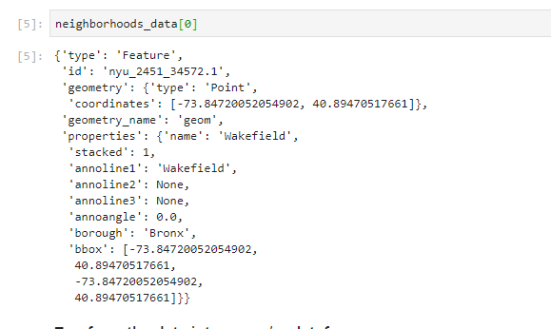

-Second, I did some cleaning on the data:

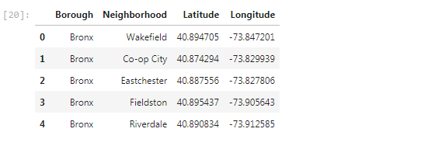

-Then I created a map of New York with all the neighborhoods on it:  
  
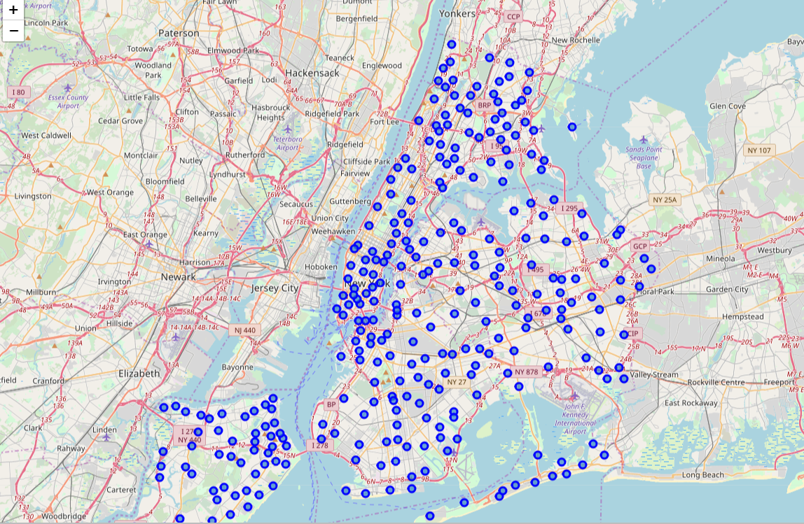

-Then I used the Foursquare API to get all the eating Venues in all Neighborhoods:

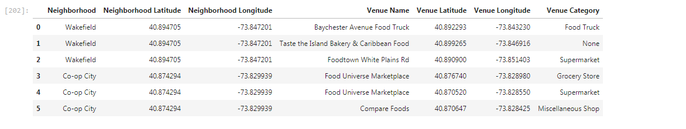

-Then I Selected Neighborhoods which have no Italian restaurants and the number of restaurants is less than 5:

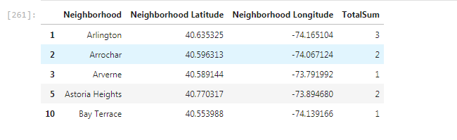

### C. Results:

-Finally, I drew a folium map of New York with all the selected neighborhoods:   
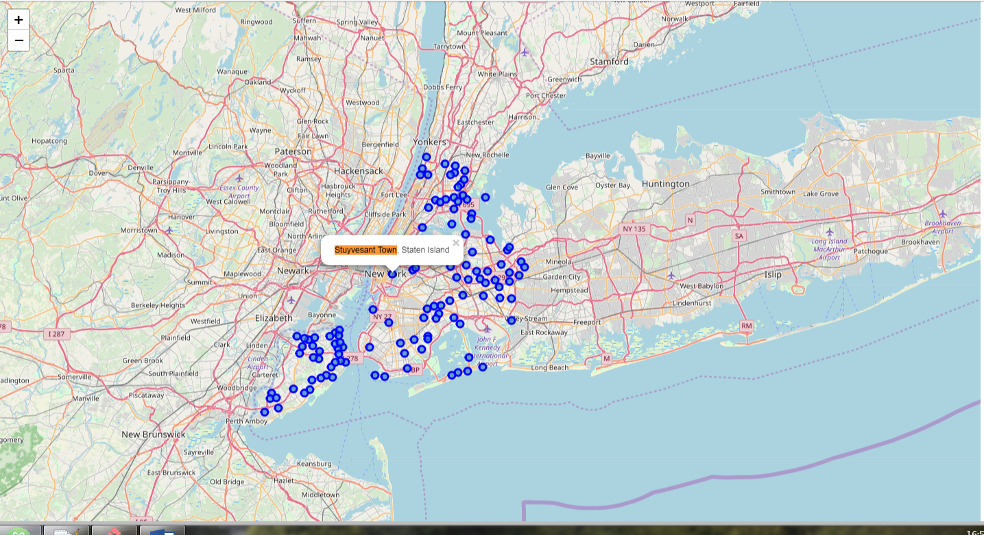

S

### D. Discussion

One of the best locations which has no Italian restaurants, number of restaurants in general is less than 5 and in Manhattan is: **Stuyvesant Town**

### To be done: Is to find a dataset of the price of leasing a square meter in New York to find the cheapest place in terms of rent and determine the profitability.