# How to add Slick slider library (requirement for SharepointSimpleSlider webpart)

* Go to Site Contents -> Style Library and create a new folder and call it SlickSlider

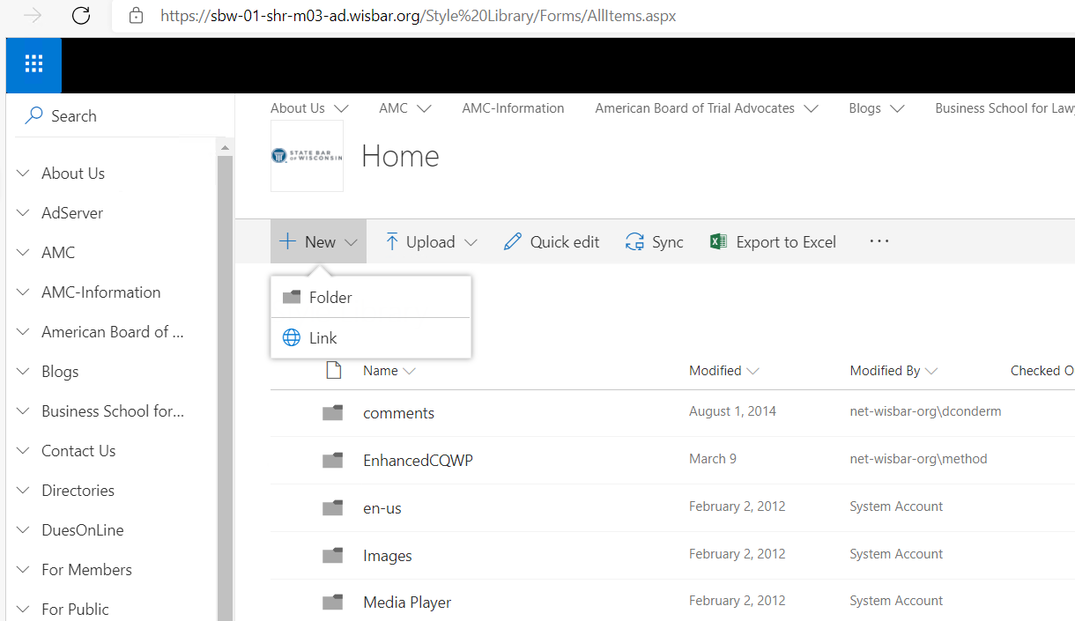

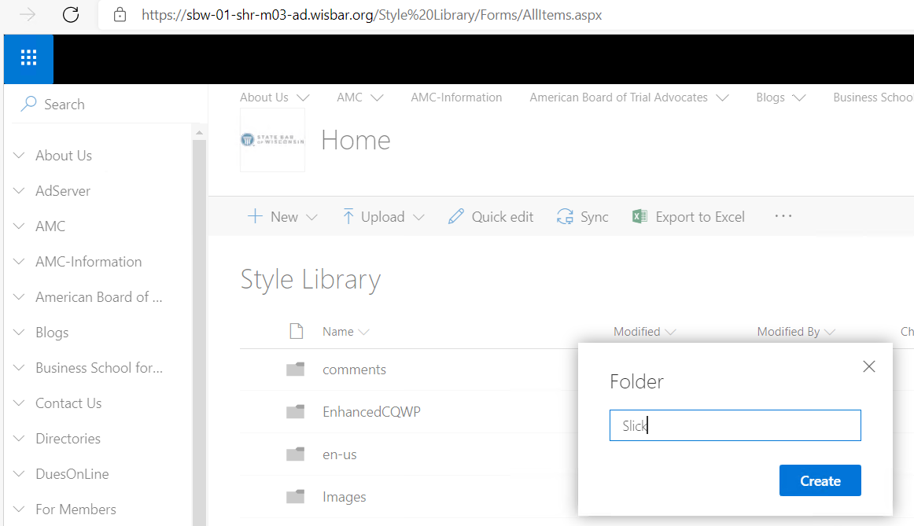

* Go to the SharepointSimpleSlider webpart project and upload the contents of the \SliderLibrary\slick folder into the SlickSlider folder created in the previous step
* Click upload folder

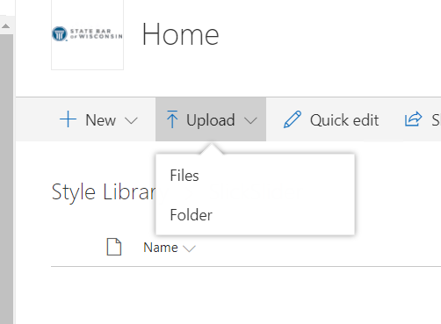

* Select the Slick folder

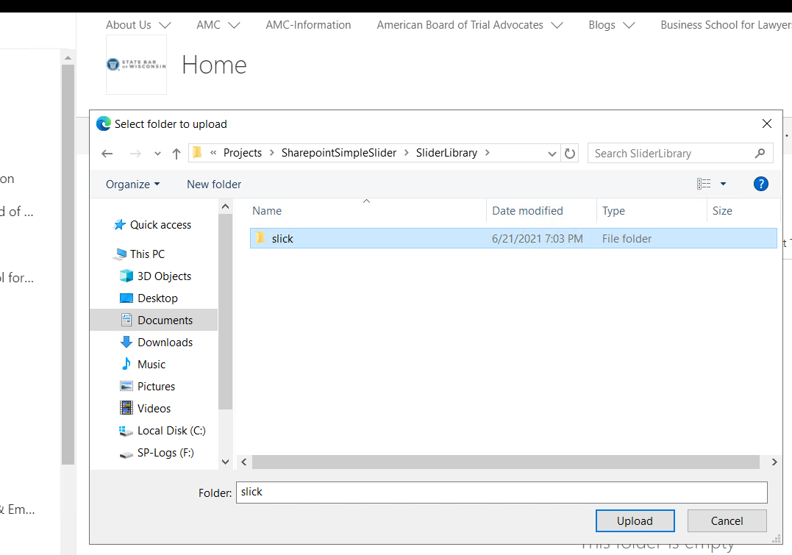

* Make sure to confirm that you want to upload all the files inside the slick folder

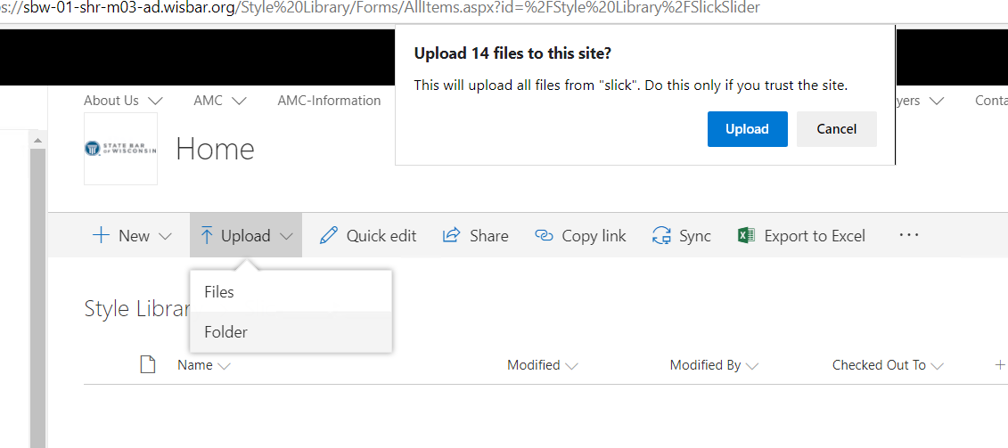

* This is how it should look like

