|  |  |  |  |  |  |
| --- | --- | --- | --- | --- | --- |
| **Fault Measures** | **Priority** | **Evolution  of Fault** | **Using schedule  object** | **Using  EMS** | **ORNL  Testing Faults** |
| Excessive infiltration around the building envelope | 1 | fan speed -> fault intensity | Y | N | 18 S/W |
| Supply air duct leakages | 2 | fan speed -> fault intensity | N | N | 17 S |
| Return air duct leakages | 2 | fan speed, ambient condition -> fault intensity | N | Y | 17 S |
| HVAC setback error: delayed onset | 3 | step function, with some frequency | Y | N | 18 S/W |
| HVAC setback error: early termination | 3 | step function, with some frequency | Y | N | 18 S/W |
| HVAC setback error: no overnight setback | 3 | step function, with some frequency | Y | N | 18 S/W |
| Nonstandard refrigerant charging | 4 | refrigerant flow rate, time -> time constant | Y | Y | 17 S |
| Lighting setback error: delayed onset | 6 | step function, with some frequency | Y | N | 18 S/W |
| Lighting setback error: early termination | 6 | step function, with some frequency | Y | N | 18 S/W |
| Lighting setback error: no overnight setback | 6 | step function, with some frequency | Y | N | 18 S/W |
| Evaporator fouling (Duct fouling) | 7 | fan speed, elapsed time of use -> time constant | N | N | 18 S |
| Condenser fouling | 8 | fan speed, ambient condition, elapsed time of use -> time constant | Y | Y | 17 S |
| Oversized equipment at design | 12 | Fault will probably not evolve | N | N |  |
| Improper time delay setting in occupancy sensors | 9 | step function, with some frequency | Y | N |  |
| Air handling unit fan motor degradation | 10 | elapsed time of use, fan speed -> time constant | Y | Y |  |
| Refrigerant liquid line restriction | #N/A | elapsed time of use -> time constant | Y | Y |  |
| Thermostat measurement bias | 16 | calibration frequency (drifting over time) = time constant | Y | N | 18 S/W |
| Economizer opening stuck at certain position | 18 | step function, with some frequency | Y | N |  |
| Condenser fan degradation | 17 | elapsed time of use, fan speed -> time constant | Y | Y |  |
| Presence of noncondensable in refrigerant | 14 | step function, with some frequency | Y | Y |  |
| Biased economizer sensor: outdoor RH | 19 | calibration frequency (drifting over time) = time constant | N | Y |  |
| Biased economizer sensor: outdoor temperature | 19 | calibration frequency (drifting over time) = time constant | N | Y |  |
| Biased economizer sensor: mixed temperature | 19 | calibration frequency (drifting over time) = time constant | Y&N | Y&N |  |
| Biased economizer sensor: return RH | 19 | calibration frequency (drifting over time) = time constant | N | Y |  |
| Biased economizer sensor: return temperature | 19 | calibration frequency (drifting over time) = time constant | N | Y |  |

**Fault measures using EMS (WorkspaceUserScript)**

**Concept**

Use EnergyManagementSystem:TrendVariable to call values from previous timestep in order to make increments from 0 to full value of the fault intensity at each time step. By defining additional parameter (time required for fault to reach full level), the fault intensity gradually increases to its full level (user defined) after the defined time period has been reached.

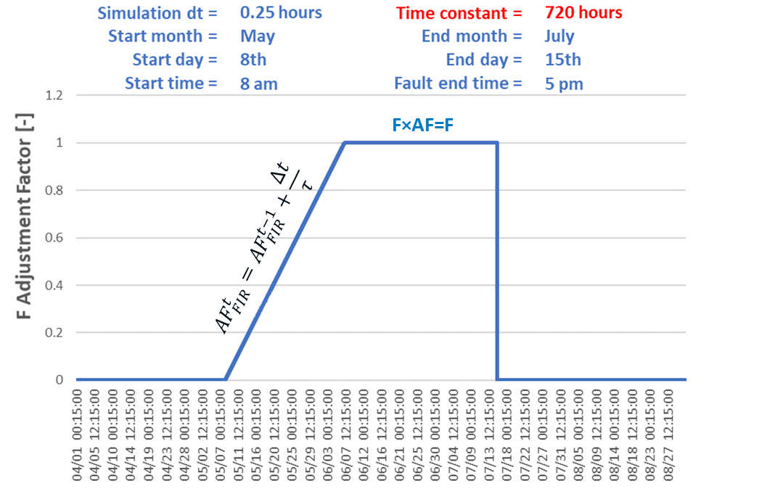

𝜏 = time required for fault to reach full level (defined as fault intensity) [hours]

∆𝑡 = simulation time step [hours]

AF = adjustment factor [-]

**Test code**

def faultintensity_adjustmentfactor(string_objects, time_constant, time_step, start_month, start_date, start_time, end_month, end_date, end_time)

#append transient fault adjustment factor

##################################################

string_objects << "

EnergyManagementSystem:Program,

AF_P, !- Name

SET SM = "+start_month+", !- Program Line 1

SET SD = "+start_date+", !- Program Line 2

SET ST = "+start_time+", !- A4

SET EM = "+end_month+", !- A5

SET ED = "+end_date+", !- A6

SET ET = "+end_time+", !- A7

SET tau = "+time_constant+", !- A8

SET dt = "+time_step+", !- A9

IF tau == 0,

SET tau = 0.001,

ENDIF,

SET ActualTime = (DayOfYear-1.0)*24.0 + CurrentTime, !- A10

IF SM == 1, !- A11

SET T_SM = 0, !- A12

ELSEIF SM == 2, !- A13

SET T_SM = 744, !- A14

ELSEIF SM == 3, !- A15

SET T_SM = 1416, !- A16

ELSEIF SM == 4, !- A17

SET T_SM = 2160, !- A18

ELSEIF SM == 5, !- A19

SET T_SM = 2880, !- A20

ELSEIF SM == 6, !- A21

SET T_SM = 3624, !- A22

ELSEIF SM == 7, !- A23

SET T_SM = 4344, !- A24

ELSEIF SM == 8, !- A25

SET T_SM = 5088, !- A26

ELSEIF SM == 9, !- A27

SET T_SM = 5832, !- A28

ELSEIF SM == 10, !- A29

SET T_SM = 6552, !- A30

ELSEIF SM == 11, !- A31

SET T_SM = 7296, !- A32

ELSEIF SM == 12, !- A33

SET T_SM = 8016, !- A34

ENDIF, !- A35

IF EM == 1, !- A36

SET T_EM = 0, !- A37

ELSEIF EM == 2, !- A38

SET T_EM = 744, !- A39

ELSEIF EM == 3, !- A40

SET T_EM = 1416, !- A41

ELSEIF EM == 4, !- A42

SET T_EM = 2160, !- A43

ELSEIF EM == 5, !- A44

SET T_EM = 2880, !- A45

ELSEIF EM == 6, !- A46

SET T_EM = 3624, !- A47

ELSEIF EM == 7, !- A48

SET T_EM = 4344, !- A49

ELSEIF EM == 8, !- A50

SET T_EM = 5088, !- A51

ELSEIF EM == 9, !- A52

SET T_EM = 5832, !- A53

ELSEIF EM == 10, !- A54

SET T_EM = 6552, !- A55

ELSEIF EM == 11, !- A56

SET T_EM = 7296, !- A57

ELSEIF EM == 12, !- A58

SET T_EM = 8016, !- A59

ENDIF, !- A60

SET StartTime = T_SM + (SD-1)*24 + ST, !- A61

SET EndTime = T_EM + (ED-1)*24 + ET, !- A62

IF (ActualTime>=StartTime) && (ActualTime<=EndTime), !- A63

SET AF_previous = @TrendValue AF_trend 1, !- A64

SET AF_current = AF_previous + dt/tau, !- A65

IF AF_current>1.0, !- A66

SET AF_current = 1.0, !- A67

ENDIF, !- A68

IF AF_previous>=1.0, !- A69

SET AF_current = 1.0, !- A70

ENDIF, !- A71

ELSE, !- A72

SET AF_previous = 0.0, !- A73

SET AF_current = 0.0, !- A74

ENDIF; !- A75

"

string_objects << "

EnergyManagementSystem:GlobalVariable,

AF_current; !- Erl Variable 1 Name

"

string_objects << "

EnergyManagementSystem:TrendVariable,

AF_Trend, !- Name

AF_current, !- EMS Variable Name

1; !- Number of Timesteps to be Logged

"

string_objects << "

EnergyManagementSystem:ProgramCallingManager,

AF_PCM, !- Name

AfterPredictorAfterHVACManagers, !- EnergyPlus Model Calling Point

AF_P; !- Program Name 1

"

##################################################

return string_objects

end

**Fault measures using schedules ruleset**

**Concept**