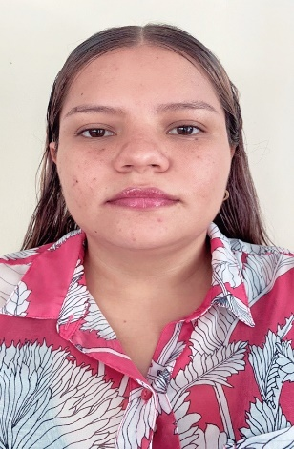

I am a student of Engineering in Computer Systems and Networks, I have skills in network administration, programming and database administration.

Cesia Flores



Web aplication to find pest.

Clinical record with face rocognition.

***DEVELOPED ACADEMIC PROJECTS***

* SCRUM
* Desing Sprint
* Kanban
* MariaDB
* Xampp
* MongoDB

AGILE METHODOLOGIES

DATABASES

* CMMI
* ISO 25000
* Unit tests
* Test of permonance
* Java Sritp
* C #
* Python
* PHP

***KNOWLEDGE***

**Title to obtain** | Engineering in computer systems and networks.

***Universidad Gerardo Barrios*** | 2020 - Present

**Vocational Technician in Electronics.**

Higher Education (In progress)

***Instituto Nacional José Simeón Cañas*** | 2017 - 2019

High School Education

**ACADEMIC TRAINIGN**

***HARD SKILLS***

* Comunication
* Adaptability
* Innovatio
* Creativity
* Teamwork
* Leadership

***SOFT SKILLS***

* Scrunm Master Fundamentals
* Introdution to Networks

***CERTIFICATIONS***

***PERSONAL INFORMATION***

Cesia Elizabeth Flores Orellana

7024-9832

florescsia@gmail.com

El Sauce, Caso El Pacun Santiago Nonualco La Paz

©AZURIUS - Modelos-de-curriculum.com

©AZURIUS - Modelos-de-curriculum.com

* Database
* Programming
* Agile Methodologies
* Network Administration
* Quality and Testing

QUALITY AND TESTING

PROGRAMMING LANGUAGES

Bluetooth controlled robotic cart project.

***PROFESSIONAL VALUES***

***ACADEMIC EXPERIENCE***

* Respect
* Honesty
* Adaptability
* Responsibility
* Loyalty
* Ethics

***Back End developer***  | 2020 - 2022

***Scrum Master*** | 2022