Name: Mike Luke
Date: 11/17/2025
Course: IT FDN 110 A Au 25: Foundations Of Python Programming

Assignment 06 –

Introduction
For Week 6, we are introduced to classes, functions, parameters, arguments, global variables and separation of concern. It is a lot of great content and concepts this week. It is starting to make a bit more sense and introduces organization with classes, functions, and separation of concern.

Topic
Starting off I began, by writing in my pseudo code to help me organize the flow. Once I had that laid in, I wrote out each of the function names.
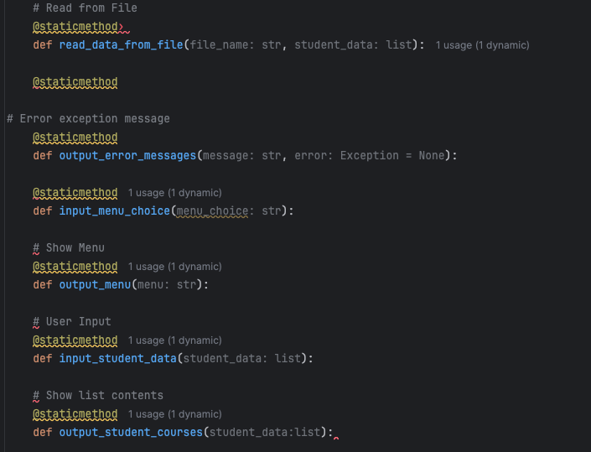
Then I organized with classes by what their functions were or handled the data.
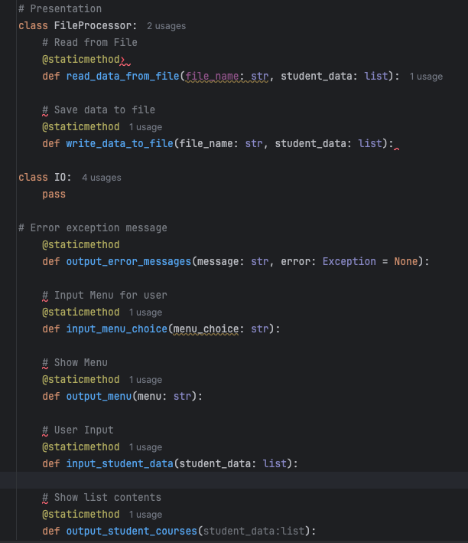
Having all my classes and functions organized made it easy to work through the code. We have been using similar if not very much the same code for a few weeks now. The difference this time is that we used functions inside of classes to do the repetitive work.
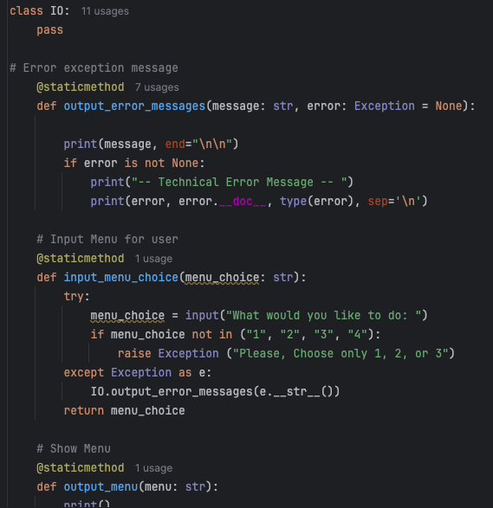
After formatting all of the functions, I started to work on the program. This was great, because it was so concise and clear once it was completed with the classes/function/arguments.
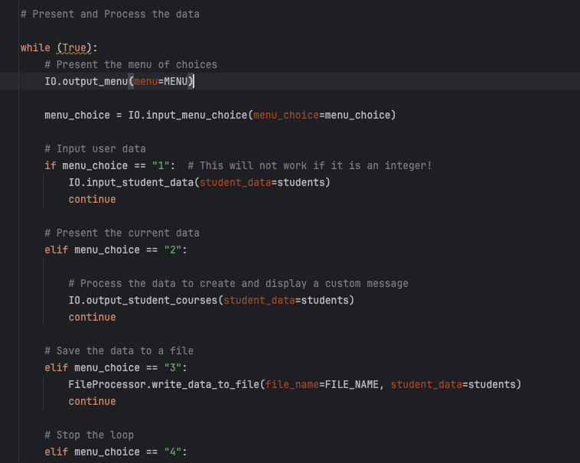
Summary
All in all this week’s module was great. It really starts to help us organize and keep everything in focus. It also gets us start thinking more deeply on how to organize, the steps required, and thoughtful names for classes and functions. This will allow us to produce a well written and understandable code base, while eliminating time by re-using functions that are pre-determined early on in our programs.

