Name: Mike Luke
Date: 11/24/2025
Course: IT FDN 110 A Au 25: Foundations Of Python Programming
Assignment 07 Code Repository
Assignment 07 –

Introduction
For Week 7, we are introduced to constructors, attributes, inheritance, and the overridden method. Week 6 was great with helping to organize code and set structure, but for this week we learned how to set a parent class that can be used to inherit attributes into a child class. This can be super helpful when there is commonality in your data. It allows you to build a base and add additional data depending on the requirement.

Topic
I simply started with the Assignment07-Starter.py file and worked my way through the “TODO” list.
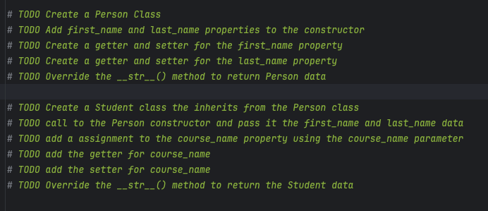
Setting the class for Person was similar to the previous week, but instead we set up and initialize its attributes. Using the getter makes it readable and the setter controls what happens when you assign the values.
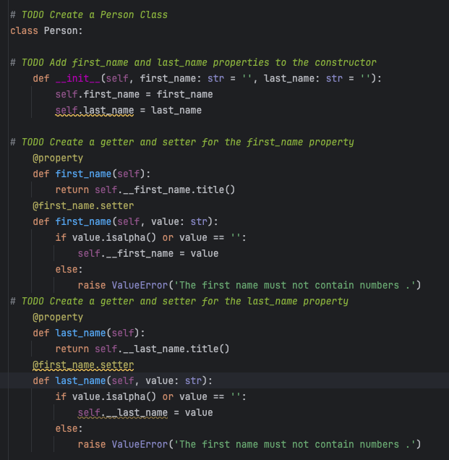
Setting up the Student class allows us to set a child class to Person. This allows us to pull the first_name and last_name and add additional data like course_name. This is useful if we were to have a list of all students and staff at a school. The commonality is the first and last names, but we can then modify this data to meet our requirements of what we would want to see for a student opposed to a teacher. Students will be registered for course, but a teacher would be assigned a course to instruct or multiple courses to instruct. Also by using the setter we are able to add in error handling allowing us to remove some of the previous code we used for week 6. It helps to simplify and make the code more modular.
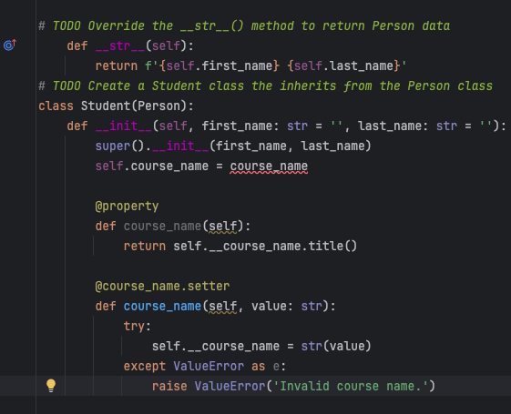
The override functionality allows us to control the output or turn it into a format we would like.
The next obstacle was taking the json data and creating a dictionary from the data and then appending to our student_data table. In order to write the data to a file we were instructed to create a dictionary then take the data and dump it into our file.

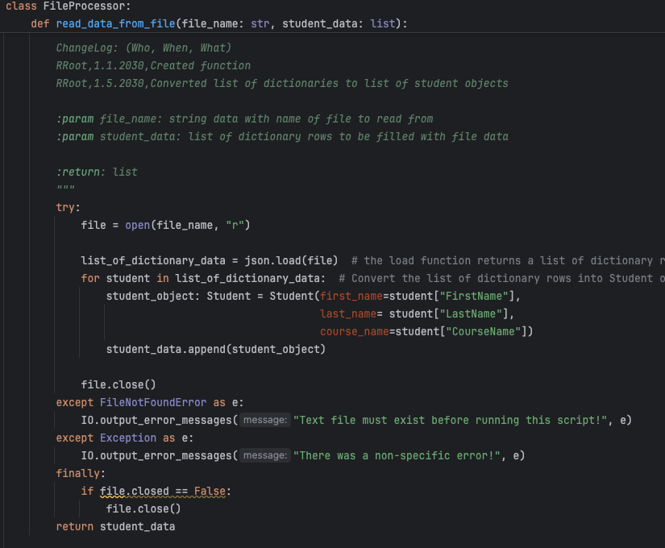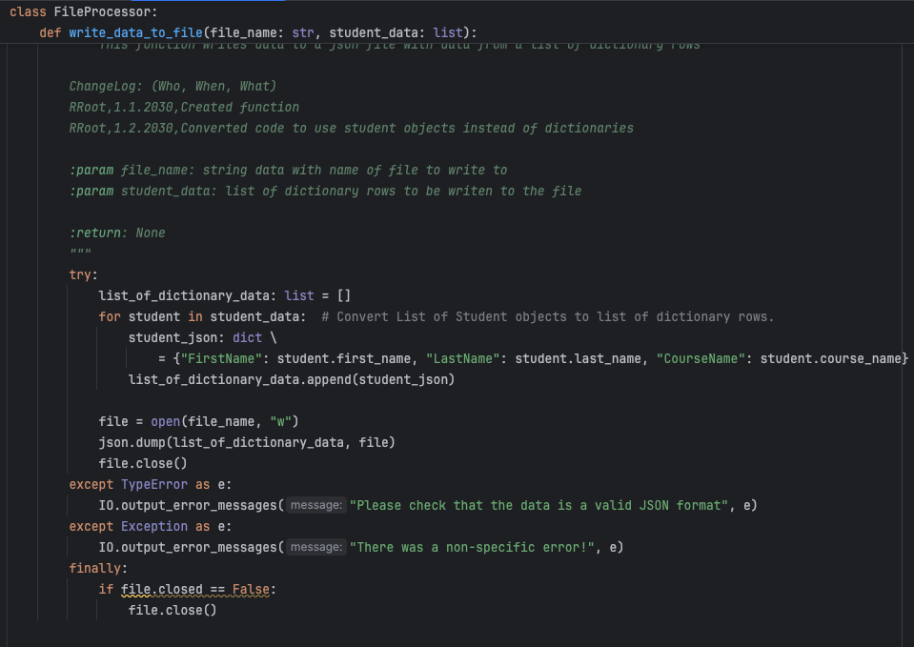
For Menu 2, we change it to print our objects.

Similarly, we capture the input data from option 1 in a student variable that is defined as Student() and append that to our table.

Summary
The assignment this week was difficult to understand, and I found that the readings, videos, and additional resources were missing some details for the assignment. This is my first programming class, so it took quite a bit of time and effort to work through all the problems I ran into. It did help to build on what we have learned previously and introduced the parent and child classes, which I can imagine will be useful in the future. It will allow us to take in data that is shared, create modular code that can be called to retrieve/process data, and add additional data if required.

