**Game Design Document**

Munch Paranoia

Christoffer Stenseth

Torkill Solberg Strømmen

Jørgen Haldorsen Tomren

Simon Hoff Tysland

Torje Dreng Andersen

Torstein Vien

Per Kristian Nyberg

Table of Contents

Overview 3

The Vision 3

Gameplay 4

Controls 4

Progression 4

On-screen Information 4

Interaction with the world 4

The World 5

Technology 6

Engine 6

Asset Creation Tools 6

Asset List 7

World Objects 7

Paintings 7

Miscellaneous Objects 8

Important characters/objects 8

Sound and music 8

Story Appendix 9

The Scribbles 10

# Overview

In this first person horror game the player controls a nameless, faceless character meant to serve as a vessel for the person playing. The player wanders around a network of twisted and to some degree absurd corridors and rooms while being stalked by a mysterious character known only as “The Murderer”.

In order to escape the Murderer and this surreal landscape, the player must collect certain information about why he/she’s there, why the Murderer is there and how to get rid of him, all of which will have something to do with Munch’s other artwork, providing a learning experience as well as a terrifying one, and then search the area for the necessary tools to get the job done and escape.

# The Vision

The goal is to create a compelling, paranoia inducing experience based on the works of Edvard Munch. By using Munch’s art style effectively mixed with everyday locales, we can create truly surreal areas for the player to explore, and adding the pressure of constantly being hunted with this surreal/normal blend we hope to create a memorable Munch experience. In terms of learning, we believe in indirect teaching, present the topic indirectly through the game, bake it into a bigger experience, and, we believe, the recipient will be more willing to absorb the knowledge.

The Murderer will present a constant danger element, hopefully inducing emotional responses in the player through fear and paranoia, which will hopefully help underline the experience.

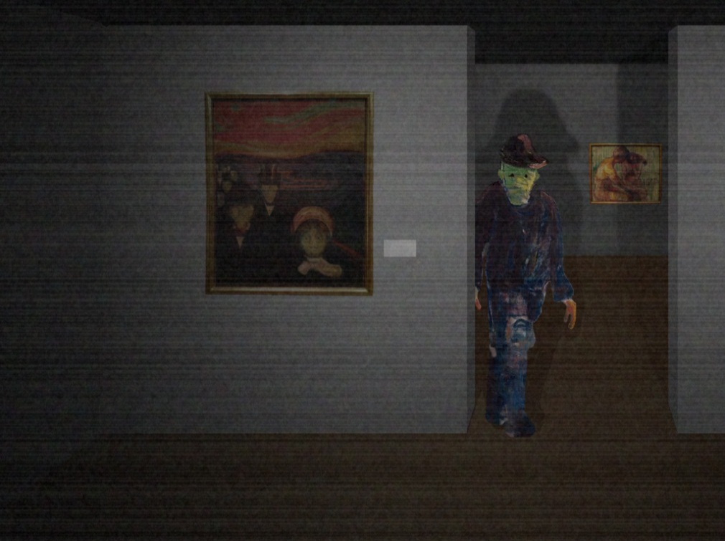

*Fig. 1: The Murderer stalking the building*

# Gameplay

## Controls

The player navigates the environment via the use of the mouse and WASD, pretty much the standard for first person games on the PC.

The game primarily consists of one level of rooms and corridors the player is free to explore.

## Progression

Progression in the game is done through the player collecting information and tools, which is also how the story is told, the player pieces together why they’re there, who the murderer is and how to get rid of him and escape. When the player has learned enough about the situation, they will need to find the tools and ultimately find the painting the Murderer originates from and erase him from existence, the empty painting now offers a doorway out.

## On-screen Information

The player won’t have much in terms of a Heads-up Display, instead, the player must actually pay attention to what’s happening to know where to go and what to look for, this information will be presented through voice clips as the player finds paintings and the tools needed to kill the Murderer.

## Interaction with the world

The player primarily observes the world, the paintings and the wall scribbles, by the end, the player will have collected some tools to defeat the Murderer, with which the player destroys the painting and makes his/her escape.

The wall scribbles along with the scratched text on the picture frames offer clues as to what’s really going on, and by piecing together this information, find a way out of this hallucinatory nightmare world. If it’s real or not will never actually be revealed, neither will the purpose of the testing that’s going in.

# The World

The area the player explores is the inside of an old building which is a combination of a warehouse, a period house with furniture and other various objects. Visually the locales will be a blend of “normal” and absurd, certain areas using the surrealist color palette of the paintings to create an unsettling world. As the player is hunted by the Murderer, the world will twist and change visually reflecting fear and the player’s journey into the mind of Munch.

The world is primarily inside, with a few outside locales, courtyards and such, giving the player some more visually satisfying incentive for exploration.

Some walls will be covered in scribbles giving hints as to what’s happening.

The world is inspired by other games such as Silent Hill due to its twisted and freaky themes.

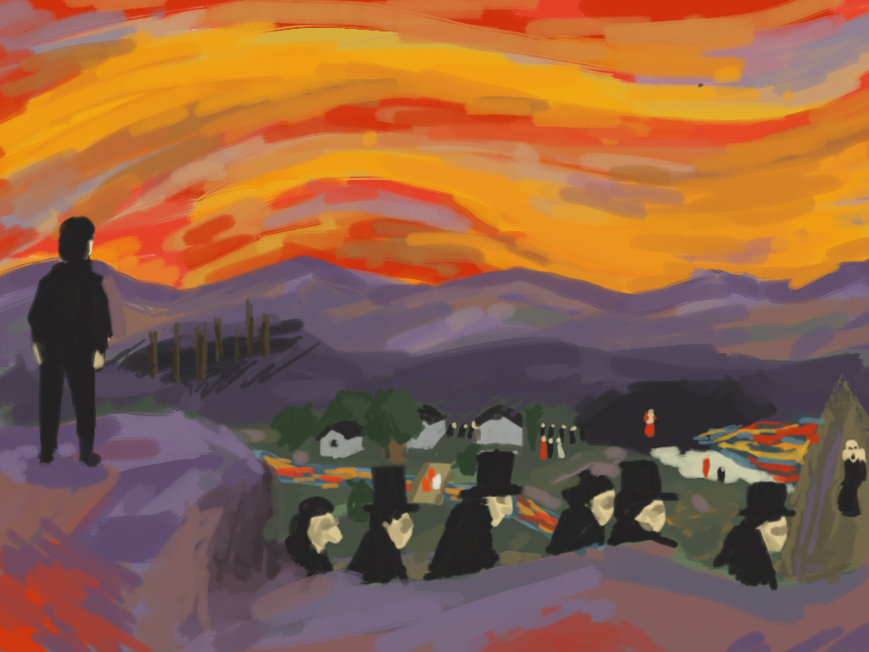

*Fig. 2: Concept art of visual design*

# Technology

## Engine

The engine used is the Unity 3 engine, chosen for its ease of access and use, this choice also means that if we wish, we can easily convert the game to run on pads and other devices with just tweaks to the control scheme.

## Asset Creation Tools

The assets will primarily be created with 3DS Max, primarily because it’s what we have access to, the code will be written with MonoDevelop, due to the programmers experience with the software and its integration with the Unity Engine.

# 

# Asset List

## World Objects

|  |  |  |
| --- | --- | --- |
| **Asset** | **Priority** | **Comments** |
| Straight corridor | 1 | 4x3x10m |
| T-junction corridor | 1 | 4x3x10m |
| Cross-junction corridor | 1 | 4x3x10m |
| Corridor corner | 1 | 4x3x10m |
| Small room | 1 | 4x10m |
| Medium room | 1 | 4x20m |
| Large room | 1 | 4x30m |
| Courtyard | 2 | 4x15m |

# C:\Users\Christoffer\Pictures\corridors.jpg

*Fig. 3: Sketch of buildings modules*

## Paintings

|  |  |  |
| --- | --- | --- |
| **Asset** | **Priority** | **Comments** |
| Scream | 1 | 1x1m |
| The Murderer | 1 | 1x1m |
| Madonna | 2 | 1x1m |
| Pikene på broen | 2 | 1x1m |
| Solen | 2 | 1x1m |
| Stjernenatt | 2 | 1x1m |
| Slåtteåker | 2 | 1x1m |

## Miscellaneous Objects

|  |  |  |
| --- | --- | --- |
| **Asset** | **Priority** | **Comments** |
| Bench | 3 |  |
| Closet | 3 |  |
| Wooden box | 3 |  |
| Wooden door | 2 |  |
| Ceiling lamp | 3 |  |
| Barrel | 3 |  |
| Carpet | 2 |  |
| Candle | 3 |  |
| Bookshelf | 3 |  |
| Reclining chair | 2 |  |
| Couch | 2 |  |
| Calendar from 1962 | 2 |  |

## Important characters/objects

|  |  |  |
| --- | --- | --- |
| **Asset** | **Priority** | **Comments** |
| The Murderer | 1 | The monster that hunts the player |
| Water bucket | 1 | A tool needed to kill the Murderer |
| Towel | 1 | A tool needed to kill the Murderer |
| A dead body | 1 | A clue as to what’s going on |

## Sound and music

|  |  |  |
| --- | --- | --- |
| **Asset** | **Priority** | **Comments** |
| Footsteps | 3 | Royalty free? |
| Background music | 1 | Royalty free? |
| Flickering fire | 3 | Royalty free? |
| Creaking door | 2 | Royalty free? |
| Crows | 3 | Royalty free? |
| Wind | 3 | Royalty free? |
| Panic music | 3 | Royalty free? |
| Breathing | 2 | Royalty free? |
| Inaudible voices | 2 | Royalty free? |

# 

# Story Appendix

The story takes place in the 1960’s when the player character is kidnapped by government agents to take part in a psychological experiment involving LSD and visual stimuli, this information is never directly revealed to the player.

The player character wakes up in what looks like a warehouse, with no clue as to where he is or what’s going on. As he explores the building, he discovers a painting with some scratching on the frame, it reads “He brought me here for a reason, something about the paintings”. Freaked out by this, the character decides to find a way out as fast as possible. As he delves deeper into the building, things seem not quite right, some of the colors are a little off, and some of the walls are covered in cryptic messages, some things don’t make sense, and just as he stumbles over another painting, he hears noises. This painting also has scratches on the frame, “The last I can remember was a man in black.” The character keeps exploring the complex, and he finally sees what the mysterious writer was talking about, a strange man with discolored skin and a hat, staring at him from the other side of a room.

The character bolts, but is constantly aware of the strange character stalking the halls. He is haunted by strange visions of things that doesn’t make sense, and as he walks through a courtyard, he sees silhouettes on the roof, he’s being watched. Filing it away as more hallucinations, he continues, and he stumbles over more paintings. “I’m starting to remember things, dreams, I’m being watched, suits”, “The green man, he has to die”, “Why are these paintings here why doesn’t anything make sense”, “THE GREEN MAN, THE MURDERER, I MUST ERASE HIS PAINTING, I MUST”.

Armed with this knowledge, the character searches the area for the painting and something to destroy it with, he finds a water bucket and a piece of cloth, and when the painting is destroyed, the blank canvas reveals a way out, a bright light, there are barely visible silhouettes on the other side of the canvas and some slight chattering, and the character steps through.

Roll credits.

If the player reads the scribbles on the walls he/she will gain insight into what’s going on, a government psychological experiment involving heavy hallucinogens, the paintings are there to instill certain emotions in the test subjects and enhance the effect of the drugs, if the player really explores there will be sightings that will make the player believe there’s actual danger to the character, a dead body, cries for help on the walls, sightings of men in suits, references to chemical formulas, a calendar that says 1962 etc.

## The Scribbles

|  |
| --- |
| ANTS EVERYWHERE |
| THE MEN ARE WATCHING |
| HELPHELPHELPHELPHELPHELPHELPHELPHELPHELP |
| C20H25N3O |
| THE MURDERERTHE MURDERERTHE MURDERER |
| VOICES IN THE DARK |
| BEING FOLLOWED |
| WHO ARE THEY WHAT DO THEY WANT |
| THE MEDICINE I TOOK THE MEDICINE |
| WATER ON PAPER |
| KILL IT KILL IT KILL IT |
| THIS IS ALL A TEST |