

**FORSIDE FOR INNLEVERING**

**TILGJENGELIGHET**

|  |  |  |  |
| --- | --- | --- | --- |
|  | **Fri** |  | **Begrenset** |

|  |  |  |
| --- | --- | --- |
| **Emnekode og emnenavn:** |  | |
| **Tittel norsk:** |  | |
| **Tittel engelsk (Hovedprosjekt):** |  | |
| **Eventuell oppdragsgiver:** |  | |
| **Utleveringsdato:** |  | |
| **Innleveringsdato:** |  | |
| **Antall sider:** |  | |
| **Antall ord:** |  | |
| **Sammendrag (maks 100 ord):** | | |
| **Gruppenummer:** |  | |
| **Studentnavn:** | **Studentnummer:** | **Signatur:** |
|  |  |  |
|  |  |  |
|  |  |  |
|  |  |  |
|  |  |  |
|  |  |  |
| **Studentens signatur er også en bekreftelse av at hun/han har gjort seg kjent med, og fulgt, NITHs retningslinjer for intellektuell redelighet (tilgjengelig på intranett).** | | |

## 1. The vision

The vision is to make a game that shows Munchs anxieties in a more modern way by combining his work with cold war conspiracy theories of government experimentation. It will take aesthetic inspiration from a combination of Munchs art and games like Silent Hill, it’s primarily a tool for the museum to attract people of “our age group”, which is something they want, but there will be some indirect learning about Munchs art and life.

## 2. Goal for sprint 3

The goal for sprint 3 was to draw a map of a level, develop rudimentary AI and pathfinding for the Murderer, create some missing assets, develop a start menu/pause menu and assemble it into a second prototype.

## 3. Documentation

## 4. Result for sprint 3

## 5. Three important experiences

Unity is incredibly simple meaning we can do a lot of cool stuff relatively easily.

All intergroup communication has to be 100% clear and proper to avoid miscommunication and such.

## **6**. Burndown graph for sprint 3

## 7. Goal and sprint backlog for next sprint

## VEDLEGG

##### Risikoliste (oppdatert – husk at dette er et levende dokument!)

##### Radartest med kommentar (kun sprint 1)

##### Gruppekontrakt (kun sprint 1)

##### Scrum-sjekkliste

##### Skjermdump Git og GitHub (f.o.m. sprint 2)

##### Timeliste/time sheet fra Jira (f.o.m. sprint 2)

##### Referater fra møte med produkteier og veileder (f.o.m. sprint 2)

##### Andre vedlegg (normalt fra punkt 3 Modeller, artefakter og oppgavespesifikk dokumentasjon)

##### Presentasjonen/versjon av løsningen presentert for produkteier på sprint review

# Scrum checklist

|  |  |  |  |
| --- | --- | --- | --- |
|  | JA | Nei | Kommentar |
| Daily Scrum completed | X |  |  |
| All tasks have been assigned story points | X |  |  |
| Burndown graph has been used | x |  |  |
| Scrum master have assigned tasks | x |  | Clarification on last checklist, the scrum master didn’t delegate tasks, the scrum master just assigned the tasks to the people who wanted them, it was just a matter of poor phrasing. |
| Scrum-master role has been utilized | x |  |  |
| Sprintbacklog worked | x |  |  |
| Produktbacklog worked | x |  |  |
| Scrum worked well | x |  |  |

**Risk Analysis/Plan**

Group 23

| Risk | Consequence | Probability | Risk Points | Preventative Measures | Contingency Plan |
| --- | --- | --- | --- | --- | --- |
| Absence. | 4 | 0,6 | 2,4 | -Make the project a priority!  -Pay attention to the schedule.  -Get enough sleep.  -Eat healthy.  -Stay away from sick people.  -Keep the schedule in an easily accessible place. | Each group member should pay attention to the work of the other members with the same roles and responsibilities as them. So that if someone is absent someone else knows their work and can step in for them. |
| New product specifications. | 3 | 0,7 | 2,1 | -Good communication with  customer, to understand what  they really want.  -Inform customer properly  about what we intend to  deliver. | Try to keep the code and other resources flexible, so it's possible to make changes. Have a good overview of the structure of our work. |
| Unfamiliar tools. | 5 | 0,5 | 2,5 | -Group members should  try to familiarize themselves  with Unity and other tools  they need. | If it becomes a problem we can go through some tutorials and other practice work together as a group. |
| Data loss. | 8 | 0,15 | 1,2 | - Take constant backups on all machines, dropbox, git and a USB stick | Roll back to latest accessible version, inform Charles and the customer, assess what we have left and estimate how much we’ll be able to redo, what we might have to scrap/revise etc. to hopefully get the project back on track. |
| Lack of effort. | 4 | 0,3 | 1,2 | -Good communication, so  people know what to do, and  feel responsible.  -Have a work schedule.  Encourage each other and not slaughter anyone for making trivial mistakes, keep morale up by socializing, and have a level of structured informality to make sure people don’t feel like they don’t belong. | Suggest tasks to members that don't do them on their own, discuss eventual problems, if it’s project related, discuss within the group what the cause is and how it can be solved, if it isn’t project related, offer moral support and help if wanted. |
| Miscommunication between group member. | 3 | 0,6 | 1,8 | If it’s an important request, important notification on structural changes or anything that will affect the group in a major fashion, if it’s anything that’s important to the project in general, write it down and save the document in a shared folder and on local systems. | If there’s still miscommunication, refer to the docs, highlight the main issues and express the intended message clearly. |
| Internet problems/speed preventing use of GitHub. | 3 | 0,2 | 0,6 | -Work somewhere that has  reliable internet access, if wireless network is unavailable, make sure to bring an Ethernet cable and a switch. | If we can't use the internet we have to use USB sticks to share files instead. |

# Notes from customer meeting

### Topic to be discussed with the customer

* Present our concept, and ask him how he feels about it.
* Try to get some feedback on how the customer wants the gameplay to be, or if we can do whatever we want (as we have a good idea on this matter).
* Ask which main factors that should be included in this sprint prototype.
* Target Audience, what does the customer want from this game?
* Try to guide and help the customer to find reasonable solutions.

### Minutes from the meeting

Meeting was held at 15:47 26. Nov. 2012.

What the customer wants from the project group on Friday is essentially something that he can hold in his arms. He wants to see some kind of a product that represents our game concept and ideas.

What we can deliver on Friday is a simple, but functional prototype. This is to show the customer the basics he can expect from the product.

Also we want to do some concept art, so we can show the customer our vision of how the end product will be. As a prototype can be somewhat difficult to explain this topic.

He wanted to know if the game concept had developed any from the first sprint week. We explained a bit more detailed on how the game will be, and the customer seemed to be pleased.

Although he wants us to carve the game ideas more into stone. He wants more explanation on the game plot and mechanics within the game.

When we asked about what target audience he wants the product to be developed for, he said that he wanted the game to be for the younger and youth. However, our initial game concept isn’t suitable for kids under the age of 8. This was not a problem for the customer, and he told us not to be too much worried about making a childish game, but rather take some freedom and create something for youth. Ages 10-12 and up. From this we can see that we have a lot of freedom when making the game.

The only criteria he had was that the game should potentially be developed so it can be also used for iOS or android touch devices.

So what he wants for Friday is something he can walk around in, something playable. Some art and more ideas for the game concept.

###### Timesheet reports

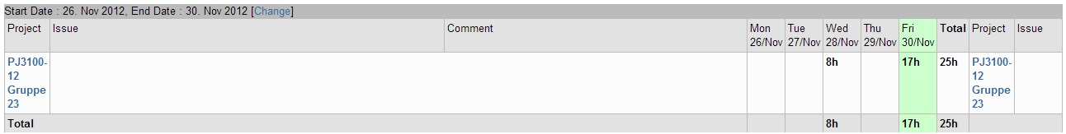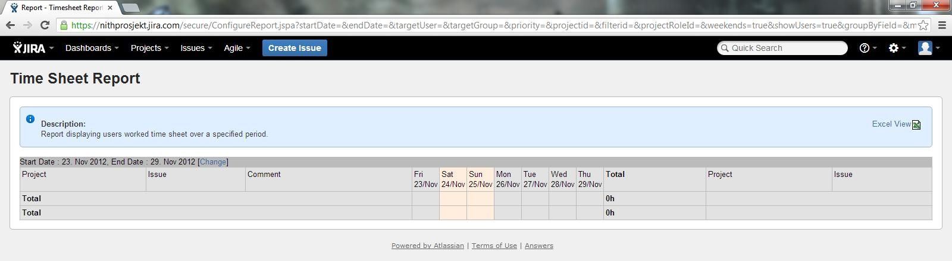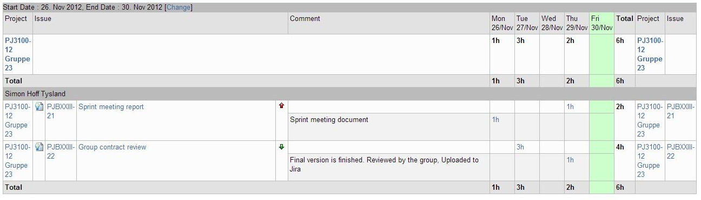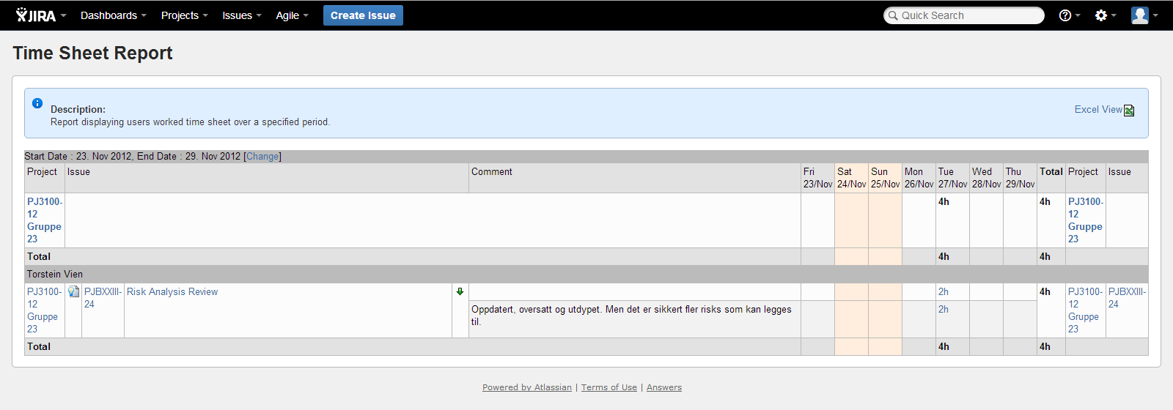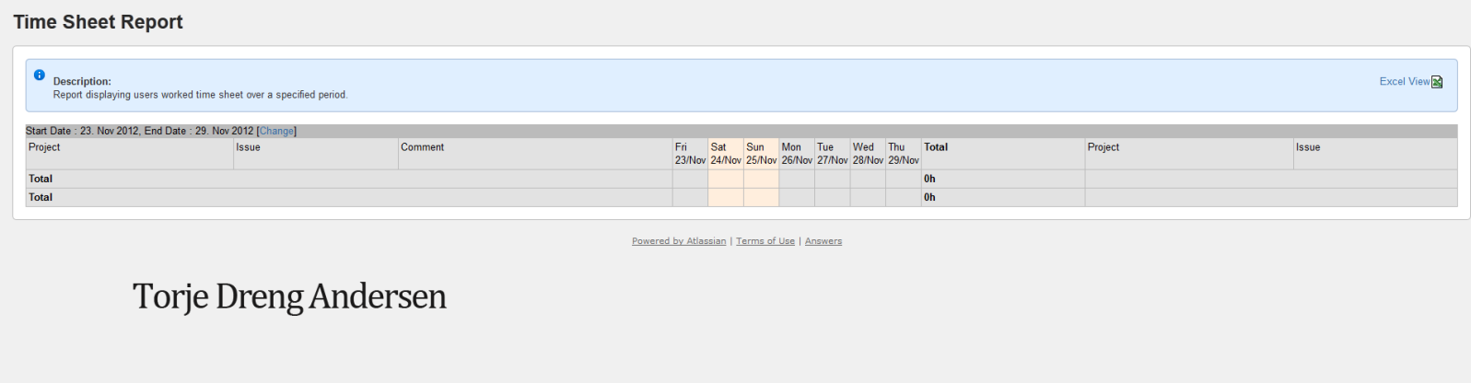

The timesheet reports are rather odd because of a mishap when assigning tasks, everyone’s done work, it was just assigned to the wrong person on Jira.

# Game Design presentation document

Munch Paranoia

Christoffer Stenseth

Torkill Solberg Strømmen

Jørgen Haldorsen Tomren

Simon Hoff Tysland

Torje Dreng Andersen

Torstein Vien

Per Kristian Nyberg

Table of contents

Game Design presentation document 1

Overview 3

The Vision 3

Gameplay 3

Controls 3

Progression 3

On-screen Information 4

Interaction with the world 4

The World 4

Development 4

Story Appendix 5

# Overview

In this first person horror game the player controls a nameless, faceless character meant to serve as a vessel for the person playing. The player wanders around a network of twisted and to some degree absurd corridors and rooms while being stalked by a mysterious character known only as “The Murderer”.

In order to escape the Murderer and this surreal landscape, the player must collect certain information about why he/she’s there, why the Murderer is there and how to get rid of him, all of which will have something to do with Munch’s other artwork, providing a learning experience as well as a terrifying one, and then search the area for the necessary tools to get the job done and escape.

# The Vision

The goal is to create a compelling, paranoia inducing experience based on the works of Edvard Munch. By using Munch’s art style effectively mixed with everyday locales, we can create truly surreal areas for the player to explore, and adding the pressure of constantly being hunted with this surreal/normal blend we hope to create a memorable Munch experience. In terms of learning, we believe in indirect teaching, present the topic indirectly through the game, bake it into a bigger experience, and, we believe, the recipient will be more willing to absorb the knowledge.

The Murderer will present a constant danger element, hopefully inducing emotional responses in the player through fear and paranoia, which will hopefully help underline the experience.

# Gameplay

## Controls

The player navigates the environment via the use of the mouse and WASD, pretty much the standard for first person games on the PC.

The game primarily consists of one level of rooms and corridors the player is free to explore.

## Progression

Progression in the game is done through the player collecting information and tools, which is also how the story is told, the player pieces together why they’re there, who the murderer is and how to get rid of him and escape. When the player has learned enough about the situation, they will need to find the tools and ultimately find the painting the Murderer originates from and erase him from existence, the empty painting now offers a doorway out.

## On-screen Information

The player won’t have much in terms of a Heads-up Display, instead, the player must actually pay attention to what’s happening to know where to go and what to look for, this information will be presented through voice clips as the player finds paintings and the tools needed to kill the Murderer.

## Interaction with the world

The player primarily observes the world, the paintings and the wall scribbles, by the end, the player will have collected some tools to defeat the Murderer, with which the player destroys the painting and makes his/her escape.

The wall scribbles along with the scratched text on the picture frames offer clues as to what’s really going on, and by piecing together this information, find a way out of this hallucinatory nightmare world. If it’s real or not will never actually be revealed, neither will the purpose of the testing that’s going in.

# The World

The area the player explores is the inside of an old building which is a combination of a warehouse, a period house with furniture and other various objects. Visually the locales will be a blend of “normal” and absurd, certain areas using the surrealist color palette of the paintings to create an unsettling world. As the player is hunted by the Murderer, the world will twist and change visually reflecting fear and the player’s journey into the mind of Munch.

# Development

Initially we’ll make a graybox prototype with corridors, a few rooms and some things on the walls to add a sense of place. In the following weeks we’ll work on the Murderer himself and the AI, as well as adding proper textures, sound and more objects in the world.

# Story Appendix

The story takes place in the 1960’s when the player character is kidnapped by government agents to take part in a psychological experiment involving LSD and visual stimuli, this information is never directly revealed to the player.

The player character wakes up in what looks like a warehouse, with no clue as to where he is or what’s going on. As he explores the building, he discovers a painting with some scratching on the frame, it reads “He brought me here for a reason, something about the paintings”. Freaked out by this, the character decides to find a way out as fast as possible. As he delves deeper into the building, things seem not quite right, some of the colors are a little off, and some of the walls are covered in cryptic messages, some things don’t make sense, and just as he stumbles over another painting, he hears noises. This painting also has scratches on the frame, “The last I can remember was a man in black.” The character keeps exploring the complex, and he finally sees what the mysterious writer was talking about, a strange man with discolored skin and a hat, staring at him from the other side of a room.

The character bolts, but is constantly aware of the strange character stalking the halls. He is haunted by strange visions of things that doesn’t make sense, and as he walks through a courtyard, he sees silhouettes on the roof, he’s being watched. Filing it away as more hallucinations, he continues, and he stumbles over more paintings. “I’m starting to remember things, dreams, I’m being watched, suits”, “The green man, he has to die”, “Why are these paintings here why doesn’t anything make sense”, “THE GREEN MAN, THE MURDERER, I MUST ERASE HIS PAINTING, I MUST”.

Armed with this knowledge, the character searches the area for the painting and something to destroy it with, he finds a water bucket and a piece of cloth, and when the painting is destroyed, the blank canvas reveals a way out, a bright light, there are barely visible silhouettes on the other side of the canvas and some slight chattering, and the character steps through.

Roll credits.

If the player reads the scribbles on the walls he/she will gain insight into what’s going on, a government psychological experiment involving heavy hallucinogens, the paintings are there to instill certain emotions in the test subjects and enhance the effect of the drugs, if the player really explores there will be sightings that will make the player believe there’s actual danger to the character, a dead body, cries for help on the walls, sightings of men in suits, references to chemical formulas, a calendar that says 1962 etc.

