OpenStack Kolla-Ansible Installation

This manual will cover OpenStack installation using Kolla-Ansible method on **Bare Metal Servers**

Source: <https://docs.openstack.org/project-deploy-guide/kolla-ansible/wallaby/quickstart.html#host-machine-requirements>

INDEX

***Topology 2***

***Preinstall 3***

***Install Dependencies: 3***

***Install Kolla-Ansible 4***

***Install Kolla for Deployment 4***

***Prepare Initial Configuration 4***

***Generate kolla passwords 8***

***Start deployment 8***

***Post Deployment 8***

# Topology

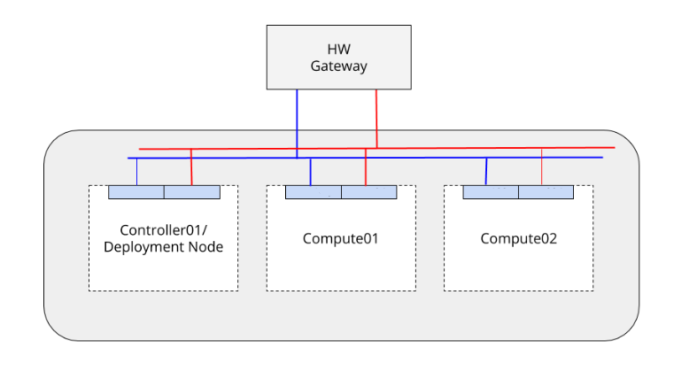

We will perform the setup based on the above topology, 1 Controller and 2 Compute nodes.

Please configure network setup according the following:

Controller:

Eth1: routed mgmt network

Eth2: isolated vxlan overlay network

Eth3: routed external (internet) network

Compute:

Eth1: routed mgmt network

Eth2: isolated vxlan overlay network

# Preinstall

On all nodes:

Create a user (ubuntu in our case) and define a password for the user

$ sudo su

# useradd -d /home/ubuntu -m ubuntu

# passwd ubuntu

Setup passwordless sudo for the new user

# nano /etc/sudoers.d/ubuntu

ubuntu ALL=(ALL) NOPASSWD:ALL

change Shell to bash for user ubuntu

# nano /etc/passwd

ubuntu:x:1001:1001::/home/ubuntu:/bin/bash

change user to ubuntu and update repo

# su – ubuntu

# apt-get update

On controller node (all further setup will be performed with this new user ubuntu):

$ su – ubuntu

$ sudo apt-get -y install sshpass

$ ssh-keygen

$ ssh-copy-id 192.168.10.20 (run for all nodes in cluster)

# 

# 

# Install Dependencies:

Following commands to be run on controller only

$ sudo apt update

$ sudo apt install python3-dev libffi-dev gcc libssl-dev

Install pip

$ sudo apt install python3-pip

Ensure latest version of pip is installed

$ sudo pip3 install -U pip

Install Ansible

$ sudo pip install -U 'ansible<3.0

# Install Kolla-Ansible

$ sudo pip3 install git+https://opendev.org/openstack/kolla-ansible@stable/xena

$ sudo mkdir -p /etc/kolla

$ sudo chown $USER:$USER /etc/kolla

$ cp -r /usr/local/share/kolla-ansible/etc_examples/kolla/* /etc/kolla

$ cp /usr/local/share/kolla-ansible/ansible/inventory/* .

# Install Kolla for Deployment

$ sudo git clone --branch stable/xena| <https://opendev.org/openstack/kolla-ansible>

$ sudo pip3 install ./kolla-ansible

$ sudo mkdir -p /etc/kolla

$ sudo chown $USER:$USER /etc/kolla

$ cp -r kolla-ansible/etc/kolla/* /etc/kolla

$ cp kolla-ansible/ansible/inventory/* .

# Prepare Initial Configuration

$ sudo cp /home/ubuntu/multinode /etc/kolla/

Edit multinode file

$ sudo nano /etc/kolla/multinode

metin içeren bir resim

Açıklama otomatik olarak oluşturuldu

Create Cinder Volumes on storage nodes

metin içeren bir resim

Açıklama otomatik olarak oluşturuldu

Edit /etc/kolla/globals.yml with required options

$ sudo nano /etc/kolla/globals.yml

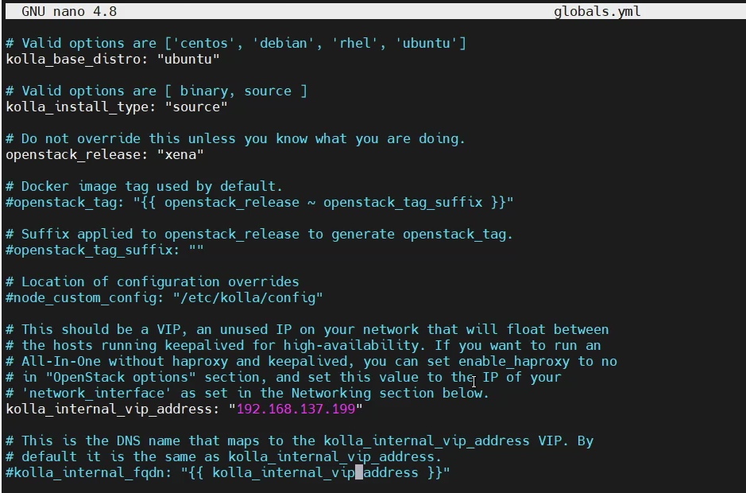

Additional to the above; Edit neutron network_interface, neutron tunnel_interface and neutron_external_interface

metin içeren bir resim

Açıklama otomatik olarak oluşturuldu

Select openvswith as neutron plugin agent

metin içeren bir resim

Açıklama otomatik olarak oluşturuldu

Enable openstack core, cinder and cinder LVM

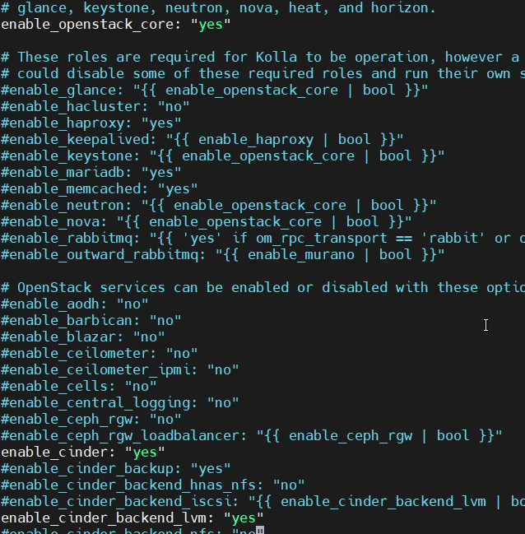

And enable KVM

metin içeren bir resim

Açıklama otomatik olarak oluşturuldu

Check if all nodes are reachable by Ansible

$ ansible -i multinode all -m ping

# Generate kolla passwords

$ kolla-genpwd

# Start deployment

$ cd /etc/kolla

$ kolla-ansible - ./multinode bootstrap-servers

$ kolla-ansible -i ./multinode prechecks

$ kolla-ansible -i ./multinode deploy

# Post Deployment

$ kolla-ansible post-deploy . /etc/kolla/admin-openrc.sh

$ pip install python-openstackclient python-glanceclient python-neutronclient

Now we can login to UI on VIP IP

U: admin

Password to be retrived from following file

$ cat /etc/kolla/admin-openrc.sh

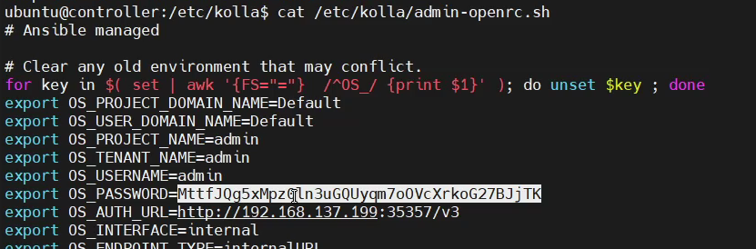

To run openstack CLI

$ source /etc/kolla/admin-openrc.sh

Confirm hypervisors are up and running

$ openstack hypervisor list

